**Assignment No:-5**

**Problem Statement:-**

Visualize the data using R/Python by plotting the graphs for assignment no. 1 and 2. Consider a

suitable data set.

a) Use Scatter plot, bar plot, Box plot and Histogram

OR

b) Perform the data visualization operations using Tableau for the given dataset.

**Theory**:-

**Methodology:**

Data visualization is the graphical representation of information and data. In this report, we utilize R/Python to visualize the data through scatter plots, bar plots, box plots, and histograms.

* **Scatter Plot:** A scatter plot displays values for two variables as points on a Cartesian plane. It is useful for identifying relationships or patterns between variables.
* **Bar Plot:** A bar plot represents categorical data with rectangular bars. It is commonly used to compare the frequency, count, or other aggregated measures across different categories.
* **Box Plot:** Also known as box-and-whisker plot, it displays the distribution of a dataset based on its quartiles. It provides insights into the spread and skewness of the data.
* **Histogram:** A histogram is a graphical representation of the distribution of numerical data. It divides the data into intervals (bins) and shows the frequency of observations within each bin.

**Advantages and Disadvantages & Limitations/Example:**

1. **Advantages:**

* Scalability: R and Python offer scalability in terms of handling large datasets and producing high-quality visualizations.
* Customization: Both R and Python provide extensive libraries (e.g., ggplot2 in R, matplotlib and seaborn in Python) with functionalities for customizing visualizations according to specific requirements.
* Interactivity: With packages like Plotly in Python or ggplotly in R, visualizations can be made interactive, allowing for deeper exploration and understanding of the data.

1. **Disadvantages & Limitations/Example:**

* Learning Curve: R and Python require some learning curve, especially for beginners, to master data visualization techniques and libraries.
* Performance: While R and Python are powerful tools, complex visualizations or large datasets might lead to performance issues.
* Tool Specificity: Each tool (R or Python) has its own ecosystem of libraries and functions, which might require switching between environments based on project requirements.

**Example:-**

For demonstration, let's consider a dataset containing information about sales transactions in a retail store. We will use R/Python to visualize various aspects of this dataset.

* Scatter plot: Visualize the relationship between sales amount and time.
* Bar plot: Compare sales performance across different product categories.
* Box plot: Analyse the distribution of sales amounts for each month.
* Histogram: Understand the frequency distribution of sales amounts.

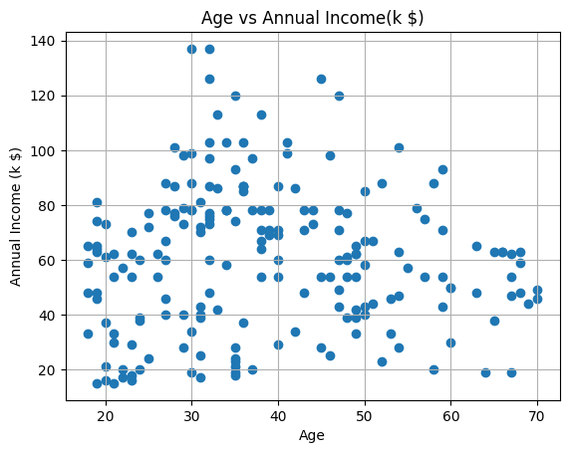**Diagram:-**

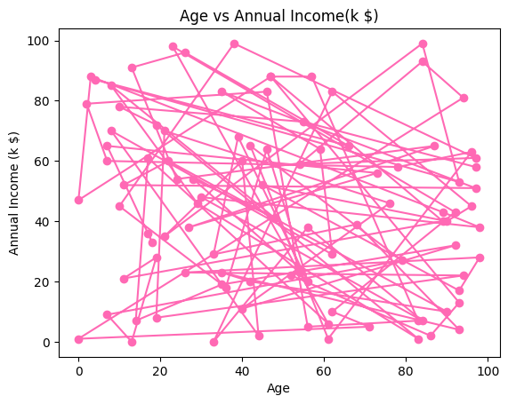

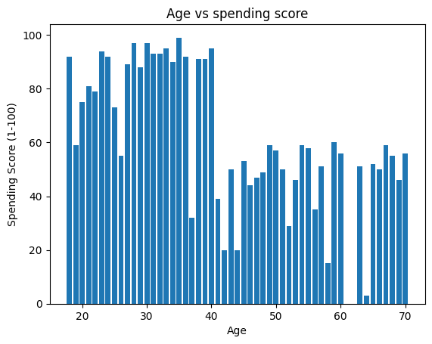

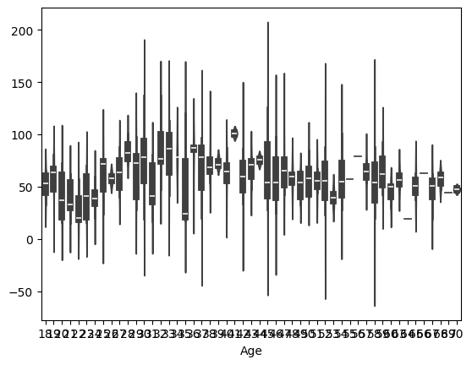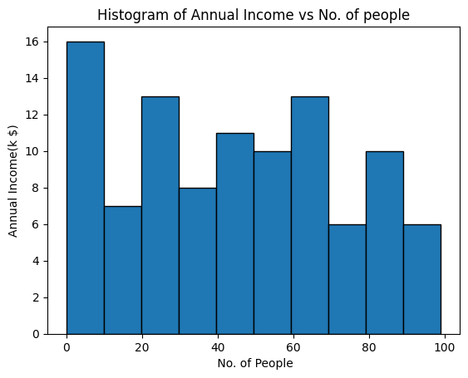**Conclusion:-**

Data visualization is a crucial step in the data analysis process as it allows for the effective communication of insights and patterns present in the data. R and Python offer powerful tools and libraries for creating a wide range of visualizations, including scatter plots, bar plots, box plots, and histograms. While each method has its advantages and limitations, the choice between them ultimately depends on factors such as data complexity, audience, and project requirements. By leveraging the capabilities of R/Python, analysts and data scientists can gain valuable insights and make informed decisions based on visual representations of their data.