

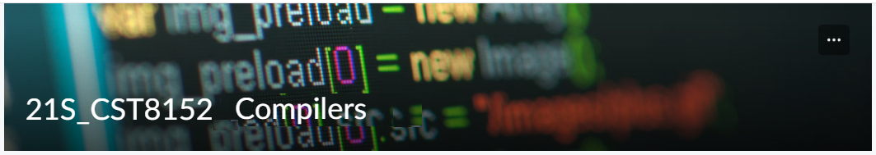

MODEL TASK FOR ASSIGNMENT 2.1 – YOUR LANGUAGE

Language: [SVP]
Team - [Sahil Kakakdiya] Id: [041052919]- –[Sajid Ahmad] [041002172]

- Note: This task is part of the Assignment 2 from Compilers Course. Any problem, contact your lab professor.

PART 1: RE – Regular Expression (1.5 mark)

Lexeme Classes: Define the classes to be used in your regular expression:

Answer:

ml = [a-zA-Z] For Letters

d = [0-9] For Digits

u = _ For Underscore

q = `”` `’` For Double Quotation Marks(SL delimitator)

Q= `’` For Single quotation marks

E = ! For MVID delimitator

b = / For Forward Slash

s = * For Star

o =[^ml.d.u.q.E] For Other chars

Define the RE to be used for: variables, literals and keywords:

Answer:

* Comments: for single line: bbq[\n\r]*q
for double line comment: bsq[\n\r]*qsb (b = / and s= *)

* Variables: ml (letters) followed by an optional combination of ml(letters), d(digits), and u(underscore)

* Methods: fn main!, printString!, printInt!, println!, printDouble!

* Literals:
- Numbers: [d]+ (digits)

- Strings Literals: q[^\n\r]*q (anything between quotation marks)

* Keywords: fn, let, continue, return, loop, if, else, break, mut

PART 2: TD – Transition Diagram (1.5 marks)

Activity: Starting from the previous lexeme classes and obeying the RE, it is possible to define the automata for your language:

Answer (draw / copy image of the automata):
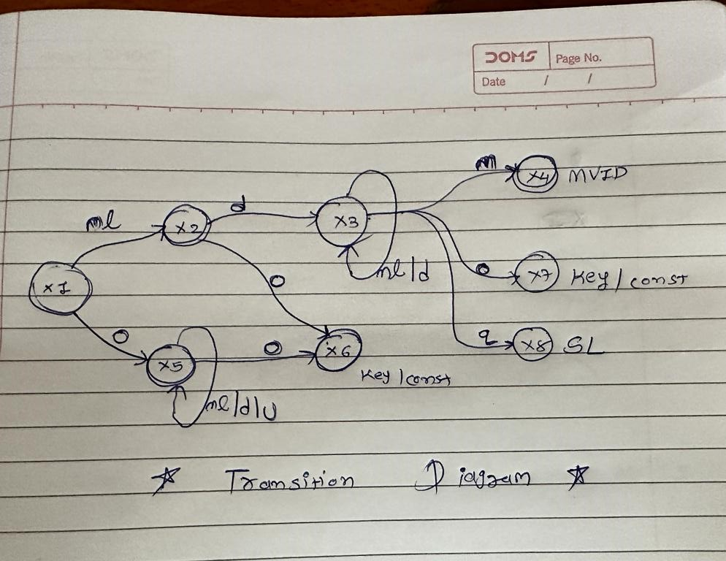

PART 3: TT – Transition Table (2 marks)

Activity: Now, it is possible to define the TT for these lexemes:

Answer (Transition Table):
State | ml( a-zA-Z ) | d ( 0-9 ) | u ( _ ) | q = `”` | m = ( & ) | o = other | Output
X1 | 2 | ESNR | ESNR | ESNR | ESNR | 5 | NOAS [1]
X2 | ESNR | 3 | ESNR | ESNR | ESNR | 6 | NOAS [2]
X3 | 3 | 3 | ESNR | 8 | 4 | 7 | NOAS [3]
X4 | FS | FS | FS | FS | FS | FS | ASNR (MNID) [4]
X5 | 5 | 5 | 5 | ESNR | ESNR | 6 | NOAS [5]
X6 | FS | FS | FS | FS | FS | FS | ASWR (KEY) [6]
X7 | FS | FS | FS | FS | FS | FS | ASWR (KEY) [7]
X8 | FS | FS | FS | FS | FS | FS | ASNR (SL) [8]

Update: May 30th 2023.

Adapted from resources developed by Prof. Svillen Ranev (Algonquin College, 2019)

