Bus Route Optimization for Mumbai

The goal is to enhance mobility, accessibility, and sustainability, while also reducing travel time for the city’s residents. Ultimately, this will lead to a more efficient and user-friendly public transportation system in Mumbai.

We have to employ an optimization procedure to come up with a near best solution. It is not possible to determine the best set of routes in a

deterministic amount of time. Therefore we employ the evolutionary algorithm approach to model our problem.

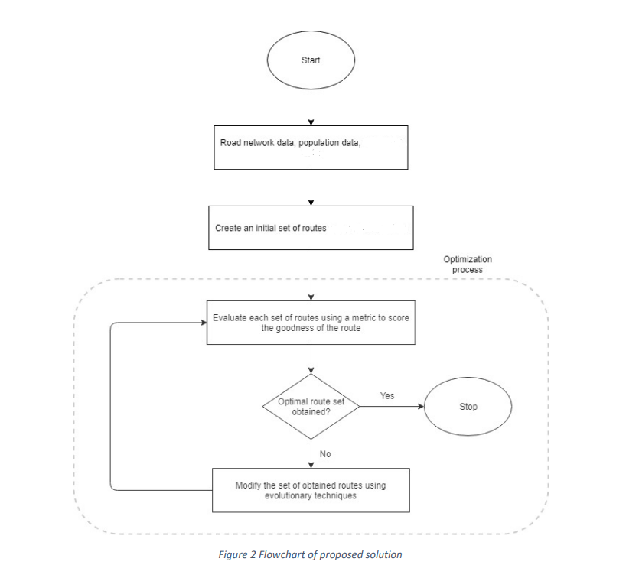

We have attached the reference paper in the folder.

The user also has the option of selecting the stops they want and the optimised route would be displayed.

We have used folium for creating interactive maps.