**Name:** Sahil Khose

**Reg no:** 180953218

CCE-B 39

**Lab batch:** CCE-4

**Lab 1:**

**Question1:**

Code:

print("Enter 2 lists:")

l1 = [*map(int, input().split())]

l2 = [*map(int, input().split())]

print("List 1: ", l1)

print("List 2: ", l2)

a = [ele for ele in l1 if ele%2 != 0]

[a.append(ele) for ele in l2 if ele%2 == 0]

print("Final List: ", a)

Output:

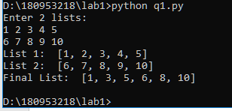

**Question 3:**

Code:

n = int(input("Enter value of n: "))

str_list = [input() for _ in range(n)]

count = 0

for string in str_list:

if string.endswith(string[0]) and len(string) > 1:

count += 1

print("Count is: ", count)

[print(string) for string in str_list if len(string)%2 != 0]

Output:

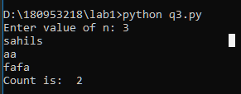

**Lab 2:**

**Question 1:**

Code:

word_dict = {}

for word in input().split():

if word not in word_dict:

word_dict[word] = 1

else:

word_dict[word] +=1

print("Number of unique words:", len(word_dict))

Output:

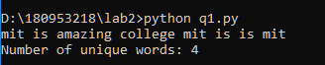

**Question 3:**

Code:

import random

### a part:

user_dict = {}

print("enter dictionary values, -1 to exit:")

while True:

value = input()

if value == "-1":

break

key = random.randrange(0, 100)

while key in user_dict.keys():

key = random.randrange(0, 100)

user_dict[key] = value

print("\nThe dictionary generated is:")

print(user_dict)

### b and c part:

num_list = []

str_list = []

for ele in user_dict.values():

if ele.isnumeric():

num_list.append(int(ele))

else:

str_list.append(ele)

if len(num_list):

print("\nAverage of numbers: ", sum(num_list) / len(num_list))

print("\nConcatenated strings: ", "".join(str_list))

### e part:

special_list = []

print("\nDisplaying all special characters values:")

for tag in user_dict.values():

if not any([ele.isalnum() for ele in list(tag)]):

special_list.append(tag)

print(tag)

### d part:

print("\nAll numbers:")

print(num_list)

print("\nOthers:")

for key, val in user_dict.items():

if not val.isnumeric() and val not in special_list:

print(key, val)

Output:

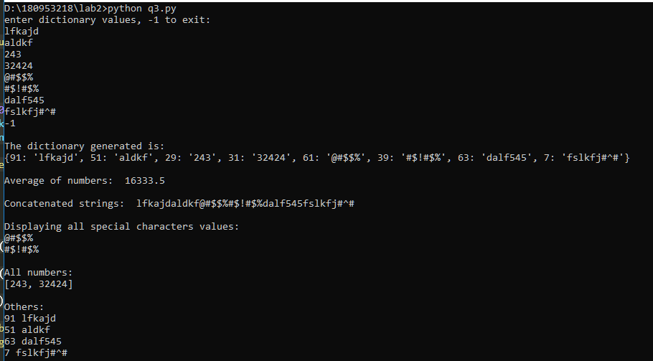

**Lab 3:**

**Question 1:**

Code:

def mul(list_):

if not len(list_):

return("Enter a non-empty list!")

res = 1.

for ele in list_:

res = res * ele

return res

if __name__ == '__main__':

list_ = [*map(float, input("Enter list: ").split())]

print(mul(list_))

Output:

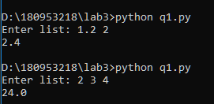

**Question 2:**

Code:

def unique(list_):

return(list(set(list_)))

if __name__ == '__main__':

print(unique([*map(float, input("Enter the numbers: ").split())]))

Output:

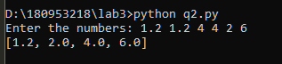

**Question 3:**

Code:

def main():

a = 180953218

s = "sahil"

if __name__ == '__main__':

print(main.__code__.co_nlocals)

Output:

