**Name:** Sahil Khose

**Reg no:** 180953218

CCE-B 39

**Lab batch:** CCE-4

**Lab 4:**

**Question1:**

Code:

import math

num = int(input("Enter a number:"))

print(f"sin({num}) = {math.sin(num)}")

print(f"square_root({num}) = {math.sqrt(num)}")

print(f"log({num}) = {math.log10(num)}")

Output:

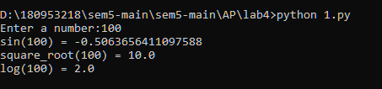

**Question 2:**

Code:

import cmath

real = int(input("Enter real part:"))

img = int(input("Enter imaginary part:"))

num = complex(real, img)

print(f"sin({num}) = {cmath.sin(num)}")

print(f"square_root({num}) = {cmath.sqrt(num)}")

print(f"log({num}) = {cmath.log10(num)}")

Output:

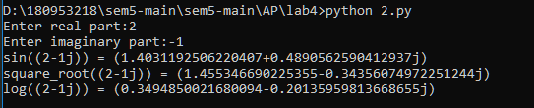

**Question 3:**

Code:

import os

for k, v in os.environ.items():

print(f"{k} : {v}")

Output:

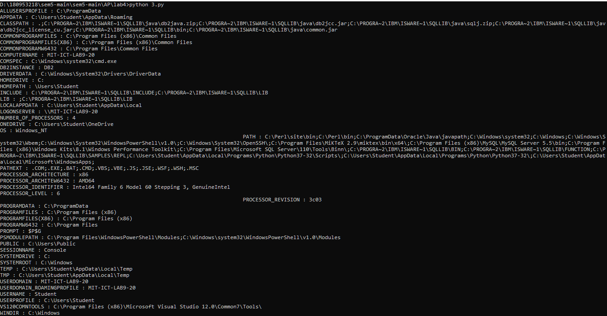

**Lab 5:**

**Question 1:**

Code:

class Employee:

def __init__(self, id_, name, salary, dept):

self.id = id_

self.name = name

self.salary = salary

self.dept = dept

self.details = (self.id, self.name, self.salary, self.dept)

def display(self):

print(f"id: {self.id}, name: {self.name}, salary: {self.salary}, dept: {self.dept}")

if __name__ == '__main__':

num = int(input("Enter the number of Employees: "))

emp_list = [] # list storing the object

emp_details_list = [] # list storing the tuples

for i in range(num):

emp_list.append(Employee(

int(input("id: ")),

input("name: "),

int(input("salary: ")),

input("dept: ")))

emp_details_list.append(emp_list[i].details)

print()

print("Employees details: ")

[print(ele) for ele in emp_details_list]

print()

id_ = int(input("enter Employee id to search: "))

for emp in emp_list:

if emp.id == id_:

emp.display()

break

else:

print("No such id was found!")

Output:

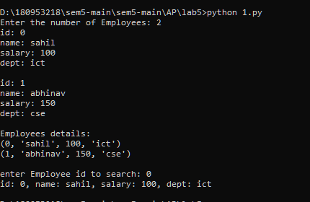

**Question 3:**

Code:

class subsets():

def __init__(self, inp_list):

self.inp_list = inp_list

def sub(self):

base = []

all_subsets = [base]

for i in range(len(self.inp_list)):

orig = all_subsets[:]

new = self.inp_list[i]

for j in range(len(all_subsets)):

all_subsets[j] = all_subsets[j] + [new]

all_subsets = orig + all_subsets

return all_subsets

if __name__ == '__main__':

l = list(map(int, input("enter the list of input: ").split()))

print(subsets(l).sub())

Output:

