**Name:** Sahil Khose

**Reg no:** 180953218

CCE-B 39

**Lab batch:** CCE-4

**Lab 6:**

**Question1:**

Code:

"""Total number of chars, words, lines in a file"""

file = open("a.txt").read().split("\n")

lines = len(file)

words = 0

chars = 0

for line in file:

for word in line.split():

words+=1

chars+=len(word) # not including spaces and \n

chars = chars + (words - 1)

print(f"Lines: {lines}, Words: {words}, Chars: {chars}")

Output:

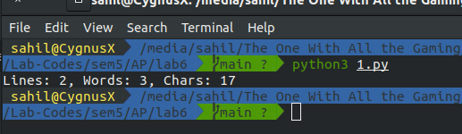

**Question 2:**

Code:

"""GUI"""

from tkinter import *

from tkinter import ttk

window = Tk()

window.title("Manipal Institute Of Technology")

window.geometry('400x400')

window.configure(background = "blue");

a = Label(window ,text = "Name").grid(row = 0,column = 0)

b = Label(window ,text = "Registration Number").grid(row = 1,column = 0)

c = Label(window ,text = "Email Id").grid(row = 2,column = 0)

d = Label(window ,text = "Contact Number").grid(row = 3,column = 0)

a1 = Entry(window).grid(row = 0,column = 1)

b1 = Entry(window).grid(row = 1,column = 1)

c1 = Entry(window).grid(row = 2,column = 1)

d1 = Entry(window).grid(row = 3,column = 1)

def clicked():

res = "Welcome to " + txt.get()

lbl.configure(text= res)

btn = ttk.Button(window ,text="Submit").grid(row=4,column=0)

window.mainloop()

Output:

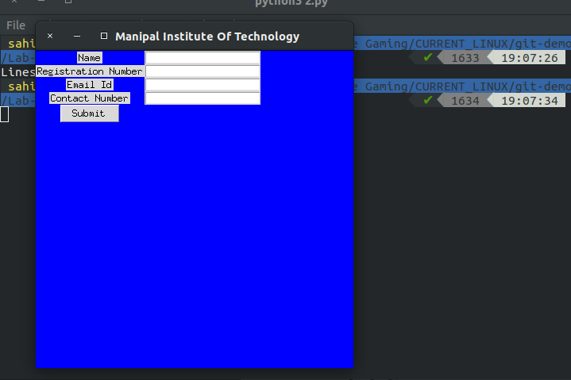**Question 3:**

Code:

import sqlite3

conn = sqlite3.connect('example.db')

print("Database connected.")

c = conn.cursor()

c.execute('''CREATE TABLE students

(ID INT PRIMARY KEY NOT NULL,

NAME TEXT NOT NULL,

email CHAR(50) NOT NULL,

ph_no INT);''')

print("Table created.")

c.execute("INSERT INTO students VALUES (180953218, 'sahil', 'sahil@gmail.com',100100100)")

c.execute("INSERT INTO students VALUES (180953222, 'abhinav', 'abhinav@gmail.com',100100101)")

conn.commit()

print("Records created.")

conn.close()

Output:

