**Sahil Khose**

**180953218**

**CCE-B (batch 4)**

**Roll no: 39**

LAB-1

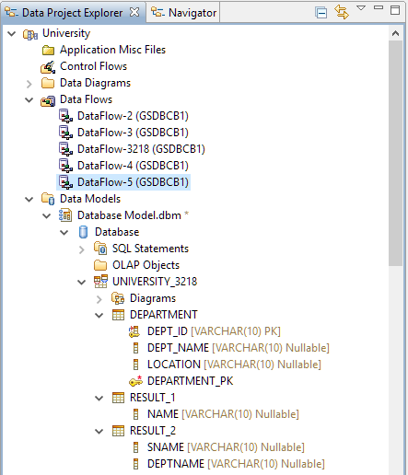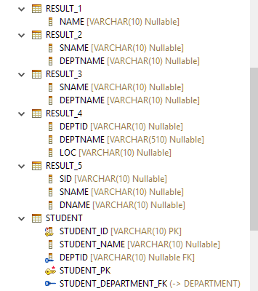

# DEPARTMENT TABLE:

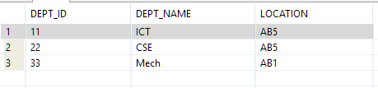

# STUDENT TABLE:

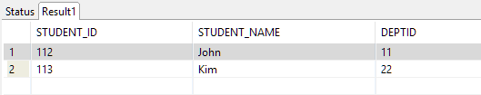

--------------------------------------------------------------------------------------------------------------------------------------

# QUERY 1:

Display names of students with department id = 11

DATA FLOW:

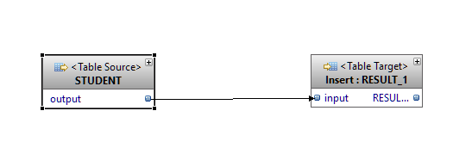

Filter Condition:

"UNIVERSITY_3218"."STUDENT"."DEPTID" = 11

OUTPUT:

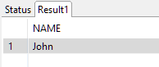

# QUERY 2:

Display name and department name of students with department id = 22

DATA FLOW:

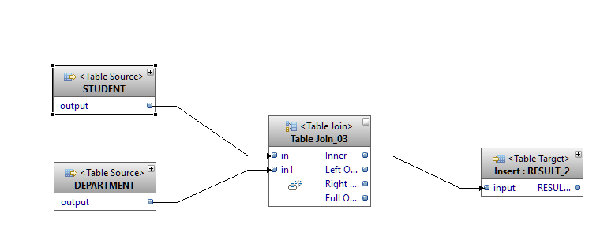

Filter Condition:

Student: "UNIVERSITY_3218"."STUDENT"."DEPTID" = 22

Table join_03: "IN_03_0"."DEPTID" = "IN1_03_1"."DEPT_ID"

OUTPUT:

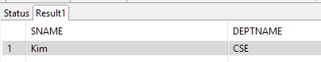

# QUERY 3:

Display name and department name of students whose department is not Mech

DATA FLOW:

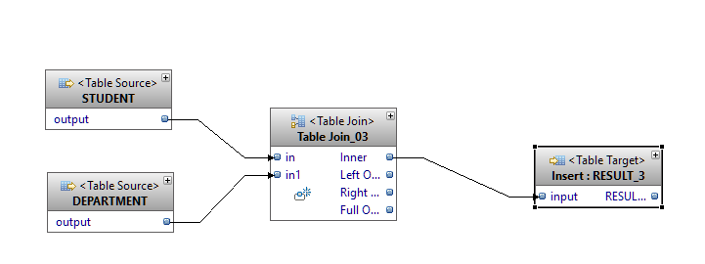

Filter Condition:

Department: "UNIVERSITY_3218"."DEPARTMENT"."DEPT_NAME" <> 'Mech'

Table Join_03: "IN_03_0"."DEPTID" = "IN1_03_1"."DEPT_ID"

OUTPUT:

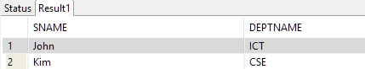

# QUERY 4:

Display department id, department name and location of department where department is not located in AB1

DATA FLOW:

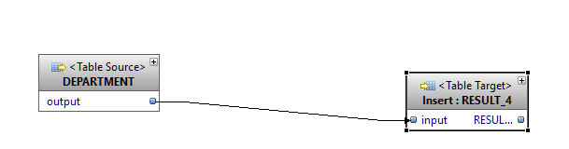

OUTPUT:

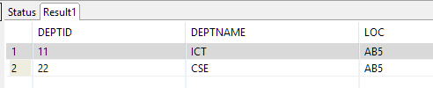

Filter Condition:

"UNIVERSITY_3218"."DEPARTMENT"."LOCATION" <> 'AB1'

# QUERY 5:

Display student id, student name and department name where student belongs to ICT department

DATA FLOW:

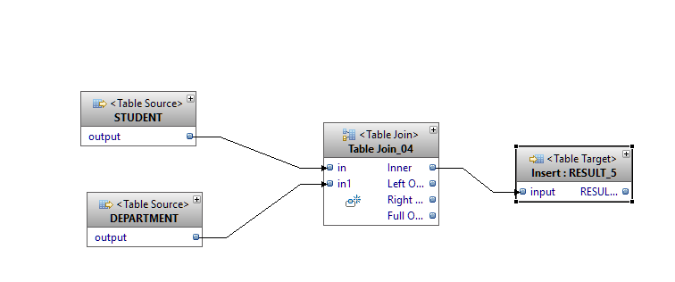

Filter Condition:

Department: "UNIVERSITY_3218"."DEPARTMENT"."DEPT_NAME" = 'ICT'

Join: "IN_04_0"."DEPTID" = "IN1_04_1"."DEPT_ID"

OUTPUT:

