Sahil Khose
180953218
CCE-B
C4 batch

LAB 5:
Q1:

Server:
#include <stdio.h>
#include <stdlib.h>
#include <unistd.h>
#include <sys/socket.h>
#include <sys/types.h>
#include <netinet/in.h>
#include <string.h>
#include <arpa/inet.h>

int main(){
int sockfd, newsockfd, retval, recvbytes, sendbytes;
char buff[50];
struct sockaddr_in server, client;
printf("Hi\n");
sockfd = socket(AF_INET, SOCK_STREAM, 0);
if(sockfd == -1){
printf("Creation Error\n");
exit(0);
}

server.sin_family = AF_INET;
server.sin_port = htons(3212);
server.sin_addr.s_addr = htonl(INADDR_ANY);

retval = bind(sockfd, (struct sockaddr*) &server, sizeof(server));
if(retval == -1){
printf("Binding Error\n");
exit(0);
}
printf("Socket Binded\n");

retval = listen(sockfd, 5);
if(retval == -1){
printf("Listening Error\n");
exit(0);
}
printf("Socket Listening\n");

pid_t child;
socklen_t clilen;
int connection = 0;
char str[50];
str[0] = '\0';
while(1){
clilen = sizeof(client);

newsockfd = accept(sockfd, (struct sockaddr*) &client, &clilen);
if(newsockfd == -1){
printf("Accepting Error\n");
close(sockfd);
exit(0);
}
printf("Socket Accepting\n");
connection++;
if(connection > 2){
printf("Connection exceeds Max Limit\n");
FILE *fptr1, *fptr2;
if((fptr1 = fopen("new.txt", "r")) == NULL){
close(newsockfd);
close(sockfd);
exit(0);
}
char temp[100];
char str[100];
while(fgets(temp, 100, fptr1) != NULL){
strcpy(str, temp);
printf("%s\n", str );
}
if(fptr1){
fclose(fptr1);
}
if((fptr2 = fopen("ip.txt", "r")) == NULL){
close(newsockfd);
close(sockfd);
exit(0);
}
char temp2[100];
char str2[100];
while(fgets(temp2, 100, fptr2) != NULL){
strcpy(str2, temp2);
printf("%s\n", str2 );
}
if(fptr2){
fclose(fptr2);
}
close(newsockfd);
close(sockfd);
exit(0);
}
printf("%s\n", str);
if((child = fork()) == 0){

close(sockfd);
recvbytes = recv(newsockfd, buff, sizeof(buff), 0);
if(recvbytes == -1){
printf("Receiving Error\n");
close(newsockfd);
exit(0);
}
puts(buff);
strcat(str, buff);
strcat(str, " ");
FILE *fp;
fp = fopen("ip.txt", "a");
char ip[INET_ADDRSTRLEN];
inet_ntop(AF_INET, &client.sin_addr, ip, sizeof(ip));
fputs(ip, fp);
fputs(" ", fp);
fclose(fp);
FILE *fp1;
fp1 = fopen("new.txt", "a");
fputs(buff, fp1);
fputs(" ", fp1);
fclose(fp1);
close(newsockfd);
}

}

close(sockfd);
exit(0);
}
Client 1:
#include <stdio.h>
#include <stdlib.h>
#include <unistd.h>
#include <sys/socket.h>
#include <sys/types.h>
#include <netinet/in.h>
#include <string.h>
#include <arpa/inet.h>

int main(){
int sockfd, recvbytes, sentbytes, retval;
char buff[50];
struct sockaddr_in server;

sockfd = socket(AF_INET, SOCK_STREAM, 0);
if(sockfd == -1){
printf("Creation Error\n");
exit(0);
}
server.sin_family = AF_INET;
server.sin_port = htons(3212);
server.sin_addr.s_addr = inet_addr("127.0.0.1");

retval = connect(sockfd, (struct sockaddr*)&server, sizeof(server));
if(retval == -1){
printf("Connection Error\n");
close(sockfd);
exit(0);
}
printf("Connection Estabilished\n");

strcpy(buff, "Institute of");
puts(buff);
sentbytes = send(sockfd, buff, sizeof(buff), 0);
if(sentbytes == -1 ){
printf("Send Error\n");
close(sockfd);
exit(0);
}

close(sockfd);
exit(0);

}
Client 2:
#include <stdio.h>
#include <stdlib.h>
#include <unistd.h>
#include <sys/socket.h>
#include <sys/types.h>
#include <netinet/in.h>
#include <string.h>
#include <arpa/inet.h>

int main(){
int sockfd, recvbytes, sentbytes, retval;
char buff[50];
struct sockaddr_in server;

sockfd = socket(AF_INET, SOCK_STREAM, 0);
if(sockfd == -1){
printf("Creation Error\n");
exit(0);
}
server.sin_family = AF_INET;
server.sin_port = htons(3212);
server.sin_addr.s_addr = inet_addr("127.0.0.1");

retval = connect(sockfd, (struct sockaddr*)&server, sizeof(server));
if(retval == -1){
printf("Connection Error\n");
close(sockfd);
exit(0);
}
printf("Connection Estabilished\n");

strcpy(buff, "Technology");
puts(buff);
sentbytes = send(sockfd, buff, sizeof(buff), 0);
if(sentbytes == -1 ){
printf("Send Error\n");
close(sockfd);
exit(0);
}

close(sockfd);
exit(0);

}
Output:
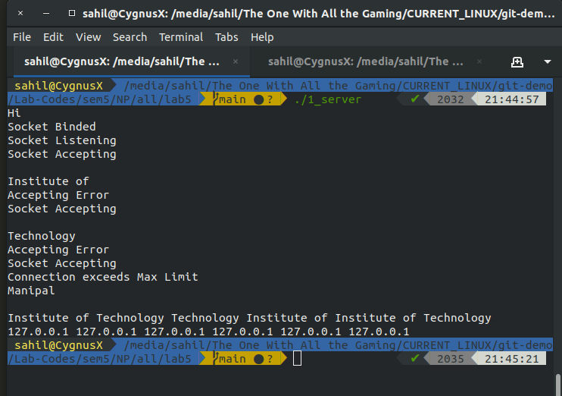

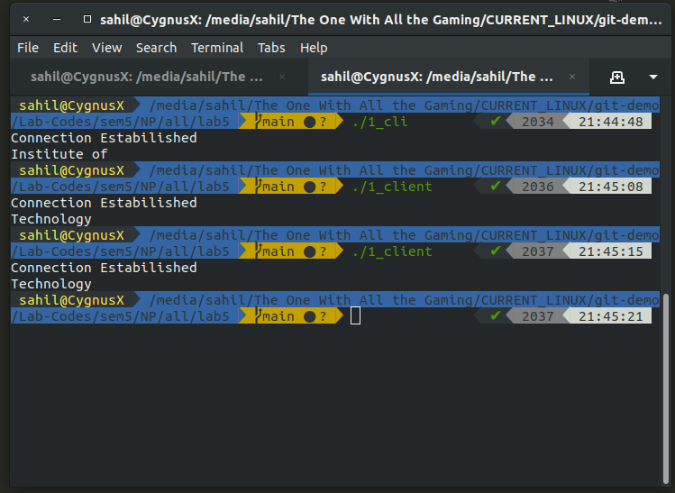

LAB 8:
Q1:
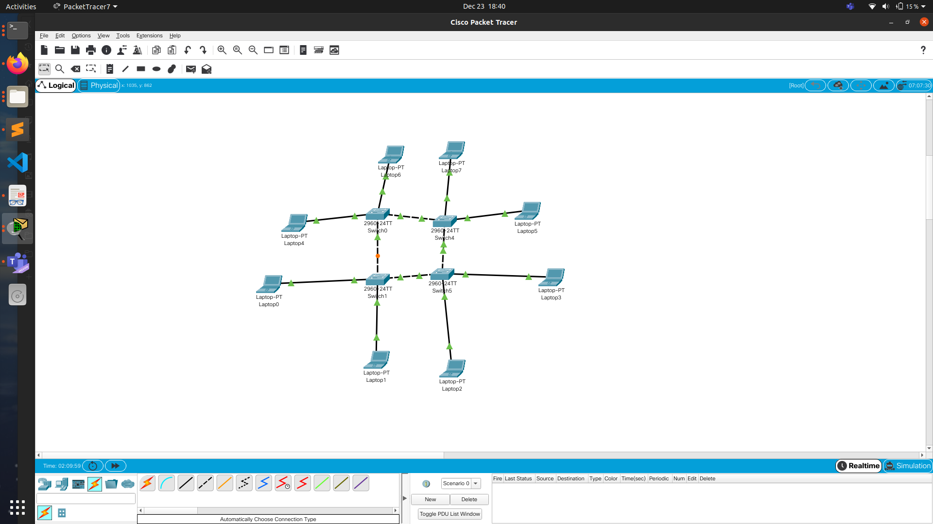

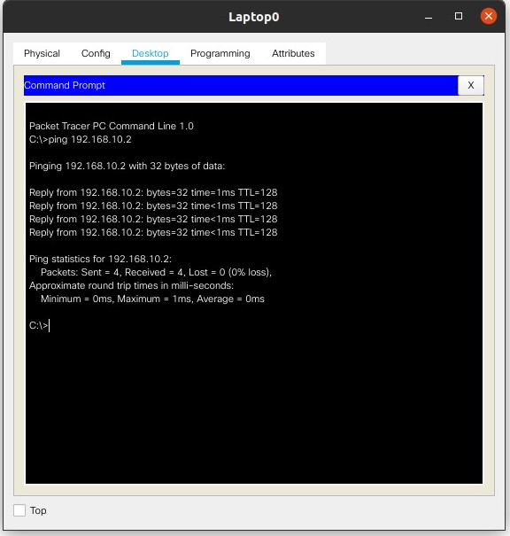


Q2:
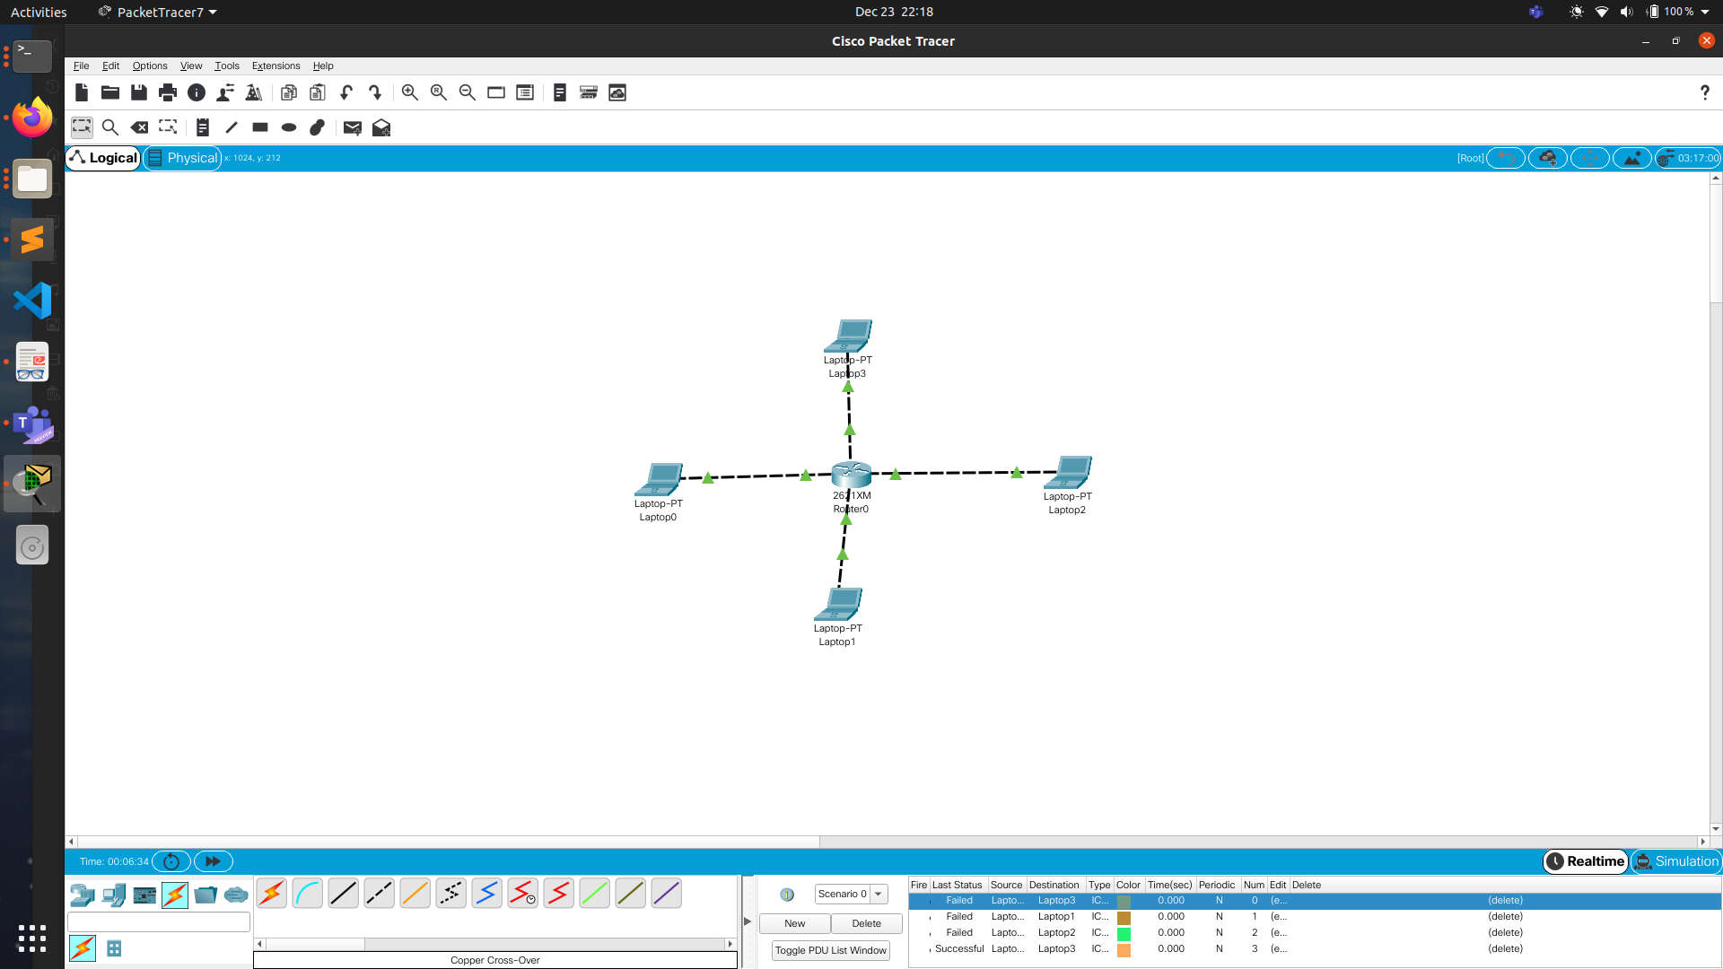

CLI:
en
conf t
int fa0/0
ip add 192.168.10.1 255.255.255.0
no shutdown
exit

int fa0/1
ip add 192.168.20.1 255.255.255.0
no shutdown
exit

int fa1/0
ip add 192.168.30.1 255.255.255.0
no shutdown
exit

int fa1/1
ip add 192.168.140.1 255.255.255.0
no shutdown
exit

exit

LAB 9:
A1:
