Internship Case Study: Vulnerability Assessment
Target: OWASP Juice Shop (Local Deployment)
Date: May 13, 2026

1. Executive Summary
This document outlines the setup, reconnaissance, and successful exploitation of five specific vulnerabilities within the OWASP Juice Shop application. The assessment was conducted locally and demonstrates practical security testing methodologies, including automated enumeration and manual interception using Burp Suite.

2. Phase 1: Setup & Reconnaissance
The application was deployed locally via Node.js (npm). Initial reconnaissance involved network and directory enumeration to discover hidden pathways and service information.
- Tooling Utilized: Nmap (Service Scanning), Dirb (Directory Enumeration)
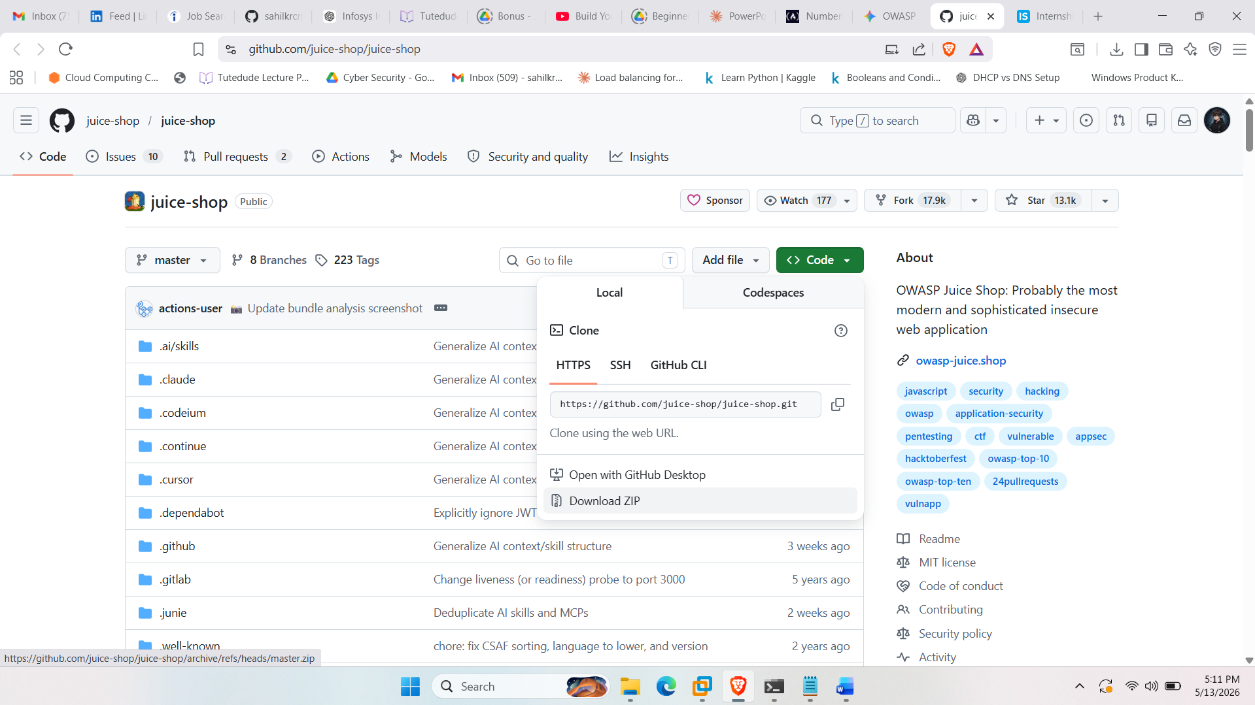

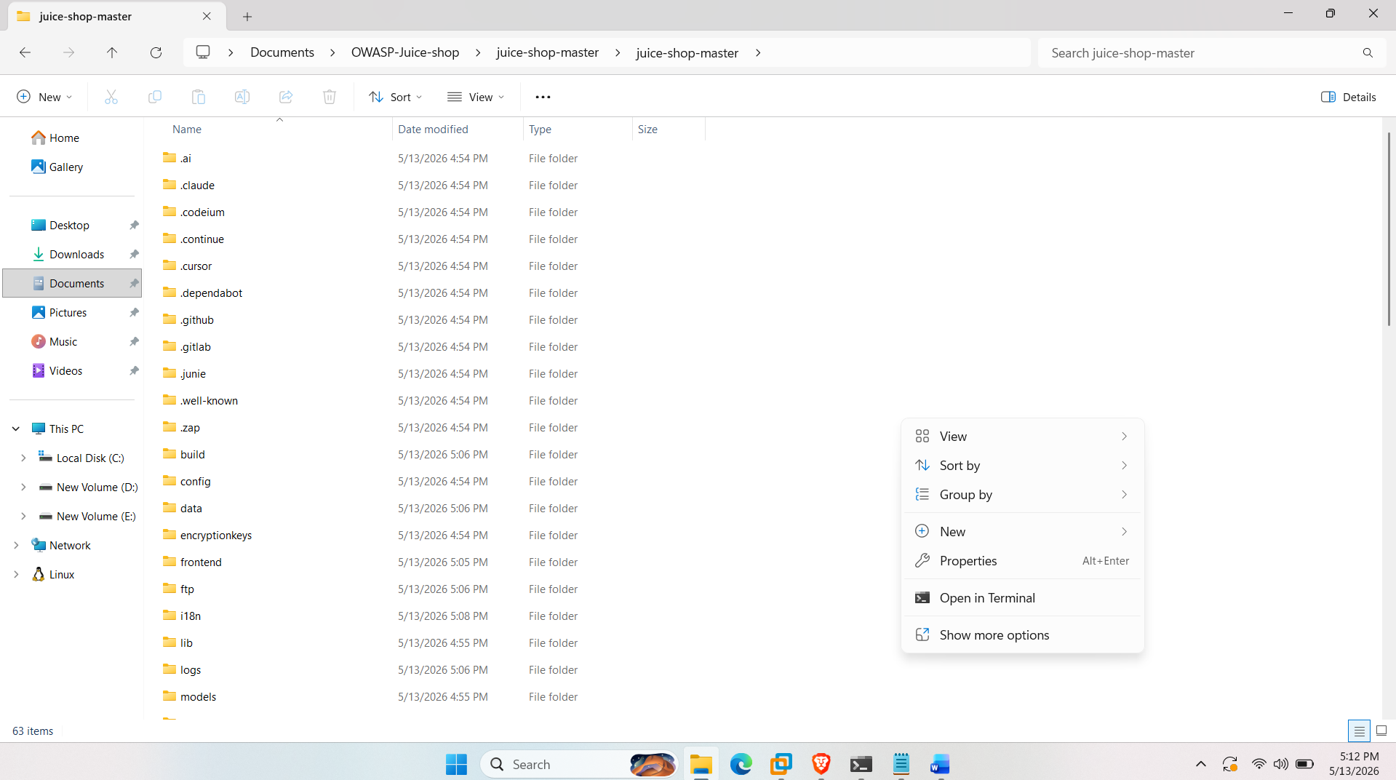

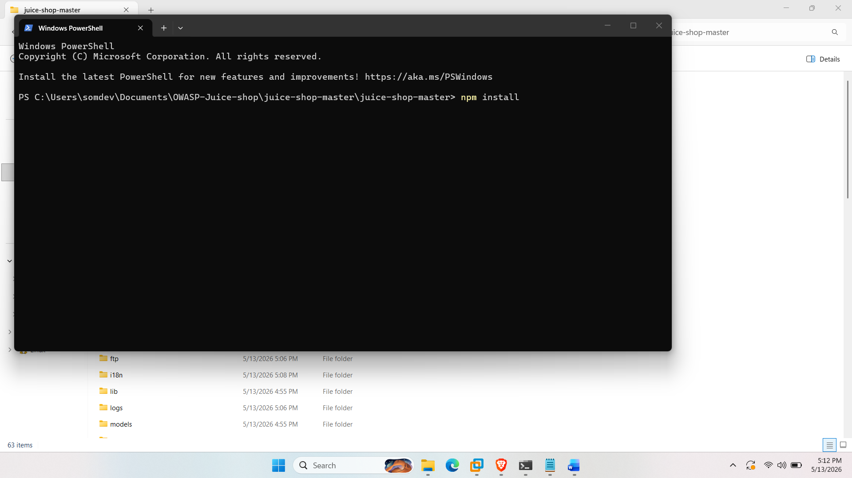
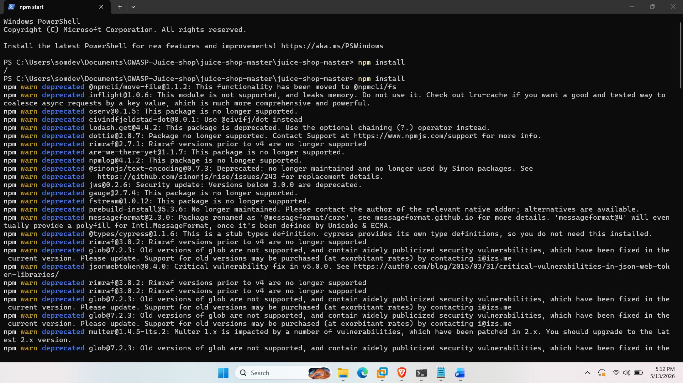

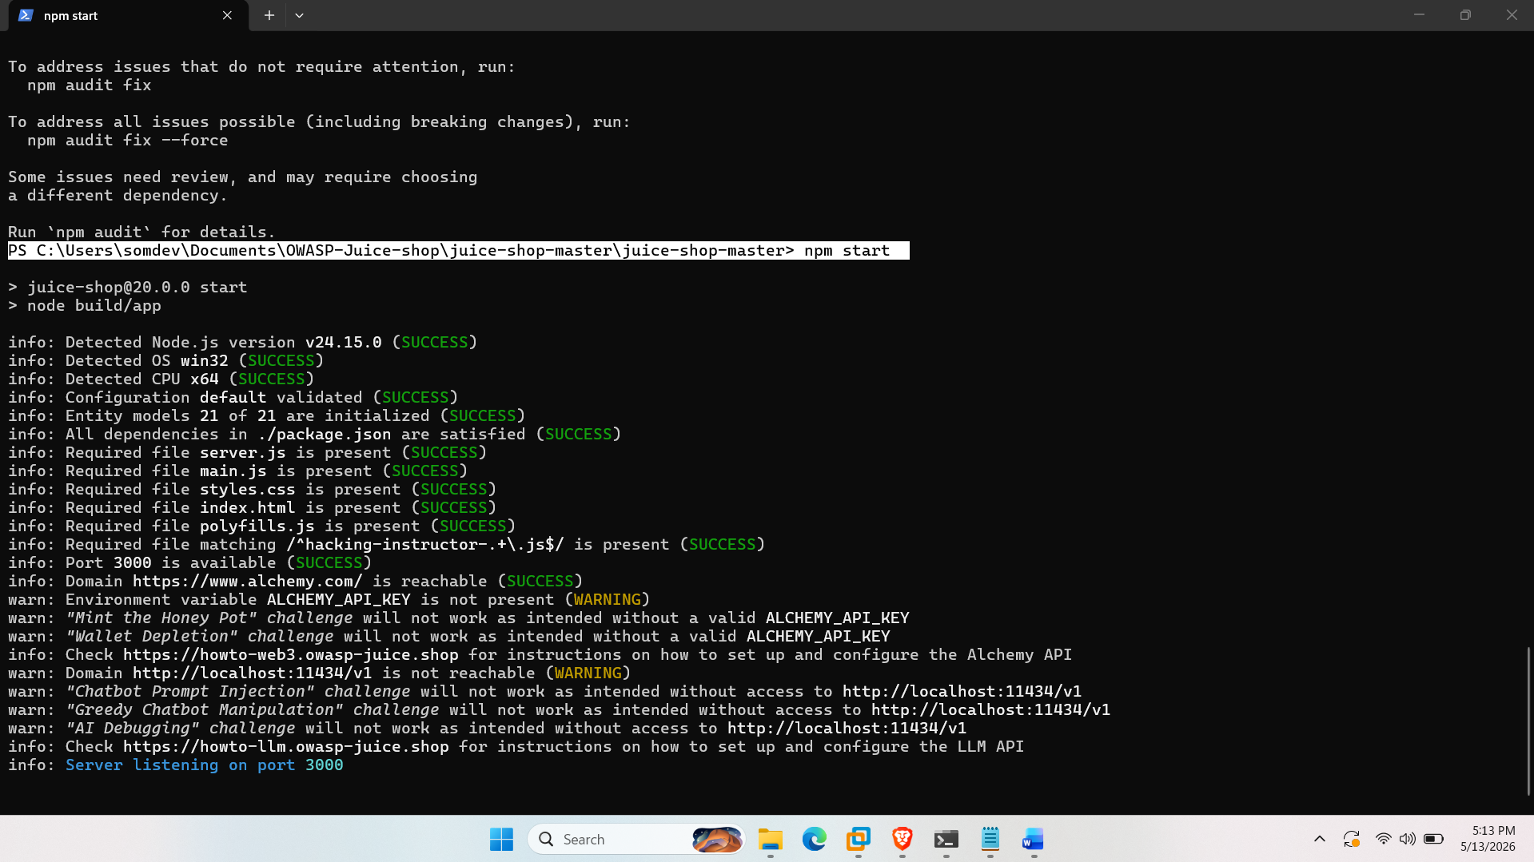
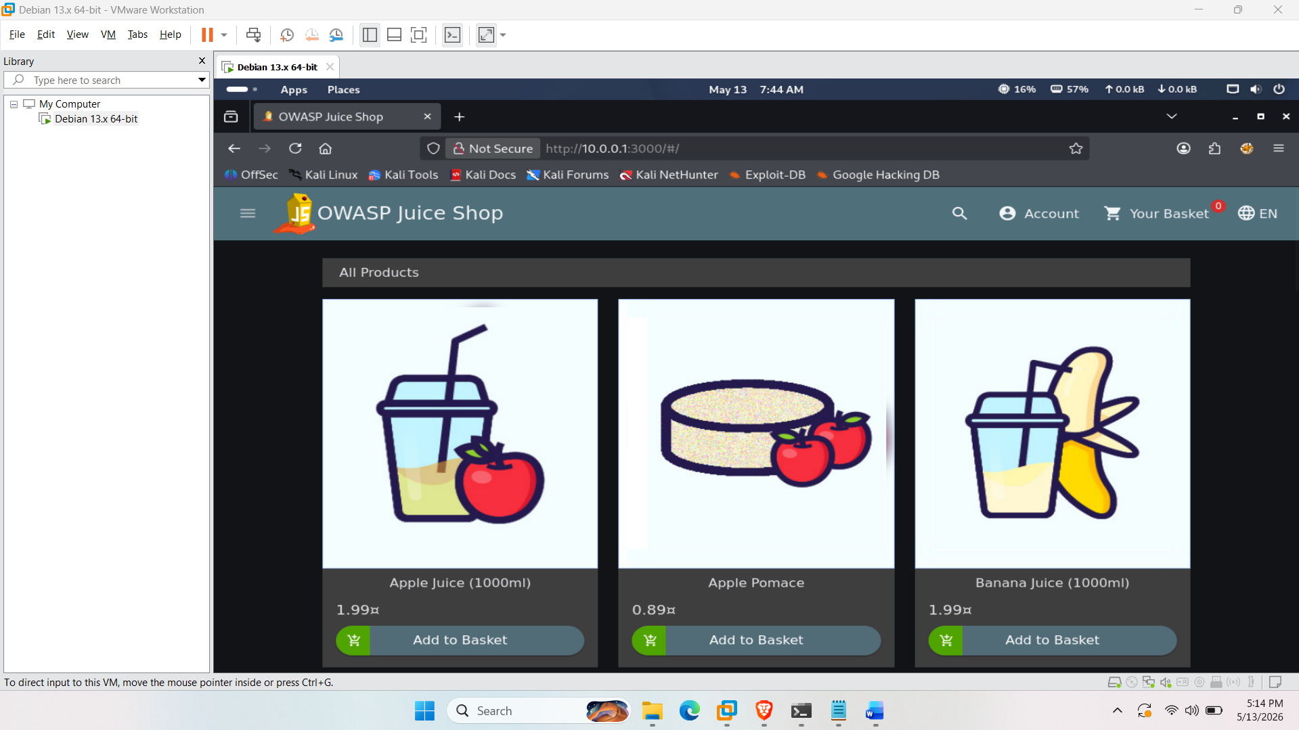
Nmap (Service Scanning)
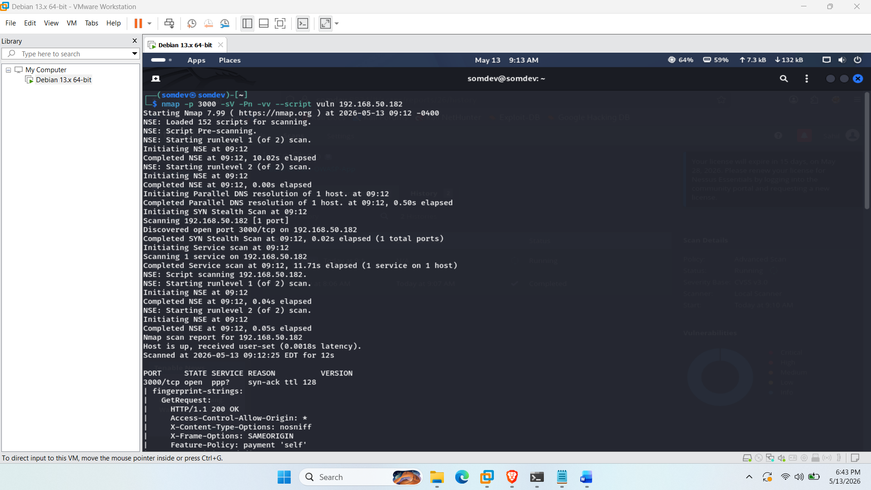
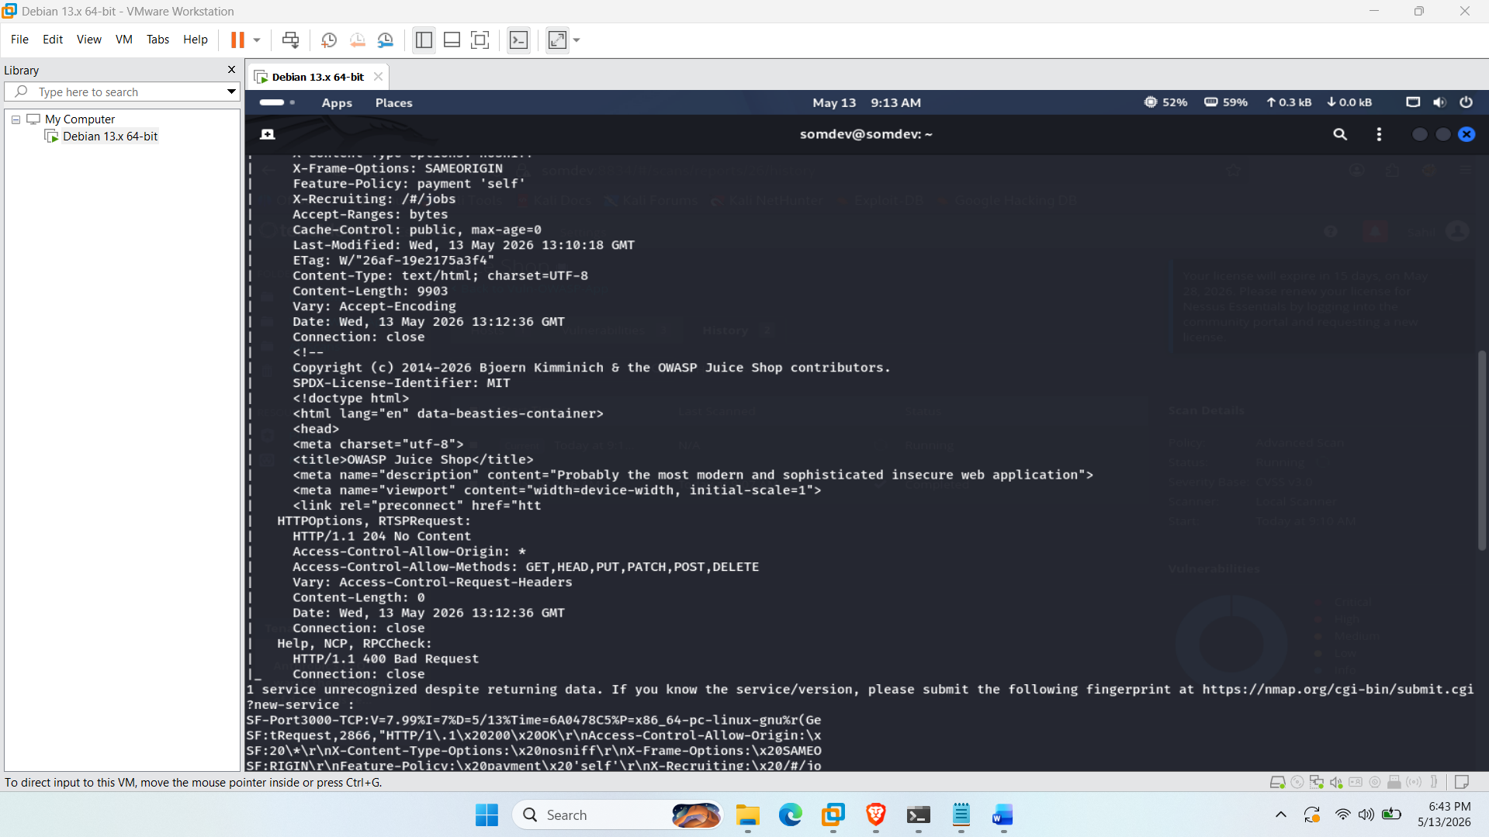
Dirb (Directory Enumeration)
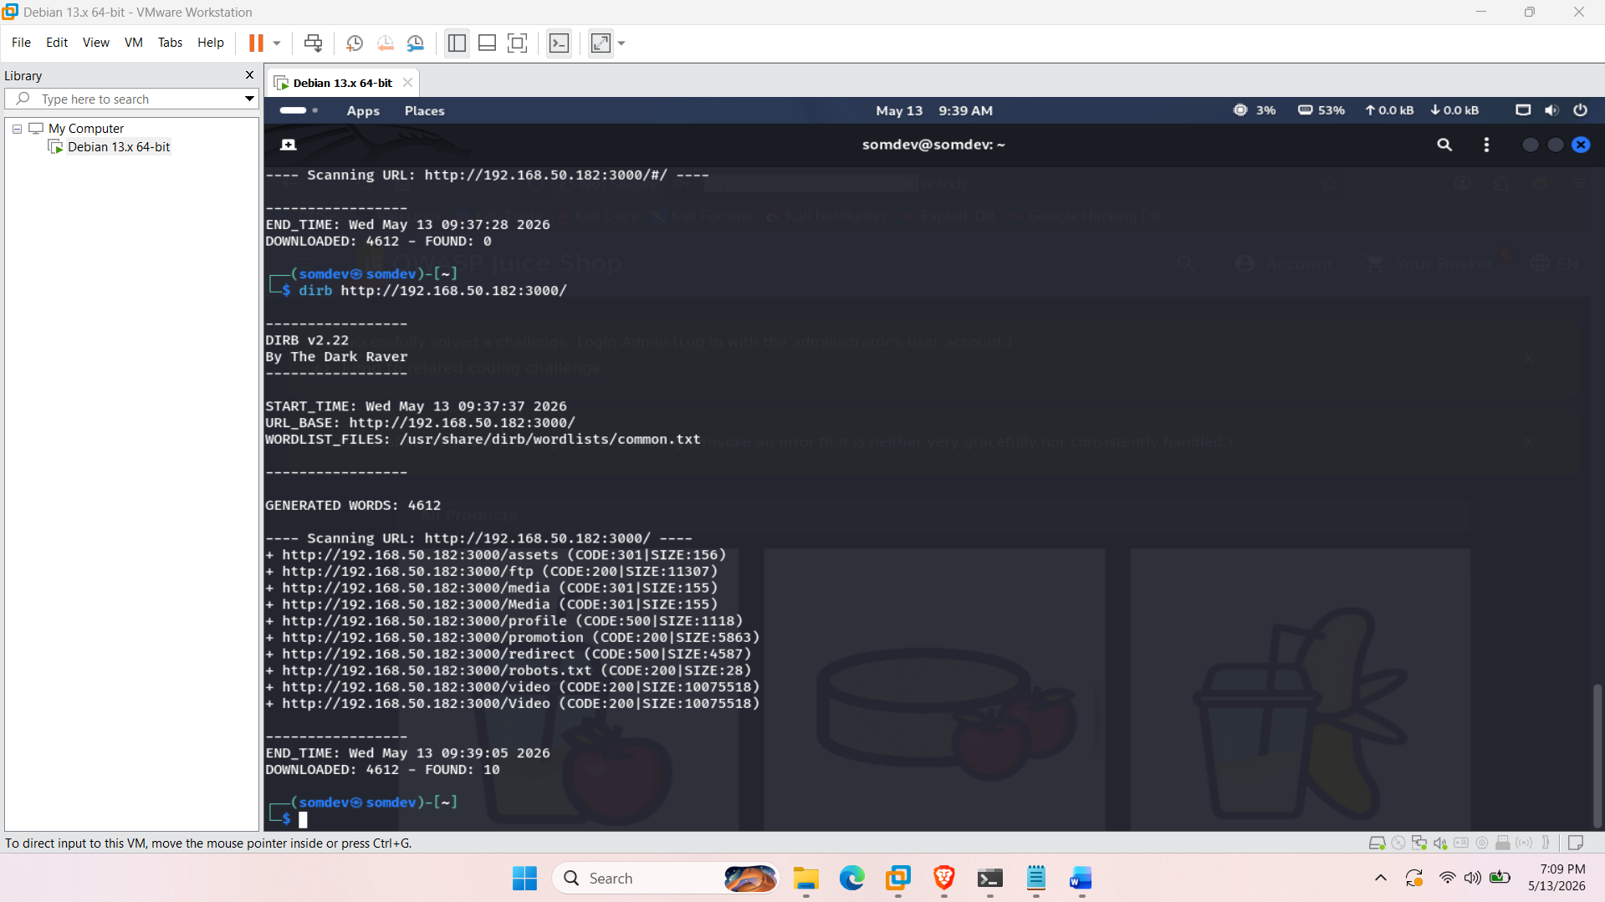

3. Phase 2: Vulnerability Exploitation

3.1 Authentication Bypass via SQL Injection
- OWASP Category: Injection
- Methodology: Manipulated the authentication form by supplying a tautology payload (' OR 1=1 --) in the email field. This successfully bypassed the authentication logic, granting unauthorized administrative access to the application.
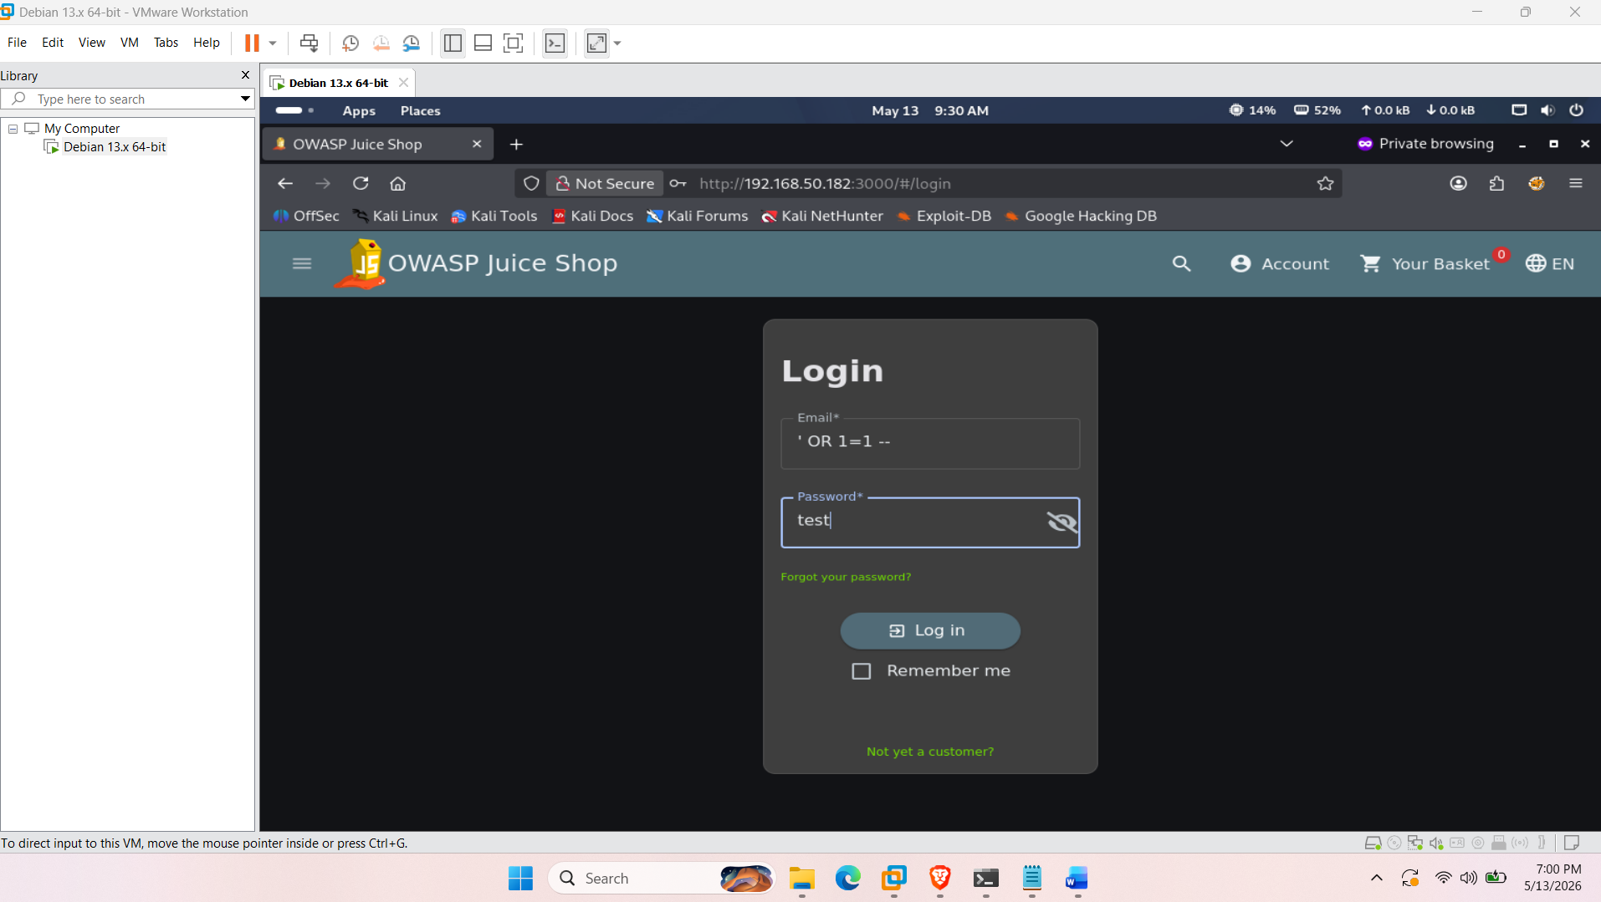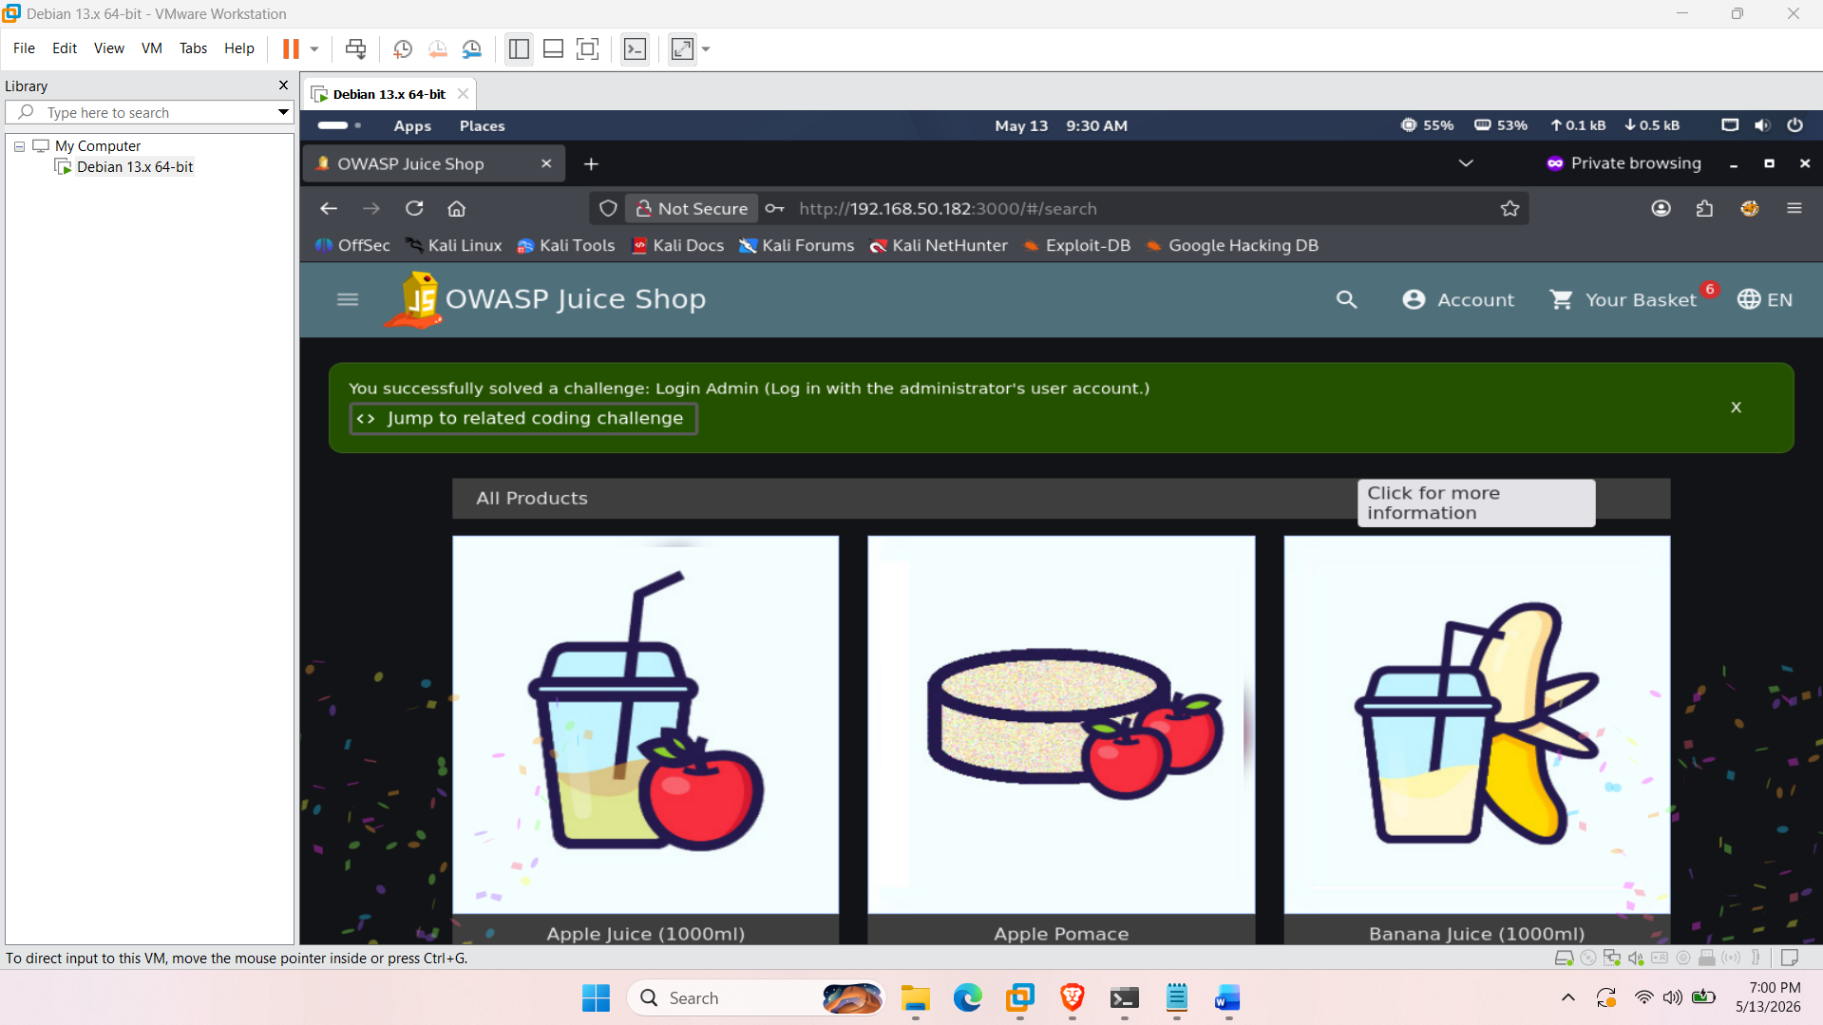

3.2 DOM-based Cross-Site Scripting (XSS)
- OWASP Category: Cross-Site Scripting (XSS)
- Methodology: Identified that the search bar reflects user input without proper sanitization. Injected a malicious HTML <iframe> tag with inline JavaScript (<iframe src="javascript:alert('xss')">), which was successfully executed by the browser.
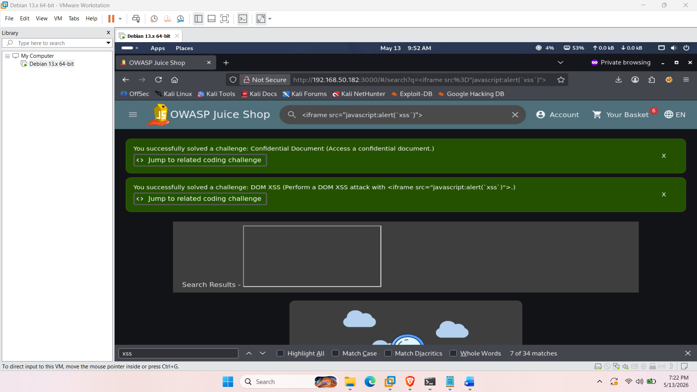

3.3 Broken Access Control (Exposed FTP Directory)
- OWASP Category: Broken Access Control
- Methodology: Utilized the 'dirb' enumeration tool with a common wordlist to brute-force hidden paths. Discovered an unlinked /ftp/ directory. Navigating to this directory directly via the browser revealed sensitive backend files and documents.

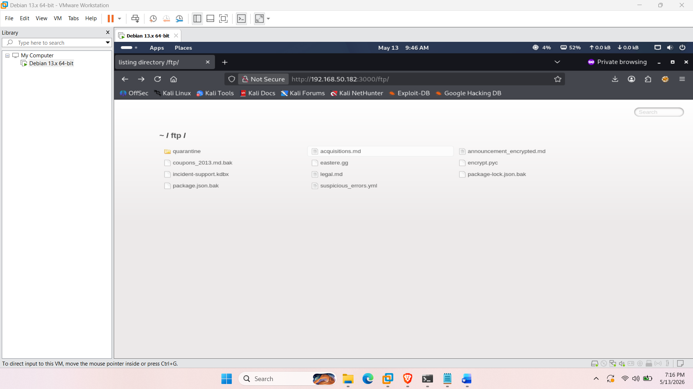

3.4 Insecure Direct Object Reference (IDOR)
- OWASP Category: (IDOR)
- Methodology: Intercepted the 'View Basket' API request using the Burp Suite proxy. Modified the GET /rest/basket/1 endpoint to request basket ID 2. The server failed to validate session ownership against the requested object, returning the contents of another user's cart.
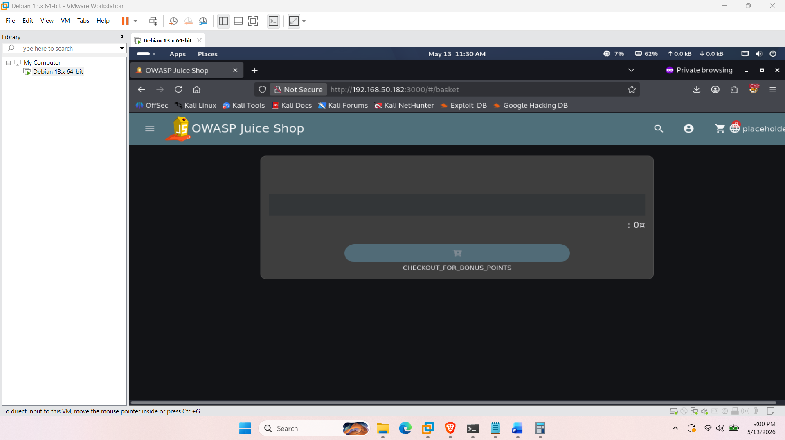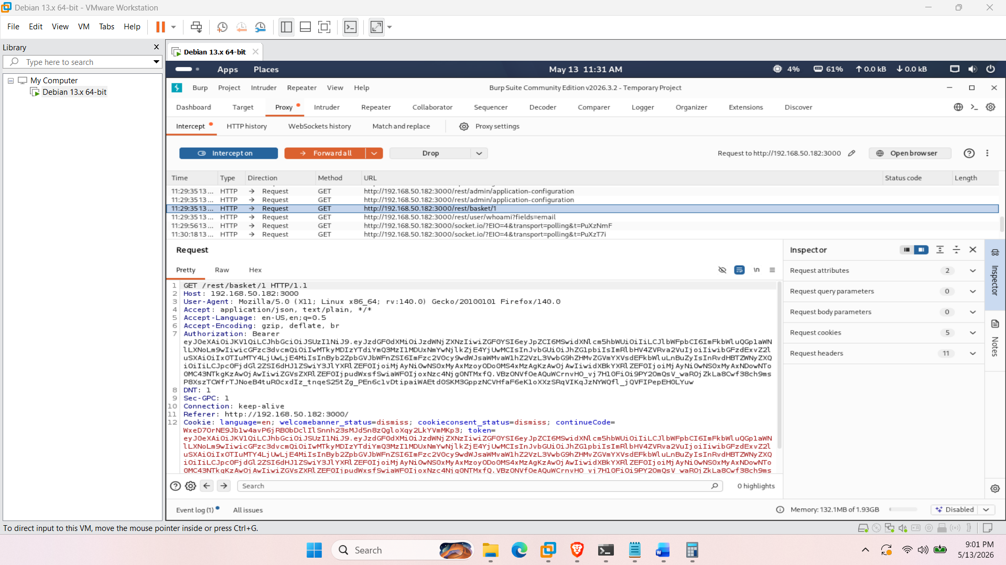
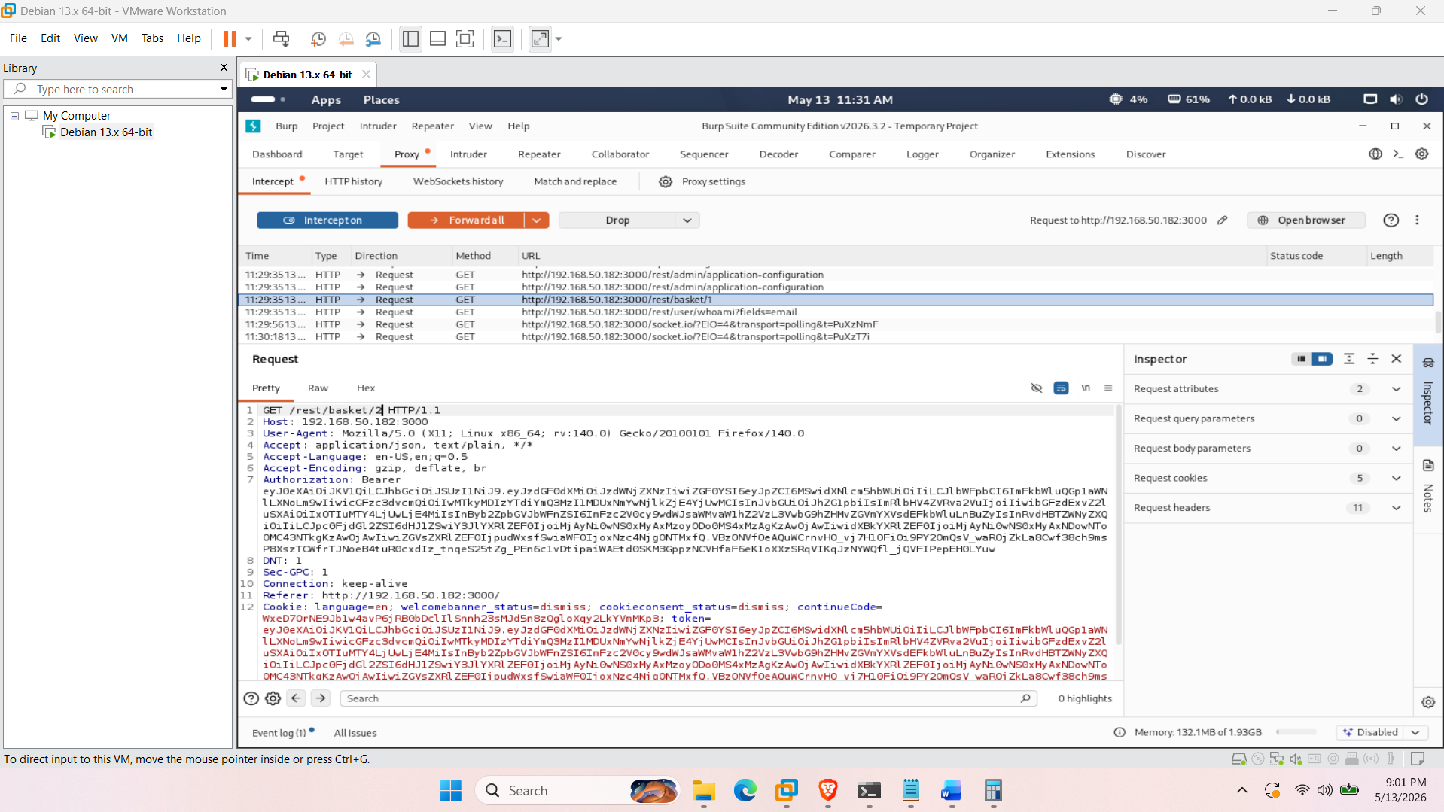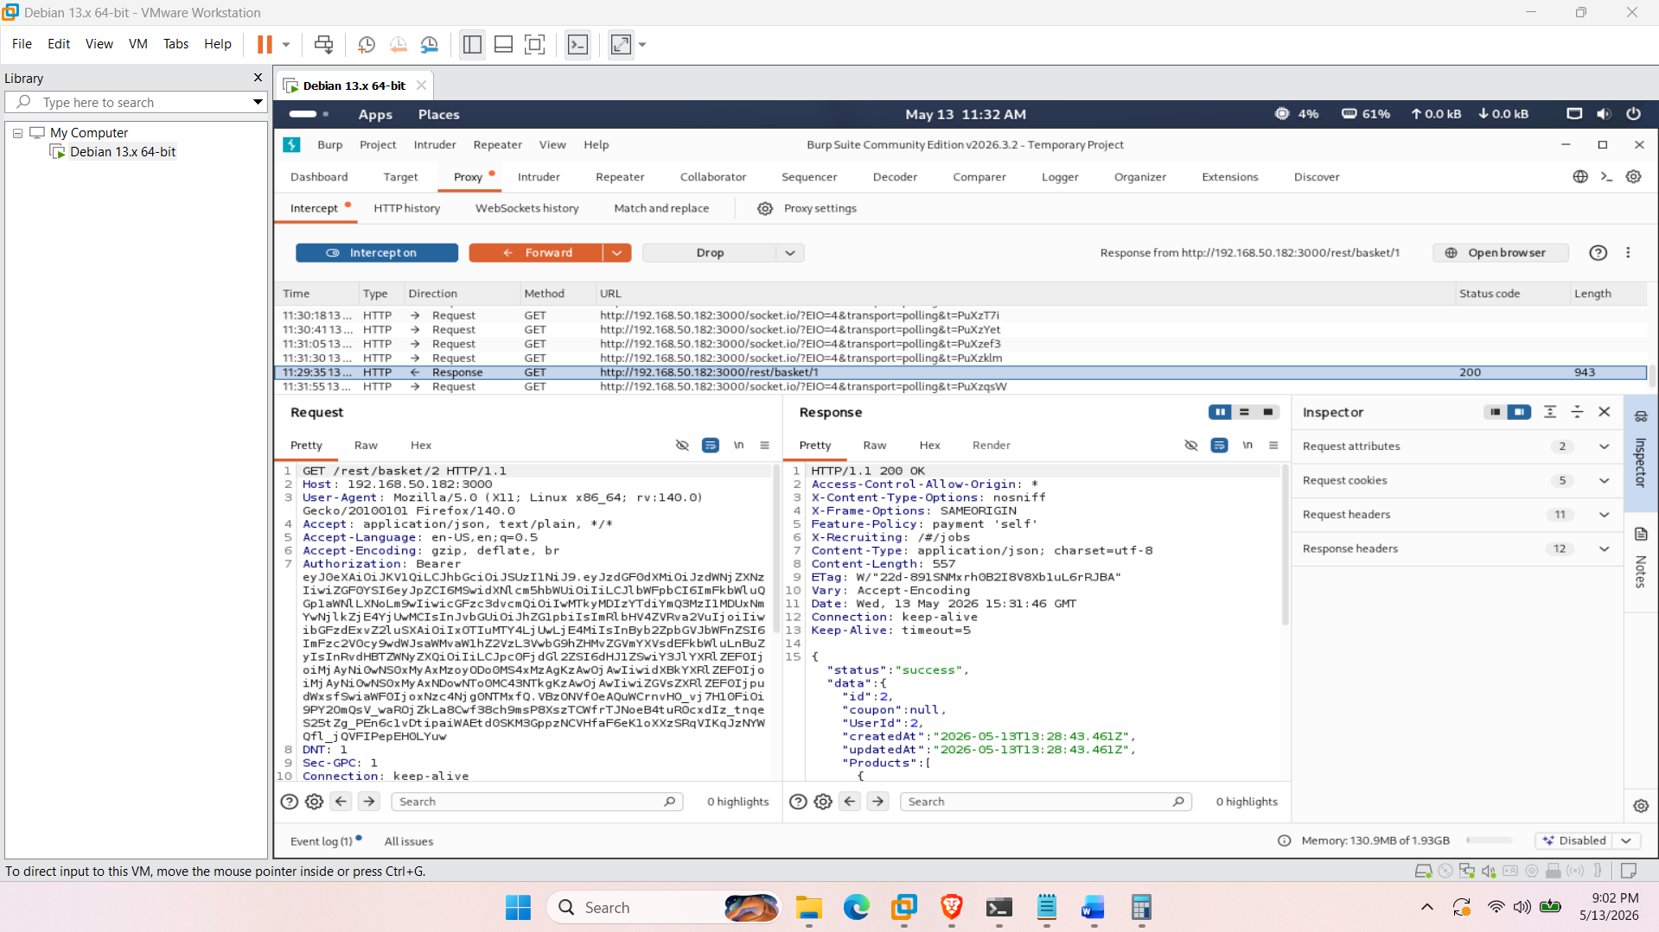
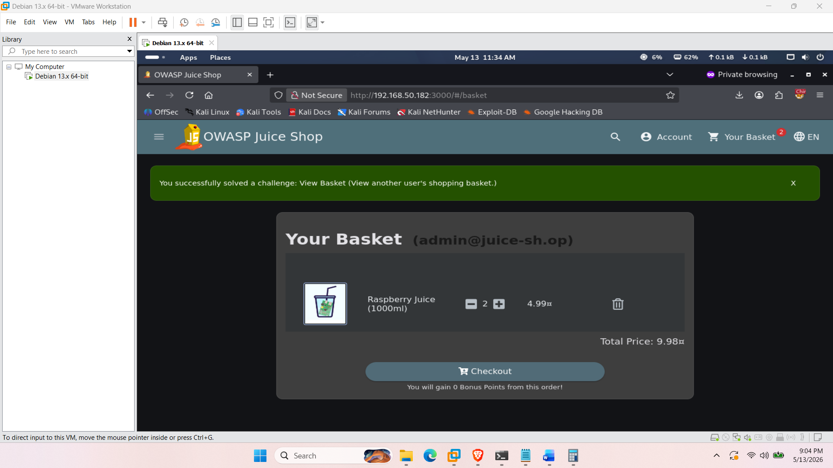

3.5 Forged Feedback (Improper Authorization)
- OWASP Category: Improper Input Validation / Authorization
- Methodology: Submitted a customer feedback form and intercepted the POST /api/Feedbacks/ request using Burp Suite. Manipulated the request body to alter the author and user ID information, forcing the server to accept and publish feedback under a different user's identity.
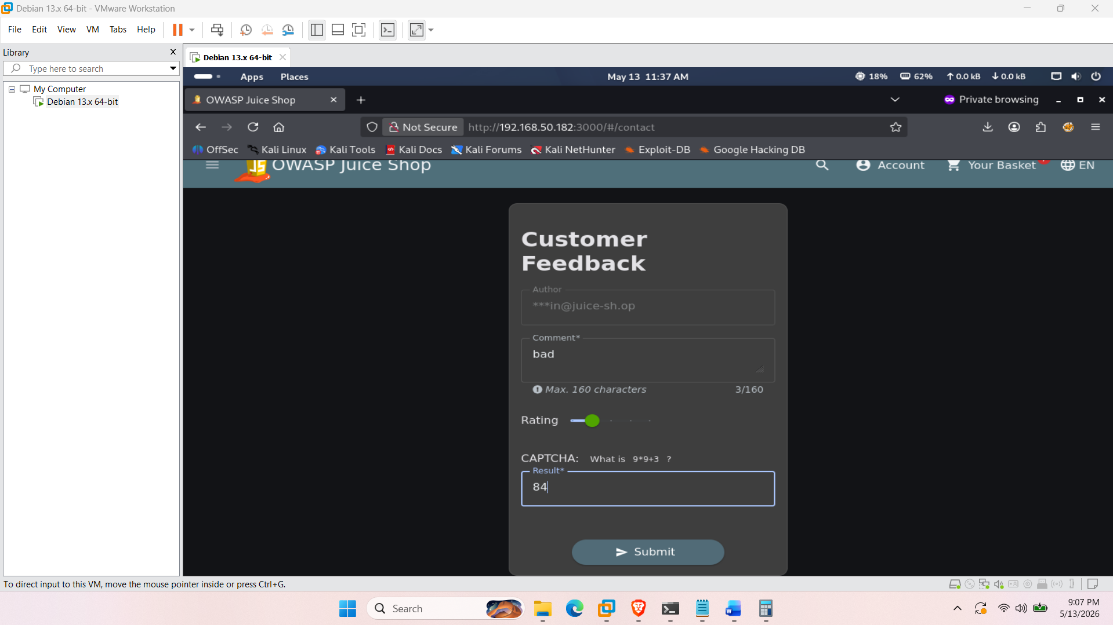
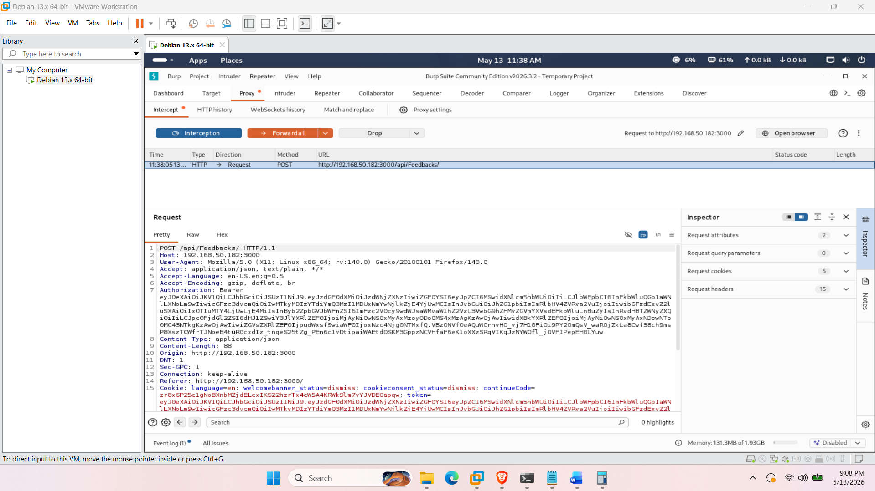
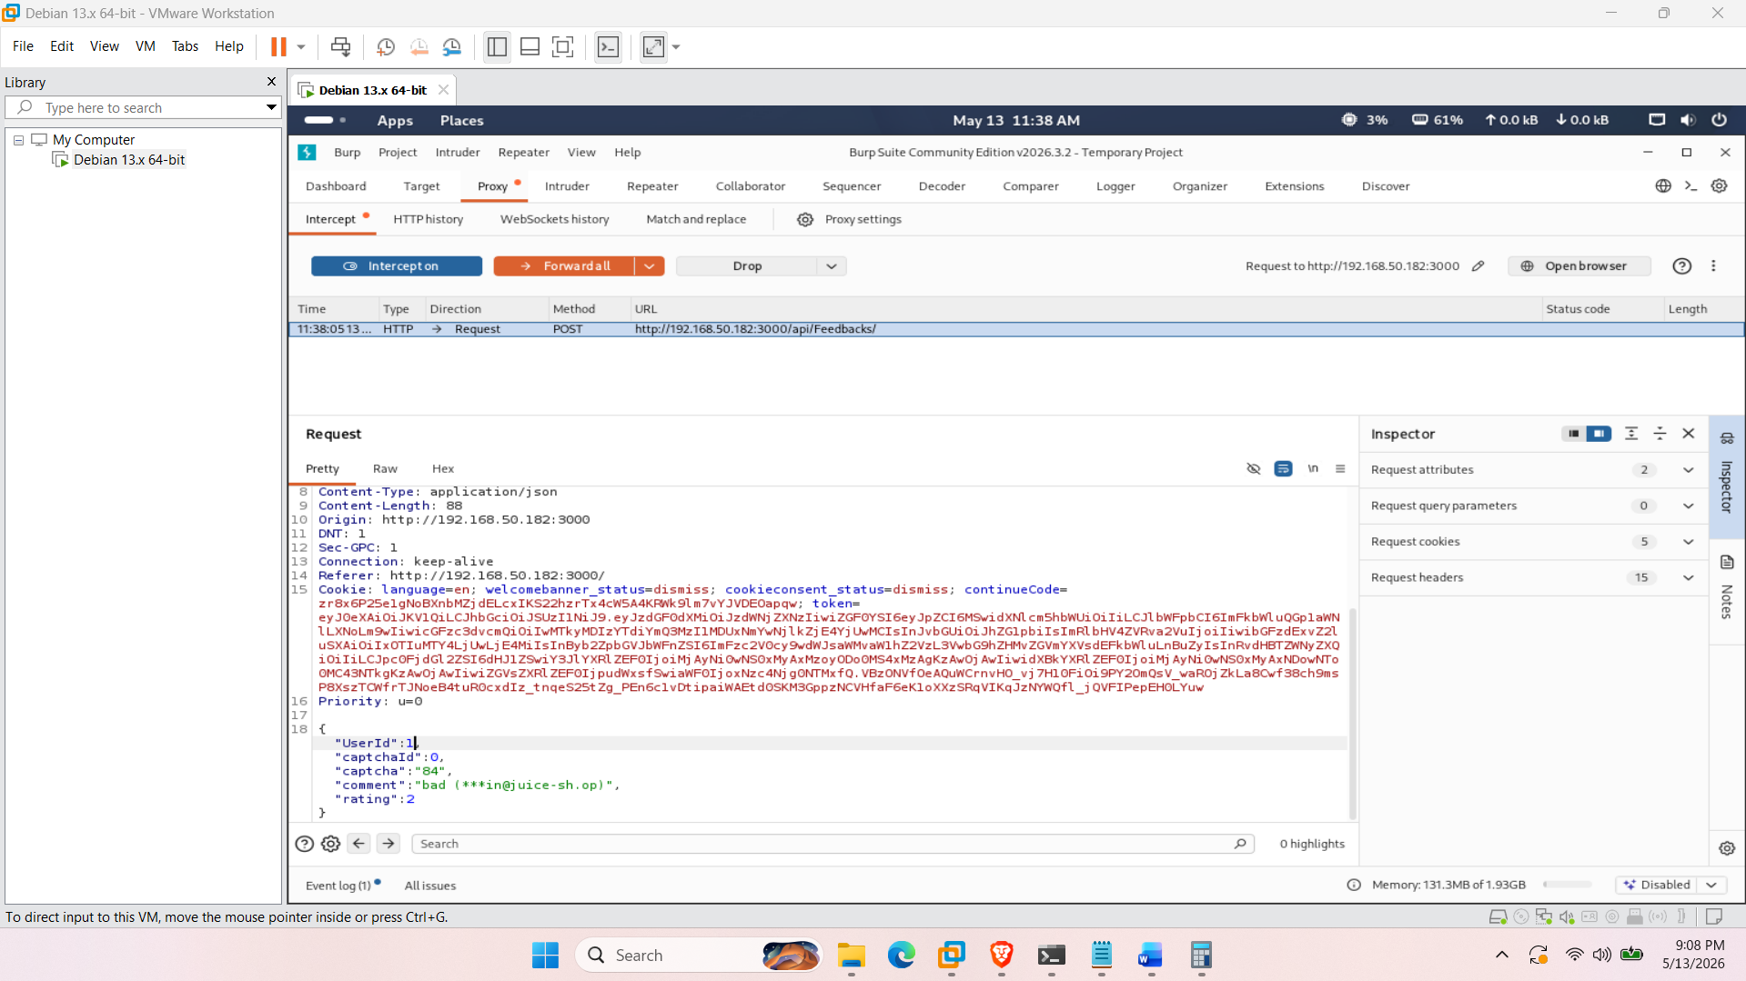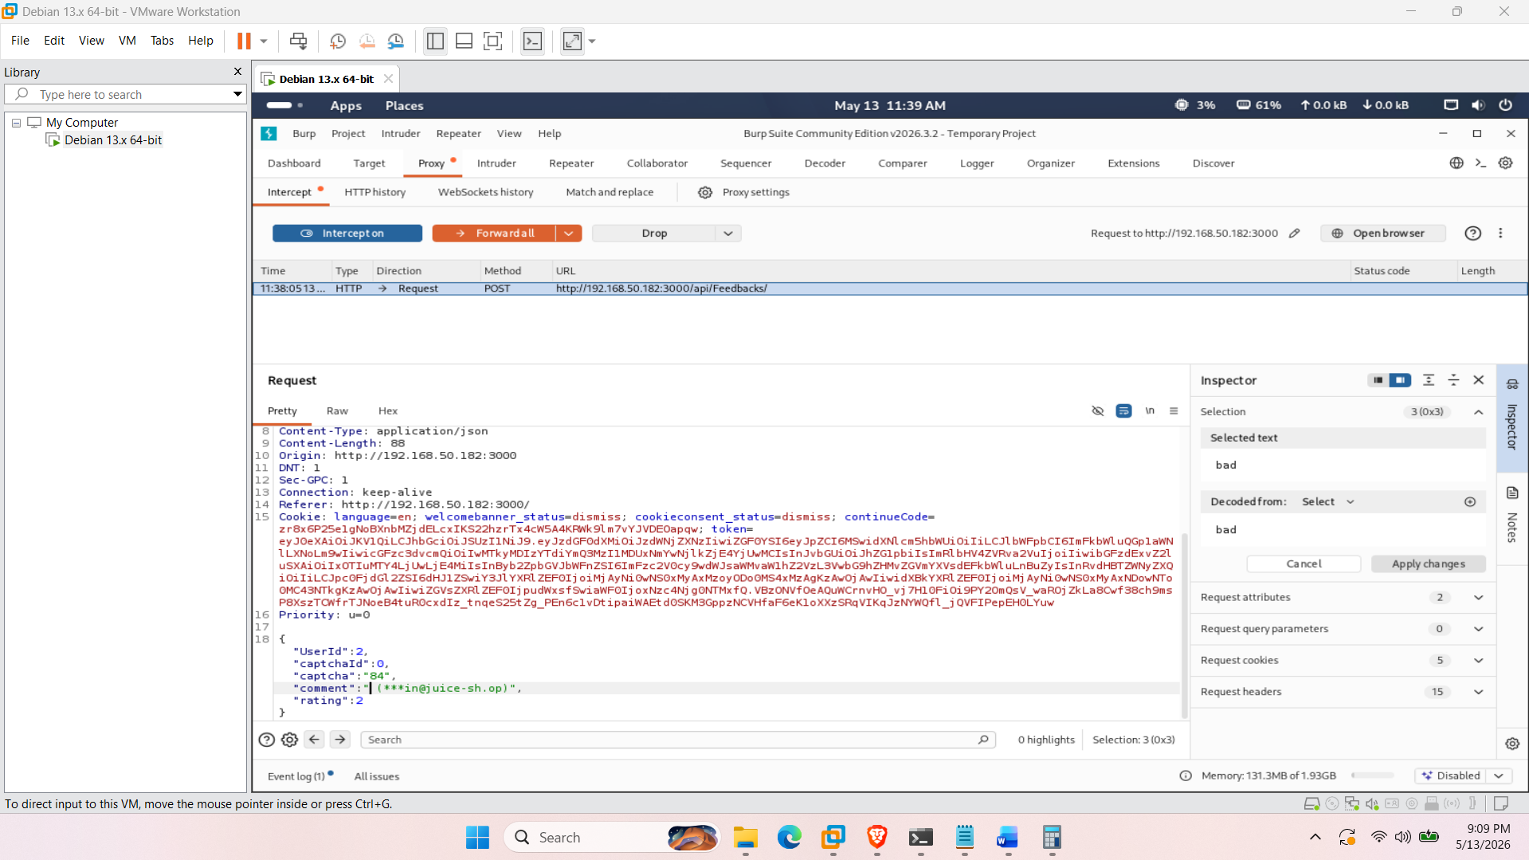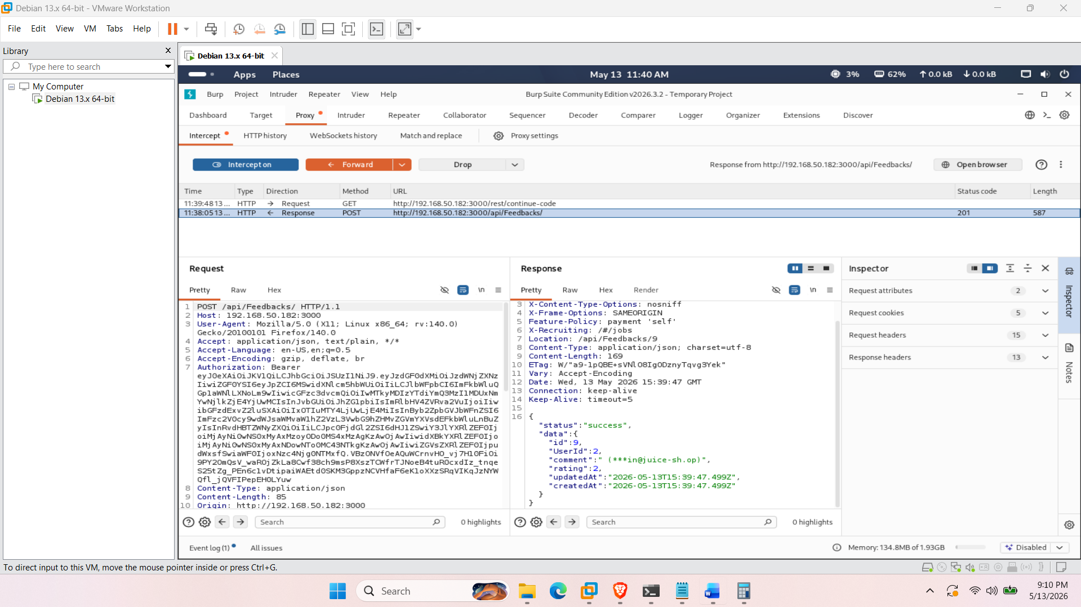
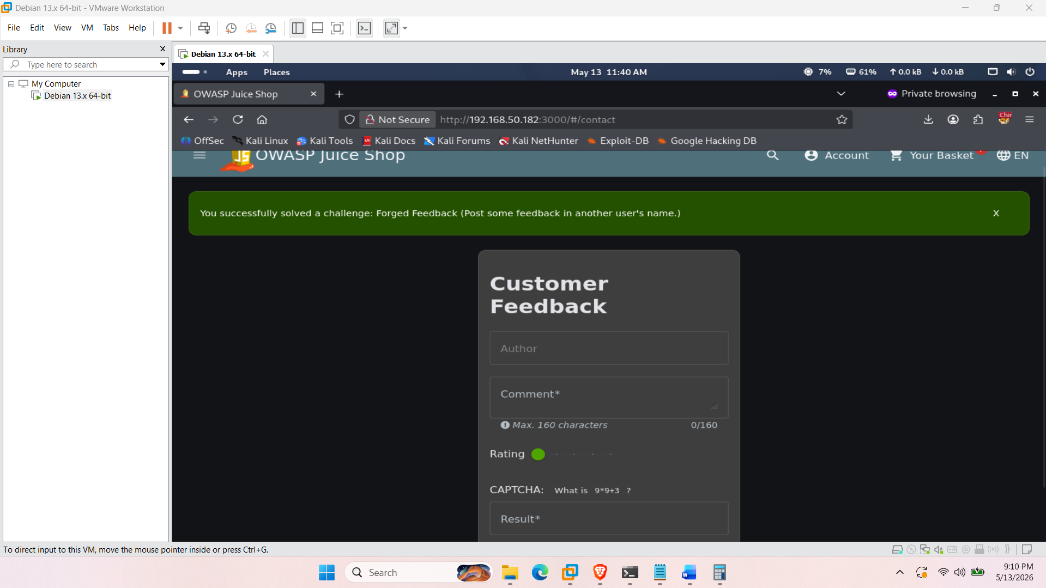

4. Conclusion & Application Score Board
Through manual testing and proxy manipulation, multiple critical vulnerabilities were identified spanning Injection, Broken Access Control, and XSS. The successful completion of these challenges is tracked on the application's hidden Score Board.
