The AI-Assisted Research Publication Management System was successfully developed using Spring Boot and MongoDB. The application provides RESTful APIs for managing departments, researchers, publications, journals, conferences, and research profiles. CRUD operations, validation mechanisms, MongoDB integration, and relationship mappings including One-to-One, One-to-Many, Many-to-One, and Many-to-Many were successfully implemented and tested using Swagger UI. The system also includes scholar dashboard, publication search, and researcher search functionalities, making it a practical backend solution for research publication management.
Technologies Used
• Java 17
• Spring Boot
• Spring Data MongoDB
• MongoDB Compass
• Swagger OpenAPI
• Maven
• REST APIs

Figure 0: Successful startup of Spring Boot application and MongoDB database connection.

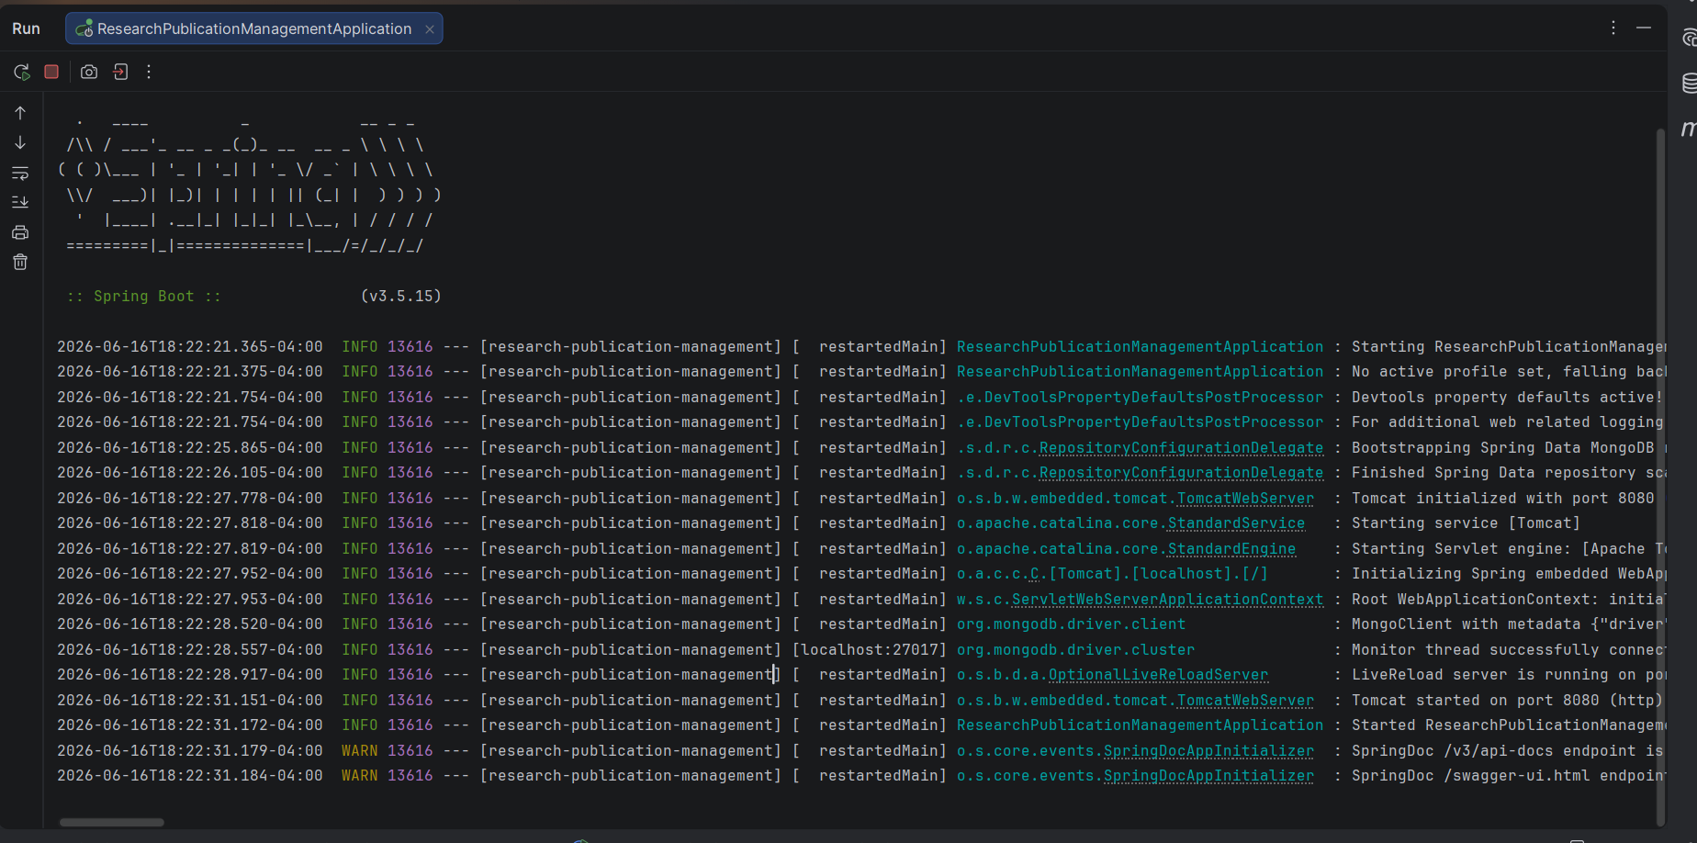

Figure 1: Spring Boot project structure implementing layered architecture.

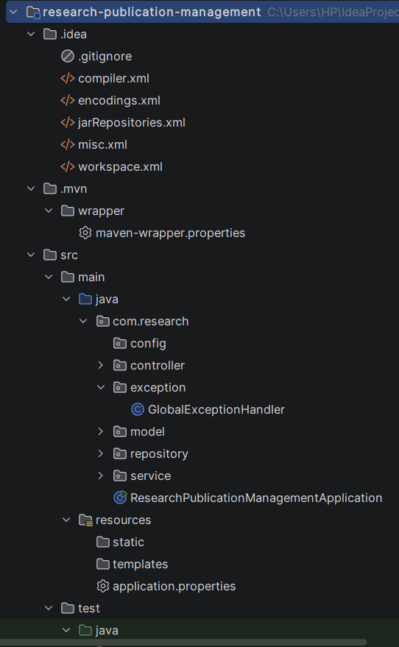

Figure 2: MongoDB database configuration.
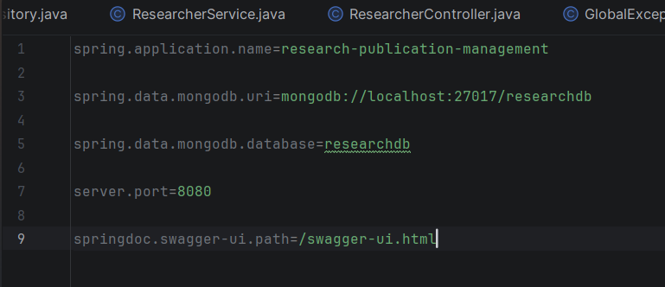

Figure 3: REST APIs eposed through Swagger UI.
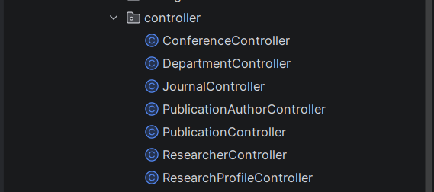

Figure 4: Department creation using REST API.
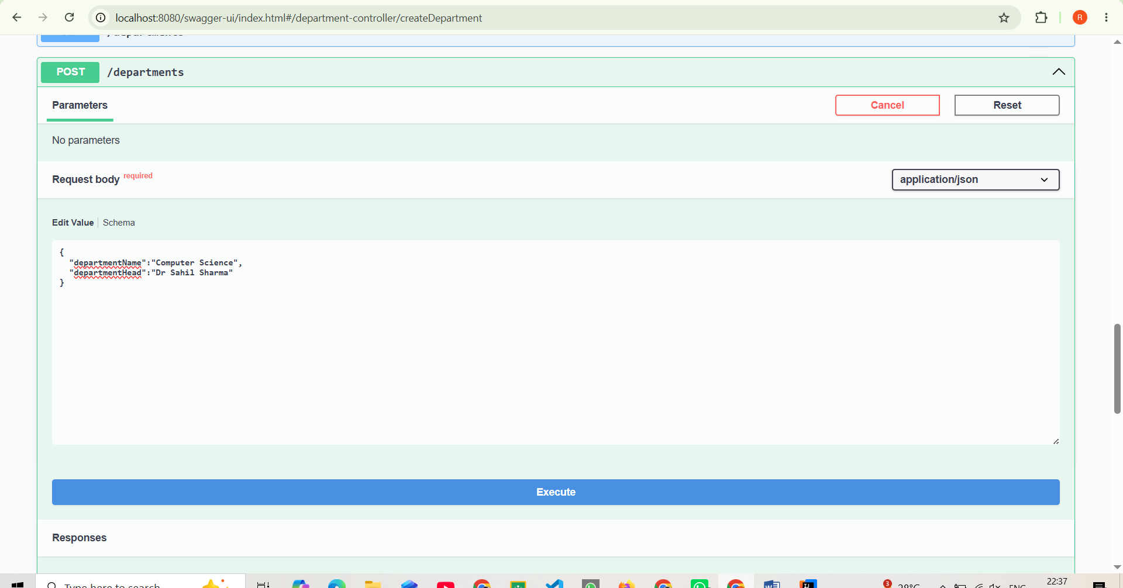

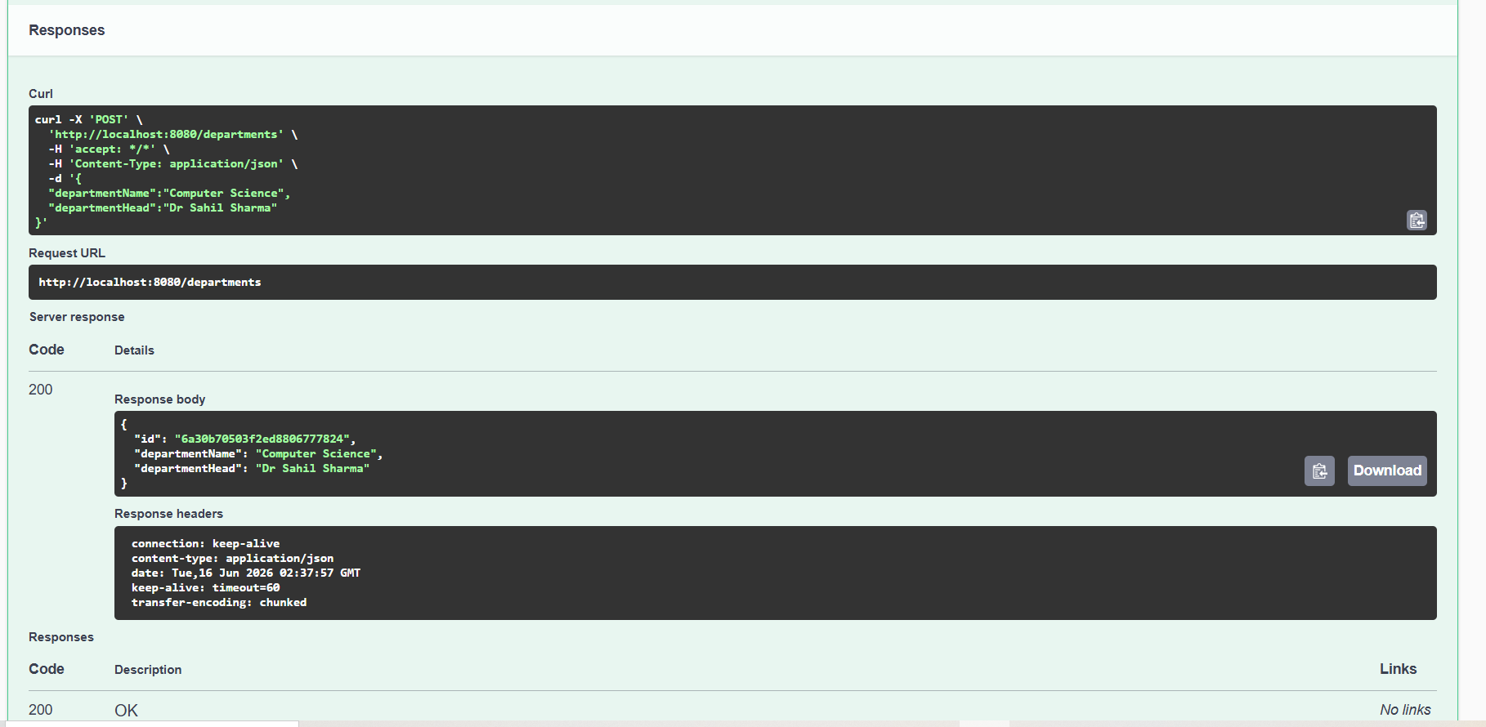

Figure 5: Input validation using Spring Validation.
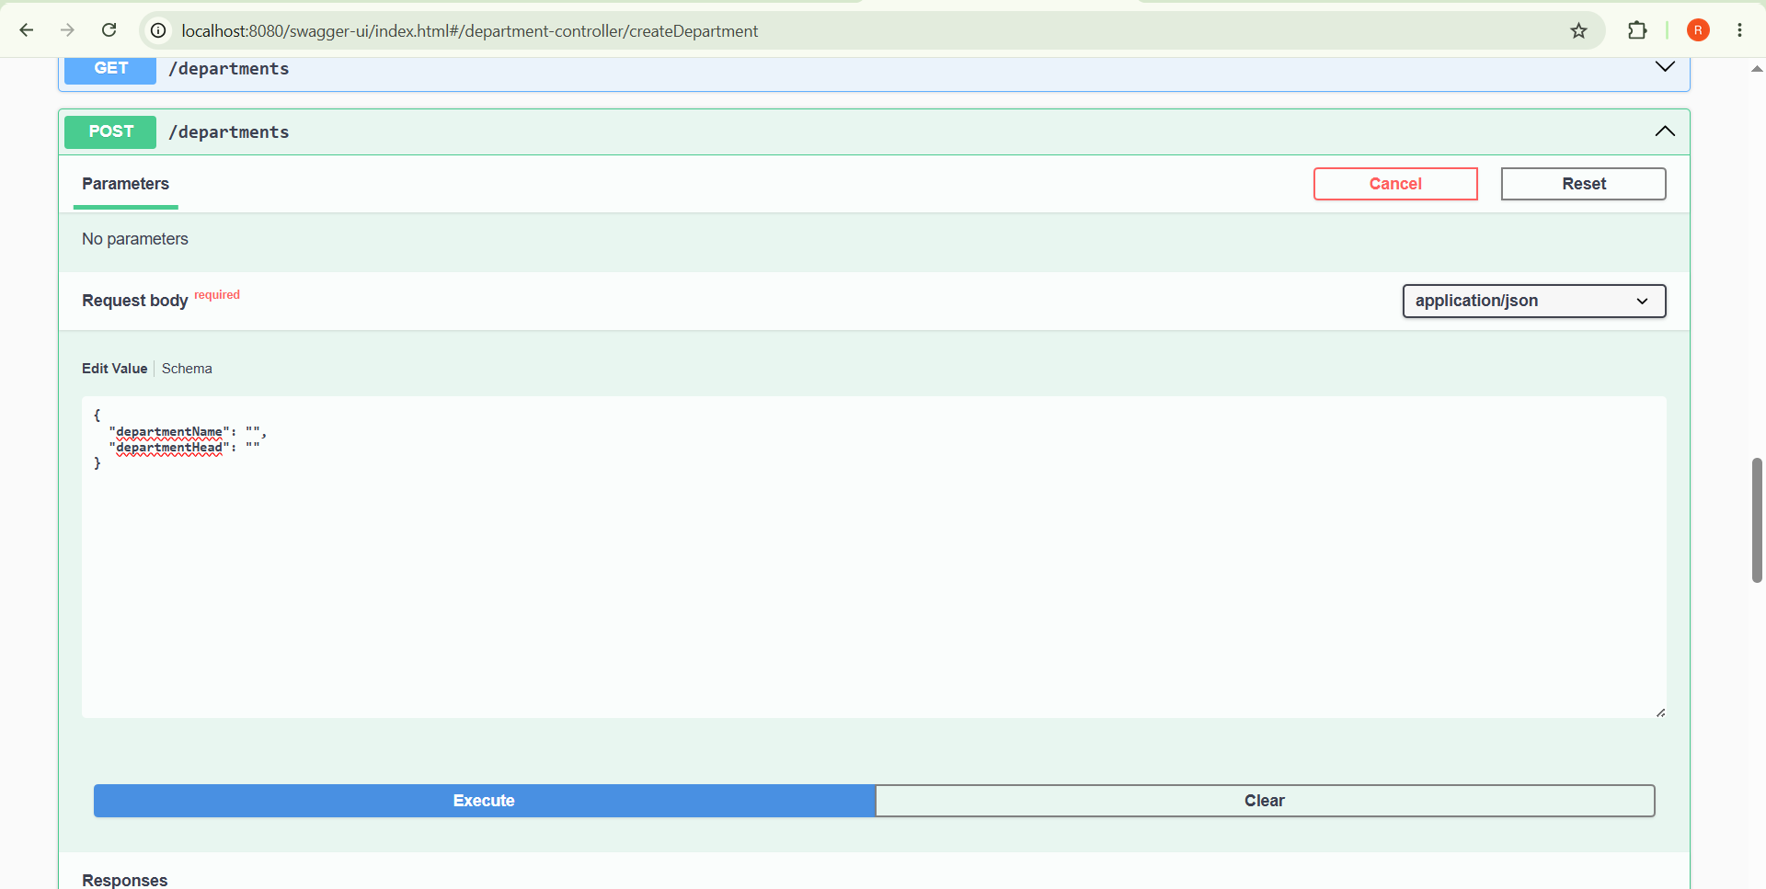
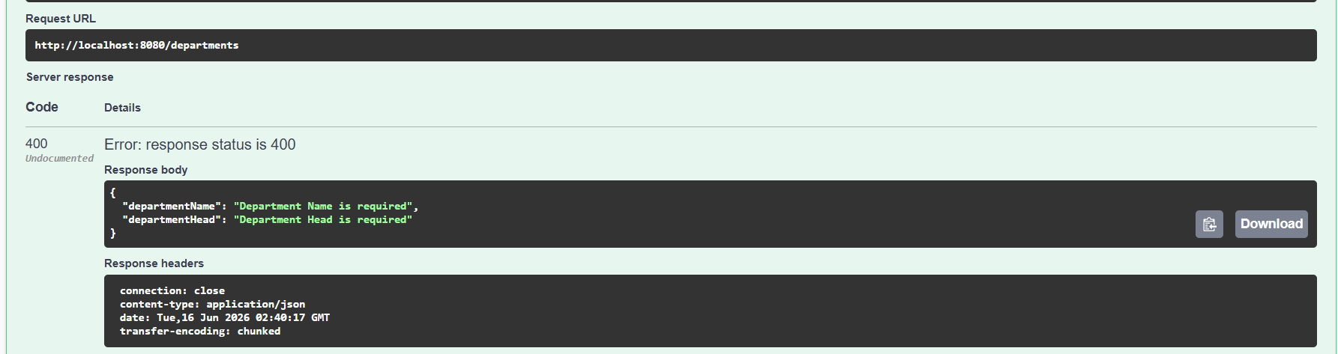

Figure 6: MongoDB collections created by the application.

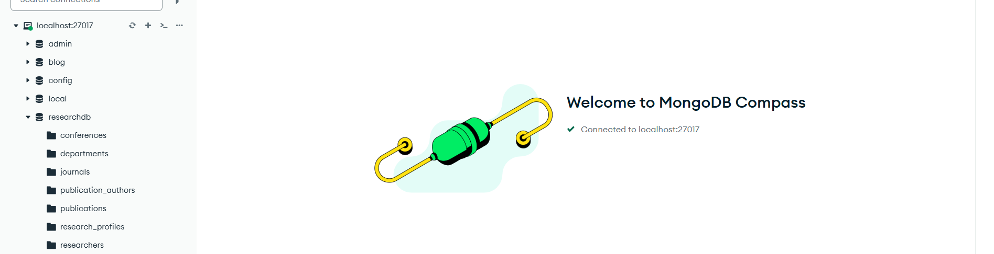

Figure 7: Department records stored in MongoDB.

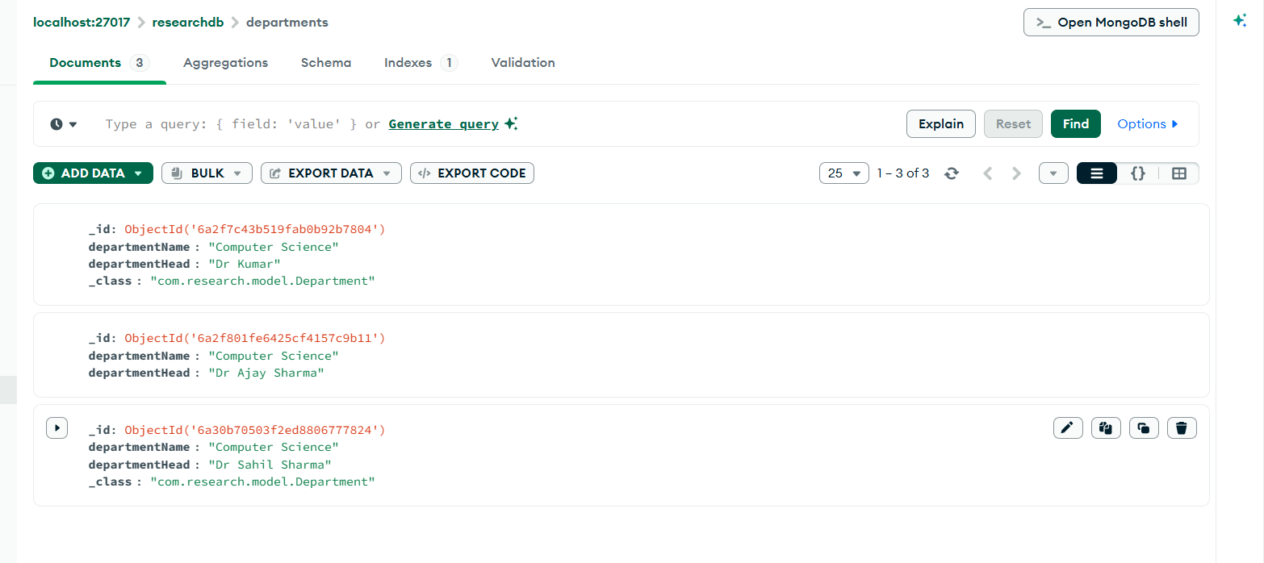

CRUD OPERATION:
CREATE:

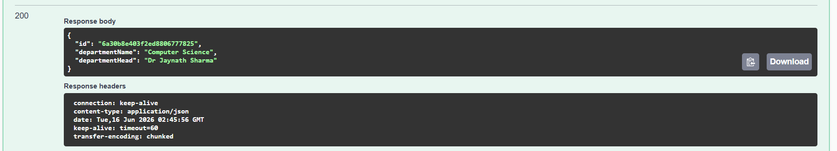
READ:
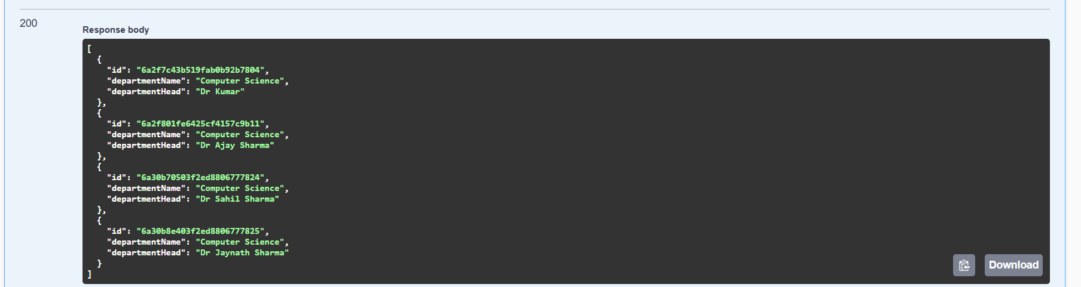

UPDATE:
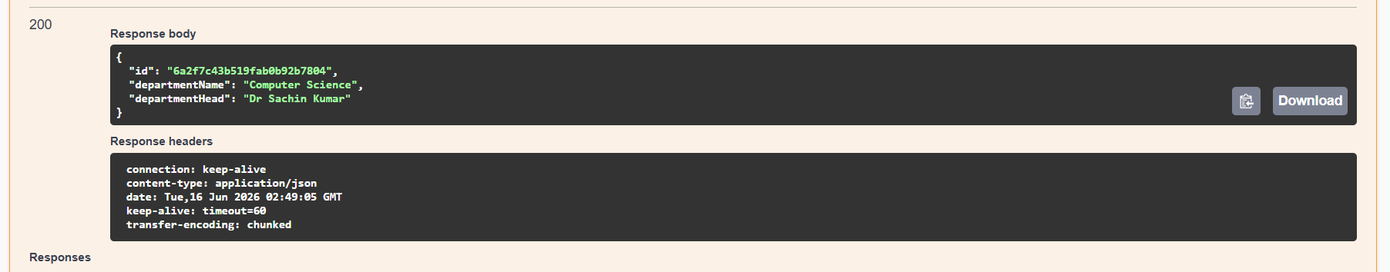
DELETE:
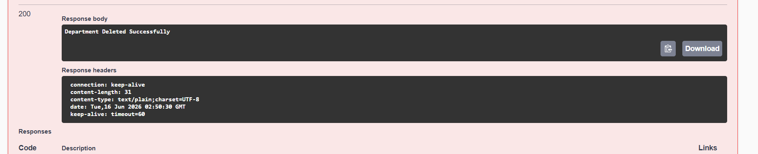

MONGODB DEPARTMENT

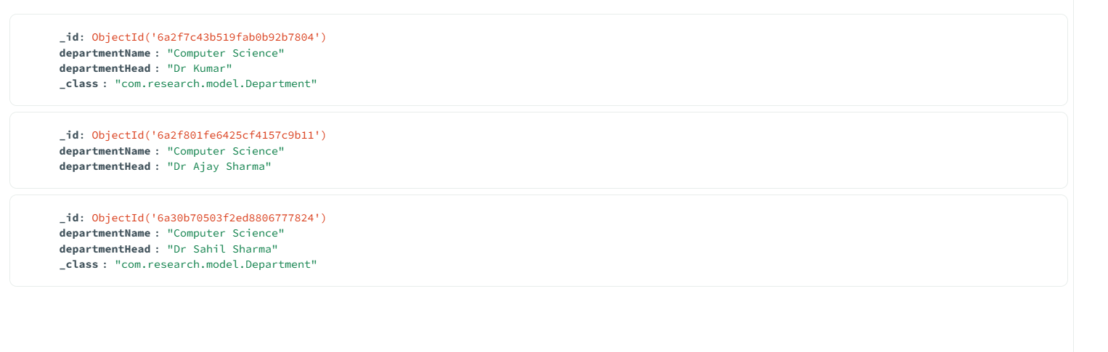

SCHEMA :
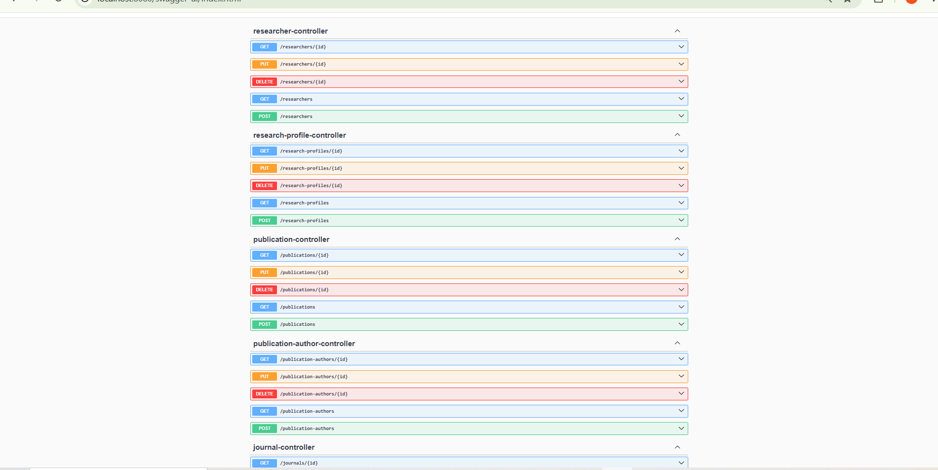

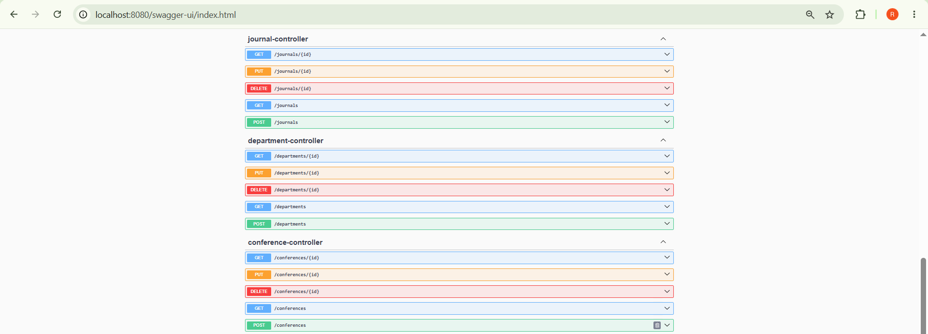

FINAL SCHEMA:
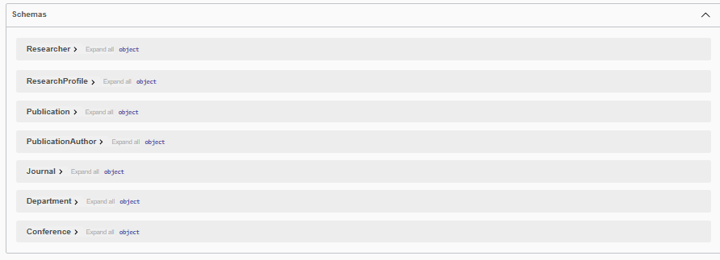
Fig: Scholar Dashboard displaying real-time statistics, system status, date, time, and motivational research insights.
-Publication search functionality enabling keyword-based retrieval of research publications.
- Researcher search functionality for locating researchers based on their names.
- Researcher search functionality for locating researchers based on their names.
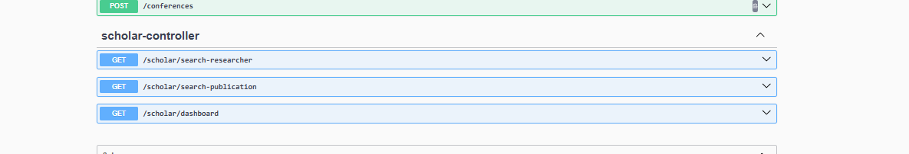

Figure : Many-to-Many relationship mapping between Researchers and Publications using the Publication Author collection.
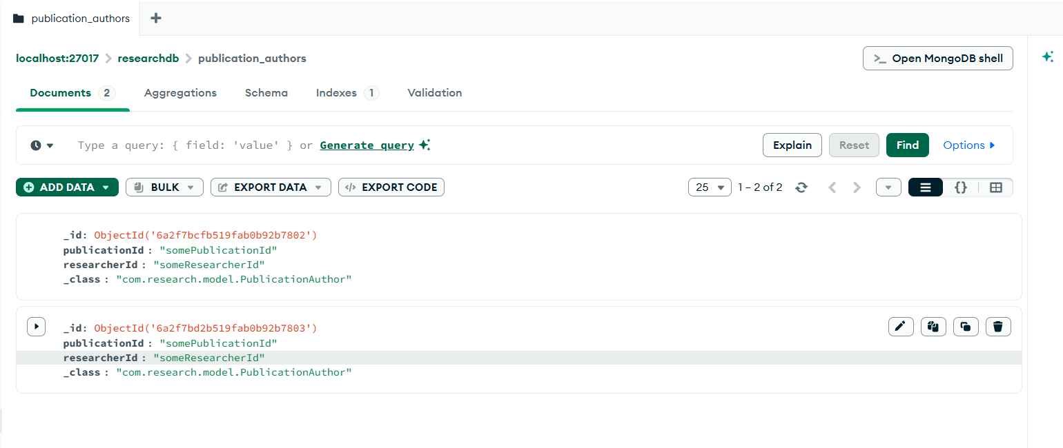

Figure : One-to-One relationship implementation between Researcher and Research Profile entities.

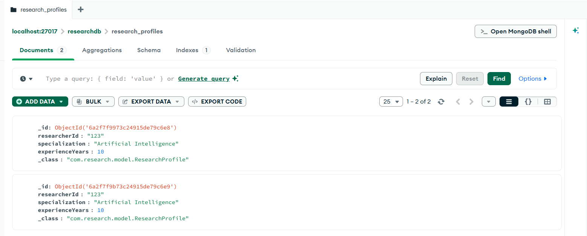

Figure : Scholar Dashboard displaying real-time research statistics, system status, date, and time.
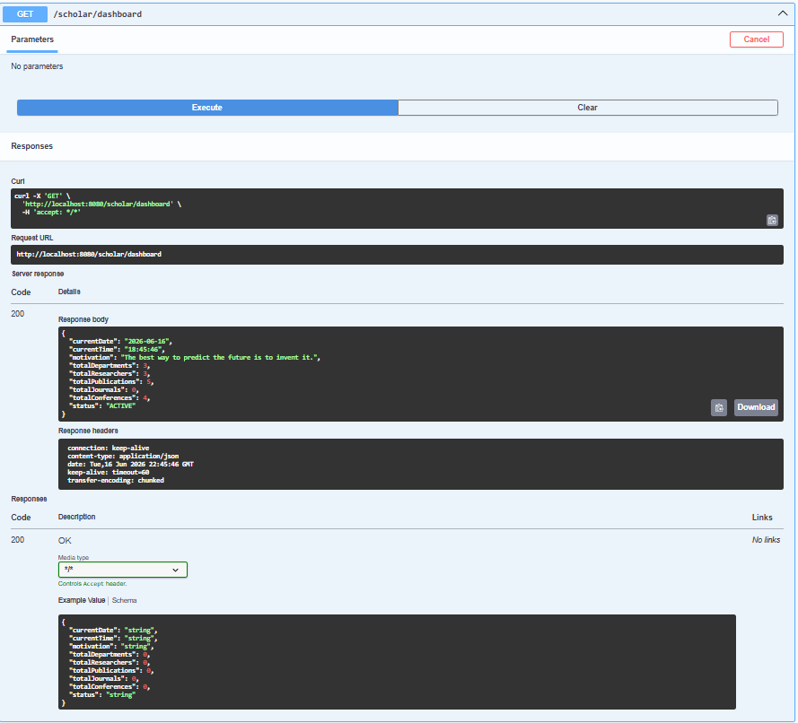

Figure : Publication search functionality enabling keyword-based retrieval of research publications.
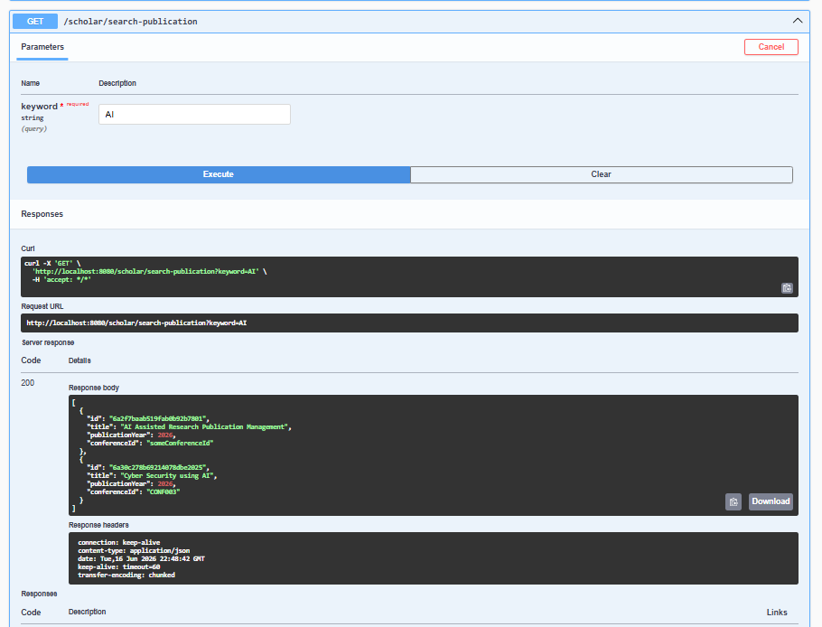

Figure : Researcher search functionality for locating researchers based on their names.
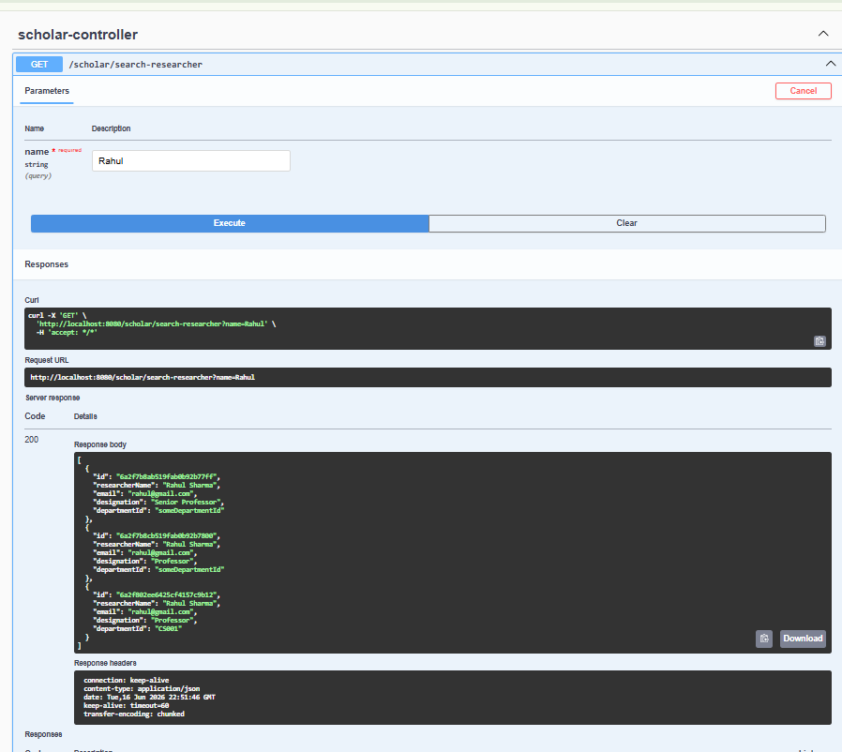

Figure : One-to-Many relationship between Department and Researchers.
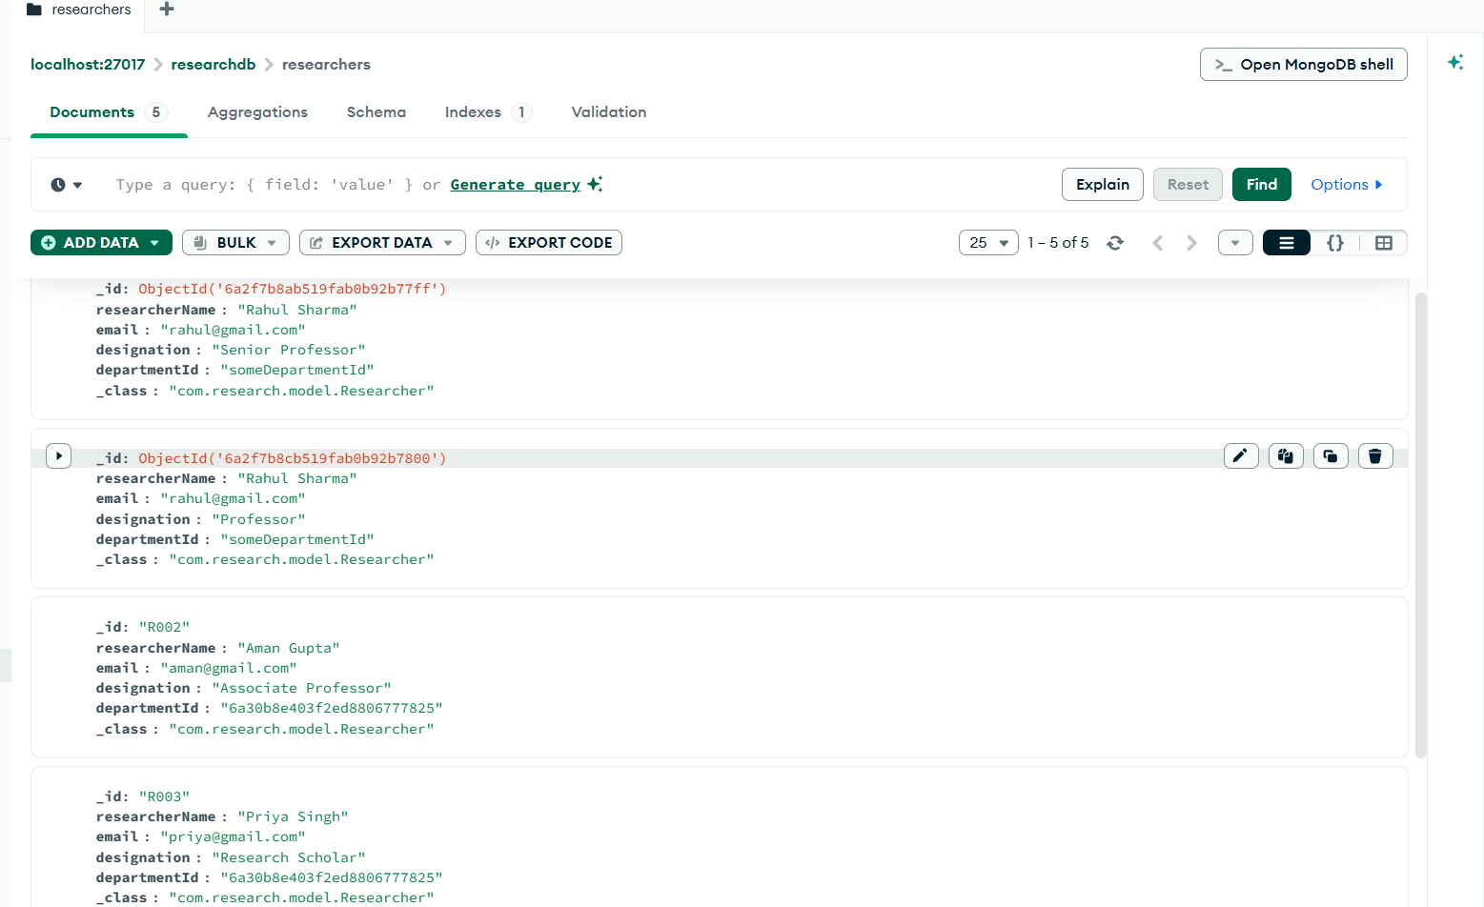

Many-to-One relationship between Researchers and Department, where multiple researchers are associated with a single department through the departmentId reference.


Fig : Conference records stored in MongoDB for managing conference information and publication events.
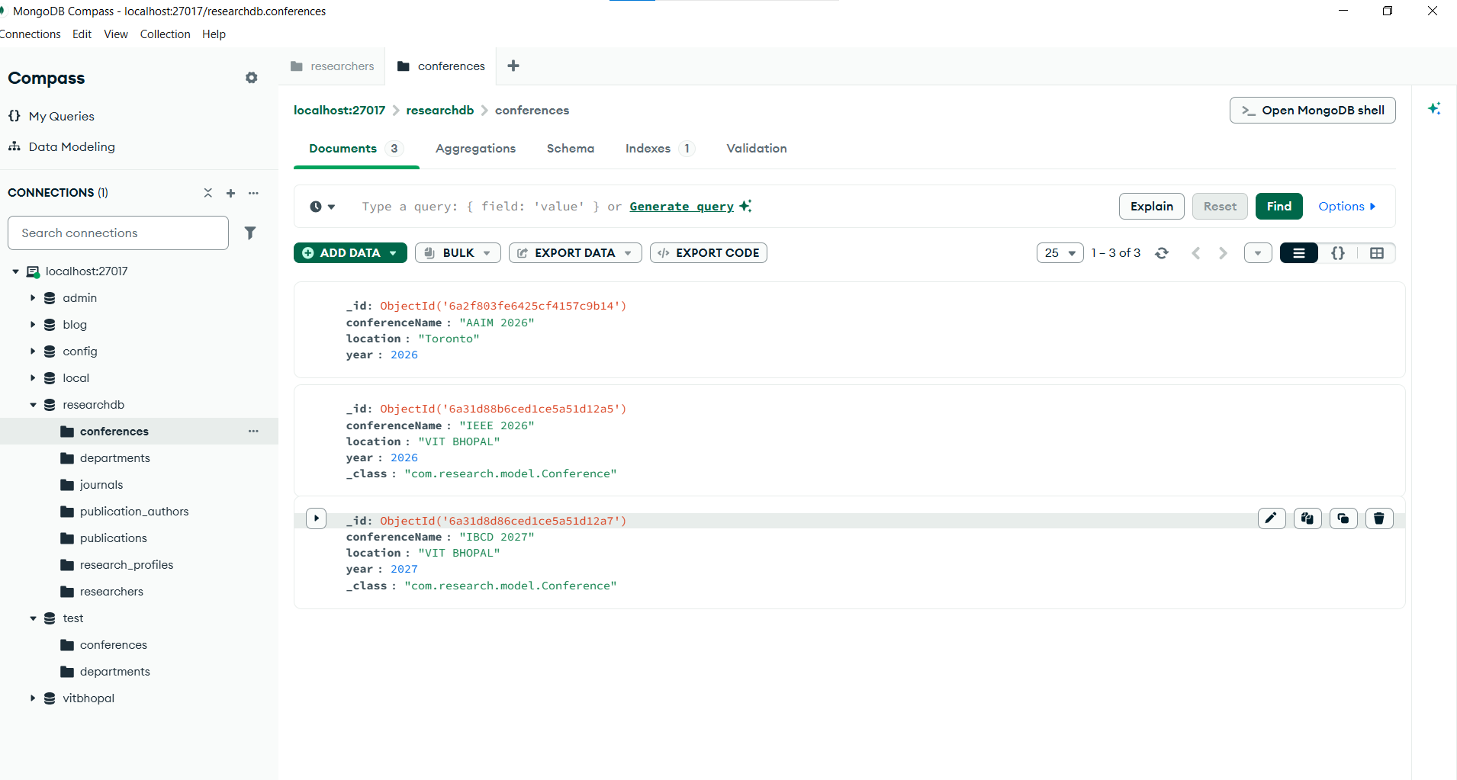

Fig: Journal records stored in MongoDB for publication categorization and management.
