
Gisma University of Applied Sciences
Department of Computer Science

Predictive Maintenance in the Aerospace Industry: A Comparative Evaluation of Machine Learning Models for Aircraft Engine Remaining Useful Life Prediction

Sahil Kumar

Submitted in partial fulfillment of the requirements for the degree of
MSc of Data Science, AI and Digital Business
Under the supervision of
Dr. Nasir Mehmood Minhas
September 2026

Acknowledgement
I wish to extend my warmest thanks to all those who helped and assisted me in the course of writing this thesis. Second, I would like to express my deep gratitude to my supervisor Dr. Nasir Mehmood Minhas, who has been a great guiding hand, giving insightful comments, and has continually nurtured me during the research. They have had a lot to do with the molding of this work by their knowledge and by their patience. I also want to appreciate the faculty and staff of Gisma University of Applied Sciences, and particularly the (Computer Science Department), since I received the conducive background and context resources that enabled me to carry out this research. I am extensively grateful to my working companions and other fellow students who always remained supportive and offered thought-provoking conversation that contributes to my learning process. I am a very thankful person to my relatives and friends who supported me unconditionally, encouraged and understood me in the process of my studies. My confidence in myself has a long way to go in being nurtured by them believing in me. Finally, I would like to acknowledge with gratitude all the interviewees and informants who took their precious time and thoughts to be interviewed and consulted in this research. This thesis would not have been possible without their support.

Abstract
Predictive maintenance has an important part to play in improving the reliability, efficiency, and performance of aircraft engines. Predicting the Remaining Useful Life (RUL) of an engine allows for maintenance planning through the identification of the lifespan of the engine. In this research, we examine the use of machine learning algorithms in predicting the RUL of aircraft engines using the NASA C-MAPSS FD001 data set. Our aim is to determine the feasibility of using three different machine learning algorithms: Random Forest, XGBoost, and LSTM for this purpose.
The experimental design involves processing the data, removing irrelevant sensor data, preparing data features, calculating RUL, and creating data sequences for LSTM. An identical structured modeling design was used to assess and compare the efficiency of the three models used in this research. The performance of each model was assessed using multiple scoring methods which included Mean Absolute Error (MAE), Root Mean Square Error (RMSE), R², and NASA PHM08 scores. The chosen methods assess the accuracy and achievements of the studied models in predicting the RUL of aircraft engines.
The results indicate that the integration of information such as time may be advantageous for the prediction of RUL of aircraft engines in a simulated environment. In addition, the findings show that the procedure of selection of models needs to include numerous criteria, as opposed to relying on a single performance measure.
At the same time, the results of the present study might have certain limitations. Specifically, the study relied on C-MAPSS datasets, rather than real world aircraft engine data, and the models were tested under chosen conditions. Moreover, the number of predictions made using the LSTM and tree-based models differed, since the use of LSTM required the use of a historical dataset of 30 cycles. Thus, it can be concluded that this was a controlled experimental comparison, rather than the proof of operational efficiency.
Github Link: https://github.com/sahilkumar2306/Dissertation
Contents
Acknowledgement 2
Abstract 3
Chapter 1: Introduction 8
1.1 Introduction 8
1.2 Background of the Research 9
1.3 Predictive Maintenance in the Aerospace Industry 10
1.4 Research Problem 11
1.5 Research Aim 11
1.6 Research Objectives 11
1.7 Research Questions 12
1.8 Research Gap 12
1.9 Research Significance 13
1.10 Research Scope 13
1.11 Dissertation Structure 14
Chapter 2: Foundations and Background 16
2.1 Introduction 16
2.2 Predictive Maintenance 16
2.3 Prognostics and Health Management 17
2.4 Aircraft-Engine Degradation 17
2.5 Remaining Useful Life Prediction 18
2.6 NASA C-MAPSS Dataset 19
2.7 Machine Learning for RUL Prediction 19
2.8 Evaluation Metrics 21
Chapter 3: Related Work and Literature Review 22
3.1 Introduction 22
3.2 Recent Development of Aircraft-Engine RUL Prediction 22
3.3 Machine Learning Approaches for RUL Prediction 23
3.4 Deep Learning and Similarity-Based Approaches 23
3.5 LSTM-Based Approaches 24
3.6 Transformer and Hybrid Deep Learning Models 25
3.7 C-MAPSS-Based Research 25
3.8 Alternative Approaches for Small Samples 26
3.9 Critical Comparison of Recent Studies 26
3.10 Positioning of the Present Research 29
Chapter 4: Approach 32
4.1 Introduction 32
4.2 Research Design 34
4.3 Dataset and Data Preparation 34
4.4 Feature Selection and Preprocessing 35
4.5 Construction of the RUL Target 35
4.6 Exploratory Data Analysis 36
4.7 Training, Validation and Testing Strategy 36
4.8 Random Forest Model 36
4.9 XGBoost Model 37
4.10 LSTM Model 37
4.11 Reproducibility and Methodological Limitations 38
Chapter 5: Results and analysis 39
5.1 Introduction 39
5.2 Dataset and Preprocessing Results 39
5.3 Random Forest Results 40
5.4 Random Forest Feature Importance 41
5.5 XGBoost Results 43
5.6 LSTM Training Results 44
5.7 LSTM Test Results 45
5.8 Comparative Model Evaluation 47
Chapter 6: Discussion 53
6.1 Introduction 53
6.2 Interpretation of the Overall Results 53
6.3 Discussion of Random Forest Performance 54
6.4 Discussion of XGBoost Performance 54
6.5 Discussion of LSTM Performance 55
6.6 Comparative Analysis of the Models 56
6.7 Implications for Predictive Maintenance 57
6.8 Critical Evaluation of the Experimental Comparison 58
6.9 Answer to the Research Questions 59
6.10 Overall Contribution and Implications 60
Chapter 7: Conclusion and Recommendations 62
7.1 Introduction 62
7.2 Practical Implications 62
7.3 Limitations of the Study 63
7.4 Recommendations for Future Research 63
7.5 Final Conclusion 64
References 66
Appendix 70
Appendix A – Dataset and Preprocessing Summary 70
Appendix B – Final Model Configuration 70
Appendix C – Final Model Performance 71
Appendix D – Supporting Experimental Evidence 71

Content of Figures
Figure 1: Research Methodology for Aircraft Engine Remaining Useful Life Prediction 33
Figure 2: Actual RUL Vs Predicted RUL by the Random Forest model. 41
Figure 3: Feature-importance scores by the Random Forest model 42
Figure 4: Actual versus predicted RUL values for the XGBoost model 44
Figure 5: The training and validation loss of the LSTM model across the training epochs. 45
Figure 6: Actual versus predicted RUL values for the LSTM model 46
Figure 7: Comparison of MAE and RMSE across the three RUL prediction models 49
Figure 8: Comparison of R² and NASA PHM08 scores across the three models 50
Figure 9: Distribution of Maximum Engine Lifetimes in the FD001 Training 51
Figure 10. Correlation Between Sensor Variables and Remaining Useful Life 52

Chapter 1: Introduction

1.1 Introduction
Aerospace is one of the most critical industries as it requires a high safety standard in its operations, so that reliability of aircrafts, their availability and the efficiency of their maintenance becomes vital for successful operation. Engines are crucial components of aircrafts, as their state significantly affects their efficiency and availability. During operation engines work under constant mechanical, thermal and environmental stress causing gradual degradation in performance. If this degradation goes unnoticed and unhandled, it can lead to unwanted malfunctioning and consequently to unplanned maintenance, downtime or Aircraft on Ground (AOG).
Conventional maintenance strategies are usually based on either planned maintenance or corrective maintenance. Planned maintenance means the maintenance, inspection, and replacement of certain parts at predetermined intervals, while corrective maintenance means performing maintenance after certain malfunction occurs. These two types of maintenance ensure safe operation of aircrafts; however they may not show true state of particular component. Early component replacement leads to unnecessary costs; late degradation identification only after malfunction causes various disruptions.
The increasing availability of operational data and sensor data has opened up new opportunities to enhance maintenance approaches. Predictive maintenance employs past and present equipment information to determine degradation trends and foresee future breakdowns. ML is especially crucial in this area because of its ability to model the complicated relationships between different variables without having to model explicitly all the physical aspects of the degradation process (Asif et al., 2022).
An extremely important task in predictive maintenance (PdM) or Prognostics and Health Management (PHM) is predicting Remaining Useful Life (RUL). Remaining Useful Life can simply be defined as the amount of useful life that is still available to an object or asset before its failure occurs and it is considered to have reached its end of life. In aviation engines, the remaining useful life can be expressed in terms of operational cycles. The availability of information about the RUL is an advantage for the maintenance department, as it will allow them to conduct preventative maintenance and repair activities, as well as component replacement (Breiman, 2001).
This dissertation investigates the application of machine learning to aircraft-engine RUL prediction using the NASA Commercial Modular Aero-Propulsion System Simulation (C-MAPSS) dataset. Three machine learning approaches are compared: Random Forest (RF), XGBoost and Long Short-Term Memory (LSTM). The efficiency of these algorithms is measured by the criteria of MAE, RMSE, R-squared, and NASA PHM08 Scoring Functions. Additionally, the research is focused on how the precision of RUL forecasts might influence the process of maintenance management to increase the efficiency and decrease expenses.

1.2 Background of the Research
An aircraft engine is a complicated system made up of many components and subsystems. However, the conditions in which an aircraft engine operates might vary significantly due to various reasons such as flight conditions, engine load, and environmental conditions (Yang et al., 2025). Degradation will develop slowly over time during the operational phases and might eventually cause a decline in the readings of sensors.
However, predicting the degradation of an aircraft engine is difficult since an engine does not always degrade in a consistent manner. For instance, even if two engines are operated under identical conditions, they will undergo different patterns of degradation.
Predictive maintenance is aimed at transforming routine maintenance that takes place on a set period schedule or via a reactive method into a condition-based approach. Rather than presuming that all components have to be serviced within the same pre-established intervals, predictive based on the use of the information available for evaluating the conditions and future state of the individual assets (Chen, 2024). The role of RUL prediction is considerable as it provides information about how long a component is expected to work.
RUL prediction goes beyond simply prediction accuracy. If an engine is going to be capable of a limited number of cycles, maintenance managers are able to make appropriate inspections or maneuvers prior to the breakdown. On the other hand, if the engine has a high RUL prediction then intervention is not needed.
Nevertheless, predictive maintenance in aircraft must not rely solely on machine learning predictions since plane maintenance is highly regulated by safety issues, engineering practices, procedures, and industry requirements. Thus, the use of machine learning in this research is limited to providing decision support.

1.3 Predictive Maintenance in the Aerospace Industry
In the process of predictive maintenance, the condition of the equipment is analyzed to foresee possible failures and to understand the need for maintenance. This method is especially important in the aviation industry, where unexpected maintenance of aircraft can disrupt the flow of flights and increase the costs.
Using traditional fixed intervals for maintenance leads to servicing components that have not yet reached a failure yet. As a result, the level of deterioration does not follow the assumptions used to define these intervals. Yet, predictive maintenance based on using data makes it possible to take the real behavior of the equipment into account.
Machine learning algorithms are capable of processing various sensor variables simultaneously and detecting the patterns that are characteristic of the engine deterioration (Cheng et al., 2024). By doing so, a predictive maintenance framework is able to establish a ranking of engines according to their risk or estimated remaining life and use this information in maintenance planning while considering the requirements of engineers and how maintenance is organized.
Beneficial effects can be forecasts to include better maintenance planning, lower unforeseen downtime, better usage of maintenance equipment and greater fleet availability. At the same time, the monetary benefits of predictive maintenance depend on many factors which are them.
This dissertation does not intend to determine the actual financial earnings. The original NASA C-MAPSS dataset is a created collection and does not offer detailed data concerning airline expenses, labor, spare-part and AOG facts that could be used for calculating of real world savings. The research aims to define the efficiency of RUL prediction and discuss how this prediction might help in maintenance and financial management.

1.4 Research Problem
While the application of machine learning techniques in predictive maintenance has been extensively explored, determining a suitable model for predicting aircraft engine remaining useful life is still a difficult task. Various research studies can employ different preprocessing methods, feature sets, definitions for remaining useful life, evaluation metrics and sequences. Thus, comparing findings from different studies proves to be challenging.
Another important issue is that various kinds of prediction errors can result in different operational consequences. In particular, a prediction that states that an engine has more life than it actually has might be worse that providing an early, but accurate prediction, because an engine operator would not be warned about the degradation process in engine’s life cycle. NASA PHM08 scoring function considers this flaw in RUL prediction.
That is why it is important to make a comparison of various machine learning prediction methods using one data set and with one preprocessing methodology and evaluation framework. This research deals with the issue by comparing three Machine Learning approaches while using NASA C-MAPSS data.

1.5 Research Aim
To evaluate and compare machine learning models for Remaining Useful Life (RUL)/End-of-Life prediction of aircraft engines and assess their potential contribution to predictive maintenance strategies in the aerospace industry.
The research therefore combines technical model evaluation with consideration of the potential practical value of accurate RUL information for aerospace maintenance.

1.6 Research Objectives
The research is guided by the following objectives:
- Review existing literature on the topic of predictive maintenance, aircraft engine prognostics, remaining useful life (RUL) estimation, and machine learning approaches.
- Analyze the NASA C-MAPSS dataset for aircraft engine RUL estimation by using data preparation and pre-processing methods.
- Construct and test Random Forest, XGBoost, and Long Short-Term Memory (LSTM) models for RUL estimation of an aircraft engine.
- Estimate model effectiveness using the MAE (Mean Absolute Error), RMSE (Root Mean Squared Error), R² (coefficient of determination), and NASA PHM08 metric.
- Compare the predictive performance of the three machine learning models and determine the best one under the given experimental conditions.
- Consider how accurately estimated RUL helps make maintenance decisions and how it can be used to improve reliability and save money.

1.7 Research Questions
The dissertation addresses the following research questions:
- RQ1: How accurately can machine learning models predict the Remaining Useful Life (RUL)/End of Life of aircraft engines using the NASA C-MAPSS dataset?
- RQ2: Which machine learning model provides the best prediction performance among Random Forest, XGBoost and LSTM?
- RQ3: How can accurate Remaining Useful Life prediction support maintenance decision-making and contribute to operational cost reduction in the aerospace industry?
The first research question focuses on the overall effectiveness of machine learning for RUL prediction. The second provides the main comparative element of the study. The third connects the technical findings with the practical objectives of predictive maintenance.

1.8 Research Gap
It has been shown that various machine learning and deep learning methods can be used for predicting the remaining useful life (RUL) of aircraft engines. Recent research tends to involve more advanced neural networks, attention mechanisms, and hybrid systems. Nevertheless, the efficiency of the model is influenced by a number of methodological aspects, such as data preparation, feature selection, RUL target definition, and evaluation of results. Thus, it seems impossible to compare the results of various studies when different datasets and methods are applied.
Consequently, there is still a need for controllable comparative experiments employing standard machine learning and deep learning methods in the same experimental conditions. Instead of constructing a more sophisticated architecture, in this paper, Random Forest, XGBoost, and LSTM models are compared using the same dataset, data preparation, and evaluation technique.
Furthermore, there is another gap in the current research concerning the practical application of RUL prediction results. Most of the studies concentrate on prediction performance and measurement results, while the potential usage of the predictions in prediction maintenance decisions is touched upon briefly. Thus, this research aims to evaluate the technical capabilities of the models selected and the practical importance of accurate RUL prediction regarding aircraft

1.9 Research Significance
The significance of the study is both technical and practical. Technically, it gives a comprehensive comparison of three models for predicting aircraft engine RUL. The use of various complementary metrics allows for evaluating results more broadly than when using a single measure.
Practically, a good prediction of RUL can provide planners with valuable information about aircraft engines. This can enable faster reaction to engines in need of maintenance, more efficient scheduling, and allocation of resources.
It should be noted, however, that although accurate predictions are likely to lead to less unnecessary maintenance and decreased risk of unplanned downtimes, the results should not be treated as actual achievements.

1.10 Research Scope
The present research touches only the case of aircraft-engine RUL prediction based on the NASA C-MAPSS dataset. The study considers the models of Random Forest, XGBoost, and LSTM methods and assesses the method performance based on the MAE, RMSE, R² scores as well as the NASA PHM08 indicator.
The study does not aim at deriving a certified aviation maintenance system. It does not apply proprietary airline data or produce the actual fleet maintenance cost either. Thus, any conclusions regarding the decrease of operational costs, increase of fleet reliability, or downtime are derived in a form of hypotheses and comments regarding the advantages of proper predictive maintenance, although the actual outcomes may be measured.

1.11 Dissertation Structure
The remainder of the dissertation is organized into seven chapters.
Chapter 2 – Foundations and Background explains the fundamental concepts underlying the research, including predictive maintenance, Prognostics and Health Management, RUL prediction, aircraft-engine degradation, NASA C-MAPSS, machine learning and the selected evaluation metrics.
Chapter 3 – Related Work critically reviews existing research on aircraft-engine RUL prediction and machine learning-based predictive maintenance. It identifies limitations in previous research and establishes the research gap.
Chapter 4 – Approach and Methodology describes the research design, dataset, preprocessing, feature selection, RUL construction, model development and experimental procedures in detail.
Chapter 5 – Evaluation and Results presents and compares the experimental results of Random Forest, XGBoost and LSTM using MAE, RMSE, R² and NASA PHM08 scoring.
Chapter 6 – Discussion interprets the findings in relation to the research questions, previous studies and potential aerospace maintenance applications. It also considers limitations and implications.
Chapter 7 – Conclusion summarizes the main findings, research contribution and conclusions and identifies potential directions for future research.

Chapter 2: Foundations and Background

2.1 Introduction
The use of predictive maintenance has become a significant research topic in the aerospace field since engines are complex, costly, and critical tools for safety. The ability to continuously monitor engines’ operating conditions is a source of useful information for detecting degradation, as well as predicting the performance of the engines in the future. The techniques of machine learning (ML) allow for creating models that can read the information coming from the engines and predict their RUL.
The chapter defines the basis for conducting the research and presents the theories that support its methodology. It examines predictive maintenance, prognosis and health management (PHM), engine deterioration, and the prediction of RUL. The chapter is dedicated to the introduction of the NASA Commercial Modular Aero-Propulsion System Simulation (C-MAPSS) database and putting forward the three machine learning methods chosen for the research, including Random Forest (RF), XGBoost, and Long Short-Term Memory (LSTM). The mechanisms for assessing the models will also be discussed.

2.2 Predictive Maintenance
In general, there are three main categories of maintenance strategies: corrective, preventive and predictive maintenance. Corrective maintenance is only used after the equipment has failed. In contrast, preventive maintenance includes checking the equipment or its parts at certain time periods. Predictive maintenance uses equipment operating and historical data to determine the required condition of the equipment and to provide recommendations for maintenance actions (Darwish, Sallam and Alrashdi, 2025).
The basic aim of predictive maintenance is to emphasize the need to apply condition-based approach to maintenance rather than the conventional time-based approach. The data can be gathered and processed to find out any changes in the machine condition which may allow predicting its degradation. Machine learning can be effectively applied for this purpose since machine learning makes it possible to find complex relationships between different processes.
Predictive maintenance has a lot of capability in the field of aerospace because airplane engines can fail unexpectedly. In the event of such an failure, the airline might have to suffer aircraft downtime, unplanned costs of maintenance, and disruptions in operational schedule. Xue et al. (2025) highlight that the concept of RUL prediction is related to predictive maintenance for airplane engines and shows that RUL information serves as the basis for maintenance schedule planning.
However, predictive maintenance should not be considered as an alternative to engineering judgment because the aviation industry has rigid laws and regulations on safety and performance. Rather, machine learning predictions might be viewed as one of the components used to support decision making together with engineering practices and traditions.

2.3 Prognostics and Health Management
Prognostics and Health Management is a general setting in which monitoring of equipment's health condition, fault detection and future behavior prediction is performed. With PHM one can utilize the condition monitoring data to estimate the health of an object at the moment and forecast how it would deteriorate in future (Deepika et al., 2025).
The prognostic part is most essential for this dissertation since the attention paid on RUL estimation. The usual process of prognosis includes collection of sensor data, data processing, degradation patterns recognition and remaining useful life estimation.
The aircraft engine prognosis is complicated due to the number of factors affecting engine degradation processes and sensor measurements may include noises, redundancies and operating variability. The actual studies, such as the one published by Elsherif et al. (2025) concerning the application of deep learning approach to turbofan engine prognostics and RUL estimation, confirm the complexity of this problem.
The given research is focused on the prediction aspect of PHM rather than developing the whole decision support system in relation to PHM.

2.4 Aircraft-Engine Degradation
As aircraft engines undergo changes in their performance level throughout the operational cycles it has impacted (Dida, Cheriet and Belhadj, 2025). The changes that occur can happen due to mechanical wear, thermal stress, and other factors related to operations. The process of degradation may not necessarily be straightforward. Different engines in similar conditions can show different patterns of degradation over time.
The sensor data give indirect hints about the working condition of an engine. The parameters of temperature, pressure, and craft speed might change with the process of degradation. Such a relationship is quite complicated because it should be determined whether a particular variation in the data indicates degradation or this is just a noise.
This complicates the modeling process because machine learning algorithms now have to tell the difference between significant degradation patterns and normal operational variations in the measurement values. Thus, the methods of feature extraction and preprocessing become significant steps of residual life prediction.
Recent studies have provided new methods to model engine degradation. One of the researches is Elsherif et al. (2025) where a hybrid architecture classified as BiLSTM-Transformer-TCN is suggested for the RUL forecasting for aircraft engines.

2.5 Remaining Useful Life Prediction
Remaining Useful Life indicates the expected amount of time left until an asset enters a defined state of failure. It is common in the NASA C-MAPSS environment to express RUL as the number of cycles remaining until the engine fails.
Prediction of RUL can be framed as a supervised regression task. Sensor and operational variables serve as input feature variables while the remaining number of cycles is the output variable (He, 2025). The goal is to minimize the difference between the predicted and actual RUL.
What is interesting about RUL prediction is the fact that prediction errors do not have the same consequences. When an engine is predicted to have much more remaining life than it actually does, the warning about impending degradation may be insufficient. On the other hand, prediction of a shorter RUL may lead to undesired early maintenance. Zhu et al. (2025) stressed the importance of taking RUL intervals into consideration when implementing aero-engine maintenance strategies.
Thus, in the current study not only traditional regression measures are utilized but NASA PHM08 scoring function has been also used in view of the fact that such function reflects the differences in consequences between an earlier and a later RUL forecast.

2.6 NASA C-MAPSS Dataset
NASA’s C-MAPSS dataset is one of the most important benchmark datasets for research conducted with a view to performing aircraft-engine prognostics and predicting remaining useful life (RUL). C-MAPSS stands for Commercial Modular Aero-Propulsion System Simulation, which means that this dataset provides turbofan-engine operational data in the form of simulation results.
Data in the C-MAPSS dataset are taken from operational cycles of engines as well as from various sensors installed and measurements taken in different operating conditions (Hochreiter and Schmidhuber, 1997). Training engines have been tracked from the start of their operation up to failure; while testing engines are studied until their point of failure is reached. The described structure of the dataset makes it suitable for supervised RUL prediction task.
The C-MAPSS dataset is extremely important as it is often used to compare prognostic methods used because of its capability to provide unified degradation dynamics and make it possible to test different methods of machine learning.
The present dissertation is dedicated to the analysis of the selected subset of C-MAPSS FD001. The experimental preparation is aimed at analyzing all the variables available in the dataset, removing some insignificant or non-informative features, constructing the targets

2.7 Machine Learning for RUL Prediction
In general, we can also separate machine learning into three types, including supervised learning, unsupervised learning and reinforcement learning. In the current thesis, supervised learning is applied, as C-MAPSS training data gives the observations with known RUL targets (Zhu et al., 2025). Three models are analyzed, namely Random Forest, XGBoost and LSTM, as these models are examples of different approaches to modeling and provide an interesting comparison between classical ensemble and sequence-based deep learning.
Random Forest is an ensemble machine learning technique that consists of a collection of decision tree (Isbilen, Bektas and Konar, 2025). For regression tasks, each decision tree makes predictions in the form of values that are aggregated together to give the final result.
The key advantage of the Random Forest algorithm is its capability to model complex connections and interactions instead of relying on linear relations between features used in the model and the target to be predicted. It can also offer variable importance values that signify those sensor data that contribute to the prediction.
Thus, Random Forest serves as a reliable point of reference in terms of RUL prediction for aircraft engines, although traditional methods do not offer a straightforward approach for modelling data relations in a sequential form according to RNN methods.
Random Forest is an ensemble machine learning technique that consists of a collection of decision trees (Karatzinis, Boutalis and Van Vaerenbergh, 2024). For regression tasks, each decision tree makes predictions in the form of values that are aggregated together to give the final result.
The key advantage of the Random Forest algorithm is its capability to model complex connections and interactions instead of relying on linear relations between features used in the model and the target to be predicted (Kim and Lee, 2025). It can also offer variable importance values that signify those sensor data that contribute to the prediction.
Thus, Random Forest serves as a reliable point of reference in terms of RUL prediction for aircraft engines, although traditional methods do not offer a straightforward approach for modeling data relations in a sequential form according to RNN methods.
Long Short-Term Memory is a type of recurrent neural network introduced by Hochreiter and Schmidhuber in 1997. The purpose of LSTM is to learn the dependency relation present in a sequence. Therefore, it can also be applied to the time-series task since it performs better than basic models for processing sequences.
Apart from regular models that treat data points as independent entities, LSTM can process multiple observations in sequence and also memories information from the previous time steps. Such ability plays an important role in aircraft-engine failure time prediction. The important point here is that aircraft degradation happens in a series of cycles (Niu et al., 2025).
Recent works have shown the success of LSTM-based methods in the context of aircraft engine prediction. Dida, Cheriet and Belhadj have studied the model of attention LSTM concerning the prediction of failure-times for aircraft engine, whereas Peringal et al. focused on LSTM use in the prediction of aircraft-engine failure times with the conservative loss function implementation. Thus, it becomes clear that recurrent architecture is of great importance for temporal degradation modeling.

2.8 Evaluation Metrics
The performance of the three models is assessed by means of four indicators: Mean Absolute Error, Root Mean Square Error, R-squared and the NASA PHM08 scoring function. The Mean Absolute Error (MAE) indicates how much the predicted values differ from the actual values on average. The Root Mean Square Error (RMSE) gives more weight to the larger prediction errors as the errors are squared prior to averaging. The smaller the RMSE, the better the performance. The R-squared (R²) measures how much of the variability in the dependent variable is accounted for by the model and the closer the value is to 1, the more accurate the model is. The NASA PHM08 scoring function assesses prediction errors in an asymmetric way. It applies different penalties for early and late predictions. In maintenance contexts, some consequences of underestimating the remaining life are different from the consequences of overestimating it.
By evaluating the models using different metrics, one can obtain a better assessment than if using only one measure for evaluation. For example, if a model performs in the same way as another model by the MAE measure of error does not mean that it also performs equally well with regard

Chapter 3: Related Work and Literature Review

3.1 Introduction
In recent years, machine learning approaches for aircraft engines Remaining Useful Life (RUL) prediction has advanced rapidly. The large amount of sensor data and enhancement of computational capabilities have enabled researchers to explore data-driven methods. Current researches moved from classic machine learning models toward recurrent neural networks, attention mechanisms and hybrid architectures (Özcan, 2025). In parallel, attempts have been made to combine RUL prediction with maintenance scheduling, cost optimization and operational management.
This chapter reviews the latest studies published mainly from 2025 and onward. The focus of the review is on RUL prediction for aircraft and turbofan engines including studies utilizing the NASA C-MAPSS dataset. The objectives are to identify major modeling approaches, explore their positives and negatives and indicate the research gap being addressed by the present dissertation.

3.2 Recent Development of Aircraft-Engine RUL Prediction
RUL estimation for aircraft engines plays a vital role in predicting preventative maintenance as its aim is to predict how much longer the engine has to work before it fails. Recent studies have increasingly focused on RUL prediction as part of a larger framework of decision support for machinery maintenance rather than simply treating it as an isolated issue of regression.
Xue et al. (2025) developed a predictive maintenance system relying on the aero engine RUL prediction technique with the help of the Trans-LSTM model which embodies both LSTM and Transformer architectures. This study was conducted in view of NASA C-MAPSS data and subsequently utilized the predicted RUL for the maintenance strategy. This research is important for the present dissertation as it illustrates the relationship accuracy of the prediction and operational maintenance activities. According to the authors, RUL-based maintenance strategy can improve the engine uptime and reduce costs linked to maintenance.
Nevertheless, the approach proposed by Xue et al. (2025) is more complicated than the modeling approach proposed in this dissertation. The method in question contains both LSTM and Transformer components and employs Bayesian optimization of the hyper parameters.

3.3 Machine Learning Approaches for RUL Prediction
Contemporary research is confirming the continuing applicability of traditional machine learning approaches due to the growing popularity of deep learning. Reimers and Gurevych (2019) evaluated machine learning solutions for aircraft-engine RUL estimation using NASA C-MAPSS data. The authors noted the promise of machine learning for predictive maintenance, but they also raised concerns about the issues connected with efficiency, computational overheads, and interpretability of deep learning solutions.
This is of significant importance to the current study. Much of the recent research has been focused on more and more complicated neural networks. While a complex model is not necessarily the most appropriate approach to every maintenance application. Tree-based machine learning solutions can effectively work on structured sensor data, generally requiring less complicated models.
Therefore, Random Forest and XGBoost have been selected as appropriate benchmark models for this dissertation. Random Forest is capable of detecting nonlinear dependencies between sensor readings and RUL, while XGBoost is responsible for modeling complicated processes through the gradient-boosting approach. The comparison of the two models with LSTM is aimed at evaluating whether the explicit modelling of sequences can provide a meaningful benefit.

3.4 Deep Learning and Similarity-Based Approaches
Isbilen, Saxena and Goebel (2008) explored the application of deep learning and similarity-based approaches in predicting RUL of turbofan engines by utilizing C-MAPSS dataset. Their paper demonstrates how the exploration of new modeling alternatives continues, which is indicative of the significance of research in the area of predictive maintenance based on the use of engine sensor data. The research was published in The Aeronautical Journal 2025 which reflects the ongoing relevance of the C-MAPSS dataset as a benchmark dataset for the prognostics of aircraft engines.
The significance of this study is not only in models under consideration but also in demonstrating how the C-MAPSS dataset continues to be widely used in experimental work and helps to carry out comparative studies of different methodologies.
Despite the existence of one common dataset, however, researchers cannot assume that the results of various studies can be compared. Researchers may apply different combinations of sensors, different methods of normalization, various definitions of the RUL target, and various training algorithms. Thus, comparison of models implies the analysis of experimental methodology used rather than just reporting in one score obtained.

3.5 LSTM-Based Approaches
Because aircraft engine sensor data has a time component, recurrent neural networks are particularly important for predicting remaining useful life (RUL). Recent research is looking into LSTM and other types of recurrent architectures due to their capability of recognizing dependencies occurring over many times.
LSTM-based architecture helps keep the information of the past observations. This feature is very important given that engine deterioration is inherently a temporal process. The meaning of one sensor value in a specific cycle may differ based on the changes the sensor value went through in the previous cycles.
Recent research has been moving away from simple LSTM architectures more and more. As an illustration, Saxena et al. (2008) suggest combining LSTM with Transformer architecture in their Trans-LSTM model. They demonstrate that scientists work on merging sequence learning capability of LSTM and ability of Transformer-based architecture to plot relationships between sensors.
The appearance of such architecture indicates that classical LSTM is still one of the important points of reference, but it is not enough to capture all the features of complex multi-sensor degradation data. However, it doesn’t mean that classical LSTM is irrelevant in comparative research as it serves as a useful

3.6 Transformer and Hybrid Deep Learning Models
Hybrid deep learning architectures are of utmost significance in the RUL literature in recent times. These models focus on maximizing the strengths of different techniques.
Yang et al. (2025) present the BLTTNet architecture, which combines bidirectional long short-term memory (LSTM), transformer, and temporal convolutional network components to predict the remaining useful life (RUL) of aircraft engines. The architecture places particular focus on feature integration across heterogeneous features as well as representation improvement of temporal patterns. This paper demonstrates a move towards multi-component neural architectures for aircraft engine forecasting.
Additionally, Si, Wang, Hu and Zhou (2011) developed an inverted Transformer that has been enriched with Fourier transformation and a spatiotemporal learning approach to predict the RUL of aircraft engines. Their methodology combines both the Transformer-based modeling with spatiotemporal graph convolution and information from the frequency area. This research reveals that the performance in RUL prediction has improved.
These studies illustrate that current research is shifting its focus toward models that can learn complicated connections between the various sensors over long periods of time. On the other hand, they also mark a possible limitation of the literature: more complicated systems are more difficult to assess which specific components of the modeling are responsible for the improvement in outcomes.

3.7 C-MAPSS-Based Research
NASA C-MAPSS plays a vital role in the recent research related to aircraft engine RUL. The dataset comprises multiple engine operating conditions and sensor data, which helps the researchers to study different degradation states of the engine.
Özcan (2025) applied C-MAPSS to create an easily interpretable ensemble framework for RUL prediction based on LightGBM, CatBoost and Gradient Boosting algorithms. In the corresponding research, RUL prediction was associated with dynamic maintenance scheduling, and a threshold of predicted-RUL was utilized to define when maintenance should take place.
The study is of great importance since it shows that predictive maintenance research is in transition from prediction accuracy to the sphere of operational decisions in maintenance. However, the choice of the methods utilized for creating the model is different from the choice of the methods used in the present dissertation. Sun et al. (2024) is concentrated on several gradient-boosting methods, while the current dissertation makes a comparison of Random Forest, XGBoost and LSTM. Therefore, a different comparison between tree ensembles and sequential deep learning is provided.

3.8 Alternative Approaches for Small Samples
Not all modern research suggests that large datasets and deep neural networks are the most effective solutions. For instance, in a 2025 study about predicting the time remaining before an aero engine fails, a more sophisticated Grey-Markov method working with small samples was applied. The authors combined feature engineering, principal component analysis, and the flexible Grey-Markov method and evaluated the results using NASA C-MAPSS datasets.
The significance of this research is in showing that one should choose the model based on the data. While deep learning tools are appealing when abundant sequential data is available, basic statistical and hybrid methods can be useful in conditions of limited training data.This research implies that it is important to work with classic machine learning tools rather than assume that deep learning models automatically work better than others.

3.9 Critical Comparison of Recent Studies
The findings depicted in this chapter emphasized the progress of aircraft-engine's Remaining Useful Life (RUL). The developments have brought the field of predictive engines from the machine-learning models in the past to the deep-learning, hybrid and attention-based architectures. The latest findings indicate that models should find a means to recognize various temporal dynamics and sensor relationships. For instance, Xue et al. (2025) introduced Trans-LSTM where both LSTM and Transformer components are merged. Likewise, Yang et al. (2025) conducted a research into the potential of their developed method which combines Bidirectional LSTM, Transformer, and Temporal Convolutional Network components. Similarly, there have been attempts to utilize the findings obtained using the Transformer network for spatiotemporal learning (Xiong, Guo and Dian, 2025). At this point, the trend towards using more complex architectures clearly exists.
Xiong, Guo and Dian (2025) have elaborated on this topic by developing a TCN prognosis that uses the fusion attention in both time and space for prognostics of aero engines as well. Their contribution shows the need to advance from mere approaches utilizing an available temporal information to the approach where sensor inputs are effectively involved. Moreover, the need for the creation of a hybrid model that incorporates
Nevertheless, the increasing number of different methods raises a significant issue on methodology. The different studies might use diverse datasets, preprocessing methods, combinations of sensors, interpretations of RUL, lengths of sequences, and training methods. As a result, it becomes impossible to say for sure whether it can be claimed about one particular algorithm that it is better than another. Indeed, Xue et al. (2025) show that C-MAPSS is still being used as a benchmark to compare. Nevertheless, even in case the same benchmark dataset is utilized, the difference in design may have an impact on the results obtained.
The relevance of this particular issue is backed by the fact that the way of forming the target variable influences RUL predictions. Kim and Lee (2025) studied the possibilities of using a nonlinear function of RUL labeling to predict aircraft engines and argued that the way of defining the target variable influences degradation. Thus, more proof has been provided that the performance of models should not be looked at separately from the formation of the target variable. Thus, the comparison of methods should include the process of preparation of the data and the target variable.
The transient nature of aircraft engine deterioration is another noteworthy difference between modeling techniques. Engine deterioration takes place gradually during operation cycles, which means that past data is able to tell us something about the present state of deterioration. LSTM-based approaches can be seen as the most suitable since they operate with time-series measurements and retain knowledge of prior steps. This is evident in the works of Xue et al. (2025), who applied LSTM together with Transformer technology, and Elsherif et al. (2025), who applied Bidirectional LSTM with its convolution and attention components.
There is a significant change found in recent literature regarding increasing attention towards uncertainty. Zhu et al. (2025) analyzed RUL prediction intervals and included them in predictive-maintenance decision-making. Their study reveals that a single RUL value may not be enough for maintenance decision-making. But by taking into account the uncertainty of the given prediction, one can improve the effectiveness of maintenance planning.
Thus, there is an important difference between the current research and developed predictive-maintenance studies. The research at hand is focused on point prediction based on MAE, RMSE, R², and NASA PHM08. No attempt will be made to predict the mentioned intervals or develop a full uncertainty-based maintenance optimization system; still, Zhu et al.’s (2025) research show the meaningful path for future work.
Many recent studies have now turned their attention towards attention mechanisms. Darwish, Sallam and Alrashdi (2025) have explored the topic of aero-engine RUL prediction through an approach based on deep learning and accompanied by an attention mechanism. Attention mechanisms have been designed to help a model locate any significant information in the provided representation and allow it to concentrate only on the relevant parameters or time intervals. As the significance of such mechanisms has been growing, it shows the general trend towards shifting away from traditional recurrent networks towards improved architectures which enable more selective intelligence.
Nonetheless, the appearance of more advanced architectures does not imply that simpler ones have become unnecessary. Deepika et al. (2025) pointed out that machine learning approaches continue to be of great importance for the prediction of aircraft engine RUL, whereas they also highlighted more serious issues to be concerned about, such as computational complexity and low interpretability of deep learning methods.
More and more studies are being published on the relationship between RUL prediction and maintenance decision-making. For instance, Özcan (2025), in his research, represents RUL prediction as part of dynamic maintenance scheduling. Xue et al. (2025) consider RUL as part of the predictive-maintenance strategy. Zhu et al. (2025) provided a further development by adding RUL prediction values and maintenance costs to the research.
The literature indicates that there are several key opportunities: the complexity of the models is increasing, there is more emphasis on time-based architectures, there are greater uses of attention mechanisms, and there is an increasing interest in uncertainty estimation and the connection between RUL predictions and maintenance decisions. Nevertheless, the literature shows that data preparation, constructing targets and applying evaluation methods are also key factors.

3.10 Positioning of the Present Research
This research paper is an attempt to conduct a controlled comparative study between three already existing aircraft engine remaining useful life prediction modeling techniques. This paper does not intend to propose a new type of a machine learning technique. This paper is trying to investigate the methodological issue brought forth in the literature indicating that various studies use different data processing techniques, definitions of performance and methods of assessment.
The use of Random Forest, XGBoost and LSTM offers three alternative perspectives on modeling. Random Forest is an example of traditional ensemble tree-based modeling technique, XGBoost implements the gradient-boosting approach and LSTM exemplifies deep learning technique based on recurrent neural networks (Yang et al., 2025). This variety allows the author to compare traditional and state-of-the-art modern modeling approaches.
The present research therefore provides a complementary perspective. Instead of continually increasing architectural complexity, it examines three established models under a common experimental design. This makes it possible to investigate whether model differences can be associated with the ability to represent temporal information rather than simply with differences between unrelated studies.
Another important aspect of this standpoint relates to distinguishing between cycle-level and sequence-level modeling. For example, Random Forest and XGBoost work with cycle-level data, while LSTM receives a sequence of 30 consecutive cycles. This helps the study determine whether past sensor data has an impact on the accuracy of predictions.
The research also discusses the issue of target formulation. For instance, as Kim and Lee (2025) claim, the way RUL labeling machine works may affect the prediction problem. In this connection, the current study maintains a unified approach to RUL formulation through all of the models (Zhao et al., 2019). This allows the research to focus precisely on the distinctions among the modeling techniques.
Consequently, the contribution of this work can be identified as follows. First, it provides a controlled comparison of the effectiveness of the Random Forest, XGBoost and LSTM algorithms. Second, it provides the comparison between cycle-level ensemble learning and sequence-based recurrent learning. Third, it uses different complementary measures to come out of the limitation of depending on a single measure. Finally, it interprets the outcomes of the research in the context of the contribution of RUL prediction methods to the field of predictive maintenance.
Moreover, the novelty of this research needs to be noted. The algorithms applied in the specific research are not new and there are recent studies that are applying advanced deep learning methodologies to achieve the RUL of the aircraft engine. However, the novelty is rather in the creation of the controlled and transparent comparison environment and explanation of the efficiency of using various approaches simultaneously.
It can thus be concluded that the existing literature confirms the research gap defined in the dissertation. Although the recent research items exhibit high accuracy by utilizing advanced structures, it is difficult to compare the results obtained due to the existence of various data preprocessing techniques, methods of building models, sequence creating and evaluating techniques. The current research solves this problem by applying a unified approach in the experiments while the results of conventional ensemble methods and sequence-based deep learning methods are compared.
Moreover, the research combines the contributions of both theoretical and practical nature. Although proper RUL estimation can be helpful in maintenance planning, the results should not be considered as the proof of the applicability of aviation maintenance process in practice. Further investigations that would involve real operation data and estimation of uncertainty and models of maintenance costs should be conducted before practical conclusions can be made.

Chapter 4: Approach

4.1 Introduction
The chapter discusses the method used in the implementation of a study that involves Machine Learning for predicting Remaining Useful Life (RUL) of aircraft engines. The method is experimental and quantitative, using the NASA C-MAPSS FD001 dataset for the study. The study uses three different machine learning algorithms, Random Forest (RF), XGBoost and Long Short-Term Memory (LSTM), during the course of the experiment. The whole methodology helped in enabling the comparison of the existing ensemble learning methods of the traditional type against one deep-learning recurrent method for predicting the Remaining Useful Life of dams as such.
The methodology is broken down into a number of steps. The process of implementation in the methodology included dataset preparation, quality evaluation, RUL construction, exploratory data analysis, selection of the features, training and validation, normalization of the features, model building and performance measurement. Special care was paid to the issue of avoiding data leaks from the dataset in connection with separating not individual observations, but engines themselves during training and validation processes.

Figure 1: Research Methodology for Aircraft Engine Remaining Useful Life Prediction

4.2 Research Design
The study employs quantitative experimental methodology. The independent variable is the machine learning technique characterized by random forest, XGBoost and LSTM, while the dependent variable is RUL predicted for the aircraft engines. Several metrics have been used to evaluate the performance of the models, such as MAE, RMSE, R² as well as NASA PHM08 scoring function (Fink et al., 2020).
The selection of the three models has been influenced by their different methodologies used for degradation data processing. Although random forest and XGboost are tree-based ensemble methods that work with separate pieces of information, LSTM is a recurrent neural network devoted to understanding temporal dependencies. This variance would offer the basis of the research as the question of whether it would be beneficial to have model created accounting for history as opposed to cycle based machine learning approaches will be addressed.

4.3 Dataset and Data Preparation
The NASA C-MAPSS (Commercial Modular Aero-Propulsion System Simulation) FD001 dataset was utilized in research. Turbofan engine run-to-failure simulation data is included in the dataset. The aim behind the study was to use the data for analysis of predictive maintenance and RUL prediction systems. There are 200 engines in the FD001 subset which includes a dataset of 100 engines for training and 100 test engines under the same working condition and under same failure mode.
The dataset used for training contained 20,631 observations while the dataset used for testing included 13,096 instances. Each observation in the dataset consisted of engine identification number, cycle number, three working conditions and 21 measurements. An RUL data file with the last RUL values of the tested engines was prepared.
Data examination proved that both the datasets contained all input data in required format. Sequence of downgrades can be formed with the help of engine identification number and cycle numbers while RUL is calculated based on it. However, these variables were not included in the list of input variables.
Table 4.1: Final machine-learning model configurations
Model | Main Configuration | Input Representation
Random Forest | 300 trees; maximum depth = 20 | Individual engine-cycle observations
XGBoost | 500 estimators; maximum depth = 6; learning rate = 0.05 | Individual engine-cycle observations
LSTM | 30-cycle sequences; 64-unit LSTM layer; 32-unit LSTM layer; dropout; dense regression output; early stopping | Sequential engine-cycle observations

4.4 Feature Selection and Preprocessing
The initial analysis of feature quality laid the foundation for recognizing any variable exhibiting no variance. Accordingly, seven static variables were eliminated: namely: setting_3, sensor_1, sensor_5, sensor_10, sensor_16, sensor_18, and sensor_19. The removal of static variables is essential to minimize unnecessary dimensionality as they give no clue that can help differentiate among various engine states.
In this way, a total of 17 variables remained for analysis. The preprocessing method was applied consistently throughout the experiment. In the case of the convolutional neural network, feature scaling was a critical step since LSTM training is especially sensitive to numerical differences. A StandardScaler was fitted only based on the training engine, and applied to the validation and testing stages, using parameters calculated based on the training data only.

4.5 Construction of the RUL Target
RUL is used to designate an anticipated number of functional cycles before an engine’s useful life has been exhausted. In the context of the training dataset, the RUL is derived from the maximum cycle observed for the studied engines.
Once calculated, RUL values were restricted to 125. This was done to eliminate the impact of large RUL values from early observations and create stronger emphasis on the models’ learning process through the mechanisms of degradation of the assets.
For the test dataset, the final RUL values have been provided, and added to the maximum test cycle count of the respective engine. Further, the 125-cycle restriction applied at the training dataset stage was carried over to the test dataset as well. Hence, the RUL definitions remained the same for both training and testing phases.

4.6 Exploratory Data Analysis
Before the commencement of model training, exploratory data analysis (EDA) was performed to gain insight into the dataset. In addition, RUL distribution was analyzed to comprehend the target variable.
A sensor-RUL correlation heatmap was created to study the relationship between the available measurements and calculated RUL. Next, sensor trends for certain variables were drawn for the first training engine during the operation cycles. This kind of visualization served as the first proof of how measurements were changing with engine degradation.
Furthermore, analysis output consisted of various results such as engine lifetime distribution, RUL distribution, sensor correlation and sensor-trend graphs. In addition, descriptive statistics were kept for further analysis.

4.7 Training, Validation and Testing Strategy
A significant methodological aspect to take into account is the prevention of the leakage of data from training to validation datasets. Unlike having to split data randomly on a row level, it’s also natural to have 100 engines only be split on the engine level. 80 engines could then be used for training the model, while 20 engines could be used for validation. The random state 42 was used.
The official NASA test set of 100 engines was kept in isolation from model building efforts. It was only used for evaluation purposes after training and selection of the model. Splitting cycles from the same engine could lead to the ability of the model to learn specific engine degradation signals from training data.

4.8 Random Forest Model
A significant methodological aspect to take into account is the prevention of the leakage of data from training to validation datasets. Unlike having to split data randomly on a row level, it’s also natural to have 100 engines only be split on the engine level. 80 engines could then be used for training the model, while 20 engines could be used for validation. The random state 42 was used.
The official NASA test set of 100 engines was kept in isolation from model building efforts. It was only used for evaluation purposes after training and selection of the model. Splitting cycles from the same engine could lead to the ability of the model to learn specific engine degradation signals from training data.

4.9 XGBoost Model
The second model was the XGBoost algorithm which employs the method of gradient boosting and is built on the idea of decision trees. The model has 500 estimators, the maximum depth of trees is six and the learning rate is about 0.05, with both row and column subsampling having the value of 0.8.
The XGBoost model was trained based on 17 features which were the same as in the case of Random Forest. The validation dataset was provided in the process of training to assess model performance, and this allowed having similar language for both prediction models from the ensemble, thus making comparisons more controlled.

4.10 LSTM Model
In the case of this third model, an LSTM neural network was used. While tree-based models simply process inputs in a static fashion, the LSTM process continuous sequences of engine observations. The sequence of the desired number of cycles was selected as 30, which means that the input sequence consists of observations from 30 successive operational cycles.
The architecture of the LSTM network had two layers. The first LSTM layer consisted of 64 units and produced the output in the form of sequences, while the second LSTM layer contained 32 units. Both of the LSTM layers had dropout applied after them in order to mitigate overfitting.
The model used the Adam optimizer and mean squared error as a loss function, in addition to monitoring the mean absolute error as a training metric. The model was trained with a maximum of 50 epochs and a batch size equal to 64. Early stopping with a patience of 8 epochs was implemented so that the validation loss could be monitored.

4.11 Reproducibility and Methodological Limitations
The experiment used a random state of 42 whenever applicable and specified the main preprocessing and modeling parameters. It also produced CSV, excel, and graphics to provide valid and reproducible research results.
Nonetheless, there are some methodological limitations that should be acknowledged. First, the experiment used only the FD001 subset of C-MAPSS, limiting the generalizability of the results to other conditions of operation and fault modes. Second, the C-MAPSS dataset is simulated and not collected from engines that are in operation. Finally, only three modeling techniques were investigated.
Moreover, the number of test observations used by each of the models is different. Random Forest and XGBoost used all of the 13,096 test rows, while LSTM only had 10,196 sequences because 30 cycles of input were needed. Therefore, the numerical comparison should be made within the framework of this experiment rather than as a valid comparison of identical samples.

Chapter 5: Results and analysis

5.1 Introduction
This chapter outlines the results of the experiments carried out in the study of three machine learning models applied to the prediction of the Remaining Useful Life of an aircraft engine. The experiments were conducted by using the NASA C-MAPSS FD001 dataset and comparing results obtained from Random Forest, XGBoost and LSTM models in accordance with the methodology described in Chapter 4.
The evaluation was based on four measures of performance: the Mean Absolute Error (MAE), the Root Mean Squared Error (RMSE), the coefficient of determination (R²) and the NASA PHM08 score. Lower MAE and RMSE values mean smaller prediction errors, while higher R² values indicate that a significant part of the variability of actual RUL values could be explained with the help of the model. The NASA PHM08 score has an asymmetric penalty structure making it more suitable for prognostics as it applies to various types of errors related to RUL prediction.

5.2 Dataset and Preprocessing Results
The analysis of the initial dataset validated that the data in the experimental setting was collected as would be expected in NASA C-MAPSS FD001 datasets. While the training set has a total of 20,631 observations and 26 columns, the testing set is much larger at a total of 13096 observations. Further analysis of the RUL file shows that this file has 100 RUL measures for each of the 100 engines that were tested at this stage.
The test and training data both had observations made for 100 engines and did not show any missing values at this stage. This proved to be a useful starting point for data modeling as no further missing value imputation processes needed to be applied.
The feature check revealed that there were 7 constant values. These constant variables (setting_3, sensor_1, sensor_5, sensor_10, sensor_16, sensor_18 and sensor_19) were removed from the analysis because they did not provide much differentiating capability. This left 17 existing features.
The RUL was calculated based on the operating cycles of the engines and was capped at a level of 125 operating cycles. From the analysis, it can be seen that there were several observations that had the maximum value of 125 for the RUL. For instance, in the very first

5.3 Random Forest Results
The Random Forest model presented results of MAE and RMSE values measured at cycles of 12.5250 and 17.4180 cycles respectively, while its R squared value was 0.6011. Hence, this score indicates that around 60.1% of the variations in the RUL values during testing were accounted for by the Random Forest model.
The total score provided by NASA PHM08 was 190,859.91. Because of the fact that smaller scores for PHM08 mean better outcomes, this score can be used to set a baseline for comparisons among different modeling approaches.
Thus, the outcome of Random Forest indicates that a conventional nonlinear ensemble model can establish important relationships among motor sensors and remaining engine life. However, all four indicators showed lower results for Random Forest in comparison to the LSTM model.
The actual/predicted plot presents a visual comparison between the results of Random Forest. Such a comparison is important, as there can be reasonable average error value for the model, while there will be significant errors on individual observations. The numerical values imply that Random Forest method captured an essential part of the relationship between degradation processes but was not able to perform at the same level of accuracy as LSTM-based approaches.
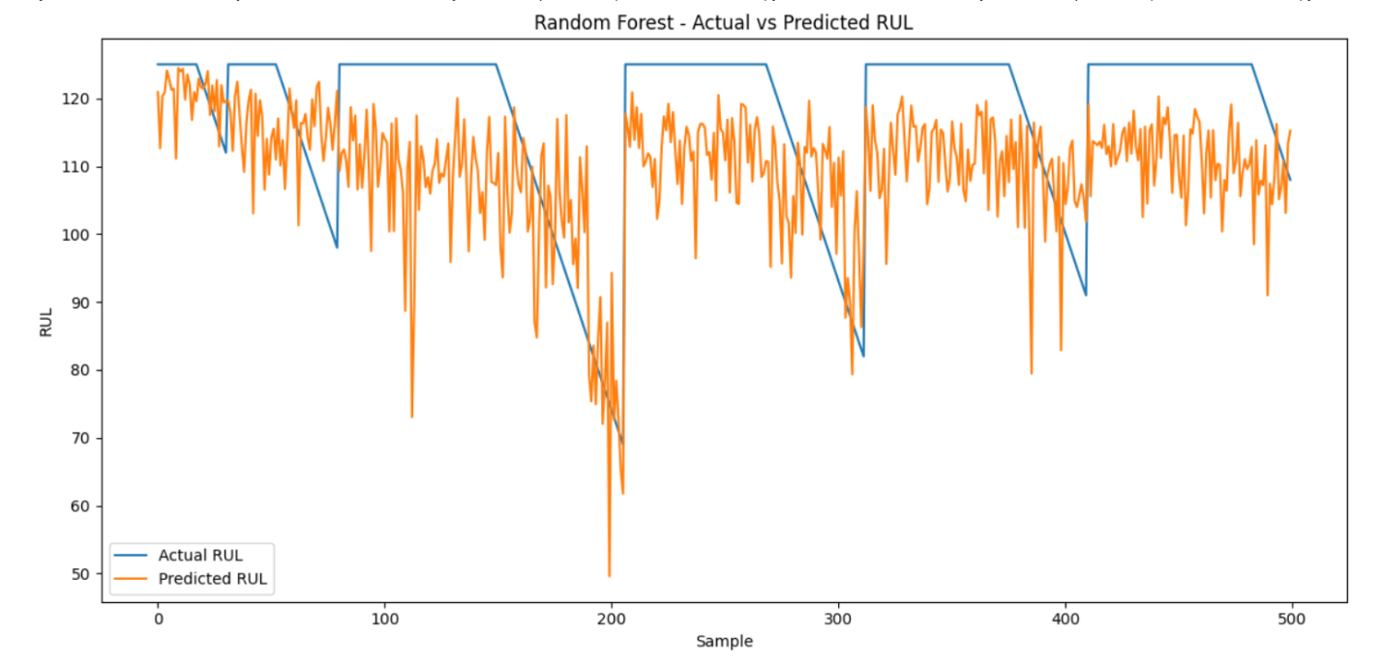
Figure 2: Actual RUL Vs Predicted RUL by the Random Forest model.
Figure 2. Compares the actual RUL values with those predicted by the Random Forest model. Predictions close to the diagonal reference line indicate greater agreement between predicted and actual RUL. The dispersion of points around the line illustrates the prediction errors that are not fully represented by the aggregate evaluation metrics. The Random Forest model achieved an MAE of 12.5250 cycles, RMSE of 17.4180 cycles and R² of 0.6011.

5.4 Random Forest Feature Importance
The assessment of feature significance was carried out in order to see which input feature made the most important contributions to the Random Forest prediction model. The analysis demonstrated that sensor_11 influenced the result the most, due to the importance coefficient of 0.571156, or approximately 57.1% of the whole importance score.
Sensor_9 was the second most contributing feature with its importance coefficient of 0.137370. Among the other key variables of importance were sensor_4 with importance of 0.072154, and sensor_12 with importance of 0.044526. There were also several other input features that impacted the predictions.
On the contrary, sensor_6 had the lowest importance coefficient of 0.000038 being the least impactful factor in the Random Forest modeling regime.
The conclusions drawn from the data imply that the model relies only on specific sensor data while providing its estimates, which could mean that some sensor metrics have higher predictive power.
Feature importance does not mean that any specific sensor causes engine degradation, but simply shows the level of contribution of the feature into the prediction result.
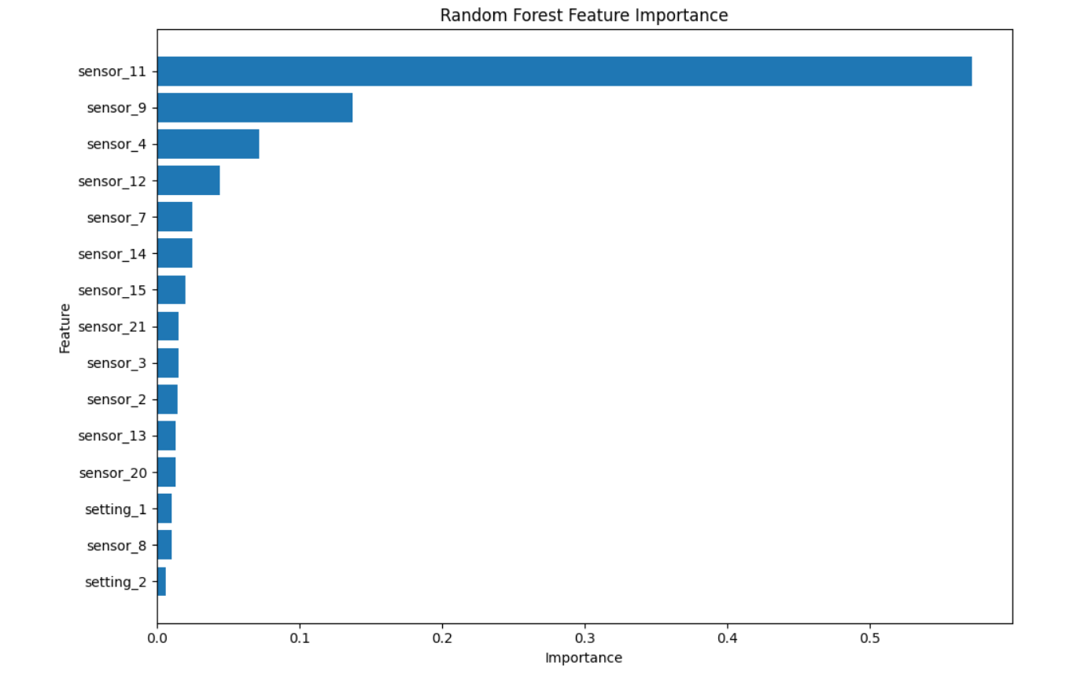
Figure 3: Feature-importance scores by the Random Forest model
Figure 3. presents the feature-importance scores generated by the Random Forest model. Sensor_11 was the most influential variable, with an importance score of 0.571156, followed by sensor_9, sensor_4 and sensor_12. Sensor_6 had the lowest importance. These results indicate that the Random Forest model relied more heavily on certain sensor measurements when estimating RUL. Feature importance should be interpreted as predictive contribution rather than evidence that a particular sensor causes engine degradation.

5.5 XGBoost Results
The mean absolute error (MAE) of the XGBoost model was 12.2332 cycles, showing slightly better results than the Random Forest model that had MAE of 12.5250 cycles. The root mean square error (RMSE) of the XGBoost model was 17.4143 cycles, which is basically equal to the RMSE of the Random Forest model, which was 17.4180 cycles. The coefficient of determination (R²) value was 0.6013 for the XGBoost model, while that of the Random
Based on the obtained MAE, RMSE and R² values, XGBoost performed a little bit better than Random Forest. However, the advantage enjoyed by the comparison is not quite significant. Both values are extremely similar in the case of R² and RMSE, indicating that the two models behave almost equally under the given experimental condition.
However, things have changed in the analysis of the PHM08 dataset. The XGBoost result, which is valued at 231,988.13, is higher than the result from the random forest algorithm, 190,859.91. What should be noted is that in this case, the higher the number, the worse it is.The outcome being mentioned is of great significance, as it illustrates how one cannot rely on one performance measure. Although XGBoost did show lower average prediction errors according to MAE and RMSE, it turned out
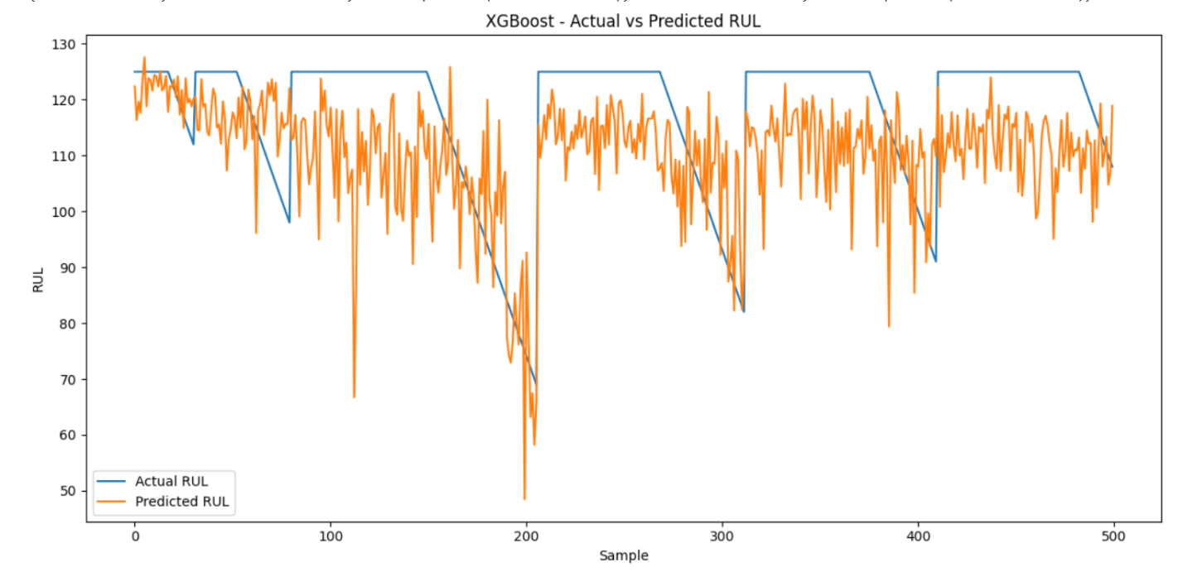
Figure 4: Actual versus predicted RUL values for the XGBoost model
Figure 4. Compares the actual RUL values with the RUL values predicted by XGBoost. The distribution of points around the diagonal reference line provides a visual indication of prediction accuracy. XGBoost achieved an MAE of 12.2332 cycles, RMSE of 17.4143 cycles and R² of 0.6013, representing a slight improvement over Random Forest for these conventional regression measures.

5.6 LSTM Training Results
The LSTM model underwent training through the analysis of the sequences made up of 30 consecutive operating cycles. The training data set was made up of 14207 sequences while the validation data set consisted of 3524 sequences. The testing data set comprised 10196 sequences.
Training outcome shows a clear trend of reduction in error within the first few epochs of training. For instance, the validation MAE for epoch 1 was 41.0021; for epoch 2 it reduced to 16.4286, while in epoch 3, it was 12.8818. By the time of epoch 11, the validation MAE was 10.8605. Later, both the validation loss and MAE experienced fluctuations. As an illustration, validation MAE rose to 12.3690 during epoch 16 but dropped again to 11.9631 during epoch 19. For this reason, the training process applied early stopping strategy on the basis of the validation loss value and used eight epochs of patience together with restoration of weights of the best model.
The motivation for using CPU for the LSTM training was due to the unavailability of Windows GPU support, as reported by TensorFlow environment. While it considerably affected the time of computing execution, it did not prevent training and testing of the given model.
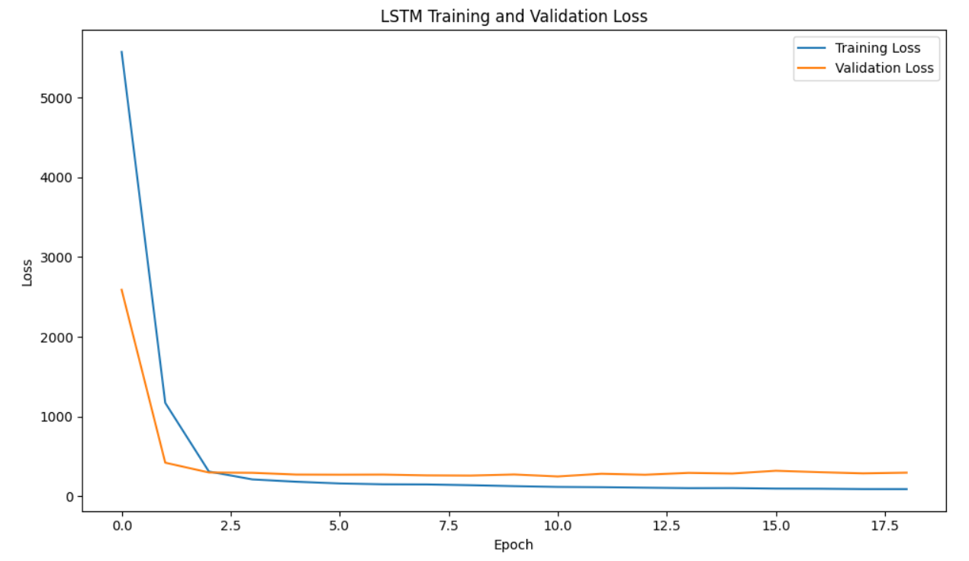
Figure 5: The training and validation loss of the LSTM model across the training epochs.
Figure 5. Illustrates the training and validation loss of the LSTM model across the training epochs. The loss decreased substantially during the early stages of training, indicating that the model progressively learned the relationship between sequences of engine sensor observations and RUL. Later fluctuations in validation performance motivated the use of early stopping, with the best model weights restored according to validation loss.

5.7 LSTM Test Results
The LSTM performed the best of the three models in terms of the test results. Its MAE was 10.7976, which is the lowest one in the experiment. The LSTM had an RMSE of 15.9693 again the lowest.
The R² value of the LSTM was 0.7114, which is quite superior to the values of 0.601 for Random Forest and XGBoost, thereby showing that LSTM accounted for significantly more variation in the test RUL values under the conduct of this experiment.
For the LSTM, the value obtained for PHM08 was 72,247.63, which is significantly lower than the values obtained for the two tree-based models. For instance, the value obtained for the random forest model was 190,859.91, whereas that for the XGBoost was 231,988.13. The low LSTM value in this scenario translates to low prediction errors. So the results give again confirming evidence in favor of the LSTM method in the selected experimental paradigm.

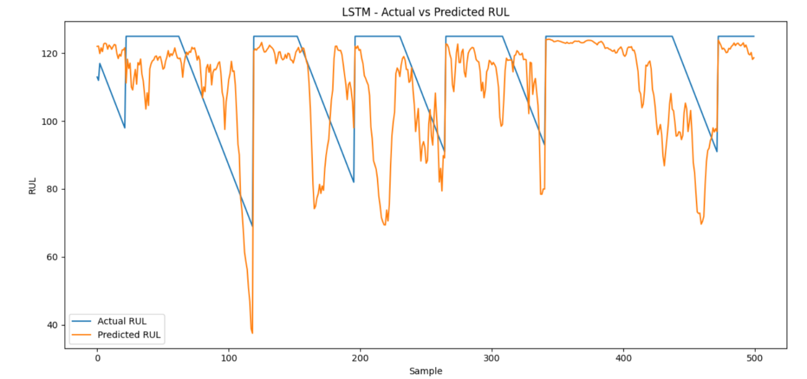
Figure 6: Actual versus predicted RUL values for the LSTM model
Figure 6. Presents the relationship between actual and predicted RUL values generated by the LSTM model on the test sequences. A closer concentration of observations around the diagonal indicates stronger agreement between predicted and actual RUL. The LSTM achieved an MAE of 10.7976 cycles, RMSE of 15.9693 cycles and R² of 0.7114, representing the strongest overall performance among the three models.

5.8 Comparative Model Evaluation
Table 5.1: Comparison of RUL Prediction Models
Model | MAE | RMSE | R² | PHM08
Random Forest | 12.5250 | 17.4180 | 0.6011 | 190,859.91
XGBoost | 12.2332 | 17.4143 | 0.6013 | 231,988.13
LSTM | 10.7976 | 15.9693 | 0.7114 | 72,247.63
The LSTM reduced MAE by approximately 13.8% compared with Random Forest and approximately 11.7% compared with XGBoost. Its RMSE was approximately 8.3% lower than the two tree-based models. The difference in R² was also notable, with LSTM achieving 0.7114 compared with approximately 0.601 for both tree-based approaches.
The results support the argument that modelling sequential information can be beneficial for aircraft-engine RUL prediction. Random Forest and XGBoost process individual observations, whereas LSTM receives a sequence of 30 cycles. Consequently, LSTM has the opportunity to learn temporal relationships and degradation patterns that are not explicitly represented in the cycle-level tree-model inputs.
However, a particular point of difference needs to be mentioned in relation to the comparison of the methods. Both Random Forest and XGBoost were tested on the whole 13,096 data points, while only 10,196 LSTM forecasted sequences were available because the method required a 30-step input sequence to make each forecast. Thus, the models were not compared with the same number of forecasts. However, the outcomes are informative as an experimental benchmark of methods.
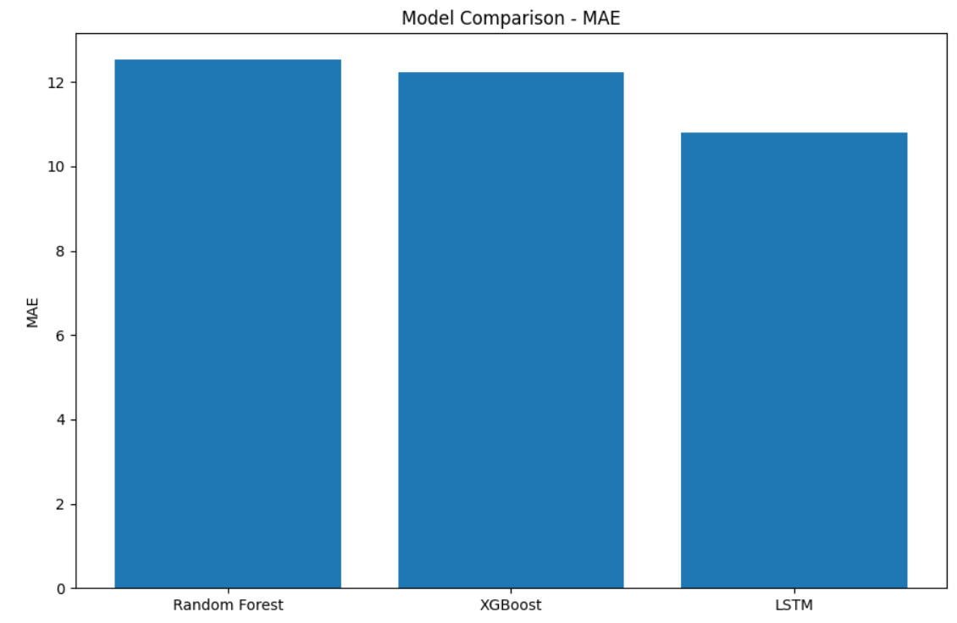
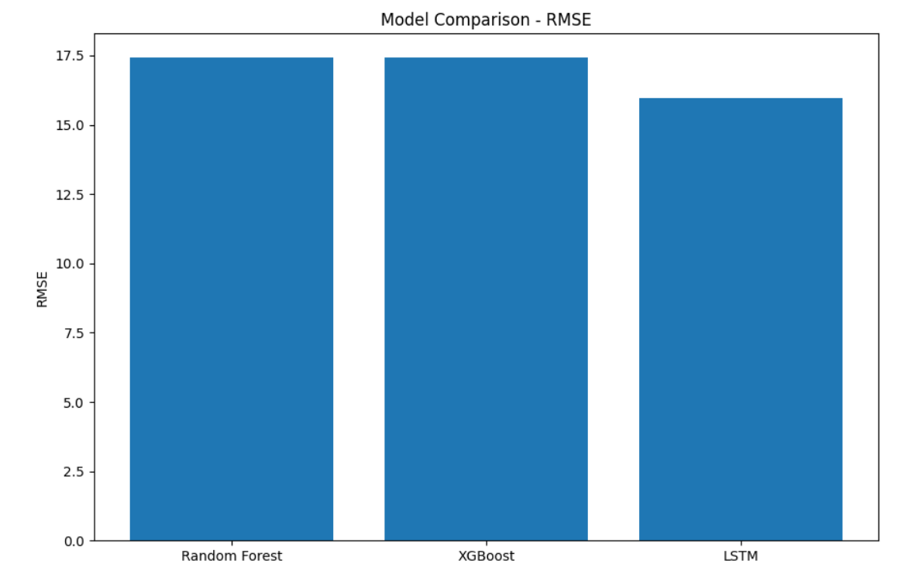
Figure 7: Comparison of MAE and RMSE across the three RUL prediction models
Figure 7 presents the MAE and RMSE values attained by using Random Forest, XGBoost, and LSTM. The lower the value is, the smaller the error is. The RMSE value of the LSTM model is lower compared to those of both tree-based algorithms, which means that the LSTM model has higher predictive accuracy. The MAE of the LSTM model is about 13.8% and 11.7% lower than those of Random Forest and XGBoost, respectively.
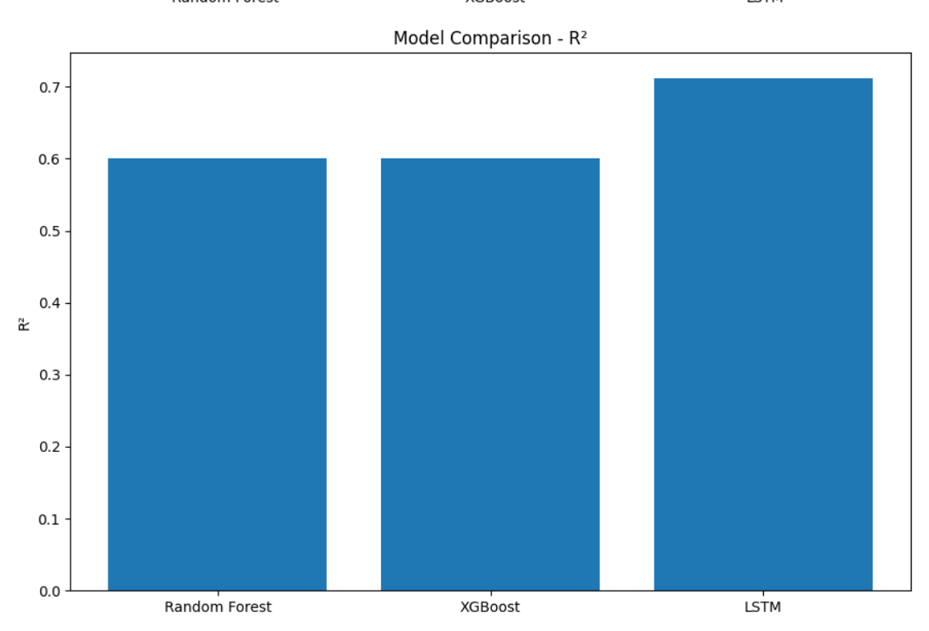
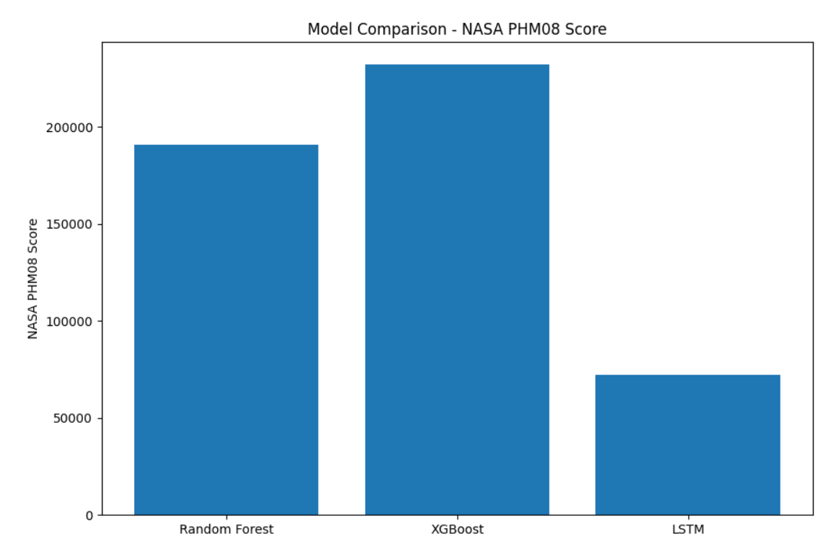
Figure 8: Comparison of R² and NASA PHM08 scores across the three models
Figure 8. Shows the comparison between the coefficient of determination (R²) and the NASA PHM08 score for the three models. The LSTM model provided the best R² score of 0.7114 followed by Random Forest of 0.6011 and XGBoost of 0.6013. The PHM08 score is lowest for the LSTM model of 72,247.63 compared to Random Forest's 190,859.91 and XGBoost's 231,988.13. Considering the fact that the lower the PHM08 score, the better the performance of the model, this proves the higher performance of the LSTM model.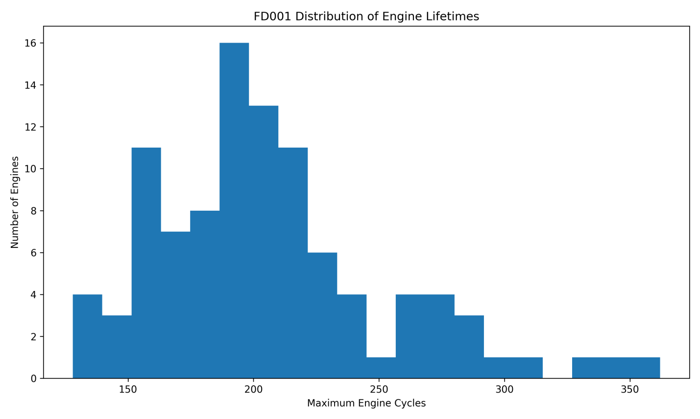
Figure 9: Distribution of Maximum Engine Lifetimes in the FD001 Training
The maximum engine lifetimes found in the NASA C-MAPPS FD001 training dataset are illustrated in Figure 9. The histogram shows there is a wide variation in engine lifetime, as most engines fail somewhere in the range of 150-230 cycles, while an insignificant few, show a significantly longer life than 300 cycles. The results imply that engines operate until failure after different number of cycles. This phenomenon is critical for the estimation of RUL, since the models have to be trained to understand how the degradation takes place in engines with different duration of operation. The analysis also lays a foundation for the assessment of the dataset variability before the models are built.
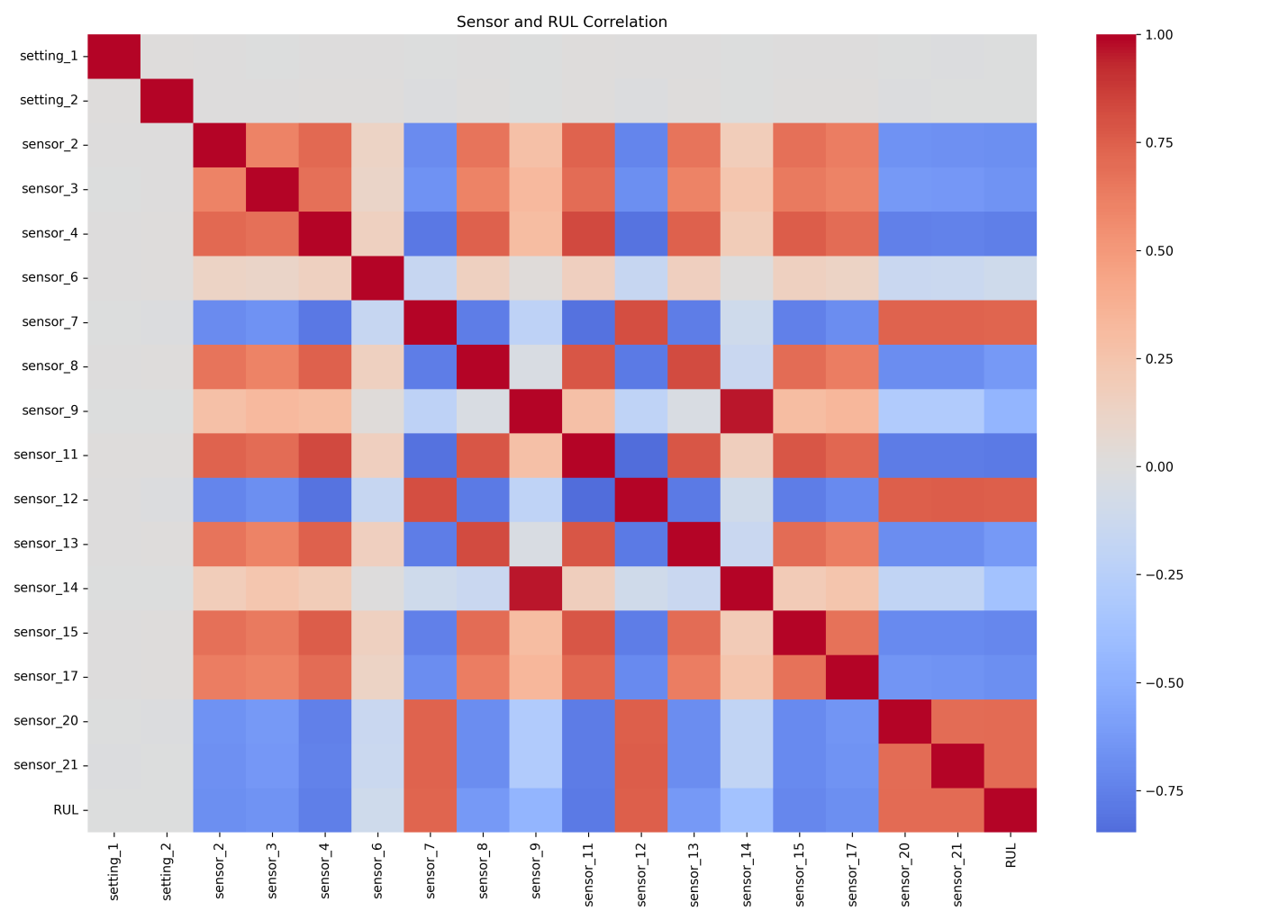
Figure 10. Correlation Between Sensor Variables and Remaining Useful Life
The relationship between engine sensor readings and Remaining Useful Life (RUL) has been illustrated using the heat map shown in Figure 5.10. The heat map has indicated that different sensors exhibit varying associations with RUL. While some sensors, particularly sensor_7, sensor_12, sensor_20 and sensor_21 have pronounced negative relationships with RUL, others including sensor_2, sensor_3, sensor_4, sensor_8, sensor_11, sensor_13, sensor_15 and sensor_17 display positive relationships. Thus shows that the measurements taken from sensors do not convey similar information about the degradation in the engine. Therefore applying correlation analysis proved useful as the preliminary step to learn the relationship between the predictors and the RUL without however relying on correlation alone to make a final decision concerning the feature set selection.

Chapter 6: Discussion

6.1 Introduction
This chapter contextualizes the outcomes of Chapter 5 in relation to the goals, objectives, and research questions of the study. The research focused on applying machine learning to forecast the Remaining Useful Life (RUL) of aircraft engines using the NASA C-MAPSS FD001 data set. In the experiments, all three models – Random Forest, XGBoost, and Long Short-Term Memory (LSTM) were implemented in a unified manner, and the assessment was made by MAE, RMSE, R², and NASA PHM08 metrics.
The key finding is that the LSTM algorithm provided the best overall performance, with an MAE of 10.7976 cycles, RMSE of 15.9693 cycles, R² of 0.7114, and PHM08 metric of 72,247.63. At the same time, the overall performance of the Random Forest and XGBoost algorithms was inferior. However, XGBoost had a slightly lower MAE, RMSE, and a slightly higher R² compared to Random Forest. Overall, these results suggest that the use of temporal information can be helpful when predicting the RUL of the engine in the FD001 experiment.

6.2 Interpretation of the Overall Results
From the results, there is a marked difference in performance between the sequence-based LSTM and the two cycle-level ensemble methods. The Random Forest method performed at an MAE of 12.5250 cycles and XGBoost at 12.2332 cycles. LSTM, on the other hand, improved the MAE from Random Forest by 13.8% and by 11.7% from XGBoost to 10.7976 cycles.
The similar trend was experienced in the RMSE, where the Random Forest method performed at 17.4180 cycles and XGBoost at 17.4143 cycles, with LSTM performing at 15.9693 cycles. The 8.3% improvement in RMSE implies that, apart from lowering the MAE, LSTM also reduces the large errors in prediction.
The difference in R² is also important. Random Forest and XGBoost achieved values of 0.6011 and 0.6013 respectively, whereas LSTM achieved 0.7114. This indicates that the LSTM explained substantially more of the variation in the RUL target under the experimental conditions. Therefore, the improvement was not restricted to one particular error metric.
The PHM08 results provide further support for the LSTM. Its score of 72,247.63 was substantially lower than the Random Forest score of 190,859.91 and the XGBoost score of 231,988.13. Since the PHM08 metric applies asymmetric penalties to prediction errors, this result suggests that the LSTM produced a more favourable pattern of prediction errors for the prognostic objective.

6.3 Discussion of Random Forest Performance
The Random Forest provides a standard machine learning benchmark. With the MAE of 12.5250 cycles and an R² of 0.6011, it shows that nonlinear dependencies between the values of the sensors and the RUL can be captured without the need to construct temporal sequences explicitly.
One possible reason why the Random Forest performs worse compared to the LSTM is the manner of presenting the input data. The model was trained on individual samples corresponding to each cycle rather than on a sequence of the previous states of the engine. Therefore, even though the model can capture complex nonlinear dependencies between the values of the sensors and the RUL, the temporal degradation pattern is not explicitly included.
The feature-importance results provide additional insight into the Random Forest model. sensor_11 was the dominant feature, with an importance of approximately 0.571, followed by sensor_9 and sensor_4. This suggests that the model relied strongly on particular sensor measurements when estimating RUL.
However, this concentration of feature importance should be interpreted carefully. A high feature-importance value does not mean that the sensor independently causes engine degradation. Instead, it indicates that the variable was particularly useful to the Random Forest prediction process under the available data and model configuration.

6.4 Discussion of XGBoost Performance
XGBoost produced a slightly better result than Random Forest for three conventional regression metrics. Its MAE was 12.2332 compared with 12.5250 for Random Forest, while RMSE was 17.4143 compared with 17.4180. The R² values were also extremely similar, at 0.6013 and 0.6011 respectively.
These results suggest that the two tree-based models performed similarly in terms of general regression accuracy. XGBoost's boosting mechanism allowed it to sequentially construct an ensemble of decision trees, potentially improving the fit to nonlinear relationships in the sensor data.
However, the PHM08 result was different. XGBoost produced a score of 231,988.13, which was higher than Random Forest's 190,859.91. This demonstrates that the model producing a slightly lower MAE does not necessarily produce the best prognostic error profile under an asymmetric scoring function.
This finding is relevant to predictive maintenance because average prediction accuracy alone may not fully represent the practical value of an RUL model. The consequences of different prediction errors may vary depending on maintenance planning and safety requirements. Therefore, using several complementary metrics provides a more balanced assessment.

6.5 Discussion of LSTM Performance
The LSTM produced the strongest results across all four evaluation measures. The principal methodological difference between LSTM and the two tree-based models was its use of 30-cycle sequences. Instead of considering each engine observation independently, the LSTM received a sequence of consecutive sensor measurements.
This design provides the model with information about how an engine's condition changes over time. Aircraft-engine degradation is inherently a temporal process, and the condition observed at one cycle may be related to measurements observed during previous cycles. The ability of LSTM networks to retain information from previous time steps therefore provides a potential advantage for prognostic applications.
This is borne out by the training results. Mean Absolute Error for validation has fallen rapidly during the early training stages, from 41.0021 in epoch one to 16.4286 in epoch two and 12.8818 in epoch three. The reported validation mean absolute error at epoch 11 is 10.8605. While the subsequent validation results have shown some fluctuation, early stopping based on validation loss has been used in order to prevent overtraining.
The final LSTM test MAE of 10.7976 was lower than the validation MAE observed at several training stages. This demonstrates that the trained sequence model generalised effectively to the test sequences within this experimental setting.
The result is consistent with the broader direction of recent RUL research, where recurrent neural networks and more advanced temporal architectures are increasingly used to model degradation sequences. Recent studies have also investigated attention-based LSTM, Transformer and hybrid approaches for aircraft-engine prognostics. However, the present study deliberately focuses on a standard LSTM rather than assuming that a more complex architecture is automatically necessary.

6.6 Comparative Analysis of the Models
The comparative evaluation of Random Forest, XGBoost and LSTM highlights differences in both predictive performance and data representation. Random Forest achieved an MAE of 12.5250 cycles, an RMSE of 17.4180 cycles and an R² of 0.6011. XGBoost produced slightly better conventional regression results, with an MAE of 12.2332 cycles, RMSE of 17.4143 cycles and R² of 0.6013. The relatively small differences between these two models indicate that their predictive behaviour was broadly similar under the selected FD001 experimental conditions.
LSTM produced more substantial improvements, achieving an MAE of 10.7976 cycles, RMSE of 15.9693 cycles and R² of 0.7114. Compared with Random Forest, the LSTM reduced MAE by approximately 13.8% and RMSE by approximately 8.3%. Its higher R² also indicates that a greater proportion of the variation in the RUL target was captured.
One possible explanation is the use of 30-cycle sequences as input. Unlike the tree-based models, LSTM could incorporate information from previous engine cycles when generating an RUL prediction. This temporal capability is particularly relevant to degradation modelling, where current engine condition can be related to its previous operating states (Hochreiter and Schmidhuber, 1997).
The NASA PHM08 results provide another dimension to the comparison. LSTM obtained a score of 72,247.63, compared with 190,859.91 for Random Forest and 231,988.13 for XGBoost. This demonstrates that similar conventional regression performance does not necessarily result in similar prognostic scoring outcomes. The asymmetric nature of the PHM08 metric makes it useful for examining the pattern and direction of prediction errors in addition to their average magnitude.
Nevertheless, the comparison has an important methodological limitation. Random Forest and XGBoost generated 13,096 predictions, whereas LSTM generated 10,196 because each prediction required a 30-cycle sequence. Therefore, the results should be interpreted as a controlled comparison within the implemented framework rather than a perfectly identical sample-level comparison. Overall, the findings suggest that temporal sequence modelling was beneficial for RUL prediction in the FD001 setting, while the tree-based models provided competitive and comparatively simpler alternatives.

6.7 Implications for Predictive Maintenance
The findings have significant practical implications since the RUL prediction can indicate the expected remaining lifetime of the aircraft engine. An RUL-based predictive maintenance approach can help maintenance teams locate engines that require special attention. Instead of relying solely on fixed intervals, companies can leverage condition data in planning maintenance activities.
The most successful implementation of LSTM indicates that temporal information can be of great value in this case. An engine does not usually change between failures and functioning states without any previous transformations. With the changes in degradation, the sensor data change as well, and the model based on the sequences of events can identify the changes in degradation process. Therefore, a model utilizing historical data may understand the behavior of an engine.
Possible advantages entail improvement of maintenance prioritization, better resource allocation in maintenance and minimization of uncertainty in useful operational life expectancy. For example, if the engine is forecasted as having low remaining useful life, maintenance team could take close look at the particular operating unit and prepare the necessary resources. On the contrary, in case of engines with high remaining useful life, prioritization intervention will depend on the requirements of applicable engineering and safety regulations.
Anyhow, the presented findings do not prove applicability of LSTM-based solution for independent maintenance decisions. The aircraft maintenance process is vital from safety perspective, as RUL forecast can be useful only in terms of decision-making support, but not a directive for maintenance. Thus, the model under development needs much validation before practical application as it should be tested with data of working aircrafts and the uncertainty of forecasted results should be assessed, while the model needs to be controlled and fitted into existing engineering procedures.
Besides, usage of simulated dataset also restricts applicability of the findings. In reality, the conditions of aircraft engines could involve sensor failures, absent observations, environmental changes and maintenance that would not appear in the FD001 dataset.

6.8 Critical Evaluation of the Experimental Comparison
A major strength of this research is that it assessed the three models under consideration using a common dataset and an identical set of performance parameters, which generates a controlled experimental environment in which the performances of Random Forest, XGBoost, and LSTM model can be evaluated. Additionally, the use of conventional ensemble models, as well as recurrent neural networks, offers methodological diversity.
However, the comparison faces several methodological issues. The major problem here is the dissimilarity between the amounts of predictions generated by the models. For example, while Random Forest and XGBoost models generated their predictions for 13,096 points of data, the LSTM model generated only 10,196 predictions as each prediction required a 30-cycle sequence. Hence, these models were not evaluated with the same number of prediction points. Despite the efficiency of the conducted analysis, the results reflect comparative efficiency rather than perfectly matching sample-to-sample performance.
Another problem resides in the use of only a portion of C-MAPSS. Although FD001 is an excellent base of study for RUL forecasting, it deals with a regulated degradation process. Other segments of C-MAPSS present diverse operation modes and failure patterns. Therefore, the model which is effective for this particular case may not perform efficiently.
The configurations of the models implemented in the experiments affect the conclusions made. Random Forest, XGBoost, and LSTM have many hyperparameter combinations. The configurations used for the research were good enough for achieving research goals, yet they are not representative of all model configurations. Therefore, the results should be used only as evidence concerning the models used, but not as proof of the highest potential of these modeling techniques.
Thus, the conducted experiments provide reasonable evidence demonstrating that temporal sequence modeling improves RUL forecasting under FD001 conditions, while also indicating the importance of appropriate evaluation of the models used with respect to the dataset properties, input representation, prediction scope, and evaluation practices.

6.9 Answer to the Research Questions
The first research question asked how effectively Random Forest, XGBoost and LSTM could predict aircraft-engine RUL using FD001. The results show that all three models were capable of learning useful relationships between the available engine measurements and RUL. However, their predictive performance differed, with LSTM producing the lowest errors.
The second research question asked which model provided the strongest performance under the proposed framework. LSTM was the strongest overall model because it achieved the best MAE, RMSE, R² and PHM08 results.
The third research question concerned the practical implications and limitations of applying these approaches to predictive maintenance. The findings indicate that sequence-based machine learning has potential to support maintenance planning through improved RUL estimation. Nevertheless, real-world deployment would require validation using operational aircraft data, consideration of uncertainty, and integration with maintenance processes and compliance with aviation safety requirements.
RQ1: How effectively can Random Forest, XGBoost and LSTM predict aircraft-engine RUL using FD001?
All three models were able to predict RUL from the available engine measurements. Random Forest achieved an MAE of 12.5250 cycles, while XGBoost achieved 12.2332 cycles. LSTM achieved a lower MAE of 10.7976 cycles.
The results therefore demonstrate that machine learning can extract useful information from the FD001 sensor data. However, the different levels of performance indicate that the representation of temporal information is important for this prediction problem.
RQ2: Which model gives the strongest performance under this framework?
LSTM provided the strongest overall performance. It achieved the lowest MAE, lowest RMSE, highest R² and lowest PHM08 score.
The result suggests that the ability to process sequential observations was beneficial for RUL estimation in the FD001 dataset. However, this conclusion is specific to the selected dataset, sequence length, preprocessing procedure and model configuration.
RQ3: What practical implications and limitations arise for aircraft-engine predictive maintenance?
The findings indicate that RUL prediction can potentially support predictive-maintenance planning by providing information about expected remaining operating life. A reliable prediction system could potentially help maintenance organizations move from purely schedule-based decisions towards condition-informed planning.
Nevertheless, aircraft maintenance is a safety-critical activity. A machine-learning prediction should therefore be treated as decision-support information rather than an autonomous maintenance instruction. Real-world deployment would require extensive validation, uncertainty assessment, engineering oversight and compliance with applicable aviation requirements.

6.10 Overall Contribution and Implications
The main contribution of the paper is in the experimental testing of Random Forest, XGBoost, and LSTM models' performance on the task of estimating the RUL of aircraft engines with the use of the NASA C-MAPSS FD001 dataset under the same conditions of prognostics-and-health-management (PHM). Models are compared based on MAE, RMSE, R², and NASA PHM08 scoring and thus give the opportunity to test the difference in the performance of conventional machine learning models and sequence-based deep learning approaches in a controlled experimental setting.
The second contribution of the paper is in the analysis of alternative approaches to sensors representation. Both Random Forest and XGBoost are based on the use of feature vectors that are generated based on a single cycle of an engine, while the LSTM is based on the processing of sequences that consist of 30 consecutive cycles. Such difference is important, since engine deterioration process takes place with time, which means that information about time can be helpful in terms of prediction.
The study additionally highlights the need to assess the RUL prediction performance in conjunction with complementary measures. In particular, the XGBoost method provided slightly smaller MAE and RMSE scores and larger R-squared (R²) value compared to Random Forest but showed a higher PHM08 score. The difference between these metrics suggests that regression-based metrics of accuracy and PHM08 scoring provide distinct assessments of the model behavior.
From the predictive maintenance point of view, the RUL predictions could be helpful for decision-making about maintenance scheduling, inspections, and resources. Nevertheless, in the current analysis, there are no historical records on the maintenance interventions, cost of downtime, expenses on spare parts replacement, or operational information of the airline. Thus, the obtained results reflect the predictive power in terms of benchmark dataset rather than a decrease in maintenance cost in reality.
In general, the technical contribution of the study includes creating an experimental framework for preparing C-MAPSS FD001 dataset, generating RUL targets, training three types of models, and assessing their performance via complementary metrics. The framework can be expanded to include more C-MAPSS subsets, different sequence length, uncertainty-aware predictions, etc.

Chapter 7: Conclusion and Recommendations

7.1 Introduction
The current dissertation aims to investigate the use of machine learning techniques for predictive maintenance in the aerospace industry, specifically remaining useful life prediction of aircraft engines. In this regard, the performance of three different machine learning algorithms is assessed: Random Forest, XGBoost, and LSTM. The choice of dataset used for experimental analysis is the NASA C-MAPSS FD001 dataset due to its suitability for prognostic analysis.
The overall aim of the research was to develop and evaluate a machine-learning framework for predicting aircraft-engine RUL through a controlled comparison of Random Forest, XGBoost and LSTM models. The study used a consistent preprocessing strategy, an engine-level training and validation split, feature normalization and four evaluation metrics: MAE, RMSE, R² and NASA PHM08.
The results demonstrated that all three approaches were capable of learning useful relationships between engine sensor measurements and RUL. Nevertheless, Long Short-Term Memory (LSTM) showed the best overall results under the experimental settings. The conclusion chapter is an overview of the main results, answers to research aims and questions, contributions of the research, limitations of the research, and suggestions for future research directions.

7.2 Practical Implications
From a predictive-maintenance perspective, the findings support the potential value of machine-learning-based RUL estimation. Rather than considering all engines equally, an RUL prediction system could potentially provide maintenance teams with an estimate of which engines are closer to degradation or failure.
Such information could contribute to maintenance planning, inspection prioritisation and resource allocation. It could also potentially reduce unnecessary maintenance when equipment remains in an acceptable condition.
However, these benefits cannot be assumed directly from the FD001 results. C-MAPSS is a simulated benchmark dataset and does not capture every factor associated with operational aircraft engines. Therefore, the findings demonstrate technical potential rather than a validated operational solution.

7.3 Limitations of the Study
Several limitations should be acknowledged.
First, the research was restricted to the NASA C-MAPSS FD001 dataset. FD001 represents a controlled degradation scenario and does not represent the full range of operating conditions and failure modes that may occur in real aircraft engines.
Secondly, the data set applied in this study is artificial. In reality, there might be missing values in data related to aircraft engines. There will also be noise, different operating conditions, interventions, and other factors.
Thirdly, the analysis was conducted using only three types of models. While Random Forest, XGBoost, and LSTM provide good methodological diversity, there are more recent techniques like Transformers, attentional neural nets, and combinations that have not been considered in the study.
Lastly, the number of test samples was different for the models. The number of test samples was 13,096 in case of Random Forest and XGBoost, while in case of the LSTM model it was 10,196, since the model needed 30 steps.
Finally, the study did not incorporate prediction uncertainty. In safety-critical predictive maintenance, a confidence estimate around an RUL prediction may be as important as the predicted value itself.

7.4 Recommendations for Future Research
Future research should first evaluate the models on additional C-MAPSS subsets, including datasets involving different operating conditions and fault modes. This would provide stronger evidence regarding model generalization.
Second, future studies could compare the LSTM model with attention-based LSTM, Transformer and hybrid architectures. Such comparisons could determine whether more advanced temporal models provide meaningful improvements over the standard LSTM.
Third, uncertainty estimation should be incorporated into future RUL models. Instead of producing only a single RUL value, the system could provide a prediction interval or probability distribution. This would give maintenance engineers additional information about prediction confidence.
Fourth, future research should investigate real aircraft-engine datasets. Testing the models against operational data would help determine whether the performance observed on C-MAPSS transfers to real maintenance environments.
Finally, future work could connect RUL prediction directly with maintenance decision-making. Rather than evaluating prediction accuracy alone, researchers could investigate whether improved RUL estimates reduce maintenance cost, improve fleet availability or support better scheduling decisions.

7.5 Final Conclusion
This dissertation investigated machine learning for aircraft-engine predictive maintenance through RUL prediction using NASA C-MAPSS FD001. Random Forest, XGBoost and LSTM were implemented within a consistent experimental framework and evaluated using MAE, RMSE, R² and NASA PHM08.
From the results, it can be deduced that the three methods provided a good estimate of RUL. For example, the MAE for the Random Forest method is 12.5250 cycles while the XGBoost method provided a MAE of 12.2332 cycles. On the other hand, the best-performing method was the LSTM, providing MAE and RMSE of 10.7976 and 15.9693 cycles respectively. Additionally, the LSTM had the highest value of R2, which was 0.7114, and the PHM08 score was 72,247.63
The findings suggest that explicitly modeling temporal sequences can provide an advantage for aircraft-engine RUL prediction under the FD001 experimental conditions. The improvement achieved by LSTM supports the importance of considering the sequential nature of engine degradation rather than relying exclusively on individual cycle-level observations.
At the same time, the study does not claim that the LSTM model is universally superior or ready for direct aircraft-maintenance deployment. The conclusions are limited by the use of one simulated dataset, the selected model configurations and the difference in test prediction counts between sequence-based and tabular approaches.
Overall, the research demonstrates that machine learning, particularly sequence-based modeling, has potential to contribute to aircraft predictive maintenance through improved RUL estimation. Future research using broader datasets, uncertainty-aware methods, advanced temporal architectures and real operational aircraft data would be necessary before such systems could be considered for practical safety-critical deployment.

References
Asif, O., Haider, S.A., Naqvi, S.R., Zaki, J.F.W., Kwak, K.-S. and Islam, S.M.R. (2022), ‘A deep learning model for remaining useful life prediction of aircraft turbofan engine on C-MAPSS dataset’, IEEE Access.
Breiman, L. (2001), ‘Random forests’, Machine Learning, 45(1), pp. 5–32. doi:10.1023/A:1010933404324.
Chen, X. (2024), ‘A novel transformer-based DL model enhanced by position-sensitive attention and gated hierarchical LSTM for aero-engine RUL prediction’, Scientific Reports, 14, 10061.
Cheng, R., Li, X., Wang, L., Wang, C., Ma, X., Miao, B. and Xu, D. (2024), ‘A method for predicting remaining useful life using enhanced Savitzky–Golay filter and improved deep learning framework’, Scientific Reports, 14, 23983.
Darwish, A., Sallam, K.M. and Alrashdi, I. (2025), ‘An attention-based deep learning model for remaining useful life prediction of aero-engine’, Sustainable Machine Intelligence Journal, 11, pp. 80–94. doi:10.61356/SMIJ.2025.11554.
Deepika, J., Reddy, P.M., Murari, K. and Rahul, B. (2025), ‘Predictive maintenance of aircraft engines: machine learning approaches for remaining useful life estimation’, in 2025 6th International Conference on Mobile Computing and Sustainable Informatics (ICMCSI). Goathgaun, Nepal: IEEE, pp. 1679–1686. doi:10.1109/ICMCSI64620.2025.10883526.
Dida, M., Cheriet, A. and Belhadj, M. (2025), ‘Remaining useful life prediction using Attention-LSTM neural network of aircraft engines’, International Journal of Prognostics and Health Management, 16(2). doi:10.36001/ijphm.2025.v16i2.4274.
Elsherif, S.M., Hafiz, B., Makhlouf, M.A. and Farouk, O. (2025), ‘A deep learning-based prognostic approach for predicting turbofan engine degradation and remaining useful life’, Scientific Reports, 15, 26251. doi:10.1038/s41598-025-09155-z.
He, G.Y. (2025), ‘A multi-model stacked ensemble architecture with Bayesian optimization: Advancing remaining useful life estimation in aircraft engines’, Measurement, 248, 120199. doi:10.1016/j.measurement.2025.120199.
Hochreiter, S. and Schmidhuber, J. (1997), ‘Long short-term memory’, Neural Computation, 9(8), pp. 1735–1780.
Isbilen, F., Bektas, O. and Konar, M. (2025), ‘Deep learning and similarity-based models for predicting turbofan engine remaining useful life: insights from the C-MAPSS dataset’, The Aeronautical Journal, 129(1337), pp. 2004–2035. doi:10.1017/aer.2025.25.
Karatzinis, G.D., Boutalis, Y.S. and Van Vaerenbergh, S. (2024), ‘Aircraft engine remaining useful life prediction: A comparison study of Kernel Adaptive Filtering architectures’, Mechanical Systems and Signal Processing, 218, 111551. doi:10.1016/j.ymssp.2024.111551.
Kim, M.-J. and Lee, K.-W. (2025), ‘Deep learning-based non-linear prediction of remaining useful life of aircraft engines’, The Transactions of the Korea Information Processing Society, 14(12), pp. 1097–1104. doi:10.3745/TKIPS.2025.14.12.1097.
Niu, T., Xu, Z., Luo, H. et al. (2025), ‘Hybrid Gaussian process regression with temporal feature extraction for partially interpretable remaining useful life interval prediction in aeroengine prognostics’, Scientific Reports, 15, 11057.
Özcan, H. (2025), ‘Interpretable ensemble remaining useful life prediction enables dynamic maintenance scheduling for aircraft engines’, Scientific Reports, 15, 39795. doi:10.1038/s41598-025-23473-2.
Reimers, N. and Gurevych, I. (2019), ‘Sentence-BERT: Sentence embeddings using Siamese BERT-networks’, in Proceedings of the 2019 Conference on Empirical Methods in Natural Language Processing and the 9th International Joint Conference on Natural Language Processing. Hong Kong: Association for Computational Linguistics, pp. 3982–3992.
Saxena, A. and Goebel, K. (2008), ‘Turbofan engine degradation simulation data set’, NASA Prognostics Data Repository. Moffett Field, CA: NASA Ames Research Center.
Saxena, A., Goebel, K., Simon, D. and Eklund, N. (2008), ‘Damage propagation modeling for aircraft engine run-to-failure simulation’, in Proceedings of the 2008 International Conference on Prognostics and Health Management. Denver, CO: IEEE, pp. 1–9.
Sun, S., Ding, H., Zhao, Z., Zhou, Y., Wang, D. and Xu, W. (2025), ‘Aeroengine remaining useful life prediction via integrating enhanced inverted transformer and spatiotemporal graph learning’, ISA Transactions, 163, pp. 209–221.
Sun, S., Wang, J., Xiao, Y., Peng, J. and Zhou, X. (2024), ‘Few-shot RUL prediction for engines based on CNN-GRU model’, Scientific Reports, 14, 16041.
Xiong, Y., Guo, B. and Dian, S. (2025), ‘Aero-engine remaining useful life prediction using a TCN prognostic model enhanced with dual-dimensional fusion attention’, Measurement Science and Technology, 36(3), 036116. doi:10.1088/1361-6501/adb1d4.
Xue, F., Jin, G., Tan, L., Zhang, C. and Yu, Y. (2025), ‘Predictive maintenance programs for aircraft engines based on remaining useful life prediction’, Scientific Reports, 15, 41756.
Yang, Y., Su, X., Wang, C., Liu, H., Fu, K., Xie, T. et al. (2025), ‘BLTTNet: feature fusion based on BiLSTM-Transformer-TCN for prediction of remaining useful life of aircraft engines’, Scientific Reports, 15, 27696.
Zhu, Z., Wang, L., Chen, M. and Zhao, X. (2025), ‘Predictive maintenance strategies for aero-engines considering remaining useful life prediction interval’, Quality and Reliability Engineering International, 41(8), pp. 3350–3359.
Zheng, S., Ristovski, K., Farahat, A. and Gupta, C. (2017), ‘Long short-term memory network for remaining useful life estimation’, in 2017 IEEE International Conference on Prognostics and Health Management (ICPHM). IEEE, pp. 88–95.
Zhao, R., Yan, R., Chen, Z., Mao, K., Wang, P. and Gao, R.X. (2019), ‘Deep learning and its applications to machine health monitoring’, Mechanical Systems and Signal Processing, 115, pp. 213–237.
Lei, Y., Li, N., Guo, L., Li, N., Yan, T. and Lin, J. (2018), ‘Machinery health prognostics: A systematic review from data acquisition to RUL prediction’, Mechanical Systems and Signal Processing, 104, pp. 799–834.
Si, X.-S., Wang, W., Hu, C.-H. and Zhou, D.-H. (2011), ‘Remaining useful life estimation – A review on the statistical data driven approaches’, European Journal of Operational Research, 213(1), pp. 1–14.
Fink, O., Wang, Q., Svensén, M., Dersin, P., Lee, W.-J. and Ducoffe, M. (2020), ‘Potential, challenges and future directions for deep learning in prognostics and health management’, International Journal of Prognostics and Health Management, 10, pp. 1–36.
Malhotra, P., TV, V., Ramakrishnan, A., Anand, G., Vig, L., Agarwal, P. and Shroff, G. (2016), ‘Multi-sensor prognostics using an unsupervised deep learning framework’, in Proceedings of the 2016 International Conference on Prognostics and Health Management. IEEE.

Appendix

Appendix A – Dataset and Preprocessing Summary
Item | Final Value
Dataset | NASA C-MAPSS FD001
Training observations | 20,631
Testing observations | 13,096
Training engines | 100
Testing engines | 100
Original variables | 26
Constant variables removed | 7
Final predictive features | 17
Missing values | None
RUL cap | 125 cycles
LSTM sequence length | 30 cycles

Appendix B – Final Model Configuration
Model | Final Configuration
Random Forest | 300 trees; maximum depth = 20
XGBoost | 500 estimators; maximum depth = 6; learning rate = 0.05
LSTM | 30-cycle sequences; 64-unit LSTM layer; 32-unit LSTM layer; dropout; dense regression output
LSTM training | Early stopping; patience = 8 epochs; best weights restored

Appendix C – Final Model Performance
Model | MAE | RMSE | R² | NASA/PHM08 Score
Random Forest | 12.5250 | 17.4180 | 0.6011 | 190,859.91
XGBoost | 12.2332 | 17.4143 | 0.6013 | 231,988.13
LSTM | 10.7976 | 15.9693 | 0.7114 | 72,247.63

Appendix D – Supporting Experimental Evidence
Evidence | Result
LSTM training sequences | 14,207
LSTM validation sequences | 3,524
LSTM test sequences | 10,196
Validation MAE – Epoch 1 | 41.0021
Validation MAE – Epoch 2 | 16.4286
Validation MAE – Epoch 3 | 12.8818
Validation MAE – Epoch 11 | 10.8605
Random Forest – sensor_11 importance | 0.571156
Random Forest – sensor_9 importance | 0.137370
Random Forest – sensor_4 importance | 0.072154
Random Forest – sensor_12 importance | 0.044526
Random Forest – sensor_6 importance | 0.000038

