Project Title: SHOP MASTER E-COMMERCE WEBSITE

A->CLIENT WIREFRAME
A.1->HOME PAGE WIREFRAME

.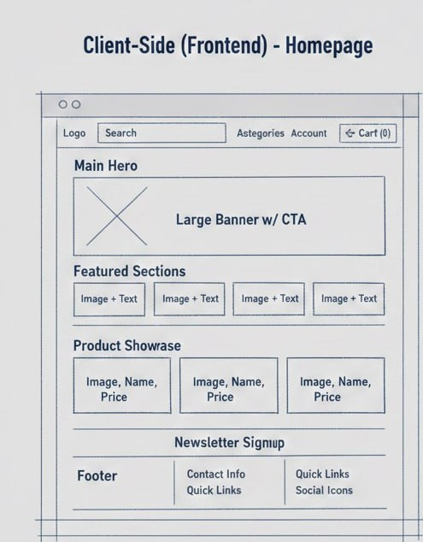

fig. 1.1 Client Home Page screen

A.2->PRODUCT LIST PAAGE
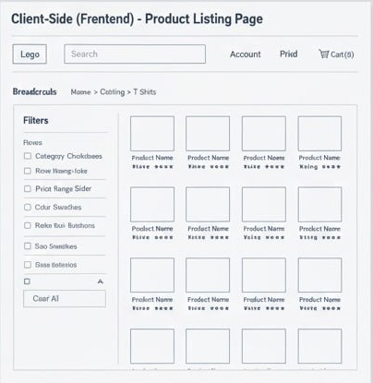

fig. 1.2 CLIENT PRODUCT LIST PAGE

A.3->CLIENT PRODUCT DETAIL PAGE
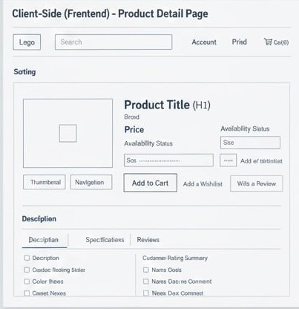

A.4->CHECKOUT PAGE
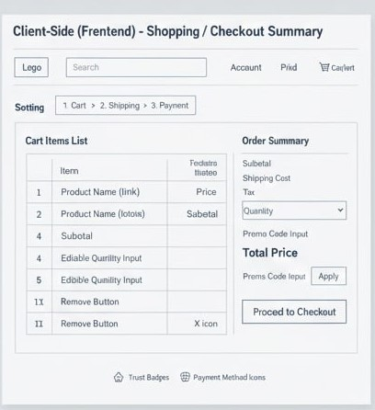

A.5->PAYMENT WIREFRAME
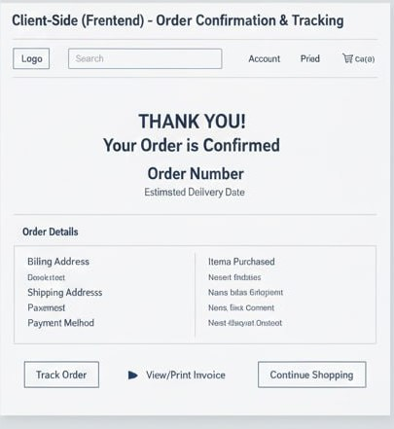

Project Title: SHOP MASTER E-COMMERCE WEBSITE

B->ADMIN WIREFRAME
B.1->DASHBOARD WIREFRAME

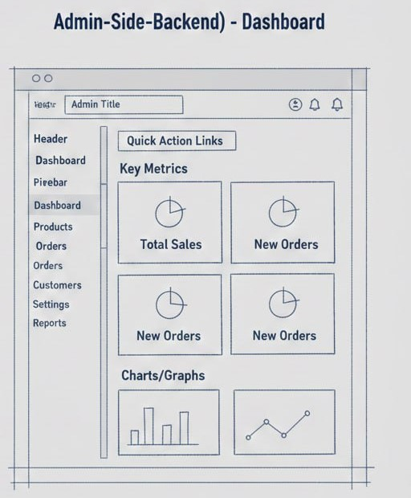

B.2->PRODUCT MANAGEMENT WIREFRAME

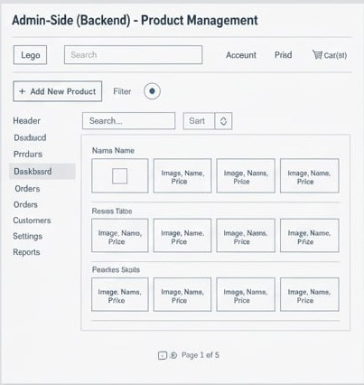

B.3->ORDER MANAGEMENT WIREFRAME

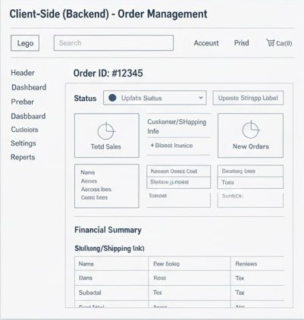

B.4->SETTINGS WIREFRAME

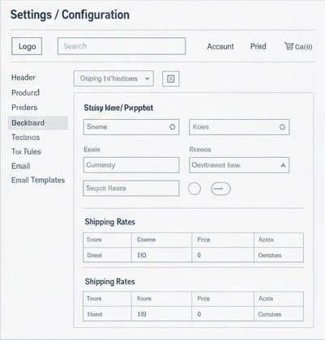

B.4->ADMIN SIDE MANAGEMENT WIREFRAME

