ANTIBACTERIAL POTENTIAL OF DIPSACUS INERMIS:
AN IN VITRO STUDY
DISSERTATION
Submitted in partial fulfillment of the requirements
for the award of a degree of
MASTER OF SCIENCE
in
ZOOLOGY
Submitted By
BAZILLA SALEEM
Enrollment No. 24061119001
Batch 2024
Under the Supervision of
PROF. FAYAZ AHMAD
Department of Zoology
ADVANCED RESEARCH LABORATORY
DEPARTMENT OF ZOOLOGY
SCHOOL OF BIOLOGICAL SCIENCES
UNIVERSITY OF KASHMIR,
HAZRATBAL, SRINAGAR-190006
(NAAC Accredited Grade ‘A++’)
2026

DEPARTMENT OF ZOOLOGY
SCHOOL OF BIOLOGICAL SCIENCES
UNIVERSITY OF KASHMIR,
HAZRATBAL, SRINAGAR-190006
(NAAC Accredited Grade ‘A++’)
***********************************************************************************
CERTIFICATE
This is to certify that the dissertation entitled “Antibacterial Potential of Dipsacus inermis: An In Vitro Study” is based on the work carried out by Ms. BAZILLA SALEEM, Enrollment No. 24061119001, Batch 2024, under course M.Sc. Zoology under my guidance and supervision from March 2026 to September 2026 at the Advanced Research Laboratory, Department of Zoology, School of Biological Sciences, University of Kashmir, Srinagar-190006, J&K.
This dissertation is being submitted to the Department of Zoology, School of Biological Sciences, University of Kashmir, Srinagar-190006, J&K, for the partial fulfilment of the requirements for the award of the Degree of Master of Science in Zoology.

Prof. Fayaz Ahmad Prof. Tariq Ahmad
Dean Head of the Department
School of Biological Sciences Department of Zoology
University of Kashmir
(Supervisor)

DEPARTMENT OF ZOOLOGY
SCHOOL OF BIOLOGICAL SCIENCES
UNIVERSITY OF KASHMIR,
HAZRATBAL, SRINAGAR-190006
(NAAC Accredited Grade ‘A++’)
***********************************************************************************
Declaration by the Candidate
I, BAZILLA SALEEM hereby declare that the dissertation entitled “Antibacterial Potential of Dipsacus inermis: An In Vitro Study” submitted to the Department of Zoology, University of Kashmir, is my original work carried out under the joint supervision of Prof. Fayaz Ahmad, Professor, Department of Zoology, University of Kashmir.
I further declare that this work has not been submitted earlier to any other University or Institution for the award of any degree or diploma. I also declare that all sources of information and references used in this dissertation have been properly acknowledged and cited.

BAZILLA SALEEM

Dated………………

ACKNOWLEDGEMENTS
All praise is due to Almighty Allah, the most compassionate and merciful, for granting me the strength, patience, and opportunity to complete this dissertation.
I would like to express my sincere gratitude to my supervisor, Prof. Fayaz Ahmad, Department of Zoology, University of Kashmir, for his expert guidance, encouragement, and invaluable support throughout the course of this work. His feedback and constant motivation enabled me to carry this project to completion.
I record my sincere thanks to Professor Tariq Ahmad , University of Kashmir, for making the laboratory facilities and materials required for this study available in a timely manner.
I am grateful to [names of lab colleagues / research scholars who assisted with the work] for their assistance and support during the laboratory work.
I would also like to thank the laboratory staff of the Department of Zoology, especially [lab assistant names], for their cooperation.
Finally, I owe my deepest gratitude to my family for their unconditional love, patience, and encouragement, which gave me the strength to complete this work.

BAZILLA SALEEM

ABSTRACT
Antimicrobial resistance (AMR) is globally acknowledged as one of the major health, developmental & socioeconomic crises of twenty-first century that has renewed interest in plant-derived antimicrobial agents as alternatives to conventional antibiotics. Medicinal plants are promising source of new antibacterial agents because they contain structurally diverse secondary metabolites with broad biological activities. Plant-derived compounds are generally biodegradable and may provide new chemical scaffolds and mechanisms of action for bacterial control. Dipsacus inermis (Himalayan teasel), a perennial herb of the family Caprifoliaceae found across the Himalayan region including Kashmir, has traditionally been used in folk medicine and has shown antimicrobial and phytochemical activity in earlier studies. The present study was undertaken to evaluate the in vitro antibacterial efficacy of an aqueous extract of the aerial parts of D. inermis against three clinically significant Gram-negative pathogenic bacterial strains — Escherichia coli, Pseudomonas aeruginosa, and Klebsiella pneumoniae.
CONTENTS
1. Introduction 1
1.1 Objectives of the Study –
2. Review of Literature –
3. Materials and Methods –
3.1 Materials –
3.1.1 Test Bacterial Strains –
3.1.2 Reagents, Culture Media, and Equipment –
3.1.3 Experimental Plant –
3.2 Methods –
3.2.1 Collection and Authentication of Plant Material –
3.2.2 Processing and Shade Drying –
3.2.3 Preparation of Aqueous Extract –
3.2.4 Preparation of Bacterial Cultures and Inoculum –
3.2.5 Antibacterial Susceptibility Testing (Well and Disc Diffusion) –
3.2.6 Measurement and Interpretation of Zone of Inhibition –
3.2.7 Statistical Analysis –
4. Results –
5. Discussion –
6. Conclusion –
7. References –
Appendix A: Raw Data Recording Template –
(Note: page numbers above are placeholders — update after final pagination in Word.)

LIST OF FIGURES
Fig. 1. Shade-dried whole plant material of Dipsacus inermis prior to size reduction –
Fig. 2. Coarse powdering of dried plant material using mortar and pestle –
Fig. 3. Coarsely powdered plant material ready for aqueous extraction –
Fig. 4. Aqueous extraction set-up (round-bottom flask, heating mantle, reflux condenser) –
Fig. 5. Close-up of the reflux extraction assembly during extraction –
Fig. 6. Pure cultures of K. pneumoniae, P. aeruginosa, and E. coli on LB agar –
Fig. 7. Pure culture of Escherichia coli on LB agar –
Fig. 8a. Agar well diffusion plate showing zones of inhibition against E. coli –
Fig. 8b. Agar well diffusion plate showing zones of inhibition against K. pneumoniae –
Fig. 8c. [Insert: agar well diffusion plate for P. aeruginosa, once available] –
Fig. 9. [Insert: graphical representation of zone of inhibition data] –

LIST OF TABLES
Table 1. Taxonomic classification of the test bacterial strains –
Table 2. Taxonomic classification of Dipsacus inermis –
Table 3a-3c. Zone of inhibition (mm) produced by the aqueous extract of D. inermis against E. coli, P. aeruginosa, and K. pneumoniae –
Table 3d. Comparative summary of zone of inhibition across all three organisms –
Table 4. Comparison of present findings with zone of inhibition values reported for DCM and MeOH extracts of D. inermis (Drakhshaan et al., 2026) –

INTRODUCTION

The progression of the antimicrobial resistance (AMR) is recognized worldwide as one of the major health, developmental & socioeconomic crises of twenty-first century. For nearly eight decades, modern medicine has relied on therapeutic regimes anchored by synthetic and semi-synthetic antibiotics to manage infectious diseases, facilitate invasive surgical interventions. The uncontrolled clinical overprescription of antibiotics in clinical practices, have exerted intense evolutionary pressure on pathogenic bacterial populations – accelerated the evolutionary proliferation of resistant bacterial lineages.
According to comprehensive global epidemiological surveys, bacterial AMR was directly linked to approximately 4.95 million deaths globally in 2019 with nearly 1.27 million deaths directly attributable to resistant pathogens. In the absence of immediate development of new treatments, annual mortality attributable to AMR is projected to rise to 1.91 million by the year 2050, concentrated heavily in developing and resource constrained economies.

Antimicrobial resistance (AMR) has emerged as one of the most pressing global public health challenges of the twenty-first century, undermining the effectiveness of conventional antibiotics and complicating the management of common bacterial infections (Antimicrobial Resistance Collaborators, 2022). Gram-negative bacteria, in particular, are of major clinical concern because of their intrinsic outer-membrane permeability barrier and their capacity to acquire multiple resistance determinants through plasmids, integrons, and efflux pumps. Among these, Escherichia coli, Pseudomonas aeruginosa, and Klebsiella pneumoniae are recognised as leading causes of community- and hospital-acquired infections, including urinary tract infections, wound and burn infections, pneumonia, and bloodstream infections, and all three are ranked as the primary contributors of the greatest global burden of bacterial antimicrobial resistance (Antimicrobial Resistance Collaborators, 2022).
Natural products, particularly those derived from medicinal plants, have historically served as an important reservoir for the discovery of antimicrobial compounds (Cowan, 1999). Plant extracts and phytochemicals — including alkaloids, flavonoids, tannins, terpenoids, and phenolic compounds — have been reported to exert antibacterial activity through diverse mechanisms such as disruption of bacterial cell membranes, inhibition of efflux pumps, interference with nucleic acid synthesis, and inhibition of bacterial enzymes (Jubair et al., 2021). Given the slowing pipeline of novel synthetic antibiotics, screening of traditionally used medicinal plants for antibacterial activity remains a valuable strategy for identifying new leads and for validating traditional therapeutic claims through modern scientific methods.
Dipsacus inermis (commonly known as the Himalayan teasel or Chinese teasel) is a perennial herb belonging to the family Caprifoliaceae, genus Dipsacus, which comprises approximately 20 species distributed across China, Europe, tropical Africa, and East Asia, including the Himalayan region (Skała & Szopa, 2023). The plant is easily recognised by its solitary, globular flower heads borne on long, leafless, channelled stalks, with flowering occurring between June and September. D. inermis and related Dipsacus species have long been used in traditional Chinese and folk medicine to manage a range of ailments, including inflammatory conditions, Lyme disease, fibromyalgia, and bacterial infections (Zhao & Shi, 2011; Hassan et al., 2020). Phytochemically, the genus is particularly well known for its triterpenoid saponins, with more than thirty distinct triterpenoid compounds reported across D. inermis and related species, in addition to phenolics, flavonoids, and alkaloids (Liebold et al., 2011; Skała & Szopa, 2023).
Within the Kashmir Valley, where D. inermis grows naturally, Wani, Singh and Pal (2017) reported in vitro phytochemical and antimicrobial activity of the species, providing early regional evidence of its antibacterial potential. More recently, Drakhshaan et al. (2026) conducted a detailed phytochemical and computational evaluation of dichloromethane (DCM) and methanolic (MeOH) extracts of D. inermis, reporting measurable zones of inhibition against Staphylococcus aureus, Bacillus subtilis, Escherichia coli, Pseudomonas aeruginosa, Salmonella typhi, and Enterobacter aerogenes using the agar well diffusion technique, with the DCM extract showing the strongest activity overall. However, this and most other antibacterial evaluations of D. inermis have relied on non-polar or semi-polar organic solvents (dichloromethane, methanol, ethanol) capable of extracting terpenoids and steroids, while the antibacterial potential of a simple aqueous extract — the form most relevant to traditional preparation as a decoction or infusion — remains comparatively unexplored. Furthermore, to the best of available literature, the antibacterial efficacy of D. inermis extracts against Klebsiella pneumoniae, an organism of major clinical importance, has not been specifically reported.
This gap forms the rationale for the present study, which evaluates the in vitro antibacterial efficacy of an aqueous extract of D. inermis against E. coli, P. aeruginosa, and K. pneumoniae using the agar well diffusion technique, with the assessment restricted to the zone of inhibition (ZOI) produced against each organism.

1.1 Botanical Description and Taxonomy of Dipsacus inermis
Dipsacus inermis Wall. (common names: Himalayan teasel; local names vary across the Himalayan region) is a robust, erect, perennial herb typically reaching between 1 and 2 metres in height at maturity. The plant produces a stout, ridged, and often sparsely prickly stem arising from a thickened taproot, and is characterised by opposite, sessile to sub-sessile leaves that are lanceolate to elliptic in outline, with margins ranging from entire to coarsely serrate; the leaf bases are frequently connate (fused around the stem), a feature typical of the genus that allows rainwater to collect at the leaf axils. The inflorescence is a dense, solitary, ovoid-to-globose flower head (capitulum) borne terminally on a long, leafless, longitudinally channelled peduncle. Each capitulum is subtended by an involucre of narrow, spine-tipped bracts, and the numerous small, tubular florets within the head are individually subtended by stiff, pointed paleae — a receptacle architecture characteristic of the traditional family Dipsacaceae. Flowering occurs between June and September, with the small florets opening in a characteristic band that progresses from the middle of the head outward in both directions. The fruit is a dry, indehiscent achene enclosed within a persistent epicalyx.
Taxonomically, Dipsacus has historically been placed in its own family, Dipsacaceae; however, molecular phylogenetic studies underpinning the Angiosperm Phylogeny Group (APG) classification system have since subsumed Dipsacaceae within a broadly circumscribed family Caprifoliaceae sensu lato, alongside Valerianaceae and other formerly segregate families (Skała & Szopa, 2023). D. inermis is accordingly classified today under Caprifoliaceae, genus Dipsacus, which comprises approximately 20 recognised species distributed across China, Europe, tropical Africa, and East Asia, with several species, including D. inermis, occurring naturally across the Himalayan belt at moderate to high elevations. Within Kashmir, the species is commonly encountered on open hill slopes, forest margins, and disturbed ground, and has long featured in regional folk medicine.

1.2 Mechanisms of Antibacterial Action of Plant Phytochemicals
The antibacterial activity of crude plant extracts is rarely attributable to a single compound; rather, it typically reflects the combined and often synergistic action of multiple co-occurring phytochemical classes, each capable of interfering with bacterial viability through a distinct mechanism (Cowan, 1999; Jubair et al., 2021). Phenolic compounds and flavonoids are thought to act principally by binding to and disrupting the integrity of the bacterial cytoplasmic membrane, altering its permeability and causing leakage of intracellular contents; several flavonoids have additionally been reported to inhibit bacterial efflux pumps and to interfere with biofilm formation and quorum-sensing signalling, thereby also potentiating the activity of co-administered antibiotics. Tannins act largely through the complexation of proteins, including bacterial enzymes and cell-surface adhesins, reducing enzymatic activity and nutrient availability to the organism, and may additionally chelate essential metal ions required for bacterial metabolism. Terpenoids and steroidal constituents, being predominantly lipophilic, are believed to partition into and disorganise the lipid bilayer of the bacterial membrane, compromising its structural integrity and function; this mechanism is of particular relevance to D. inermis, whose dichloromethane extract has been shown to be dominated by terpenoid, steroidal, and sesquiterpenoid constituents (Drakhshaan et al., 2026). Alkaloids have been proposed to act by intercalating with bacterial DNA or by disrupting membrane-associated processes, while saponins, through their amphipathic, cholesterol-interacting structure, can form pores in the bacterial membrane in a manner analogous to their haemolytic activity. Quinones, for their part, are able to complex irreversibly with nucleophilic amino acid residues in membrane and cell-wall proteins, inactivating them and, in some cases, generating additional oxidative stress within the bacterial cell. Because aqueous extraction preferentially recovers polar constituents — chiefly phenolics, flavonoids, tannins, and certain glycosides — while extracting non-polar terpenoids and steroids far less efficiently than organic solvents such as dichloromethane, the antibacterial profile expected of an aqueous extract of D. inermis would, on mechanistic grounds, be expected to differ from that previously reported for its organic solvent extracts, providing further motivation for the present study.

1.3 CURRENT GAPS IN RESEARCH
Despite the accumulating evidence for the antimicrobial potential of Dipsacus inermis, several specific gaps remain in the published literature. First, essentially all antibacterial evaluations of D. inermis to date, including the most comprehensive recent study (Drakhshaan et al., 2026), have been conducted using dichloromethane or methanolic extracts; no study has specifically isolated and reported the antibacterial efficacy of a simple aqueous extract — the extraction form most consistent with the plant's traditional preparation as a decoction or infusion. Second, no published study, to the best of available literature, has evaluated the antibacterial activity of D. inermis, in any extract form, against Klebsiella pneumoniae, despite this organism's recognised clinical importance and its designation as a critical-priority pathogen in several antimicrobial resistance frameworks. Third, regional evaluation of D. inermis collected from Kashmir remains limited to the relatively early work of Wani, Singh and Pal (2017), with no more recent regional study directly comparing aqueous extract efficacy against clinically relevant Gram-negative organisms using a standardised technique such as agar well diffusion. The present study addresses these three specific gaps.

OBJECTIVES OF THE STUDY
The present study was carried out with the following objectives:
1. To collect, identify, and prepare an aqueous extract of Dipsacus inermis.
2. To evaluate the aqueous extract for phytochemical analysis.
3. To evaluate the in vitro antibacterial efficacy of the aqueous extract of D. inermis against Escherichia coli, Pseudomonas aeruginosa, and Klebsiella pneumoniae.

2. Review of Literature

2.1 Antimicrobial Resistance and the Rationale for Plant-Based Antibacterials
The global burden of bacterial antimicrobial resistance has been comprehensively documented by the Antimicrobial Resistance Collaborators (2022), whose systematic analysis estimated that bacterial AMR was directly responsible for over a million deaths and was associated with several million more worldwide in a single year, with Escherichia coli, Klebsiella pneumoniae, and Pseudomonas aeruginosa among the leading pathogens contributing to this burden. This has intensified interest in alternative antibacterial strategies, including plant-derived compounds. Cowan (1999), in a widely cited review, catalogued the diversity of plant secondary metabolites — phenolics, quinones, flavonoids, tannins, coumarins, terpenoids, alkaloids, and lectins — that display antimicrobial activity, noting that such compounds often act through multiple, non-specific mechanisms that may reduce the likelihood of resistance development compared with single-target synthetic antibiotics. More recently, Jubair et al. (2021) reviewed the mechanisms by which plant-derived compounds act against multidrug-resistant bacteria, including membrane disruption, efflux pump inhibition, quorum-sensing interference, and biofilm inhibition, reinforcing the rationale for continued screening of medicinal plants against clinically relevant, resistant bacterial strains.

2.2 Mechanisms of Antibacterial Action of Phytochemicals
A substantial body of pharmacognostic literature has characterised the mechanisms by which plant secondary metabolites exert antibacterial effects, and these mechanisms provide the conceptual framework within which the present study's findings must be interpreted (Cowan, 1999; Jubair et al., 2021).

2.2.1 Phenolics and Flavonoids
Phenolic acids and flavonoids are widely reported to disrupt the bacterial cytoplasmic membrane, increasing its permeability and causing leakage of intracellular ions, metabolites, and nucleic acids. Several flavonoids additionally inhibit bacterial efflux pump systems and interfere with quorum-sensing and biofilm formation, mechanisms that are particularly relevant against biofilm-forming organisms such as P. aeruginosa and K. pneumoniae.

2.2.2 Tannins
Tannins act principally through the complexation of proteins, including extracellular bacterial enzymes and surface adhesins, thereby reducing enzymatic activity and impairing bacterial adhesion; they are also capable of chelating metal ions essential for bacterial metabolic processes, indirectly starving the organism of cofactors required for growth.

2.2.3 Terpenoids and Steroids
Terpenoids and steroidal compounds are predominantly lipophilic and are thought to partition into the bacterial lipid bilayer, disorganising membrane structure and compromising its barrier function. This class of compounds was found to dominate the dichloromethane extract of D. inermis in the most detailed phytochemical evaluation of the species to date (Drakhshaan et al., 2026), and is considered a principal contributor to its reported antibacterial activity.

2.2.4 Alkaloids, Saponins, and Quinones
Alkaloids are proposed to act by intercalating with bacterial nucleic acids or by disrupting membrane-associated transport processes. Saponins, owing to their amphipathic structure and affinity for membrane sterols and sterol-like lipids, can form pores in bacterial membranes in a manner analogous to their well-documented haemolytic activity. Quinones can form irreversible complexes with nucleophilic amino acid residues in membrane and cell-wall-associated proteins, inactivating them, and may additionally generate oxidative stress within the bacterial cell.
Because these compound classes differ considerably in polarity, the solvent used for extraction directly determines which classes — and, by extension, which antibacterial mechanisms — predominate in a given plant extract. This principle underlies the comparative discussion, in Chapter 5, between the aqueous extract evaluated in the present study and the organic solvent extracts of D. inermis previously reported in the literature.

2.3 The Genus Dipsacus: Phytochemistry and Biological Activity
The genus Dipsacus (family Caprifoliaceae sensu lato) has attracted sustained phytochemical interest owing to its diverse array of triterpenoid saponins, iridoid glycosides, and phenolic constituents. Zhao and Shi (2011) reviewed the phytochemistry and biological activities of Dipsacus species broadly, highlighting their anti-inflammatory, antioxidant, and antimicrobial potential. Skała and Szopa (2023), in a more recent review of Dipsacus and Scabiosa species, catalogued numerous specialised metabolites of high biological relevance across the genus and emphasised the continued pharmacological interest in these plants. Liebold, Straubinger and Rauwald (2011) demonstrated that lipophilic extracts from the roots of the related species Dipsacus sylvestris inhibited the growth of Borrelia burgdorferi, the causative agent of Lyme disease, in vitro, providing early mechanistic support for the antimicrobial reputation of the genus in traditional medicine. Oszmiański (2020) similarly reported notable biological activity in root and leaf extracts of Dipsacus fullonum.
Specific to Dipsacus inermis, Hassan et al. (2020) demonstrated that the species modulates inflammation by inhibiting the NF-κB signalling pathway in both in vitro and in vivo models, supporting its traditional use as an anti-inflammatory agent. Most directly relevant to the present study, Drakhshaan et al. (2026) undertook an integrated phytochemical, in vitro, and computational investigation of D. inermis, evaluating dichloromethane (DCM) and methanol (MeOH) extracts of the whole plant against six bacterial strains — Staphylococcus aureus, Bacillus subtilis, Escherichia coli, Pseudomonas aeruginosa, Salmonella typhi, and Enterobacter aerogenes — using the agar well diffusion (zone of inhibition) and broth microdilution (minimum inhibitory concentration) methods. The DCM extract produced the largest zones of inhibition, including 17.87 ± 0.23 mm against S. aureus and E. aerogenes, 16.83 ± 0.29 mm against P. aeruginosa, and 15.93 ± 0.11 mm against E. coli, at a concentration of 100 µg/mL, with a clear dose-dependent reduction in activity at 50 µg/mL, and corresponding minimum inhibitory concentrations as low as 1.562 mg/mL against B. subtilis and E. aerogenes.
GC-MS analysis of the DCM extract by Drakhshaan et al. (2026) identified 85 distinct compounds, with the chemical profile dominated by terpenoids, monoterpenoids, steroids, sesquiterpenoids, sterols, and cannabinoids (collectively 32.94% of the profile), fatty acids such as dodecenedioic acid (18.82%), cyclohexanols and alkanes (8.23%), a phorbol ester (9.41%), and alkaloids (4.70%), alongside minor epoxide and isohumolone constituents. HPLC-UV/Vis analysis of the MeOH extract, in contrast, identified and quantified phenolic and flavonoid constituents, with the highest concentrations recorded for rutin (68.66 µg/mg), reserpine (53.76 µg/mg), and ferulic acid (31.64 µg/mg); quercetin was below the limit of detection. Molecular docking of the identified compounds against five bacterial protein targets — DNA gyrase B, tyrosyl-tRNA synthetase, PBP2X, PBP4, and dihydrofolate reductase (DHFR) — identified two terpenoid/alkaloid compounds, designated DI10 and DI31, as potent multi-target leads, and a third, DI22, as selectively active against PBP4; these predictions were further supported by ADMET profiling indicating favourable absorption and low toxicity risk, density functional theory (DFT) and molecular electrostatic potential (MESP) analyses of reactive binding sites, and molecular dynamics simulations demonstrating stable protein–ligand complexes with favourable binding free energies (approximately −45 to −52 kcal/mol by MM-PBSA). Taken together, this study establishes D. inermis as a rich source of antibacterial phytoconstituents, with its activity attributed principally to terpenoid, steroidal, and phenolic compounds recovered by organic solvent extraction; however, the study is explicitly limited to non-polar and semi-polar (DCM, MeOH) extracts, and neither the antibacterial efficacy of a purely aqueous extract nor activity against K. pneumoniae specifically was addressed — the two gaps that the present study is designed to address.

2.4 Dipsacus inermis in the Kashmir Region
Wani, Singh and Pal (2017) carried out an in vitro phytochemical and antimicrobial evaluation of D. inermis collected from the Kashmir Valley, reporting the presence of antimicrobial activity alongside various phytochemical constituents in the species as it occurs regionally. This work provides an important regional precedent for the present study, which similarly sources plant material from the Kashmir region, and highlights the continued relevance of locally available D. inermis as a subject for antibacterial screening.

2.5 Biology and Clinical Significance of the Test Organisms

2.5.1 Escherichia coli
Escherichia coli is a Gram-negative, rod-shaped, facultatively anaerobic bacterium of the family Enterobacteriaceae, first described by Theodor Escherich in 1885. While most strains exist as normal commensal flora of the human and animal gastrointestinal tract, pathogenic strains are classified into distinct pathotypes — including uropathogenic E. coli (UPEC), enterotoxigenic E. coli (ETEC), enteropathogenic E. coli (EPEC), and enterohaemorrhagic E. coli (EHEC) — on the basis of the virulence factors they carry, such as adhesins, toxins, and iron-acquisition systems. UPEC strains in particular are the leading cause of community-acquired urinary tract infections worldwide, while other pathotypes are implicated in gastroenteritis, neonatal meningitis, and bloodstream infections. The increasing global prevalence of extended-spectrum beta-lactamase (ESBL)-producing and carbapenem-resistant E. coli strains has made it a priority organism for antimicrobial susceptibility surveillance and for the screening of novel antibacterial agents.

2.5.2 Pseudomonas aeruginosa
Pseudomonas aeruginosa is a Gram-negative, aerobic, rod-shaped, motile opportunistic pathogen belonging to the family Pseudomonadaceae, frequently identified in clinical settings by its characteristic blue-green pigmentation (pyocyanin) and grape-like odour on culture. It is a major cause of infections in immunocompromised patients, individuals with cystic fibrosis, burn wound patients, and those on mechanical ventilation, and is a leading cause of ventilator-associated pneumonia and catheter-associated infections in intensive care settings. P. aeruginosa is intrinsically resistant to many antibiotic classes owing to its low outer-membrane permeability, constitutively expressed and inducible multidrug efflux pumps, chromosomally encoded AmpC beta-lactamase, and pronounced capacity for biofilm formation, which further shields it from both host immune defences and antimicrobial agents. These features make it one of the more difficult Gram-negative pathogens to treat and a priority target organism for the screening of novel antibacterial agents, including plant-derived compounds.

2.5.3 Klebsiella pneumoniae
Klebsiella pneumoniae is a Gram-negative, encapsulated, non-motile, rod-shaped bacterium of the family Enterobacteriaceae. Its prominent polysaccharide capsule is a key virulence determinant, conferring resistance to phagocytosis and complement-mediated killing, and contributing to the mucoid colony morphology characteristic of the organism on culture media. K. pneumoniae is a significant cause of hospital-acquired pneumonia, urinary tract infections, liver abscesses, wound infections, and bloodstream infections, particularly in immunocompromised, critically ill, and hospitalised patients. The emergence and global spread of carbapenem-resistant K. pneumoniae (CRKP), often mediated by carbapenemase enzymes such as KPC and NDM, has been designated a critical-priority pathogen by international public health authorities, as such strains are frequently resistant to nearly all available antibiotic classes, underscoring the urgency of identifying alternative antibacterial agents, including those derived from medicinal plants, that remain effective against this organism.

2.6 The Agar Well Diffusion and Disc Diffusion Techniques
The agar well diffusion method is a widely used, simple, and reproducible technique for the preliminary screening of the antibacterial activity of plant extracts and other test substances. In this method, a bacterial lawn of the test organism is prepared on a solidified agar medium, wells are bored into the agar using a sterile borer, and the test substance is introduced into the wells at a defined volume and concentration. On incubation, the substance diffuses radially into the surrounding medium, and a zone of inhibition — a clear area free of bacterial growth — forms around the well if the substance possesses antibacterial activity. The diameter of this zone, typically measured in millimetres, provides a semi-quantitative measure of antibacterial potency and allows comparison between different extracts, concentrations, and standard antibiotic controls (CLSI, 2024). This method was employed in the present study, following the general approach used for D. inermis extracts by Drakhshaan et al. (2026), to allow direct comparability with previously reported zone of inhibition values for this species.
The disc diffusion method (Kirby-Bauer method) is the related, CLSI-standardised technique conventionally used for antibiotic susceptibility testing, in which a paper disc pre-impregnated with a fixed concentration of a standard antibiotic is placed directly on the surface of the inoculated agar, rather than introduced into a bored well. The antibiotic diffuses outward from the disc, and the resulting zone of inhibition is measured in the same manner as for the well diffusion method. In the present study, the two aqueous extract concentrations (C1, C2) and the negative control were tested by the agar well diffusion technique, while the standard antibiotic (Gentamicin) positive control was tested by the disc diffusion technique — the conventional method for antibiotic controls — with both sets of zones read from the same inoculated plates for direct comparability (CLSI, 2024).

2.7 Research Gap and Rationale
Taken together, the reviewed literature establishes that D. inermis possesses antibacterial activity when extracted with organic solvents such as dichloromethane and methanol, and that the species has a history of traditional and regional use, including within Kashmir. However, two specific gaps remain: first, the antibacterial efficacy of a simple aqueous extract of D. inermis — the extraction form most consistent with traditional preparation — has not been systematically evaluated using the agar well diffusion technique; and second, its activity against Klebsiella pneumoniae, a clinically critical Gram-negative pathogen, has not been specifically reported. The present study addresses both gaps.

3. Materials and Methods

3.1 Materials

3.1.1 Test Bacterial Strains
The antibacterial activity of the aqueous extract of Dipsacus inermis was evaluated against three Gram-negative bacterial strains of clinical importance: Escherichia coli, Pseudomonas aeruginosa, and Klebsiella pneumoniae. The taxonomic classification of the test organisms is presented in Table 1.

Taxon | Escherichia coli | Pseudomonas aeruginosa | Klebsiella pneumoniae
Kingdom | Bacteria | Bacteria | Bacteria
Phylum | Pseudomonadota | Pseudomonadota | Pseudomonadota
Class | Gammaproteobacteria | Gammaproteobacteria | Gammaproteobacteria
Order | Enterobacterales | Pseudomonadales | Enterobacterales
Family | Enterobacteriaceae | Pseudomonadaceae | Enterobacteriaceae
Genus | Escherichia | Pseudomonas | Klebsiella
Species | E. coli | P. aeruginosa | K. pneumoniae

Table 1. Taxonomic classification of the test bacterial strains
The bacterial strains used in this study were obtained from the Advanced Research Laboratory, Department of Zoology, University of Kashmir. Stock cultures were maintained and periodically sub-cultured on Luria-Bertani (LB) agar (Fig. 6, Fig. 7) and stored as per standard laboratory practice.

3.1.2 Reagents, Culture Media, and Equipment
The culture medium used for the maintenance and growth of the test bacterial strains was Luria-Bertani (LB) agar and broth. Distilled water was used as the extraction solvent for the plant material and as the negative control in the antibacterial assay. Additional reagents required for the study included [insert any additional reagents used, e.g., McFarland turbidity standard reagents, normal saline for inoculum preparation, ethanol for surface sterilisation]. The major equipment used included an electronic weighing balance, a hot-air oven and/or autoclave for sterilisation, a laminar air-flow cabinet for aseptic work, a BOD/bacteriological incubator maintained at 37°C, a heating mantle with a round-bottom flask and reflux condenser assembly for aqueous extraction (Fig. 4, Fig. 5), a sterile cork/gel borer of 6 mm diameter for well preparation (used for the agar well diffusion assay of the extract concentrations and the negative control), commercially prepared Gentamicin antibiotic discs and sterile forceps for the disc diffusion assay of the positive control, and a transparent ruler or Vernier caliper for measurement of the zone of inhibition. Mortar and pestle were used for the mechanical size reduction of the dried plant material (Fig. 2), and muslin cloth and Whatman No. 1 filter paper were used for filtration of the crude extract.

3.1.3 Experimental Plant
Dipsacus inermis (commonly known as the Himalayan teasel) is a perennial, herbaceous plant belonging to the family Caprifoliaceae. It is distributed across the Himalayan region, including Kashmir, and is recognised by its solitary, globular flower heads borne on long, leafless, channelled stalks, with flowering occurring between June and September. The taxonomic classification of the experimental plant is presented in Table 2.

Rank | Taxon
Kingdom | Plantae
Clade | Angiosperms
Order | Dipsacales
Family | Caprifoliaceae
Genus | Dipsacus
Species | D. inermis

Table 2. Taxonomic classification of Dipsacus inermis

3.2 Methods

3.2.1 Collection and Authentication of Plant Material
Whole plant material of D. inermis was collected from Botanical Garden, University of Kashmirinsert collection site and GPS coordinates, e.g., a locality in the Kashmir Valley] during [insert month and year of collection]. The plant was identified and authenticated by [insert name and designation of the taxonomist / botanist, and herbarium voucher number if assigned], Department of Botany / Department of Zoology, University of Kashmir.

3.2.2 Processing and Shade Drying
After collection, the plant material was thoroughly washed with distilled water to remove adhering soil and debris, and then shade-dried at room temperature for several days to preserve heat-labile phytochemical constituents (Fig. 1). The shade-dried material was subsequently pulverised into a coarse powder using a mortar and pestle (Fig. 2, Fig. 3), and the powdered material was stored in an airtight container at room temperature, protected from light and moisture, until further use.
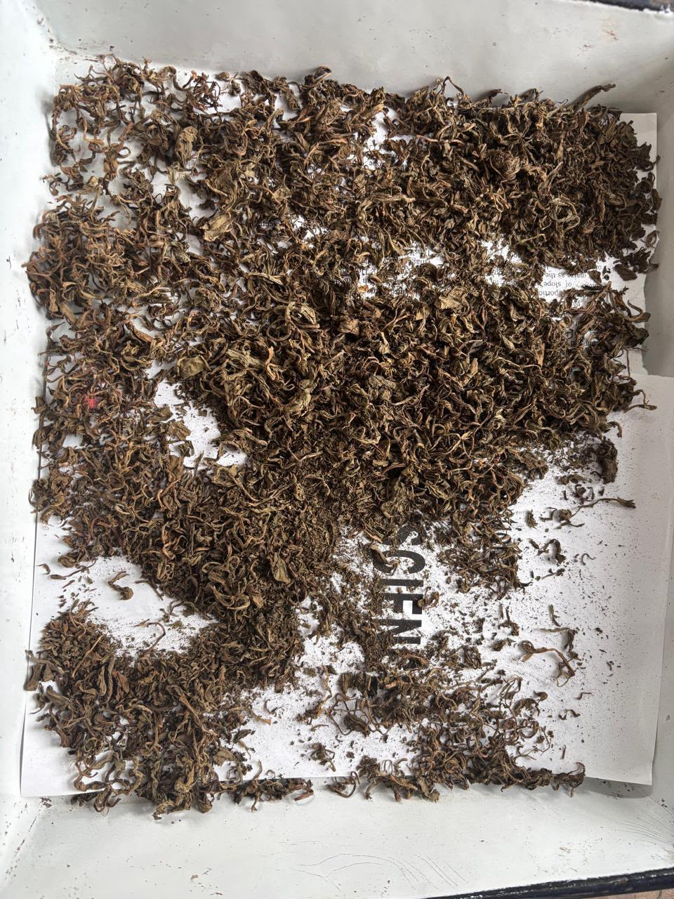
Fig. 1. Shade-dried whole plant material of Dipsacus inermis prior to size reduction
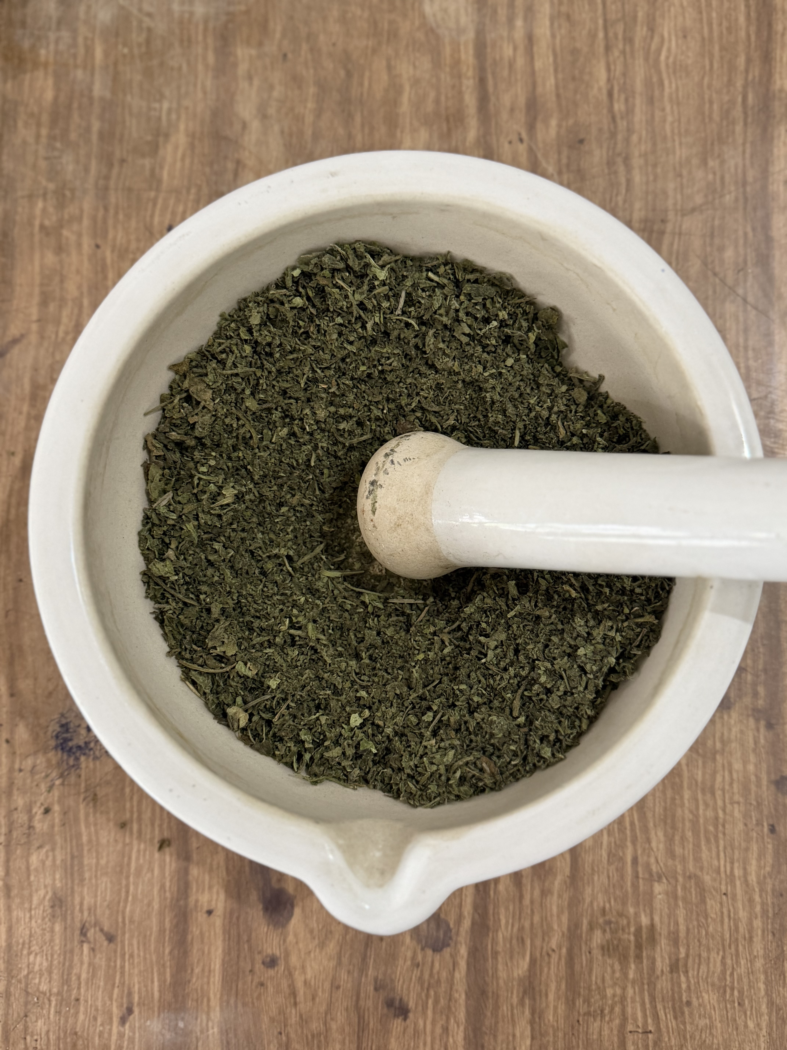
Fig. 2. Coarse powdering of dried plant material using mortar and pestle
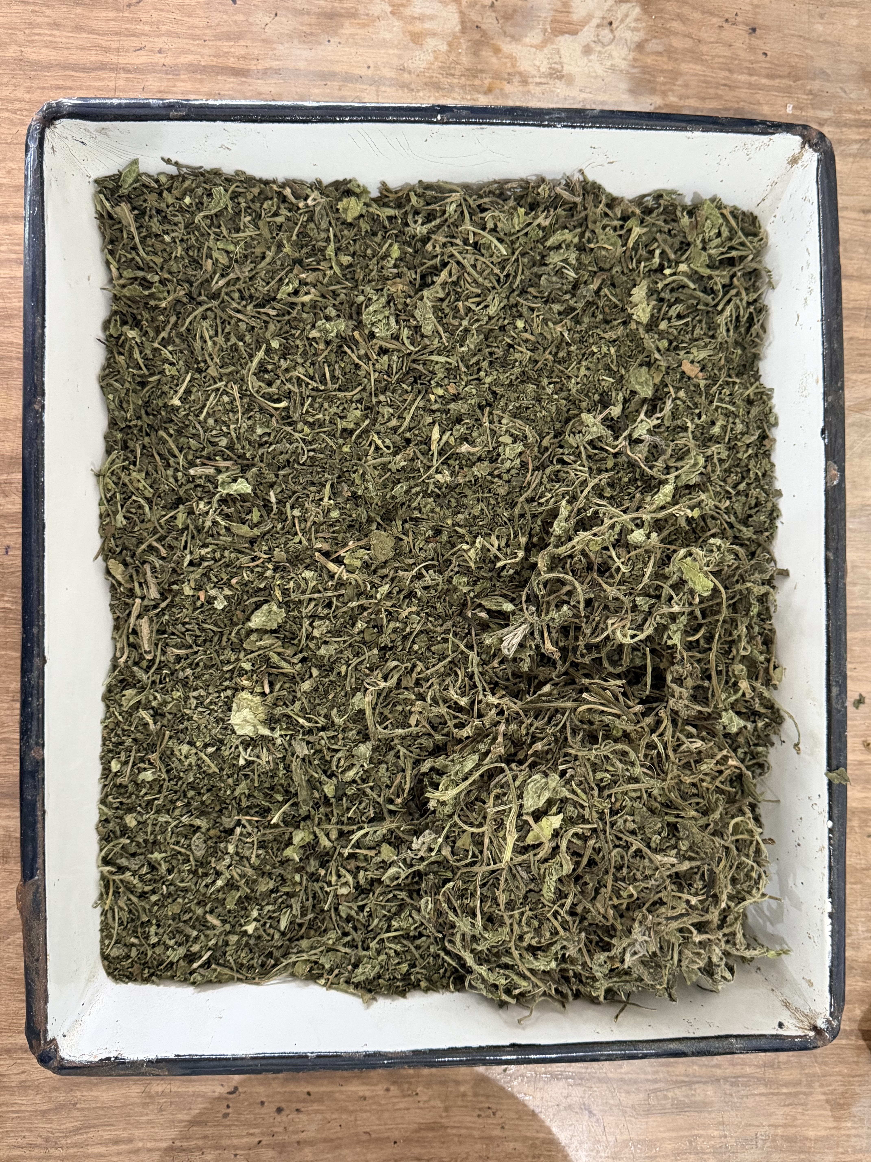
Fig. 3. Coarsely powdered plant material ready for aqueous extraction

3.2.3 Preparation of Aqueous Extract
The aqueous extract of D. inermis was prepared using the Soxhlet (hot continuous) extraction technique (Fig. 4, Fig. 5). Briefly, 50 g of the coarsely powdered plant material was loaded into a thimble and extracted with 500 mL of distilled water (1:10, w/v) using a round-bottom flask fitted with a reflux condenser mounted on a heating mantle, run continuously for 24 hours. The resulting extract was filtered, first through muslin cloth and then through Whatman No. 1 filter paper, to remove particulate matter, and was subsequently concentrated and stored in vials at 4C. The yield of the concentrated aqueous extract was recorded as 24.13% (w/w, relative to the starting powdered plant material). The concentrated extract was reconstituted in sterile distilled water to obtain two working concentrations for the antibacterial assay — C1 (50 µg) and C2 (100 µg) — matching the concentration range used by Drakhshaan et al. (2026) for comparability.
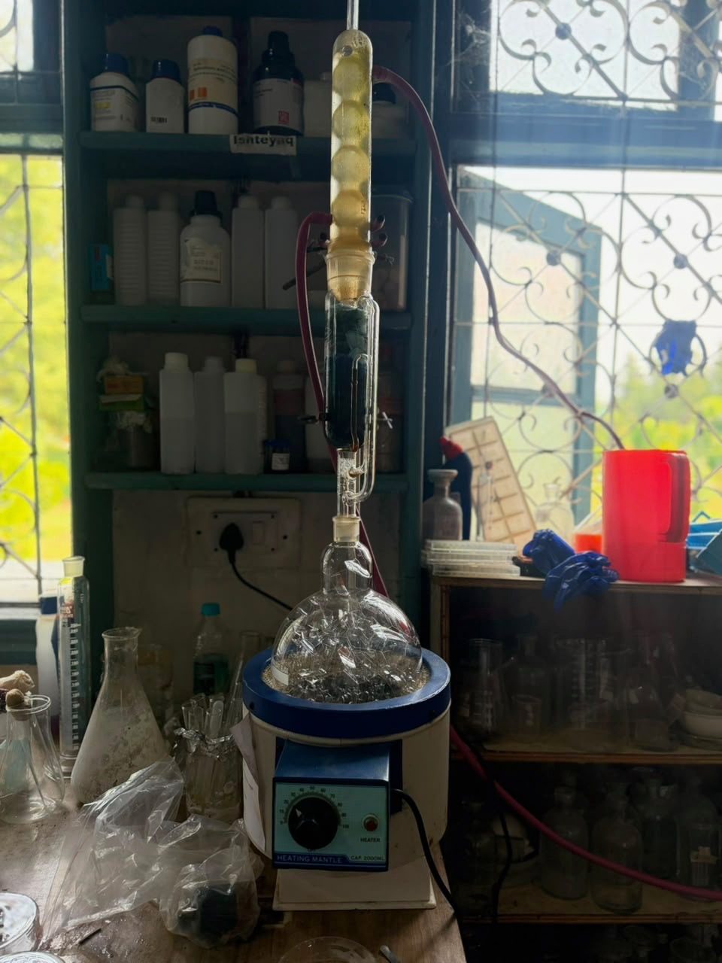
Fig. 4. Aqueous extraction set-up: round-bottom flask, heating mantle, and reflux condenser used for hot continuous extraction of powdered D. inermis in distilled water
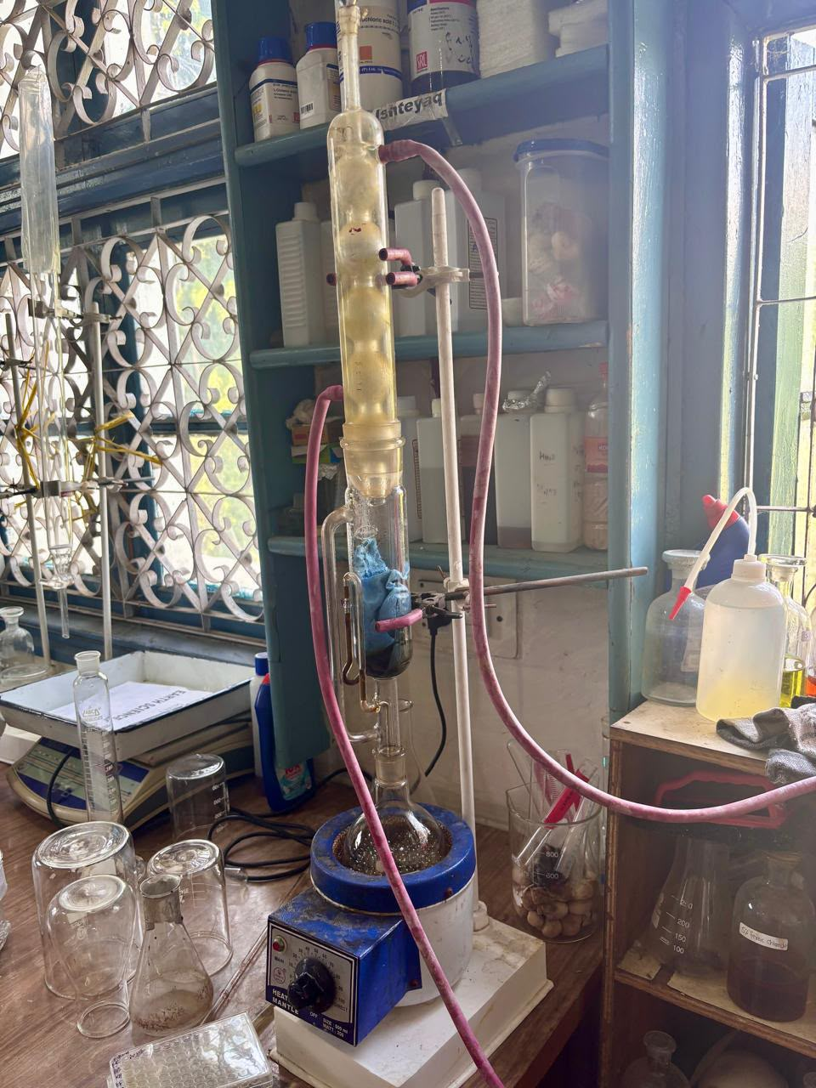
Fig. 5. Close-up view of the reflux extraction assembly during extraction

3.2.4 Preparation of Bacterial Cultures and Inoculum
Pure cultures of E. coli, P. aeruginosa, and K. pneumoniae were maintained and grown on Luria-Bertani (LB) agar (Fig. 6, Fig. 7). A single, well-isolated colony of each organism was inoculated into [insert broth medium used, e.g., nutrient broth / LB broth] and incubated at 37°C for [insert incubation duration, e.g., 18–24 hours] on a rotary shaker to obtain fresh, actively growing bacterial suspensions. The turbidity of each suspension was standardised to match the 0.5 McFarland turbidity standard (approximately 1.5 × 10⁸ CFU/mL) prior to use in the antibacterial assay.
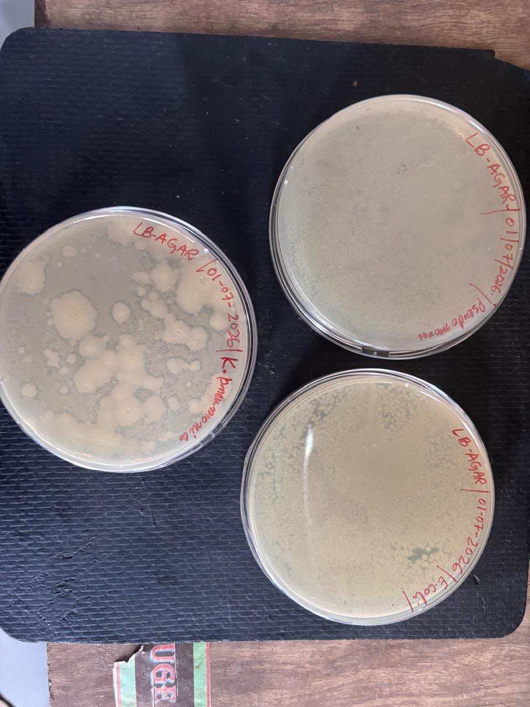
Fig. 6. Pure cultures of Klebsiella pneumoniae (left), Pseudomonas aeruginosa (top right), and Escherichia coli (bottom right) on LB agar, established 01 July 2026
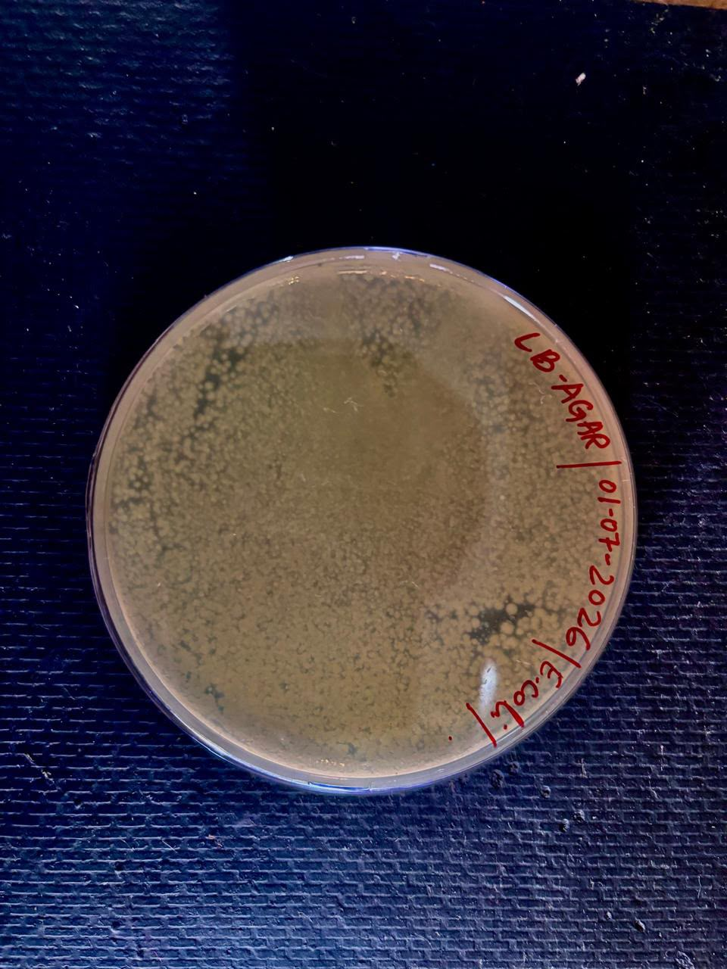
Fig. 7. Pure culture of Escherichia coli on LB agar showing characteristic bacterial lawn

3.2.5 Antibacterial Susceptibility Testing: Agar Well Diffusion and Disc Diffusion Assays
The antibacterial activity of the aqueous extract of D. inermis was evaluated using two complementary diffusion techniques on the same inoculated plates: the agar well diffusion technique for the two extract concentrations and the negative control, and the disc diffusion technique for the standard antibiotic positive control. This combination follows the general procedure described for D. inermis extracts by Drakhshaan et al. (2026), with modifications. Sterile [insert medium used, e.g., Mueller-Hinton agar / LB agar] was poured into sterile Petri dishes and allowed to solidify under aseptic conditions. The standardised bacterial suspension of each test organism was uniformly spread over the surface of the solidified agar to form a confluent lawn.

Agar Well Diffusion (Extract Concentrations and Negative Control)
Wells of approximately 6 mm diameter were bored into the inoculated agar using a sterile cork/gel borer. A volume of [insert volume introduced per well, e.g., 50–100 µL, at each of the C1 (50 µg) and C2 (100 µg) concentrations] of the aqueous extract was introduced into separate wells for the C1 and C2 concentrations, while [insert negative control used, e.g., sterile distilled water] was introduced into a further well to serve as the negative control.

Disc Diffusion (Positive Control)
A sterile, commercially prepared Gentamicin antibiotic disc was placed directly on the surface of the same inoculated agar to serve as the positive control, following the conventional disc diffusion (Kirby-Bauer) method used for antibiotic susceptibility testing (CLSI, 2024), rather than being introduced into a bored well. Placing the positive control disc alongside the extract-loaded wells on the same plate allowed the zone of inhibition produced by the extract to be directly benchmarked against that of a standard antibiotic under identical incubation conditions.
The plates prepared by both methods were left undisturbed for a short period to allow diffusion of the test substances into the agar, and were then incubated at 37°C for 24 hours. Each test — for both the well diffusion and disc diffusion components — was performed in triplicate.

3.2.6 Measurement and Interpretation of Zone of Inhibition
Following incubation, the diameter of the clear zone of inhibition (ZOI) surrounding each well or disc — including the diameter of the well or disc itself — was measured in millimetres (mm) using a transparent ruler. The mean of the triplicate measurements was calculated for each organism and each treatment. As no CLSI interpretive breakpoints exist for plant extracts, the zone of inhibition values obtained by well diffusion for the aqueous extract were interpreted descriptively and compared with the disc diffusion zone obtained for the Gentamicin positive control, the negative control, and previously reported values for organic solvent extracts of D. inermis (Drakhshaan et al., 2026).

3.2.7 Statistical Analysis
All experiments were performed in triplicate, and results are expressed as mean. Zone of inhibition values obtained for the aqueous extract were compared across the three test organisms and against the positive and negative controls using [insert statistical test used, e.g., one-way ANOVA in [software name, e.g., Microsoft Excel / GraphPad Prism / SPSS], with p < 0.05 considered statistically significant].

4. Results

4.1 Yield of Aqueous Extraction
Soxhlet extraction of 50 g of shade-dried, powdered D. inermis whole plant material with 500 mL of distilled water (1:10, w/v) over 24 hours yielded a concentrated aqueous extract corresponding to 24.13% (w/w) of the starting powdered material. This yield is markedly higher than the 2.72% and 2.9% yields reported for dichloromethane and methanolic extracts of D. inermis, respectively, by Drakhshaan et al. (2026) — a difference discussed further in Chapter 5.

4.2 Antibacterial Activity: Zone of Inhibition
The antibacterial activity of the aqueous extract of D. inermis was evaluated against Escherichia coli, Pseudomonas aeruginosa, and Klebsiella pneumoniae at two concentrations, C1 (50 µg) and C2 (100 µg), by the agar well diffusion technique, with the vehicle (negative) control also tested by well diffusion. Gentamicin, the positive control, was tested on the same plates by the disc diffusion technique. Results for each organism are presented individually below (Tables 3a–3c) and summarised together in Table 3d.

4.2.1 Escherichia coli

Treatment | C1 (50 µg) ZOI (mm) — well diffusion | C2 (100 µg) ZOI (mm) — well diffusion | Gentamicin (+, disc diffusion) / Negative (–, well) (mm)
E. coli | [ __ ± __ ] | [ __ ± __ ] | [ + __ / – __ ]

Table 3a. Zone of inhibition (mm) produced by the aqueous extract of D. inermis against E. coli (mean, n = 3)

[Insert narrative description once the assay is complete — e.g., whether inhibition was concentration-dependent, and how C1/C2 compared with the Gentamicin control.]

4.2.2 Pseudomonas aeruginosa

Treatment | C1 (50 µg) ZOI (mm) — well diffusion | C2 (100 µg) ZOI (mm) — well diffusion | Gentamicin (+, disc diffusion) / Negative (–, well) (mm)
P. aeruginosa | [ __ ± __ ] | [ __ ± __ ] | [ + __ / – __ ]

Table 3b. Zone of inhibition (mm) produced by the aqueous extract of D. inermis against P. aeruginosa (mean ± SD, n = 3)

[Insert narrative description once the assay is complete.]

4.2.3 Klebsiella pneumoniae

Treatment | C1 (50 µg) ZOI (mm) ± SD — well diffusion | C2 (100 µg) ZOI (mm) ± SD — well diffusion | Gentamicin (+, disc diffusion) / Negative (–, well) (mm)
K. pneumoniae | [ __ ± __ ] | [ __ ± __ ] | [ + __ / – __ ]

Table 3c. Zone of inhibition (mm) produced by the aqueous extract of D. inermis against K. pneumoniae (mean ± SD, n = 3)

[Insert narrative description once the assay is complete. Note: no prior published ZOI data exists for D. inermis against K. pneumoniae, so this result cannot be benchmarked directly against earlier literature — see Chapter 5.]

4.2.4 Comparative Summary Across Organisms
[Insert Table 3d here: a combined summary table placing the C1, C2, and positive-control ZOI values for all three organisms side by side, to allow direct visual comparison of relative susceptibility.]
Representative photographs of the agar well diffusion plates for E. coli and K. pneumoniae are presented below as Fig. 8a and Fig. 8b, showing the wells and the zones of inhibition — or their absence — around the extract-loaded wells and the negative control.
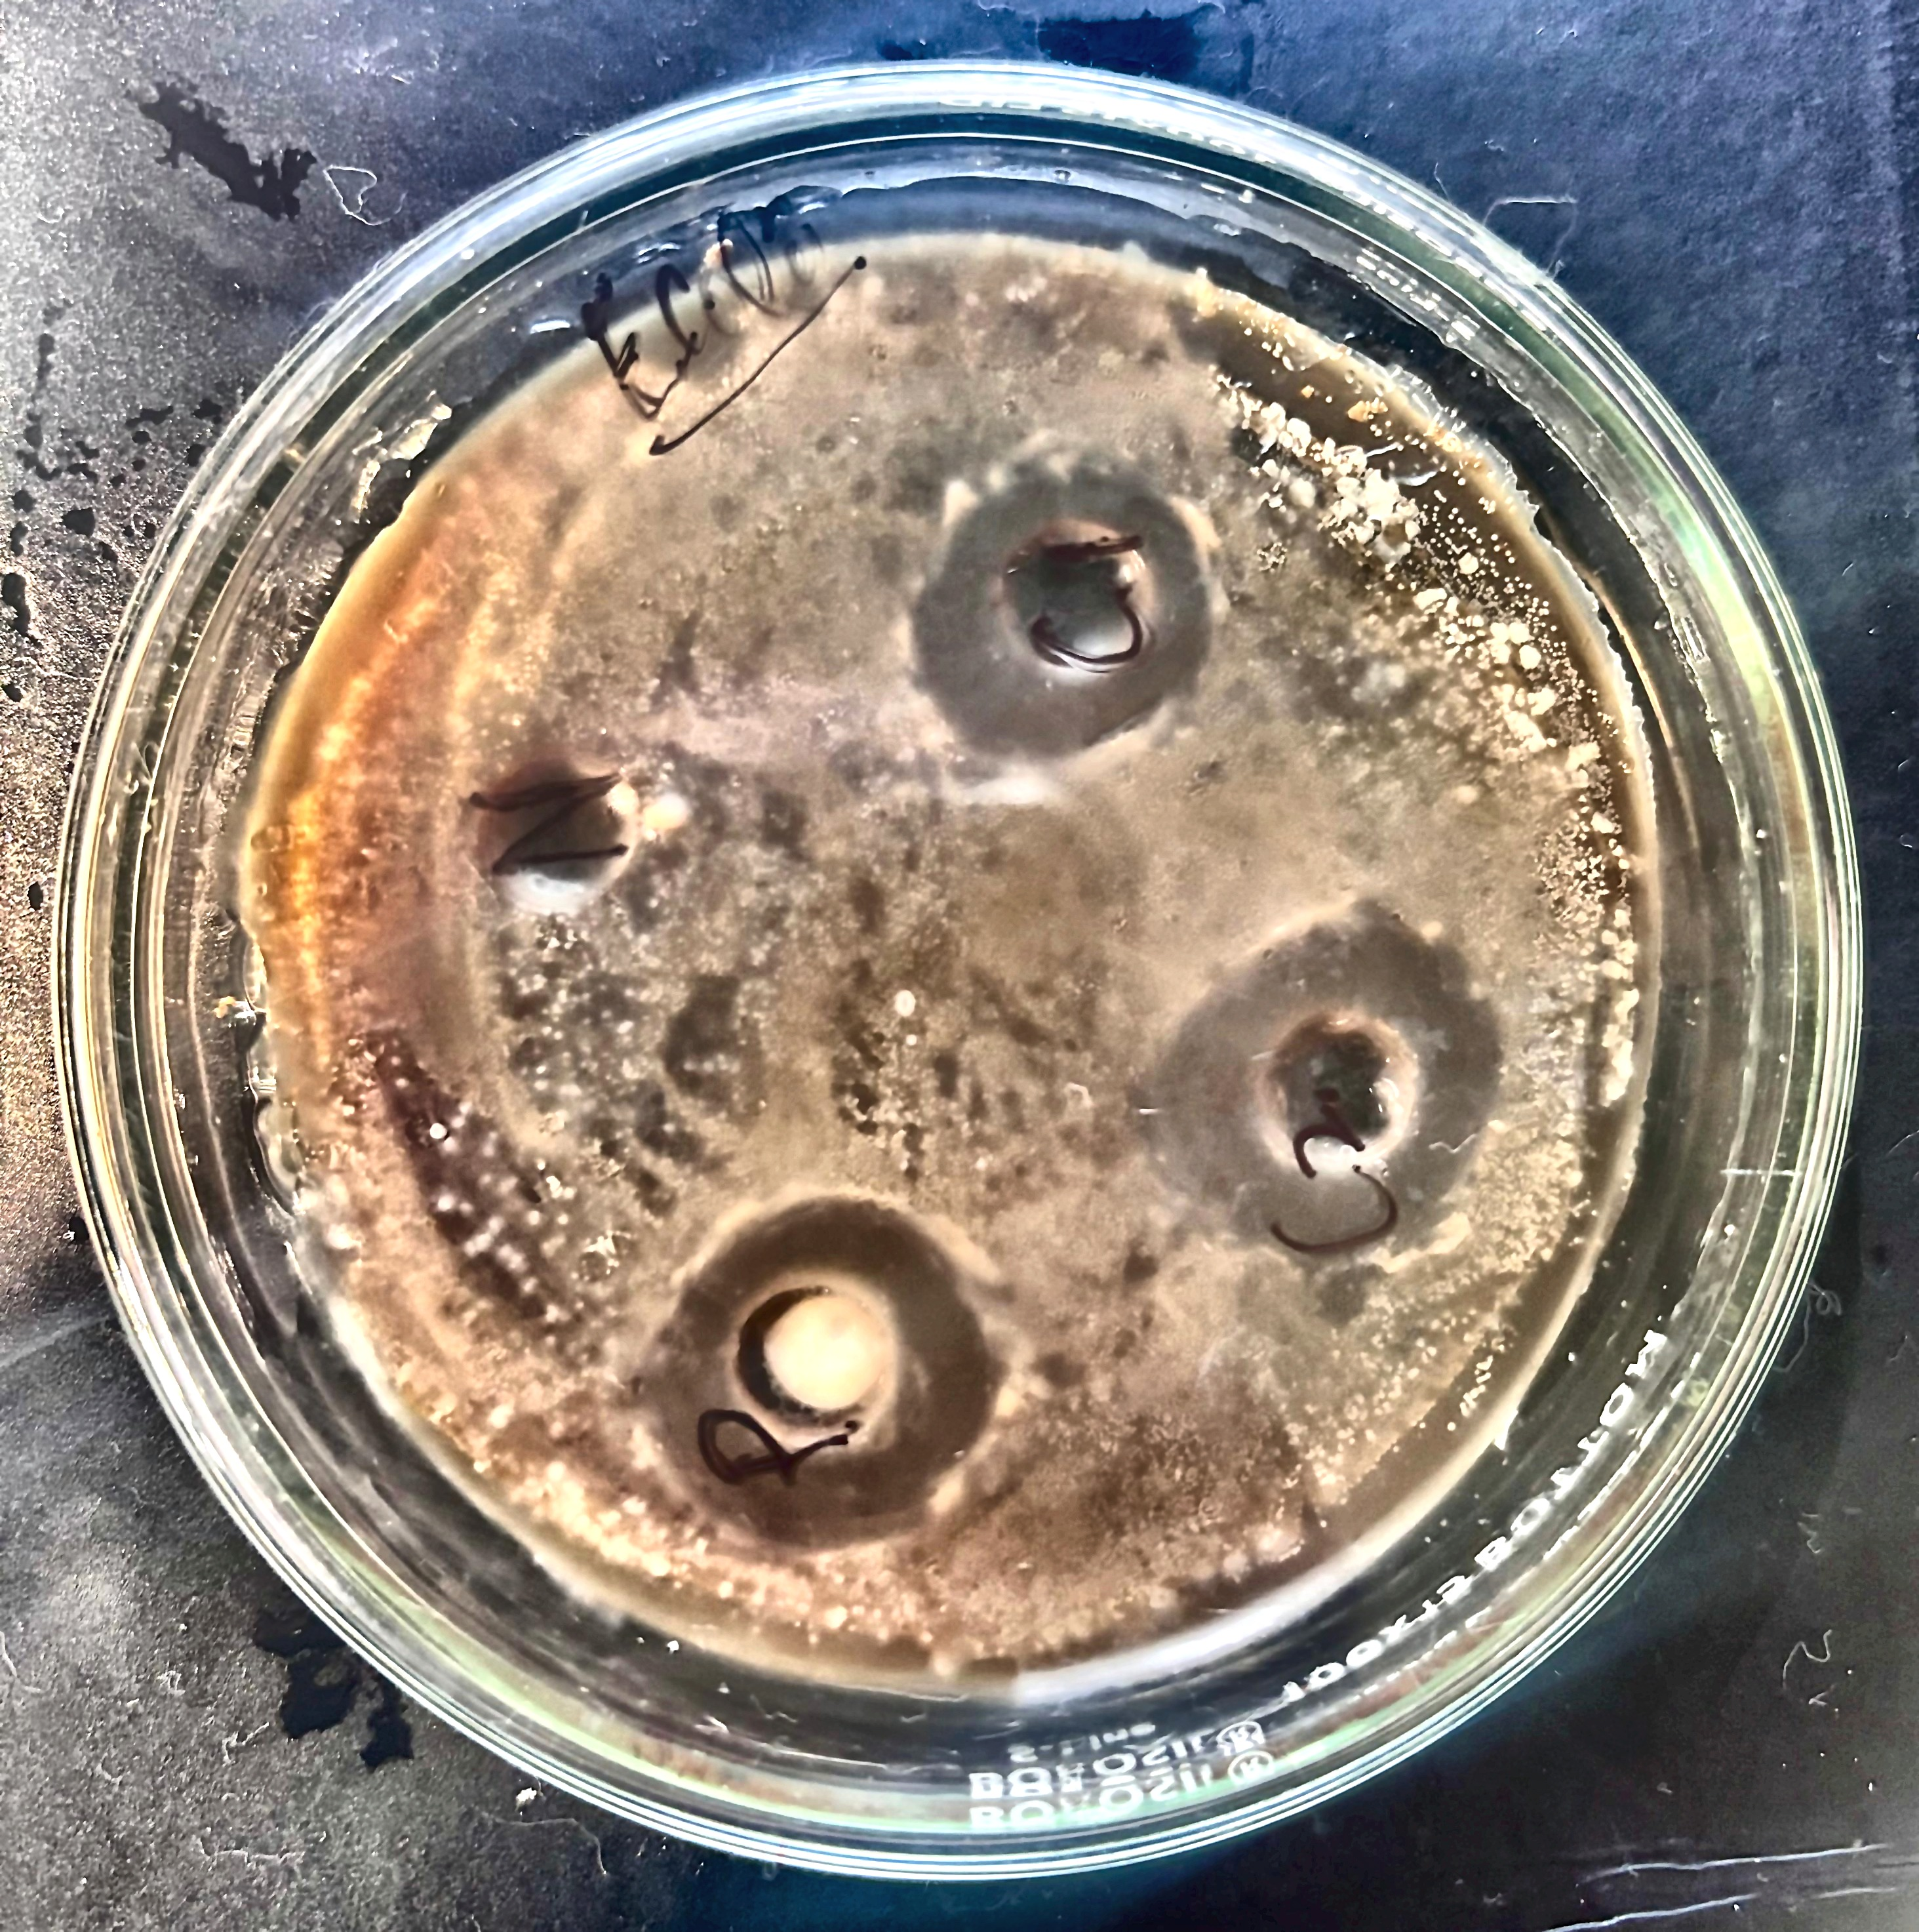
Fig. 8a. Agar well diffusion plate for Escherichia coli, showing the wells loaded with the aqueous extract (C1, C2) and the negative control
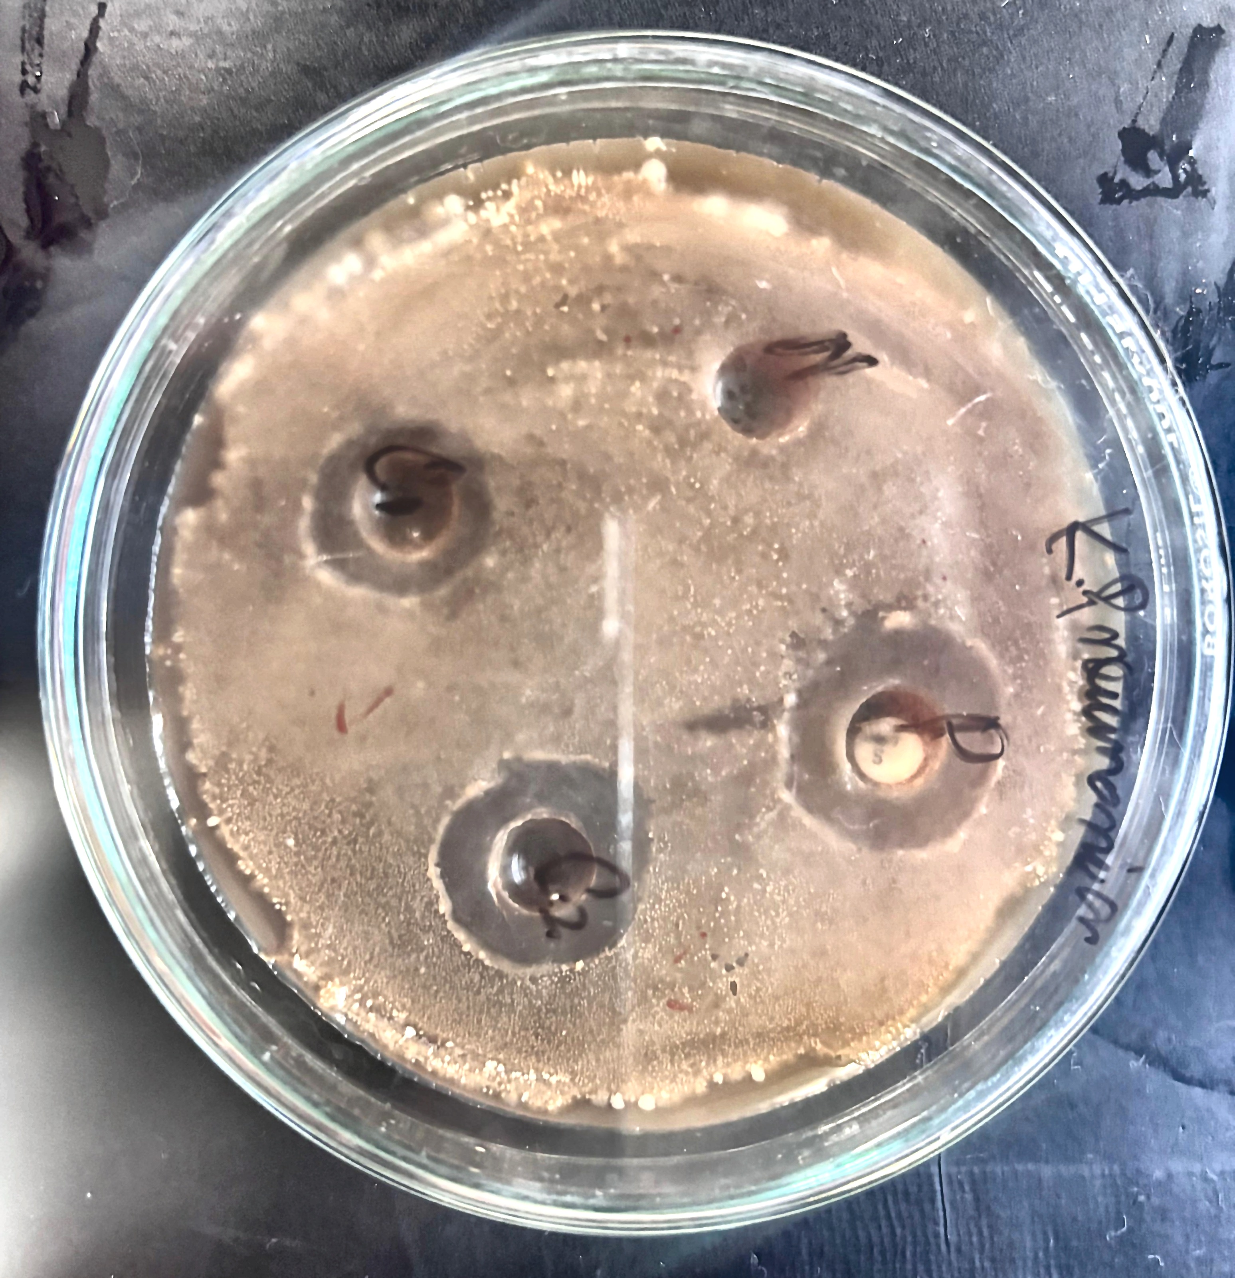
Fig. 8b. Agar well diffusion plate for Klebsiella pneumoniae, showing the wells loaded with the aqueous extract (C1, C2) and the negative control
[Insert Fig. 8c here: photograph of the corresponding agar well diffusion plate for Pseudomonas aeruginosa, once available.]
[Insert Fig. 9 here: a bar graph comparing the mean zone of inhibition produced against E. coli, P. aeruginosa, and K. pneumoniae at C1 and C2, alongside the Gentamicin control.]
[Insert overall summary once all three tables are complete — e.g., which organism was most/least susceptible to the aqueous extract, whether the extract's activity was concentration-dependent across all three organisms, and how its magnitude compared with the Gentamicin control.]

5. Discussion
[The narrative sections below are structured for you to complete once the actual zone of inhibition results (Tables 3a–3c) are filled in. Sections grounded in confirmed facts — the extraction yield and the phytochemical rationale — have already been written.]

5.1 Extraction Yield in Context
The 24.13% (w/w) yield obtained for the aqueous extract in the present study is substantially higher than the 2.72% and 2.9% yields reported by Drakhshaan et al. (2026) for the dichloromethane and methanolic extracts of D. inermis, respectively, prepared from the same starting material. This is consistent with the general behaviour of water as an extraction solvent: being highly polar and miscible with a broad range of plant constituents, water tends to co-extract not only phenolics, flavonoids, tannins, and glycosides but also bulk polar material such as soluble sugars, mucilage, and polysaccharides, resulting in a higher overall crude yield than more selective organic solvents such as dichloromethane. A higher crude yield does not, however, imply a proportionally higher concentration of antibacterially active constituents — indeed, it may reflect a greater proportion of inert or non-bioactive polar material — and this distinction is relevant to interpreting the zone of inhibition results that follow.

5.2 Antibacterial Activity Observed
The aqueous extract of D. inermis [insert whether it did / did not produce measurable zones of inhibition] against E. coli, P. aeruginosa, and K. pneumoniae at the concentrations tested (C1, 50 µg; C2, 100 µg). [Insert whether a concentration-dependent increase in ZOI was observed between C1 and C2 for each organism, and which organism was most and least susceptible to the extract.]

5.3 Comparison with Organic Solvent Extracts of D. inermis
For context, Table 4 compares the present findings for the aqueous extract with the zone of inhibition values reported by Drakhshaan et al. (2026) for dichloromethane (DCM) and methanolic (MeOH) extracts of D. inermis against E. coli and P. aeruginosa — the two organisms common to both studies.

Treatment | E. coli ZOI (mm) | P. aeruginosa ZOI (mm)
Present study — Aqueous extract | [ __ ± __ ] | [ __ ± __ ]
DCM extract, 100 µg/mL (Drakhshaan et al., 2026) | 15.93 ± 0.11 | 16.83 ± 0.29
DCM extract, 50 µg/mL (Drakhshaan et al., 2026) | 12.93 ± 0.11 | 13.10 ± 0.17
MeOH extract, 100 µg/mL (Drakhshaan et al., 2026) | 15.80 ± 0.34 | 15.17 ± 0.29
MeOH extract, 50 µg/mL (Drakhshaan et al., 2026) | 11.13 ± 0.23 | 9.07 ± 0.11
Gentamicin, 10 µg (Drakhshaan et al., 2026) | 15.00 ± 0.12 | 14.50 ± 0.30

Table 4. Comparison of present findings with zone of inhibition values reported for DCM and MeOH extracts of D. inermis (Drakhshaan et al., 2026)

[Insert comparative discussion once results are available — e.g., ‘The aqueous extract produced a smaller/comparable/larger zone of inhibition than the DCM and MeOH extracts reported by Drakhshaan et al. (2026)...’]

5.4 Possible Phytochemical Basis for the Observed Activity
The phytochemical profile reported for D. inermis provides a plausible mechanistic basis for interpreting the present findings. Drakhshaan et al. (2026) found the antibacterial dichloromethane extract to be dominated by terpenoids, steroids, sesquiterpenoids, and fatty acids (identified by GC-MS), while the methanolic extract was characterised chiefly by phenolic and flavonoid constituents — including rutin, reserpine, and ferulic acid — identified by HPLC. Aqueous extraction, being a highly polar process, is inherently far less efficient than dichloromethane at solubilising non-polar terpenoids and steroids, but is well suited to recovering polar phenolics, flavonoids, tannins, and glycosides. On this basis, any antibacterial activity produced by the aqueous extract in the present study would be mechanistically attributable chiefly to these polar constituents, acting principally through membrane permeabilisation and protein/enzyme complexation rather than through the membrane-lipid disruption associated with terpenoids and steroids (Cowan, 1999; Jubair et al., 2021; see also Section 2.2). Conversely, if the aqueous extract showed markedly weaker activity than the organic solvent extracts reported previously, this would itself be consistent with the terpenoid- and steroid-dominated profile of the more active DCM extract, and would support the inference that these non-polar constituents are the principal drivers of D. inermis's antibacterial potential rather than its polar phytochemical fraction.
[Insert which of the above two scenarios the present data support, and any organism-specific variation observed (e.g., Gram-negative cell-envelope differences between E. coli/K. pneumoniae, which possess a classical outer membrane and LPS layer, and P. aeruginosa, which additionally exhibits constitutive efflux pump activity and low outer-membrane permeability — see Section 2.5).]

5.5 Klebsiella pneumoniae: A Novel Data Point
No previous study, to the best of available literature, has reported the antibacterial activity of D. inermis — in any extract form — specifically against Klebsiella pneumoniae. [Insert discussion of the present study's findings for K. pneumoniae specifically, noting whether they support or do not support the extract's potential against this organism, and highlighting that this represents a new data point for the species regardless of the direction of the result.]

5.6 Comparison with Regional Literature
The findings of Wani, Singh and Pal (2017), who reported in vitro antimicrobial activity of D. inermis collected from the Kashmir Valley, provide a regional precedent broadly consistent with the antibacterial potential of the species; the present findings extend this regional evidence specifically to an aqueous extract and to K. pneumoniae as a test organism.

5.7 Limitations
[Insert any additional discussion of limitations — e.g., only two extract concentrations tested, ZOI-only assessment without MIC determination, absence of instrumental (GC-MS/HPLC) phytochemical characterisation of the aqueous extract itself, sample size, or single-laboratory measurement without inter-observer verification of zone diameters.]

6. Conclusion
The present study evaluated the in vitro antibacterial efficacy of an aqueous extract of Dipsacus inermis against three clinically important Gram-negative bacterial strains — Escherichia coli, Pseudomonas aeruginosa, and Klebsiella pneumoniae — using the agar well diffusion technique, with efficacy assessed in terms of the zone of inhibition. [Insert overall summary of findings once results are available — e.g., whether the aqueous extract demonstrated antibacterial activity against all three organisms, and the general order of susceptibility observed.]
[Insert concluding statement on the significance of the findings — e.g., whether the results support the traditional use of D. inermis as an antibacterial agent, and whether they extend existing knowledge (from organic solvent extracts) to the aqueous extract form and to K. pneumoniae specifically.]
While the present in vitro findings provide preliminary evidence regarding the antibacterial potential of the aqueous extract of D. inermis, further studies are recommended, including phytochemical screening and quantification of the aqueous extract itself, determination of the minimum inhibitory concentration (MIC) against the tested organisms, evaluation of a wider range of extract concentrations, and eventual in vivo validation, before any therapeutic application can be considered.
In conclusion, this study contributes to the limited body of literature on the aqueous extract of D. inermis and reinforces the broader case for continued screening of regionally available medicinal plants of the Kashmir Himalaya as potential sources of plant-derived antibacterial agents against clinically significant, and increasingly resistant, Gram-negative pathogens.

7. References
(APA style; arranged alphabetically. All entries below correspond to real, published sources cited in this dissertation.)
Antimicrobial Resistance Collaborators. (2022). Global burden of bacterial antimicrobial resistance in 2019: A systematic analysis. The Lancet, 399(10325), 629–655. https://doi.org/10.1016/S0140-6736(21)02724-0
Clinical and Laboratory Standards Institute (CLSI). (2024). Performance standards for antimicrobial susceptibility testing (34th ed.).
Cowan, M. M. (1999). Plant products as antimicrobial agents. Clinical Microbiology Reviews, 12(4), 564–582. https://doi.org/10.1128/CMR.12.4.564
Drakhshaan, Chohan, T. A., Qayyum, A., Alzahrani, A. R., Mansour, A. A., Alzahrani, H. A., Khan, A., & Khan, M. U. (2026). Identification of antimicrobial compounds in Dipsacus inermis via phytochemical profiling, in vitro assessment, and advanced computational techniques. PLoS ONE, 21(2), e0341424. https://doi.org/10.1371/journal.pone.0341424
Hassan, S., Sajjad, N., Khan, S. U., Gupta, S., Bhat, M. A., Ali, R., et al. (2020). Dipsacus inermis Wall. modulates inflammation by inhibiting NF-κB pathway: An in vitro and in vivo study. Journal of Ethnopharmacology, 254, 112710. https://doi.org/10.1016/j.jep.2020.112710
Jubair, N., Rajagopal, M., Chinnappan, S., Abdullah, N. B., & Fatima, A. (2021). Review on the antibacterial mechanism of plant-derived compounds against multidrug-resistant bacteria (MDR). Evidence-Based Complementary and Alternative Medicine, 2021, 3663315. https://doi.org/10.1155/2021/3663315
Liebold, T., Straubinger, R. K., & Rauwald, H. W. (2011). Growth inhibiting activity of lipophilic extracts from Dipsacus sylvestris Huds. roots against Borrelia burgdorferi s. s. in vitro. Pharmazie, 66(8), 628–630.
Oszmiański, J. (2020). Roots and leaf extracts of Dipsacus fullonum L. and their biological activities. Plants, 9(1), 78.
Skała, E., & Szopa, A. (2023). Dipsacus and Scabiosa species — The source of specialized metabolites with high biological relevance: A review. Molecules, 28(9), 3754. https://doi.org/10.3390/molecules28093754
Wani, I. M., Singh, K., & Pal, A. (2017). In-vitro phytochemical and antimicrobial activity of Dipsacus inermis in Kashmir Valley. International Journal of Science and Research (IJSR), 6(3), 586–592.
Zhao, Y.-M., & Shi, Y.-P. (2011). Phytochemicals and biological activities of Dipsacus species. Chemistry & Biodiversity, 8(3), 414–430. https://doi.org/10.1002/cbdv.201000022

Appendix A: Raw Data Recording Template
The blank tables below are provided as a ready-to-use template for recording the raw, triplicate zone of inhibition (ZOI) measurements obtained during the agar well diffusion assay (extract concentrations and negative control) and the disc diffusion assay (Gentamicin positive control) for each test organism. These should be completed directly from laboratory observations and used to calculate the mean ± SD values reported in Table 3 (Chapter 4).

Escherichia coli
E. coli | Replicate 1 (mm) | Replicate 2 (mm) | Replicate 3 (mm)
Aqueous extract — C1 (50 µg) [well diffusion]
Aqueous extract — C2 (100 µg) [well diffusion]
Positive control (Gentamicin) [disc diffusion]
Negative control [well diffusion]

Pseudomonas aeruginosa
P. aeruginosa | Replicate 1 (mm) | Replicate 2 (mm) | Replicate 3 (mm)
Aqueous extract — C1 (50 µg) [well diffusion]
Aqueous extract — C2 (100 µg) [well diffusion]
Positive control (Gentamicin) [disc diffusion]
Negative control [well diffusion]

Klebsiella pneumoniae
K. pneumoniae | Replicate 1 (mm) | Replicate 2 (mm) | Replicate 3 (mm)
Aqueous extract — C1 (50 µg) [well diffusion]
Aqueous extract — C2 (100 µg) [well diffusion]
Positive control (Gentamicin) [disc diffusion]
Negative control [well diffusion]

Date(s) of experiment: _______________________________
Batch/lot of aqueous extract used: _______________________________
Name of positive control agent and concentration: _______________________________
Recorded by: _______________________________ Verified by (Supervisor): _______________________________

