ANTIBACTERIAL POTENTIAL OF Dipsacus inermis: AN in vitro STUDY
DISSERTATION
Submitted in partial fulfillment of the requirements for the award of the degree of
MASTER OF SCIENCE
in
ZOOLOGY
Submitted By:
BAZILLA SALEEM
Enrollment No: 24061119001
Batch: 2024
Under the Supervision of:
PROF. FAYAZ AHMAD
Professor
Department of Zoology
ADVANCED RESEARCH LABORATORY
DEPARTMENT OF ZOOLOGY
SCHOOL OF BIOLOGICAL SCIENCES
UNIVERSITY OF KASHMIR
HAZRATBAL, SRINAGAR-190006, J&K
(NAAC Accredited Grade ‘A++’)
SEPTEMBER 2026

DEPARTMENT OF ZOOLOGY
SCHOOL OF BIOLOGICAL SCIENCES
UNIVERSITY OF KASHMIR, HAZRATBAL, SRINAGAR-190006
(NAAC Accredited Grade ‘A++’)
CERTIFICATE
This is to certify that the dissertation entitled “Antibacterial potential of Dipsacus inermis: an in vitro study” is based on the original research work carried out by Ms. BAZILLA SALEEM, Enrollment No. 24061119001, Batch 2024, under the course M.Sc. Zoology, under my guidance and supervision from March 2026 to September 2026 at the Advanced Research Laboratory, Department of Zoology, School of Biological Sciences, University of Kashmir, Srinagar-190006, J&K.
This dissertation is being submitted to the Department of Zoology, School of Biological Sciences, University of Kashmir, Srinagar-190006, J&K, for the partial fulfilment of the requirements for the award of the Degree of Master of Science in Zoology.
It is further certified that the candidate has fulfilled all the statutory requirements and that this work has not been submitted previously to this or any other university or institution for any degree or diploma.
Prof. Fayaz Ahmad
Supervisor
Department of Zoology
School of Biological Sciences
University of Kashmir
Prof. Tariq Ahmad
Head of the Department / Dean
Department of Zoology
School of Biological Sciences
University of Kashmir

DEPARTMENT OF ZOOLOGY
SCHOOL OF BIOLOGICAL SCIENCES
UNIVERSITY OF KASHMIR, HAZRATBAL, SRINAGAR-190006
(NAAC Accredited Grade ‘A++’)
DECLARATION BY THE CANDIDATE
I, BAZILLA SALEEM, hereby declare that the dissertation entitled “Antibacterial potential of Dipsacus inermis: an in vitro study” submitted to the Department of Zoology, School of Biological Sciences, University of Kashmir, Srinagar, is my original work carried out under the supervision of Prof. Fayaz Ahmad, Professor, Department of Zoology, University of Kashmir.
I further declare that this work has not been submitted earlier to any other University or Institution for the award of any degree or diploma. I also declare that all sources of information, published literature, data, and scientific references used in this dissertation have been properly acknowledged, cited, and listed in the bibliography as per academic standards.
Dated:
Place: Srinagar, J&K
BAZILLA SALEEM
Enrollment No: 24061119001
M.Sc. Zoology (Batch 2024)
Department of Zoology
University of Kashmir

ACKNOWLEDGEMENTS
All praise and gratitude are due to Almighty Allah, the Most Beneficent and the Most Merciful, for granting me the health, strength, and perseverance to complete this dissertation entitled “Antibacterial potential of Dipsacus inermis: an in vitro study”.
I thank my supervisor, Prof. Fayaz Ahmad, Department of Zoology, School of Biological Sciences, University of Kashmir, Srinagar. His guidance, comments, and laboratory access were central to finishing this work.
I also thank Prof. Tariq Ahmad, Head, Department of Zoology, and Dean, School of Biological Sciences, University of Kashmir, for laboratory, library, and departmental support.
I thank the faculty of the Department of Zoology for their advice and discussion during my M.Sc. programme.
I thank the Centre for Biodiversity and Taxonomy, Department of Botany, University of Kashmir, for botanical authentication of the plant material, and the Kashmir University Botanical Garden for access to the collection site.
I thank the senior research scholars, laboratory colleagues, and friends at the Advanced Research Laboratory, Department of Zoology, for help with cultures, media, and screening.
I am thankful to the administrative, technical, and non-teaching staff of the Department of Zoology, particularly the laboratory assistants, for help with equipment and logistics.
I thank my parents, siblings, and family for their support, prayers, and encouragement.
BAZILLA SALEEM
Enrollment No: 24061119001

ABSTRACT
Antimicrobial resistance among Gram-negative bacteria remains a clinical problem. The outer membrane limits the entry of many drugs. Pumps and enzymes then reduce the effect of those that do enter. Escherichia coli, Pseudomonas aeruginosa, and Klebsiella pneumoniae cause urinary, wound, lung, and bloodstream infection. Plant extracts are therefore one source of antibacterial compounds.
Medicinal plants contain alkaloids, flavonoids, phenolics, tannins, saponins, terpenoids, and related glycosides. These classes can disturb membranes, bind proteins, and interfere with adhesion. Water is the solvent used in many household decoctions. An aqueous extract is therefore closer to traditional use than a dichloromethane or methanol extract, even if water recovers a different set of constituents.
Dipsacus inermis Wall., the Himalayan teasel, belongs to Caprifoliaceae. It grows in the Kashmir Himalaya and is known locally as wopal haakh. Folklore records use of the leaves for inflammation, cough, and postnatal bathing. Earlier laboratory work on this species has focused on organic-solvent extracts and on anti-inflammatory models. The antibacterial behaviour of a simple aqueous Soxhlet extract, read only as a zone of inhibition on seeded agar, has received less attention. Klebsiella pneumoniae has not been a regular test organism in that literature.
The present study was carried out at the Advanced Research Laboratory, Department of Zoology, University of Kashmir. Aerial material was collected from the Kashmir University Botanical Garden, authenticated at the Centre for Biodiversity and Taxonomy, shade-dried, powdered, and extracted with distilled water in a Soxhlet apparatus. The extract was concentrated and reconstituted at a lower working strength and at an elevated working strength. Qualitative tube tests recorded the main metabolite classes. Antibacterial activity was then scored only as the zone of inhibition against the three named pathogens. Distilled water was the negative control. A gentamicin GEN 5 paper disc was the positive control.
Phytochemical tests gave positive reactions for flavonoids, terpenoids, quinones, alkaloids, tannins, saponins, phenols, carbohydrates, and phytosterols. Saponin tubes held a persistent froth. Distilled water produced no zone of clearance on any plate, which indicates that the solvent itself did not suppress growth. Both extract strengths produced visible zones. The lower strength gave a pronounced zone against Pseudomonas aeruginosa. The elevated strength enlarged the zone against Escherichia coli and, more modestly, against Klebsiella pneumoniae, but did not enlarge the zone against Pseudomonas aeruginosa. The gentamicin disc produced a wide zone on every plate and remained the strongest comparator.
The pattern is consistent with polar phenolics, tannins, flavonoids, and saponins recovered by water, acting against organisms that still possess an outer-membrane barrier. It does not support a uniform rise in activity with extract strength, and it does not replace a minimum inhibitory concentration assay. Within those limits, the aqueous extract of Dipsacus inermis showed in vitro antibacterial activity against the three Gram-negative isolates tested here.
Key words: Dipsacus inermis, aqueous extract, phytochemical screening, disc diffusion, zone of inhibition, gentamicin, Gram-negative bacteria, Kashmir.

LIST OF ACRONYMS / ABBREVIATIONS
AMR | Antimicrobial resistance
CBT | Centre for Biodiversity and Taxonomy
CLSI | Clinical and Laboratory Standards Institute
DCM | Dichloromethane
FeCl$​_{3}$ | Ferric chloride
GEN | Gentamicin (disc marked GEN 5)
HCl | Hydrochloric acid
HPLC | High-performance liquid chromatography
KUBG | Kashmir University Botanical Garden
LB | Luria–Bertani
LC-MS | Liquid chromatography–mass spectrometry
LPS | Lipopolysaccharide
MBC | Minimum bactericidal concentration
MeOH | Methanol
MET | Methicillin (disc marked MET 5; not the tabulated control)
MIC | Minimum inhibitory concentration
NaOH | Sodium hydroxide
RND | Resistance–nodulation–division efflux family
SD | Standard deviation
WGS84 | World Geodetic System 1984
WHO | World Health Organization
ZOI | Zone of inhibition

1 Introduction
Antimicrobial resistance (AMR) is the capacity of a bacterium to grow in the presence of a drug that once suppressed it. Gram-negative rods are a large part of that problem because their outer membrane, built from lipopolysaccharide (LPS) and porin proteins, slows the entry of many antibiotics (Nikaido 2003; Pagès et al. 2008). Pumps of the resistance–nodulation–division (RND) family then remove drug that does enter (Poole 2005). Escherichia coli, Pseudomonas aeruginosa, and Klebsiella pneumoniae are listed among current priority pathogens for that reason (Antimicrobial Resistance Collaborators 2022; World Health Organization 2024). They cause urinary tract infection, pneumonia, wound infection, and bacteraemia in hospitals and in the community.
The 2019 global burden analysis linked bacterial AMR to a large share of infectious deaths, with these three organisms among the leading contributors (Antimicrobial Resistance Collaborators 2022). The World Health Organization bacterial priority list keeps carbapenem-resistant Acinetobacter, Enterobacterales, and P. aeruginosa in the critical group (World Health Organization 2024). Plant secondary metabolites remain a source of compounds that act on membranes and proteins rather than on a single enzyme (Cowan 1999; Jubair et al. 2021).
Water extracts are not equivalent to dichloromethane or methanol extracts. Water favours phenolics, tannins, flavonoids, saponins, and glycosides. Non-polar solvents favour terpenoids and steroids (Cowan 1999; Azwanida 2015). Traditional decoctions are aqueous. An in vitro screen of a water extract therefore answers a different question from a screen of an organic extract of the same plant.

1.1 Gram-negative test organisms
Escherichia coli is a facultative rod of the Enterobacterales. Commensal strains occupy the gut. Pathogenic lineages cause urinary infection, diarrhoea, neonatal meningitis, and bloodstream infection. Extended-spectrum beta-lactamases and carbapenemases are now common in clinical collections (Antimicrobial Resistance Collaborators 2022).
Pseudomonas aeruginosa is an aerobic opportunistic rod. It produces pigments, forms biofilms, and expresses inducible AmpC, low outer-membrane permeability, and several RND pumps (Hancock and Speert 2000; Poole 2005). Burn wounds, ventilated lungs, and catheters are typical sites.
Klebsiella pneumoniae is a capsulated, non-motile enterobacterium. The capsule resists phagocytosis. Hospital pneumonia, urinary infection, liver abscess, and bacteraemia are typical presentations. Carbapenemase-producing lineages are treated as a critical-priority group (World Health Organization 2024). The three organisms therefore share an outer-membrane barrier but differ in pump repertoire and capsule, which is why they were tested in parallel.

1.2 The study plant
Dipsacus inermis Wall. is a perennial herb of the genus Dipsacus. Older floras placed the genus in Dipsacaceae. The Angiosperm Phylogeny Group treatment folds that family into Caprifoliaceae sensu lato (Angiosperm Phylogeny Group 2016; Skała and Szopa 2023). The plant is recognised by opposite leaves, a ridged stem, and a solitary globose head of florets on a long peduncle. Flowering in the western Himalaya falls in the summer monsoon months. Local Kashmiri names include wopal haakh (Skała and Szopa 2023; Lone et al. 2015).
The genus is rich in triterpenoid saponins, iridoid glycosides, and phenolics (Zhao and Shi 2011; Skała and Szopa 2023). Lipophilic root extracts of the related Dipsacus sylvestris inhibit Borrelia burgdorferi in vitro (Liebold et al. 2011). Leaf and root extracts of Dipsacus fullonum also show biological activity (Oszmiański et al. 2020). For D. inermis itself, a Kashmir group reported NF-$κ$B-dependent anti-inflammatory activity in vitro and in vivo (Hassan et al. 2020). Dichloromethane and methanol extracts of the species inhibit several bacteria in well-diffusion and broth-dilution assays, with the dichloromethane fraction the more active of the two (Drakhshaan et al. 2026). Those antibacterial data do not include an aqueous Soxhlet extract, and they do not include K. pneumoniae.

1.3 Rationale
The experimental gap is limited. Aqueous Soxhlet extraction is the form closest to a decoction. The antibacterial procedure in this study is limited to a diffusion assay on seeded agar, scored only as the zone of inhibition. Gentamicin on a paper disc (GEN 5, 5 µg) is the positive control. Distilled water is the negative control. The work was done with plant material from the Kashmir University Botanical Garden and with bacterial stocks held in the Advanced Research Laboratory, Department of Zoology.

1.4 Objectives of the study
The study was carried out with the following objectives:
- To collect Dipsacus inermis from the Kashmir University Botanical Garden, obtain botanical authentication, and prepare an aqueous extract by Soxhlet extraction followed by concentration.
- To record the preliminary qualitative phytochemical profile of that aqueous extract across the major secondary-metabolite classes that the tube tests can detect.
- To measure the in vitro antibacterial effect of the extract at two working concentrations against Escherichia coli, Pseudomonas aeruginosa, and Klebsiella pneumoniae sourced from the Advanced Research Laboratory, using disc diffusion for gentamicin GEN 5, distilled water as the negative control, and zone of inhibition as the sole measurement.

2 Review of Literature
The literature is arranged by date, oldest first, in three geographic tiers. International work on Dipsacus, related Caprifoliaceae, plant antimicrobials, and Gram-negative envelopes comes first. Indian work on medicinal-plant extraction and clinical Gram-negative resistance comes second. Kashmir Himalayan ethnobotany and laboratory studies of Dipsacus inermis come last.

2.1 International studies
Jensen et al. (1979) isolated and characterised novel bis-iridoid glucosides from Dipsacus sylvestris, establishing cantleyoside as a dimeric iridoid glucoside formed through bridge condensation between iridoid and secoiridoid units. The investigation demonstrated that cyclopentanoid monoterpene iridoids, including loganin and sweroside, constitute distinctive chemotaxonomic markers across the order Dipsacales. Owing to their polyhydroxylated glucopyranosyl substituents, these iridoid glucosides possess high water solubility and partition readily into boiling aqueous decoctions and Soxhlet liquors.
Li et al. (1995) identified the tripartite organisation of the primary resistance-nodulation-division (RND) multidrug efflux system in Pseudomonas aeruginosa, encoded by the mexA-mexB-oprM operon. The inner-membrane transporter MexB functions as a proton-motive-force-dependent antiporter, supported by the periplasmic membrane-fusion protein adaptor MexA and the outer-membrane duct OprM. Substrates captured from the inner leaflet or periplasm are extruded across the outer membrane through the trimeric OprM channel without releasing them into the cytoplasm.
Cowan (1999) catalogued plant secondary metabolites with antimicrobial activity. Phenolics and flavonoids were described as membrane-active. Tannins were described as protein-binding and metal-chelating. Terpenoids were described as lipophilic disruptors of the bilayer. Alkaloids, saponins, and quinones were assigned intercalation, pore formation, and thiol binding, respectively. The review is still the standard starting point for a crude-extract screen because it links solvent polarity to the metabolite class recovered.
Hancock and Speert (2000) summarised why Pseudomonas aeruginosa fails many antimicrobial agents that inhibit other Gram-negative rods. Low outer-membrane permeability, inducible chromosomal AmpC $β$-lactamase, and multiple active RND efflux systems function concurrently to restrict intracellular drug concentrations. The paper is relevant here because one of the three test strains is P. aeruginosa, and non-linear zone responses across concentrations require evaluation against that envelope background.
Masuda et al. (2000) examined substrate specificities of the P. aeruginosa efflux systems MexAB-OprM, MexCD-OprJ, and MexXY-OprM. MexAB-OprM displayed broad substrate promiscuity, accommodating structurally diverse amphiphilic and lipophilic compounds, aromatic structures, and hydrophobic organic molecules.
Nikaido (2003) restated the structural basis of Gram-negative outer-membrane permeability. Asymmetric lipopolysaccharide (LPS) packaging in the outer leaflet, stabilised by divalent cation bridges, retards passive permeation of hydrophobic terpenoids, whereas polar solutes depend upon proteinaceous water-filled porin channels. In crude aqueous extracts, polar phenolics and saponins encounter this outer leaflet as their initial cellular barrier.
Poole (2005) reviewed active efflux as a coordinated Gram-negative resistance mechanism. RND pumps in P. aeruginosa operate synergistically with the low-permeability outer envelope: slow inward diffusion through narrow or gated porins enables active extrusion to maintain sub-inhibitory intracellular concentrations of diverse xenobiotics, including plant polyphenols and glycosides.
Pagès et al. (2008) described porin channel regulation as a selective diffusion barrier. Down-regulation or conformational closure of outer-membrane channels limits the influx of hydrophilic agents. In an agar diffusion assay, porin gating and active extrusion govern the threshold concentration required to arrest bacterial lawn growth.
Zhao and Shi (2011) comprehensively reviewed the phytochemical profile and biological activities of Dipsacus species. Triterpenoid saponins and iridoids represent the primary specialized metabolite classes characteristic of the genus. Pentacyclic triterpenoid saponins of Dipsacus are based on an oleanane skeleton, primarily featuring hederagenin ($3β,23$-dihydroxyolean-12-en-28-oic acid) as the aglycone. Among these, dipsacoside B is a prominent bidesmosidic saponin with a C-3 glycosidic chain (hederagenin 3-$O$-$α$-L-rhamnopyranosyl-(1$→$2)-$α$-L-arabinopyranoside) and a C-28 ester-linked gentiobiose moiety (28-$O$-$β$-D-glucopyranosyl-(1$→$6)-$β$-D-glucopyranosyl ester). Asperosaponin VI (akebia saponin D) carries an identical hederagenin core with an arabinopyranoside at C-3 and a gentiobiosyl ester at C-28, serving as the official statutory quality marker for Dipsaci Radix in pharmacopoeial monographs. The amphiphilic character of these bidesmosidic saponins imparts surfactant properties, enabling them to perturb lipid packing and form transient pores in microbial bilayers. Zhao and Shi (2011) also documented monoterpene iridoids, notably loganin, sweroside, and cantleyoside derivatives, confirming that hot aqueous extractions recover both saponins and iridoids in abundance.
Liebold et al. (2011) tested lipophilic extracts of Dipsacus sylvestris roots against Borrelia burgdorferi sensu stricto. Growth was inhibited in vitro. The solvent was not water, and the organism was a spirochaete, not an enteric rod. The result still supports the broader claim that Dipsacus tissues yield biologically active antimicrobial fractions.
Azwanida (2015) compared maceration, Soxhlet, ultrasound, and related methods. Soxhlet was described as exhaustive and reproducible for a defined solvent, with heat as the main drawback for thermolabile constituents. Distilled water as the Soxhlet solvent is therefore a deliberate choice: it matches decoction chemistry and accepts some thermal cost.
Balouiri et al. (2016) reviewed diffusion and dilution assays. Disc diffusion remains the Kirby–Bauer format for a standard antibiotic (Bauer et al. 1966; Clinical and Laboratory Standards Institute 2024). Zone diameter is semi-quantitative. It is not a minimum inhibitory concentration. The present study uses that diffusion readout only: zone of inhibition, measured inclusive of the disc.
The Angiosperm Phylogeny Group IV classification (Angiosperm Phylogeny Group 2016) updated familial circumscriptions for flowering plants, placing the order Dipsacales within the asterid clade Campanulids (euasterids II). Under APG IV, the historically segregated family Dipsacaceae Juss. is treated as subfamily Dipsacoideae Eaton within a broadly circumscribed Caprifoliaceae Juss. sensu lato. This phylogenetic placement groups Dipsacus alongside honeysuckles and scabious herbs, reflecting shared morphological traits and common biosynthetic pathways for iridoid glucosides and oleanane saponins.
Chevalier et al. (2017) detailed the structure, function, and regulation of P. aeruginosa outer-membrane porins, explaining why its outer envelope restricts polar solute uptake far more than that of E. coli. The major porin, OprF, exists primarily (over 95%) as a closed two-domain conformer with low single-channel conductance, whereas only a minor fraction (1–5%) adopts an open 16-stranded $β$-barrel conformation. This structural gating accounts for the low baseline permeability of the P. aeruginosa outer membrane, setting a stringent barrier to passive influx of water-soluble phytochemicals.
Oszmiański et al. (2020) reported phenolic profiles and biological activity of root and leaf extracts of Dipsacus fullonum. The paper adds a European teasel to the set of chemically studied species and shows that leaves, not only roots, carry phenolics.
Jubair et al. (2021) updated mechanisms of plant compounds against multidrug-resistant bacteria: membrane leakage, efflux inhibition, quorum-sensing interference, and biofilm suppression. Saponins disrupt outer and plasma membrane bilayers through surfactant action, whereas polar iridoids and phenolics can act concurrently to impair cellular homeostasis.
Antimicrobial Resistance Collaborators (2022) estimated the 2019 global mortality associated with bacterial AMR. E. coli, K. pneumoniae, and P. aeruginosa were among the pathogens that contributed most. That ranking is the clinical reason for choosing the three strains.
Skała and Szopa (2023) reviewed specialised metabolites of Dipsacus and Scabiosa. The authors reaffirmed that oleanane-type triterpenoid saponins—predominantly dipsacoside B and asperosaponin VI—together with iridoid glucosides such as cantleyoside, sweroside, and loganin, represent the hallmark chemical profile of the genus. For D. inermis, they recorded the Kashmiri name wopal haakh, a Himalayan distribution, and traditional use against inflammation, cough, and related complaints. The review is the most compact recent statement of the genus-level chemistry.
The World Health Organization bacterial priority list of 2024 keeps carbapenem-resistant Enterobacterales and P. aeruginosa in the critical group (World Health Organization 2024). A student zone-of-inhibition screen does not address that clinical need directly. It can only ask whether a local aqueous extract still clears a lawn of those genera.
Soxhlet extraction with water is slower than a one-pot decoction, but it repeats the solvent until the thimble runs pale. That matters for tannins and saponins, which can take several siphons to leave the powder. Heat is the cost: some glycosides may hydrolyse. The present protocol accepts that cost because the research question is the aqueous extract, not a cold macerate (Azwanida 2015; Harborne 1998).
Drakhshaan et al. (2026) is the most detailed antibacterial study of D. inermis to date. Dichloromethane and methanol extracts were tested by agar well diffusion at 50 µg/mL and 100 µg/mL against Staphylococcus aureus, Bacillus subtilis, E. coli, P. aeruginosa, Salmonella typhi, and Enterobacter aerogenes, with gentamicin 10 µg discs as the reference. Dichloromethane at the higher concentration gave the largest zones, including 15.93 mm against E. coli and 16.83 mm against P. aeruginosa. Methanol was weaker. GC-MS of the dichloromethane fraction and HPLC of the methanol fraction pointed to terpenoids, steroids, and phenolics. K. pneumoniae was not tested, and water was not the extraction solvent. Those two omissions define the present study. Direct millimetre comparison with the present C1 and C2 values is not valid on a milligram-per-millilitre scale.

2.2 National studies (India)
Ahmad and Beg (2001) screened ethanolic extracts of forty-five Indian medicinal plants against drug-resistant clinical bacteria and Candida. Forty extracts were active against one or more bacteria. Phenols, tannins, and flavonoids were the metabolites most often detected in the active fractions. The work established a national template: traditional use, solvent extract, diffusion assay, and a short phytochemical panel. The present dissertation follows that template with water rather than ethanol and with a Himalayan teasel rather than the north-Indian taxa they used.
Laxminarayan and Chaudhury (2016) described the drivers of antibiotic resistance in India: high infectious burden, over-the-counter access, hospital overuse, and limited diagnostics. Gram-negative rods in Indian hospitals were already difficult to treat. The paper supplies the national public-health frame for testing E. coli, P. aeruginosa, and K. pneumoniae in an Indian university laboratory.
Taneja and Sharma (2019) reviewed AMR in the Indian environment as well as in the clinic. Resistant Enterobacterales and Pseudomonas circulate in water, waste, and farms as well as in wards. The paper also warns against reading an in vitro plant-extract zone as an environmental or therapeutic solution.
Indian laboratories routinely use Soxhlet extraction for pharmacognostic dissertations, with water, ethanol, or methanol as the solvent (Azwanida 2015). Harborne’s phytochemical handbook remains the source of the tube tests used here: Mayer’s reagent for alkaloids, alkaline reagent for flavonoids, ferric chloride for phenols and tannins, froth for saponins, Salkowski for terpenoids and phytosterols, Fehling’s for carbohydrates, and concentrated acid for quinones (Harborne 1998). Those tests are qualitative. A colour or precipitate is not a concentration.
Indian hospital laboratories follow CLSI disc tables for gentamicin and related drugs (Clinical and Laboratory Standards Institute 2024). Those tables apply to the disc content, not to a plant extract. The GEN 5 disc in this study is a concurrent reference. It is not used to call the extract susceptible or resistant.
Indian teaching laboratories also publish Soxhlet yields and crude zone diameters without converting those diameters into broth MIC values (Azwanida 2015; Balouiri et al. 2016). That restraint is kept here. The antibacterial procedure is limited to disc diffusion for gentamicin GEN 5 and to zone-of-inhibition measurement, inclusive of the disc (Bauer et al. 1966; Balouiri et al. 2016).
The present work stays inside that national method set: defined powder-to-solvent ratio, continuous hot extraction, concentration, and a short qualitative tube panel before the diffusion assay (Harborne 1998; Ahmad and Beg 2001). What it adds is a Himalayan teasel and an aqueous solvent on three Gram-negative isolates held in a Kashmir zoology laboratory.
Taken together, the national literature supports three practical choices: aqueous Soxhlet extraction, a classical tube panel, and a diffusion assay scored as zone of inhibition, with GEN 5 as the disc reference. It also supports caution. Indian Gram-negative isolates are often harder to inhibit than laboratory strains used in older European papers.

2.3 Regional studies (Jammu and Kashmir)
Lone et al. (2015) documented medicinal plant use in Bandipora district, Kashmir. Dipsacus inermis, recorded as wopal hakh (wopal haakh), appears in that inventory of local remedies. The paper is an ethnobotanical catalogue, not an antibacterial assay. It is the earliest dated regional source used here that names the species in a Kashmiri district flora of use.
Hassan et al. (2020), working at the University of Kashmir, showed that D. inermis modulates inflammation by inhibiting the NF-$κ$B pathway in vitro and in vivo. The study links a local plant to a defined signalling path. It does not report zones of inhibition. It does show that Himalayan material of this species is chemically active in a university laboratory in Srinagar, which is the same institutional setting as the present work. The anti-inflammatory end-points cannot be read as antibacterial end-points, and the present LB plates cannot be read as an NF-$κ$B assay.
Bhat et al. (2021) reviewed medicinal plant use in Kashmir regions and argued for documentation before that knowledge is lost. Himalayan teasels and related herbs sit in that wider list of taxa used for inflammation, cough, and gastrointestinal complaints. The review does not isolate an aqueous antibacterial protocol.
Haq et al. (2023) recorded high-altitude botanical resources among ethnic groups in the Kashmir Himalaya. Leaves of D. inermis were used for internal injuries and body inflammation. That is a specific folkloric claim, not a laboratory result. It is consistent with the anti-inflammatory work of Hassan et al. (2020) and with the saponin–phenolic chemistry summarised by Skała and Szopa (2023).
Ahad et al. (2023) worked with Dard informants in Gurez. Crushed, boiled leaves of D. inermis (wopal haakh) were used as a postnatal bath, and the leaves were also cooked as food. Boiling in water is an aqueous preparation. The present Soxhlet water extract is a laboratory analogue of that solvent choice, not a reconstruction of the bath.
No regional paper located for this review reports an aqueous Soxhlet extract of Kashmir-grown D. inermis scored by zone of inhibition against E. coli, P. aeruginosa, and K. pneumoniae together. Drakhshaan et al. (2026) remains the nearest antibacterial benchmark, but it used organic solvents and did not include K. pneumoniae. The present chapters fill that narrow regional and methodological gap without treating the result as a clinical recommendation.

2.4 Synthesis
From 1979 to 2026 the international literature progressed from iridoid and saponin structural characterisation (Jensen et al. 1979; Cowan 1999) through Gram-negative envelope mechanics and efflux architecture (Li et al. 1995; Hancock and Speert 2000; Masuda et al. 2000; Nikaido 2003; Chevalier et al. 2017) to genus-level phytochemical profiling of Dipsacus (Zhao and Shi 2011; Skała and Szopa 2023) under APG IV phylogenetic circumscription (Angiosperm Phylogeny Group 2016) and an organic-solvent antibacterial study of D. inermis (Drakhshaan et al. 2026). Indian work supplied the AMR setting and the extraction-and-screen template (Ahmad and Beg 2001; Laxminarayan and Chaudhury 2016; Taneja and Sharma 2019). Kashmir work supplied names, uses, and an anti-inflammatory mechanism for the same species (Lone et al. 2015; Hassan et al. 2020; Haq et al. 2023; Ahad et al. 2023). The open experimental question is the aqueous Soxhlet extract, read as millimetre zones of inhibition on LB plates, with GEN 5 as the disc reference.

3 Materials and Methods
The experimental work was carried out from March 2026 to September 2026 at the Advanced Research Laboratory, Department of Zoology, University of Kashmir, Srinagar.

3.1 Materials

3.1.1 Experimental plant
Dipsacus inermis Wall. (Caprifoliaceae) was the sole plant used. Whole aerial material was taken from plants growing in the Kashmir University Botanical Garden, University of Kashmir, Srinagar (latitude 34.12981$​^{∘}$ N, longitude 74.83396$​^{∘}$ E; WGS84). The stand is shown in 3.1. The material was authenticated at the Centre for Biodiversity and Taxonomy, Department of Botany, University of Kashmir. A herbarium voucher number was not available at the time of writing and is not invented here. The taxonomic placement used in this dissertation is given in 3.1.
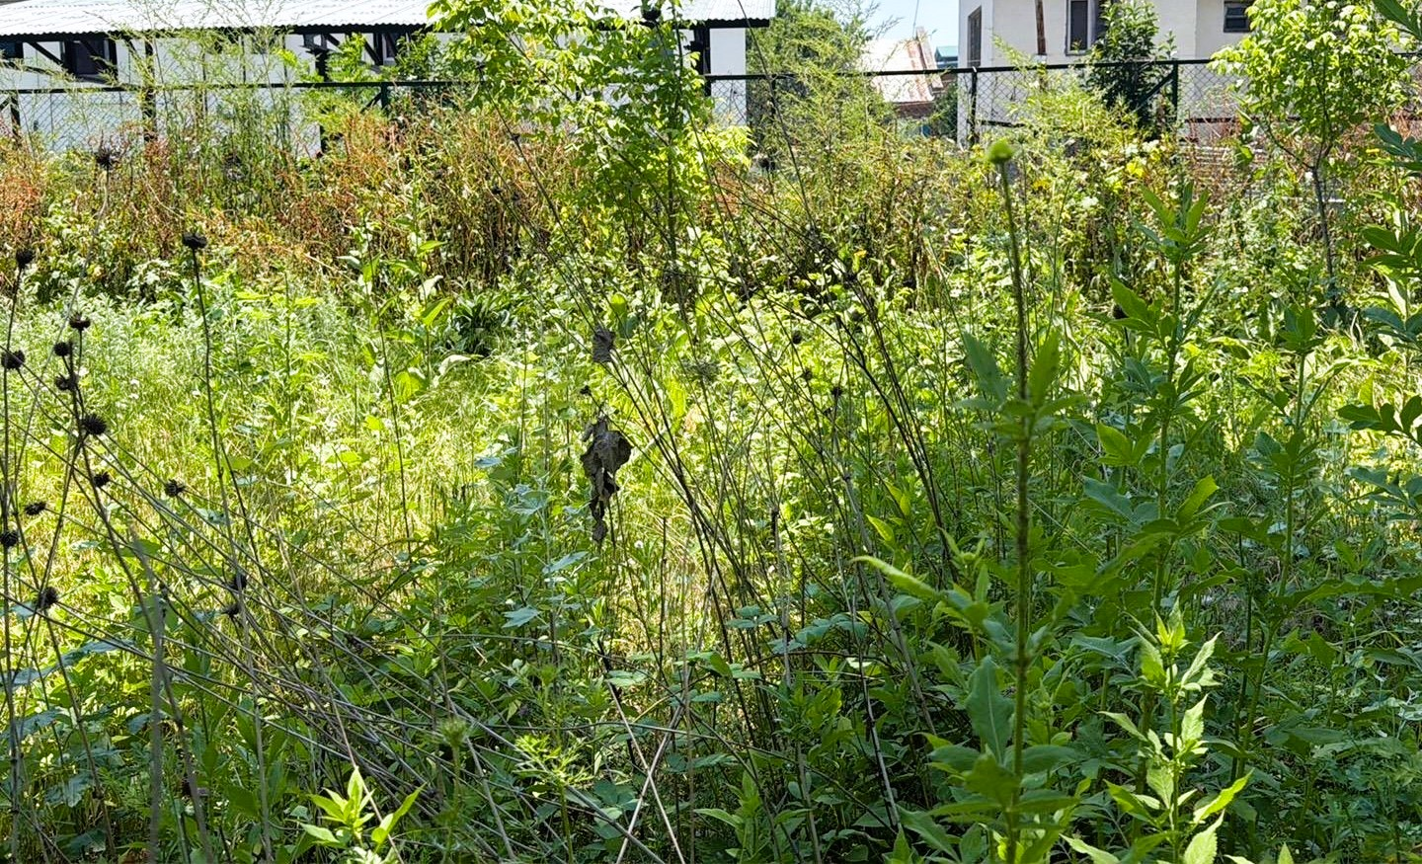
Dipsacus inermis at the Kashmir University Botanical Garden, collection locality 34.12981$​^{∘}$ N, 74.83396$​^{∘}$ E (WGS84). Erect stems and globose heads are visible; garden fencing and buildings stand behind the plot.
Taxonomic placement of Dipsacus inermis used in this study.
Rank | Taxon
Kingdom | Plantae
Clade | Angiosperms
Order | Dipsacales
Family | Caprifoliaceae
Genus | Dipsacus
Species | D. inermis Wall.

3.1.2 Test bacterial strains
Three Gram-negative isolates were drawn from working stocks of the Advanced Research Laboratory, Department of Zoology, University of Kashmir: Escherichia coli, Pseudomonas aeruginosa, and Klebsiella pneumoniae. Strain accession numbers (ATCC or equivalent) were not supplied with the stocks and are not added here. Placement follows standard bacterial taxonomy (3.2). Cultures were maintained on Luria–Bertani (LB) agar.
Taxonomic placement of the test bacterial isolates.
Rank | E. coli | P. aeruginosa | K. pneumoniae
Kingdom | Bacteria | Bacteria | Bacteria
Phylum | Pseudomonadota | Pseudomonadota | Pseudomonadota
Class | Gammaproteobacteria | Gammaproteobacteria | Gammaproteobacteria
Order | Enterobacterales | Pseudomonadales | Enterobacterales
Family | Enterobacteriaceae | Pseudomonadaceae | Enterobacteriaceae
Genus | Escherichia | Pseudomonas | Klebsiella
Species | E. coli | P. aeruginosa | K. pneumoniae

3.1.3 Reagents, media, and equipment
LB agar and broth were used for maintenance and for the diffusion plates. Culture media were sterilised in an autoclave before use. Distilled water was the extraction solvent, the reconstituting vehicle, and the negative control. Phytochemical reagents followed Harborne (Harborne 1998): Mayer’s reagent, alkaline sodium hydroxide, ferric chloride, Salkowski reagents (chloroform and concentrated sulphuric acid, or thionyl chloride as recorded in the laboratory notebook), Fehling’s A and B, and concentrated sulphuric acid for the quinone tube. Commercial gentamicin discs marked GEN 5 (5 µg) were the positive control. Some additional plates received a methicillin disc marked MET 5; those plates are not the source of 4.2. Major equipment comprised an electronic balance, heating mantle, Soxhlet assembly, autoclave, laminar-flow cabinet, bacteriological incubator at 37 °C, and a millimetre scale.

3.2 Methods

3.2.1 Collection, drying, and powdering
Aerial parts were washed in distilled water and shade-dried at room temperature (3.2). The dried herb was reduced to a coarse powder in a ceramic mortar (3.3). Powder was stored in a closed container, protected from light, until extraction.
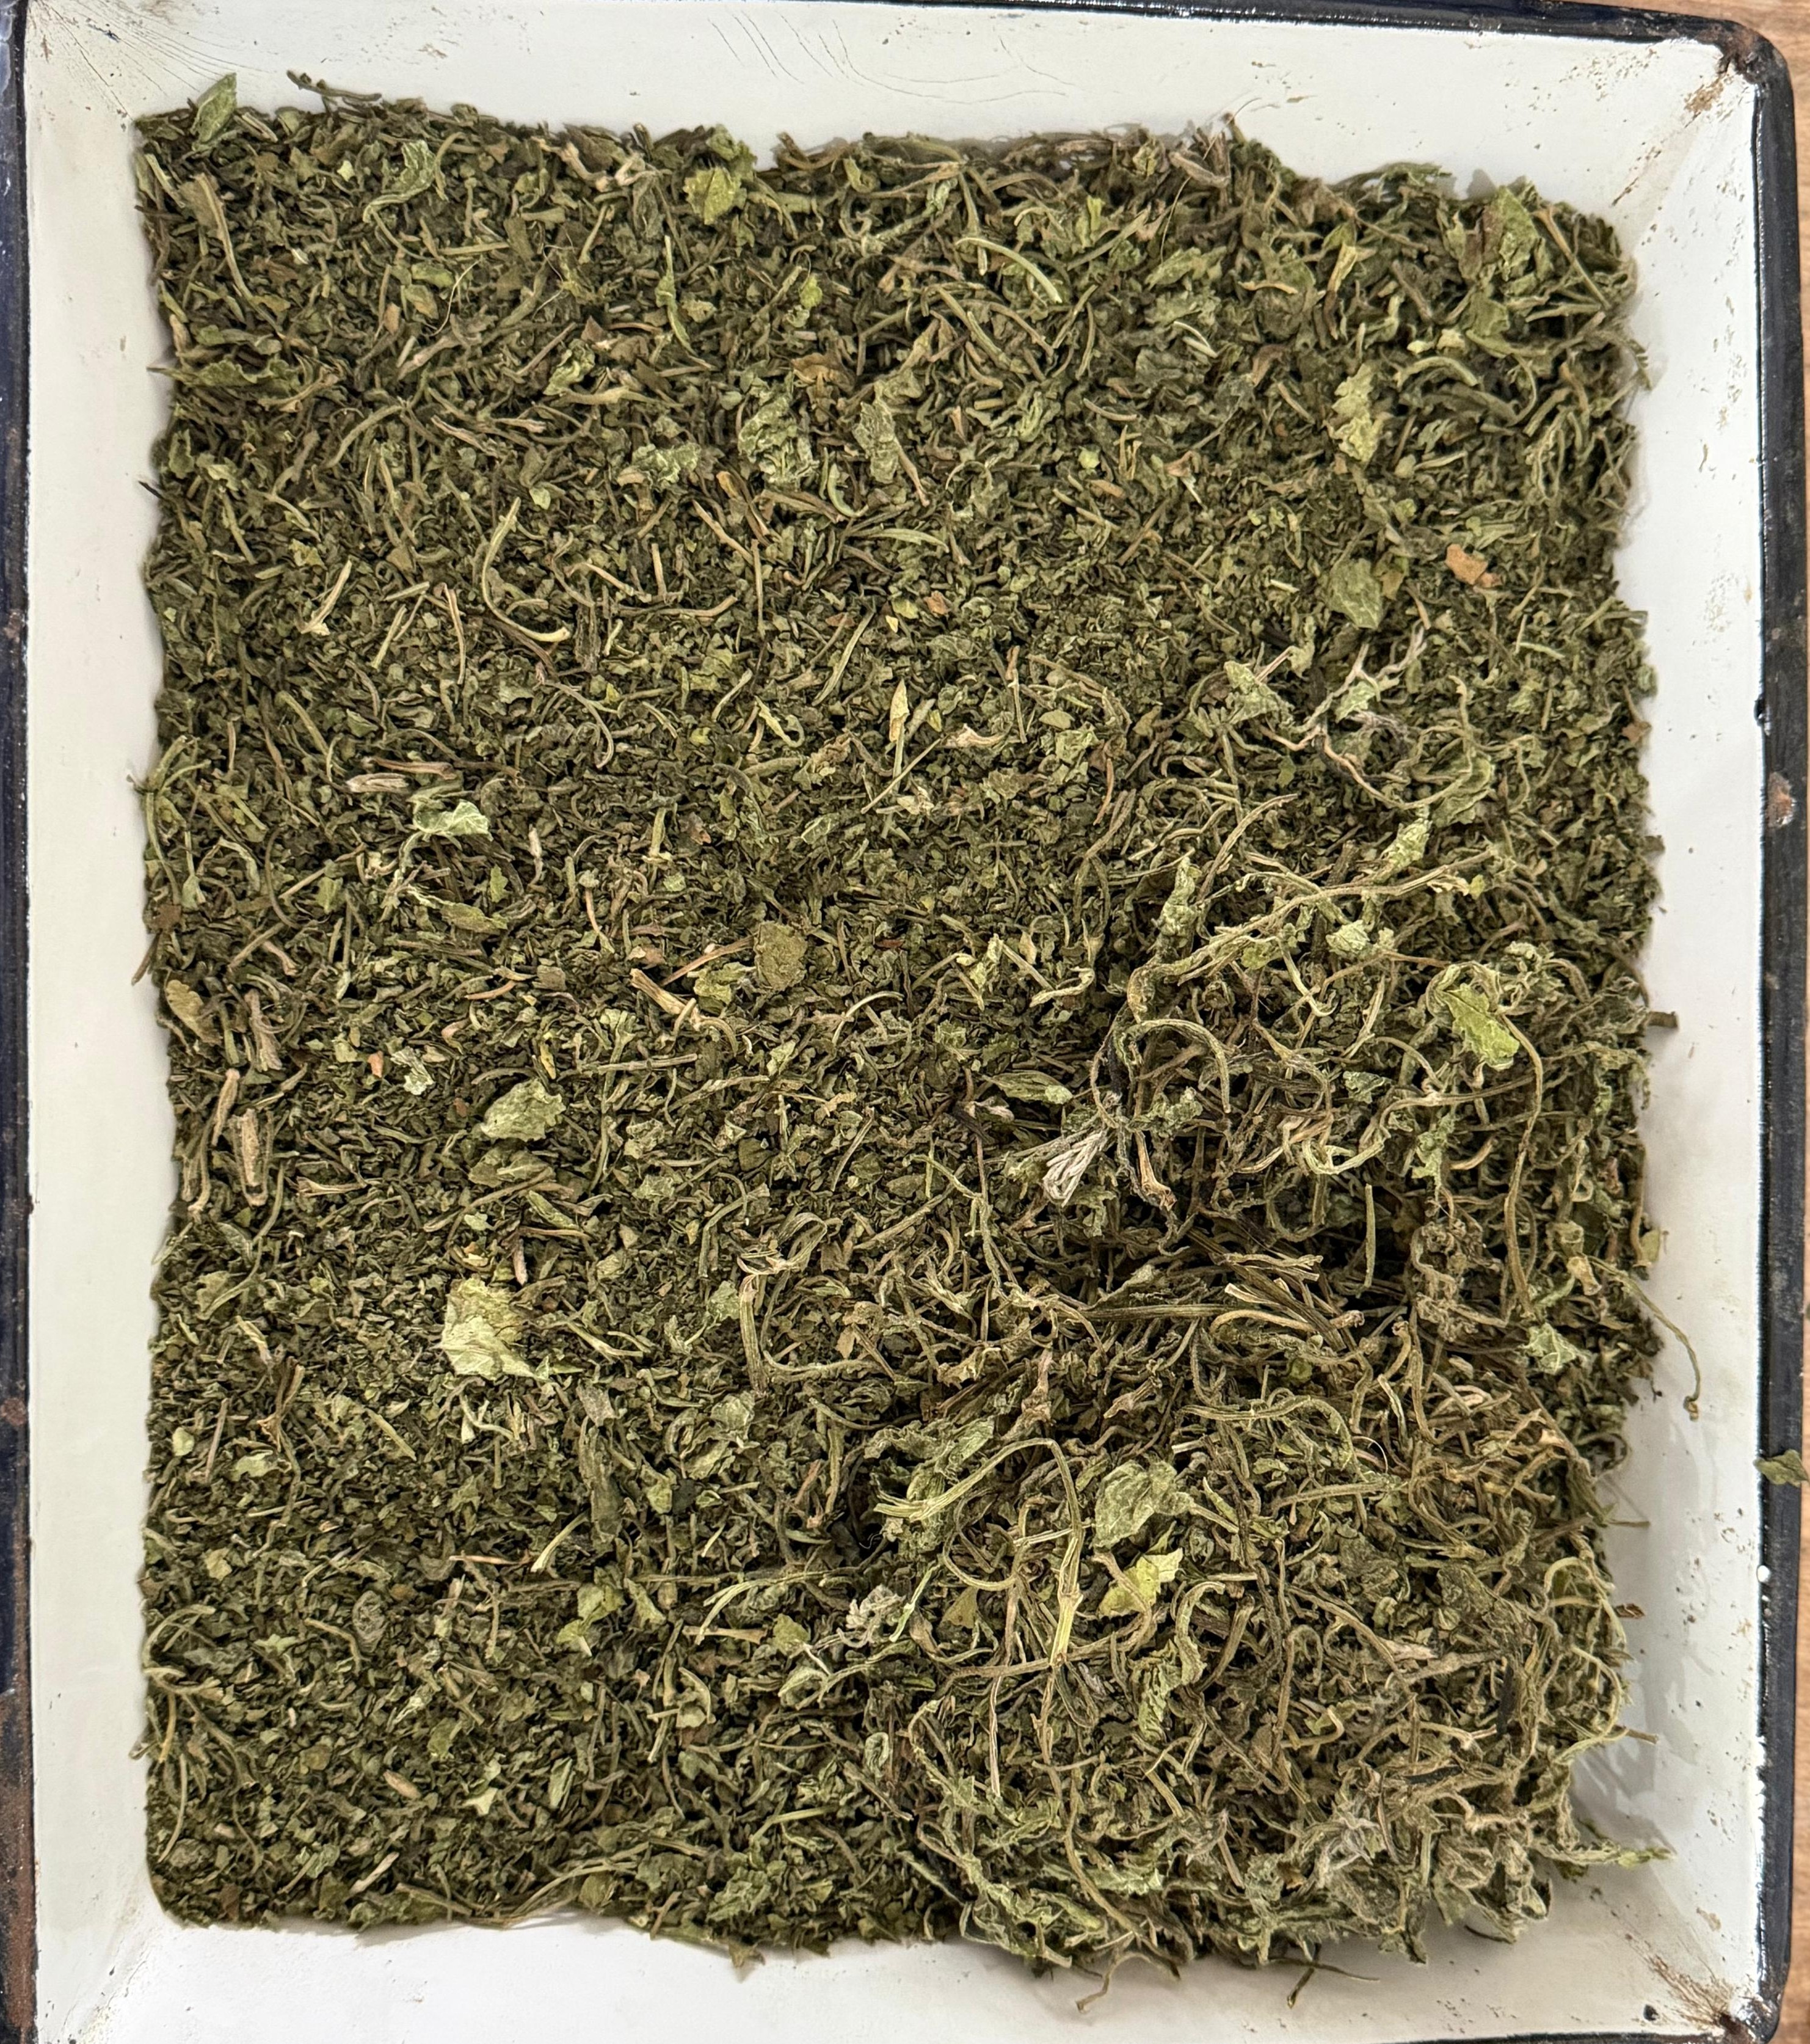
Shade-dried aerial parts of Dipsacus inermis in an enamel tray, prior to size reduction.
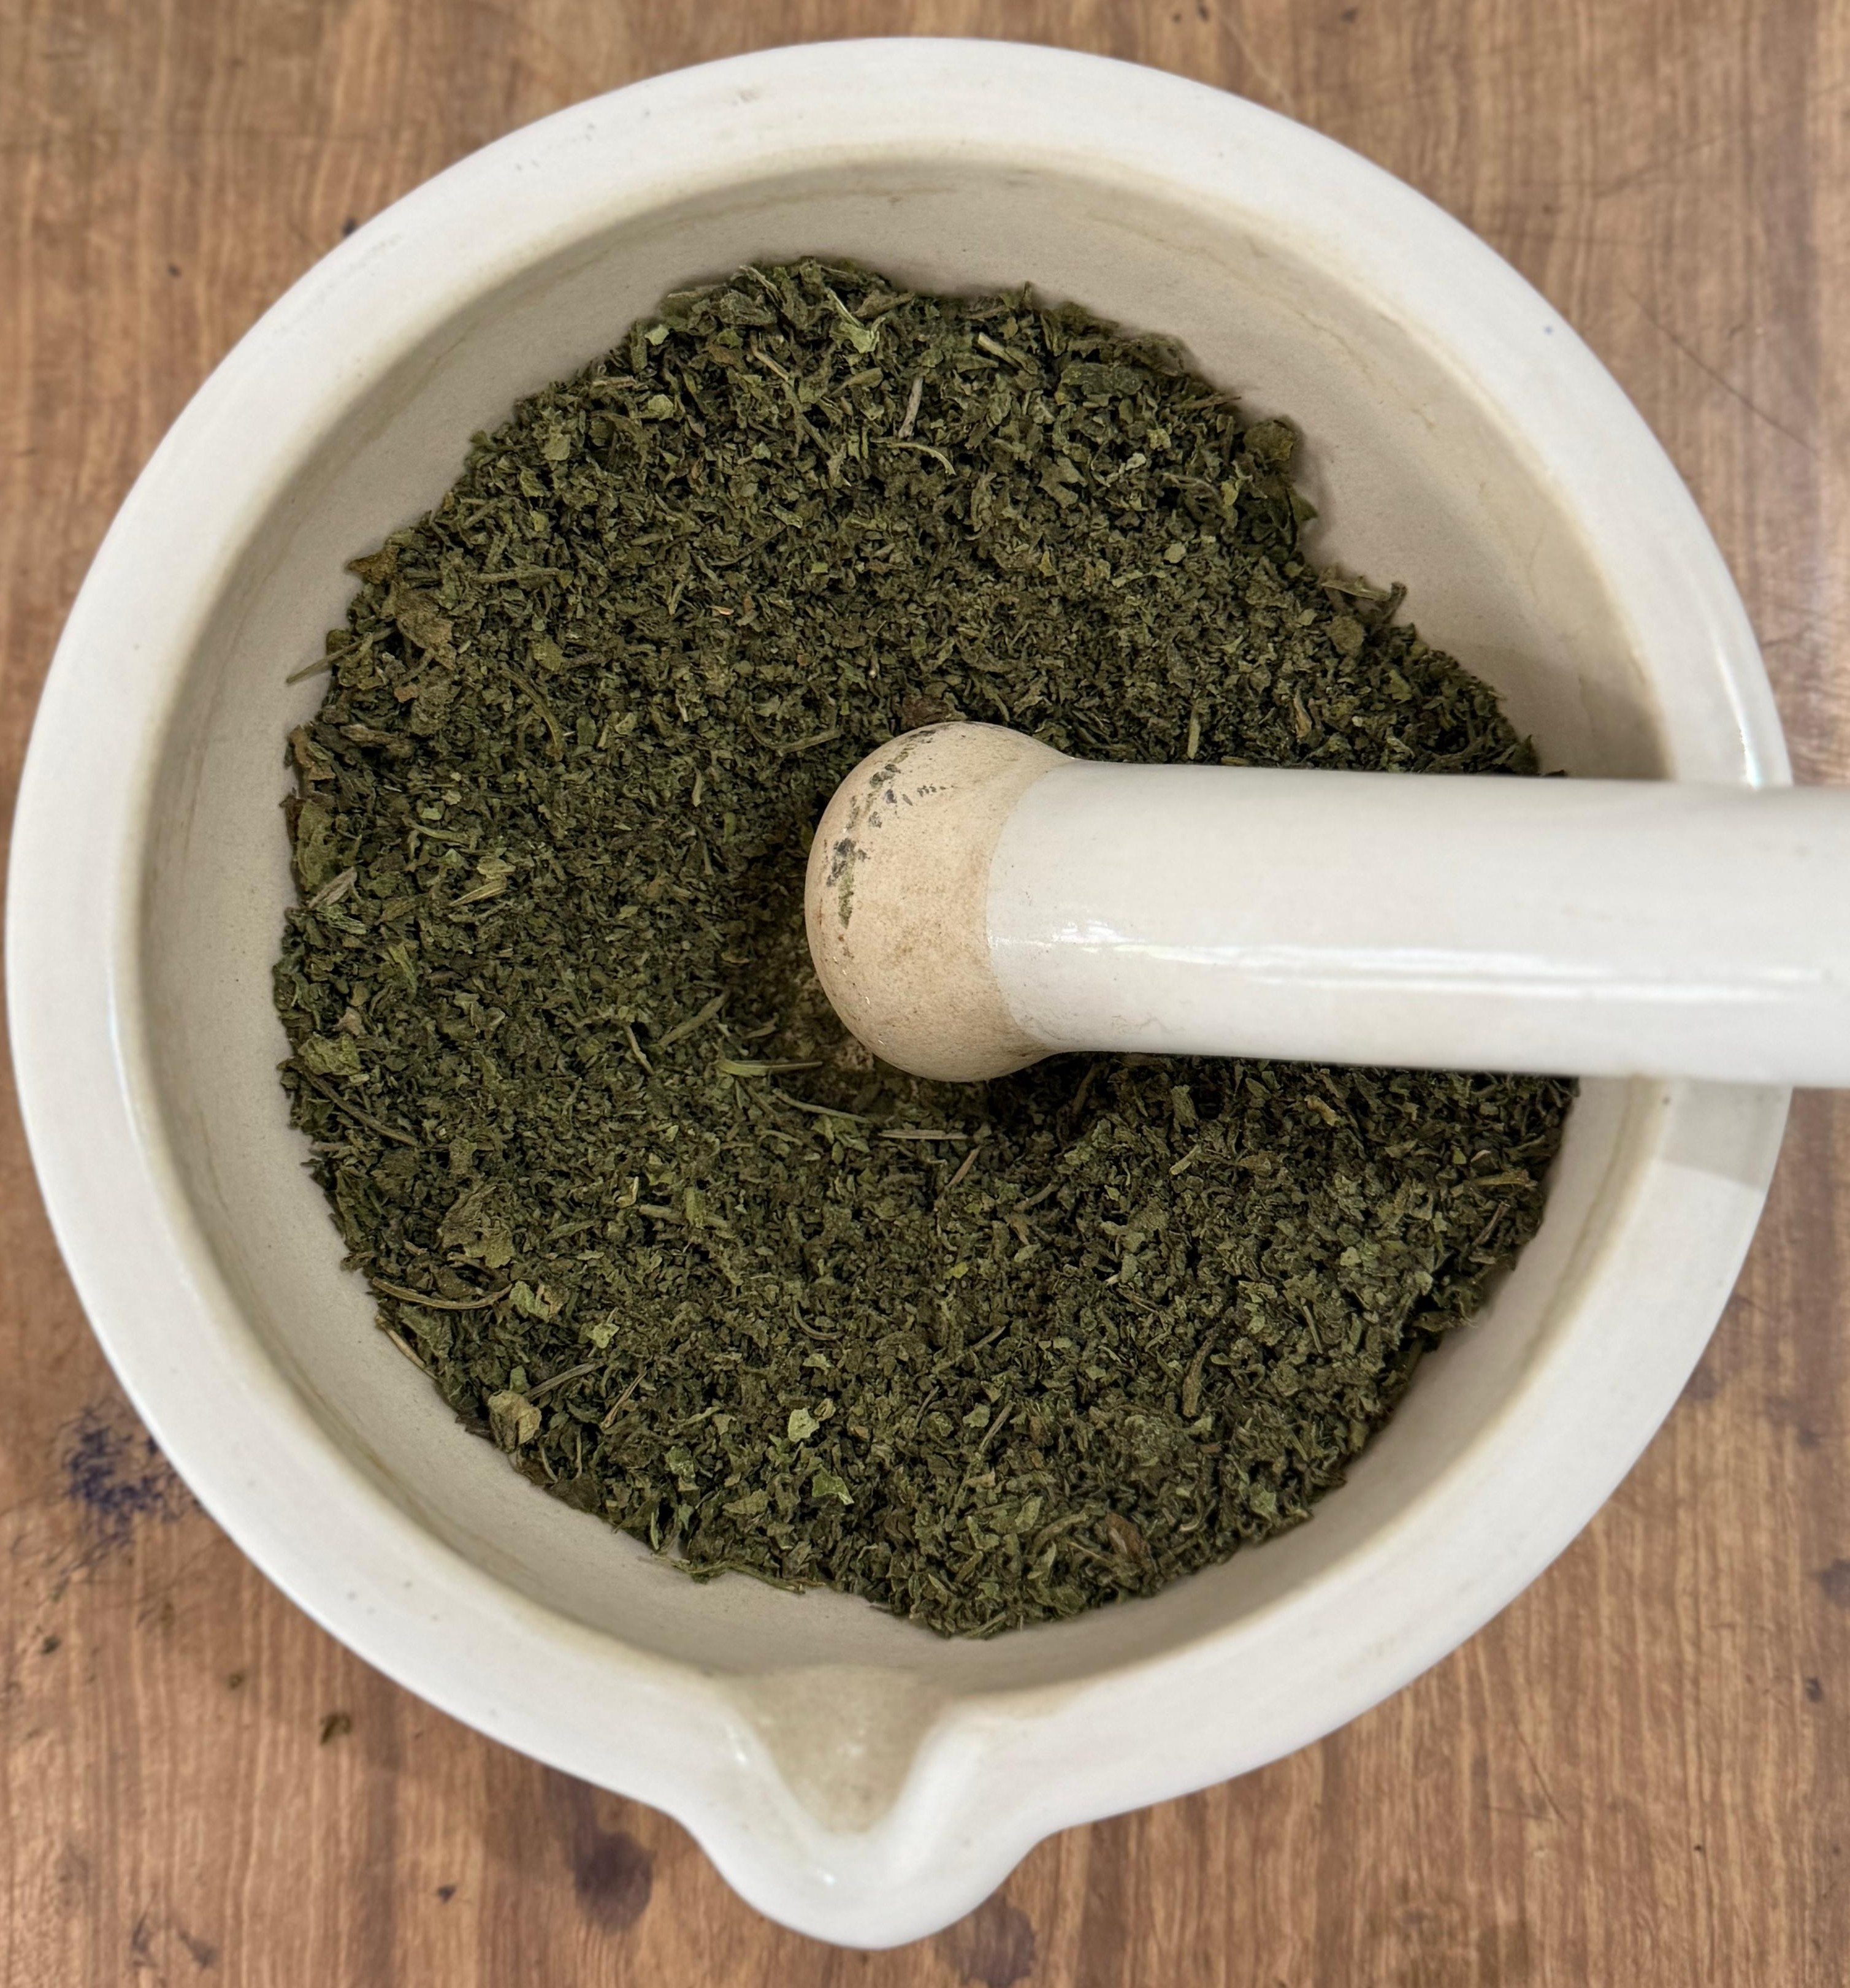
Coarse powdering of the dried plant material using a mortar and pestle.

3.2.2 Aqueous Soxhlet extraction and working concentrations
A 50 g portion of powder was extracted with 500 mL of distilled water (1:10, w/v) in a Soxhlet apparatus on a heating mantle (3.4, 3.5). Extraction was run as a continuous hot extraction. The filtrate was passed through muslin and then Whatman No. 1 paper and concentrated. Rotary-evaporator, vacuum, and freeze-drying settings are not specified because they were not recorded beyond concentration of the liquor. The concentrated extract corresponded to 24.13% (w/w) of the starting powder. The concentrate was reconstituted in sterile distilled water to give two working concentrations: C1, 50 mg/mL; C2, 100 mg/mL.
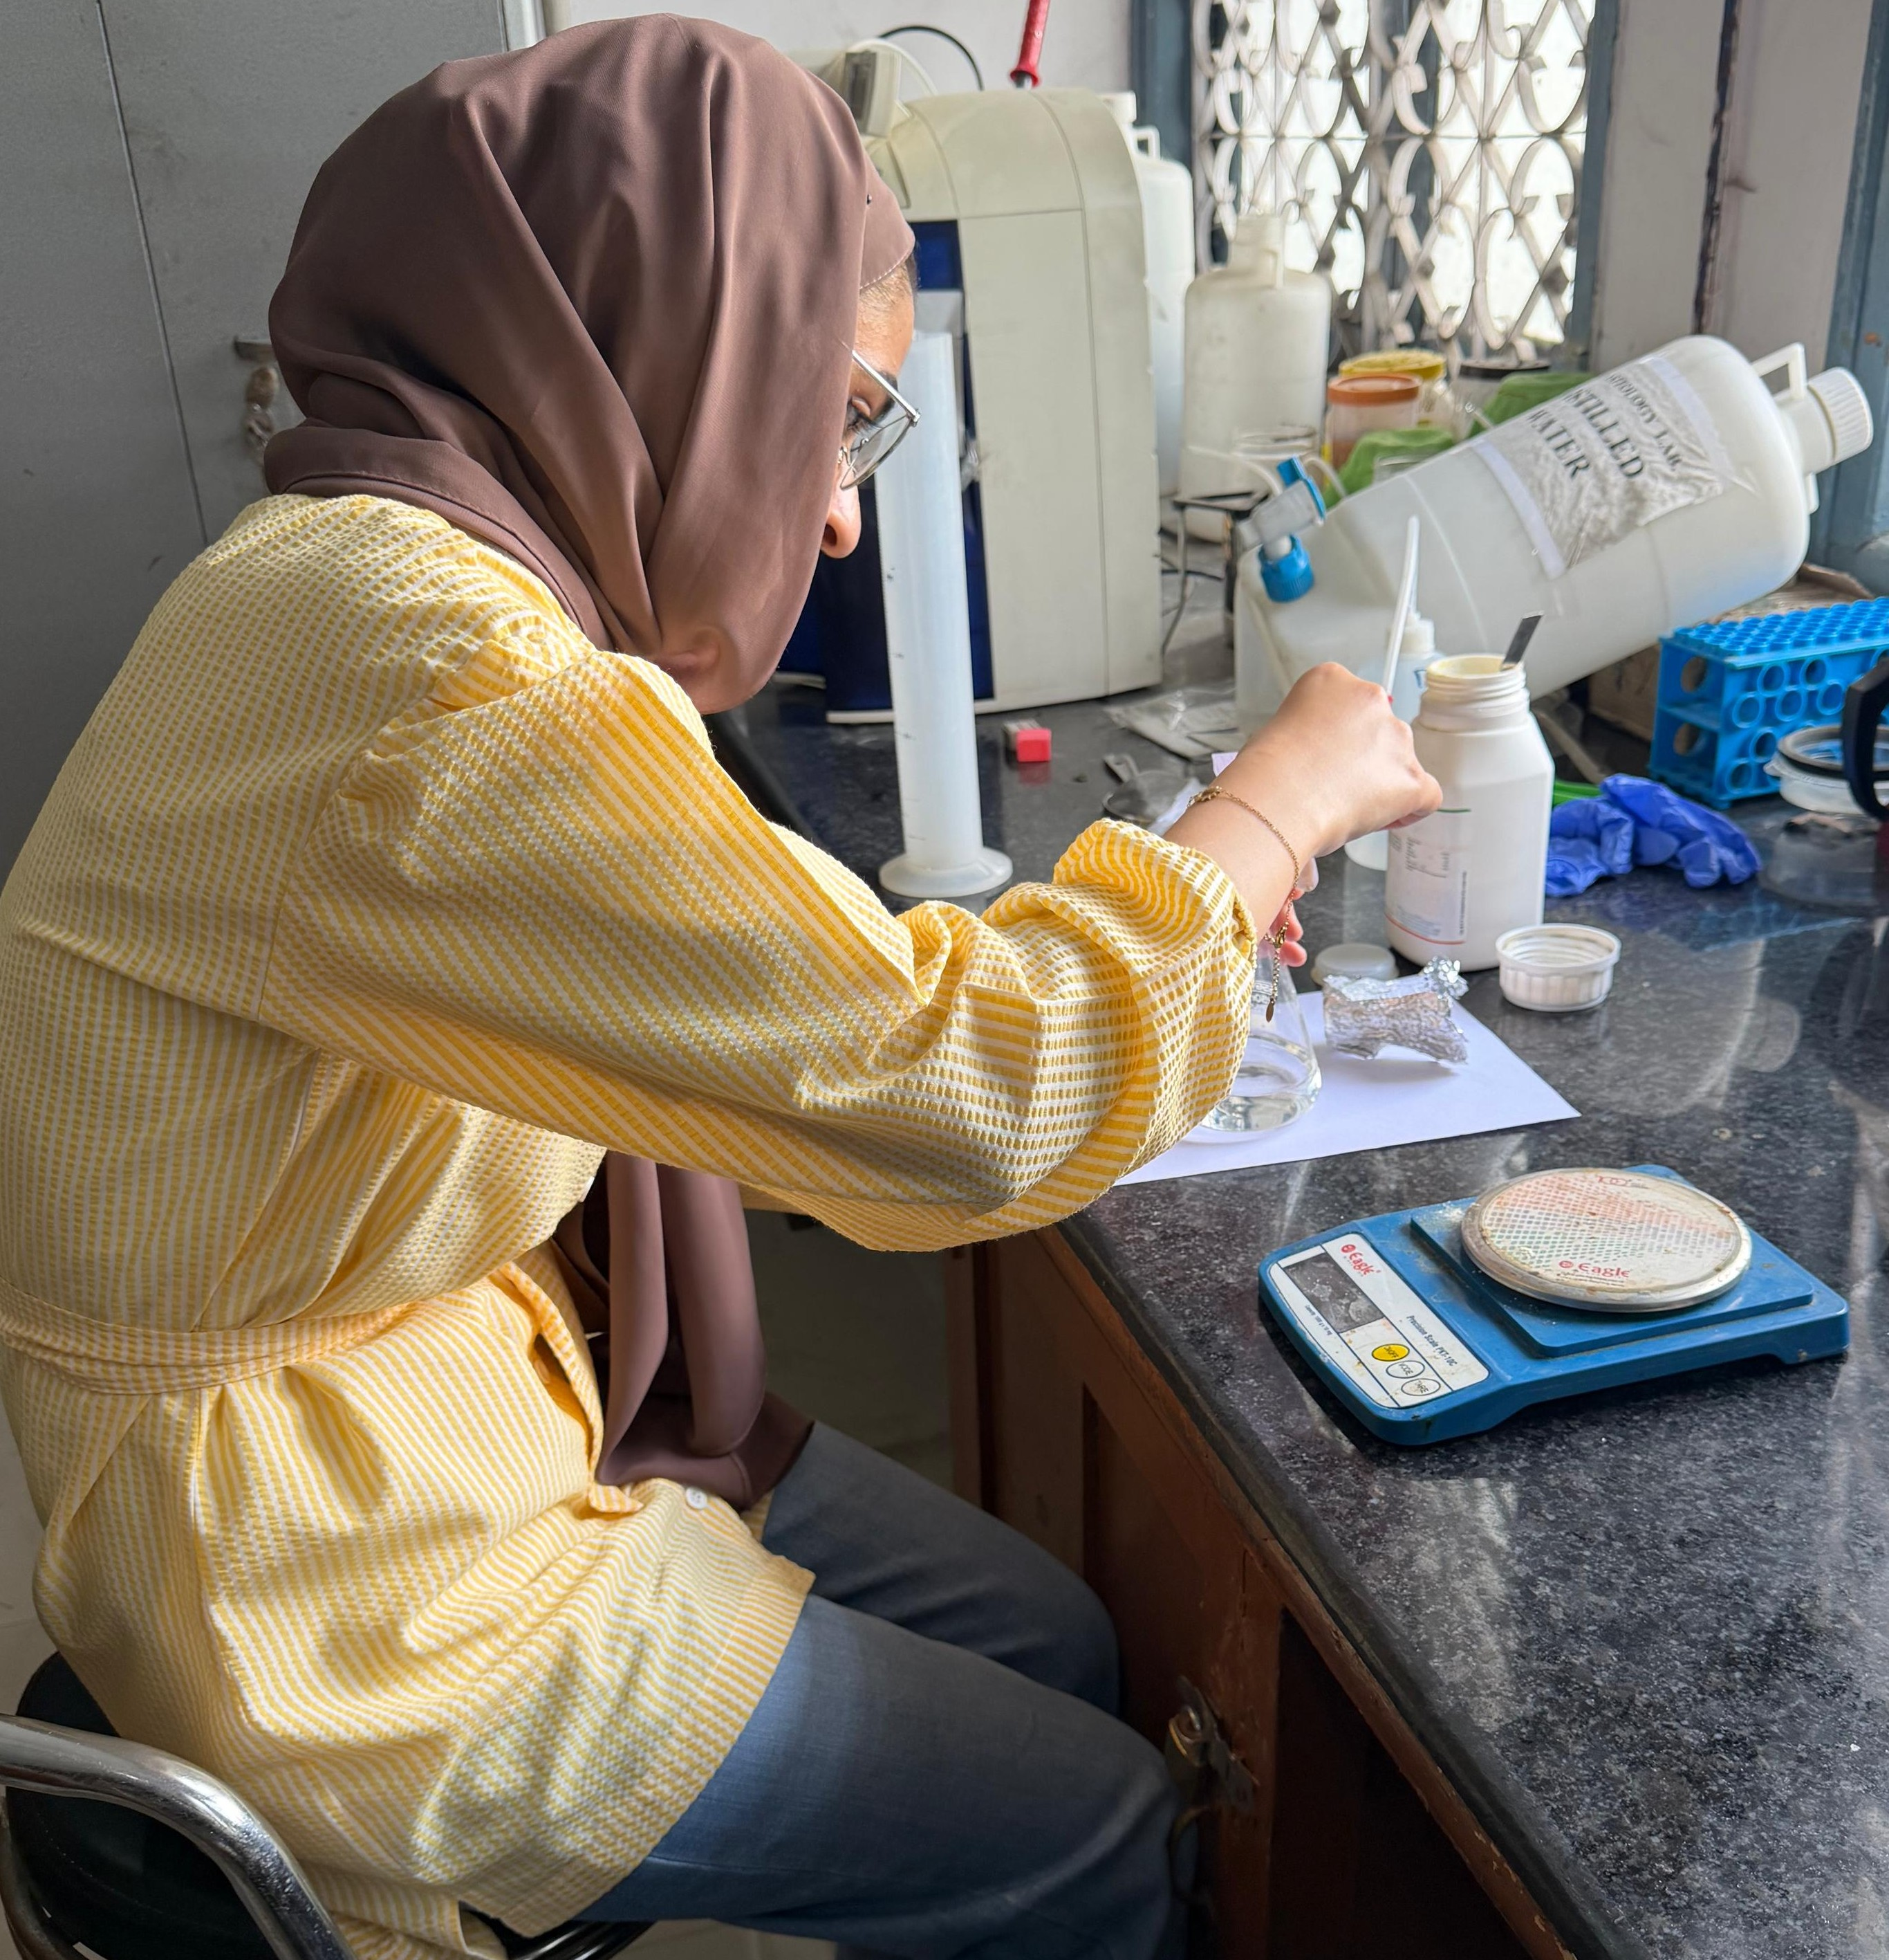
Weighing and aqueous preparation at the laboratory bench, with an electronic balance and a distilled-water reservoir.
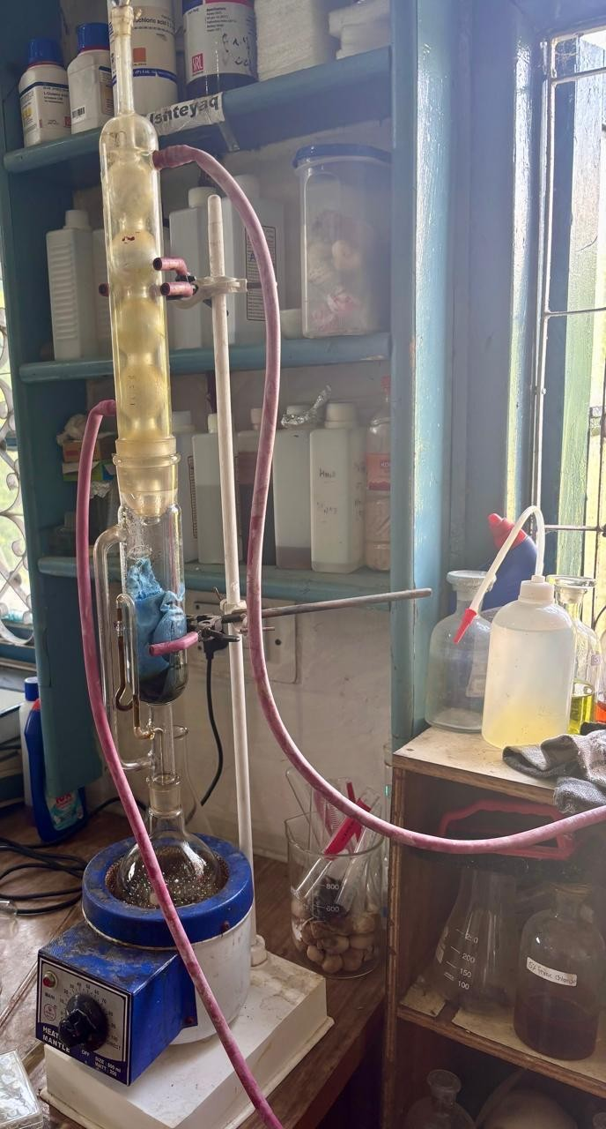
Continuous hot aqueous extraction of Dipsacus inermis in a Soxhlet apparatus mounted on a heating mantle.

3.2.3 Culture maintenance and inoculum
Isolates were grown on LB agar. Pure cultures dated 01 July 2026 are shown in 3.6. A colony of each organism was inoculated into LB broth, incubated at 37 °C, and adjusted by eye to a 0.5 McFarland turbidity standard (Clinical and Laboratory Standards Institute 2024). The adjusted culture was spread as a lawn on LB agar before the disc-diffusion assay.
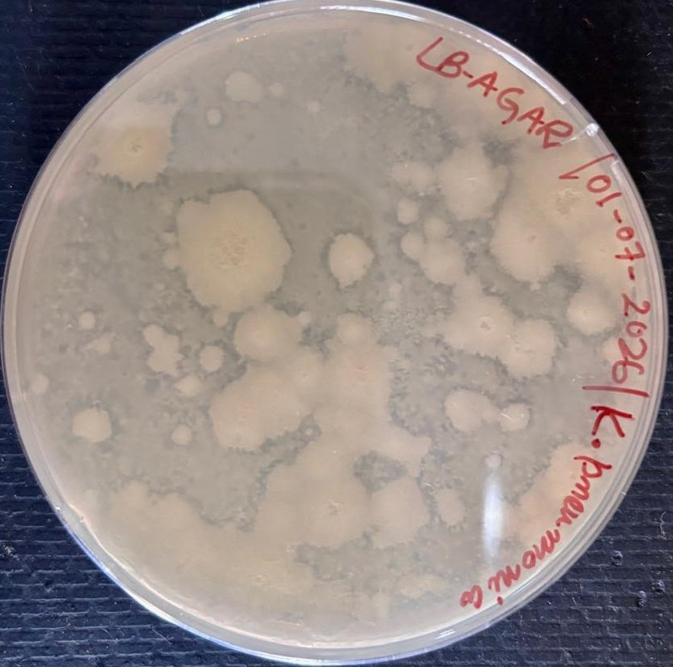  Klebsiella pneumoniae, mucoid colonies. | 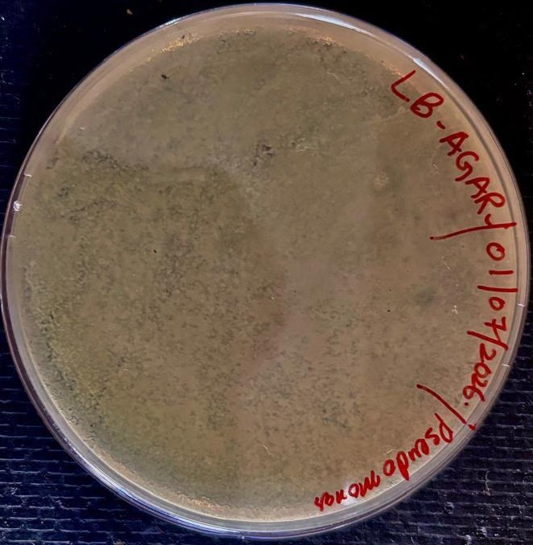  Pseudomonas aeruginosa (lid reads Pseudomonas), greenish lawn. | 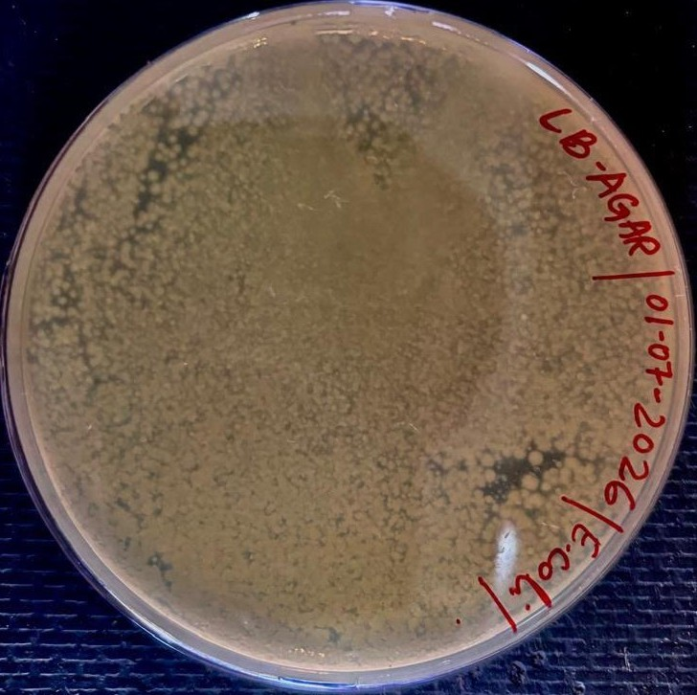  Escherichia coli, confluent lawn.
Pure cultures on LB agar, 01 July 2026. (A) Klebsiella pneumoniae. (B) Pseudomonas aeruginosa (lid reads Pseudomonas). (C) Escherichia coli.

3.2.4 Qualitative phytochemical tests
Tube tests were performed on the aqueous extract as summarised in 3.3 (Harborne 1998). Only tests that were actually run are listed. Wagner’s, Shinoda, lead acetate, and Keller–Kiliani tests were not performed. Tube photographs appear with the scored table in the results chapter.
Qualitative phytochemical tests applied to the aqueous extract.
Class | Test | Reagents | Positive reading
Alkaloids | Mayer’s | Mayer’s reagent + extract | Dull white precipitate
Carbohydrates | Fehling’s | Fehling A and B, heated | Brick-red precipitate
Saponins | Froth | Extract shaken with water | Persistent honeycomb froth
Phytosterols | Salkowski | Extract + chloroform + sulphuric acid | Reddish-brown interface
Tannins | Ferric chloride | Extract + FeCl$​_{3}$ | Dark blue / greenish black
Phenols | Ferric chloride | Extract + 10% FeCl$​_{3}$ | Bluish black
Flavonoids | Alkaline reagent | Extract + 10% NaOH | Yellow colour
Terpenoids | Salkowski | Extract + thionyl chloride (notebook) | Pink / reddish colour
Quinones | Sulphuric acid | Extract + H$​_{2}$SO$​_{4}$ | Red colour

3.2.5 Antibacterial assay (disc diffusion) and zone of inhibition
The zone of inhibition is the clear area around a disc or loaded position where bacterial growth is suppressed. Antibacterial activity was read only as that diameter on LB agar plates seeded with a lawn of each isolate (Balouiri et al. 2016; Bauer et al. 1966; Clinical and Laboratory Standards Institute 2024). No broth dilution, MIC, or MBC assay was performed.
Two extract concentrations were tested: C1, 50 mg/mL; C2, 100 mg/mL. Distilled water was the negative control. Gentamicin GEN 5 (5 µg disc) was the positive control. C1, C2, and distilled water (N) were placed on the seeded plates together with a GEN 5 disc marked P (3.7). Plates were incubated at 37 °C for 24 h. Each treatment was run in triplicate.
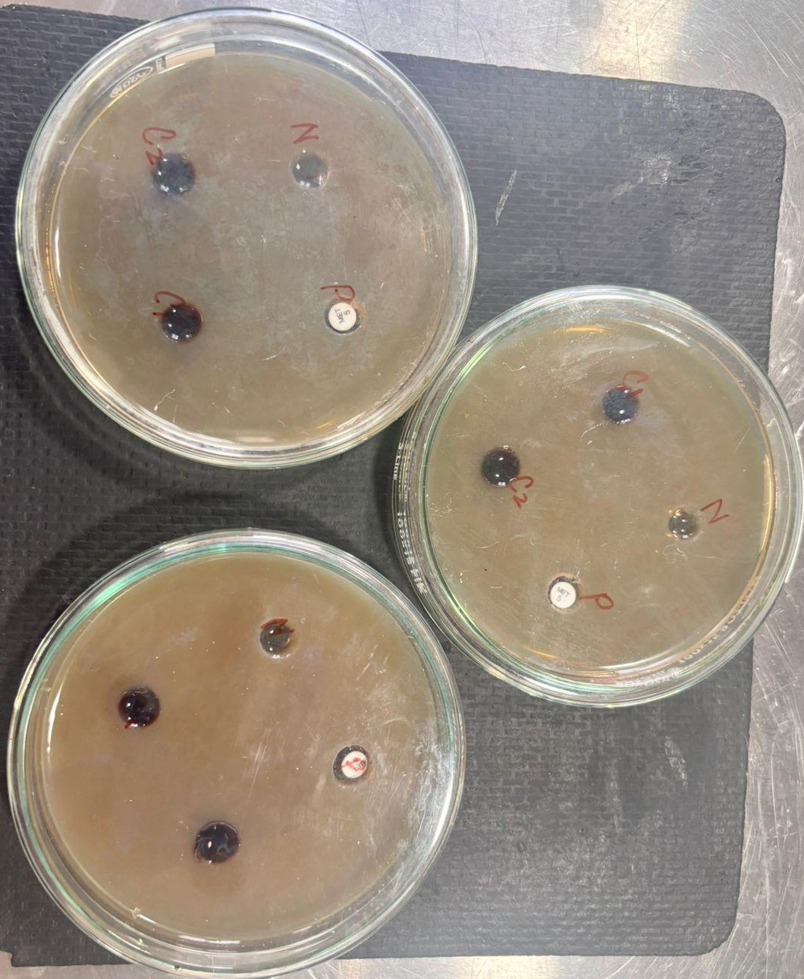
Assay plates marked C1, C2, distilled water (N), and a gentamicin disc (P). Species names are not written on these lids.

3.2.6 Measurement and statistics
The diameter of each clear zone of inhibition was measured in millimetres with a millimetre scale, inclusive of the disc. Results are reported as mean $±$ standard deviation ($n=3$). No analysis of variance was applied. CLSI breakpoints were not used to call the extract susceptible or resistant (Clinical and Laboratory Standards Institute 2024).

3.2.7 Ethical considerations
No vertebrate animals were used. An Institutional Animal Care and Use Committee (IACUC) protocol is not applicable. Plant material was collected from the Kashmir University Botanical Garden with departmental access. Bacterial isolates were laboratory stocks held in the Advanced Research Laboratory; they were not taken from patients for this study.

4 Results

4.1 Extract yield and appearance
Soxhlet extraction of 50 g of powdered aerial material with 500 mL of distilled water gave a dark, concentrated aqueous extract corresponding to 24.13% (w/w) of the starting powder. Working solutions C1 (50 mg/mL) and C2 (100 mg/mL) were brown to black.

4.2 Qualitative phytochemical profile
All nine labelled tubes on the rack gave a positive reading (4.1, 4.1). Flavonoids were yellow-brown after alkaline reagent. Terpenoids and quinones were dark. Alkaloids gave a dull deposit with Mayer’s reagent. Tannins and phenols were blue-black with ferric chloride. Saponins held a froth in the tube. Carbohydrates and phytosterols were also scored positive. No class on the rack was negative.
Qualitative phytochemical analysis of the aqueous extract of Dipsacus inermis.
Class | Test | Reagents | Observation | Inference
Alkaloids | Mayer’s | Mayer’s reagent | Dull white precipitate | Positive (+)
Flavonoids | Alkaline reagent | 10% NaOH | Yellow colour | Positive (+)
Phenols | Ferric chloride | 10% FeCl$​_{3}$ | Bluish black | Positive (+)
Tannins | Ferric chloride | FeCl$​_{3}$ | Dark blue / greenish black | Positive (+)
Saponins | Froth | Water, shaken | Persistent froth | Positive (+)
Terpenoids | Salkowski | Thionyl chloride (notebook) | Pink / dark colour | Positive (+)
Phytosterols | Salkowski | Chloroform + H$​_{2}$SO$​_{4}$ | Reddish brown | Positive (+)
Carbohydrates | Fehling’s | Fehling A and B, heated | Brick-red precipitate | Positive (+)
Quinones | Sulphuric acid | H$​_{2}$SO$​_{4}$ | Red / dark colour | Positive (+)
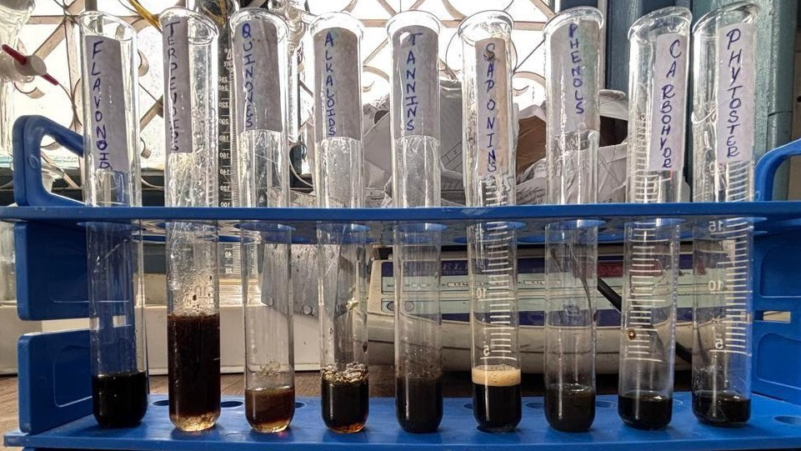
Qualitative phytochemical reactions of the aqueous extract of Dipsacus inermis. Tubes, left to right: flavonoids, terpenoids, quinones, alkaloids, tannins, saponins (froth visible), phenols, carbohydrates, phytosterols.

4.3 Zone of inhibition
Distilled water (N) gave $0.00±0.00$ mm against all three isolates. Both extract concentrations produced measurable zones (4.2). Zones were measured inclusive of the disc. Mean values are from the triplicate readings and are not rounded beyond two decimal places.
Against Escherichia coli the C1 mean was $11.94±0.14$ mm and the C2 mean was $14.99±0.51$ mm. The GEN 5 disc measured $17.00±0.00$ mm.
Against Pseudomonas aeruginosa the C1 mean was $16.03±0.25$ mm and the C2 mean was $12.53±0.45$ mm. The GEN 5 disc measured $17.17±0.29$ mm. C1 was the largest extract zone in the study. C2 was smaller than C1 for this isolate.
Against Klebsiella pneumoniae the C1 mean was $12.35±0.56$ mm and the C2 mean was $13.25±0.43$ mm. The GEN 5 disc measured $15.17±0.29$ mm.
Incubated plates marked N, C1, C2, and GEN 5 are shown in 4.2. Species names are not written on those two plates. Assay plates dated 04 August 2026 are shown in 4.3. The upper-left lid reads K. pneumoniae. The right lid reads Pseudomonas. The species line on the lower lid is not fully legible and is not named here. A representative GEN 5 plate is shown in 4.4. Mean values with standard-deviation bars from 4.2 are plotted in 4.5.
Antibacterial activity (zone of inhibition, mm) of the aqueous extract of Dipsacus inermis. Values are mean $±$ SD ($n=3$), measured inclusive of the disc. C1 = 50 mg/mL; C2 = 100 mg/mL; GEN 5 = gentamicin 5 µg disc; N = distilled water.
Isolate | N (water) | C1 | C2 | GEN 5
E. coli | 0.00 | 11.94 | 14.99 | 17.00
P. aeruginosa | 0.00 | 16.03 | 12.53 | 17.17
K. pneumoniae | 0.00 | 12.35 | 13.25 | 15.17
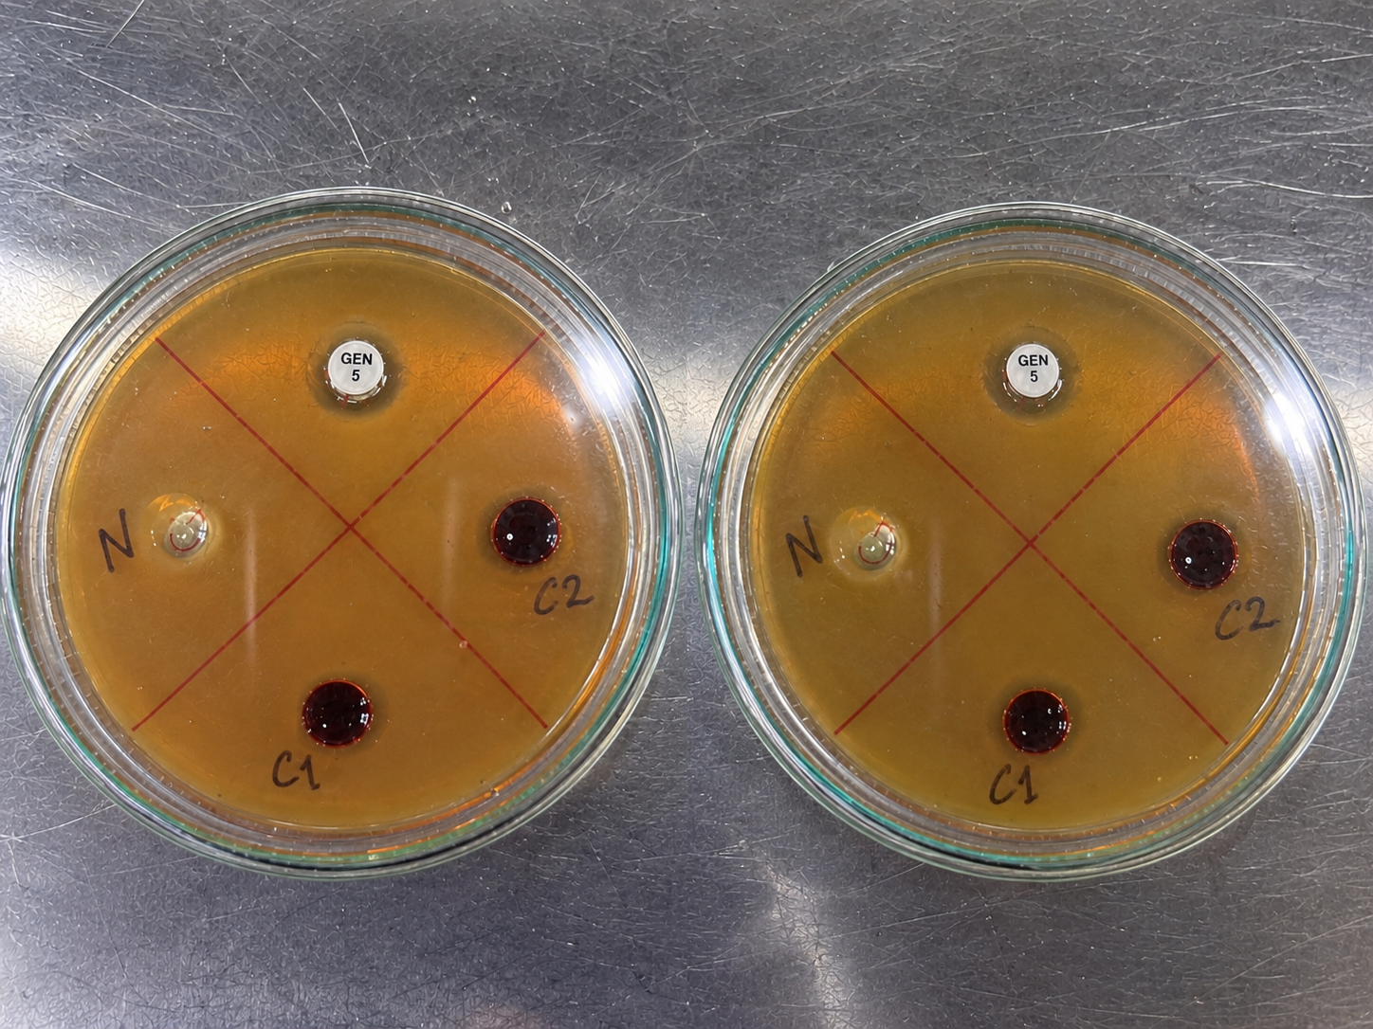
Two LB assay plates after incubation, marked distilled water (N), C1, C2, and gentamicin GEN 5. Clearance is visible around the extract wells and the GEN 5 disc. No binomial is written on these plates.
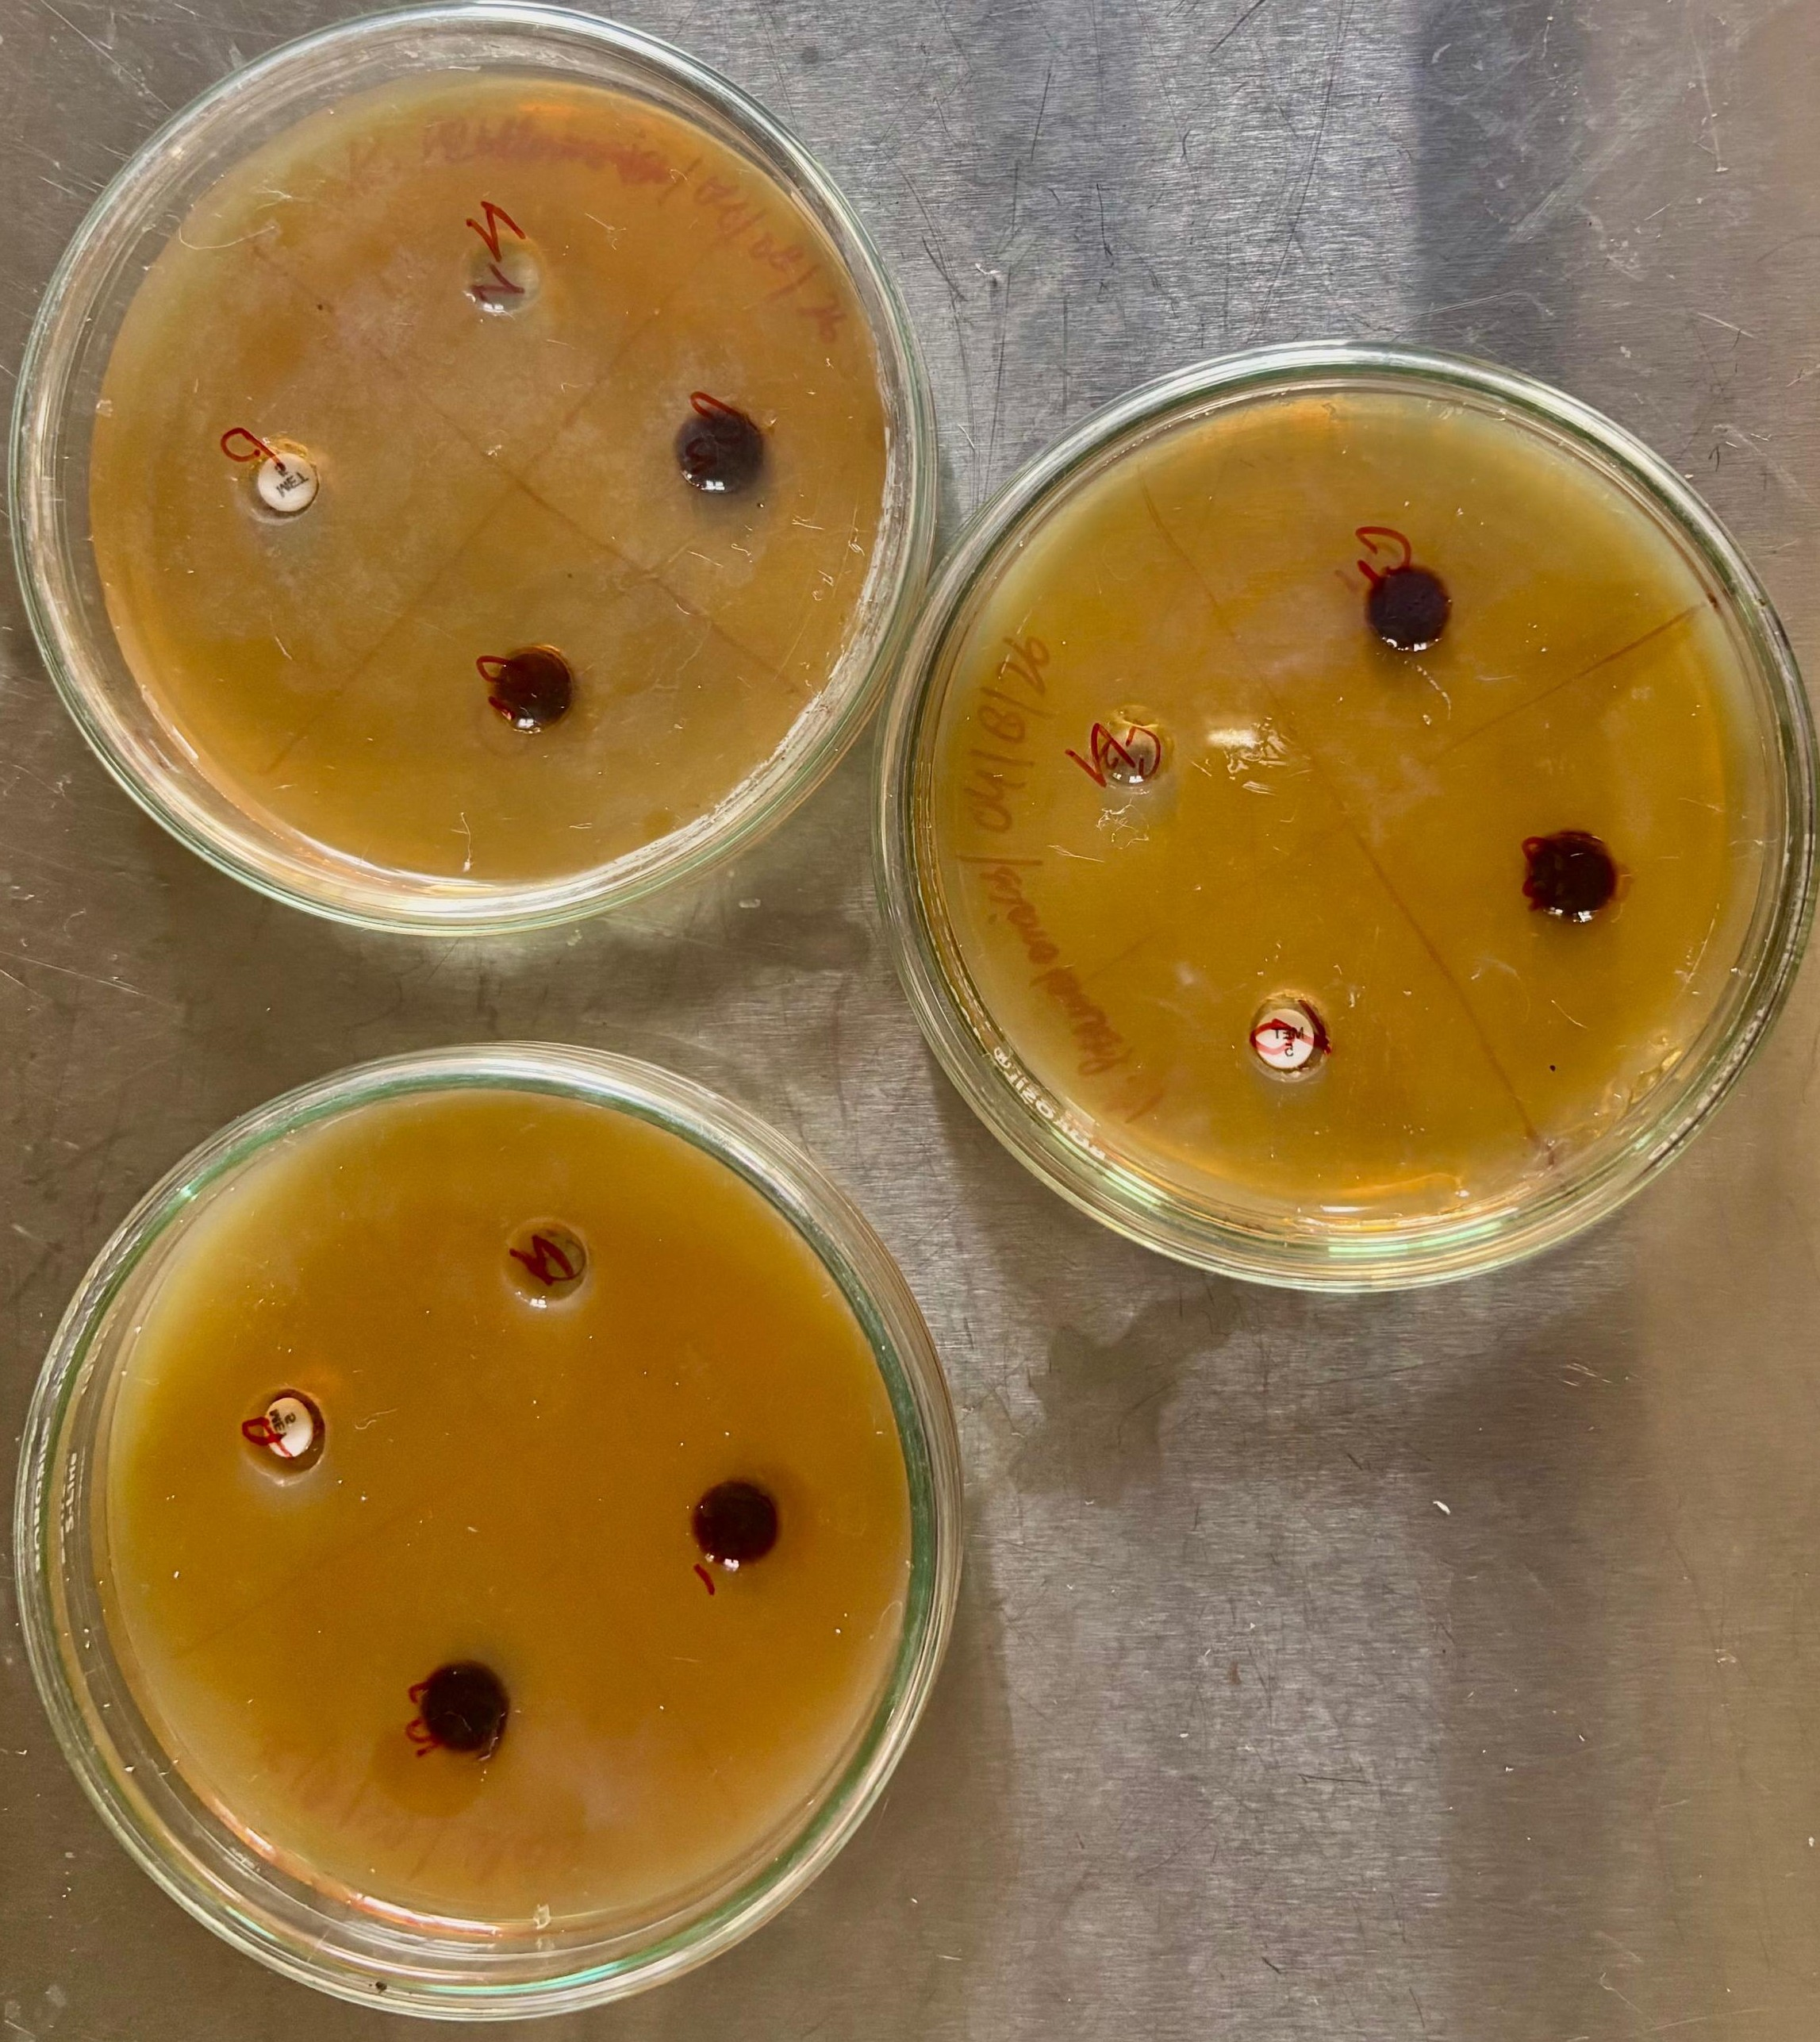
Assay plates, 04 August 2026. The upper-left lid reads K. pneumoniae. The right lid reads Pseudomonas. The species line on the lower plate is not fully legible and is not assigned here. Positions C1, C2, N, and a paper disc are present on each plate.
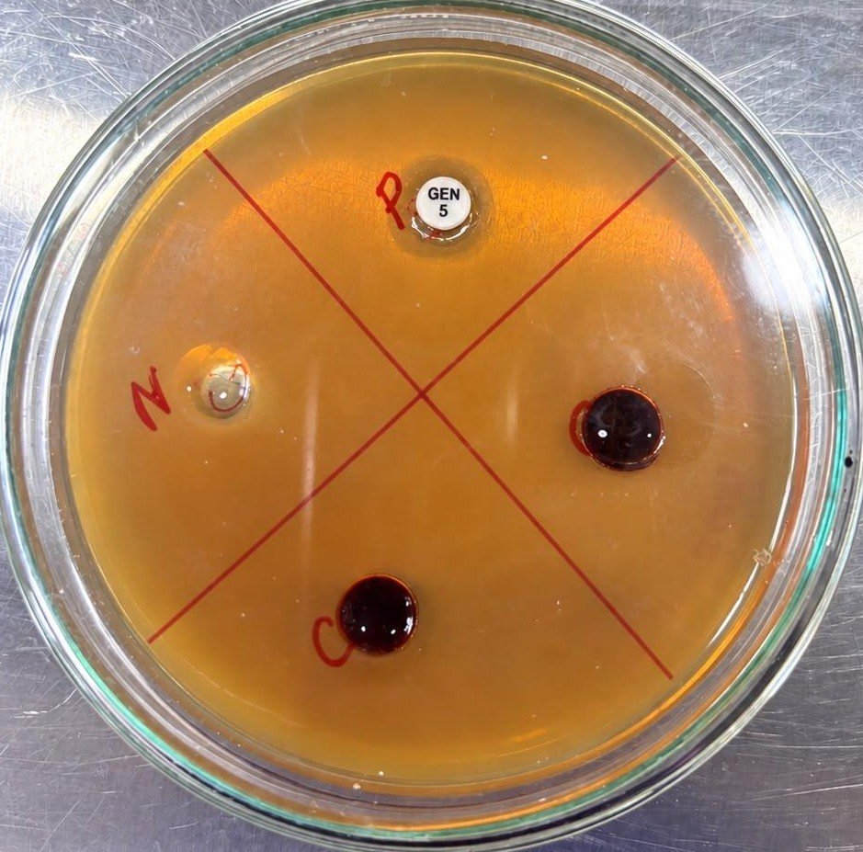
Representative plate showing gentamicin GEN 5 (P), sterile water (N) with no halo, and two extract positions with surrounding clearance. No binomial is written on this close-up.
Clustered bar graph of mean zone of inhibition ($±$ SD) for C1 (50 mg/mL), C2 (100 mg/mL), and gentamicin GEN 5 against the three isolates.
Raw triplicate readings are listed in 7.

5 Discussion
The aqueous extract contained the polar classes expected from a water Soxhlet: flavonoids, phenols, tannins, saponins, alkaloids, terpenoids, phytosterols, carbohydrates, and quinones (4.1, 4.1). Cowan’s catalogue assigns membrane leakage to phenolics and flavonoids, protein binding to tannins, and pore-like disruption to saponins (Cowan 1999; Jubair et al. 2021). Those assignments are consistent with a clear zone around the extract. They are not proof that any one class caused the zone.
Distilled water produced no zone. The solvent therefore does not explain the clearance. GEN 5 produced the widest mean zone on every isolate, as expected for a defined aminoglycoside disc (Clinical and Laboratory Standards Institute 2024). The extract never matched that disc. C1 and C2 are milligrams per millilitre of a crude concentrate. GEN 5 is five micrograms of a single drug. The comparison is a benchmark, not a potency ratio.

5.1 Isolate profiles
Escherichia coli showed a larger mean zone at C2 than at C1 ($14.99$ mm versus $11.94$ mm). That direction matches a simple concentration effect: more solute at C2, more diffusion into the lawn. The outer membrane of E. coli is a barrier (Nikaido 2003; Pagès et al. 2008), but it did not abolish activity at either strength.
Klebsiella pneumoniae also increased from C1 to C2, but only by about one millimetre ($12.35$ mm to $13.25$ mm). The capsule and a typical enterobacterial envelope are a plausible reason for the smaller step (World Health Organization 2024). Drakhshaan et al. (2026) did not test this species, so the values cannot be stacked against their dichloromethane table. They are a new row for the aqueous extract, not a claim of first discovery in the whole Dipsacus literature.
Pseudomonas aeruginosa did not follow the same direction. C1 gave $16.03±0.25$ mm, the largest extract mean in the study. C2 gave $12.53±0.45$ mm, representing an inverted response of $−3.50$ mm. Calling this isolate “resistant” would contradict the C1 plate, where the extract produced a clear, reproducible zone across all three replicates ($16.00$, $16.30$, and $15.80$ mm; 7.2). Technical explanations, including well-loading discrepancies, pigment masking of the C2 perimeter, or inter-plate agar variation, cannot be excluded. Two biological and physical hypotheses reconcile this non-linear behaviour.
The first hypothesis concerns active efflux kinetics and outer-membrane permeation dynamics. Pseudomonas aeruginosa possesses an envelope with inherently low permeability, governed by the slow porin OprF, in which over 95% of molecules adopt a closed two-domain conformer with minimal conductance, leaving only 1–5% in an open $β$-barrel conformation (Chevalier et al. 2017). Active drug extrusion is driven by the tripartite MexAB-OprM efflux pump, in which the inner-membrane proton antiporter MexB operates with the periplasmic adaptor MexA and the outer-membrane duct OprM to expel diverse amphiphilic and aromatic substrates (Li et al. 1995; Masuda et al. 2000). At C1 (50 mg/mL), passive influx of polar phytochemicals across open OprF channels and surfactant-destabilised lipid domains exceeds basal MexAB-OprM extrusion velocity. Periplasmic and intracellular accumulation reaches inhibitory concentrations, driving cell lysis and establishing a wide clear zone ($16.03$ mm). At C2 (100 mg/mL), elevated solute influx raises the local concentration to the critical threshold required for MexB allosteric cooperativity or stress-mediated transcriptional induction of the mexAB-oprM operon (Li et al. 1995; Poole 2005). Accelerated active extrusion through OprM outpaces inward diffusion through closed-conformer OprF channels, lowering steady-state intracellular accumulation below lethal levels at the zone periphery and permitting bacterial growth closer to the well ($12.53$ mm).
The second hypothesis concerns colloidal micellar self-assembly and hydrogel diffusion impedance. Phytochemical analysis confirmed abundant saponins (froth test) and a high extraction yield of 24.13% (w/w), consistent with substantial recovery of oleanane bidesmosides such as dipsacoside B and asperosaponin VI (Zhao and Shi 2011; Skała and Szopa 2023). Amphiphilic saponins assemble into multimolecular micellar aggregates once their concentration exceeds the Critical Micelle Concentration (CMC). At C1 (50 mg/mL), saponin molecules exist predominantly as unassociated monomers that diffuse through the 1.5% agar hydrogel network. At C2 (100 mg/mL), the concentration surpasses the CMC, promoting self-assembly into bulky micellar aggregates exceeding 50–100 kDa with substantially enlarged hydrodynamic radii. These macromolecular assemblies suffer severe steric restriction within the fibrous agar matrix. Retarded diffusion is compounded by the high solution viscosity of the concentrated extract, which contains water-soluble polysaccharides and mucilage (evidenced by a strong positive Fehling’s reaction; 4.1). The resulting steep, truncated diffusion gradient confines the effective inhibitory concentration to a narrower radius around the C2 well.
These interpretations remain reasoned biophysical hypotheses. In the absence of isogenic knockout strains ($Δ$mexB, $Δ$oprF), efflux pump inhibitor controls, or quantitative LC-MS profiling of the specific extract batch, the relative contributions of active efflux induction, micellar aggregation, and technical factors cannot be definitively resolved from agar diffusion assays alone. Candidate metadata limitations noted in earlier chapters—the unrecorded herbarium voucher accession number, lack of ATCC strain accession identifiers, unrecorded extract well loading volume, and unrecorded collection month—prevent direct kinetic modeling. The data are therefore reported as measured, without forcing the numbers into a monotonic concentration gradient.

5.2 Comparison with organic-solvent extracts
Drakhshaan et al. (2026) used 50 µg/mL and 100 µg/mL dichloromethane and methanol extracts. Their gentamicin disc was 10 µg. The present C1 and C2 are milligrams per millilitre, a thousand-fold difference on the label, and GEN 5 is not a ten-microgram disc. Millimetre values from that paper are therefore listed only to show that organic extracts of the same species can clear E. coli and P. aeruginosa lawns (5.1). They are not same-dose replicates.
Published zones for organic extracts of D. inermis (Drakhshaan et al. 2026) beside the present aqueous means. Units of the extract dose are not the same.
Treatment | E. coli (mm) | P. aeruginosa (mm)
Present aqueous C2, 100 mg/mL | 14.99 | 12.53
Present aqueous C1, 50 mg/mL | 11.94 | 16.03
DCM 100 µg/mL | 15.93 | 16.83
DCM 50 µg/mL | 12.93 | 13.10
MeOH 100 µg/mL | 15.80 | 15.17
MeOH 50 µg/mL | 11.13 | 9.07
Gentamicin 10 µg (that study) | 15.00 | 14.50
GEN 5 (this study) | 17.00 | 17.17
The 24.13% aqueous yield is much higher than the 2.72% dichloromethane and 2.9% methanol yields reported by Drakhshaan et al. (2026). Water also extracts sugars, mucilage, and other bulk polar matter as well as phenolics. A high yield does not mean a high titre of antibacterial molecules.

5.3 Regional context
Kashmiri use of wopal haakh as a boiled leaf preparation (Lone et al. 2015; Haq et al. 2023; Ahad et al. 2023) is an aqueous tradition. The Soxhlet water extract is a laboratory relative of that solvent, not a clinical decoction trial. The NF-$κ$B study from the same university shows that local D. inermis is pharmacologically active (Hassan et al. 2020). Antibacterial zones on LB plates do not extend that claim to patients.

5.4 Limits
The screen used two concentrations, one solvent, three isolates without accession numbers, LB rather than Mueller–Hinton agar, and zone of inhibition only. MIC and MBC were not measured. GC-MS and LC-MS of the aqueous concentrate were not done. Some plates in the photograph set carry MET 5 discs; those discs were not entered in 4.2. Collection month and a herbarium voucher number were not available. The work is a preliminary in vitro record for an aqueous extract from the Botanical Garden stand.

6 Conclusion and Future Prospects
The three objectives were met within the limits of a zone-of-inhibition screen.
Plant material of Dipsacus inermis was collected from the Kashmir University Botanical Garden at 34.12981$​^{∘}$ N, 74.83396$​^{∘}$ E (WGS84), authenticated at the Centre for Biodiversity and Taxonomy, dried, powdered, and extracted with distilled water in a Soxhlet apparatus. The concentrate was reconstituted at 50 mg/mL (C1) and 100 mg/mL (C2).
Qualitative tubes were positive for alkaloids, flavonoids, phenols, tannins, saponins, terpenoids, phytosterols, carbohydrates, and quinones.
Both extract concentrations produced zones against Escherichia coli, Pseudomonas aeruginosa, and Klebsiella pneumoniae held in the Advanced Research Laboratory. Distilled water produced none. GEN 5 remained the widest reference. Zones were measured inclusive of the disc. E. coli and K. pneumoniae gave larger means at C2 than at C1. P. aeruginosa gave its largest extract mean at C1. The aqueous extract is therefore active in vitro on these lawns, but activity is not a simple function of the two labelled strengths, and it is not a clinical result.
Future work should determine MIC and MBC in broth, preferably on Mueller–Hinton medium with identified strains. LC-MS or GC-MS of the aqueous concentrate would show which polar peaks are present. A wider concentration series would test whether the P. aeruginosa inversion repeats. Until those data exist, the present tables should be read as a preliminary aqueous screen of a Kashmir Botanical Garden collection, not as a treatment claim.

7 Raw zone-of-inhibition replicates
Triplicate millimetre readings from which 4.2 was calculated. Zones were measured inclusive of the disc. C1 = 50 mg/mL; C2 = 100 mg/mL; GEN 5 = gentamicin 5 µg disc; N = distilled water.
Raw zone diameters (mm) for Escherichia coli.
Treatment | R1 | R2 | R3
C1 | 12.00 | 11.78 | 12.05
C2 | 15.00 | 15.50 | 14.48
GEN 5 | 17.00 | 17.00 | 17.00
N | 0.00 | 0.00 | 0.00

Raw zone diameters (mm) for Pseudomonas aeruginosa.
Treatment | R1 | R2 | R3
C1 | 16.00 | 16.30 | 15.80
C2 | 13.00 | 12.50 | 12.10
GEN 5 | 17.50 | 17.00 | 17.00
N | 0.00 | 0.00 | 0.00

Raw zone diameters (mm) for Klebsiella pneumoniae.
Treatment | R1 | R2 | R3
C1 | 12.00 | 13.00 | 12.05
C2 | 13.50 | 13.50 | 12.75
GEN 5 | 15.50 | 15.00 | 15.00
N | 0.00 | 0.00 | 0.00

REFERENCES
Ahad, L., M. Hassan, M. S. Amjad, et al. 2023. “Ethnobotanical Insights into Medicinal and Culinary Plant Use: The Dwindling Traditional Heritage of the Dard Ethnic Group in the Gurez Region of the Kashmir Valley, India.” Plants 12 (20): 3599. https://doi.org/10.3390/plants12203599.
Ahmad, I., and A. Z. Beg. 2001. “Antimicrobial and Phytochemical Studies on 45 Indian Medicinal Plants Against Multi-Drug Resistant Human Pathogens.” Journal of Ethnopharmacology 74 (2): 113–23. https://doi.org/10.1016/S0378-8741(00)00335-4.
Angiosperm Phylogeny Group. 2016. “An Update of the Angiosperm Phylogeny Group Classification for the Orders and Families of Flowering Plants: APG IV.” Botanical Journal of the Linnean Society 181 (1): 1–20. https://doi.org/10.1111/boj.12385.
Antimicrobial Resistance Collaborators. 2022. “Global Burden of Bacterial Antimicrobial Resistance in 2019: A Systematic Analysis.” The Lancet 399 (10325): 629–55. https://doi.org/10.1016/S0140-6736(21)02724-0.
Azwanida, N. N. 2015. “A Review on the Extraction Methods Use in Medicinal Plants, Principle, Strength and Limitation.” Medicinal & Aromatic Plants 4 (3): 196. https://doi.org/10.4172/2167-0412.1000196.
Balouiri, M., M. Sadiki, and S. K. Ibnsouda. 2016. “Methods for in Vitro Evaluating Antimicrobial Activity: A Review.” Journal of Pharmaceutical Analysis 6 (2): 71–79. https://doi.org/10.1016/j.jpha.2015.11.005.
Bauer, A. W., W. M. Kirby, J. C. Sherris, and M. Turck. 1966. “Antibiotic Susceptibility Testing by a Standardized Single Disk Method.” American Journal of Clinical Pathology 45 (4): 493–96. https://doi.org/10.1093/ajcp/45.4_ts.493.
Bhat, M. N., B. Singh, O. Surmal, B. Singh, V. Shivgotra, and C. M. Musarella. 2021. “Ethnobotany of the Himalayas: Safeguarding Medical Practices and Traditional Uses of Kashmir Regions.” Biology 10 (9): 851. https://doi.org/10.3390/biology10090851.
Chevalier, S., E. Bouffartigues, J. Bodilis, et al. 2017. “Structure, Function and Regulation of Pseudomonas Aeruginosa Porins.” FEMS Microbiology Reviews 41 (5): 698–722. https://doi.org/10.1093/femsre/fux020.
Clinical and Laboratory Standards Institute. 2024. Performance Standards for Antimicrobial Susceptibility Testing. 34th ed. Clinical; Laboratory Standards Institute.
Cowan, M. M. 1999. “Plant Products as Antimicrobial Agents.” Clinical Microbiology Reviews 12 (4): 564–82. https://doi.org/10.1128/CMR.12.4.564.
Drakhshaan, T. A. Chohan, A. Qayyum, et al. 2026. “Identification of Antimicrobial Compounds in Dipsacus Inermis via Phytochemical Profiling, in Vitro Assessment, and Advanced Computational Techniques.” PLoS ONE 21 (2): e0341424. https://doi.org/10.1371/journal.pone.0341424.
Hancock, R. E. W., and D. P. Speert. 2000. “Antibiotic Resistance in Pseudomonas Aeruginosa: Mechanisms and Impact on Treatment.” Drug Resistance Updates 3 (4): 247–55. https://doi.org/10.1054/drup.2000.0152.
Haq, S. M., M. Waheed, A. A. Khoja, M. S. Amjad, R. W. Bussmann, and K. Ali. 2023. “A Cross-Cultural Study of High-Altitude Botanical Resources Among Diverse Ethnic Groups in Kashmir Himalaya, India.” Journal of Ethnobiology and Ethnomedicine 19: 12. https://doi.org/10.1186/s13002-023-00582-8.
Harborne, J. B. 1998. Phytochemical Methods: A Guide to Modern Techniques of Plant Analysis. 3rd ed. Chapman & Hall.
Hassan, S., N. Sajjad, S. U. Khan, et al. 2020. “Dipsacus Inermis Wall. Modulates Inflammation by Inhibiting NF-$κ$B Pathway: An in Vitro and in Vivo Study.” Journal of Ethnopharmacology 254: 112710. https://doi.org/10.1016/j.jep.2020.112710.
Jensen, S. R., C. B. Lyse-Petersen, and B. J. Nielsen. 1979. “Novel Bis-Iridoid Glucosides from Dipsacus Sylvestris.” Phytochemistry 18 (2): 273–76. https://doi.org/10.1016/0031-9422(79)80068-X.
Jubair, N., M. Rajagopal, S. Chinnappan, N. B. Abdullah, and A. Fatima. 2021. “Review on the Antibacterial Mechanism of Plant-Derived Compounds Against Multidrug-Resistant Bacteria (MDR).” Evidence-Based Complementary and Alternative Medicine 2021: 3663315. https://doi.org/10.1155/2021/3663315.
Laxminarayan, R., and R. R. Chaudhury. 2016. “Antibiotic Resistance in India: Drivers and Opportunities for Action.” PLoS Medicine 13 (3): e1001974. https://doi.org/10.1371/journal.pmed.1001974.
Li, X.-Z., H. Nikaido, and K. Poole. 1995. “Role of MexA-MexB-OprM in Antibiotic Efflux in Pseudomonas Aeruginosa.” Antimicrobial Agents and Chemotherapy 39 (9): 1948–53. https://doi.org/10.1128/AAC.39.9.1948.
Liebold, T., R. K. Straubinger, and H. W. Rauwald. 2011. “Growth Inhibiting Activity of Lipophilic Extracts from Dipsacus Sylvestris Huds. Roots Against Borrelia Burgdorferi s. S. In Vitro.” Die Pharmazie 66 (8): 628–30. https://doi.org/10.31083/ph.2011.0887.
Lone, P. A., A. K. Bhardwaj, and F. A. Bahar. 2015. “Study of Indigenous/Traditional Medicinal Plant Knowledge—an Endeavour Towards New Drug Discovery.” African Journal of Traditional, Complementary and Alternative Medicines 12 (2): 73–89. https://doi.org/10.21010/ajtcam.v12i2.14.
Masuda, N., E. Sakagawa, S. Ohya, N. Gotoh, H. Tsujimoto, and T. Nishino. 2000. “Substrate Specificities of MexAB-OprM, MexCD-OprJ, and MexXY-OprM Efflux Pumps in Pseudomonas Aeruginosa.” Antimicrobial Agents and Chemotherapy 44 (12): 3322–27. https://doi.org/10.1128/AAC.44.12.3322-3327.2000.
Nikaido, H. 2003. “Molecular Basis of Bacterial Outer Membrane Permeability Revisited.” Microbiology and Molecular Biology Reviews 67 (4): 593–656. https://doi.org/10.1128/MMBR.67.4.593-656.2003.
Oszmiański, J., A. Wojdyło, P. Juszczyk, and P. Nowicka. 2020. “Roots and Leaf Extracts of Dipsacus Fullonum L. And Their Biological Activities.” Plants 9 (1): 78. https://doi.org/10.3390/plants9010078.
Pagès, J.-M., C. E. James, and M. Winterhalter. 2008. “The Porin and the Permeating Antibiotic: A Selective Diffusion Barrier in Gram-Negative Bacteria.” Nature Reviews Microbiology 6 (12): 893–903. https://doi.org/10.1038/nrmicro1994.
Poole, K. 2005. “Efflux-Mediated Antimicrobial Resistance.” Journal of Antimicrobial Chemotherapy 56 (1): 20–51. https://doi.org/10.1093/jac/dki171.
Skała, E., and A. Szopa. 2023. “Dipsacus and Scabiosa Species—the Source of Specialized Metabolites with High Biological Relevance: A Review.” Molecules 28 (9): 3754. https://doi.org/10.3390/molecules28093754.
Taneja, N., and M. Sharma. 2019. “Antimicrobial Resistance in the Environment: The Indian Scenario.” Indian Journal of Medical Research 149 (2): 119–28. https://doi.org/10.4103/ijmr.IJMR_331_18.
World Health Organization. 2024. WHO Bacterial Priority Pathogens List, 2024: Bacterial Pathogens of Public Health Importance to Guide Research, Development and Strategies to Prevent and Control Antimicrobial Resistance. World Health Organization. https://www.who.int/publications/i/item/9789240093461.
Zhao, Y.-M., and Y.-P. Shi. 2011. “Phytochemicals and Biological Activities of Dipsacus Species.” Chemistry & Biodiversity 8 (3): 414–30. https://doi.org/10.1002/cbdv.201000022.

