UNIVERSITY INSTITUTE OF COMPUTING
PROJECT REPORT ON
HOSTING A STATIC WEBSITE ON ORACLE
LINUX

Program Name: BCA
Subject: Linux Administration
Code: 23CAP-305

SUBMITTED BY: SUBMITTEDTO:
Name: Sahil Name: Ragini chandel
UID: 23BCA10737 Designation: Asst. Professor
Branch:BCA

Section/Group:5-A
Semester:5th

➢ TABLE OF CONTENTS
- Introduction
- Objectives
- Tools and Technologies Used
- Implementation Steps
- Workflow diagram
- Advantages
- Disadvantages
- Output
- Use cases
- Future scopes
- Conclusion

- INTRODUCTION
A static website is a collection of web pages that are fixed and display the same content to every user. Unlike dynamic websites, static sites do not require server-side processing or databases.
This project focuses on hosting a static website on Oracle Linux, a powerful and enterprise-grade operating system widely used for server deployments. The main goal is to deploy and configure a simple website using web server software (like Apache or Nginx) on an Oracle Linux environment.
Hosting on Oracle Linux ensures stability, scalability, and security — making it a suitable choice for both enterprise and personal web projects.

- OBJECTIVES
• To install and configure a web server on Oracle Linux.
• To host and deploy a static HTML-CSS website.
• To understand the server setup, firewall rules, and permissions.
• To verify and test the website accessibility across the network.
• To document the deployment process for future reference.

➢ TOOLS AND TECHNOLOGIES USED
Technology | Description
Oracle Linux | Enterprise-grade Linux distribution for server hosting.
Apache HTTP Server / Nginx | Web server used to host and serve static files.
HTML & CSS | Languages used to design and style the static web pages.
Terminal / Command Line | Used for system administration and configuration.
SSH (Secure Shell) | For remote access and management of the Oracle Linux server.
FirewallD / iptables | Used for managing server security and network access.

➢ IMPLEMENTATION STEPS
- Update the Oracle Linux system:
sudo dnf update -y
- Install Apache web server:
sudo dnf install httpd -y
- Start and Enable the service:
sudo systemctl start httpd
sudo systemctl enable httpd
- Adjust Firewall for web Traffic:
sudo firewall-cmd --permanent --add-service=http
sudo firewall-cmd --reload
- Deploy Website Files:
/var/www/html/
- Set Permissions:
sudo chown -R apache:apache /var/www/html
sudo chmod -R 755 /var/www/html
- Verify Website:
• Open a browser and enter the server’s IP address.
• If successful, your homepage should display.

Workflow Diagram:
Create html website
↓
Install oracle Linux
↓
Install Apache/Nginx
↓
Configure web server
↓
Deploy website files
↓
Access via browser/IP

➢ ADVANTAGES:
Category | Advantage
Performance | Fast and reliable static content delivery
Security | SELinux, firewall, and regular updates
Cost | Open-source and resource-efficient
Maintenance | Simple setup, minimal configuration
Scalability | Supports multiple sites and Oracle Cloud
Learning | Improves understanding of server hosting

➢ DISADVANTAGES:
Category | Disadvantage

Functionality | No dynamic features or database connectivity

Ease of Use | Requires Linux and command-line knowledge

Maintenance | Manual updates and deployments

Flexibility | Difficult to scale for frequently updated sites

Security | Misconfigurations can lead to vulnerabilities

➢ OUTPUTS:
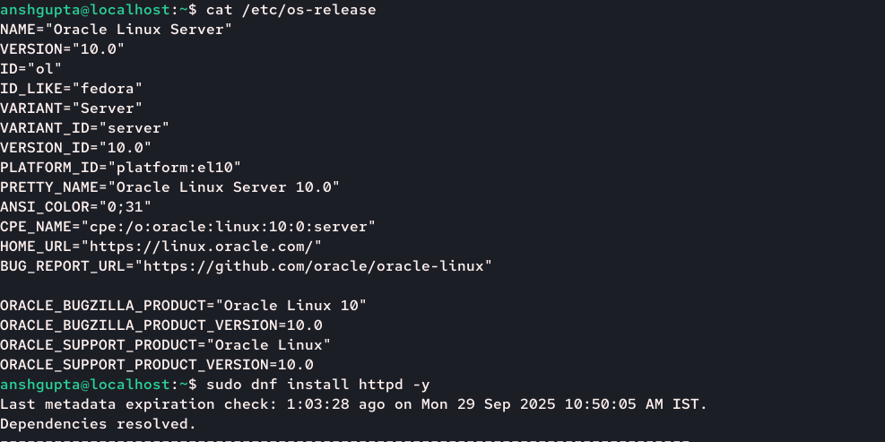

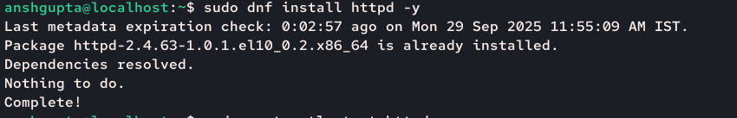
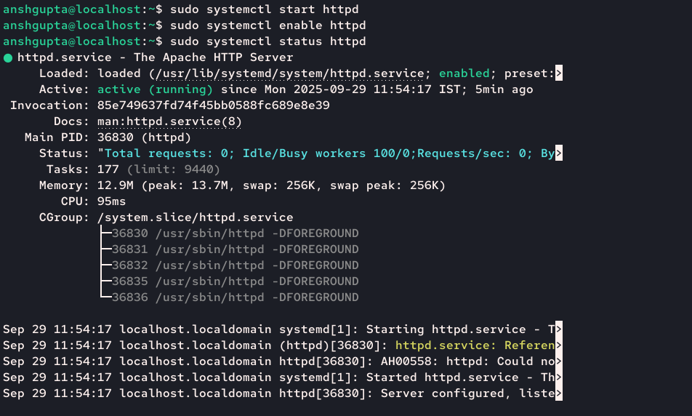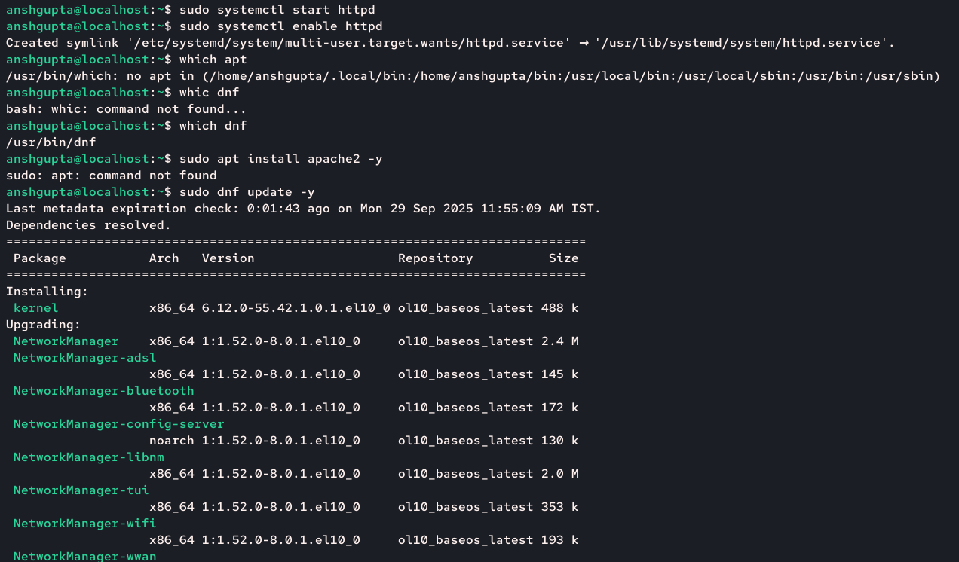
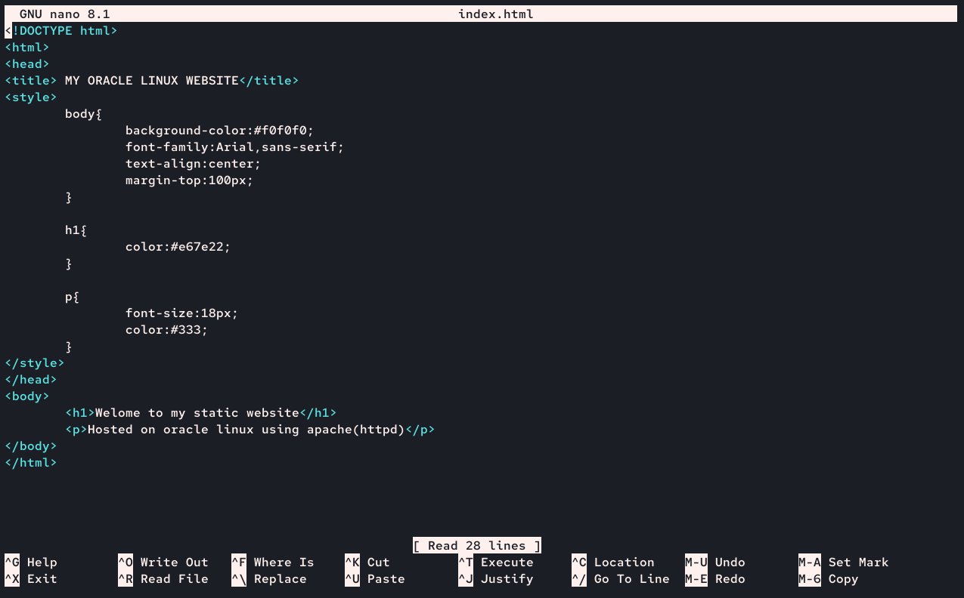
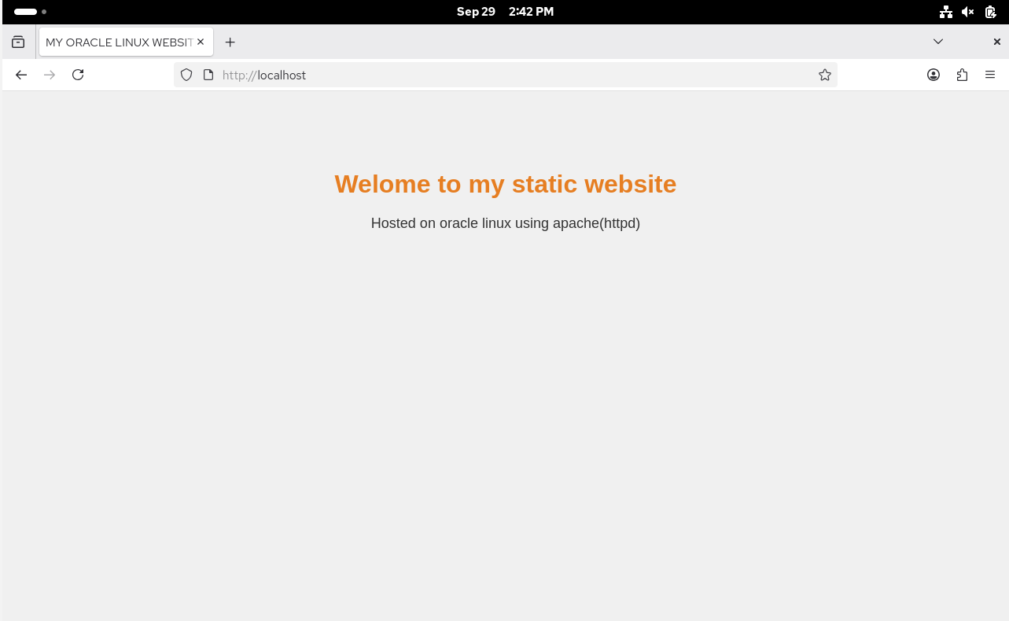
➢ USE CASES:
• Personal portfolio or resume websites
• Company landing and marketing pages
• Technical documentation or knowledge portals
• Educational and student project hosting
• Internal dashboards and static reports
• Product or event microsites
• Government or public information sites
• Backup or mirror websites

➢ FUTURE SCOPE:
• Integrate HTTPS using SSL/TLS certificates for secure access
• Automate website deployment using shell or Ansible scripts
• Host multiple websites using virtual hosting configurations
• Deploy on Oracle Cloud Infrastructure (OCI) for scalability
• Add monitoring tools for uptime and performance tracking
• Implement a CI/CD pipeline for automated updates
• Include dynamic features using backend technologies (PHP, Node.js)
• Create a web-based control panel for easier management
• Use Docker containers for portable and efficient hosting.

➢ CONCLUSION:
The project “Hosting a Static Website on Oracle Linux” successfully demonstrates the process of deploying and managing a website on a secure and reliable Linux environment. By using Oracle Linux and Apache/Nginx, the project highlights essential concepts of web server configuration, file management, and firewall setup.
This implementation proves that static website hosting is a cost-effective, fast, and efficient solution for personal portfolios, institutional pages, and business landing sites. Through this project, a strong understanding of Linux-based web hosting, command-line operations, and system administration has been developed.

