Worksheet 4

Student Name: Sahil Sharma UID: 26MCI10257
Branch: MCA (AIML) Section/Group: 26MAM-4B
Semester: 1st Date of Performance: 08/09/2026
Subject: Python Programming (LAB) Subject Code: 26CAH-606

EXPERIMENT 4(A):

AIM:

Write an experiment to swap two columns in numpy array.

OBJECTIVE:

The objective of this experiment is to understand and implement NumPy arrays in Python. The experiment aims to create a NumPy array, access its columns using indexing, and swap two selected columns without changing the remaining elements of the array.

THEORY:

- NumPy: NumPy is a Python library used for numerical and array-based operations.
- NumPy Array: A NumPy array is a collection of elements arranged in one or more dimensions. A two-dimensional array consists of rows and columns.
- Column: A column contains elements arranged vertically in a two-dimensional NumPy array. Columns can be accessed using indexing.
- Indexing: NumPy uses zero-based indexing to access rows and columns. For example, array[:, 0] accesses the first column.
- Column Swapping: Two columns can be swapped by assigning one column to the other using NumPy indexing. A temporary variable can also be used to preserve the original column values.
- Array Slicing: The : operator is used to select all rows while accessing a particular column.
- Output: The program displays the original NumPy array and the array after swapping the selected columns.

CODE :

import numpy as np
# Create a sample NumPy array
array = np.array([[1, 4, 7],
[2, 5, 8],
[3, 6, 9]])
print("Original Array:")
print(array)

# Swap the first and third columns
array[:, [0, 2]] = array[:, [2, 0]]
print("\nArray after swapping first and third columns:")
print(array)

OUTPUT:

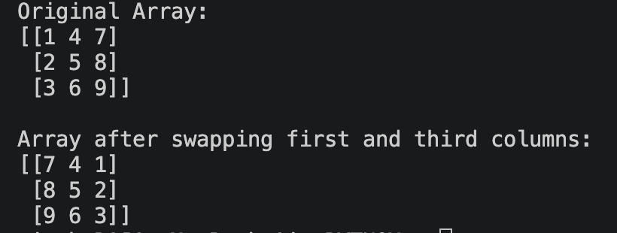

LEARNING OUTCOMES:

- Understand the basic concepts of NumPy arrays.
- Learn to create and initialize two-dimensional NumPy arrays.
- Understand how to identify and access rows and columns using indexing.
- Learn to use array slicing to select specific columns.
- Perform column swapping using NumPy operations.
- Understand the use of the : operator for accessing all rows of a column.
- Develop practical skills in manipulating NumPy arrays.
- Display and verify the original and modified arrays after swapping columns.

EXPERIMENT 4(B)

AIM:

Given a DataFrame df containing employee data, write a Pandas script to filter rows where the 'Department' is 'Sales', calculate the average 'Salary' for this department, and handle any missing values in the 'Salary' column by filling them with the median.

OBJECTIVE:

The objective of this experiment is to understand and implement data manipulation using Pandas DataFrames. The experiment aims to filter employee records based on their department, handle missing salary values using the median, and calculate the average salary of employees in the Sales department.

THEORY:

- Pandas: Pandas is a Python library used for data analysis and manipulation.
- DataFrame: A DataFrame is a two-dimensional tabular data structure in Pandas consisting of rows and columns.
- Filtering: Pandas allows rows to be filtered based on a condition. For example, employees can be filtered where the Department is "Sales".
- Missing Values: Missing data in a DataFrame is commonly represented as NaN. Pandas provides functions to identify and handle missing values.
- Median: The median is the middle value of a dataset when the values are arranged in order. It can be used to replace missing values in the Salary column.
- Filling Missing Values: The fillna() function is used to replace missing values. The missing salaries can be filled using the median salary.
- Average Salary: The mean() function is used to calculate the average salary of employees in the Sales department.
- Output: The program displays the filtered Sales department data and the calculated average salary after handling missing values.

CODE :
import pandas as pd

# Create employee DataFrame
data = {
'Employee': ['Raja', 'Sahil', 'Adiya', 'Suryansh', 'Swarup', 'Yash'],
'Department': ['Sales', 'IT', 'Sales', 'HR', 'Sales', 'Sales'],
'Salary': [100000, 150000, None, 100000, 50000, None]
}

df = pd.DataFrame(data)

print("Original DataFrame:")
print(df)

# Fill missing Salary values with median
median_salary = df['Salary'].median()
df['Salary'] = df['Salary'].fillna(median_salary)

# Filter employees from Sales department
sales_df = df[df['Department'] == 'Sales']

# Calculate average salary of Sales department
average_salary = sales_df['Salary'].mean()

print("\nSales Department:")
print(sales_df)

print("\nAverage Salary of Sales Department:", average_salary)

OUTPUT:

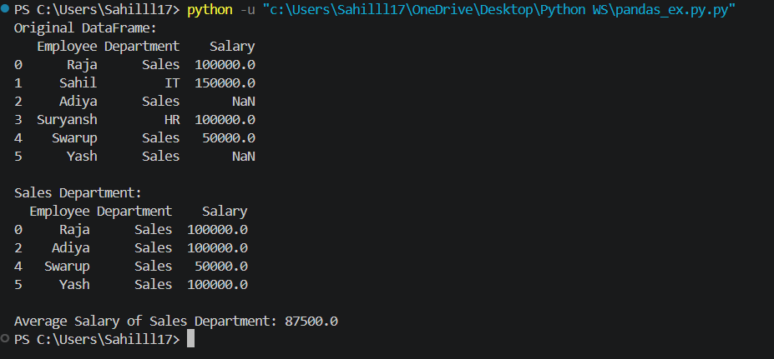

LEARNING OUTCOMES:

- Understand the basic concepts of Pandas and DataFrames.
- Learn to create and work with employee data using a DataFrame.
- Learn to filter rows based on a specific condition.
- Understand and handle missing values in a DataFrame.
- Learn to calculate the median of a column.
- Use fillna() to replace missing salary values with the median.
- Use mean() to calculate the average salary.
- Develop practical skills in data filtering and analysis using Pandas.
- Display the filtered Sales department data and average salary.

