Valuation of TATA, Mahindra and Maruti Suzuki through FCFF and FCFE models

**Assignment-4**

Submitted in partial fulfilment of the

requirements of the course

**ECON F355 Business Analysis and Valuation**

By

2020A4PS2241H VIPUL SINGH 8630034288

2020A4PS2171H PRIYANSHU RAJ 7439968303

2020A3PS1139H SHREYAAN SHARMA 7738338418

2020A4PS2274H VAIBHAV VERMA 8890765928

2020A4PS0847H SAHIL LUTHRA 9653628611

Under the supervision of

**Prof. Niranjan Swain**



**BIRLA INSTITUTE OF TECHNOLOGY AND SCIENCE PILANI**

**25 DECEMBER 2022**

**Group Details**

**Industry: Automobile**

**Company Name: Tata Motors, Mahindra, Maruti Suzuki**

|  |  |  |  |
| --- | --- | --- | --- |
| **S. No.** | **Name** | **ID No.** |  |
|  |  |  |  |
| **1** | **Sahil Luthra** | **2020A4PS0847H** |  |
| **2** | **Shreyaan Sharma** | **2020A3PS1139H** |  |
| **3** | **Priyanshu Raj** | **2020A4PS2171H** |  |
| **4** | **Vaibhav Verma** | **2020A4PS2274H** |  |
| **5** | **Vipul Singh** | **2020A4PS2241H** |  |

ACKNOWLEDGEMENT

*We would like to express our sincere gratitude to Dr. Niranjan Swain, for giving us an opportunity to work under him for this assignment and taking his valuable time to provide us with the required guidance wherever required. His input proved to be very vital for the assignment. We would like to thank him for providing us with such a wonderful opportunity to apply our course knowledge on real-life data and get hands-on experience. We are indebted for all his help and guidance throughout the course and this assignment.*

**ABSTRACT**

The purpose of this project is to do the valuation of three automobile companies namely, TATA Motors, Mahindra, Maruti Suzuki using different valuation methods. The valuation is done using 2-Stage DDM, 3-Stage DDM and FCFF, FCFE methods. Historical data was studied and interpreted to predict the future growth rate and the duration of this high growth. Based on the expected future cash flows, the current value of the company was determined. The future cash flows were discounted by an appropriate discount rate to get the present value.

TABLE OF CONTENTS

**Section 1: Overview of companies**

1. TATA Motors
2. Mahindra and Mahindra
3. Maruti Suzuki

**Section 2: Two-Stage DDM**

1. Procedure for Two-Stage DDM
2. Mahindra Valuation
3. Maruti Suzuki Valuation

**Section 3: FCFE method**

1. Procedure for FCFE method
2. TATA Motors Valuation
3. Mahindra Valuation
4. Maruti Suzuki Valuation

**Section 4: FCFF method**

1. Procedure for FCFF method
2. TATA Motors Valuation
3. Mahindra Valuation
4. Maruti Suzuki Valuation

**Section 5: Three-Stage DDM**

1. Procedure for Three-Stage DDM
2. Mahindra Valuation
3. Maruti Suzuki Valuation

**Section: Conclusion**

1. Summary
2. Conclusion

**TATA Motors**

Tata Motors is a $42 billion company that manufactures a variety of automobiles and is a world leader in manufacturing. Their brand is well-known in more than 175 nations and has established itself as a serious rival in the world's auto market. It is one of India’s biggest car manufacturers.

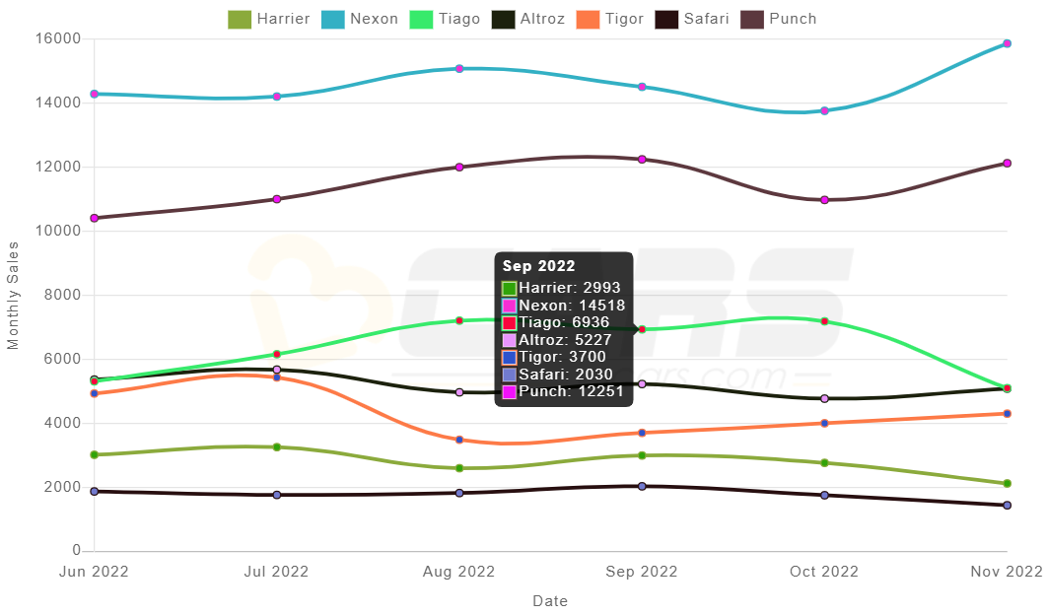

The company has stable growth in the car segment with TATA Nexon being its highest sold product.

**Mahindra and Mahindra**

One of India's largest private corporations, Mahindra and Mahindra (M&M), has dominated the auto sector for many years. M&M, a company that specialises in farm equipment, is the third-largest tractor producer in the world. It has two key operating divisions that together produce more than 100,000 tractors annually. M&M currently runs six facilities in India. With a production capacity of 200,000 vehicles per year, the Nashik facility produces five different types of automobiles, including the popular models Scorpio and Xylo.

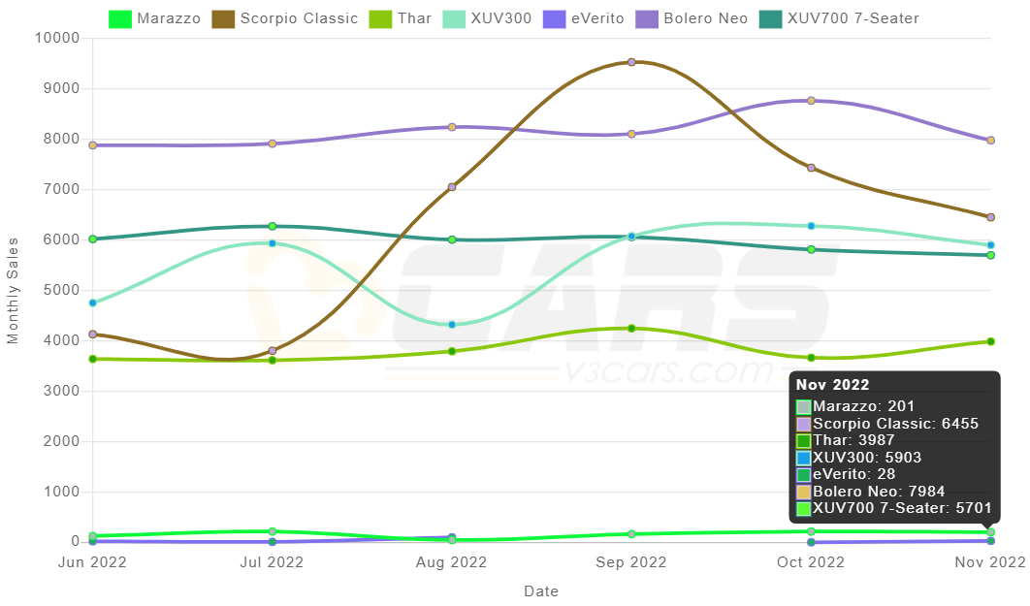

**Maruti Suzuki**

Indian automaker Maruti Suzuki India Limited has its headquarters in New Delhi. When it was established in 1981, the Indian government held it until 2003, when Suzuki Motor Corporation of Japan purchased it. Maruti Suzuki has a 44.2% market share in the Indian passenger car industry as of February 2022. In India, Maruti Suzuki has two factories. The annual output capacity of all manufacturing facilities is 1,200,000 automobiles. The 300-acre Gurgaon manufacturing park features three completely integrated production facilities. Additionally, 240,000 K-Series engines are produced there each year.

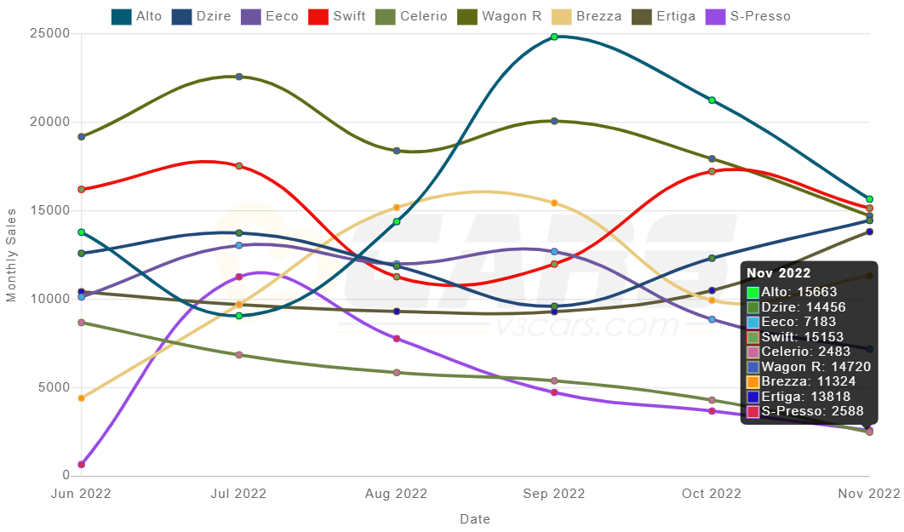

**Two-Stage DDM**

The two-stage dividend discount model is used to find the value of the company based on its dividend payout and growth in revenue. The rationale for the model lies in the present value rule - the value of any asset is the present value of expected future cash flows discounted at a rate appropriate to the riskiness of the cash flows.

There are two basic inputs to the model – (1) expected dividends and (2) cost on equity. To obtain the expected dividends, assume about expected future growth rates in earnings and payout ratios The required rate of return on a stock (Ke) is determined by its riskiness of the business. Historical data of the company is analysed to figure out the future expected growth rate and the future dividend payment.

In the Two-stage model of DDM, a company has two phases of growth. A high growth period with low dividend payout ratio and shorter duration. This phase if followed by a stable growth period with a high dividend payout ratio which is maintained for a very long time.

The present value of the dividends during high growth period is found. Then the terminal value of the company is found with the assumption that the growth rate will be constant. The present of this terminal value is then added to the sum of dividends to obtain the value of the firm.

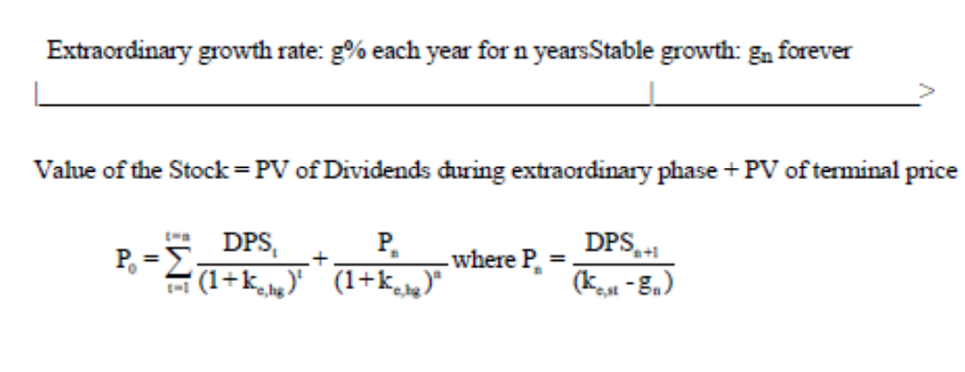

**Mahindra and Mahindra**

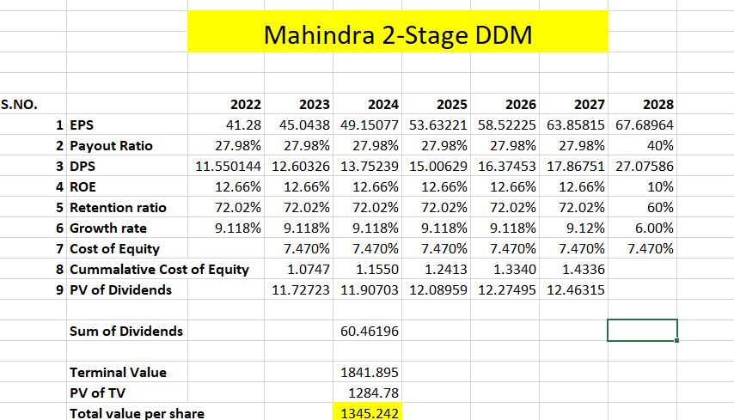

|  |
| --- |
| 1. Based on past data, Mahindra is expected to grow by 9.118% each year for the next 5 years |
| 2. It is also expected to maintain the current retention ratio and ROE for the next 5 years |
| 3. After 5 years the company will attain stable growth of 6% till perpetuity |
| 4. After 5 years, the ROE will drop to 10% |

**Price per share = Rs. 1345.242**

**Maruti Suzuki**

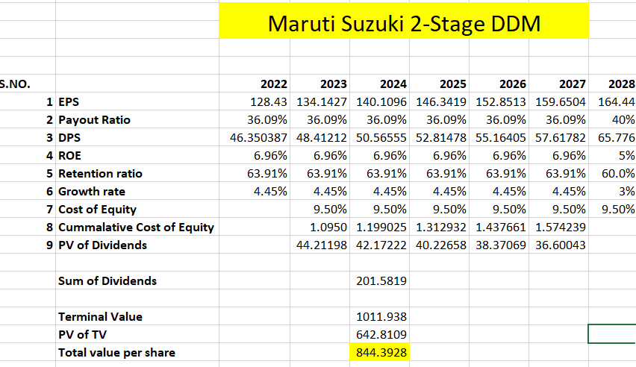

|  |
| --- |
| 1. Based on past data, Maruti-Suzuki is expected to grow by 4.55% each year for the next 5 years |
| 2. It is also expected to maintain the current retention ratio and ROE for the next 5 years |
| 3. After 5 years the company will attain stable growth of 3% till perpetuity |
| 4. After 5 years, the ROE will drop to 5% |

**Price per share = Rs. 844.3928**

**\*\*\* TATA Motors does not dividends and hence DDM method cannot be used for it\*\*\***

**FCFE Method**

FCFE method or Free cash flow to equity method is used to find the value of the company based on its free cash flow. The underlying principle is that there will be no future cash buildup in the firm, since the cash that is available after debt payments and reinvestments needs is paid out to stockholders each period The FCFE is a measure of what a firm can afford to pay out as dividends. Dividends paid are different from the FCFE. The value of equity, under the constant growth model, is a function of the expected FCFE in the next period, the stable growth rate and the required rate of return.

This model is most suitable when:

1. The firm is in steady state.
2. Capital expenditure is not significantly greater than depreciation.
3. The beta of the stock is close to one or below one.
4. The firm has FCFE which are significantly different from dividends, or dividends are not relevant.
5. The leverage is stable.

The free cash flow to the equity is evaluated and is discounted by an appropriate rate to find its present value. The terminal value of the firm is found by using expected future cash flow and using perpetuity formula. The present value of this terminal value is added to get the value o the firm.

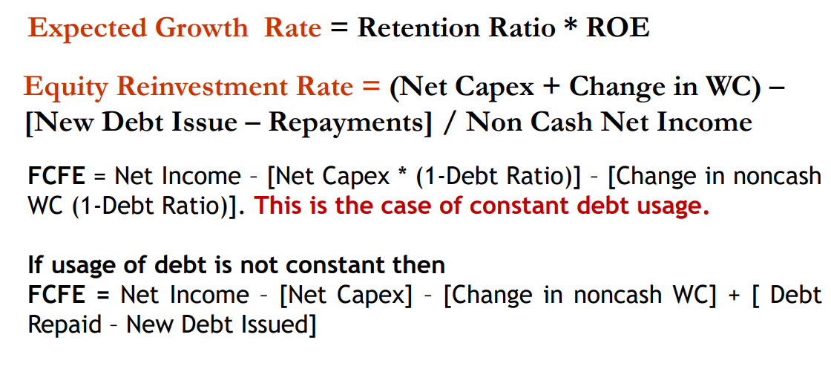

**TATA Motors 3-stage FCFE**

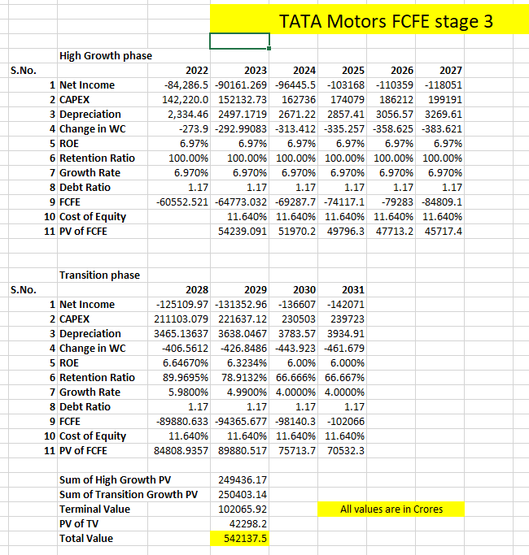

|  |
| --- |
| 1. Based on historical data, Maruti Suzuki is expected to grow at 4.44% for the next 5 years. |
| 2. Capex, depreciation and change in WC will also grow at the same rate. |
| 3. The company will maintain its ROE and retention ratio for the high growth period. |
| 4. After the 5 years the growth will slow down to 4% and ROE will become 6% |
| 5. There will be stable growth from 2031 onwards |

**Value of company – Rs. 542137.5 crores**

**Mahindra 3-stage FCFE**

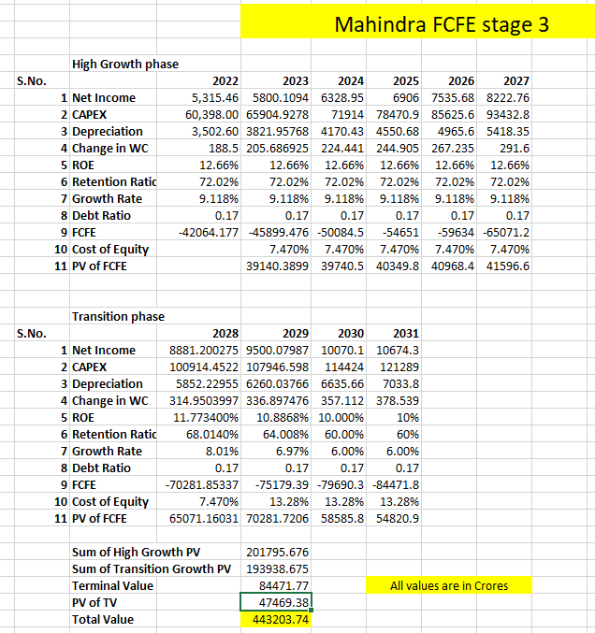

|  |
| --- |
| 1. Based on historical data, Maruti Suzuki is expected to grow at 4.44% for the next 5 years. |
| 2. Capex, depreciation and change in WC will also grow at the same rate. |
| 3. The company will maintain its ROE and retention ratio for the high growth period. |
| 4. After the 5 years the growth will slow down to 3% and ROE will become 5% |
| 5. There will be stable growth from 2031 onwards |

**Value of company – 443203.74 crores**

**Maruti Suzuki 3-stage FCFE**



|  |
| --- |
| 1. Based on historical data, Maruti Suzuki is expected to grow at 4.44% for the next 5 years. |
| 2. Capex, depreciation and change in WC will also grow at the same rate. |
| 3. The company will maintain its ROE and retention ratio for the high growth period. |
| 4. After the 5 years the growth will slow down to 3% and ROE will become 5% |
| 5. There will be stable growth from 2031 onwards |

**Value of company – Rs. 443203.74 crores**

**TATA MOTORS 2 STAGE FCFE**

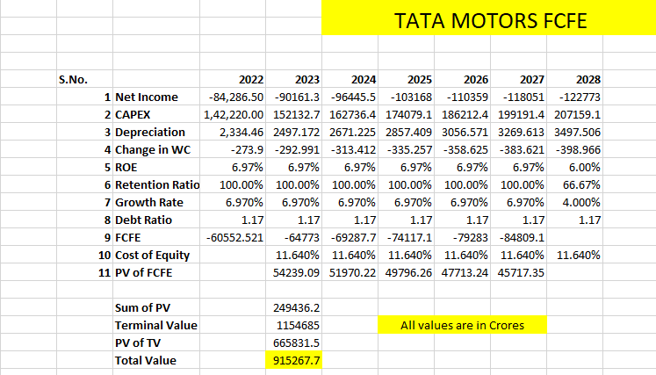

|  |
| --- |
| 1. Based on historical data, TATA MOTORS is expected to grow at 6.97% for the next 5 years. |
| 2. Capex, depreciation and change in WC will also grow at the same rate. |
| 3. The company will maintain its ROE and retention ratio for the high growth period. |
| 4. After the 5 years the growth will slow down to 4% and ROE will become 6% |
| 5. As the payout is 0, therefore the company won't be paying any dividends |

Total value of company = RS. 915267.7 Crores

**MAHINDRA 2 STAGE FCFE**

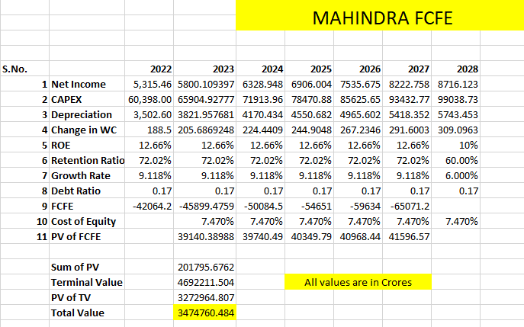

|  |
| --- |
| 1. Based on historical data, Mahindra is expected to grow at 9.118% for the next 5 years. |
| 2. Capex, depreciation and change in WC will also grow at the same rate. |
| 3. The company will maintain its ROE and retention ratio for the high growth period. |
| 4. After the 5 years the growth will slow down to 6% and ROE will become 10% |

Total value of the company = Rs. 3474760.484 crores

**MARUTI SUZUKI 2 STAGE FCFE**

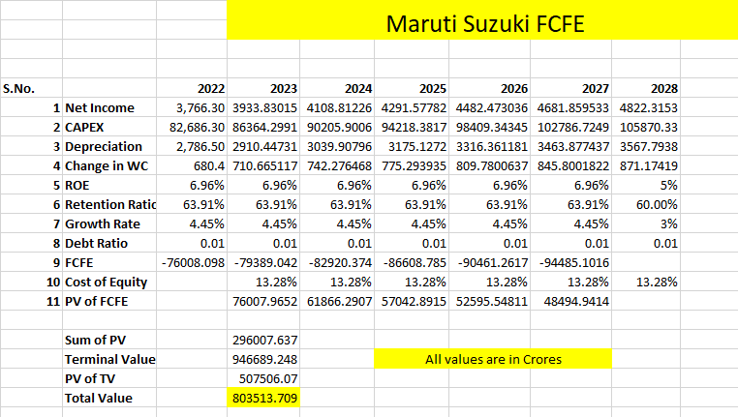

|  |
| --- |
| 1. Based on historical data, Maruti Suzuki is expected to grow at 4.44% for the next 5 years. |
| 2. Capex, depreciation and change in WC will also grow at the same rate. |
| 3. The company will maintain its ROE and retention ratio for the high growth period. |
| 4. After the 5 years the growth will slow down to 3% and ROE will become 5% |

Total value of the company = Rs. 8083513.709 crores

**Three-Stage DDM**

The two-stage dividend model had a limitation that the growth rate changed from very high to low overnight. This limitation is corrected in the three-stage dividend discount model which has three phases: a high growth phase where dividend payout is low, a transition phase where the growth reduces slowly and the payout ratio increases and a stable growth phase where the growth is constant till perpetuity.

This method works best for firm which has changing growth over time and change in other dimensions like payout policies and risk. It is used for firms with extraordinary growth rate which they are expected to maintain for an initial period after which the differential advantage is expected to deplete leading to gradual decline to stable growth rate.

The same principal of finding the present value of future cash flows is used in this model. The present value of the transition phase dividend is found by discounting it by an appropriate rate. The present value of the terminal value is added to the present value of dividends of high growth and transition phase to obtain the value of the firm.

**Mahindra and Mahindra**

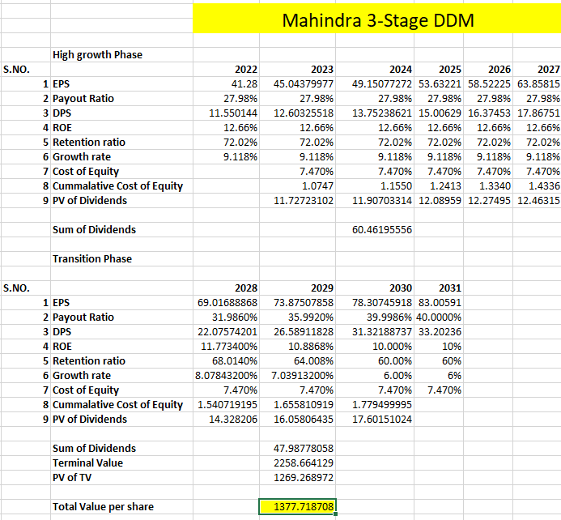

|  |
| --- |
| 1. After 5 years of high growth, the growth rate will decrease to 6% over 3 years. |
| 2. The ROE will decrease to 10% over 3 years. |
| 3. The retention ratio will decrease to 60% in 3 years’ time. |

**Price per share = Rs. 1377.718**

**Maruti Suzuki**

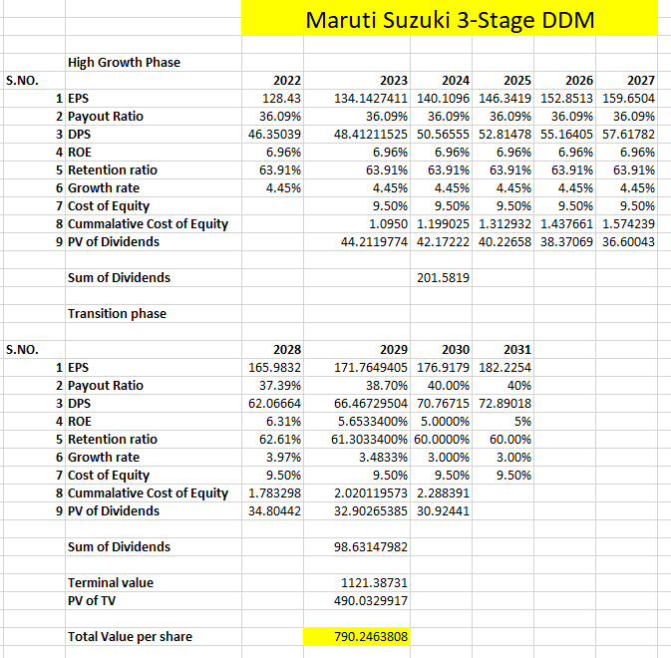

|  |  |
| --- | --- |
| 1. After high growth of 5 years, growth rate will decrease to 3% in 3 years. |  |
| 2. ROE will decrease linearly to 5% in 3 years. | |
| 3. The retention ratio will also decrease to 60% in 3 years | |

**Price per share = Rs. 790.246**

**FCFF Method**

Free cash flow to firm method is used to estimate the value of firm by using the free cash flow. FCFF, or Free Cash Flow to Firm, is the cash flow available to all funding providers (debt holders, preferred stockholders, common stockholders, convertible bond investors, etc.). This can also be referred to as unlevered free cash flow, and it represents the surplus cash flow available to a business if it was debt-free. A common starting point for calculating it is Net Operating Profit After Tax (NOPAT), which can be obtained by multiplying Earnings Before Interest and Taxes (EBIT) by (1-Tax Rate). From that, we remove all non-cash expenses and remove the effect of CapEx and changes in Net Working Capital, as the core operations are the focus. To arrive at the FCFF figure, a Financial Analyst will have to undo the work that the accountants have done. The objective is to get the true cash inflows and outflows of the business.





**TATA Motors**

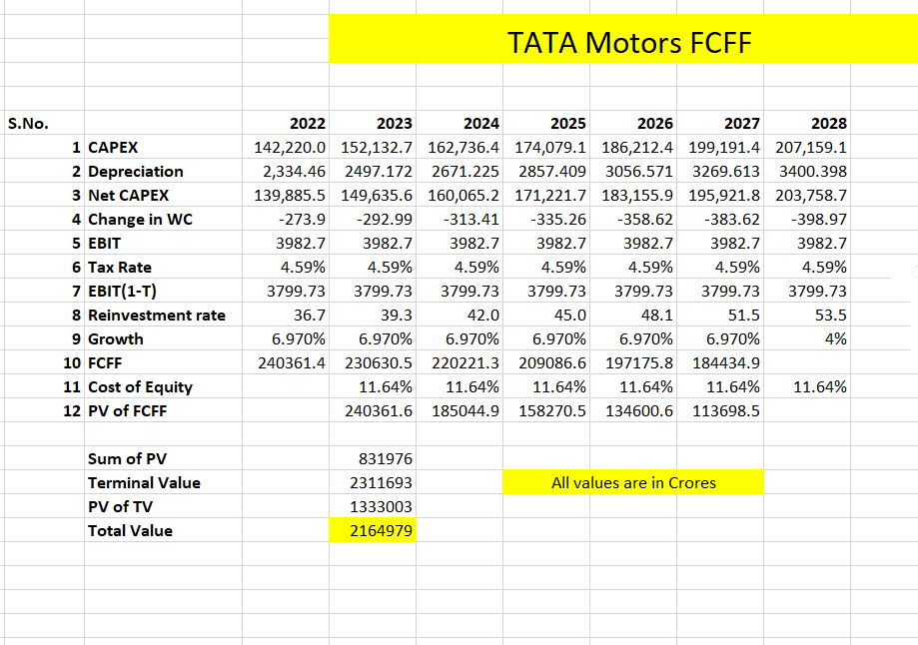

|  |
| --- |
| 1. Capex, and change in WC will also grow at the same rate. |
| 2. After the 5 years the growth will slow down to 4% |

**Value of firm = Rs. 2164979 crores**

**Mahindra and Mahindra**

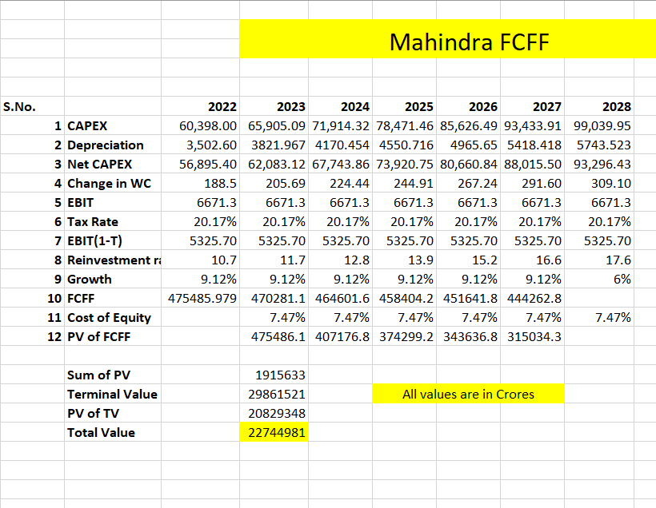

|  |
| --- |
| 1. Capex, and change in WC will also grow at the same rate. |
| 2. After the 5 years the growth will slow down to 6% |

**Value of company = Rs. 22744981 crores**

**Maruti Suzuki**

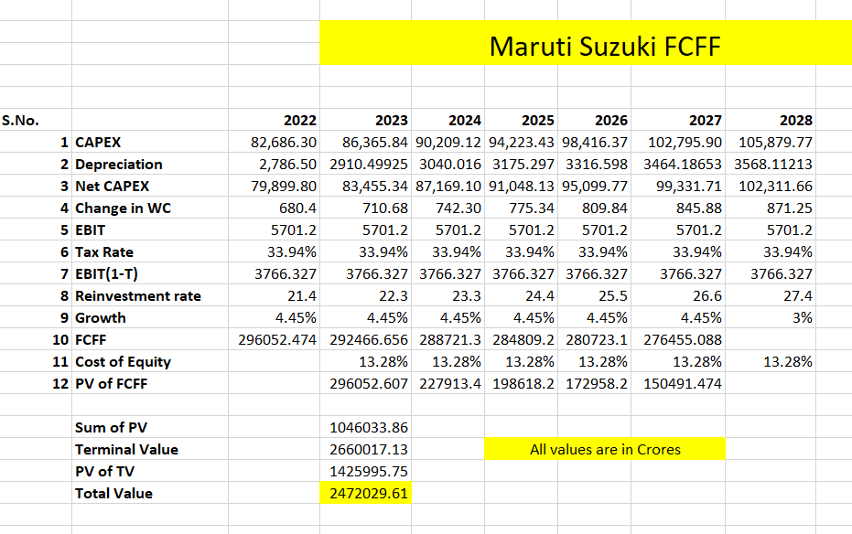

|  |
| --- |
| 1. Capex, and change in WC will also grow at the same rate. |
| 2. After the 5 years the growth will slow down to 3% |

**Value of Company = Rs. 247209.61 crores**

**Conclusion**

The valuation of the companies was done using 2-stage and 3-stage DDM as well as FCFF and FCFE methods. The methods yielded different results from each other. This is because the basic principal and assumptions of the models is different. Also the dividends paid by the companies are less than the FCFE because they retain their earnings for reinvestment.

After analysing historical data, it was clear that the growth of the companies was hit hard by the covid pandemic. However the automobile sector has almost recovered from the crisis and is back to its normal growth with the sales returning to pre-covid numbers.

Companies with high growth sometimes had lower values because their high cost of equity which nullified their growth.

The price per share obtained from these valuation are slightly different from actual prices. This is because of assumptions in growth are different for each business analyst.