STATISTICAL ANALYSIS AND
MACHINE LEARNING-BASED PREDICTION
OF WINE QUALITY
USING PHYSICOCHEMICAL PROPERTIES

Data Analytics Coursework Project

Dataset: UCI Wine Quality – Red Wine Dataset (winequality-red.csv)
Original observations: 1,599 | Cleaned observations: 1,359
Primary outcome: Wine Quality Score

Prepared by: Sahil Madaan
Roll No.: 2023BCSE048
Course / Subject: Data Analytics
Instructor:

Contents
1. Executive Summary
2. Introduction
3. Problem Statement
4. Objectives
5. Dataset Description and Data Quality
6. Data Preprocessing
7. Statistical Methodology
8. Descriptive Statistical Analysis
9. Wine Quality Profile
10. Confidence Intervals and Hypothesis Testing
11. Group Comparison: Low vs High Quality Wines
12. Correlation Analysis
13. Repeated Sampling and Effect of Sample Size
14. Visual Analysis
15. Machine Learning and 5-Fold Cross-Validation
16. Integrated Discussion of Findings
17. Limitations
18. Reproducibility and Python Implementation
19. Conclusion
20. References
Appendix A. Key Numerical Results

1. Executive Summary
This project presents a statistical and machine-learning analysis of the UCI Wine Quality red-wine dataset. The dataset contains physicochemical measurements such as acidity, sulphates, sulfur dioxide, density, pH and alcohol, together with a sensory wine-quality score. The original dataset contains 1,599 observations and 12 numerical variables. Exact duplicate rows were removed as a project-level preprocessing choice, leaving 1,359 unique observations.
Descriptive statistics were calculated for the eleven physicochemical predictors, including mean, median, variance, standard deviation, quartiles, interquartile range, skewness, kurtosis and coefficient of variation. Statistical inference was then performed using 95% confidence intervals, a one-sample t-test for alcohol content, a Welch two-sample t-test comparing low- and high-quality wines, and Pearson correlation analysis.
The cleaned-data mean alcohol content was 10.4323%, with a 95% confidence interval of 10.3747% to 10.4899%. A one-sample t-test against a hypothesized mean of 10% produced t = 14.7284 and p ≈ 1.16 × 10⁻⁴⁵, leading to rejection of the null hypothesis at α = 0.05. High-quality wines had substantially higher mean alcohol content than low-quality wines: 10.8876% versus 9.9208%, a difference of about 0.9669 percentage points.
Pearson correlation between alcohol and quality was r = 0.4803 with p ≈ 2.28 × 10⁻⁷⁹, indicating a statistically significant positive linear association. Repeated sampling across n = 50, 100, 250, 500 and 1,000 showed that the average 95% confidence interval becomes narrower as sample size increases. Finally, 5-fold cross-validation compared Linear Regression and Random Forest models for quality prediction. Random Forest achieved the better mean RMSE (0.6440 versus 0.6645) and R² (0.3853 versus 0.3465).

Key Results at a Glance
Measure | Result
Original dataset size | 1,599 observations
Duplicate rows removed | 240
Cleaned dataset size | 1,359 observations
Missing values | 0
Mean quality score (cleaned) | 5.6233
Mean alcohol content (cleaned) | 10.4323%
95% CI for mean alcohol | [10.3747%, 10.4899%]
Alcohol vs 10% one-sample t-test | t = 14.7284, p ≈ 1.16×10⁻⁴⁵
High-quality vs low-quality alcohol difference | +0.9669 percentage points
Alcohol–quality Pearson correlation | r = 0.4803, p ≈ 2.28×10⁻⁷⁹
Best CV model | Random Forest
Random Forest mean RMSE | 0.6440
Random Forest mean R² | 0.3853

2. Introduction
Wine quality is influenced by multiple chemical and physical properties. Measurements such as volatile acidity, citric acid, sulphates, sulfur dioxide, density, pH and alcohol can vary considerably between wines and may be associated with sensory quality ratings. Statistical analysis provides a systematic way to summarize these measurements, quantify uncertainty, compare groups and identify relationships.
This project uses the red-wine portion of the UCI Wine Quality dataset. The analysis deliberately combines classical statistics with a machine-learning component. The statistical component focuses on descriptive measures, confidence intervals, hypothesis testing, correlation and the effect of sample size. The machine-learning component evaluates whether the physicochemical variables can predict the quality score using cross-validated Linear Regression and Random Forest models.
An important distinction is maintained throughout the report: statistical significance and predictive association do not imply causation. The results describe patterns in the supplied dataset and should not automatically be interpreted as causal effects or as guaranteed behavior for every wine population.

3. Problem Statement
How are physicochemical properties related to wine quality, and how does sample size influence the precision and stability of statistical estimates? The project further asks whether different wine-quality groups show statistically significant differences in alcohol content and whether machine-learning models can predict wine quality from physicochemical properties.

4. Objectives
- Describe the physicochemical properties of the red-wine dataset using appropriate descriptive statistics.
- Calculate mean, median, variance, standard deviation, quartiles, IQR, skewness, kurtosis and coefficient of variation.
- Construct and interpret a 95% confidence interval for mean alcohol content.
- Perform a one-sample t-test for the mean alcohol content using a clearly stated null hypothesis.
- Compare alcohol content between low-quality and high-quality wine groups using Welch's independent-samples t-test.
- Measure the linear relationship between alcohol and quality using Pearson correlation.
- Repeat sampling at multiple sample sizes and study the effect of sample size on confidence-interval width, estimate variability and hypothesis-test behavior.
- Visualize distributions, group differences, correlations and sample-size effects.
- Build Linear Regression and Random Forest models and evaluate them using 5-fold cross-validation.
- Interpret the findings, limitations and practical implications without making causal claims.

5. Dataset Description and Data Quality
The project uses the UCI Wine Quality red-wine dataset. It contains 1,599 wine observations and twelve numerical columns: eleven physicochemical variables and one quality score. The quality score is an ordered sensory rating in the supplied red-wine data, ranging from 3 to 8.
Variable | Type | Description
fixed acidity | Continuous | Acid concentration
volatile acidity | Continuous | Volatile acidity concentration
citric acid | Continuous | Citric acid concentration
residual sugar | Continuous | Residual sugar concentration
chlorides | Continuous | Chloride concentration
free sulfur dioxide | Continuous | Free sulfur dioxide level
total sulfur dioxide | Continuous | Total sulfur dioxide level
density | Continuous | Wine density
pH | Continuous | Acidity / alkalinity measure
sulphates | Continuous | Sulphate concentration
alcohol | Continuous | Alcohol percentage
quality | Ordinal / numerical | Wine quality score

5.1 Data Quality Checks
Check | Result
Rows before cleaning | 1,599
Columns | 12
Missing values | 0
Exact duplicate rows | 240
Rows after duplicate removal | 1,359
All variables numeric | Yes
Quality range in original data | 3 to 8
No missing values were found. There were 240 exact duplicate rows. These duplicates were removed to prevent identical records from disproportionately weighting the statistical summaries and machine-learning evaluation. This is a methodological choice rather than proof that repeated records were invalid observations; therefore, the cleaned dataset should be understood as the analysis dataset selected for this project.

6. Data Preprocessing
- Loaded the CSV dataset into a Pandas DataFrame.
- Checked dimensions, data types and missing values.
- Identified 240 exact duplicate rows.
- Removed exact duplicates using row-level deduplication.
- Used the resulting 1,359-row dataset for the main statistical and machine-learning analysis.
- Separated the quality variable as the target and the eleven physicochemical variables as predictors for the machine-learning stage.
- No feature scaling was required for the Random Forest model; Linear Regression was evaluated directly on the numeric features.
The cleaned dataset has a mean quality score of 5.6233 compared with 5.6360 in the original data, showing that duplicate removal changed the overall mean only slightly. Mean alcohol changed from 10.4230% in the original data to 10.4323% after cleaning.

7. Statistical Methodology

7.1 Descriptive Statistics
For each physicochemical variable, the analysis calculates measures of central tendency and dispersion. The sample variance is used together with standard deviation. Quartiles and IQR describe the central 50% of observations, while skewness and kurtosis provide information about distribution shape. The coefficient of variation (CV) is calculated as standard deviation divided by mean and expressed as a percentage.

7.2 Confidence Interval for Mean Alcohol
A two-sided 95% t-based confidence interval is calculated as x̄ ± t(0.975, n−1) × s/√n. Here n = 1,359, x̄ is the sample mean alcohol content and s is the sample standard deviation.

7.3 One-Sample t-Test
For the alcohol hypothesis test, the null hypothesis is H₀: μ = 10%, while the alternative hypothesis is H₁: μ ≠ 10%. The significance level is α = 0.05. The t-statistic compares the observed sample mean with the hypothesized population mean relative to the estimated standard error.

7.4 Welch Two-Sample t-Test
Low-quality wines are defined as quality ≤ 5 and high-quality wines as quality ≥ 6. Welch's independent-samples t-test compares the mean alcohol content of the two groups without assuming equal population variances. The hypotheses are H₀: μ_low = μ_high and H₁: μ_low ≠ μ_high.

7.5 Pearson Correlation
Pearson's correlation coefficient r measures the strength and direction of the linear relationship between alcohol content and quality. The associated p-value tests H₀: ρ = 0 against H₁: ρ ≠ 0.

7.6 Repeated Sampling
Random samples of sizes 50, 100, 250, 500 and 1,000 were repeatedly drawn from the cleaned dataset. Thirty repetitions were performed for each sample size. For every sample, the mean alcohol content, variance, standard deviation, t-based 95% confidence interval and t-test against μ = 10 were computed. Additional summary measures include the standard deviation of sample means, average confidence-interval width, confidence-interval coverage relative to the cleaned-data reference mean, and H₀ rejection rate.

8. Descriptive Statistical Analysis
Feature | Mean | Median | Variance | Std Dev | Min | Q3 | Max | CV %
Fixed acidity | 8.3106 | 7.9000 | 3.0171 | 1.7370 | 4.6000 | 9.2000 | 15.9000 | 20.9009
Volatile acidity | 0.5295 | 0.5200 | 0.0335 | 0.1830 | 0.1200 | 0.6400 | 1.5800 | 34.5683
Citric acid | 0.2723 | 0.2600 | 0.0382 | 0.1955 | 0.0000 | 0.4300 | 1.0000 | 71.8006
Residual sugar | 2.5234 | 2.2000 | 1.8288 | 1.3523 | 0.9000 | 2.6000 | 15.5000 | 53.5909
Chlorides | 0.0881 | 0.0790 | 0.0024 | 0.0494 | 0.0120 | 0.0910 | 0.6110 | 56.0314
Free sulfur dioxide | 15.8933 | 14.0000 | 109.1455 | 10.4473 | 1.0000 | 21.0000 | 72.0000 | 65.7338
Total sulfur dioxide | 46.8260 | 38.0000 | 1116.1577 | 33.4089 | 6.0000 | 63.0000 | 289.0000 | 71.3470
Density | 0.9967 | 0.9967 | 0.0000035 | 0.0019 | 0.9901 | 0.9978 | 1.0037 | 0.1875
pH | 3.3098 | 3.3100 | 0.0240 | 0.1550 | 2.7400 | 3.4000 | 4.0100 | 4.6842
Sulphates | 0.6587 | 0.6200 | 0.0291 | 0.1707 | 0.3300 | 0.7300 | 2.0000 | 25.9095
Alcohol | 10.4323 | 10.2000 | 1.1709 | 1.0821 | 8.4000 | 11.1000 | 14.9000 | 10.3722
The table shows substantial differences in relative variability. Density has extremely low coefficient of variation because its numerical range is narrow, whereas citric acid, sulfur dioxide measures and chlorides show much larger relative dispersion. Residual sugar and chlorides are strongly right-skewed, as reflected by their large skewness and kurtosis values. Alcohol has a comparatively low CV of about 10.37%, indicating less relative dispersion than most other predictors.

8.1 Distribution of Wine Quality
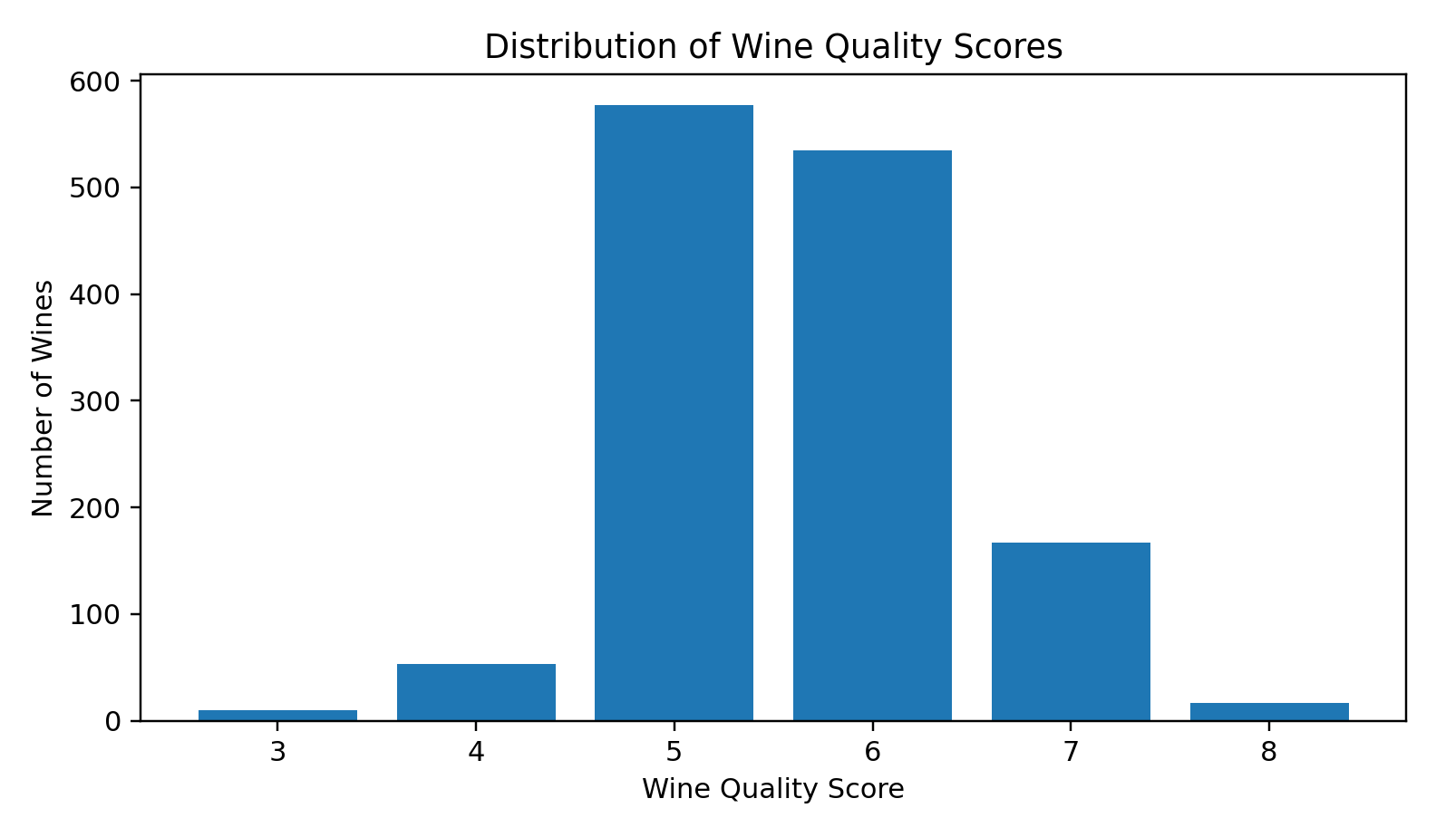
Figure 1. Distribution of wine quality scores in the original dataset.
Quality Score | Count
3 | 10
4 | 53
5 | 577
6 | 535
7 | 167
8 | 17
Quality scores are concentrated around 5 and 6. Scores of 3 and 8 are rare, while scores 5 and 6 account for most observations. This imbalance across quality categories is important when interpreting group comparisons and machine-learning performance.

9. Confidence Intervals and Hypothesis Testing

9.1 95% Confidence Interval for Mean Alcohol
Statistic | Value
Sample size (n) | 1,359
Sample mean | 10.4323%
Sample standard deviation | 1.0821
Confidence level | 95%
t-critical | 1.9617
Margin of error | 0.0576
95% CI | [10.3747%, 10.4899%]
With 95% confidence, the interval estimate for the mean alcohol content of the population represented by the cleaned dataset is approximately 10.3747% to 10.4899%. The interval is narrow because the analysis uses 1,359 observations.

9.2 One-Sample t-Test for Alcohol
Item | Result
H₀ | μ = 10%
H₁ | μ ≠ 10%
α | 0.05
Sample mean | 10.4323%
t-statistic | 14.7284
p-value | 1.1561 × 10⁻⁴⁵
Decision | Reject H₀
Interpretation | Strong evidence that the mean alcohol content differs from 10%.
Because the p-value is far below 0.05, the null hypothesis is rejected. The sample provides extremely strong statistical evidence that the mean alcohol content is different from 10%. This conclusion concerns the mean represented by the analysis dataset and does not imply that every wine has alcohol content above 10%.

9.3 Confidence-Interval Width Across Sample Sizes
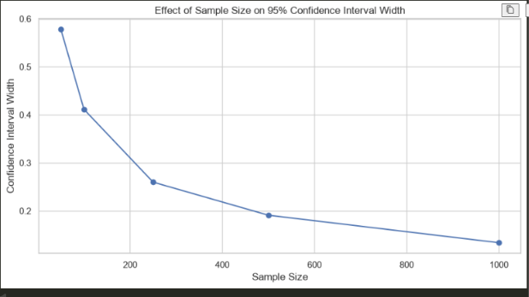
Figure 2. Effect of sample size on average 95% confidence-interval width.

10. Group Comparison: Low vs High Quality Wines
For a more interpretable group comparison, wines with quality ≤ 5 are treated as the low-quality group (n = 640), while wines with quality ≥ 6 are treated as the high-quality group (n = 719).
Group | n | Mean Alcohol | Std Dev | Median | Q1 | Q3
Low quality (≤5) | 640 | 9.9208% | 0.7735 | 9.7000 | 9.4000 | 10.3000
High quality (≥6) | 719 | 10.8876% | 1.1141 | 10.8000 | 10.0000 | 11.7000
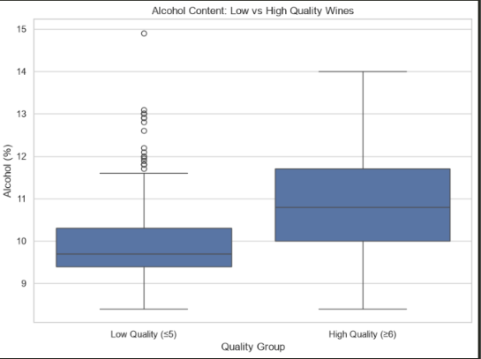
Figure 3. Alcohol content in low-quality and high-quality wine groups.

10.1 Welch t-Test
Statistic | Value
H₀ | μ_low = μ_high
H₁ | μ_low ≠ μ_high
Low-quality mean | 9.9208%
High-quality mean | 10.8876%
Difference (high − low) | 0.9669 percentage points
t-statistic | −18.7427
p-value | 1.8012 × 10⁻⁶⁹
Welch df | 1283.31
95% CI for difference | [0.8657, 1.0681]
Decision | Reject H₀
The difference is statistically significant at α = 0.05. High-quality wines have a mean alcohol content approximately 0.967 percentage points higher than low-quality wines. The 95% confidence interval for the difference is entirely above zero, reinforcing the evidence of a group-level difference.
Statistical significance should not be interpreted as proof that increasing alcohol causes higher quality. Alcohol may be correlated with other wine properties or production processes that also influence quality.

11. Correlation Analysis
Pearson correlation between alcohol and quality is r = 0.4803 with p ≈ 2.28 × 10⁻⁷⁹. This represents a moderate positive linear association: higher alcohol values tend to be associated with higher quality scores in the cleaned dataset.
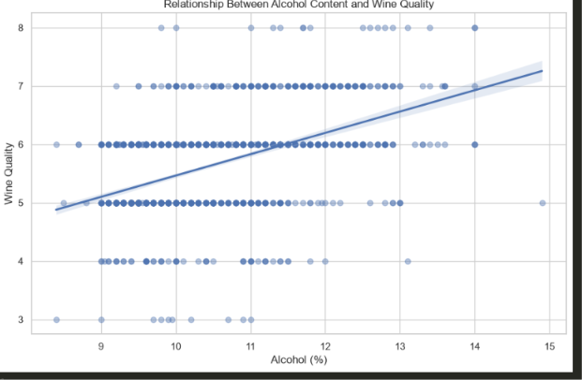
Figure 4. Relationship between alcohol content and wine quality.
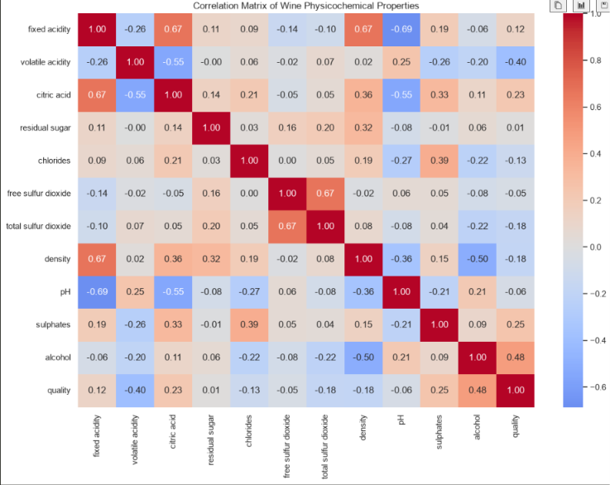
Figure 5. Correlation matrix of wine physicochemical properties.
The correlation matrix shows that alcohol has the strongest positive correlation with quality among the listed physicochemical variables (r ≈ 0.48). Volatile acidity has a moderate negative relationship with quality (about −0.40), while sulphates and citric acid show weaker positive relationships. Several other variables have weak correlations with quality. These values indicate association, not causation.

12. Repeated Sampling and Effect of Sample Size
To demonstrate sampling variability, 30 random samples were drawn without replacement for each sample size n = 50, 100, 250, 500 and 1,000. The cleaned-dataset mean alcohol content (10.4323%) was used as the reference value for confidence-interval coverage. The repeated experiment shows how point estimates fluctuate from sample to sample and how uncertainty changes as n increases.
n | Mean of sample means | SD of sample means | Mean variance | Mean SD | Avg 95% CI width | CI coverage | H₀ rejection rate
50 | 10.4453 | 0.1626 | 1.2037 | 1.0917 | 0.6205 | 96.67% | 83.33%
100 | 10.4221 | 0.1137 | 1.1120 | 1.0525 | 0.4177 | 93.33% | 100%
250 | 10.4404 | 0.0691 | 1.1722 | 1.0819 | 0.2695 | 93.33% | 100%
500 | 10.4201 | 0.0445 | 1.1608 | 1.0771 | 0.1893 | 96.67% | 100%
1000 | 10.4325 | 0.0160 | 1.1660 | 1.0797 | 0.1340 | 100% | 100%

12.1 Interpretation
The standard deviation of the sample mean falls from 0.1626 at n = 50 to 0.0160 at n = 1,000. Average 95% confidence-interval width also decreases substantially, from 0.6205 to 0.1340. Thus, larger samples provide more precise estimates of the mean alcohol content.
Coverage ranges from 93.33% to 100% across the five sample sizes. These values fluctuate around the theoretical 95% level because only 30 repetitions were performed at each n. The H₀ rejection rate is 83.33% at n = 50 and reaches 100% for n ≥ 100 in this particular experiment, illustrating increased statistical power as sample size grows.
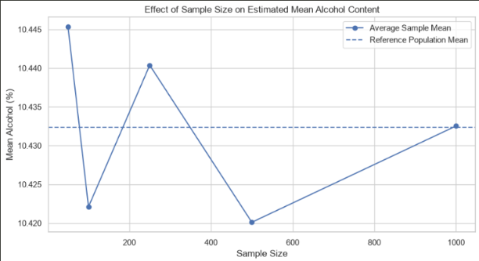
Figure 6. Effect of sample size on estimated mean alcohol content.
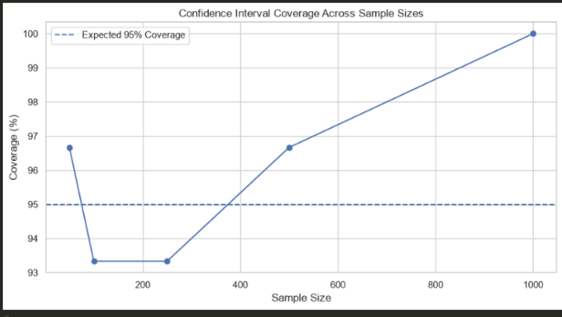
Figure 7. Confidence-interval coverage across sample sizes.
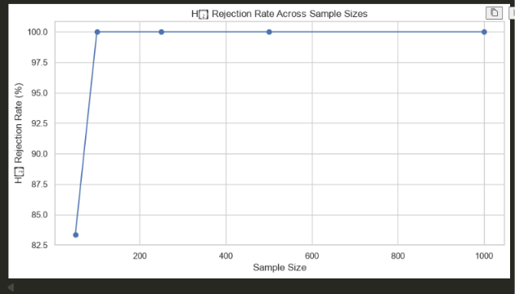
Figure 8. H₀ rejection rate across sample sizes.

13. Visual Analysis
The figures complement the numerical analysis by making distributions, group differences, correlations and sampling behavior easier to inspect.
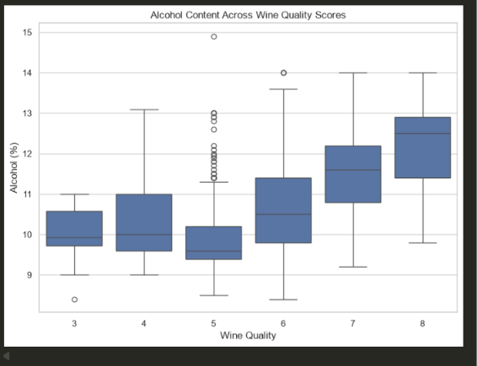
Figure 9. Alcohol content across individual wine quality scores.
The boxplot shows a general upward shift in alcohol content as the quality score increases. Lower quality groups have lower central alcohol values, while scores 6–8 generally show higher medians. Some high-alcohol observations occur among lower quality wines, so the relationship is not deterministic.
Figure 11. Low-quality versus high-quality alcohol distributions.

14. Machine Learning and 5-Fold Cross-Validation
The machine-learning stage treats the eleven physicochemical variables as predictors and wine quality as the numerical target. Two models were evaluated: Linear Regression and Random Forest Regression. Five-fold cross-validation was performed using shuffled folds with random_state = 42. Each model was trained on four folds and evaluated on the remaining fold, repeated until every fold served as the validation set.

14.1 Linear Regression – 5-Fold Results
Fold | MAE | MSE | RMSE | R²
1 | 0.5041 | 0.4310 | 0.6565 | 0.3915
2 | 0.4928 | 0.4236 | 0.6508 | 0.3423
3 | 0.5213 | 0.4474 | 0.6689 | 0.3535
4 | 0.5346 | 0.4622 | 0.6798 | 0.3139
5 | 0.5062 | 0.4444 | 0.6667 | 0.3312
Mean | 0.5118 | 0.4417 | 0.6645 | 0.3465
Std Dev | 0.0163 | 0.0150 | 0.0113 | 0.0291

14.2 Random Forest – 5-Fold Results
Fold | MAE | MSE | RMSE | R²
1 | 0.4699 | 0.3816 | 0.6178 | 0.4613
2 | 0.4873 | 0.4131 | 0.6428 | 0.3585
3 | 0.4909 | 0.4110 | 0.6411 | 0.4061
4 | 0.5067 | 0.4288 | 0.6548 | 0.3634
5 | 0.5106 | 0.4406 | 0.6638 | 0.3370
Mean | 0.4931 | 0.4150 | 0.6440 | 0.3853

14.3 Model Comparison
Model | Mean MAE | Mean MSE | Mean RMSE | Mean R²
Linear Regression | 0.5118 | 0.4417 | 0.6645 | 0.3465
Random Forest | 0.4931 | 0.4150 | 0.6440 | 0.3853
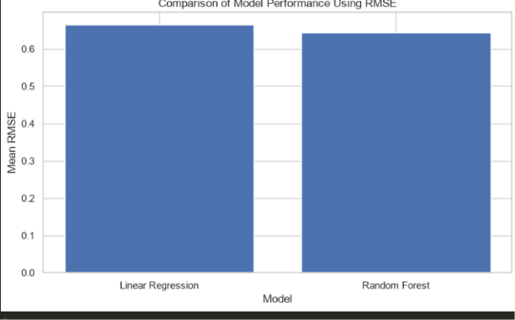
Figure 12. Comparison of model performance using mean RMSE.
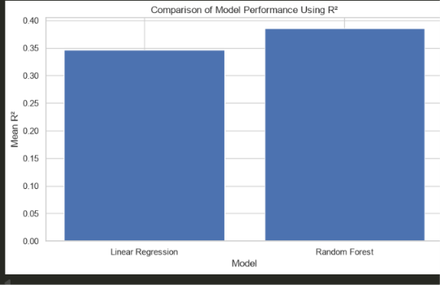
Figure 13. Comparison of model performance using mean R².
Random Forest performs better on all four reported metrics: it has lower MAE, lower MSE, lower RMSE and higher R². The mean R² of 0.3853 indicates that the model captures a meaningful but incomplete portion of the variation in wine quality. Therefore, the model should be viewed as a useful analytical baseline rather than a complete explanation of sensory quality.

14.4 Random Forest Feature Importance
Feature | Importance
Alcohol | 0.2777
Sulphates | 0.1392
Volatile acidity | 0.1295
Total sulfur dioxide | 0.0770
Chlorides | 0.0623
Residual sugar | 0.0583
pH | 0.0578
Density | 0.0520
Fixed acidity | 0.0506
Citric acid | 0.0483
Free sulfur dioxide | 0.0475
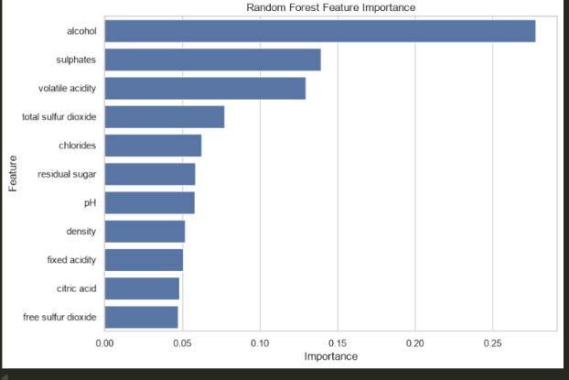
Figure 14. Random Forest feature importance.
Alcohol has the largest Random Forest feature importance at approximately 0.2777, followed by sulphates and volatile acidity. This ranking is consistent with the statistical analysis, where alcohol also shows the strongest positive correlation with quality among the listed predictors. Feature importance, however, is a model-specific measure and should not be interpreted as a causal effect.

15. Integrated Discussion of Findings
Several results point in the same direction. Alcohol is associated positively with quality, and high-quality wines have a higher mean alcohol content than low-quality wines. Alcohol also emerges as the most important predictor in the Random Forest model. These three findings—correlation, group comparison and feature importance—are complementary rather than interchangeable: correlation measures linear association, the t-test compares group means, and feature importance reflects contribution to a predictive model.
Volatile acidity is negatively associated with quality and has relatively high Random Forest importance. Meanwhile, sulphates show a positive correlation with quality and rank second in the Random Forest importance measure. The results suggest that wine quality is related to multiple physicochemical properties rather than a single variable.
The repeated-sampling experiment demonstrates the statistical principle that larger samples reduce estimation uncertainty. At n = 50, the average confidence interval is substantially wider and sample means fluctuate more than at n = 1,000. The coverage results remain close to the expected 95% level given the limited number of repetitions.
The machine-learning results also show the value of cross-validation. Rather than relying on one train-test split, 5-fold cross-validation evaluates each observation through a validation fold and provides a more stable estimate of model performance. Random Forest outperforms Linear Regression, indicating that nonlinear relationships and interactions may contribute to quality prediction.

16. Limitations
- The dataset represents a particular red-wine collection and should not automatically be generalized to all wines or all production regions.
- Quality is a sensory score and may contain subjectivity or evaluator variation.
- Removing exact duplicates is a project-level methodological choice; some repeated records could represent legitimate repeated observations.
- Correlation and statistical significance do not establish causation.
- The quality categories are unevenly distributed, with most wines concentrated around scores 5 and 6.
- The repeated-sampling experiment resamples from the same cleaned finite dataset, so it demonstrates sampling variability within the dataset rather than uncertainty from independently collected populations.
- Only 30 repetitions were performed per sample size, so empirical confidence-interval coverage can fluctuate around 95%.
- The Random Forest R² is moderate, showing that physicochemical variables alone do not fully explain the quality score.
- Feature importance is model-dependent and should not be interpreted as causal importance.

17. Reproducibility and Python Implementation
The analysis can be reproduced using Python with Pandas and NumPy for data handling, SciPy for statistical tests and distributions, Matplotlib/Seaborn for visualization, and Scikit-learn for cross-validation and machine learning.

17.1 Core Workflow
- Load winequality-red.csv.
- Check shape, data types, missing values and duplicate rows.
- Remove exact duplicates to obtain df_clean.
- Generate descriptive statistics for the eleven physicochemical variables.
- Compute the 95% t-based confidence interval for alcohol.
- Run the one-sample t-test against μ = 10.
- Split wines into low-quality (≤5) and high-quality (≥6) groups and run Welch's t-test.
- Compute Pearson correlation and the full correlation matrix.
- Repeat sampling at n = 50, 100, 250, 500 and 1,000 with 30 repetitions.
- Train Linear Regression and Random Forest models using 5-fold shuffled cross-validation.
- Compare MAE, MSE, RMSE and R² and inspect Random Forest feature importance.

17.2 Software
Tool / Library | Purpose
Python | Analysis environment
Pandas | Data loading and tabular analysis
NumPy | Numerical computation
SciPy | t-tests, t-distribution and correlation
Matplotlib | Graphs and figures
Seaborn | Statistical visualizations / heatmap
Scikit-learn | Models and 5-fold cross-validation

18. Conclusion
This project provides a complete statistical and machine-learning analysis of the UCI red-wine quality dataset. After removing 240 exact duplicate records, 1,359 unique observations remained for the main analysis. The descriptive statistics reveal substantial variation among the physicochemical properties, while wine quality is concentrated around scores 5 and 6.
The inferential analysis provides strong evidence that mean alcohol content differs from 10%, and that high-quality wines have significantly higher mean alcohol content than low-quality wines. Alcohol has a moderate positive correlation with quality (r = 0.4803), while volatile acidity shows a notable negative relationship. These associations are supported by the Random Forest feature-importance results, in which alcohol is the most important predictor.
The repeated-sampling experiment demonstrates that increasing sample size reduces the variability of sample means and narrows confidence intervals. The machine-learning stage shows that Random Forest provides better cross-validated performance than Linear Regression, although the moderate R² indicates that much of the variation in quality remains unexplained.
Overall, the project demonstrates how descriptive statistics, confidence intervals, hypothesis testing, correlation, repeated sampling and cross-validated machine learning can be combined into a coherent data-analytics workflow. The conclusions should be interpreted as statistical associations and predictive findings within the supplied dataset rather than causal claims.

19. References
- Cortez, P., Cerdeira, A., Almeida, F., Matos, T., & Reis, J. (2009). Wine Quality [Dataset]. UCI Machine Learning Repository. DOI: 10.24432/C56S3T.
- Cortez, P., Cerdeira, A., Almeida, F., Matos, T., & Reis, J. (2009). Modeling wine preferences by data mining from physicochemical properties. Decision Support Systems, 47(4), 547–553.
- UCI Machine Learning Repository. Wine Quality dataset documentation.
- Python Pandas documentation – data analysis and manipulation.
- NumPy documentation – numerical computing.
- SciPy documentation – statistical functions and hypothesis testing.
- Scikit-learn documentation – model evaluation, Linear Regression and Random Forest Regression.
- Matplotlib and Seaborn documentation – statistical visualization.

Appendix A. Key Numerical Results

A.1 Sample-Size Experiment Summary
n | Mean | Variance | Std Dev | CI Lower | CI Upper | CI Width | t-stat | p-value
50 | 10.3480 | 1.0336 | 1.0166 | 10.0591 | 10.6369 | 0.5779 | 2.4204 | 0.0193
100 | 10.3750 | 1.0748 | 1.0367 | 10.1693 | 10.5807 | 0.4114 | 3.6171 | 0.0005
250 | 10.4234 | 1.0872 | 1.0427 | 10.2935 | 10.5533 | 0.2598 | 6.4205 | ≈0
500 | 10.4818 | 1.1798 | 1.0862 | 10.3864 | 10.5773 | 0.1909 | 9.9192 | ≈0
1000 | 10.4334 | 1.1584 | 1.0763 | 10.3666 | 10.5002 | 0.1336 | 12.7338 | ≈0

A.2 Repeated-Sampling Summary
n | Mean sample means | SD sample means | Avg CI width | CI coverage | H₀ rejection rate
50 | 10.4453 | 0.1626 | 0.6205 | 96.67% | 83.33%
100 | 10.4221 | 0.1137 | 0.4177 | 93.33% | 100%
250 | 10.4404 | 0.0691 | 0.2695 | 93.33% | 100%
500 | 10.4201 | 0.0445 | 0.1893 | 96.67% | 100%
1000 | 10.4325 | 0.0160 | 0.1340 | 100% | 100%

A.3 5-Fold Cross-Validation Summary
Model | MAE | MSE | RMSE | R²
Linear Regression | 0.5118 | 0.4417 | 0.6645 | 0.3465
Random Forest | 0.4931 | 0.4150 | 0.6440 | 0.3853
Graph files already generated during the project have been embedded where available. A clearly labeled placeholder is retained for the feature-distribution/histogram figure so that the exact version from the project notebook can be inserted if required by the submission format.

