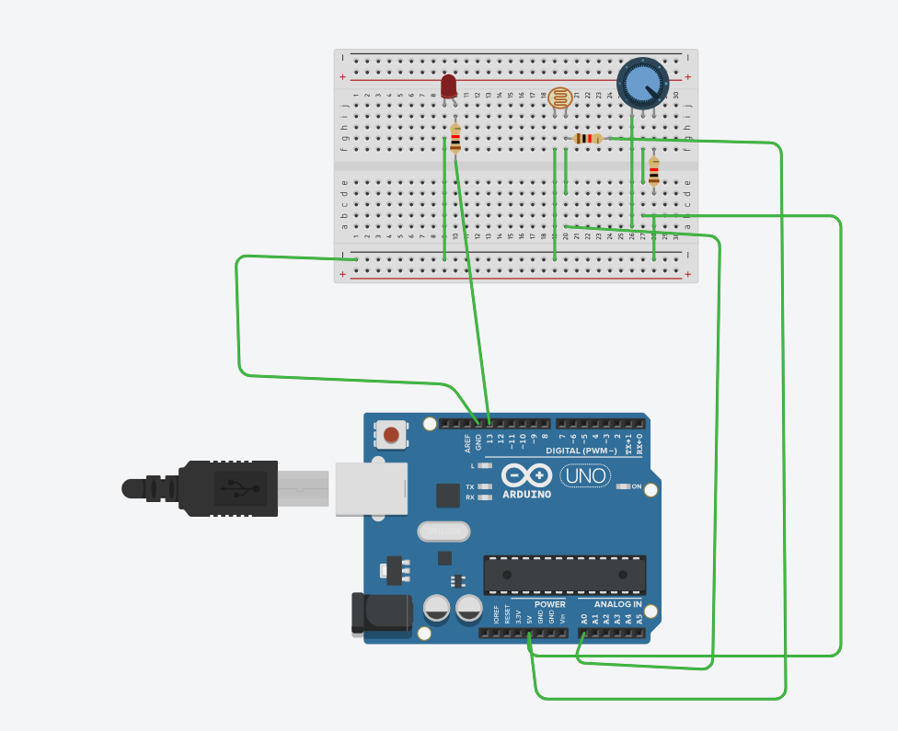

// C++ code
//

const int ldr = A0;
const int led = 13;
int threshold = 500;

void setup()
{
pinMode(led, OUTPUT);
Serial.begin(9600);
}

void loop()
{
int val = analogRead(ldr);
Serial.println(val);
if (val > threshold) {

digitalWrite(led, HIGH);
} else {
digitalWrite(led, LOW);
}
delay(200); // Wait for 1000 millisecond(s)
}

