

CHAROTAR UNIVERSITY OF SCIENCE AND TECHNOLOGY
FACULTY OF TECHNOLOGY AND ENGINEERING
B. TECH (IT/CE/CSE/AIML)

Subject: Advanced Web Development Frameworks (ITUE301) | Semester: 5th

Practical Statement: Building a RESTful API with Node.js and Express

Objective

Build a RESTful Task Management API using Node.js and Express with:
- CRUD Operations
- Logging Middleware
- Global Error Handling
- Proper HTTP Status Codes
- In-Memory Storage (No Database)

Screenshots:

package.json

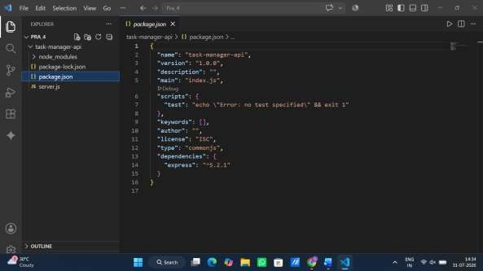
server.js

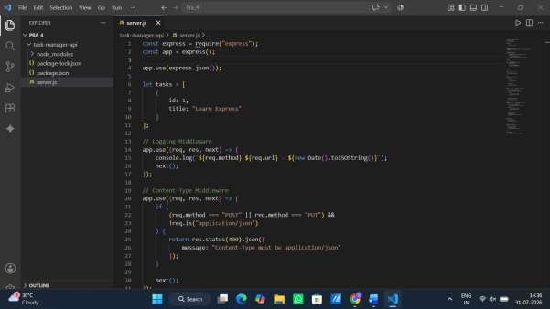

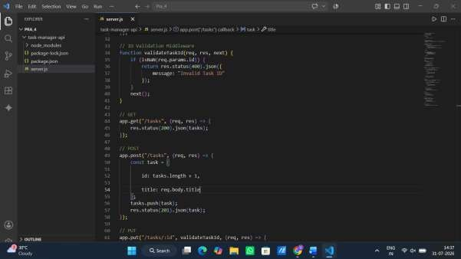
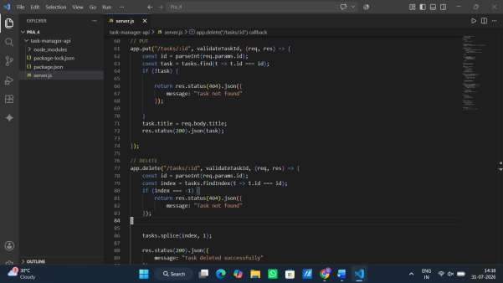

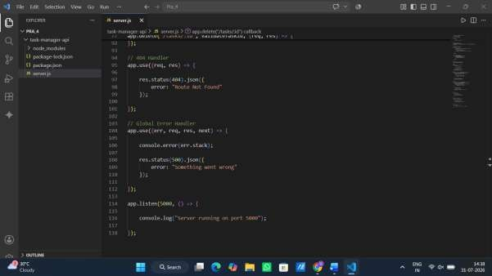

OUTPUT:

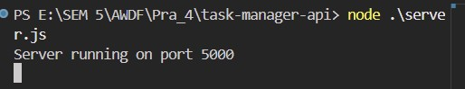

- GET

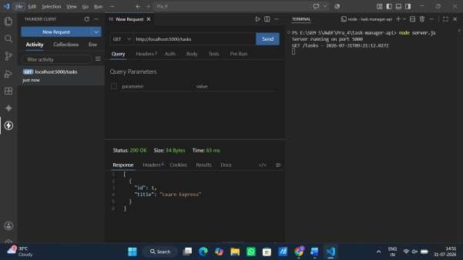

- POST
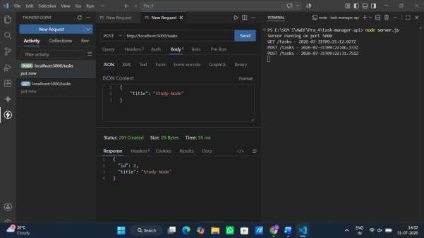

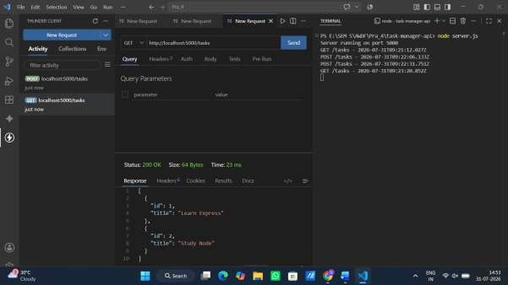

- PUT
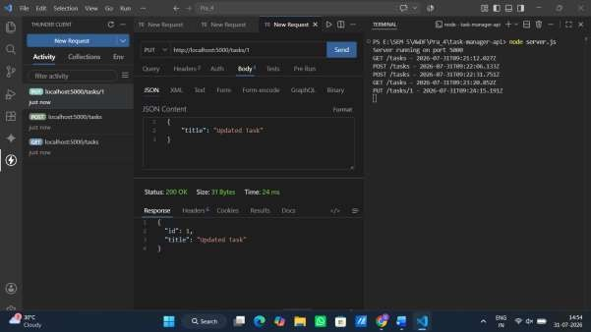

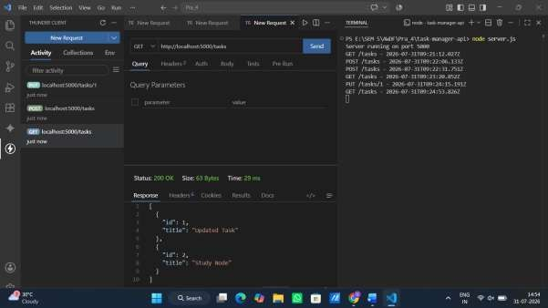

- DELETE

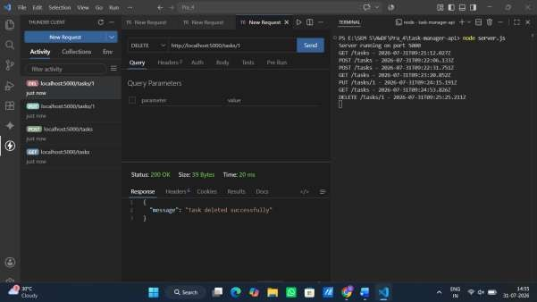

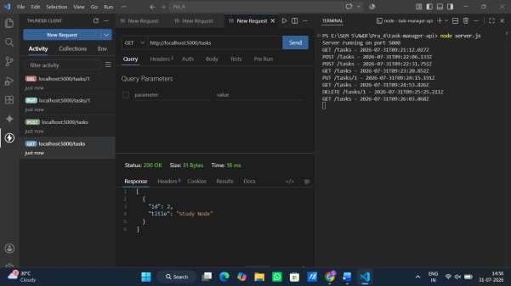

- Verify 404 Handler

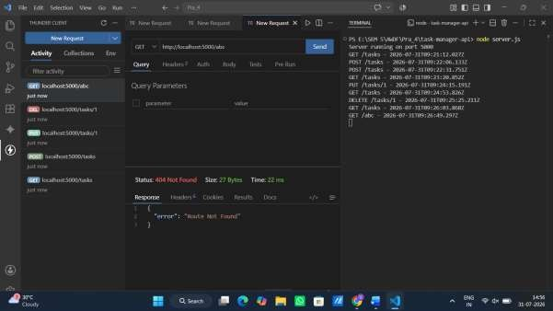

Github Repo Link: https://github.com/sahilmak1602/WDF_24IT045_SAHIL.git

ASSIGNMENT – 1

To evaluate the Task Management REST API using the Richardson Maturity Model and determine its maturity level.

Theory: Richardson Maturity Model

The Richardson Maturity Model (RMM) is a framework used to evaluate how well a REST API follows REST principles. It consists of four maturity levels, from Level 0 to Level 3.

Level 0 – Single Endpoint (RPC Style)
At this level, the API uses a single endpoint for all operations. Different actions are identified through request parameters instead of separate URLs and HTTP methods.

Level 1 – Resources Using URIs
The API uses separate URLs (URIs) for different resources. For example, /tasks and /tasks/1 represent different resources, making the API more organized.

Level 2 – HTTP Methods and Status Codes
The API uses the correct HTTP methods such as GET, POST, PUT, and DELETE, along with appropriate HTTP status codes like 200 OK, 201 Created, 404 Not Found, and 500 Internal Server Error. Most modern REST APIs follow this level.

Level 3 – HATEOAS
The API includes HATEOAS (Hypermedia as the Engine of Application State) links in its responses. These links help clients discover available actions without hardcoding URLs.

Example:
{
"id": 1,
"title": "Task A",
"_links": {
"self": "/tasks/1",
"delete": "/tasks/1"
}
}

Richardson Maturity Model Evaluation

Level | Criterion | Satisfy? | Evidence
Level 0 | Single endpoint | No | Multiple endpoints are used
Level 1 | Resource URIs | Yes | /tasks, /tasks/:id
Level 2 | HTTP methods & status codes | Yes | GET, POST, PUT, DELETE with 200, 201, 404, 500
Level 3 | HATEOAS | No | Not implemented

API Endpoints

Method | Endpoint | Purpose
GET | /tasks | Get all tasks
POST | /tasks | Create task
PUT | /tasks/:id | Update task
DELETE | /tasks/:id | Delete task

Most production APIs stop at Level 2 because it provides a good balance between simplicity and REST principles. Clients usually know the API endpoints from documentation, so implementing HATEOAS adds complexity without significant benefit for many applications.

Conclusion:

The Task Management API successfully follows the principles of Richardson Maturity Model Level 2 by using resource-oriented URLs, appropriate HTTP methods (GET, POST, PUT, DELETE), and meaningful HTTP status codes. Since it does not provide HATEOAS links to guide clients, it does not qualify as a Level 3 REST API.

