## **Recommendations**

Based on the regression and neural network analysis, we have arrived at the decision to have the below stocks in the ‘Buy’ category:

* Apple
* Boeing
* Microsoft
* Johnson & Johnson
* IBM
* Procter & Gamble

We have run a portfolio optimization exercise to maximize the risk-return pay off in an effort to best utilization of the recommendations from the sentiment analysis. For this purpose, we have used the parameters including mean returns, standard deviations, and co-variances. Desired levels of risk or return are used as objectives and constraints.

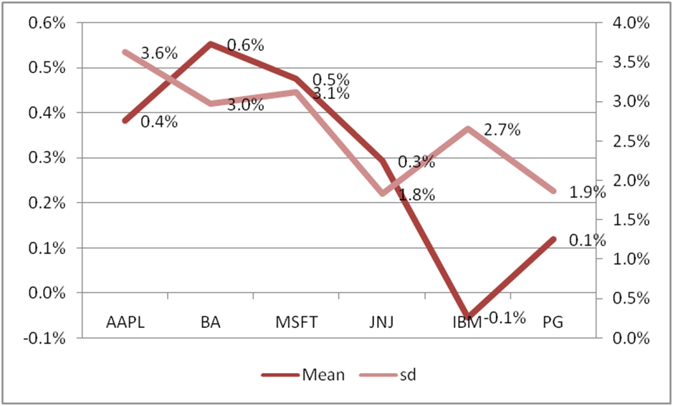

*Fig: Mean Return and standard deviation of selected stocks*

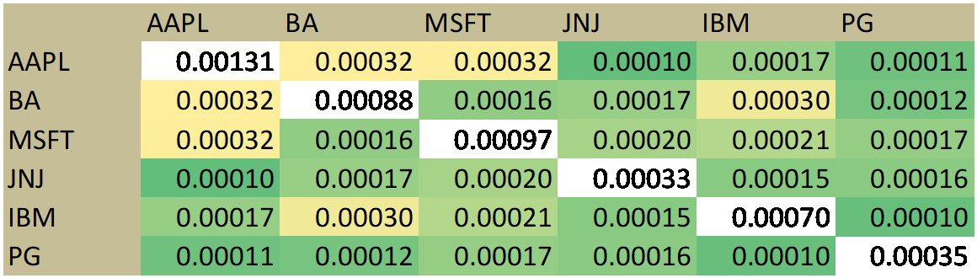

*Fig: Covariance Matrix*

We have minimized the portfolio risk with the target to achieve 0.3% weekly return on portfolio – and following is the weightings that lead to 0.02% risk:

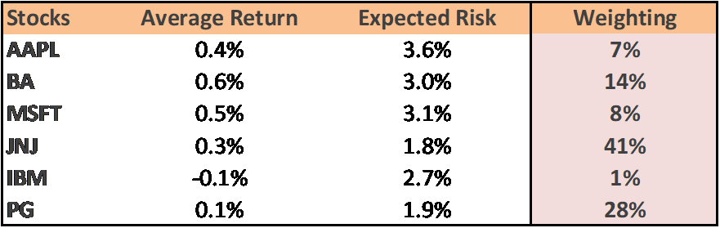

Alternatively, we have maximized the portfolio return with the target to limit the risk at 0.03% on portfolio – and following is the weightings that lead to 0.40% return:

