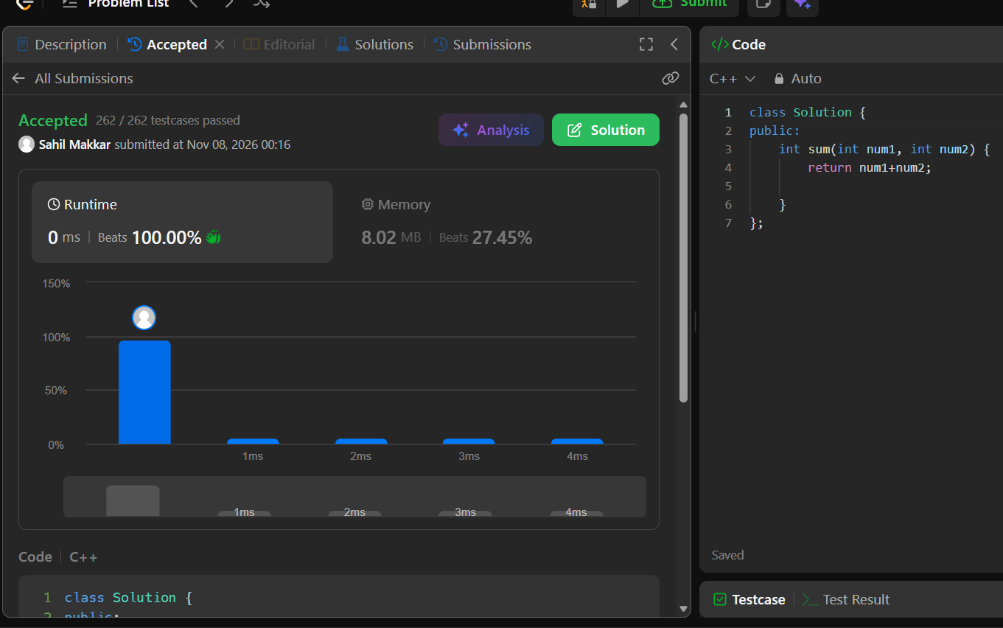
https://leetcode.com/problems/add-two-integers/description/
add two integers
leet code
int sum(int num1, int num2) {
return num1 + num2;
}

