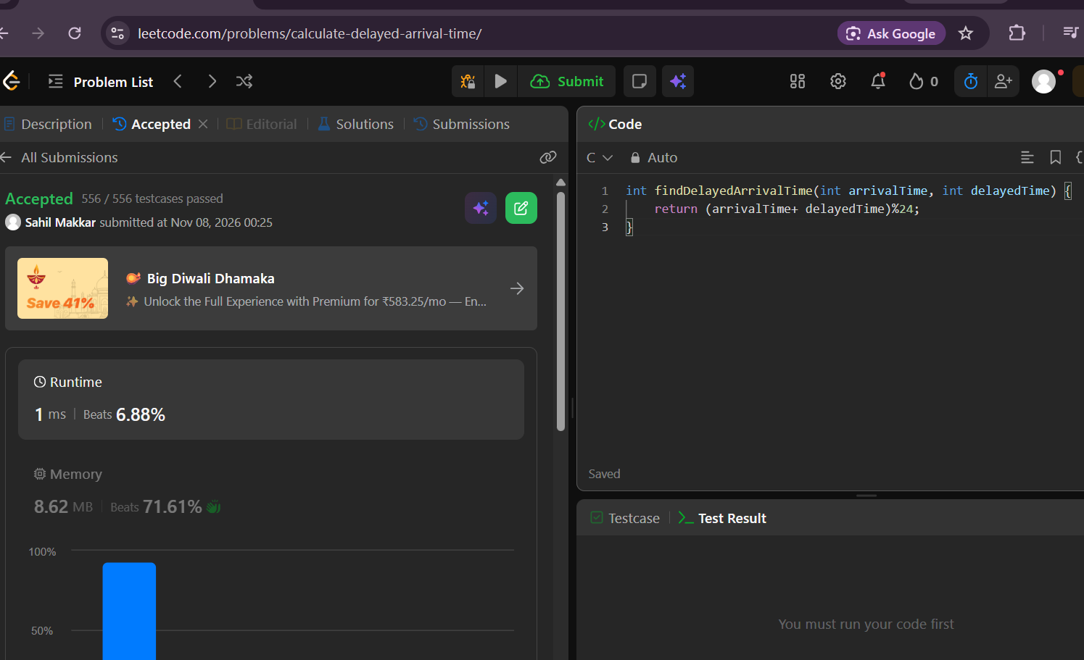

Leet code: https://leetcode.com/problems/calculate-delayed-arrival-time/
Delayed arrival time
int findDelayedArrivalTime(int arrivalTime, int delayedTime) {
return (arrivalTime+ delayedTime)%24;
}

