Read from STDIN, Write to STDOUT

Read from STDIN, Write to STDOUT | Basics of Input/Output & Basic Programming Practice Problems

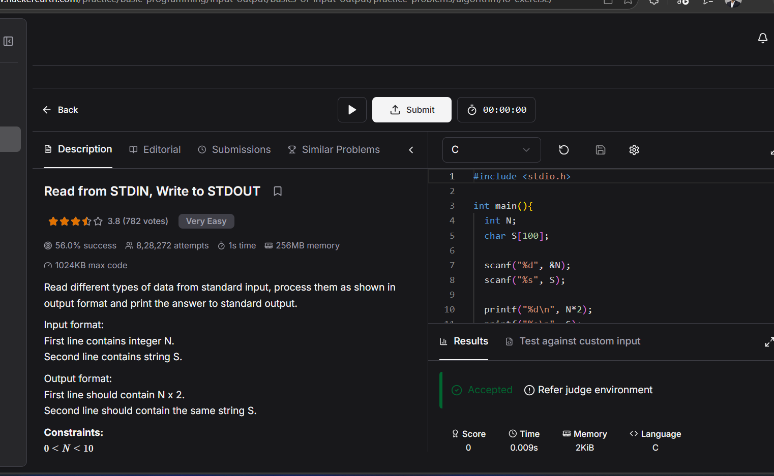

#include <stdio.h>

int main(){
int N;
char S[100];

scanf("%d", &N);
scanf("%s", S);

printf("%d\n", N*2);
printf("%s\n", S);
}

