Hacker rank factorial: Factorial! | Basics of Input/Output & Basic Programming Practice Problems
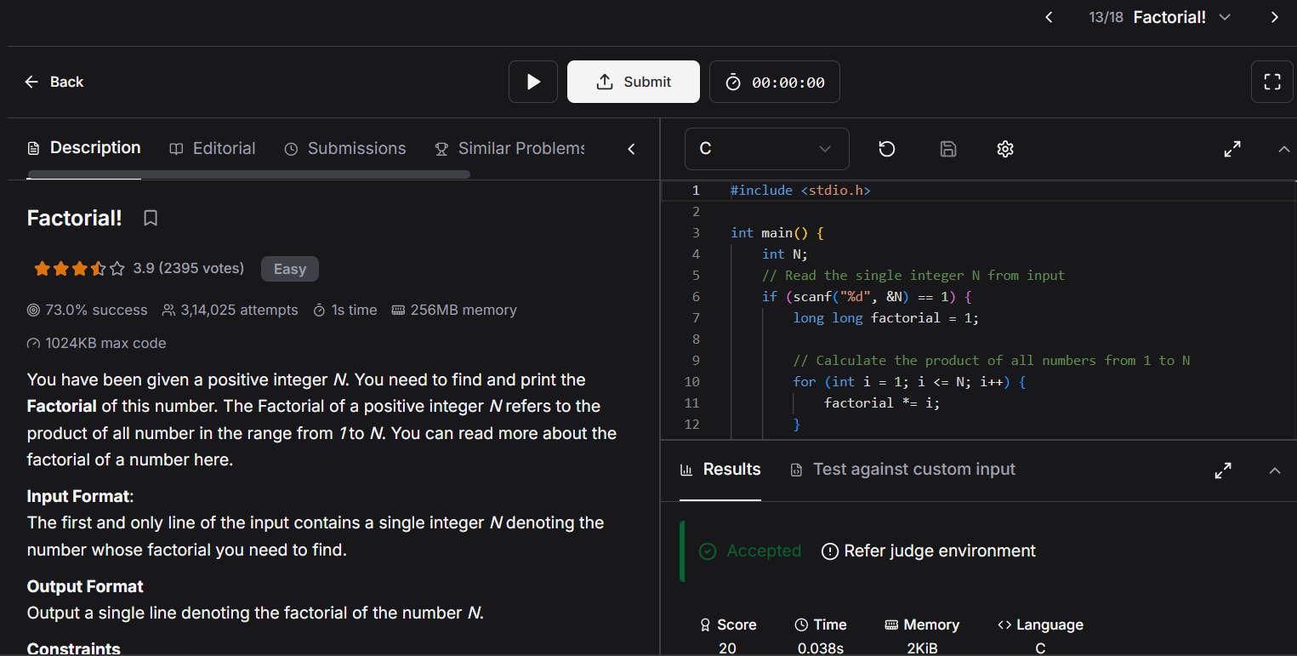

#include <stdio.h>

int main() {
int N;
// Read the single integer N from input
if (scanf("%d", &N) == 1) {
long long factorial = 1;

// Calculate the product of all numbers from 1 to N
for (int i = 1; i <= N; i++) {
factorial *= i;
}

