Leet code 326: https://leetcode.com/problems/power-of-three/submissions/2192133464/

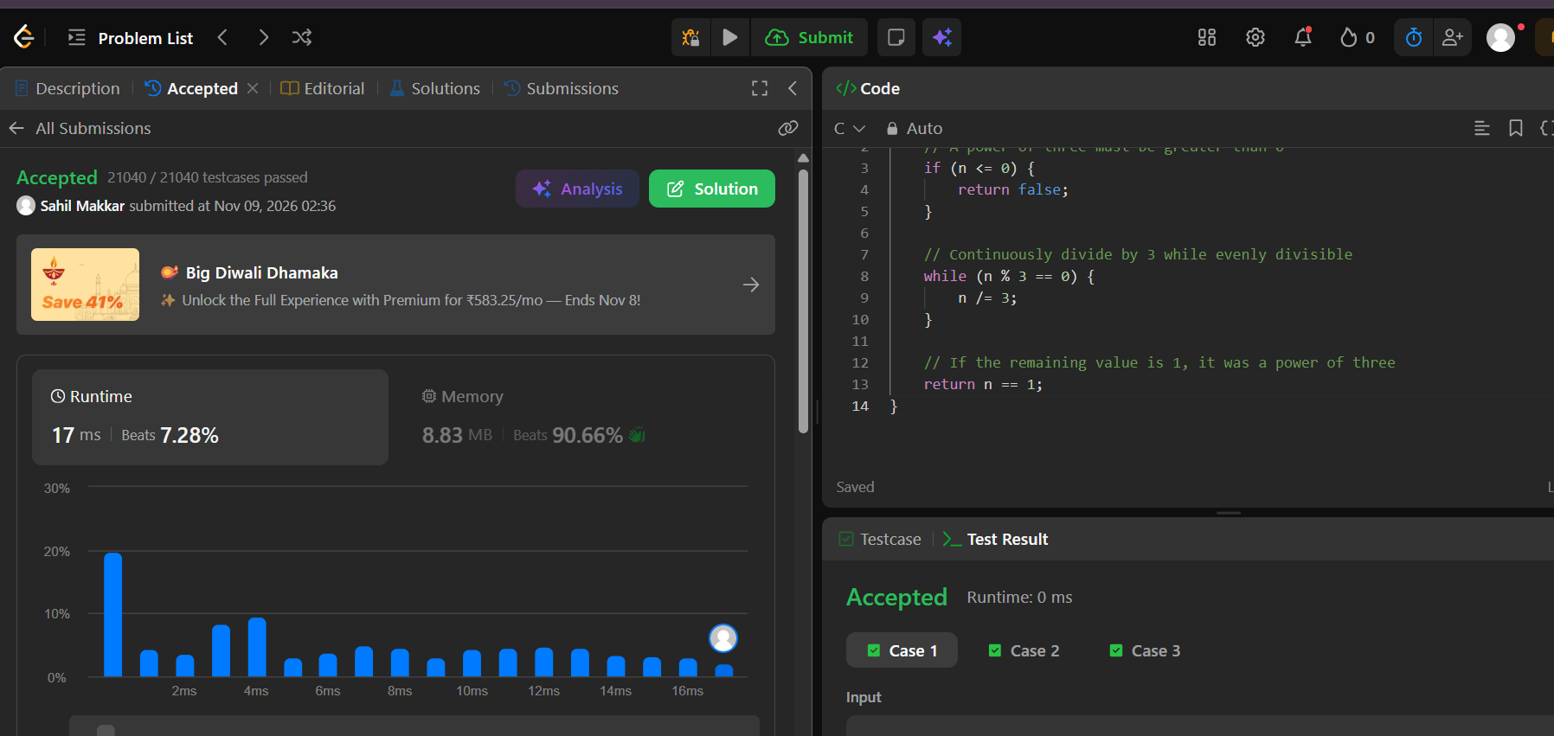

bool isPowerOfThree(int n) {
// A power of three must be greater than 0
if (n <= 0) {
return false;
}

// Continuously divide by 3 while evenly divisible
while (n % 3 == 0) {
n /= 3;
}

// If the remaining value is 1, it was a power of three
return n == 1;
}

