**PROGRAM-1(i)**

**AIM-** Write small HTML code

**CODE-**

<html>

<body>

<h1>Chitkara University</h1>

<p>Welcome to our university</p>

</body>

</html>

**OUTPUT-**

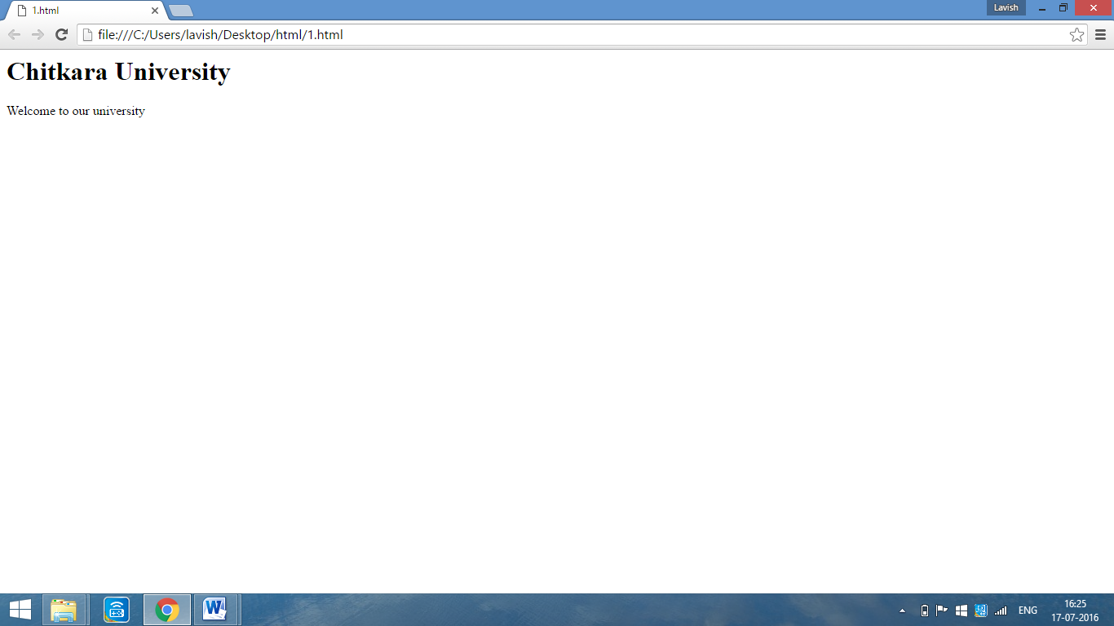

**PROGRAM-1(ii(a))**

**AIM-** Write HTML Code to display the following: CPU: CPU stands for Central Processing Unit.

It is the portion of a computer system that carries out the instructions of a computer program.

It carries out each instruction of the program in sequence, to perform the basic arithmetical, logical, and input/output operations of the system

**CODE-**

<html>

<body>

<p>CPU: CPU stands for Central Processing Unit.<br/> It is the portion of a <u>computer</u> system that carries out the instructions of a <u>computer program.</u><br/><br/>It carries out each <u>instruction</u> of the program in sequence, to perform the basic arithmetical, logical, and input/output operations of the system

</body>

</html>

**OUTPUT-**

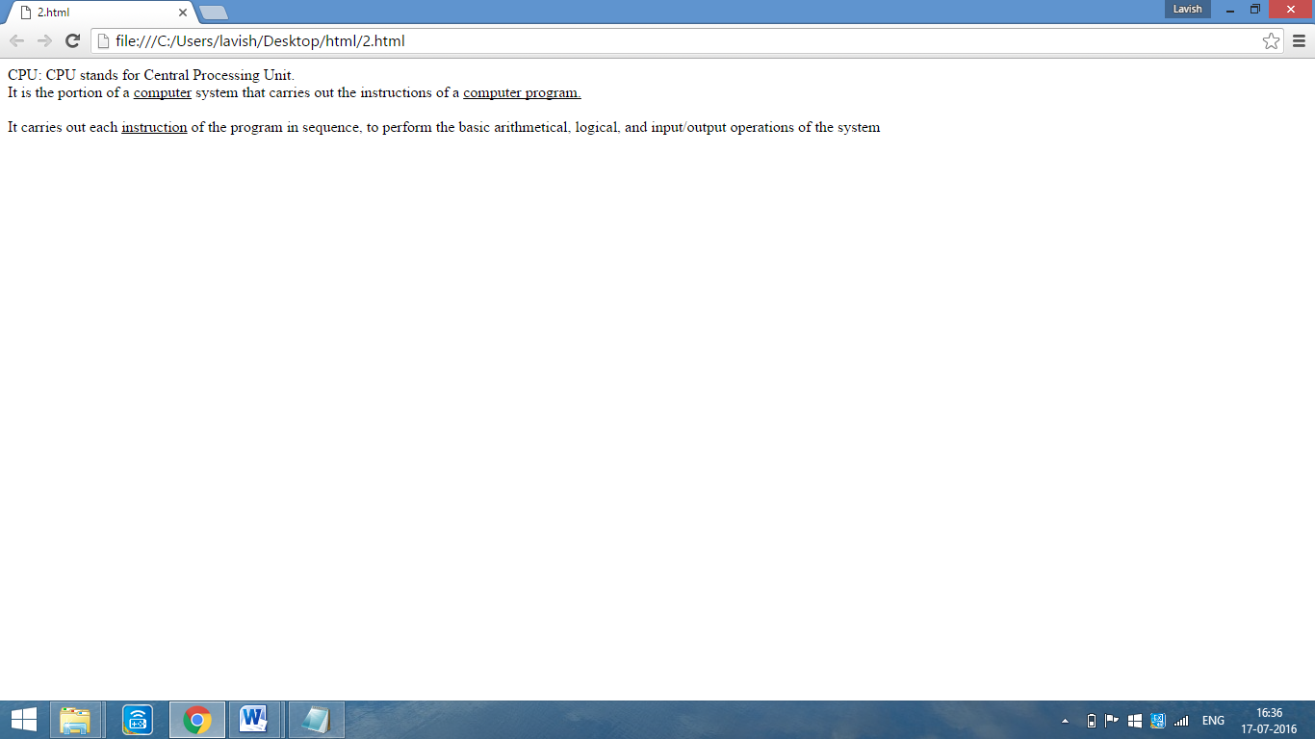

**PROGRAM-1(ii(b))**

**AIM-** WAP demonstrating the use of line break and paragraph tag.

**CODE-**

<html>

<body>

HTML

<p>It's full form is Hyper Text Markup Language<br/>It is used for web designing</p>

</body>

</html>

**OUTPUT-**

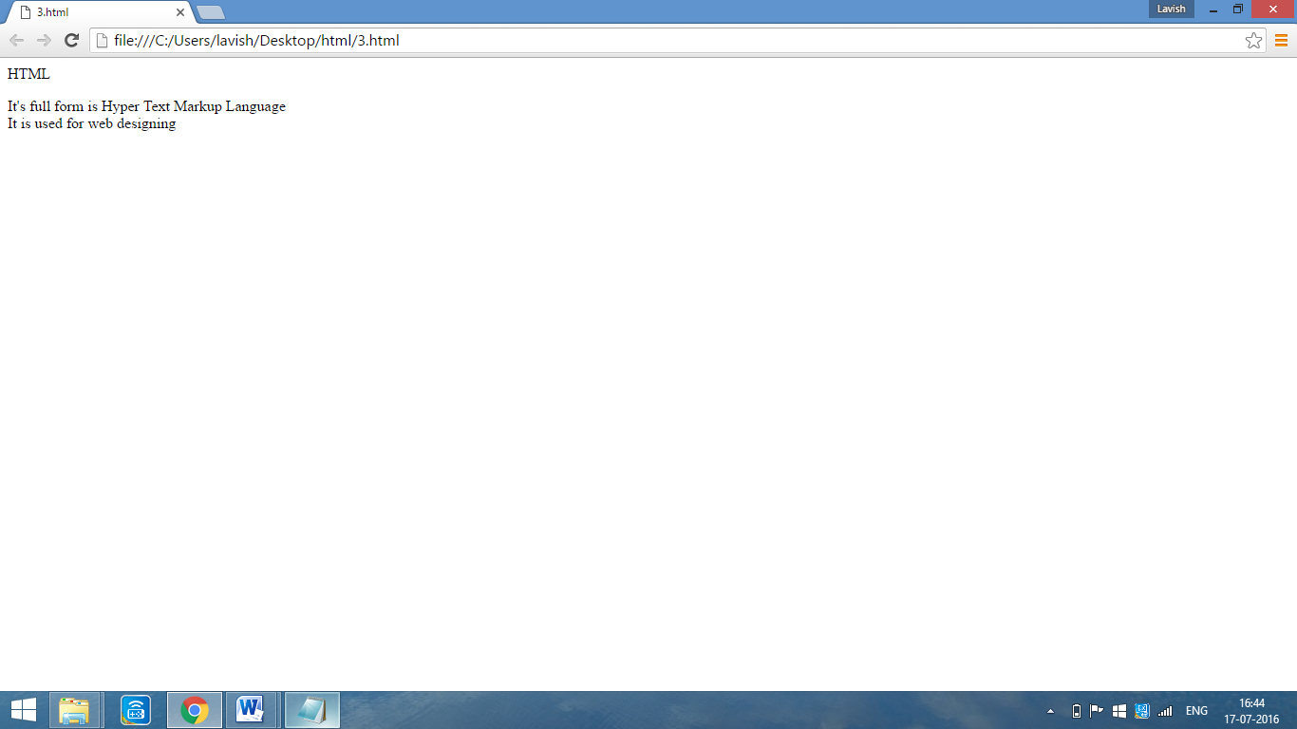

**PROGRAM-2(i)**

**AIM-** Write HTML code for using horizontal line and stating the difference between heading tag .

**CODE-**

<html>

<body>

<hr size=5 width=250 color=red align=center>

<h1>HEADING</h1>

<h2>HEADING</h2>

<h3>HEADING</h3>

<h4>HEADING</h4>

<h5>HEADING</h5>

<h6>HEADING</h6>

</body>

</html>

**OUTPUT-**

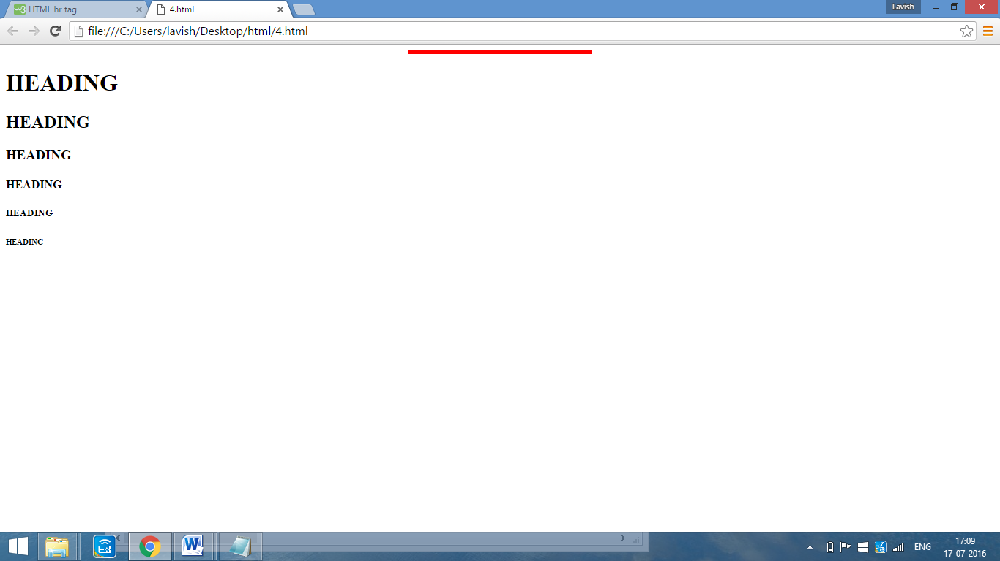

**PROGRAM-2(ii)**

**AIM-** Apply various colors to suitably distinguish key words. Also apply font styling like italics, underline and two other fonts to words you find appropriate. Also use header tags.

**CODE-**

<html>

<body>

<h1 align=center><font size=10 face=calibri color=red>HTML</font></h1>

<p>

<font size=5 face=impact color=green><b><u>HTML-</u></b></font><font face=verdana size=4> It is known as </font><font color=blue><i>HYPER TEXT MARKUP LANGUAGE</i></font>

</p>

</body>

</html>

**OUTPUT-**

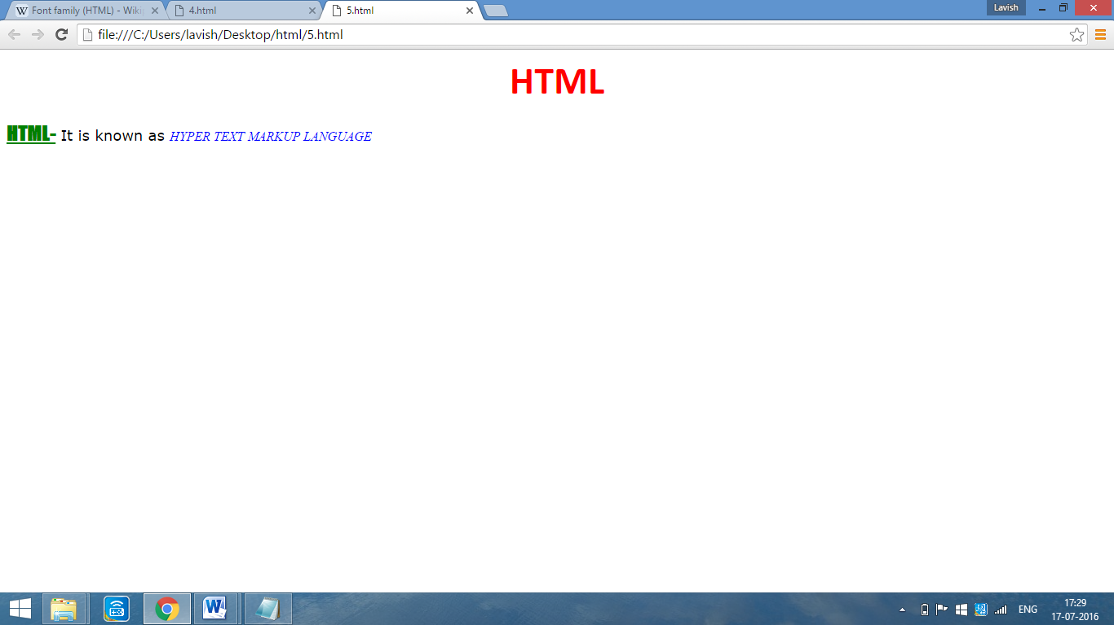

**PROGRAM-3(i)**

**AIM-** i) Demonstrate the usage of various output tags, font and formatting Tags.

Also Write HTML code for the following text:

H2O

H2SO4

Text

X2

X2 + Y2=Z

**CODE-**

<html>

<body>

<font face=calibri size=5><b>FORMATTING TAGS</b></font><br/>

<b>This text is bold</b><br>

<strong>This text is strong</strong><br>

<i>This text is italic</i>

<h2>HTML <small>Small</small> Formatting</h2>

<h2>HTML <mark>Marked</mark> Formatting</h2>

<p>My favorite color is <del>blue</del> red.</p>

<p>My favorite <ins>color</ins> is red.</p>

<p>This is <sub>subscripted</sub> text.</p>

<p>This is <sup>superscripted</sup> text.</p>

H<sub>2</sub>O<br/>H<sub>2</sub>SO<sub>4</sub><br/><strike>Text</strike><br/>x<sup>2</sup><br/>X<sup>2</sup>+Y<sup>2</sup>=Z

</body>

</html>

**OUTPUT-**

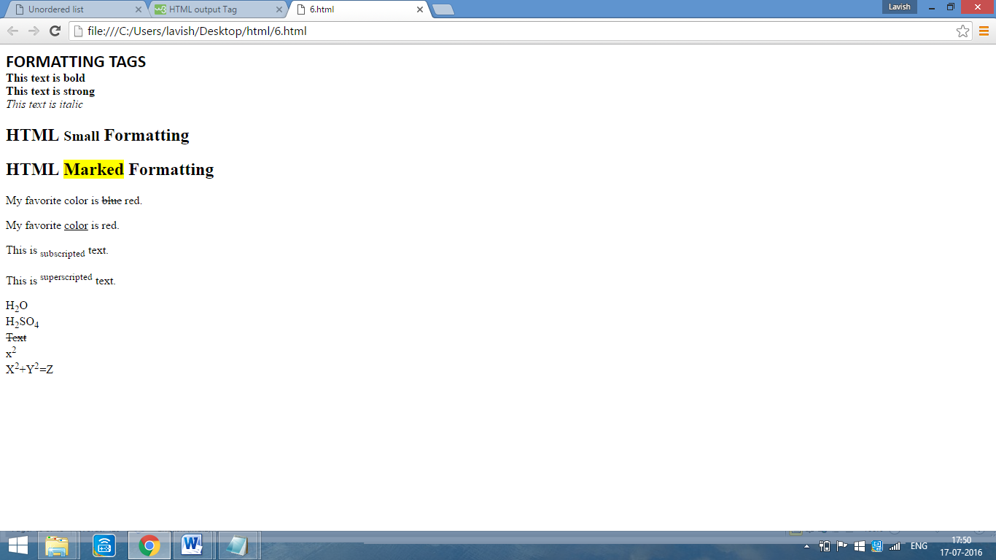

**PROGRAM-3(ii)**

**AIM-** Demonstrate the use of marque tag along with its attributes.

**CODE-**

<html>

<body>

<h1><marquee bgcolor=orange scrollamount=10>our website is under construction. New link will be provided shortly </marquee></h1>

</body>

</html>

**OUTPUT-**

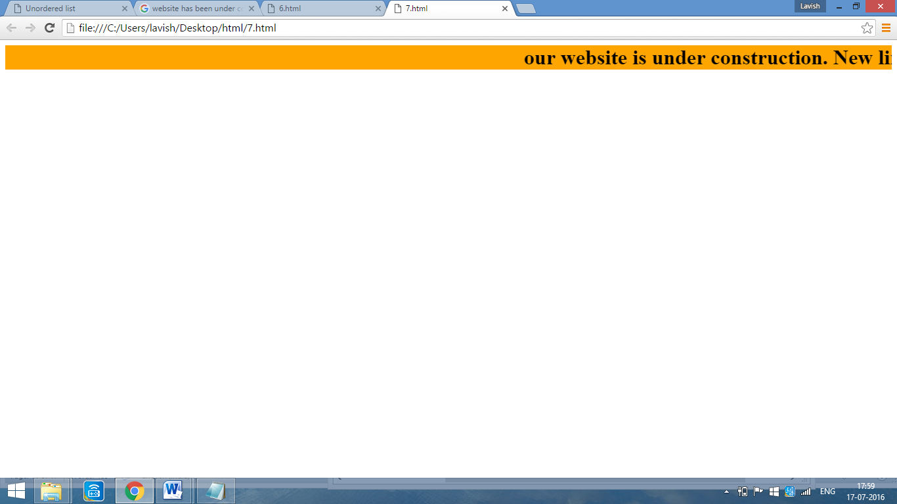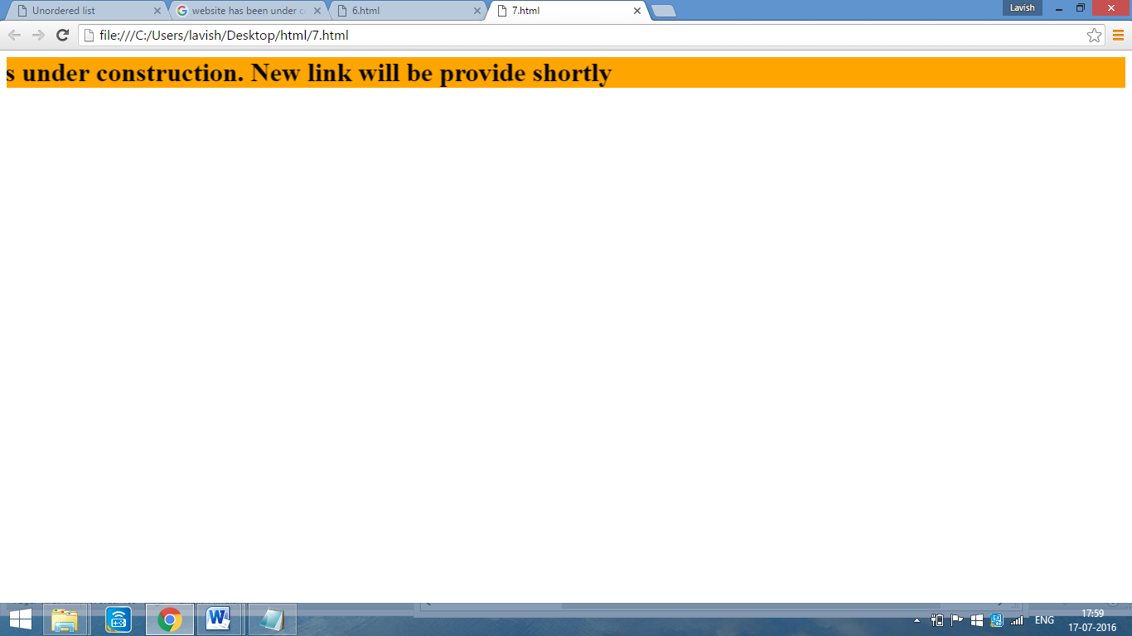

**PROGRAM-4**

**AIM-** Write HTML code to display following Lists –

1. Linux

2. Unix

3. HTML

4. DHTML

5. JavaScript

6. Perl

7. PHP

8. SQL

9. Oracle

10. CCNA

**CODE-**

<html>

<head>

<title>Ordered list</title>

</head>

<body>

<ol typ=1>

<li>Linux

<li>Unix

<li>HTML

<li>DHTML

<li>JavaScript

<li>Perl

<li>PHP

<li>SQL

<li>Oracle

<li>CCNA

</ol>

</body>

</html>

**OUTPUT-**

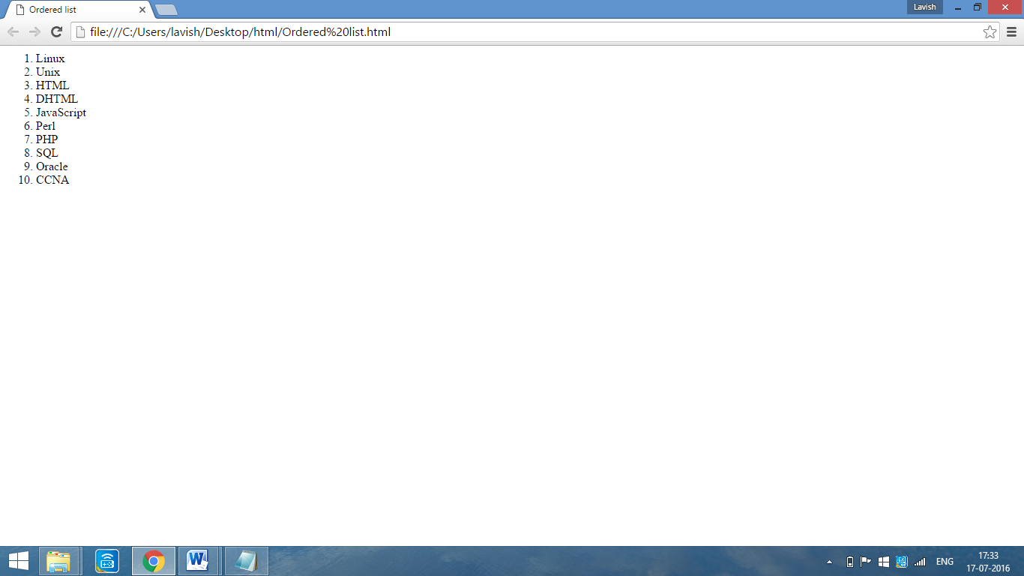

**PROGRAM-5**

**AIM-** Write HTML code to display following Lists –

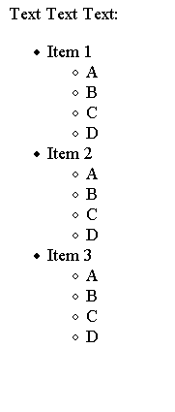

**CODE-**

<html>

<head>

<title>Unordered list</title>

</head>

<body>

Text Text Text:

<ul typ=disc>

<li>Item 1

<ul type=circle>

<li>A

<li>B

<li>C

<li>D

</ul>

<li>Item 2

<ul type=circle>

<li>A

<li>B

<li>C

<li>D

</ul>

<li>Item 3

<ul type=circle>

<li>A

<li>B

<li>C

<li>D

</ul>

</ol>

</body>

</html>

**OUTPUT-**

