1. User ID should be login ID, mobile number max length - 10 and support only digits
2. Aadhar number – digits, limit to 12
3. Working hours in integer box
4. Qualification – 1:12, diploma, graduation, post-graduation – New Add
5. Attendance – past attendance is not locked
6. Employee image crop manually while uploading in Ration 1\*1 , square
7. After deleting client - sites will remain in database
8. Assign role – Description of pages e.g. – View record , edit , delete , print
9. After visiting on a page menu get close and not highlight the current page
10. Remove Wise from all the menu and add hover description on the title of the page
11. Keep text in a single line remove extra space from column name

Graph admin:-

* Total Clients – Active / InActive
* Total Sites – Active / InActive
* Total Employee – Active / InActive
* Total Employee Active (Present Today / total) in Digits

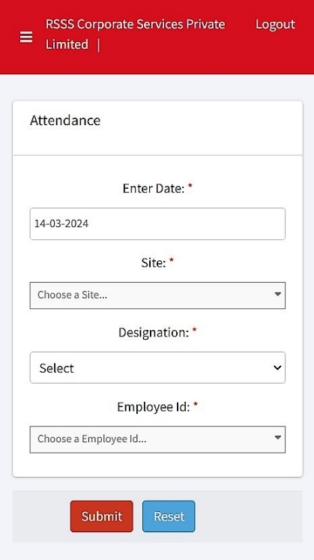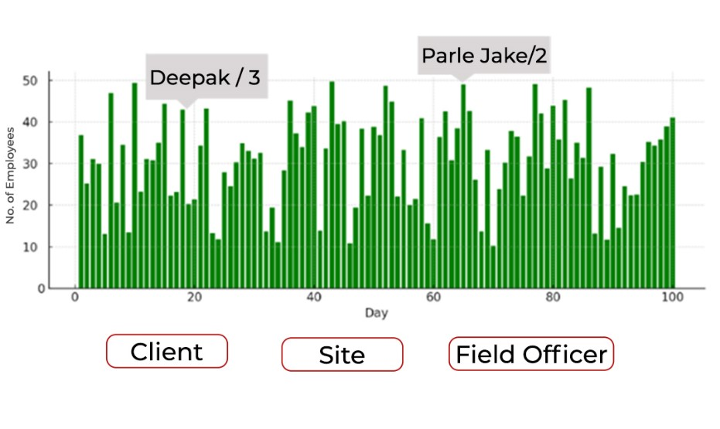Graph

