LA1:

Case study:

Before coding of the website, planning is important, students should visit different websites

(Min. 10) for the different client projects and note down the evaluation results for these websites,

either good website or bad website in following format:

| Sr No. | Website URL | Purpose of  Website | Things liked  in the website | Things  disliked in  the website | Overall evaluation  of the website  (Good/Bad) |
| --- | --- | --- | --- | --- | --- |

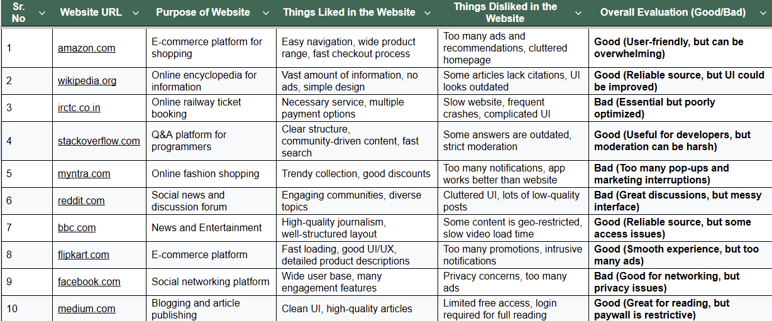

| **Sr. No** | **Website URL** | **Purpose of Website** | **Things Liked in the Website** | **Things Disliked in the Website** | **Overall Evaluation (Good/Bad)** |
| --- | --- | --- | --- | --- | --- |
| 1 | amazon.com | E-commerce platform for shopping | Easy navigation, wide product range, fast checkout process | Too many ads and recommendations, cluttered homepage | **Good** (User-friendly, but can be overwhelming) |
| 2 | wikipedia.org | Online encyclopedia for information | Vast amount of information, no ads, simple design | Some articles lack citations, UI looks outdated | **Good** (Reliable source, but UI could be improved) |
| 3 | irctc.co.in | Online railway ticket booking | Necessary service, multiple payment options | Slow website, frequent crashes, complicated UI | **Bad** (Essential but poorly optimized) |
| 4 | stackoverflow.com | Q&A platform for programmers | Clear structure, community-driven content, fast search | Some answers are outdated, strict moderation | **Good** (Useful for developers, but moderation can be harsh) |
| 5 | myntra.com | Online fashion shopping | Trendy collection, good discounts | Too many notifications, app works better than website | **Bad** (Too many pop-ups and marketing interruptions) |
| 6 | reddit.com | Social news and discussion forum | Engaging communities, diverse topics | Cluttered UI, lots of low-quality posts | **Bad** (Great discussions, but messy interface) |
| 7 | bbc.com | News and Entertainment   |  | | --- |  |  | | --- |  |  | | --- | | High-quality journalism, well-structured layout | Some content is geo-restricted, slow video load time | **Good** (Reliable source, but some access issues) |
| 8 | flipkart.com | E-commerce platform | Fast loading, good UI/UX, detailed product descriptions | Too many promotions, intrusive notifications | **Good** (Smooth experience, but too many ads) |
| 9 | facebook.com   |  | | --- |  |  | | --- | | Social networking platform | Wide user base, many engagement features | Privacy concerns, too many ads | **Bad** (Good for networking, but privacy issues) |
| 10 | medium.com | Blogging and article publishing | Clean UI, high-quality articles | Limited free access, login required for full reading | **Good** (Great for reading, but paywall is restrictive) |

LA 2:

Implement a web page index.htm for any client website (e.g., a restaurant website project) using following:

a. HTML syntax: heading tags, basic tags and attributes, frames, tables, images, lists, links for text and images, forms etc.

b. Use of Internal CSS, Inline CSS, External CSS  
  
  
  
______________________________________________________

https://sahilmate.github.io/restaurant