

## Mamasaheb Mohol College

## Paud Road, Pune-38

# Department of Computer Science

### Savitribai Phule Pune University,Pune 2021-2022

A

PROJECT REPORT ON

**“JOBSCOPE”**

Submitted In Partial Fulfilment Of The Requirement For The Award Of The Degree OF

TYBSc(Comp.Sci) Sem-VI

#### Guided by**:-** Submitted by**:-**

Prof. P.A. Jadhav Sahil Gaikwad

&

Rushikesh Pilankar.



## Mamasaheb Mohol College

## Paud Road, Pune-38

# Department of Computer Science

#### CERTIFICATE

This is to certify that Mr./ Miss **Rushikesh Pilankar & Sahil Gaikwad** of TYB.Sc(Computer Science) Sem-VI has satisfactorily completed project work entitled **“JOBSCOPE”** prescribed by Savitribai Phule Pune University, Pune during academic year 2021-22 and this report represents his/her bonafide work.

Project Guide HOD

Internal Examiner External Examiner







**1.PROJECT DEFINATION , SCOPE AND OBJECTIV**

**1.1 PROJECT PROFILE**

* **Project Title** : Jobscope
* **Objective :** To develop a user-friendly & efficient system
* **Operating System :** Linux ,Windows 7 , Windows 10.
* **Back End :** SQL Server
* **Front End Used :** PHP,CSS.
* **Project Duration :** 1 YEAR
* **Project Guide :** Ms .Priyanka Jadhav
* **Submitted By :** MR.RUSHIKESH PILANKAR & SAHIL GAIKWAD
* **Submitted To :** MAMASAHEB MOHOL,COLLEGE, PUNE.

**1.2 PROJECT DEFINATION**

Internet has made this world smaller now. The world environment is becoming competitive. Every person nowadays wants to reach at the heights. Especially when education is growing among the people, the need for job comes first. Even there are so many big firms who need so many experts.

So many people are recruited and given chance to show their talents. For that, sometimes, job openings are created on websites. The advertisements are given in newspapers. Also campus interviews are held for recruiting freshers. Some exams taken and then interviews are held, which filters the people and selects the candidates.

For giving flexibility to this recruitment process, this project has been developed. This project contains both modules – Client side module (to apply for job online) as well as Admin side module (for creating job vacancies and to manage the applied candidates). Let’s see more detailed information about the project in following sections.

## 1.3 GOALS AND OBJECTIVES

The purpose of this project is to develop the user friendly and interactive website which will allow the candidate to apply for the job vacancy available in the company. The person will be able to see the vacancies if present. He can apply for any number of jobs he wishes to apply. He will be able to register for that and will be notified for which jobs from his selected jobs, he is eligible.

The main purpose of this project is about giving flexibility to the Company’s Recruitment Managers as this website plays main role at admin side. The project contains layers for different users at admin part so there is no chance of disturbing any of the process as the sub-admin (lower level admin) will not be given rights to make any changes in the functionality. Even given, the sub-admin will be only able to send requests to higher level admin for any changes like posting job vacancies etc.

The company will be able to post these vacancies on internet in his own website so there is no need to advertise for his company’s vacancy at any other place except his own site. Any user will be able to open the company’s site and see the vacancies in the company

**1.4 SCOPE**

The aim of the project is to build a simple, effective computerized Recruitment Module, which complements the regular workflow of HR management. It starts from the process of collecting relevant details and requirements from the Users until the candidate becomes a successful employee in the company. It covers the traditional HR functions:

1. Define Recruitment Processes
2. Smoothen the process of recruitment replacing the traditional method of recruitment.
3. Collect and Manage applicants’ profile, including personal detail, education details and work experience (if any).
4. Convert successful Applicants to Employees.
5. Manage the Recruitment Process for each Position through tracking all steps.
6. Enable Users to view the website for various jobs posted on the system
7. Allow Registered Users to add their profile and appear for the evaluation process
8. Provide useful analysis; in the form of Reports and Statistics to support decision-making.
9. Filter worthy candidates based on the company’s requisites

**2.2 SOFTWARE AND HARDWARE REQUIREMENT**

* **Software Environment:**

|  |  |  |  |
| --- | --- | --- | --- |
| **Tools/Technology** | **Front-end** | **-** | PHP |
| **Back-end** | **-** | MySQL |
| **Browser** | **-** | Internet Explorer, Firefox, Google Chrome,etc. |
|  | **Editor** | **-** | Notepad++,text editor , etc. |
| **Operating System** | Linux ,Windows 7 , Windows 10. | | |

* **Hardware Environment:**

|  |
| --- |
| **Client Configuration** |
| * Pentium IV, 750 MHz, 20GB HDD * Operating System : Linux ,Windows 7 , Windows 10. * RAM : 512 MB minimum * 400MB Minimum Free Space on Drive * Microsoft Office |
| **Server Configuration** |
| Servers, each with following configuration   * CPU * Operating System: Windows XP * RAM : 1GB Minimum * 40GB Minimum Free Space on Drive * 750MHz |

## 2.3CONSTRAINTS

**2.3.1 User Interface**

The user Interface is provided by the any kind of web browser like Internet Explorer, Mozilla Firefox, etc. As the project is the extension of the live project, based on the client’s requirement, the project testing will be done for the above specified four browsers so the project would be portable and will have pluggable look and feel.

**2.3.2 Communication Interfaces**

This is website so it requires HTTP protocol and Internet connection.

**2.3.3 Software Interface**

The application mainly interacts with the SQL Server database for storing data at the back end. Other than this it does not deal with any software.

**3.SYSTEM ANALYSIS**

**3.1 STUDY OF CURRENT SYSTEM**

The recruitment process is a very important process for all kinds of people as the common man wants the job and the company needs man power. The current system is based only on human beings. The all activities of this process are done on paper work, nothing is system dependent. The candidates apply for job manually to the company by sending their resumes. The company responds them if they are qualified and then the evaluation process takes place which filters the candidates. Filtered candidates are called for the interviews and thus the whole recruitment process takes place.

## 3.2 Problems and Weaknesses of Current System

The recruitment process is a very large and important process which is mostly done by human beings, not by the system. The conventional approach of submitting resumes to the company and then helding the evaluation process is a very tedious task as the company has to give advertisements or has to go to the colleges for recruiting people. This process can be made easy and flexible for the candidates as well as the company managers so that the whole recruitment process is handled automatically.

This conventional approach of recruiting people increases the work of maintaining candidates on paper work which requires a lot of manpower. Other than this, it increases the complexity and also contains less efficiency. The automated system needs to be found which replaces the current conventional system or at least decreases this whole process' complexity.

**3.3 REQUIREMENTS OF NEW SYSTEM**

The problems of the conventional recruitment process increases the need of some automated system which handles the process at some extent and can decrease the work of this process. The system can be built which is general and not specific to any company as the evaluation process contains different steps for different companies. Any company can use that system and can decrease complexity of the conventional approach. The new system may not include the phase of evaluation process but other general formalities of saving resumes and other details of the candidates, maintaining their data etc. can be included.

## 3.4 Feasibility Study

The feasibility study is the important step in any software development process. This is because it makes analysis of different aspects like cost required for developing and executing the system, the time required for each phase of the system and so on. If these important factors are not analyzed then definitely it would have impact on the organization and the development and the system would be a total failure. So for running the application and the organization successfully this step is a very important step in a software development life cycle process.

By making analysis with the requirement of the organization it would be possible to make a report of identified area of problem. By making a detailed analysis in this area a detailed document or report is prepared in this phase which has details like project plan or schedule of the project, the cost estimated for developing and executing the system, target dates for each phase of delivery of system developed and so on. This phase is the base of software development process since further steps taken in software development life cycle would be based on the analysis made on this phase and so careful analysis has to be made in this phase.

Though the feasibility study cannot be focused on a single area some of the areas or analysis made in feasibility study is given below. But all the steps given below would not be followed by all system developed. The feasibility study varies based on the system that would be developed.

* Feasibility study is made on the system being developed to analyze whether the system development process require training of personnel. This help in designing training sessions as required in later stage.
* Is the system developed has scope for expanding or scope for switching to new technology later if needed in ease. In other study is made to find the portability of the system in future.
* The above feasibilities are analysis which helps in development of the system. But the scope of feasibility study does not end with this. Analysis or feasibility study also includes the analysis of maintenance stage. In other words feasibility study is made to analyze how one would maintain the system during maintenance stage. This helps sin planning for this stage and also helps in risk analysis. Also the analysis helps in making analysis about what training must be given and how and what all documents must be prepared to help users and developers to face maintenance phase.

**3.5 FUNCTION OF SYSTEMS**

**3.5.1 USE CASE DIAGRAM**

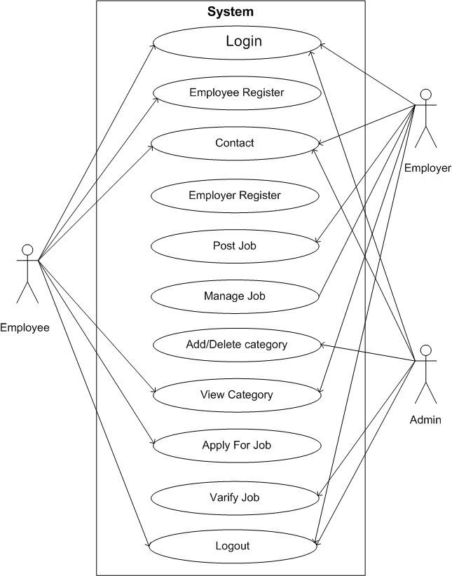

**3.6 DATA MODELLING**

**3.6.1 CLASS DIAGRAM**

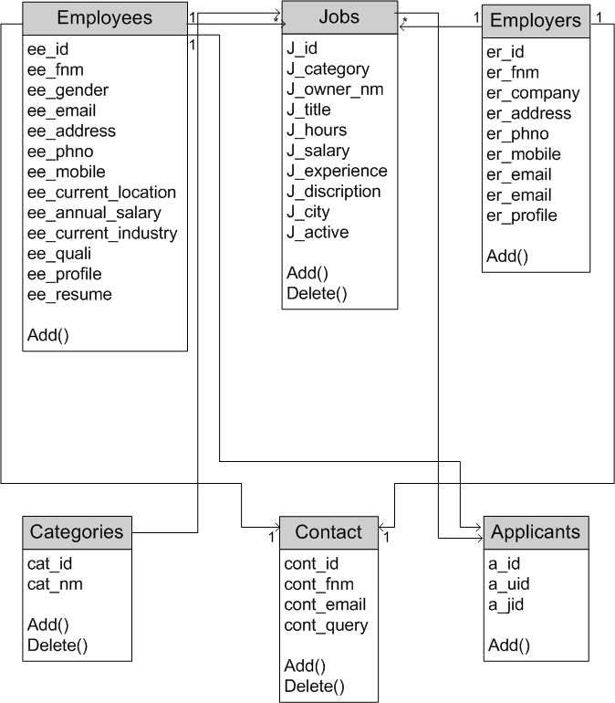

**3.6.2 OBJECT DIAGRAM**

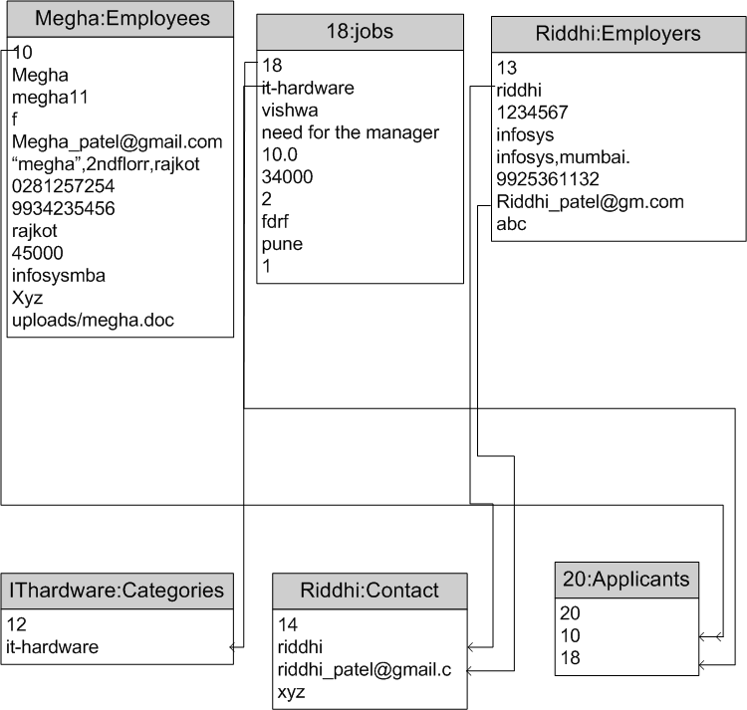

**3.6.3 SEQUENCE DIAGRAM**

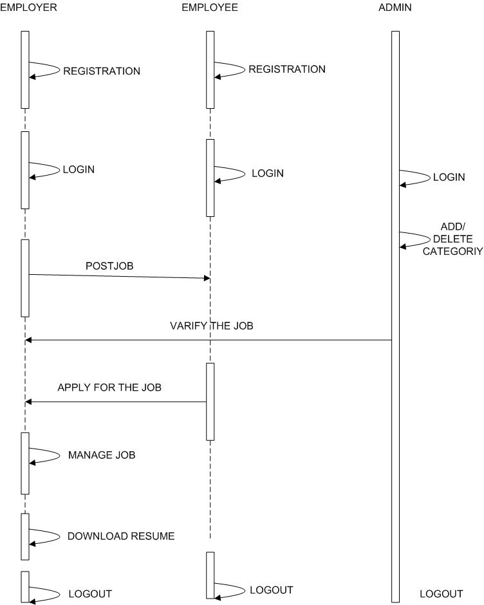



**3.6.4 DATA DICTIONARY**

**1.EMPLOYEES TABLE**

|  |  |  |  |  |
| --- | --- | --- | --- | --- |
| FIELD | TYPE | NULL | EXTRA | PRIMARYKEY |
| Ee_id | Int(4) | NO | Autoincreament | YES |
| Ee_fnm | Varchar(40) | NO | - | NO |
| Ee_pwd | Varchar(10) | NO | - | NO |
| Ee_gender | Varchar(1) | NO | - | NO |
| Ee_email | Varchar(30) | NO | - | NO |
| Ee_add | Varchar(300) | NO | - | NO |
| Ee_phno | Varchar(10) | NO | - | NO |
| Ee_mobileno | Varchar(10) | NO | - | NO |
| Ee_current_location | Varchar(20) | NO | - | NO |
| Ee_annual_salary | Int(10) | NO | - | NO |
| Ee_current_industry | Varchar(20) | NO | - | NO |
| Ee_qualification | Varchar(10) | NO | - | NO |
| Ee_profile | Varchar(10) | NO | - | NO |
| Ee_resume | Longtext | NO | - | NO |

**2 EMPLOYERS TABLE**

|  |  |  |  |  |
| --- | --- | --- | --- | --- |
| FIELD | TYPE | NULL | EXTRA | PRIMARYKEY |
| Er_id | Int(4) | NO | Autoincreament | YES |
| Er_fnm | Varchar(30) | NO | - | NO |
| Er_pwd | Varchar(10) | NO | - | NO |
| Er_company | Varchar(30) | NO | - | NO |
| Er_add | Varchar(100) | NO | - | NO |
| Er_ph | Varchar(10) | NO | - | NO |
| Er_email | Varchar(30) | NO | - | NO |
| Er_company_profile | Varchar(300) | NO | - | NO |

**3.CONTACTS TABLE**

|  |  |  |  |  |
| --- | --- | --- | --- | --- |
| FIELD | TYPE | NULL | EXTRA | PRIMARYKEY |
| Cont_id | Int(4) | NO | Autoincreament | YES |
| Cont_fnm | Varchar(30) | NO | - | NO |
| Cont_email | Varchar(20) | NO | - | NO |
| cont_query | Varchar(300) | NO | - | NO |

**4.JOBS**

|  |  |  |  |  |
| --- | --- | --- | --- | --- |
| FIELD | TYPE | NULL | EXTRA | PRIMARYKEY |
| J_id | Int(4) | NO | AUTOINCREAMENT | YES |
| J_category | Varchar(40) | NO | - | NO |
| J_owner_name | Varchar(30) | NO | - | NO |
| J_title | Varchar(30) | NO | - | NO |
| J_hours | Float(3,1) | NO | - | NO |
| J_salary | Int(10) | NO | - | NO |
| J_experience | Int(3) | NO | - | NO |
| J_discription | Varchar(300) | NO | - | NO |
| J_city | Varchar(20) | NO | - | NO |
| J_active | Int(1) | NO | - | NO |

**5.APPLICANT TABLE**

|  |  |  |  |  |
| --- | --- | --- | --- | --- |
| FIELD | TYPE | NULL | EXTRA | PRIMARYKEY |
| A_id | Int(4) | NO | Autoincreament | YES |
| A_uid | Varchar(30) | NO | - | NO |
| A_jid | Varchar(30) | NO | - | NO |

**6.CATEGORIES TABLE**

|  |  |  |  |  |
| --- | --- | --- | --- | --- |
| FIELD | TYPE | NULL | EXTRA | PRIMARYKEY |
| Cat_id | Int(4) | NO | Autoincreament | YES |
| Cat_nm | Varchar(30) | NO | - | NO |

**3.6.5 E-R DIAGRAM**

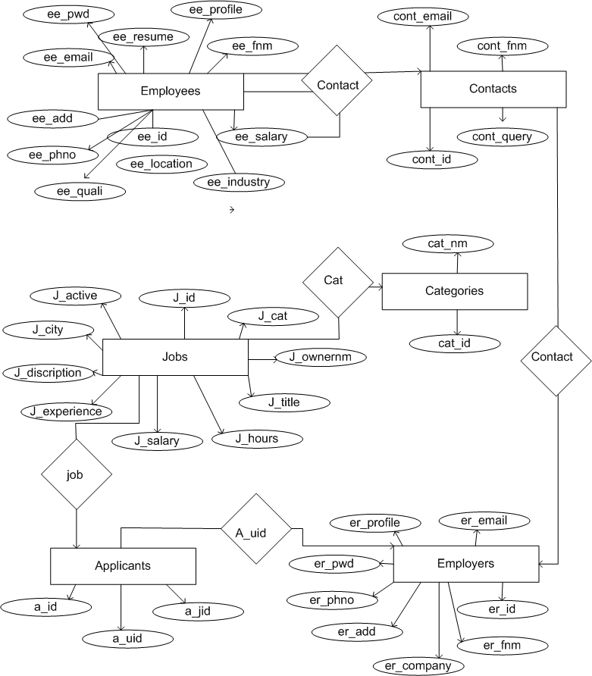

**3.7 FUNCTIONAL AND BEHAVIORAL MODELLING**

**3.7.1 CONTEXT DIAGRAM**

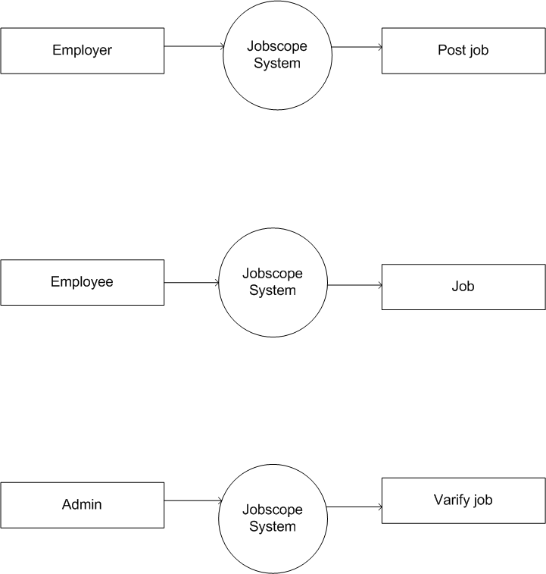

**3.7.2 DATA FLOW DIAGRAM**

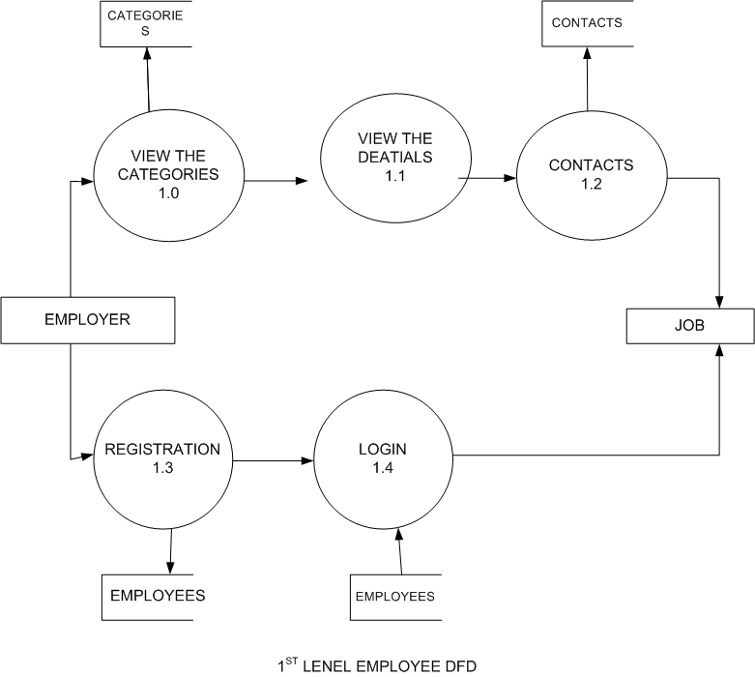

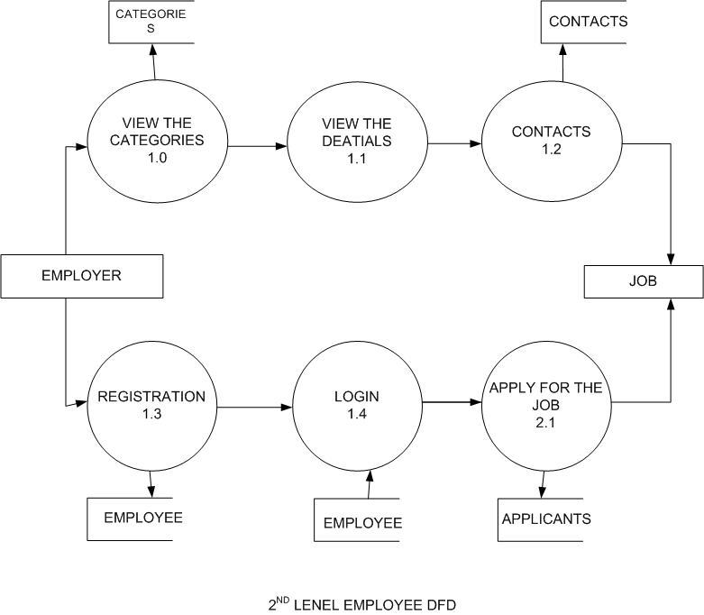

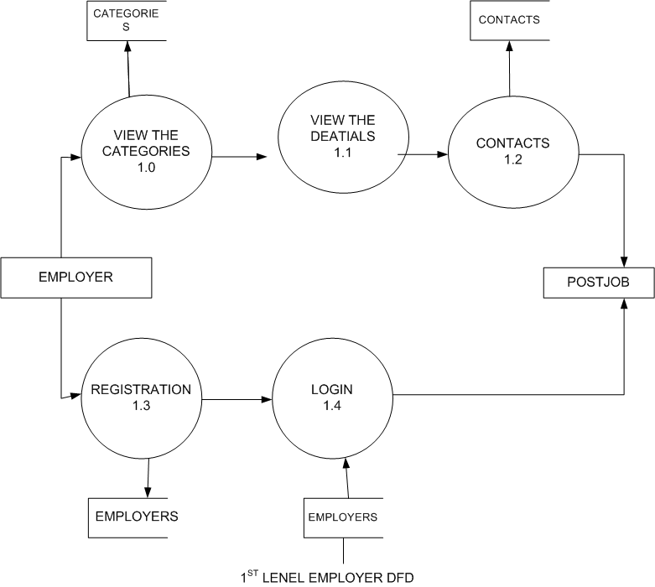

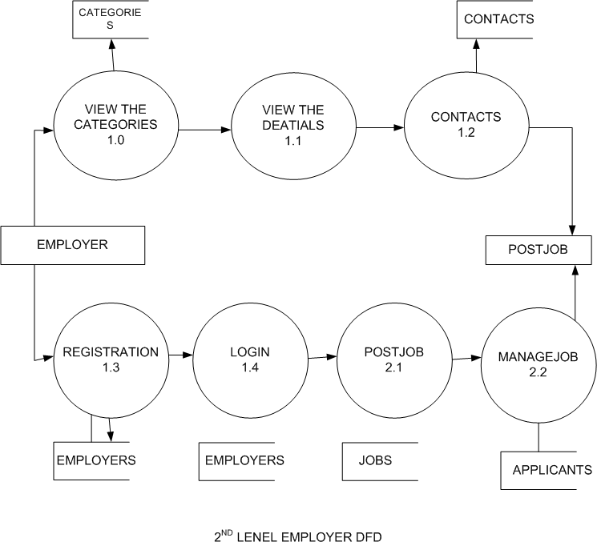

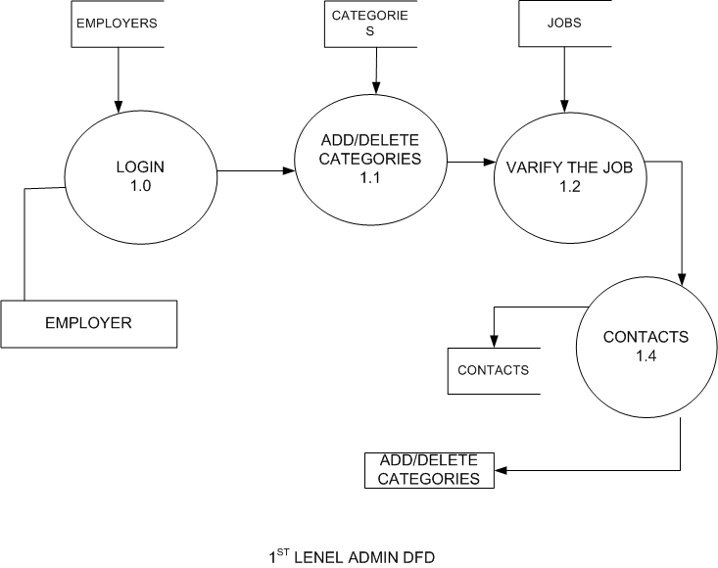

**3.7.3 CONTROL FLOW DIAGRAM**

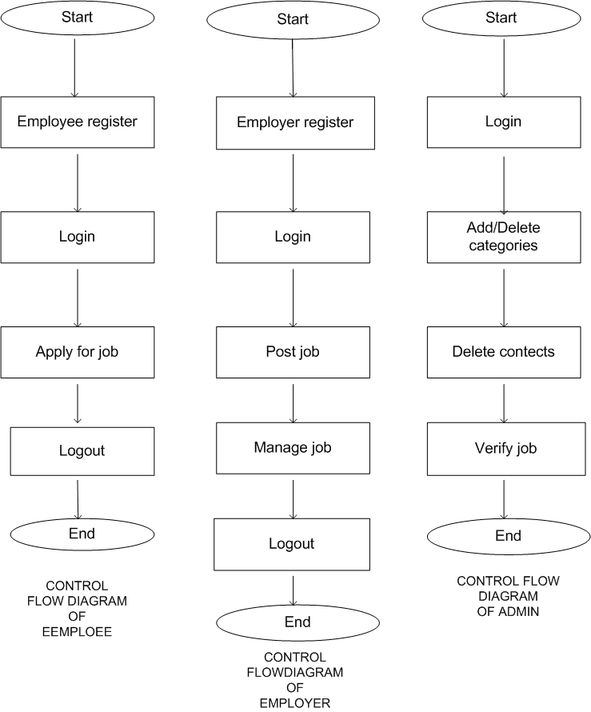

**3.7.4 STATE DIAGRAM**

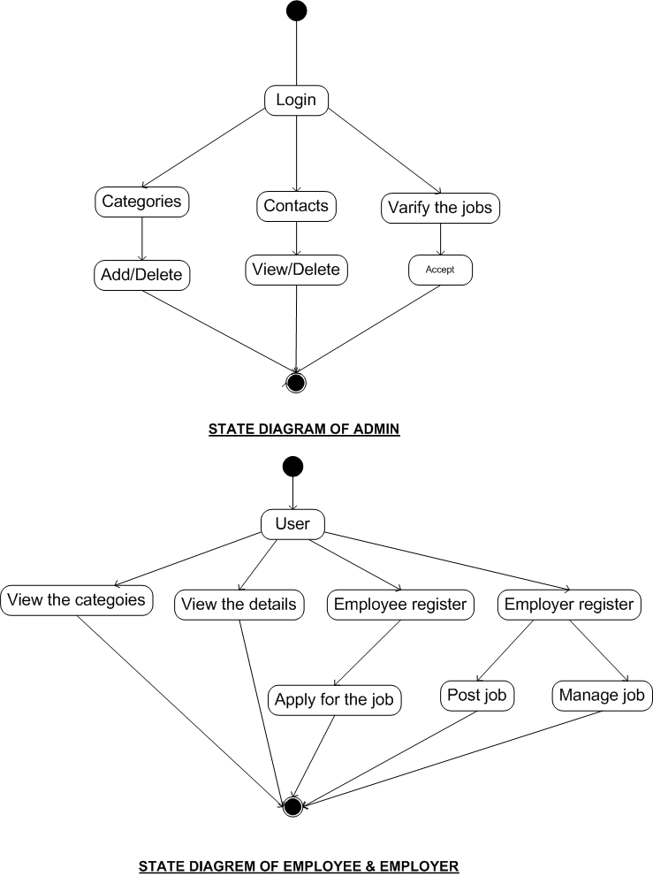

**3.7.5 ACTIVITY DIAGRAM**

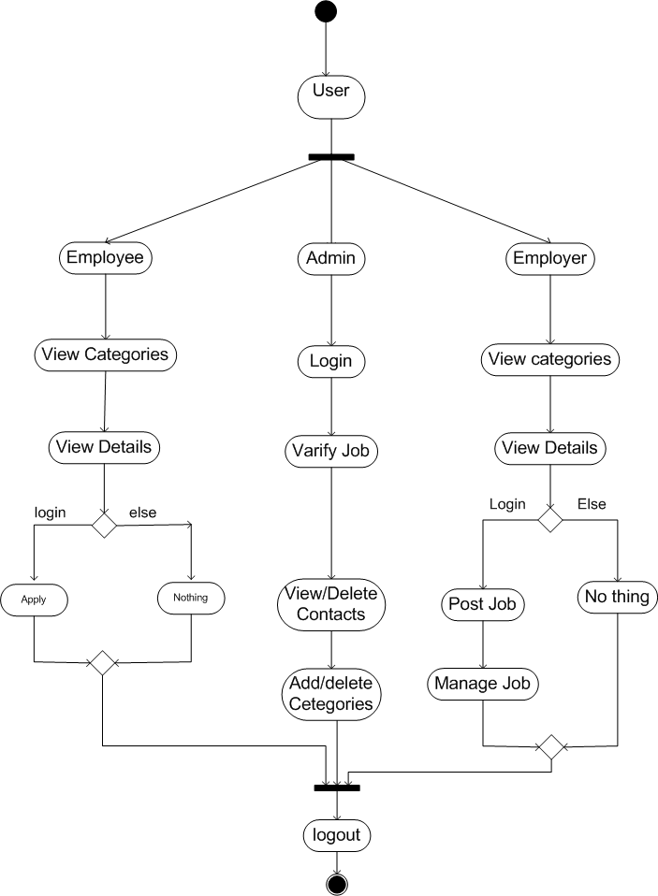

**4.SNAPSHOTS**

**4.1HOME PAGE**

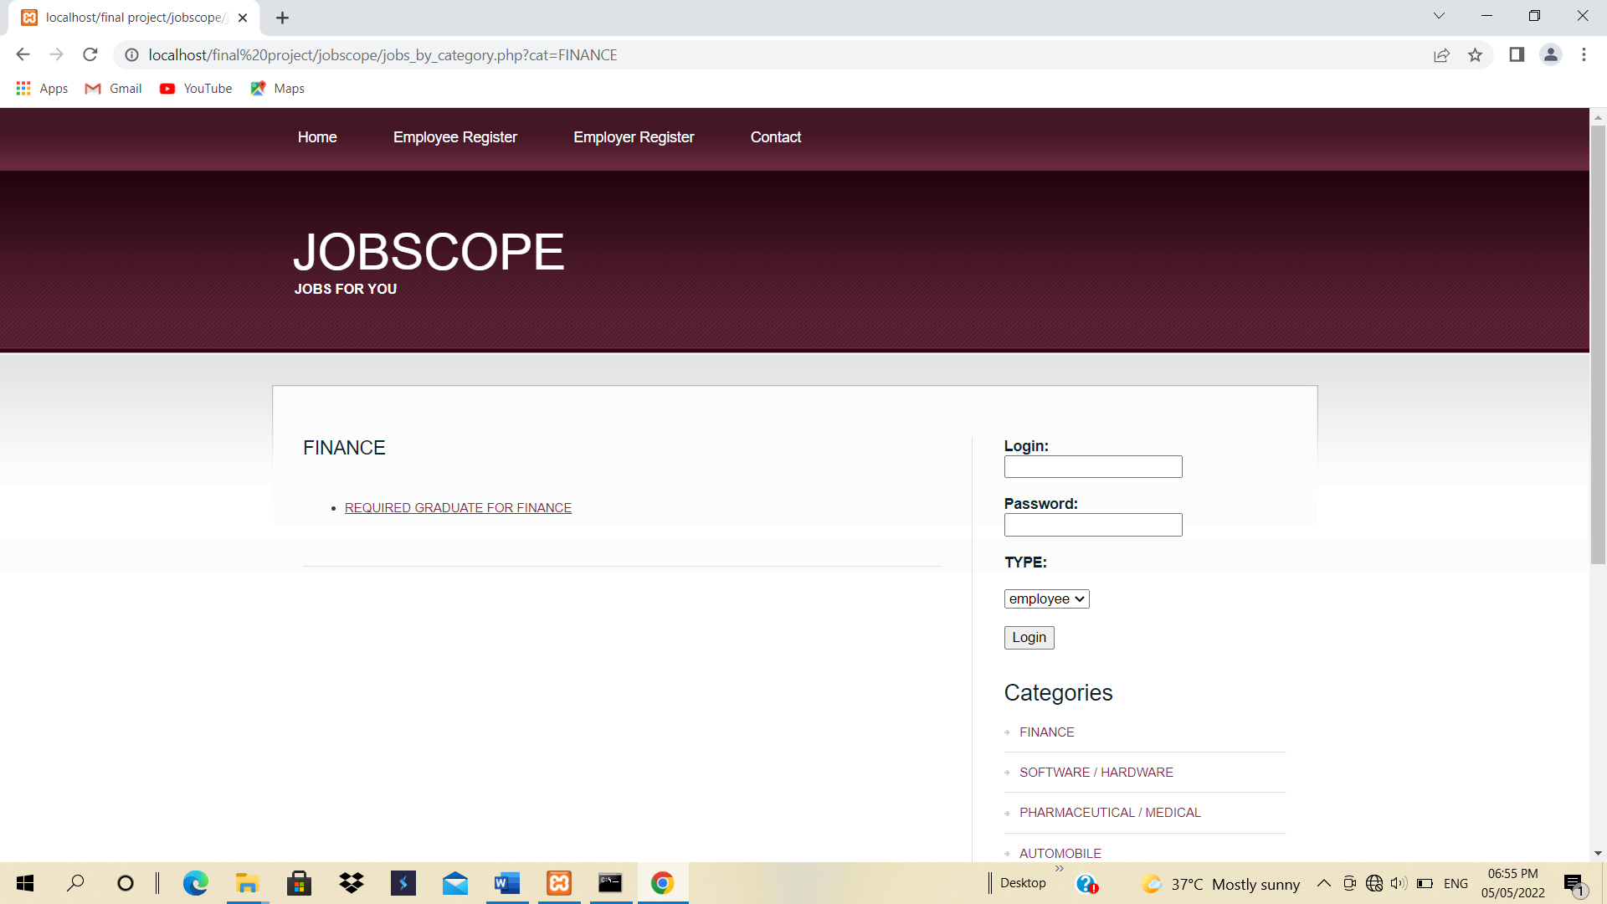

This is the home page. In this page the latest jobs are shown. This page contains login form.

**4.2 EMPLOYEE REGISTRATION PAGE**

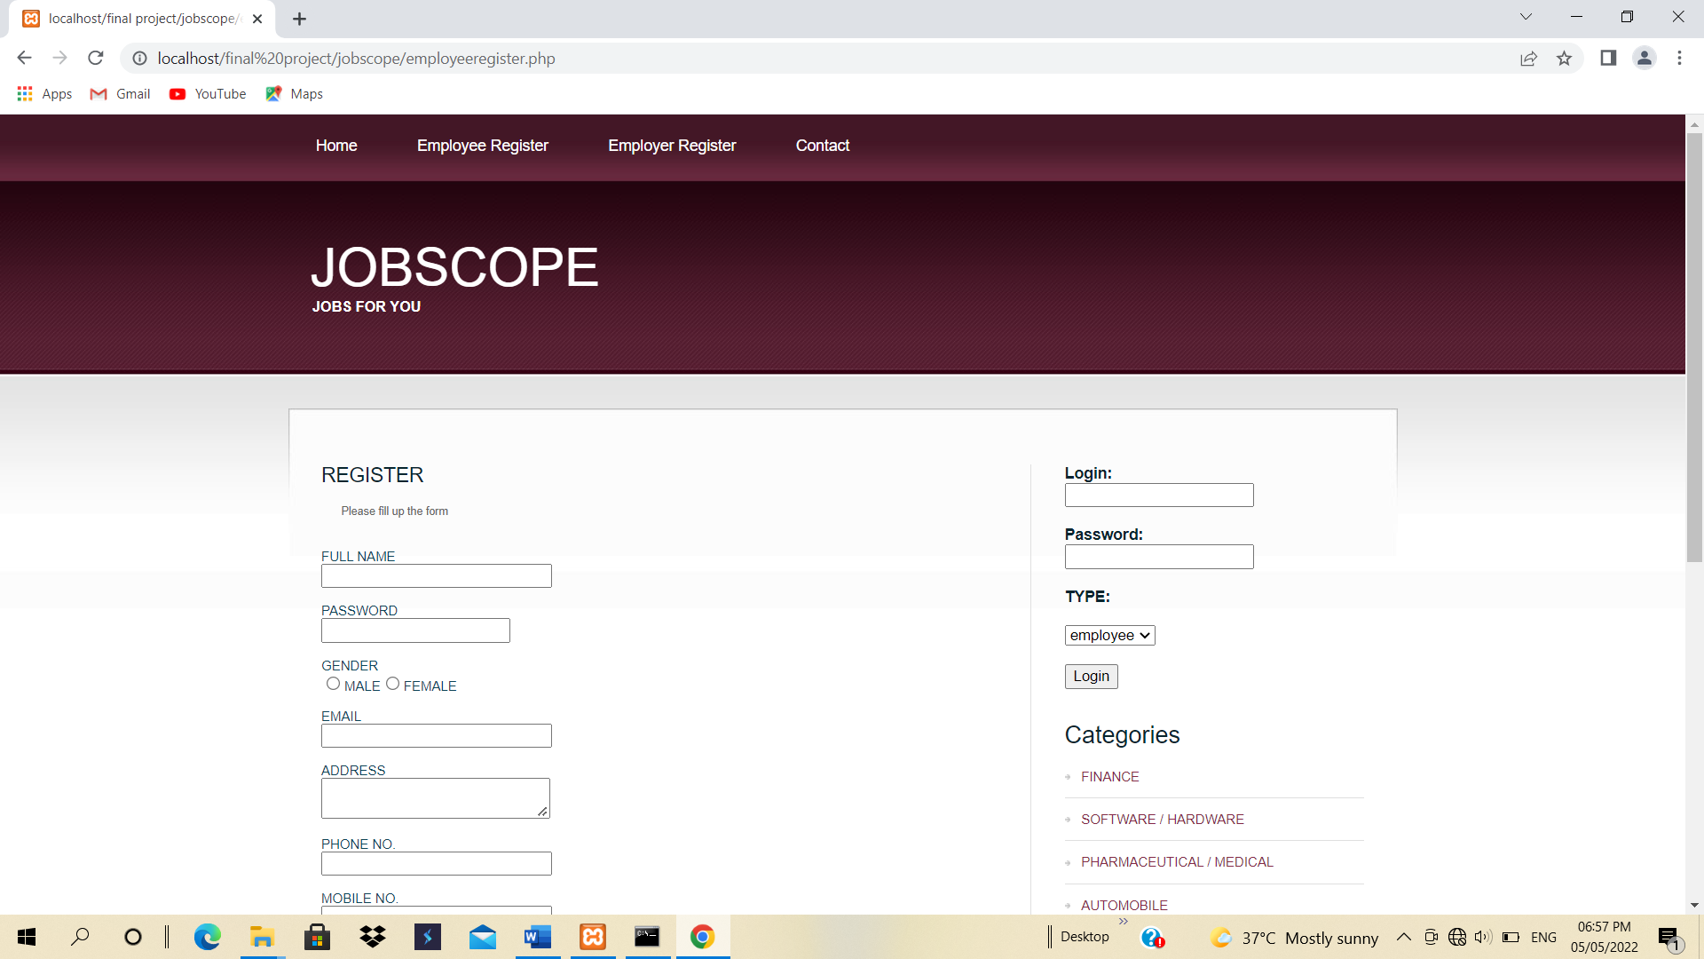

This is the employee registration form who want to login they should be fill this registration form. For registration insert query is used to store the data in employees table.

**4.3 EMPLOYER REGISTRATION PAGE**.

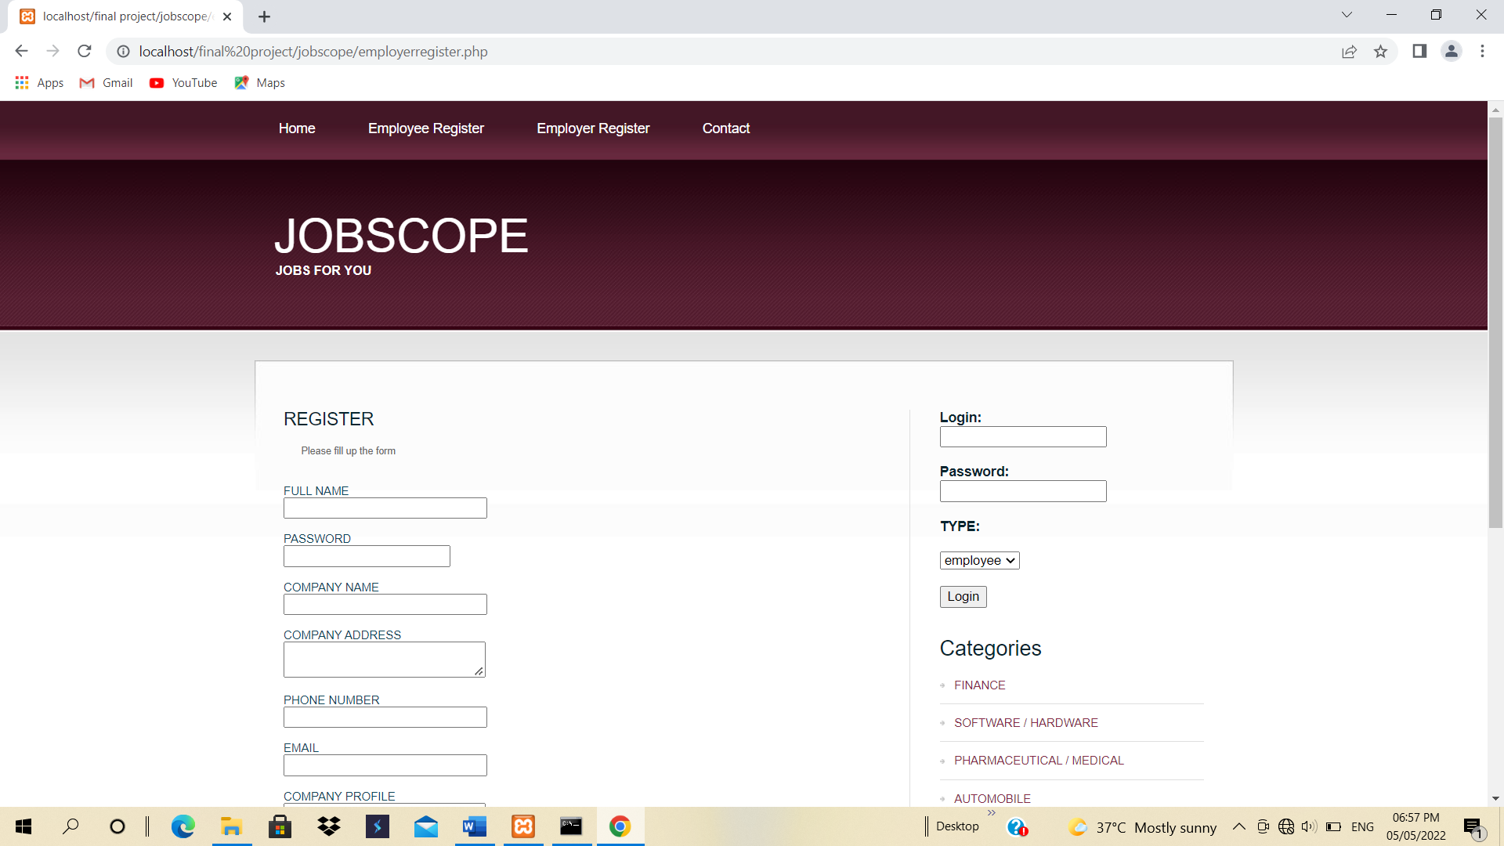

This is the employer registration form who want to login they should be fill this registration form. For registration insert query is used to store the data in employers table.

**4.4 CONTACT PAGE**

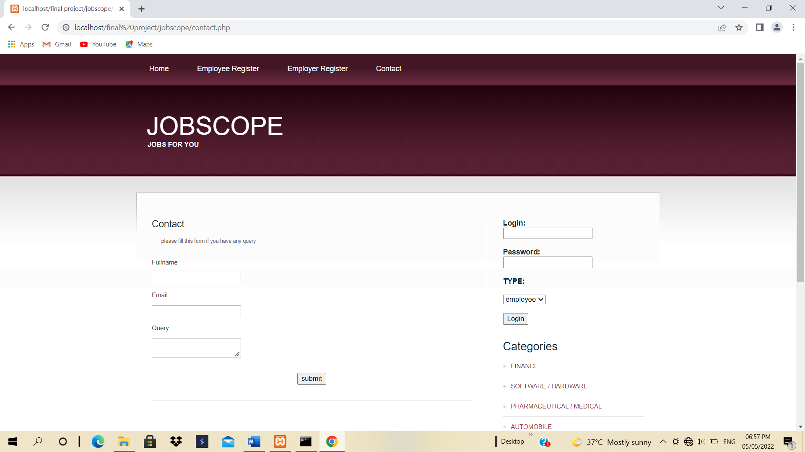

This is the contact page . if employer or employee have some query they can fill up this form. In this form insert query is used for store the data in contacts table.

**4.5 POST JOB PAGE**

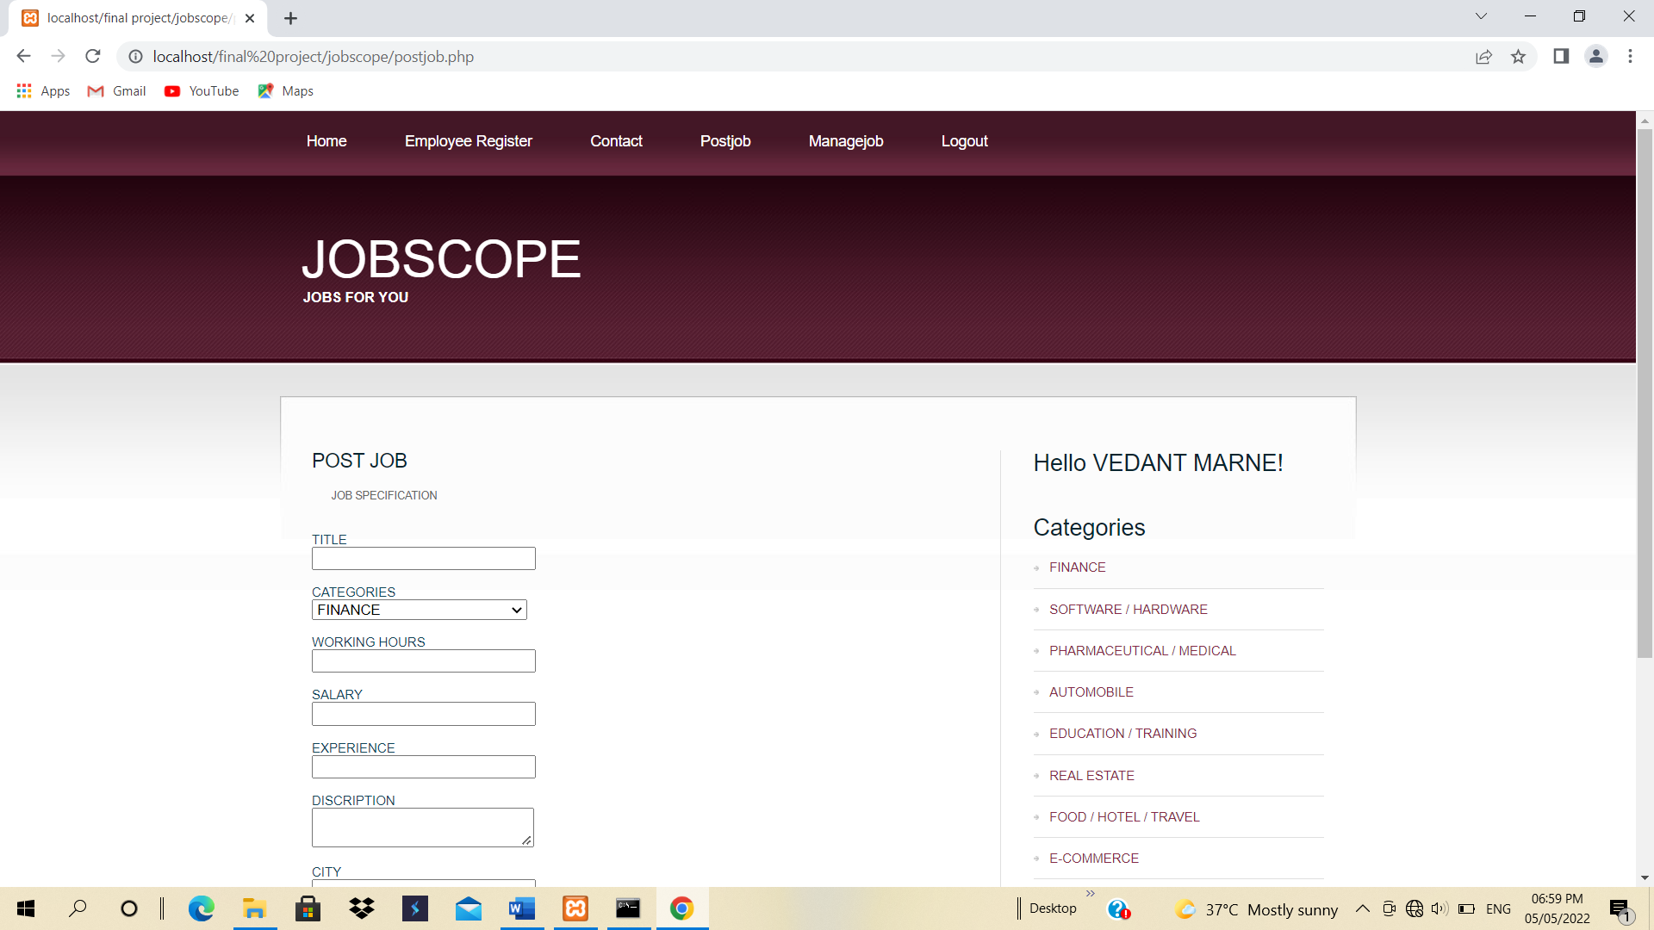

If the employer is login then he/she can post the job from this form .In this form insert query is used for data store in jobs table.

**4.6 MANAGE JOB PAGE**

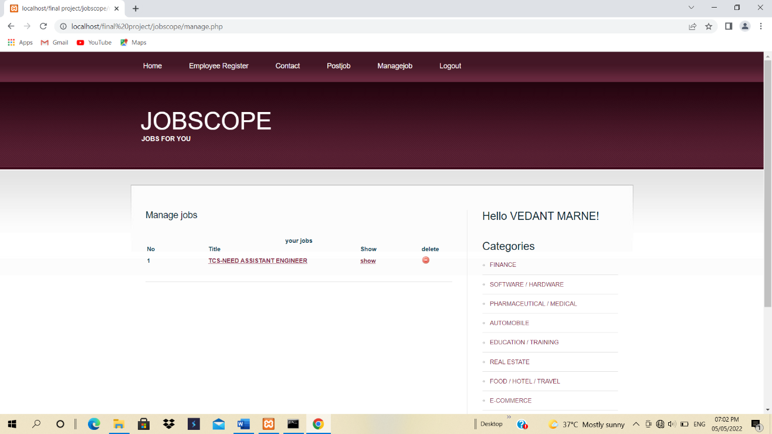

This is the manage jobs form. This form shows the list of vacant jobs listed by employer. In this form the delete query is used for delete the vacant job.

**4.7 JOB BY DEATIALS PAGE**

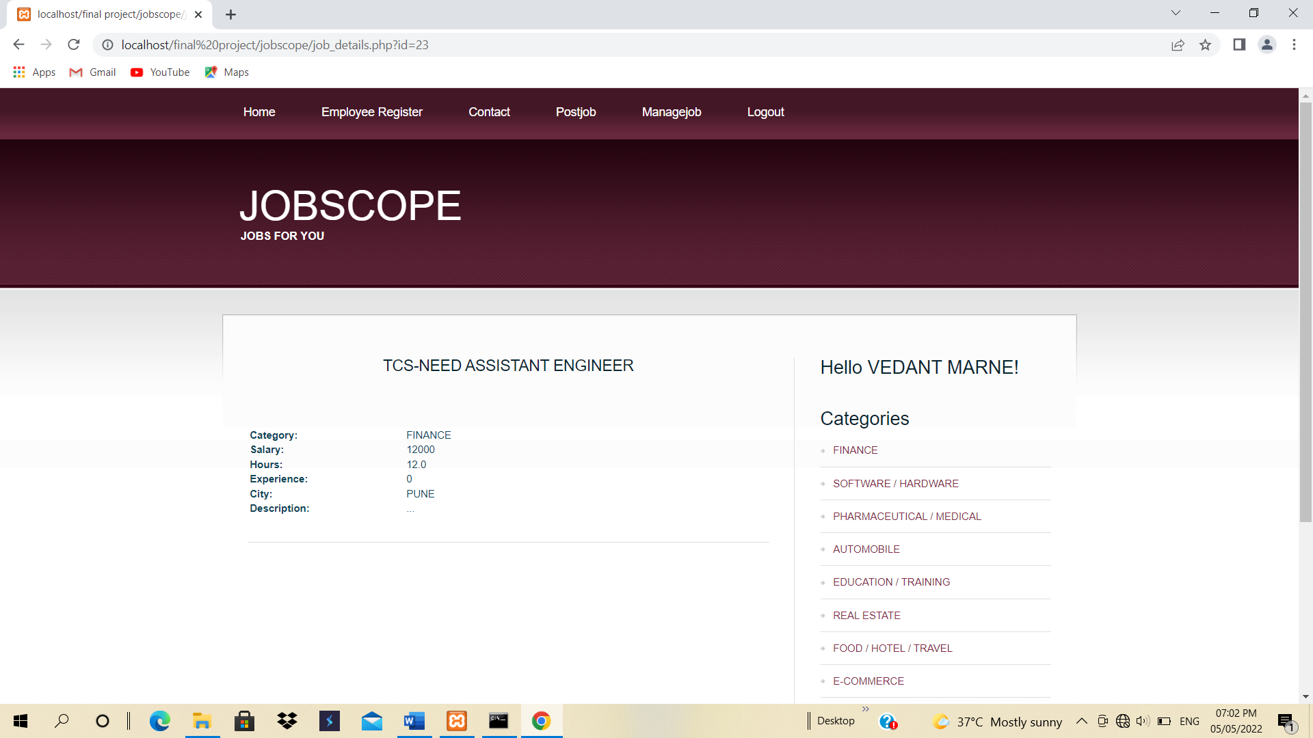

If the employee is login then he/she is apply for the job from this page.

**4.8 ADD/DELETE CATEGORIES PAGE**

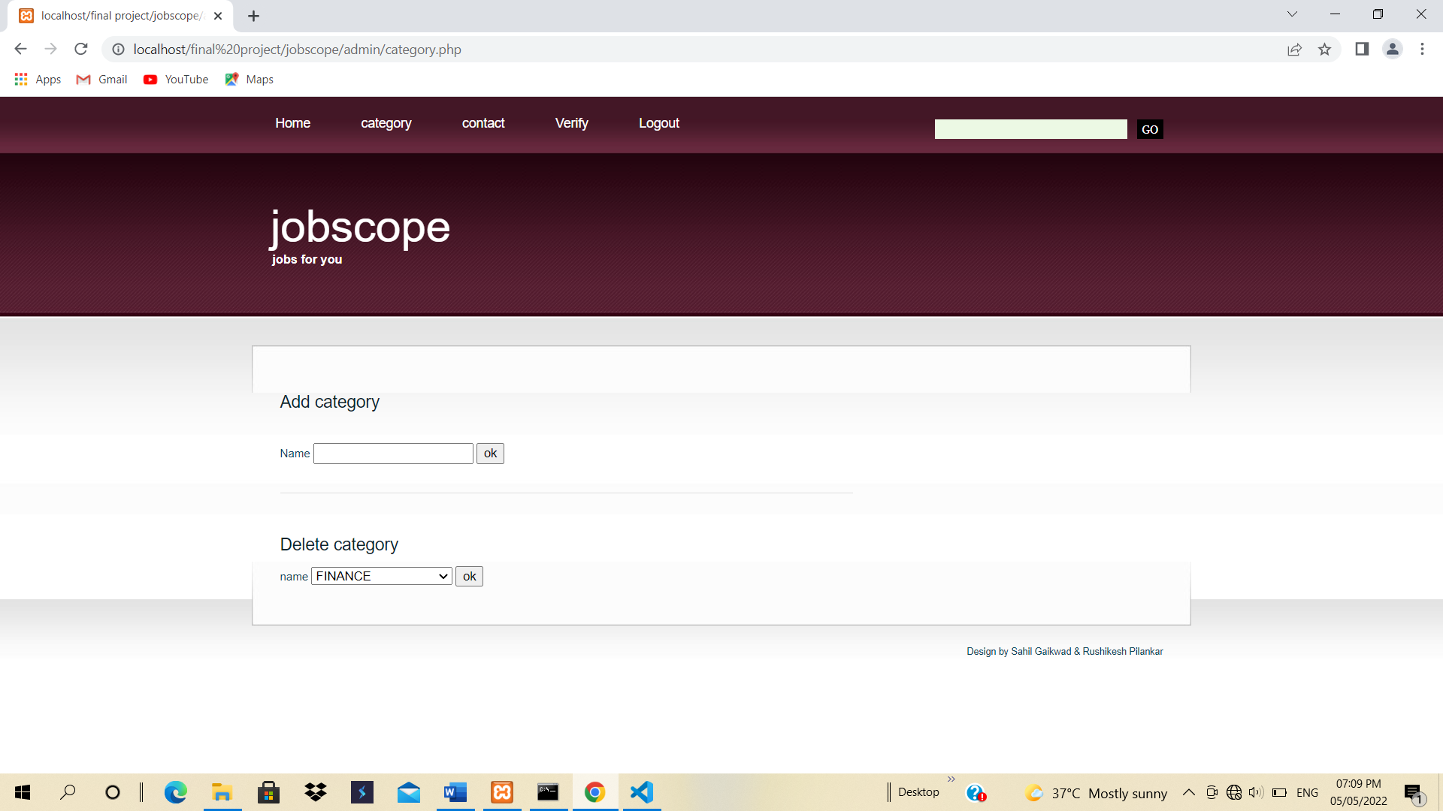

Admin can add/delete categories from this page. In this form insert and delete query is used.

**4.9 CONTACTS PAGE**

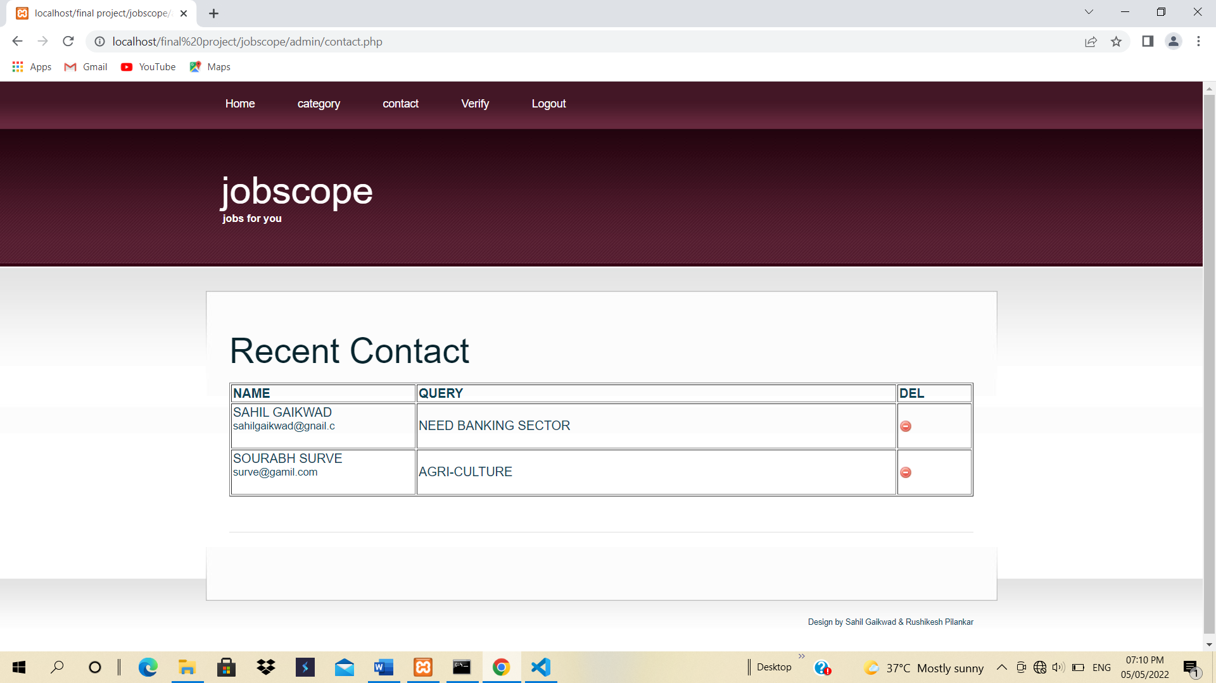

In this form admin can view and delete the query submitted by the employer and employee.

**4.10 VERIFY PAGE**

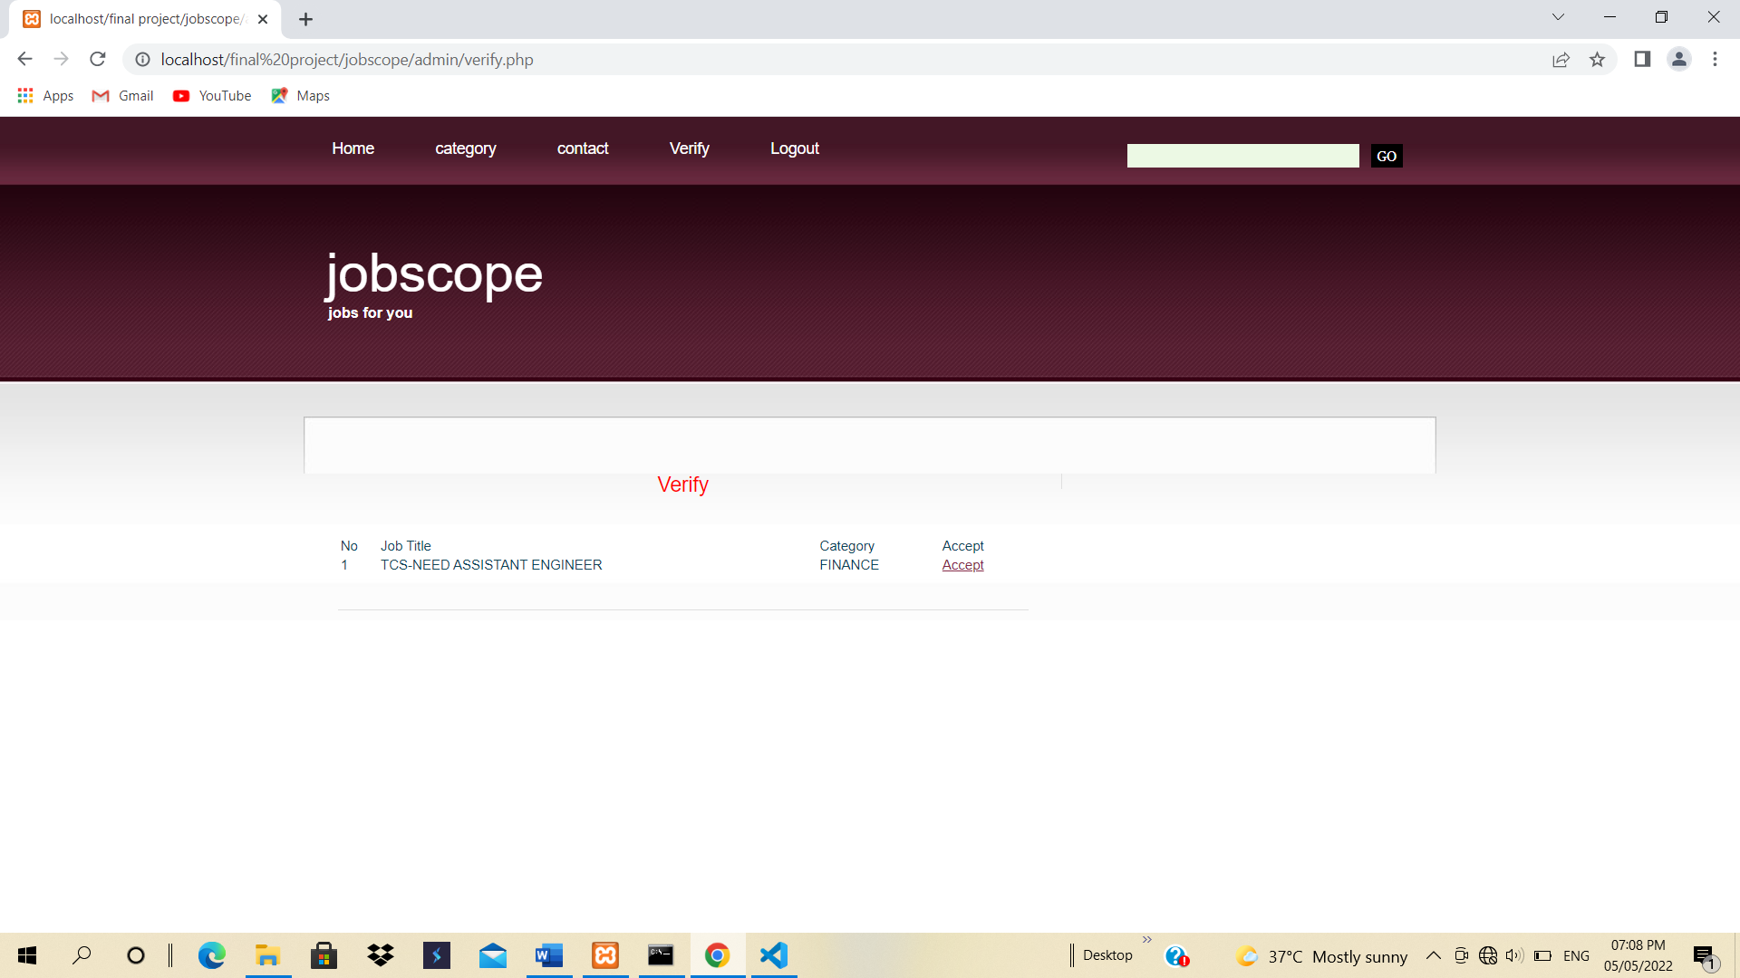

In this form admin can verify the jobs posted by the employer.

**5.ARCHITECTURE OF NEW SYSTEM**

**5.1 PACKAGE DIAGRAM**

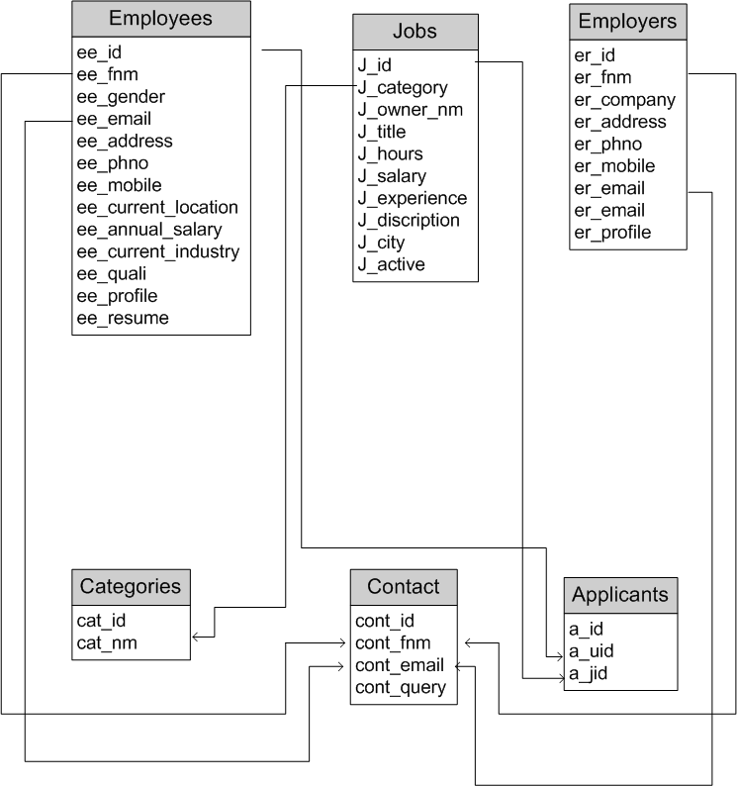

**6.CONCLUSION**

* The working on the project “Jobscope” Was an extremely learning experience. We came across a no of new concepts and also enhanced our knowledge.
* Although we faced some problem during the designing and the implementation part but due to the moral support of our guide we were able to overcome the situation.
* In this project I completely enjoyed.
* The project has been completed as per the schedule.

