**Vehicle to Vehicle (V2V) Communication Protocols: Avoiding Accidents and Connecting Cars to Foster a Safer Commute**

Sahil Gandhi, *University of California - Los Angeles*

ABSTRACT

At the current stage of vehicular technology, a car that is able to drive autonomously/semi-autonomously does not mitigate collisions because drivers are too dependent on an imperfect technology to pay attention to the road and there is a lack communication between different vehicles. While addressing careless drivers will continue to be a problem, an issue that is currently being addressed is vehicle to vehicle communication (V2V). Rather than just relying on the car’s sensors to guide it on a road or highway, if vehicles could also communicate amongst each other to provide additional feedback loops, the safety of individuals driving down the road would increase significantly. In this paper, I address the benefits and costs of integrating V2V protocols in modern vehicles and also talk about one way to implement V2V to work around software and hardware delays in the signal.

**1. Introduction**

With the continuous integration of IR/image sensors, machine learning and other related technologies into vehicles, the idea of a “self-driving” car is slowly becoming a reality. However, with reports like the recent death of an individual while driving the Tesla sedan in “Autopilot” mode on the rise, the true advancements in autonomous technology are at doubt. These cars, like the Tesla semi-autonomous sedans or the Google fully autonomous SUVs, perform superbly during tests on the track, but can come under public scrutiny when applied in the practical world when the software fails under unforeseen circumstances.

Approximately 94% of all crashes on the road involve some kind of human error [1]. It has been an age long attempt to get humans to keep their eyes on the road and not on their phones or dashboards, and to reduce the amount of drunk drivers on the road, but that is not the optimal place to look for a solution to reduce vehicular accidents.

The common point between everyone on the road, regardless of their blood alcohol content (BAC), stress, or desire to look at a screen is the vehicle that they are driving. Vehicles, for the most part, are far more predictable than humans. Turning the steering wheel left will move the car left, pressing the brakes will slow it down, and pressing the gas pedal will accelerate the car forward. With such a constant mechanism on the road, it is only logical that if these mechanisms were linked together and were aware of each other, then they could override human error and make daily commutes safer.

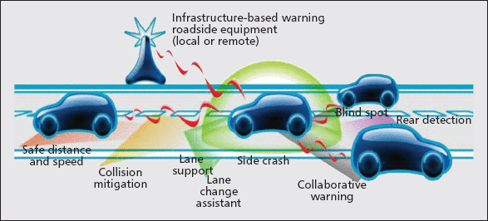

Figure 1 [2]. Vehicle communicating with its surrounding vehicles to gather information and reduce the chances of a collision due to human errors.

Some automation already exists in today’s cars like automatically steering into lanes if cars drift too far away, or adaptive cruise control to speed up or slow down the car depending on the speed of other cars in the lane, but that can be taken to the next level with V2V communication. Using Dedicated Short Range Communications (DSRC), a wireless communication form similar to Wi-Fi, cars can exchange data with each other about topics like location, speed and the current direction [1]. This protocol would allow cars to securely transmit 10 messages to each other every second for up to 1,000 feet in any direction, and that information would be utilized via feedback loops to control the car and avoid accidents.

1.1. Pros of V2V Communication

Some of the immediate benefits of V2V communication include traffic dispersion and accident mitigation. Usually when there is an accident on the road, there are long lines and roadblocks as the ripple effect on the road happens. One car slows down partially and since there is a delay in human reaction time to speed up again, every car behind it also slows down a little more. The result is a long traffic jam which could have easily been avoided if cars could automatically speed up and slow down based on the speed of other cars in the lane, as well as shift lanes based on information from cars ahead that a lane is blocked due to an accident. Furthermore, the intercommunication between cars would actually reduce accidents because as one car senses another car entering in its lane or speeding up from behind, it can adjust itself proportionally to avoid the collision.

Thus, connectivity further increases the effectivity of automation, as autonomous and semi-autonomous cars have more information about their surroundings to adjust the speed and direction of the car. The federal government estimates that V2V connectivity could reduce the severity of 80% of collisions that do not involve an impaired driver, and that would definitely make the road a safer place to commute [1].

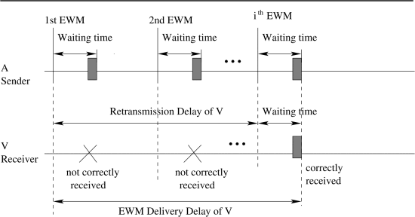

Figure 2 [3]. Waiting time in between EWMs (Emergency Warning Messages) and retransmission of EWMs. If the delay is not taken into account, the vehicle will react in an erronous way.

1.2. Cons of V2V Communication

At the same time that V2V communication can help avoid numerous accidents, it also creates an invasion of privacy, a new channel open to cyberattacks, and can lead to other unintended side effects. With so much personal data about one’s location, speed, and other factors given to random cars around, the ethical question of privacy comes to mind. Even though the data is to only be used to help other cars find their way around the road, it may have other unintended uses that users may not know about or agree with. Additionally, as we have seen with the recent hack on the Internet of Things devices that led to many websites being taken down, opening another channel of communication between cars leads to the risk of another channel where hackers can find a way to manipulate and steal data. This kind of attack could undo the benefits of having the communication protocol on the first place, as hackers could feed malicious data that cause cars to collide with one another.

There are other side effects of having V2V/autonomous vehicles that are still currently being researched as well. For example, once people realize that they do not have to pay attention to the road when they drive, will they distract themselves by going on their phones or reading books or other practices that are forbidden today? And if so, in the case where the control of the vehicle must be passed back to the driver, will they be able to react fast enough to bring the vehicle back in control or will the driver still be too distracted? As the technology matures, we will receive the answers to questions such as this, but as of this moment, these are arguments against the implementation of V2V communication or for increased regulation and research into the protocol before it is declared safe for the public to use.

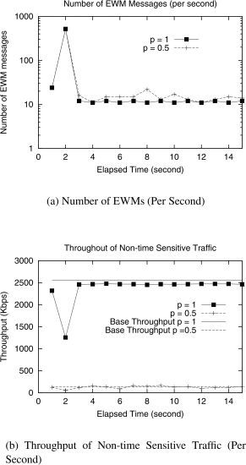

Figure 3 [3].During an accident/collision, the number of EWMs given will increase. Since they are added to the priority queue, which vehicles will access first, the throughput of non-sensitive information at that time is reduced. This way the more sensitive information is received and processed first.

2. Signal Delays and a Current Solution to Work around Them

A current research topic in V2V communication is designing a way to take signal propagation and delay into account. With just a couple cars on the road, the software and hardware delays are insignificant, but when hundreds of cars on the road are communicating with each other, then the delay can be an issue. The waiting delay can be given with the following equation, where $λ$ is the arrival rate of the messages and $μ$ is the rate at which the channel can process messages:

$Delay_{wait}=\frac{1}{μ-λ}+\frac{1}{μ}$ [3].

These delays will accumulate over every car on the road, so there needs to be some kind of method to tackle this issue. One proposed method to tackling this issue is by using priority queues to handle EWMs versus regular messages. As a new EWM is signaled, it is added to a separate priority que and is placed behind all other EWMs already located in that queue. Vehicles will then take the messages from this que before any other messages so that they can respond to collisions and accidents faster.

3. Conclusion

Ultimately, V2V communication still has several hurdles to overcome before it can be a reality, and even then, it needs to be extremely secure and anonymous to protect the data transferred and user privacy. However, rather than attempting to change the driving habits of every driver, it is far easier to change the communication and behavior of the vehicles themselves so that they can automatically respond to threats on the road and make the commute safer. V2V communication has a promising future ahead and it is inevitable that as companies like Google, Uber, and Tesla build their fleet of autonomous vehicles, they will begin to incorporate V2V communication in their designs.

References

[1] Peng, Huei. "Saving Lives by Letting Cars Talk to Each Other." *The Conversation*. N.p., 11 Sept. 2016. Web.16Nov.2016. <https://theconversation.com/saving-lives-by-letting-cars-talk-to-each-other-59221>

[2] Papadimitratos, Panos, et al. "Vehicular communication systems: Enabling technologies, applications, and future outlook on intelligent transportation." IEEE Communications Magazine 47.11 (2009):84-95. <http://ieeexplore.ieee.org/document/5307471/?arnumber=5307471> DOI = 10.1109/MCOM.2009.5307471

[3] Yang, Xue, et al. "A vehicle-to-vehicle communication protocol for cooperative collision warning." *Mobile and Ubiquitous Systems: Networking and Services, 2004. MOBIQUITOUS 2004. The First Annual International Conference on*. IEEE, 2004. <http://ieeexplore.ieee.org/document/1331717/?arnumber=1331717&tag=1>DOI=10.1109/MOBIQ.2004.1331717