# RM294 – Optimization I – Project 1

Group Members:

* Sahil Natu
* Charan Musunuru
* Jacob Rhymes
* Aditya Soni

## Problem Definition

Marketing budgets now comprise 11 percent of total company budgets, based on a CMO survey sponsored by the Fuqua School of Business at Duke University, Deloitte LLP, and the American Marketing Association. However, the effectiveness of marketing varies significantly: on the one hand, P&G cut more than $100 million in digital marketing spending because their digital ads were largely ineffective; on the other hand, Netflix plans a 54% boost in ad spending because they got very positive feedback in international markets.

One potential reason for such variation is the way of making marketing budget allocations. Namely, how much to invest in each advertisement platform. As stated in the Handbook of Marketing Analytics:

*…budget decisions are often based on gut feelings or on negotiation skills of individual managers. Consequently, politics and individual opinions tend to shape the decision process instead of fact-based discussions. Obviously, these rules and practices bear the risk of results far away from the optimal, profit-maximizing budget.*

Indeed, the marketing strategy of Netflix seems to be steered by data. In this project, we use linear programming to build a simple marketing budget allocation strategy.

## Steps

### Calculating Allocation of Marketing Budget based on ROI from Firm 1 (Q1-3)

Here, we calculate the allocation of marketing budget of $10mn based on the ROI estimates provided by the first firm for all 10 marketing mediums. The ROI estimates are as follows:

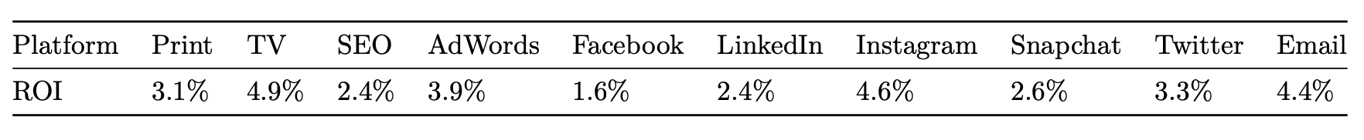

The following constraints have been employed when calculating the optimum allocation:

1. Amount spent on Print and TV should be less than or equal to the amount spent on Facebook and Email mediums
2. Amount spent on Social Media mediums (Facebook, LinkedIn, Instagram, Snapchat, and Twitter) should be cumulatively at least twice the amount spend on SEO and AdWords mediums
3. Amount spent on any individual medium should be capped at $3mn

Upon optimizing the objective function to get maximum returns with the above set of constraints, we arrive at the following allocation strategy:

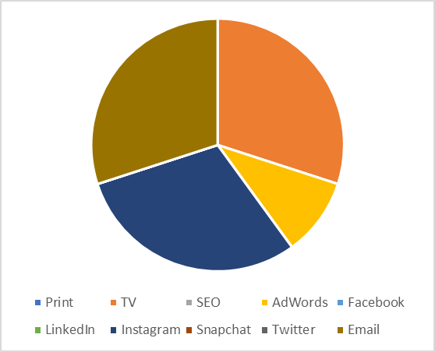

### Calculating Allocation of Marketing Budget based on ROI from Firm 2 (Q4)

Next up, we calculate the allocation of marketing budget of $10mn based on the ROI estimates provided by the second firm for all 10 marketing mediums. The ROI estimates are as follows:

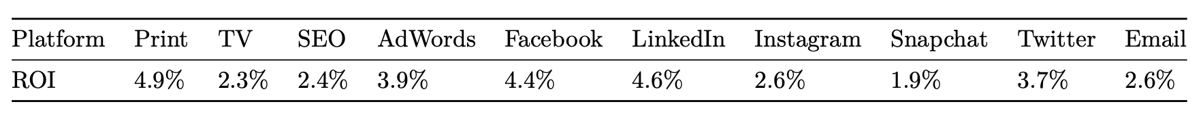

The same constraints are in place as before. Upon optimizing the objective function to get maximum returns with the same constraints, we arrive at the following allocation strategy:

### Cost of Using the Wrong Allocation Strategy (Q5)

The allocations strategies based on the estimates of ROI from the 2 firms are different, even though the maximum returns turn out to be same at $456k.

However, if the ROI estimates of the first firm are correct and we allocate based on the ROI estimates of the second firm, and vice versa, the returns change. We evaluate the same below:

#### ROI Estimates of Firm 1 are correct, we Allocate based on Firm 2 Estimates

In this case, we multiply the allocation strategy achieved using the firm 2 estimates with the objective function for firm 1 (ROI estimates from firm 1). The resultant returns in this case are $252k. It is $204k less than the optimal returns.

#### ROI Estimates of Firm 2 are correct, we Allocate based on Firm 1 Estimates

In this case, we multiply the allocation strategy achieved using the firm 1 estimates with the objective function for firm 2 (ROI estimates from firm 2). The resultant returns in this case are $264k. It is $192k less than the optimal returns.

#### ROI Estimates of Firm 1 are correct, we Allocate based on Firm 2 Estimates, 3rd Constraint is Removed

In this case, we multiply the allocation strategy achieved using the firm 2 estimates with the objective function for firm 1 (ROI estimates from firm 1). We also remove the 3rd constraint where we cannot allocate more than $3mn to any medium. The resultant returns in this case are $235k, which is less than $252k that we achieved with the 3rd constraint in place. It is $230k less than the optimal returns.

#### ROI Estimates of Firm 2 are correct, we Allocate based on Firm 1 Estimates, 3rd Constraint is Removed

In this case, we multiply the allocation strategy achieved using the firm 1 estimates with the objective function for firm 2 (ROI estimates from firm 2). We also remove the 3rd constraint where we cannot allocate more than $3mn to any medium. The resultant returns in this case are $245k, which is less than $264k that we achieved with the 3rd constraint in place. It is $220k less than the optimal returns.

|  |  |  |
| --- | --- | --- |
| **Constraint 3** | ROI Set 1 Used | ROI Set 2 Used |
| ROI Set 1 Correct | $456,000 | $252,000 |
| ROI Set 2 Correct | $264,000 | $456,000 |
|  |  |  |
|  |  |  |
| **Constraint 3 Removed** | ROI Set 1 Used | ROI Set 2 Used |
| ROI Set 1 Correct | $465,000 | $235,000 |
| ROI Set 2 Correct | $245,000 | $465,000 |

The above analysis helps us understand the need for the 3rd constraint. This constraint prevents the team from allocating all the marketing budget to the medium that is estimated to have the maximum returns as these estimates can go wrong. Putting all the eggs in the same basket will often lead to lesser returns than using an allocation strategy that targets multiple mediums. This is ensured by putting in the 3rd constraint.

### Sensitivity Analysis on Allocation Strategy using ROI Estimates of Firm 1 (Q6)

Here, we perform a sensitivity analysis by wiggling the values in the objective function while keeping the allocation strategy unchanged. We use Gurobi’s inbuilt capabilities to achieve the same. The range of values for each ROI estimate for which the allocation strategy remains the same are as follows:

|  |  |  |
| --- | --- | --- |
| Medium | Min Value | Max Value |
| Print | Neg Inf | 4.90% |
| TV | 3.90% | 6.20% |
| SEO | Neg Inf | 3.90% |
| AdWords | 3.30% | 4.60% |
| Facebook | Neg Inf | 2.90% |
| LinkedIn | Neg Inf | 3.90% |
| Instagram | 3.90% | Inf |
| Snapchat | Neg Inf | 3.90% |
| Twitter | Neg Inf | 3.90% |
| Email | 2.90% | Inf |

### Reinvesting with Updated Budget based on Allocation Strategy from ROI Estimates of Firm 1 (Q7-8)

We proceed with running a scenario where we invest the original budget of $10mn with the allocation strategy arrived at by assuming ROI estimates provided by firm 1. We invest every month for a year using this strategy but returns vary as given in the monthly returns spreadsheet. Additionally, the invested amount varies each month by adding half of the returns earned in the previous month to the budget amount for the current month.

The monthly returns are as follows:

|  |  |  |  |  |  |  |  |  |  |  |
| --- | --- | --- | --- | --- | --- | --- | --- | --- | --- | --- |
|  | Print | TV | SEO | AdWords | Facebook | LinkedIn | Instagram | Snapchat | Twitter | Email |
| January | 4 | 3.6 | 2.4 | 3.9 | 3 | 3.5 | 3.6 | 2.25 | 3.5 | 3.5 |
| February | 4 | 3.9 | 2.7 | 3.8 | 4.3 | 3.2 | 2.7 | 1.8 | 3.7 | 3.5 |
| March | 3.5 | 2.9 | 3.1 | 3.8 | 2.4 | 4.1 | 3.7 | 2.6 | 4.2 | 2.5 |
| April | 3.8 | 3.1 | 2.4 | 4.4 | 2.4 | 3.8 | 3.7 | 2.5 | 3.6 | 2.9 |
| May | 3.5 | 3.2 | 1.9 | 3.4 | 2.7 | 2.7 | 3.9 | 2.2 | 4.5 | 3.9 |
| June | 4 | 3.2 | 2.7 | 3.4 | 3.4 | 3 | 4.5 | 2.1 | 3.8 | 4.1 |
| July | 3.9 | 3.6 | 2 | 4.4 | 3.9 | 3.7 | 4.3 | 1.8 | 4 | 3.8 |
| August | 4.2 | 3.3 | 2.8 | 4.2 | 2 | 3.7 | 3.6 | 1.5 | 4.4 | 4.3 |
| September | 4.1 | 2.8 | 2.5 | 4.2 | 2.9 | 3.7 | 2.8 | 2.5 | 4 | 3.4 |
| October | 3 | 3 | 3.1 | 4.6 | 3.1 | 3.3 | 3.2 | 2.3 | 2.5 | 3.2 |
| November | 4.8 | 3.3 | 2.7 | 4.1 | 2.9 | 3.6 | 4.2 | 3 | 3.1 | 4.1 |
| December | 4.8 | 4 | 1.9 | 3.7 | 4.2 | 3.6 | 2.6 | 2.9 | 3.6 | 3.7 |

The allocation strategy and the monthly returns we obtain are as follows:

|  |  |  |  |  |  |  |  |  |  |  |  |  |
| --- | --- | --- | --- | --- | --- | --- | --- | --- | --- | --- | --- | --- |
|  | Jan | Feb | Mar | Apr | May | June | July | Aug | Sep | Oct | Nov | Dec |
| Print | 0k | 0k | 0k | 0k | 0k | 0k | 0k | 0k | 0k | 0k | 0k | 0k |
| TV | 3000k | 3000k | 3000k | 3000k | 3000k | 3000k | 3000k | 3000k | 3000k | 3000k | 3000k | 3000k |
| SEO | 0k | 0k | 0k | 0k | 0k | 0k | 0k | 0k | 0k | 0k | 0k | 0k |
| AdWords | 1000k | 1180k | 1354k | 1505k | 1565k | 1630k | 1700k | 1773k | 1846k | 1908k | 1973k | 2050k |
| Facebook | 0k | 0k | 0k | 0k | 0k | 0k | 0k | 0k | 0k | 0k | 0k | 0k |
| LinkedIn | 0k | 0k | 0k | 0k | 0k | 0k | 0k | 0k | 0k | 0k | 0k | 0k |
| Instagram | 3000k | 3000k | 3000k | 3000k | 3000k | 3000k | 3000k | 3000k | 3000k | 3000k | 3000k | 3000k |
| Snapchat | 0k | 0k | 0k | 0k | 0k | 0k | 0k | 0k | 0k | 0k | 0k | 0k |
| Twitter | 0k | 0k | 0k | 11k | 130k | 260k | 399k | 547k | 692k | 817k | 947k | 1099k |
| Email | 3000k | 3000k | 3000k | 3000k | 3000k | 3000k | 3000k | 3000k | 3000k | 3000k | 3000k | 3000k |
| Optimal Returns | 360k | 348k | 324k | 358k | 389k | 419k | 442k | 435k | 375k | 390k | 458k | 424k |
| Budget | 10mn | 10.18mn | 10.35mn | 10.5mn | 10.69mn | 10.88mn | 11.09mn | 11.32mn | 11.53mn | 11.72mn | 11.92mn | 12.14mn |

Print, SEO, Facebook, LinkedIn, Snapchat

Twitter

AdWords

Email, Instagram, TV

Since the allocation to any medium across consecutive months does not change by more than $1mn, the budget is deemed to be stable. To ensure that the budget always comes out to be stable, additional constraints could be added during optimization such that allocation to a medium in a month is no more than $1mn off from the allocation to the same medium in the previous month.

## Conclusion

The analysis that we have performed has led us to multiple conclusions:

* Ensure constraints are in place to avoid allocating all the budget to the same medium and thus minimize the risk, do not put all your eggs in the same basket
* Estimates can vary by a certain margin while still allowing for the same allocation strategy, thereby providing us with an error margin when estimating the ROIs
* Allocation strategy must be stable and be governed by certain business rules, which can be incorporated into the problem as additional constraints