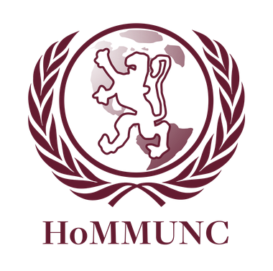

Disarmament and International Security Committee

Chair: Jacqueline Goodman

Moderator: Jacqueline Maier

Dear Delegates,

Welcome to DISEC! My name is Jacqueline Goodman and I will be chairing this committee. Last year, I was a moderator on this committee and I’m excited to return. I am currently a senior at Horace Mann and I am one of the Secretaries-General of Horace Mann Model UN. I have been doing Model UN since freshman year and it has been a major part of my life both in and out of school for the past four years. I couldn’t be more excited to not only chair this committee, but also to share a passion for Model UN with all of the delegates attending this conference.

At school, I am most interested in Economics, Spanish and Environmental Science. Part of the reason why I love Model UN is that it gives me the opportunity to learn about sophisticated topics and material that relates to things that I am studying in each of these classes. Embedded at the heart of each international issue is information that can be found, with a little time and research, within the courses you take at school. These are global problems that affect millions of people, but I believe that they are issues that we as students can understand and even try to ameliorate.

We hope that in this committee, you embrace all styles of leadership, and we encourage that you engage in positive and respectful diplomatic discourse. We hope that you prepare yourselves beforehand by actively researching both Biological and Chemical Warfare along with Piracy on the High Seas. Similarly, we emphasize the importance of understanding and staying true to your country’s policy in committee. While the background guide is a resource for you, these topics and positions are elaborate enough to demand further research. You all, as delegates, will gain more from the experience if you make the effort to challenge yourself and also challenge others while working together and solving problems. I look forward to a day of exciting and enriching debate.

Sincerely,

Jacqueline Goodman

Chair, DISEC

Secretary-General, Horace Mann Model UN

[Jacqueline.goodman@hommunc.org](mailto:Jacqueline.goodman@hommunc.org)

**COMMITTEE BACKGROUND**

The Disarmament and International Security Committee (DISEC) of the United Nations is the first committee of the General Assemblies. The committee functions to discuss a variety of topics including issues related to the disarmament of nations, global challenges and threats to peace that affect the international community. Under the UN Charter all United Nations member states and observers automatically participate on DISEC’s committee. Due to the diverse collective of DISEC, the committee is able to express international opinion most accurately.

Essentially, your goal as a member of DISEC is to pass resolutions that best convey the predominant belief of the committee and allow us to engage in interesting and productive debate. Though DISEC resolutions are non contractual (like other GA committees), DISEC is able to propose policy recommendations to be implemented by the United Nations Security Council (UNSC). Delegates can expect DISEC to operate as a traditional General Assembly.

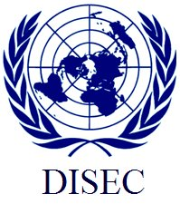

Figure I. Disarmament and International Security Committee logo <http://bosmun.org/committees/ga/disec>

**TOPIC 1: BIOLOGICAL AND CHEMICAL WARFARE**

**INTRODUCTION:**

The use of biological and chemical weapons has plagued the international community for decades. Biological and chemical warfare, also known as, bioterrorism is the intentional dissemination of harmful biological agents. Biological agents spread through the air, water, or in food. Some can also spread from person to person.[1] They are so dangerous because while they can often be fatal, they can be very hard to detect as well. Their usage is both a moral and technological debate. While chemical weapons were first addressed by international law long before biological weapons, both have been extensively regulated by conventions prohibiting their production, stockpiling, and use.[2] Despite stringent international law forbidding the use of chemical and biological weapons, this has not prevented individuals and governments from weaponizing certain chemical gases, toxins, or infectious diseases for use against both armed combatants and civilians. Recently, the crisis in Syria has brought the use of chemical weapons to the attention of the international community amidst accusations that the Syrian government has used toxic weapons against opponents. Furthermore, advancing terrorist tactics make fears of bioterrorism a growing likelihood.[3]

Biological and chemical threats are organized into three categories. Category A threats are high priority agents that “pose a risk to national security, can be easily transmitted and disseminated, result in high mortality, have potential major public health impact, may cause public panic, or require special action for public health preparedness.” Category B threats are categorized as moderately easy to disseminate and have low mortality rates. Category C threats are emerging pathogens that could be engineered for mass dissemination because of their availability, ease of production and dissemination, high mortality rate, or ability to cause a major health impact.[4]

Organizations such as the Organization for the Prohibition of Chemical Weapons, The ICRC, Medline Plus, The United States Marine Corps’ Chemical Biological Incident Response Force, The United States Center for Disease Control and the United States Army’s 20th Support Command (CBRNE), help to detect, identify, and neutralize threats, and decontaminate victims exposed to bioterror agents.[5]

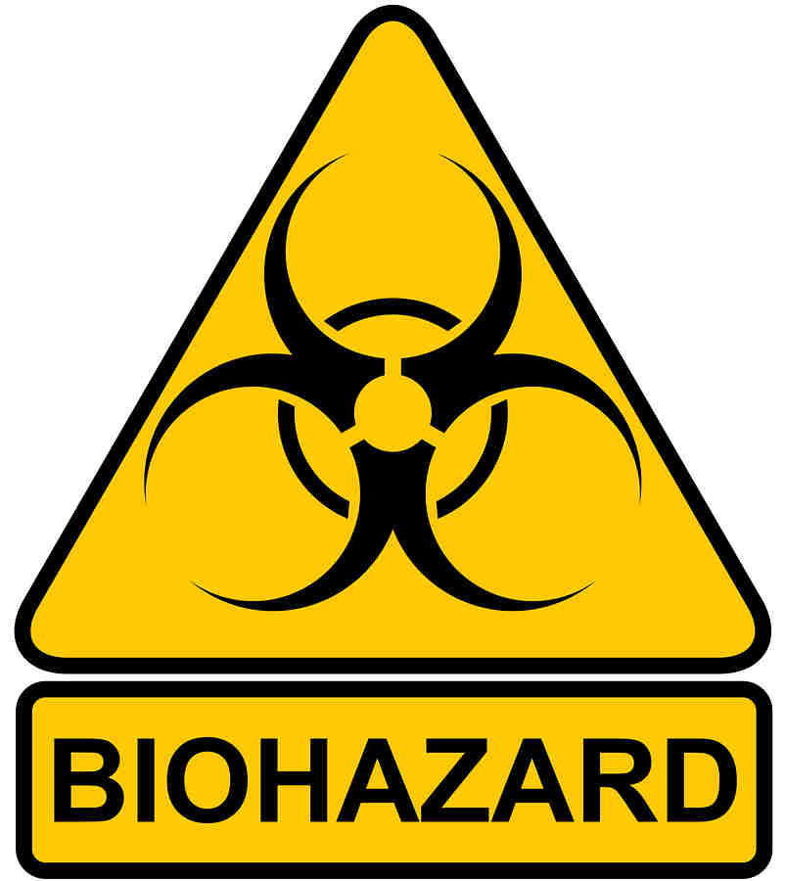

Figure II. Logo for bio agent materials <http://www.wyatt-lorenz.com>

**PAST CONFLICTS:**

BIOLOGICAL WARFARE:

Biological warfare began in Ancient Rome where excrement was thrown into the faces of enemies. Biological warfare continued into the 1300s in the form using the bubonic plague to infiltrate enemy cities, both by instilling the fear of infection in residences, in hopes that they would evacuate, and also to destroy defending forces that would not yield to the attack. “Primitive medical technology provided limited means of protection for the aggressor and a battle's surrounding geographical regions.”[6] Unfortunately after the battle was won, the inability to contain enemies who escaped death led to widespread epidemics affecting not only the enemy forces, but also surrounding regions' inhabitants. Due to lack of medical knowledge concerning these bio agents, widespread epidemics were able to quickly span all of Europe, destroying large portions of the population. Advancement in bioterrorism was the victim being seen as a biological weapon as well.[7]

As time progressed, biological warfare became more intricate. Countries were able to develop bio agents, which were more effective and much less likely to cause infection to the wrong party. A significant discovery in the bioterrorism was the development and use of anthrax.[8] Anthrax became a preferred biological weapon in the early 1800s due to its easy transference, poor ability to spread beyond the targeted population, easy obtainability and high mortality rate.

Shortly after World War I began, Germany launched a bioterrorism campaign against the United States, Russian Federation Romania and France. A German agent, Anton Dilger was sent to the United States with cultures of glanders, a disease of horses and mules. He infected horses with glanders while they were waiting to be shipped to England. Though he was never arrested, Russians arrested an agent with similar intentions in 1916. Germany was able to infect French and Russian horses, hindering artillery, troop movements and supply convoys.[9]

American biological weapon development began in 1942 under the administration of Franklin Roosevelt. George W. Merck was commanded to create a developmental program.[10] These programs continued until 1969 when Richard Nixon stopped all programs related to the research of American biological weaponry on the grounds of “They may produce global epidemics and impair the health of future generations.” He then stated The United States would destroy its entire stockpile of biological weapons and only research defensive measures such as field detectors and vaccines. As the 1970s passed, international efforts concentrated on how to prevent the development and use of biological weapons.

August 10, 1972, President Richard Nixon officially transmitted the Biological Weapons Convention to the United States Senate for ratification. In his transmittal he refers to the DISEC Convention held in Geneva on biological weaponry, stating: “It provides that the Parties undertake not to develop, produce, stockpile, acquire or retain biological agents or toxins, of types and in quantities that have no justification for peaceful purposes, as well as weapons, equipment and means of delivery designed to use such agents or toxins for hostile purposes or in armed conflict."[11] In 1972 and again in 1993 biological and chemical weapons were banned.[12]

Smaller parties began to develop small-scale biological weapons to instill fear into larger groups. In Oregon, during the 1984 election followers of the Bhagwan Shree Ranjneeshee poisoned local restaurants, grocery stores, and doorknobs with Salmonella typhimurium. 751 people contracted severe food poisoning but there were no fatalities. This became known as the fist act of bioterrorism in the United States during the 1900s. Another example of non-widespread bioterrorism was the 1993 release of anthrax in Japan. A religious group attempted to infect the population with anthrax but it was a failure and no one was infected.

In the 2000s, bioterrorism is significantly less common on both small and large-scale productions.

CHEMICAL WARFARE:

By the end of World War I, The Hague Declaration of 1899 and Hague Convention of 1907 forbade the use of “poison or poisoned weapons” in warfare yet over 124,000 tons of gas was produced. The French were the first to use chemical weapons during World War I, using tear gas. The Germans fired shells containing dianisidine chlorosulfonate near British troops in 1914. This method was repeated by the Germans against the Russians in 1915 as well. The first large-scale deployment of chemical warfare agents was during World War I at the Second Battle of Ypres when Germans attacked French, Canadian and Algerian troops with chlorine gas. In 1919, the Royal Air Force dropped mustard gas on Bolshevik troops. After World War I, chemical agents were sparingly used to quiet populations and rebellions. In 1921 the Bolsheviks employed poison gas to subdue the Tambov rebellion. In 1921-1927, the combined Spanish and French forces used similar tactics to suppress the Berber rebellion.

In 1925, sixteen of the world’s major nations signed the Geneva Protocol, pledging to never use gas in warfare again. In 1935, Italy used mustard gas during the invasion of Ethiopia, breaking their signing of the Geneva Protocol 7 years earlier.

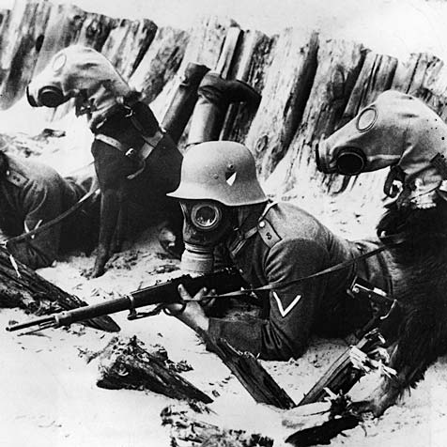

Figure III. Biological warfare during World War I

<http://multiple.kcvs.ca/chemical_weapons/3classificationweapons.html>

With the start of World War II, the Japanese broke their agreement on the Versailles Peace Treaty and League of Nations agreement by using chemical weapons. By 1938, the Japanese Army began full-scale use of sneeze and nausea gas against both Kuomintang and Communist troops.

Due to their success with chemical warfare during World War I, the German army negotiated with the USSR to build a chemical weapons plant in 1923. Prior to World War II, chemical warfare was revolutionized by Nazi Germany’s discovery of the nerve agents; tabun, soman and sarin in 1937. In 1943, the international community greatly feared German chemical warfare threats.

In 1963, during the North Yemen Civil War, 100 citizens of the town Kawma were subjected to an amateur chemical attack with few fatalities. Reports of chemical warfare in Yemen grew more frequent in 1966. Fatalities and mortality rates greatly increased as the war progressed despite Egypt’s denial of chemical agents.

During the Cold War, Westerners put enormous amounts of research into the development of chemical and biological weapons. In 1952, England invented another nerve agent and the knowledge was exchanged with the United States. In 1953, the U.S. Army patented a process to produce particular nerve agents.

In 1961 and 1962, under the administration of Kennedy, the use of chemicals to destroy vegetation and food crops in South Vietnam was authorized. This was known as Herbicidal Warfare. “Between 1961 and 1967 the U. S. Air Force sprayed 12 million US gallons of concentrated herbicides.”[13]

During the war between Afghanistan and Russia, Russians developed and used several deadly toxins against the Afghans. Iraq employed the used of mustard gas in the Iran-Iraq War in 1980. Shortly after the war ended, Iraqi Kurdish villages were exposed to multiple chemicals agents, killing 5,000 residents.

For many terrorists, chemical weapons are an ideal choice if they are cheap and accessible. In 2001, Al-Qaeda announced they were attempting to acquire biological, radiological and chemical weapons.

In July 2012, Syria admitted to possessing a stockpile of chemical weapons, claiming they were on reserve for national defense. Allegations that Syria was using chemical weapons against domestic opposition appeared in newspaper in December 2012. In April 2013, an American newspaper confirmed reports of chemical warfare by testing a smuggled sample of soil. It is believed the Syrian military research center, which Israel struck on 5 May, held chemical weapons. On June 13, the United States announced that, “there is definitive proof that the Assad government has used limited amounts of chemical weapons on multiple occasions on rebel forces, killing 100 to 150 people.”[14]

**PROBLEMS NEEDING TO BE ADDRESSED:**

For both biological and chemical warfare, the core of the issue lies in political or social instability. Terrorism is often the motive behind use of chemical or biological weapons when the group or individual feels threatened. As seen with the Syrian War, chemical weapons were used in the state of rebellion. For a more long-term approach, DISEC should focus on how to eradicate terrorism by focusing on political, social or economic instability within the region. For biological warfare, one must approach the issue from multiple angles. More strict food regulations need to be enforced such as increased surveillance over the production, importation and preparation of food; developing and testing technologies for detecting altered food and working to reduce threats and vulnerabilities. Also more effective medical products must be engineered and distributed for an immediate solution when confronted with biological or chemical weapons. [15]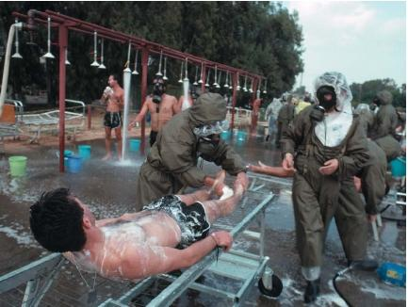

Figure IV. Chemical decontamination

<http://www.scienceclarified.com/Ca-Ch/Chemical-Warfare.html#b>

As seen with chemical weapons, after an attack decontamination is essential. Regions without the means to conduct a decontamination plan are extremely vulnerable targets, often experiencing fatalities to their health.[16]

**BLOC POSITIONS:**

United States, France and United Kingdom:

The United States, France and United Kingdom no longer produce chemical or biological weapons. They are both members of the Geneva Protocol. The United States, France and United Kingdom only produce defensive biological and chemical materials such as vaccines. The United Kingdom, France and United States were deeply alarmed by the Syrian usage of chemical weapons. The United Kingdom, United States and France provided opposition forces with non-lethal military aid, including communications equipment and medical supplies. The United States was reported to be involved in covert operations along the Turkish-Syrian border, grant funds to the rebels to fund the Free Syrian Army and assist in armed force training.[17]

China:

China signed the Geneva Protocol in 1953. During the Syrian Civil War, China initially supported Syria but now has distanced themselves and would support a transition of power.

Russia and the Middle East:

Both Russia and the Middle East have chemical stockpiles and research centers. During the Syrian Civil War, Russia provided Syria with weapons and continues to support them. Currently in the Middle East, at least six Middle Eastern countries manufacture chemical weapons –Israel, Iran, Iraq, Syria, Egypt, Libya-additionally, Syria, Iran and Iraq are reportedly developing chemical warheads for ballistic missiles. At least five countries in the Middle Eastern region have, or are working to acquire, a biological warfare capability: Egypt, Iran, Iraq, Israel, and Syria. Iraq and Syria appear to have the most advanced programs.

**QUESTIONS:**

1. What is the primary issue causing the use of chemical and biological weapons and how can the UN combat that?
2. What sorts of initiatives can the UN enact to decrease the need or desire to possess biological and chemical weapons?
3. In regions where chemical and biological warfare cannot be prevented, what protocols can be established in the short term to prevent mass fatality?
4. How can UN organizations be involved without impeding on the national sovereignty of proliferating nations?
5. At what point does the UN take a more active role to protect the human rights of citizens regardless of national sovereignty?

**TOPIC 2: PIRACY ON THE HIGH SEAS**

**INTRODUCTION:**

Piracy is defined by the United Nations Convention on the Law of the Sea (UNCLOS) as “any illegal acts of violence or detention, or any act of depredation, committed for private ends by the crew or the passengers of a private ship or a private aircraft on the high seas, against another ship” as well as “any act of voluntary participation in the operation of a ship or of an aircraft with knowledge of facts making it a pirate ship or aircraft.” The term “high seas” is defined as “all parts of the sea that are not included in the territorial sea or in the internal waters of a State.”

Despite our romantic perception of pirates, piracy on the High Seas is a prevalent issue in the modern world. Oceans Beyond Piracy estimated worldwide losses total to US$5.7 to $6 billion per year. Piracy is most rampant in regions such as the Red Sea and Indian Ocean, The Somali coast, The Bay of Bengal, The Gulf of Aden, The Horn of Africa, and the Strait of Malacca and Singapore. Pirates frequently thrive in regions with developing or struggling countries, large trade routes and small navies.

Under a principle of international law known as the "universality principle”, a government may "exercise jurisdiction over conduct outside its territory if that conduct is universally dangerous and used as a means to protect the global community. Piracy experts claim the goal is to “deter and disrupt” pirate activity, so pirates are often detained, interrogated, disarmed, and released. The best measure to be taken against piracy is to simply avoid encountering them. This is usually out of one’s control so successful measures in the past have included; equipping the ship with anti-piracy weaponry such as LRAD or helicopter patrols where pirate activity has been reported, deployment of unmanned aerial vehicles (UAVs) and remotely controlled boats.[18]

The International Maritime Organization (IMO), The North Atlantic Treaty Organization (NATO), The European Union (EU), The US Department of State, The United Nations Security Council, The Contact Group on Piracy off the Coast of Somalia (CGPCS), The Maritime Security Centre (Horn of Africa), run by the EU Naval Force (EU NAVFOR) along with many other organizations work to prevent piracy.[19]

**PAST CONFLICTS:**

Piracy has existed for as long as seas held boats filled with commercial goods. Piracy is committed for various reasons such as political unrest, possession of cargo, possession of ship member’s personal belongings, possession of the ship or environmental action. Piracy often includes the following actions; boarding, hostage taking, kidnapping of people for ransom, extortion, robbery, murder, seizure, shipwrecking, sabotage.

The classic and most successful era of the pirate extends from 1560 up until 1730. Pirates originally operated for their personal desires and needs. By the 1500s piracy was used as a weapon against other countries. England and Denmark would commission privateers to ransack and harass Spanish vessels. Privateering also occurred in Asia, where the Japanese were believed to have sponsored Wako pirates to ransack Chinese ships during the 1500s as well. By the late 1700s Europeans, largely England and Northern Europe, expanded efforts to eradicate piracy. By the mid 1800s England, Denmark and Norway were able to control pirate bands and piracy decreased through the 1800s and into the 1900s. Until the end of the Cold War, piracy ceased to be a large-scale international issue despite its not being completely eliminated. At the end of the Cold War, a lack of international navy patrol and significant increase in international trade allowed the reemergence of piracy.

By the end of the1900s, piracy increased with sea robbers emerging from economically depressed and war-torn African countries such as Somalia. Piracy in Somalia can be linked to the collapse of its government in 1991 and the absence of costal protection along with it. The International Maritime Bureau (IMB), an organization established for the purpose of protecting international seas, created a Piracy Reporting Center (PRC), a sub sector to maintain records for piracy beginning in 1995. Despite several major regions of pirate activity emerging, piracy actually decreased until the 2000s.

However, beginning in 2005 until present day, piracy has substantially increased and become a prominent issue on our international agenda. Recently piracy attacks have become more complex and more successful. More often, pirates harass ships to obtain ransom rather than plundering the goods on board. The rise in piracy is largely in the region of the East Indian Ocean, in bodies of water close to the coast of Somalia. Somalia maintains a failed state status, with no central government. The state of chaos allows Somalia to act as a “host nation” to pirates. The piracy of Somalia has reinforced the importance of addressing the piracy issue in present day. Piracy in 2008 brought piracy up to the forefront of the international agenda.

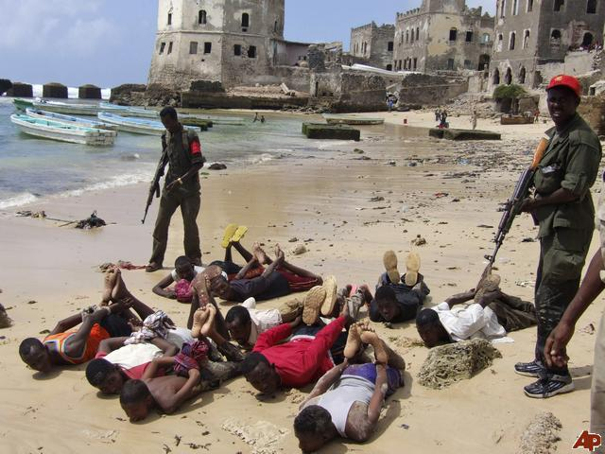

Figure V. Somali pirate hostages

<http://newshopper.sulekha.com/somalia-piracy_photo_962378.htm>

The International Maritime Bureau (IMB) statistics depicts the quick rise of piracy in the earlier 2000s until about 2008 contrasting with the slight decline more recently. In more recent years however, the IMB noted a rising trend of pirate attacks against vessels in East and West Africa in 2011. The IMB reports 275 pirate attacks originated in Somalia out of the 439 attacks in 2011.

The IMB report indicated a slight decrease in total number of recorded piracy and armed robbery incidents of internationally; “comparing the 439 recorded incidents of piracy and armed robbery in 2011 to 445 in 2010.” The decreased data comes after four consecutive years of large-scale piracy and armed robbery.

The current socio-political situation in Somalia has allowed for piracy to thrive there. Often people unable to support themselves turn to piracy as a means of finance. Somali pirates remain the greatest threat and account for approximately 54% of attacks. While the overall number of Somali attacks increased, the number of successful attacks decreased. In 2011 due to pre-emptive strikes by international navies, at least 20 Pirate Action Groups (PAGs) were disrupted before they could become a threat to commercial fleets.

Other regions of Africa such as Nigeria and Benin remain piracy hotspots. The IMB states the issue is the underreporting and unawareness of incidents in Nigerian waters. While piracy captivity in Benin and Nigeria usually lasts 10 days, much shorter than 6 month Somali capturings, these attacks can be more violent.

In South East Asian and Indian Subcontinent, piracy reports have decreased due to the initiative taken by the Bangladesh Coast Guard. The South China Sea has seen a decrease in pirate attacks as well since 2010. Indonesia has seen an increase in armed robbery for the second consecutive year.[20]

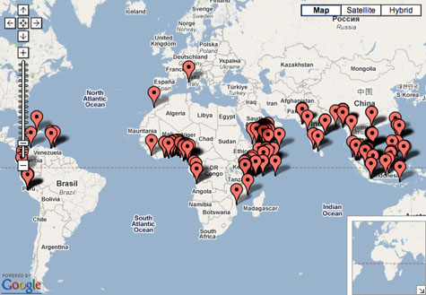

Figure I. Map indicating concentration of piracy attacks <http://futurismic.com/2008/11/20/the-live-piracy-map/>

**PROBLEMS NEEDING TO BE ADDRESSED:**

In the past, the United Nations has implemented multiple resolutions and programs to combatpiracy. The UN has established anti-piracy patrol areas, creating a safe transit of passage through which ships may travel. The EU, NATO and other organizations have made additional safe zones near the anti-piracy patrol area, thus expanding the range of safe routes. Defense measures are being implemented in most cargo ships such as high-powered hoses or electric fences. The UN has also encouraged nations surrounded by seas such as Sri Lanka, India and Indonesia to increase their anti-piracy patrols to protect ships arriving or departing from their nations.

To combat piracy at its root, one must consider where piracy stems from. Piracy largely stems from nations in poverty or political unrest. By implementing programs over a long-term timeline in the economic and political sphere of nations rampant with piracy, the UN believes citizens will no longer have to turn to piracy as a means of economic support or political expression.

Piracy cannot be dissolved long-term immediately so short-term plans must be implemented as well to prevent piracy attacks. Measures must be taken to ensure the safe passage of ships and proper treatment of pirates. It is mandatory to expand safe zones and anti piracy patrols. Currently, the international community has instated safe routes among several seas with high piracy rates but often these routes are under patrolled. Ships carrying valuable cargo need safe zones fully patrolled to secure safety and economic protection. Ships not passing through these safe zones need better defensive technology to help safeguard themselves and their cargo. It is also essential that once pirates are arrested, the UN is able to properly prosecute them. Most recently, harsher jail terms have lowered piracy rates.

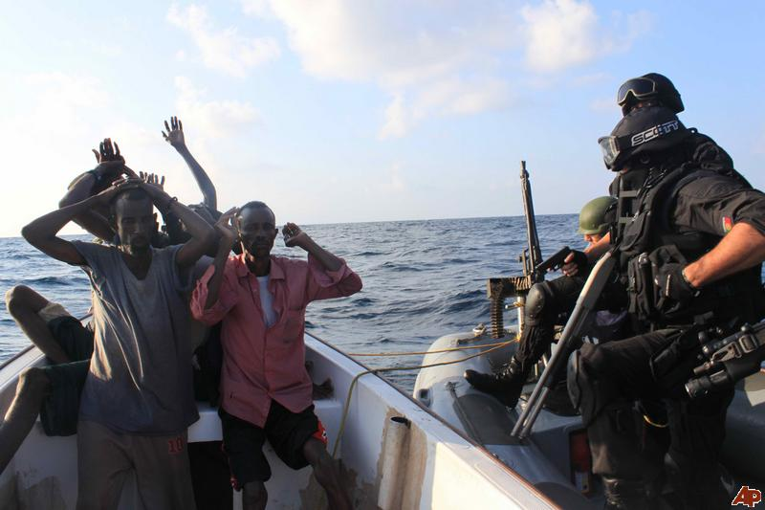

Figure VI. Arrest of Somali pirates

<http://newshopper.sulekha.com/somalia-piracy_photo_1103371.htm>

**BLOC POSITIONS:**

United States:

The United States has experienced vast economic losses due to piracy. The United States has worked in collaboration with the Security Council to pass Resolutions 1816 (2008), 1838 (2008), 1846 (2008), 1851 (2008), 1897 (2009) and 1950 (2010), authorizing international action in Somalia against pirates. In addition, the United States helped to create the international Contact Group on Piracy off the Coast of Somalia to help coordinate and expand national counter-piracy efforts. The United States authorizes criminal prosecution of piracy in the U.S. Constitution. The United States continues to combat piracy through more robust approaches.

Europe and Russian Federation:

Russia and all European Union member states are engaged in the fight against piracy. A boarding team comprised of NATO and Russian assault forces trained together in counter piracy efforts known as Operation Ocean Shield. The event was organized by the NATO-Russian Council (NRC) and conducted in the Gulf of Aden. The EU works in conjunction with NATO and other organizations to fight piracy. The European Union Naval Force (EU NAVFOR) attacked pirate infrastructure in Somalia, one of the more recent aggressive attacks.

The European Union has agreed to expand its efforts to the anti-piracy approach, particularly against Somalia by allowing the use of military forces to attack land targets. Starting in 2008, the anti-piracy operation will extend until 2014 and will cover Somali internal territory and waters. All European Union member states and Russia have been subject to the brutality of piracy and hope a more aggressive approach will be the step in the right direction.

China:

China, as a large participant of the global and maritime economy, feels the economic affects of piracy. Further, many Asian countries surrounding China are politically and economically instable and act as “host nations” to pirates. China being a big maritime country, is obliged to suppress piracy under international treaties it ratified, including the UN Convention on the Law of the Sea and the two 1988 Conventions against maritime terrorism. China has been making increased efforts to eradicate piracy despite its inadequacy of existing domestic law and law enforcement by strengthening anti-piracy measures.

Middle East:

The Middle East is a large exporter of oil and therefore a very vulnerable target to maritime piracy. In the past India and Iran have deployed ships in an individual effort to combat piracy. Experts have suggested Middle Eastern and East African countries should patrol the Somali coast. The Middle East is in a unique position. While certain countries and oceans within its borders are regions with high piracy rates, several regions of the Middle East have the resources to combat this piracy.

Africa:

Africa experiences political and socio-economic instability that fuels piracy. Unfortunately, Africa doesn’t have the large resources needed to combat piracy attacks as well as its roots. Africa, host to countries rampant with piracy such as Somalia and most East and West African coastal

countries, is considered the “perfect pirate environment.” Africa acts as a base for most anti-piracy efforts. Recently, The European Union allocated US$47.7 million to fortify anti-piracy efforts in several Eastern and Southern African countries. The new program will assist in developing the legal and judicial system of unstable African regions to be better equipped to manage piracy. Training African authorities to allocate funds away from the benefit of pirates will strengthen economic oversight systems. The sharing of expertise, training, material and security support will help improve coastline surveillance. Particularly in Somalia, the program will include anti-piracy awareness campaigns to deter the youth away from involvement in piracy. This is only an example of several programs being implemented in Africa currently but it discusses many crucial points in the fight against piracy. “Strengthening security in the maritime routes is crucial for us because it will help boost trade and growth in the region, which would enormously improve people's lives,” said Andris Piebalgs, the EU’s development commissioner, in a written statement.[21]

**QUESTIONS:**

1. How can the UN combat piracy with a long-term approach?
2. What programs can the UN implement on case-to-case basis of piracy attacks?
3. How can the UN expand the short-term efforts currently being made?
4. How can the UN instill political, social or economic stability within a region without impeding on national sovereignty?
5. How will the UN handle a more proper prosecution of pirates?

1. http://www.scienceclarified.com/Ca-Ch/Chemical-Warfare.html#b
2. <http://en.wikipedia.org/wiki/Bioterrorism#History>
3. <http://en.wikipedia.org/wiki/Bioterrorism#History>
4. <http://en.wikipedia.org/wiki/Bioterrorism#History>
5. http://news.nationalgeographic.com/news/2013/13/130423-syria-conflict-chemical-biological-weapons-world-history/
6. <http://en.wikipedia.org/wiki/Bioterrorism#History>
7. <http://en.wikipedia.org/wiki/Bioterrorism#History>
8. <http://en.wikipedia.org/wiki/Bioterrorism#History>
9. <http://en.wikipedia.org/wiki/Bioterrorism#History>
10. <http://en.wikipedia.org/wiki/Bioterrorism#History>
11. <http://en.wikipedia.org/wiki/Bioterrorism#History>
12. <http://en.wikipedia.org/wiki/Bioterrorism#History>
13. <http://en.wikipedia.org/wiki/Chemical_warfare#World_War_>
14. <http://en.wikipedia.org/wiki/Syria_and_weapons_of_mass_destruction#History>
15. <http://www.fda.gov>
16. http://en.wikipedia.org/wiki/Chemical_warfare
17. <http://en.wikipedia.org/wiki/Syria_and_weapons_of_mass_destruction>
18. http://www.bbc.co.uk/news/world-africa-18548810
19. <http://my-munofs-iii.wikispaces.com/file/view/Measures+to+combat+piracy+on+the+high+seas.pdf>
20. http://en.wikipedia.org/wiki/Piracy#History
21. <http://www.joc.com/maritime-news/maritime-piracy/indian-ocean/eu-provides-funding-anti-piracy-efforts-africa_20130521.html>

    **BIB**

    **BIBLIOGRAPHY**

    http://www.scienceclarified.com/Ca-Ch/Chemical-Warfare.html#b

    <http://en.wikipedia.org/wiki/Bioterrorism#History>

    http://news.nationalgeographic.com/news/2013/13/130423-syria-conflict-chemical-biological-weapons-world-history/

    <http://en.wikipedia.org/wiki/Chemical_warfare#World_War_>

    <http://en.wikipedia.org/wiki/Syria_and_weapons_of_mass_destruction#History>

    <http://www.fda.gov>

    http://www.bbc.co.uk/news/world-africa-18548810

    <http://my-munofs-iii.wikispaces.com/file/view/Measures+to+combat+piracy+on+the+high+seas.pdf>

    http://en.wikipedia.org/wiki/Piracy#History

    <http://www.joc.com/maritime-news/maritime-piracy/indian-ocean/eu-provides-funding-anti-piracy-efforts-africa_20130521.html>