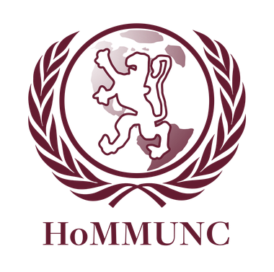

JCC: Islamic Invasion of Gaul, Gaul

Chair: Danny Baudoin

Moderator: Jenna Barancik

Table of Contents

1. Letter from the Chair

Page 3

1. Introduction to the Committee

Page 4

1. Overview and History of

the Topic

Page 5

1. Questions to Consider

Page 9

1. Committee Positions

Page 10

Dear Delegates,

My name is Danny Baudoin and I could not be more excited to be on the dais of HoMMUNC’s JCC- Islamic Invasion of Gaul! I am a senior at Horace Mann School and one of the Senior Board Members of Horace Mann’s Model UN Team. As you probably could have guessed, I am interested in international relations and history. As captain of the varsity swimming and tennis teams, you can find me at the courts or in the pool when I’m not busy bossing around the MUN juniors. Model UN has taught me what being a leader is really all about, and I hope that over the short time we get to spend together at HoMMUNC I will be able to share my love of MUN with all of you. Jenna and I are looking forward to a day simulated war . Sometimes it will be necessary that you compromise and other times it will be necessary that you stand firm on your position’s beliefs. Over the course of the day, your beliefs and your research will be challenged, and you will be forced to think on your feet #munproblemz. Model UN truly has the power to make us better thinkers, better listeners, and better problem solvers. I hope that you are all as excited about HoMMUNC as we are. In the following background guide, you will find a place to start your research – but we do expect that you research elsewhere so that the committee can engage in productive and respectful diplomatic discourse.

Best Regards,

Danny Baudoin

Introduction to the Committee

This committee will function like any other crisis committee but with an exciting twist. Like in other crisis committees, the crisis staff will continually challenge delegates with new and pressing issues to tackle. As such, committee will run at a faster pace compared to General Assemblies, and delegates will frequently vote on solutions to the problems at hand in the form of directives (short resolutions). However, this committee will offer an additional element of surprise and perhaps difficulty, because the other Joint Crisis Committee’s actions will influence debate in the same manner as crises generated by the crisis staff. Likewise, this committee will be able to thwart the attempts of our aggressor and sister committee, the Umayyad Caliphate.

The JCC will also function as a historical committee. This committee will contain the leaders of ancient France during the early 8th century, as the Umayyad Caliphate tries to conquer Gaul. Depending on the pace and productivity of both committees, the crisis staff may decide to accelerate the timeline by leaping forward a few months or even a few years. Although delegates must research up to only 719 CE, some delegates may wish to develop an elementary understanding of important events in the subsequent years of the invasion. However, mention of historical events that have not occurred in committee is prohibited during debate. Keep in mind that delegates of the Umayyad Caliphate have also researched the topic, so members of this committee are encouraged to produce creative directives.

Overview of the Topic

This is war. The year is 719 CE, and after making major territorial gains in modern-day Spain, the Umayyads have turned their eyes towards Gaul (modern-day France). All of Gaul is depending on this committee to defend it against the Umayyad invaders by stemming the Umayyad Caliphate’s northern advancement and driving the invaders back towards their homeland in northern Africa. In essence, the fate of Gaul is in your hands.

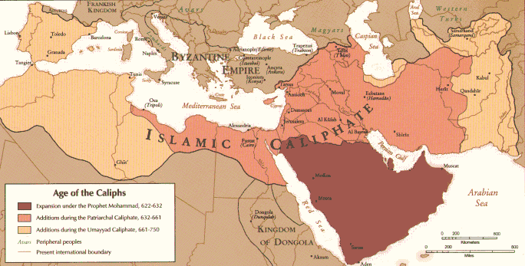

The Islamic Caliphate controlled much of northwest Africa and the Iberian Peninsula, notably modern-day Morocco and Spain. To the northeast of the Iberian Peninsula was the Frankish Kingdom (Gaul). Source: <http://upload.wikimedia.org/wikipedia/commons/2/20/Age_of_Caliphs.png>

History of Gaul

During the Roman Age, Gaul stretched over a vast area in Western Europe that encompassed modern-day France, Belgium, Northern Italy, and the area around the Rhine River in Western Germany. The Gauls were a subgroup of the Celts but were also subdivided into various tribes that occupied different areas. The Romans referred to modern-day France as three distinct regions: Gallia Celtica, Gallia Narbonensis, and Gallia Aquitania. A rudimentary knowledge of the locations of these three regions will be helpful in tracking the Umayyads’ advancement later on.

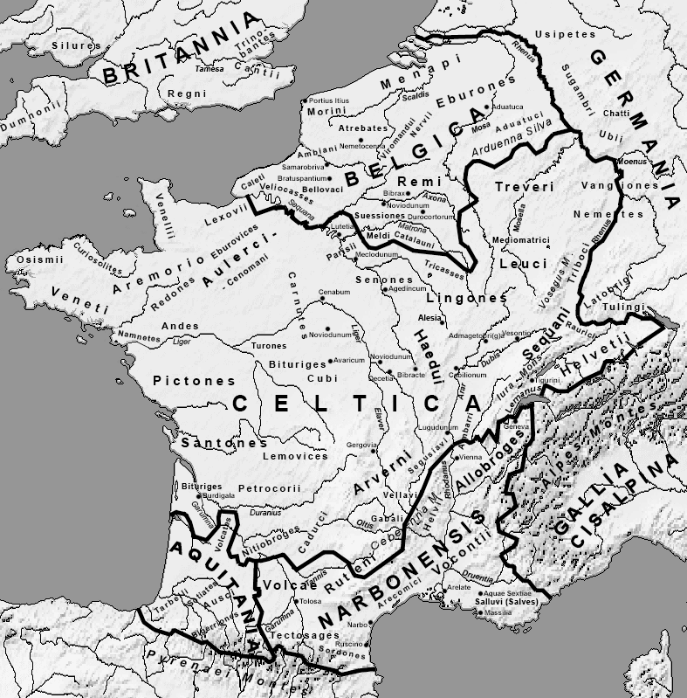

Gaul from the Roman perspective: <http://upload.wikimedia.org/wikipedia/commons/b/ba/Map_Gallia_Tribes_Towns.png>

Julius Caesar successfully began the Roman conquest of central Gaul (modern-day France) in 58 BCE. Caesar’s campaign devastated the Gauls, dramatically impacting nearly 10 million people through slaughter in battle, death by exposure or starvation, and slavery. Gaul remained under Roman rule until the 5th century CE.

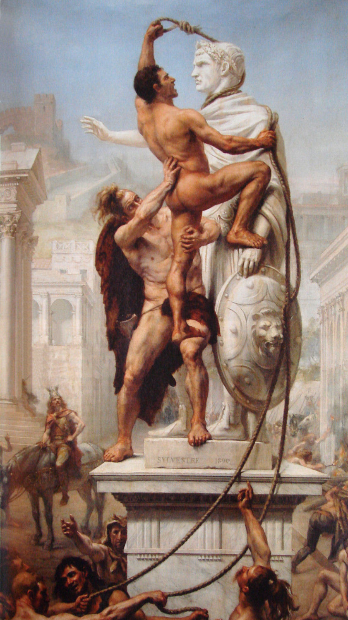Although Rome’s culture and language would have a lasting impact on the region, revolts in Gaul consistently posed an existential threat to Roman rule. Increasing incursions by the Germanic tribes also threatened stability. In particular, the Franks from the Rhine region along the border of Roman occupied Gaul at first existed peacefully with the Romans, even sometimes fighting alongside them against the Vandals and the Huns. However, relations soured in the mid 3rd century CE as Franks sporadically retaliated against Roman rule and raided Gallic cities.

Once the Western Roman Empire fell, the Romans failed to retain control of Gaul. The Franks, Visigoths, and Burgundii – all Germanic tribes – slowly took over Gaul until by the 6th century CE, they had completely eradicated Roman influence. Gaul descended into the Dark Ages.

The Western Empire falls, and the Visigoths sack Rome in 410 CE. Source: <http://upload.wikimedia.org/wikipedia/commons/a/a0/Sack_of_Rome_by_the_Visigoths_on_24_August_410_by_JN_Sylvestre_1890.jpg>

During the 6th century, the Franks clashed with the Visigoths and Burgundii and gained control of most of Gaul. Rather than consolidate power in one central government, Frankish kings originally divided their kingdoms amongst their multiple sons. As such, many different kingdoms, duchies, and city-states arose.

Pépin II formed a united Frankish kingdom in 687 CE, but by 719 CE, the Frankish kings had not gained absolute power. The Franks were only beginning to form their empire, and future duchies had different stances on consolidating power versus remaining autonomous. Members of the ruling class throughout Gaul still wielded power and influence, but this concept is further elaborated in the “Committee Positions” section of this background guide.

Brief History of the Umayyad Caliphate

The “Umayyad Caliphate” was the Arab Empire during the dynasty of Umayyad caliphs, who were both religious and political authorities to their followers.



The Arab Empire: <http://upload.wikimedia.org/wikipedia/commons/2/20/Age_of_Caliphs.png>

Referring to the map above, the light beige-colored areas designate the Empire’s expansion during the Umayyad Dynasty. The Umayyad Dynasty began in 661 CE and by 698 CE had conquered most of the Maghreb (northwestern Africa), including modern-day Morocco.

Now part of the Umayyad Caliphate, the Moors invaded the nearby Iberian Peninsula in 711 CE. The Moors easily conquered and retained the majority of the peninsula, reaching the border of Frankish Gaul at the Pyrenees by 717 CE. They then started to invade the region of Septimania (Gallia Narbonensis). By 719 CE, the beginning of committee, they had captured the Septimanian city of Narbonne. They plan to conquer all of Gaul.

Questions to Consider

* Which military tactics will be most effective against the Umayyad invaders?
* How greatly should Gaul consolidate power in a central government or under one leader?
* What role does Gaul’s political stability play in defeating the Umayyads?
* How are territorial expansion, economic stability, and political stability related?

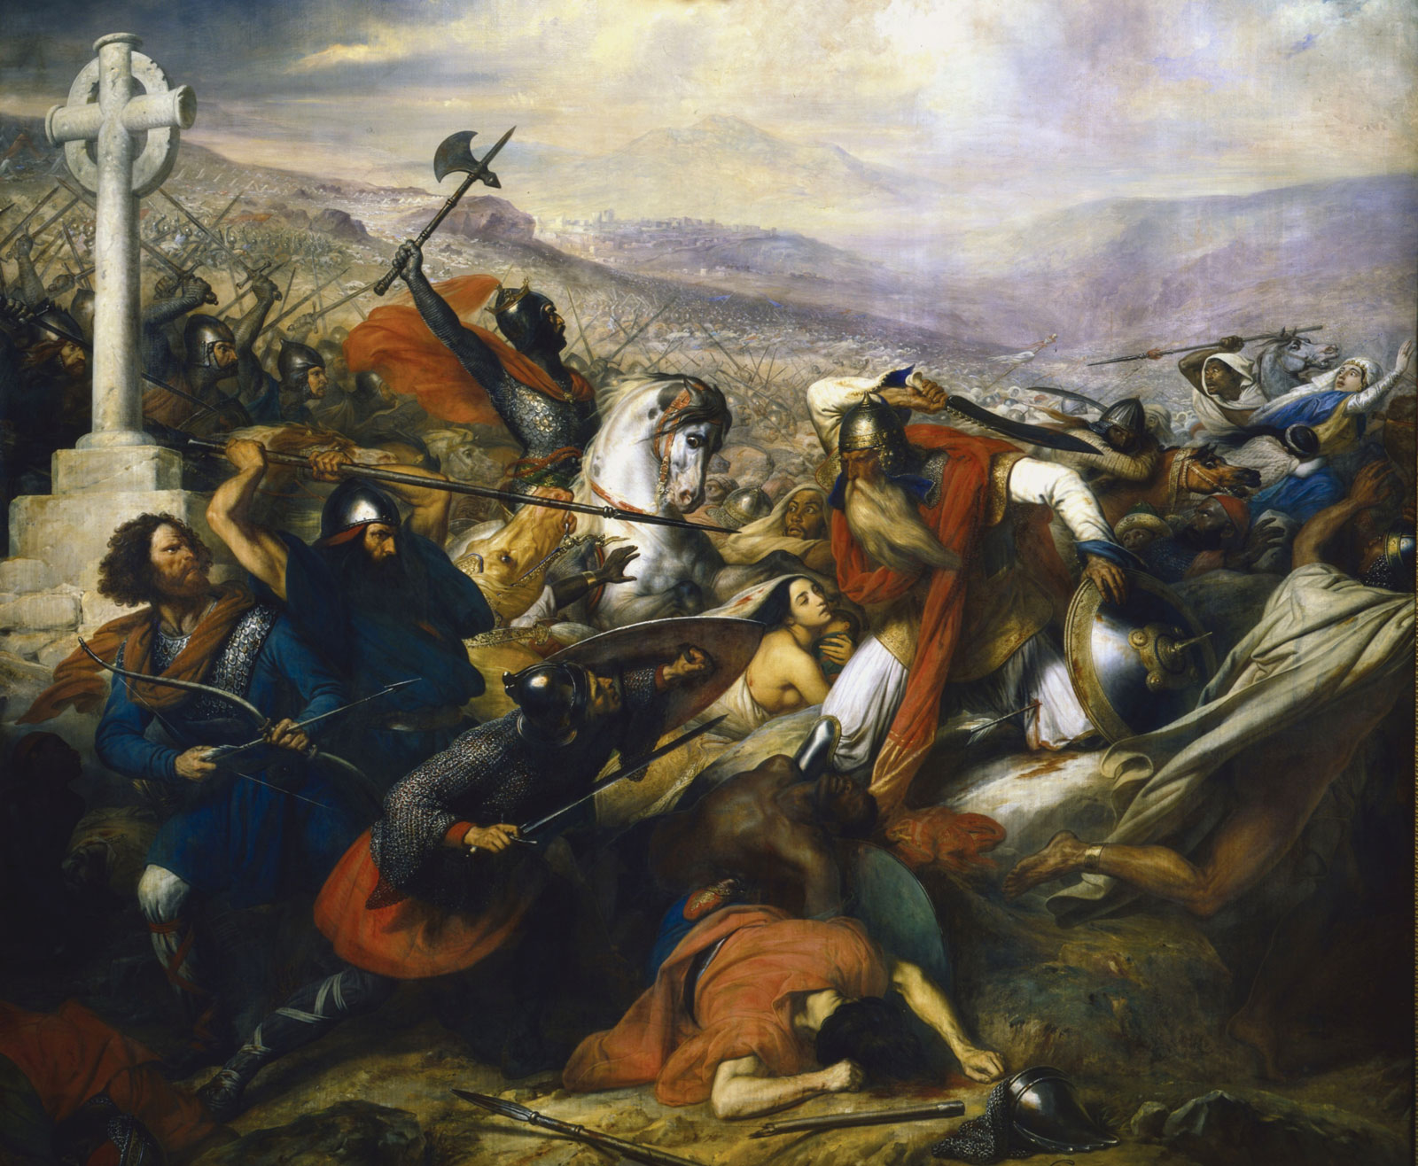

The Battle of Tours in October 732 CE: <http://upload.wikimedia.org/wikipedia/commons/e/e7/Steuben_-_Bataille_de_Poitiers.png>

Committee Positions

**King**

Two dynasties of kings ruled the Frankish Empire: the Merovingians and the Carolingians. In 719 CE, the Frankish autocrats, whom delegates will represent, had not yet ended the Merovingian Dynasty. However, the Merovingian kings’ waning power had earned them the title *rois fainéants,* “do-nothing kings.” The king still functioned as a symbolic ceremonial and wartime figure, but the autocrats were really in charge. For the purpose of this committee, the chair will serve first as King Chilperic II and then as King Theuderic IV as the committee progresses through time. He will have more authority than any individual delegate, but like a true Merovingian king of the time period, he will follow the recommendations of the autocrats.

1. Charles Martel

You are the “Mayor of the Palace” of all Franks. If the king is a puppet ruler, then you pull the strings. As perhaps the true leader of the Frankish Empire, Charles Martel would later become a military legend and rule without a king during an interregnum. However, he did not achieve all this by 719 CE. If you wish to solidify your authority in Gaul and defeat the Moors, you will need the support of the other autocrats.

2. General of the Consolidated Frankish Army

You oversee the consolidated forces of Gaul. Additionally, if you and Charles Martel both oppose a committee directive that makes use of Consolidated Frankish troops, passing the directive will require a two-thirds supermajority. If you choose to take unilateral actions, remember that you merely command and do not own the troops. Command wisely as not to anger the autocrats.

3. General of the Austrasian Forces

Although the members of committee will have to join forces to defeat the Umayyads, different regions of Gaul function on varying levels of independence. Austrasia was the first kingdoms to name Charles Martel its Mayor of the Palace. Austrasia’s forces are therefore fully integrated into the Consolidated Frankish Army. As General, you will command the Austrasian wing of the Army.

4. General of the Neustrian Forces

Despite Austrasia and Neustria’s historic rivalry, the two kingdoms are now unified under the Frankish King and Charles Martel. Neustria’s forces are also completely integrated into the Consolidated Frankish Army, and you are in command of the Neustrian wing.

**Dukes and Mayor of the Palaces**

Although much Gaul has already been consolidated into a unified Frankish kingdom, dukes will represent the regional leaders and would-be kings of the former Gallic kingdoms and duchies. Historically, dukes functioned as military leaders while mayor of the palaces ran the political operations of their duchies. For the purposes of committee, each duke and corresponding mayor of the palace will have equal resources from his duchy. Duchies possess their own, albeit in some cases relatively small, armies. Together, the armies comprise a significant portion of the Consolidated Frankish Army. The dukes and mayor of the palaces are as follows:

5. Odo, Duke of Aquitaine and Vasconia

6. Mayor of the Palace of Aquitaine

7. Mayor of the Palace of Vasconia

8. Childebrand I, Duke of Burgundy

9. Mayor of the Palace of Burgundy

10. Maurontus, Duke of Provence

11. Mayor of the Palace of Provence

12. Duke of Septimania

13. Mayor of the Palace of Septimania

14. Lantfrid, Duke of Alamannia

15. Mayor of the Palace of Alamannia

16. Poppo, Duke of Frisia

17. Mayor of the Palace of Frisia

**Counts**

A Frankish “count” ruled either a large city or a small region. Although they possessed lesser military capabilities than dukes, they had great political influence stemming from the vibrant economies and strategic locations of their demesnes. As a count, you must make the decisions and alliances you believe will increase your city’s economic opportunities or protect your city from ruin.

18. Count of Autun

19. Count of Narbonne

20. Count of Champagne

Sources

Beetz, Kirk H. "empires and dynasties in ancient Europe." In Bogucki, Peter, ed. *Encyclopedia of Society and Culture in the Ancient World*. New York: Facts On File, Inc., 2008. *Ancient and Medieval History Online*. Facts On File, Inc.  <http://www.fofweb.com.ezy.hmsl.sirsi.net/activelink2.asp>? ItemID=WE49&iPin=ESCAW232&SingleRecord=True (accessed July 10, 2013).

Bunsen, Matthew. "Gaul." *Encyclopedia of the Roman Empire*, Revised Edition. New York: Facts On File, Inc., 2002. *Ancient and Medieval History Online*. Facts On File, Inc. <http://www.fofweb.com.ezy.hmsl.sirsi.net/activelink2.asp>? ItemID=WE49&iPin=ERE0758&SingleRecord=True (accessed July 10, 2013).

Corfield, Justin. "Gaul." In Ackermann, Marsha E., Michael Schroeder, Janice J. Terry, Jiu-Hwa Lo Upshur, and Mark F. Whitters, eds. *Encyclopedia of World History: The Ancient World, Prehistoric Eras to 600 CE*, vol. 1. New York: Facts On File, Inc., 2008. *Ancient and Medieval History Online*. Facts On File, Inc. <http://www.fofweb.com.ezy.hmsl.sirsi.net/activelink2.asp>? ItemID=WE49&iPin=WHI137&SingleRecord=True (accessed July 10, 2013).

Cosman, Madeleine Pelner, and Linda Gale Jones. "History of Western Europe During the Middle Ages." *Handbook to Life in the Medieval World*. New York: Facts On File, Inc., 2008. *Ancient and Medieval History Online*. Facts On File, Inc.  <http://www.fofweb.com.ezy.hmsl.sirsi.net/activelink2.asp>? ItemID=WE49&iPin=histwest&SingleRecord=True (accessed July 10, 2013).

English, Edward D. "Pépin III the Short." *Encyclopedia of the Medieval World*, vol. 2. New York: Facts On File, Inc., 2005. *Ancient and Medieval History Online*. Facts On File, Inc. <http://www.fofweb.com.ezy.hmsl.sirsi.net/activelink2.asp>? ItemID=WE49&iPin=EMW1115&SingleRecord=True (accessed July 10, 2013).

Jones, Linda G. and Campo, Juan E. "Islam in Europe." In Campo, Juan E., ed.  *Encyclopedia of Islam*, Encyclopedia of World Religions. New York: Facts On File, Inc., 2009. *Ancient and Medieval History Online*. Facts On File, Inc.  <http://www.fofweb.com.ezy.hmsl.sirsi.net/activelink2.asp>? ItemID=WE49&iPin=ENI201&SingleRecord=True (accessed July 10, 2013).

“Merovingians.” *Encyclopedia of the Middle Ages.* 2000. *History Study Center.* Web. 10 July 2013.

O'Halloran, Kate. "Umayyad dynasty." In Campo, Juan E., ed. *Encyclopedia of Islam*, Encyclopedia of World Religions. New York: Facts On File, Inc., 2009. *Ancient and Medieval History Online*. Facts On File, Inc.  <http://www.fofweb.com.ezy.hmsl.sirsi.net/activelink2.asp>? ItemID=WE49&iPin=ENI535&SingleRecord=True (accessed July 10, 2013).

Page, Willie F., and R. Hunt Davis, eds. "Umayyad dynasty.” *Encyclopedia of African History and Culture: African Kingdoms (500 to 1500)*, vol. 2. New York: Facts On File, Inc., 2005. *Ancient and Medieval History Online*. Facts On File, Inc.  <http://www.fofweb.com.ezy.hmsl.sirsi.net/activelink2.asp>? ItemID=WE49&iPin=AHCII0515&SingleRecord=True (accessed July 10, 2013).

“Pippin the Short (c.715-768).” *Encyclopedia of the Middle Ages.* 2000. *History Study Center.* Web. 10 July 2013.

Waldman, Carl, and Catherine Mason. "Franks." *Encyclopedia of European Peoples*. New York: Facts On File, Inc., 2006. *Ancient and Medieval History Online*. Facts On File, Inc. <http://www.fofweb.com.ezy.hmsl.sirsi.net/activelink2.asp>? ItemID=WE49&iPin=EEPI0213&SingleRecord=True (accessed July 10, 2013).

Waldman, Carl, and Catherine Mason. "Gauls." *Encyclopedia of European Peoples*. New York: Facts On File, Inc., 2006. *Ancient and Medieval History Online*. Facts On File, Inc. <http://www.fofweb.com.ezy.hmsl.sirsi.net/activelink2.asp>? ItemID=WE49&iPin=EEPI0228&SingleRecord=True (accessed July 10, 2013).

Waldman, Carl, and Catherine Mason. "Germanics." *Encyclopedia of European Peoples*. New York: Facts On File, Inc., 2006. *Ancient and Medieval History Online*. Facts On File, Inc. <http://www.fofweb.com.ezy.hmsl.sirsi.net/activelink2.asp>? ItemID=WE49&iPin=EEPI0231&SingleRecord=True (accessed July 10, 2013).

Yahaya, Nurfadzilah. "Muslim Spain." In Ackermann, Marsha E., Michael Schroeder, Janice J. Terry, Jiu-Hwa Lo Upshur, and Mark F. Whitters, eds. *Encyclopedia of World History: The Expanding World, 600 CE to 1450*, vol. 2. New York: Facts On File, Inc., 2008. *Modern World History Online*. Facts On File, Inc.  <http://www.fofweb.com.ezy.hmsl.sirsi.net/activelink2.asp>? ItemID=WE49&iPin=WHII206&SingleRecord=True (accessed July 10, 2013).