

JCC: Islamic Invasion of Gaul,

Umayyad Caliphate

Chair: David Paduano

Moderator: Jonathan Coden

Dear Delegates,

My name is David Paduano and I could not be more excited to be back on the dais of HoMMUNC’s JCC: Islamic Invasion of Gaul. I am a senior at Horace Mann School have been doing Model UN all four years. As you probably could have guessed, I am interested in history and the Arab world. Model UN has taught me what being a leader is really all about, and I hope that over the short time we get to spend together at HoMMUNC I will be able to share my love of MUN with all of you. I am looking forward to a day of heated debate while you plan and execute the invasion strategy of Gaul. I hope that while struggling to address this important historical issue you will also hone your leadership skills and meet new friends.

The complex strategies that you will need to create and the various cultural and political issues you will need to overcome certainly will test your abilities as delegates. Sometimes it will be necessary that you compromise and other times it will be necessary that you stand firm on your persona’s beliefs. Over the course of the day, your beliefs and your research will be challenged, and you will be forced to think on your feet. Model UN truly has the power to make us better thinkers, better listeners, and better problem solvers. I hope that you are all as excited about HoMMUNC as we are. In the following background guide, you will find a succinct summary on the Umayyad Empire – and so we do expect you to continue your research on the topic and discover more about your specific views and background.

Regards,

David Paduano

The First Caliphate:

With the passing of Muhammad in 632 it became necessary to appoint a new leader of the Islam. This job fell to a collection of distinguished Muslim leaders, who in turn elected Muhammad’s father-in-law Abu Bakr as the first Rashidun Caliph or secular head of Islam. However, in this council no member of Muhammad’s immediate family was present, and thus Muhammad’s son-in-law, Ali, many of whom who believed was the rightful successor, was never considered. Nonetheless Ali did not make any claims to the title of Caliph, and even in partook in the government of Umar, Abu Bakr’s successor and the second Rashidun Caliph. Only when Umar’s successor Uthman, the third Rashidun Caliph and a member of the Umayyad family came to power did Ali begin to act.

The Umayyad family had fought fiercely against Muhammad, and to make matters worse Uthman put various family members in charge of the vast empire pictured below; however, they were extremely inadequate rulers and led to many rebellions across the empire. This caused much dissent within the empire and to the eventual murder of Uthman. Under pressure from the prominent families of Medina Ali became the final Rashidun Caliph of Islam in 656, yet this was not a lasting arrangement.[1] 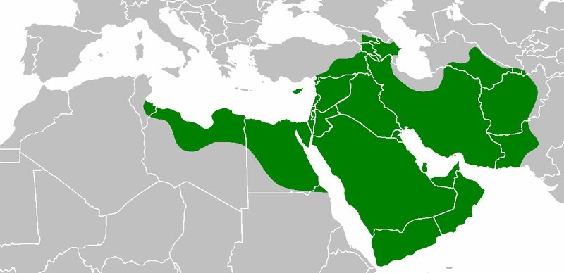[2]

In that same year the First Fitna (Muslim civil war) erupted between Ali and Muawiyah I. Muawiyah was a former secretary of Muhammad, the current governor of Syria, and most importantly a member of the Umayyad family. The First Fitna concluded in 661 with the victory of Muawiyah I who established himself as the first Sufyanid Caliph (second Umayyad Caliph) and established the Umayyad Caliphate.[3]

The Rise and Fall of the Sufyanid:

Once Muawiyah came to power he moved the capital of the empire to Damascus where it would remain until the Caliphate became extinguished. Muawiyah is credited with both advancing the empire as well as inciting much outrage within the Caliphate. He raised a large army of Syrian soldiers, which was then used to expand the Caliphates power into Khorasan in the east and North Africa to the west. Muawiya even led a three-year siege upon Constantinople (647-677) that was eventually proven unsuccessful.[4] Throughout all these expansions Muawiyah sought to make the language of both everyday life and religion Arabic as to centralize the Caliphate. In the end Muawiya expanded Muslim influence as well as united the Middle East together under one government. While Muawiya did much for the Caliphate his reign was under scrutiny from the very beginning.

During Muawiya’s rise to power he had angered the Ulema, the religious scholars and religious decision makers. The anger manifested in the fact that Muawiya ruled as a somewhat secular king suppressing Islam only fueling the fire of the Shi’a people. The Shi’ites had long disputed that Muawiyah even had a right to the position of Caliph. The Shi’a did not believe that Muawiyah, nor any Umayyad for that matter, were in any way shape or form related to Muhammad. In the Shi’ites eyes this discredited any Umayyad of rightfully being Caliph. The Sunni on the other hand revered Muawiyah and consider him to be one of the greatest rulers of Islam. In 680 Muawiyah died in Damascus passing on the role of Caliph to his son Yazid I, the last of Sufyanid.[5]

While Muawiyah had met resistance from notable Islamic figures, the hostility towards Yazid was even greater. The main opposition against Yazid was led by Ibn al-Zubayr and Husayn ibn Ali, the son of the final Rashidun Caliph Ali who had died in 661 at the hands of Muawiyah’s army. Both of these men refused to take an oath of loyalty to Yazid that was customary for members of the government to take when a new Caliph took over.

The Shi’a, who had long hated the Ummayad, rose up in the city of Karbala and invited Husayn to be their leader (the Shi’a believed that because Husayn was blood of Mohammad he was the only rightful leader). Husayn left Mecca with his family and supporters in tow; however, when he arrived at Karbala he was met with thousands of troops from Yazid’s army. Husayn mustered 72 fighting men who were all subsequently slaughtered by Yazid’s troops. In death Husayn became a martyr for the Shi’a people leading to lasting division between the Sunni and Shi’ite people, the Second Fitna, and the fall of the Sufyanid.

Following Yazid’s death revolts rose up throughout the vast kingdom. In 682 Ibn al-Zubayr led a revolt in Mecca and Medina that posed a serious threat to Yazid’s control of the empire. Yazid first sent an army to Medina, where the Medinese were quickly defeated. The army then began to lay siege to Mecca where Ibn al-Zubayr had taken refuge; however, in 683 news reached the siege that Yazid had died. Yazid’s son Muawiyah II then rose to the title of caliph. Muawiyah II was weak and when he died in 684 (after only 4 months as Caliph) infighting exploded to claim the title of Caliph

Out of this disarray of warring factions Marwan al-Hakam rose to power as Caliph and established the Marwanid line.[6]

The Reunification of Islam:

Marwan only lived for a year after becoming caliph; however, he succeeded in securing the right to be caliph for his son Abd al-Malik. His task to reunite the Islamic world was an extremely difficult one. Three different factions warred for control of the divided empire. The Shi’a, the Kharijites, and forces led by Ibn al-Zubayr, who had been named the caliph in Mecca, waged war throughout Iraq. Al-Malik understood that he could not defeat all three forces at once, so he bided his time for three years during which Mus’ab, Ibn’s brother, defeated the Shi’a. Then in 689 as Mus’ab led troops against the Kharijities, al-Malik sent troops to intercept Mus’ab and defeat him. From 689-691 through intermittent fighting Mus’ab’s forces were defeated and Mus’ab himself was killed. Iraq now belonged to the Caliph.

The only things that stood between al-Malik and total reunification of Islam were Ibn al-Zubayr and his followers walled up within Mecca. Al-Malik’s troops then layed siege to Mecca for several months till the walls were breached in September of 692 and Ibn al-Zubayr was slain. With al-Malik’s main opposition defeated Iraq and much of the former Caliphate land had been reunited under one ruler. Attention was then turned towards the Kharijites who were still in constant rebellion. In 697 the Persian Kharijites as well as Kharijites who had captured the city of Mosul were both defeated by al-Malik’s forces, and it seemed that after over a decade of turmoil Islam had once again been reunited.[7]

The Umayyad Expansion:

In 689 Abd al-Malik resumed expansion of Umayyad control targeting North Africa. Al-Malik’s soldiers were met with resistance from both the native Berbers as well as the Byzantines. The Berbers were eventually convinced to join the side of the Umayyad and in 697 Carthage was captured and control of North Africa had been established.

Abd al-Malik then ruled a rather peaceful empire until 705 when he died. His son Al-Walid I became the new Caliph, and under his reign the people saw the greatest expansion of the Caliphate. In 711 the conquest of the Iberian Peninsula began. Led by Tariq ibn Ziyad the army, composed largely impart by newly converted Berbers, started their conquest from Gibraltar and swept up through the Christian Visigoth Kingdom. Within eight years (719) the Iberien Peninsula had been conquered and renamed al-Andalus, all that remained now was to conquer Gaul.[8]

How the Committee Will Work:

Each delegate will be assigned a general/governor who might not have served all at the same time, but for the purpose of this committee will be working together in a single council. Each delegate will be assigned their own personal company of troops to use at their disposal. The delegate does not need committee approval to take actions with their own troops. However, the majority of troops will be concentrated in the main army that will be controlled by committee actions.

The Umayyad Leaders:

Umar ibn Abd al-Aziz (Umar II) (Chair):

Umar was born in 682 in Medina where he would live until his father’s death. After this Umar was married to Fatima, the daughter of the current caliph Abd al-Mailk, and then was subsequently appointed governor of Medina. Umar served as governor through al-Malik’s reign as caliph building a grand reputation. Umar then served through Sulayman’s time as caliph (al-Malik’s brother and the next caliph after al-Malik). When Sulayman grew extremely ill, and his children proved to young to appoint caliph, he turned to Umar and entrusted Umar with the title of caliph. As caliph Umar pushed to educate more of the populous, reduce corruption, and of course expand the borders of the Caliphate.

Ismail ibn Abd Allah ibn Abi al-Muhajir (Moderator):

Umar II appointed Ismail as governor of Ifriqiya in 718. Ismail had grown up as part of the Quraysh tribe, and was even the grandson of a former governor of Ifriqiya. Ismail is most notably known for converting the numerous Beber tribes of North Africa into Muslims. From then on the Berbers were treated as a part of the Caliphate, unlike their treatment in the past as conquered people. In reality Ismail was the only governor of Ifriqiya not given authority over al-Andalus; however, for this committee he will.

Musa bin Nusayr:

While Musa’s ancestry remains under question to this day it is generally agreed upon that he was born Karafarma in the year 640. Later under caliph Abd al-Malik Musa was appointed as co-governor of Iraq. Even though Musa’s term was cloaked in corruption he became extremely well known and rose to prominence in the kingdom. After the first Umayyad general’s attempt to conquer North Africa failed bin Nusayr was appointed to lead the army. Unlike his predecessor, Musa welcomed the local Berbers and was able to conquer North Africa. He was subsequently appointed the governor of the region, and directed Tariq ibn Ziyad’s conquest onto the Iberian Peninsula. Once the peninsula was conquered Musa bin Nusayr became the first governor of al-Andalus.

Tariq ibn Ziyad:

While Tariq’s birth and nationality are a hotly debated topic he grew up to become a major figure in shaping the history of al-Andalus. Under Musa bin Nusayr’s orders Tariq led an army from North Africa and up the Iberian Peninsula conquering the entire peninsula. Tariq’s military expertise was applauded throughout the Caliphate; however, Tariq was only able to ascend to the post of governor for a short amount of time as simply a placeholder for Musa.[9]

Tarif ibn Malik:

Tarif served as a general under Tariq ibn Ziyad during the conquest of the Iberian Peninsula. While Tarif proved an invaluable general his most famous victory came in his successful raid of the south coasts. Tarif’s raid was conducted with a small force, but it produced so many spoils that it convinced both Tariq and Musa bin Nusayr that invading and conquering the Iberian Peninsula was an extremely plausible notion.[10]

Abd al-Aziz ibn Musa:

Al-Aziz was the son of Musa ibn Nusayr the former governor of Ifriqiya and al-Andalus. Al-Aziz rose to power during the original conquest of the Iberian Peninsula. Once Musa was called back to Damascus in 714, al-Aziz took over the position as governor of al-Andalus. Al-Aziz started a trend among the Umayyad generals of taking local Iberian women for wives. While al-Aziz was generally well respected in al-Andalus, Damascus grew weary of al-Aziz’s growing power. Under direction of the caliph al-Aziz was assassinated in 716 under extremely precarious circumstances.

Ayyub ibn Habib al-Lakhmi:

Ayyub took over as the govenor of al-Andalus after his cousin Abd al-Aziz ibn Musa was assassinated in 716. Ayyub only ruled as governor for 6 months in which is most notable achievement would be moving the capital of al-Andalus from Toldeo to Cordoba.

Al-Hurr ibn Abd al-Rahman al-Thaqafi:

After Ayyub’s brief stint as governor Al-Hurr was assigned to the post of governor. Al-Hurr had been part of the original conquest of the Iberian Peninsula in 711. He then served in the adminstration of the peninsula until 716 when Al-Hurr was appointed governor of al-Andalus. Al-Hurr was able to complete the centralization of the capital to Cordoba, improve the efficiency of government operations, and crush remaining rebel Iberian Visigoths. It was under Al-Hurr’s leadership that the Caliphate began attempting to expand influence through Septimania and into France; however, Al-Hurr was unsuccessful and was thus deposed by the caliph and then replaced.

Al-Samh ibn Malik al-Khawlani:

Umar II directly appointed al-Samh governor of Al-Andalus in 718. Al-Samh, unlike the previous governors, did not have to report back to government in Kairouan, but rather directly back to Damascus. This enabled Al-Samh to govern with more freedom and automity. He was well known for leading the initial charge into Septimania; however, in 721 Al-Samh and his troops were cornered by the Visigoths of Sepitimania during the Battle of Toulouse. Subsequently Al-Samh and all his men were massacred.

Abdul Rahman Al Ghafiqi:

Abdul served twice as governor of al-Andalus for one month in 721 and then from 730-732. He served in the Battle of Toulouse alongside Al-Samh, and when Al-Samh was slain Abdul and his men retreated back to regroup. Abdul was then named interim governor for one month. After a string of governors Abdul was appointed as governor again in 730. After squashing small rebellions throughout the territory Abdul lend a charge through Gaul with 50,000+ men, sacking each town and city as they went. The diverse ethnic groups and love of loot caused the army to fracture and in 732 Abdul Rahman was killed in battle.

Anbasa ibn Suhaym Al-Kalbi:

Anbasa’s first action as governor was to double taxes on Christians and Jewish property. Shortly after Anbasa’s appointment a struggle over the right to be caliph erupted. In order to appease Damascus Anbasa imposed more and more laws raising taxes on non-Muslims. These new laws caused a major rebellion within al-Andalus in 722; however, Anbasa and his men quickly squashed it. From then on Anbasa began a campaign north to conquer more land north of the Pyrenees, but shortly after the campaign began in 726 he died of natural causes.

Udrra ben Abd Allah al-Fihrí:

Udrra was chosen by Anbasa to be his successor; however, his term only lasted six months in 726. Udrra’s only accomplishment as governor was directing the retreat of the troops that Anbasa had led on his last campaign into Gaul.

Yahya ibn Salama al-Kalbi:

Yahya was appointed governor by Caliph Hisham ibn Abd al-Malik in 726. Immediatley after taking the position of governor Yahya reversed the majority of the policies laid forth by Anbasa regarding taxation. Yahya then began prosecuting Arabs and Berbers who had illegally obtained Christian goods during Anbasa’s time as governor. Yahya’s radical reform of the unjust system of taxation system lasted only three years until 728 when Yahya was replaced as governor.

Abd al-Malik ibn Katan al-Fihri:

Al-Malik came from an extremely wealthy and noble family, allowing him, without any significant military victories to be appointed governor. He was appointed governor in 732, after which he promptly began an offensive against Aquitanian and Frankish troops had conquered small swaths of land. Al-Malik was defeated in all the battles he fought, but managed to escape with his life. Al-Malik was then deposed and replaced as governor; however, he returned to prominence in 740. Al-Malik was appointed governor once again in 740, and immediately faced a large-scale Berber rebellion. The rebellion was only squashed once al-Malik had borrowed Syrian troops. After the uprising al-Malik was arrested by Balj ibn Bishr al-Qushayri, the commander of the borrowed Syrian troops, and put to death for his past crimes.

Uqba ibn al-Hajjaj:

Uqba was appointed governor in 734 and he served until his death in 740. He proceeded to take a census of the province and subsequently began a more rigorous tax collection. On top of this Uqba began recruiting youths into the army and essentially kidnapping young maidens to serve the royal family. These new policies caused great unrest within the Berbers of North Africa and it became evident that Uqba needed to squash the rebellion. Uqba led an expedition south to quell the rebellion; however, he was then killed in battle.

Balj ibn Bishr al-Qushayri:

Balj was the nephew of the Kulthum ibn Iyad al-Qasi, the governor of Ifriqiya. In 741 Balj was given command of a large number of Syrian troops in order to crush the Berber revolt at the time; however, during there first attack the Syrian army took heavy casualties including Balj’s uncle. Balj was able to eventually escape to al-Andalus where he joined forces with Abd al-Malik ibn Qatan al-Fihri. The combined force was able to swiftly vanquish the Berber uprising. After the Berbers had been defeated Balj declared himself the rightful governor of Ifriqiya and thus had power over al-Malik. Balj proceeded to execute al-Malik and declare himself governor of al-Andalus. Many Andalusians took up arms in response to the overthrow of al-Malik. Balj’s forces were able to swiftly defeat the Andalusians; however, Balj was mortally wounded in the Battle of Aqua Portora and died shortly after. Balj had only served as governor for a few months.

Thalaba ibn Salama al-Amili:

Thalaba was Balj’s most important lieutenant, so when Balj died in the Battle of Aqua Portora Thalaba was the natural replacement. Thalaba had little to no control outside of Cordoba because of the hostile nature in which he had acquired the position of governor. This caused numerous hotbeds of rebel activity to spring up across al-Andalus. In 743 Thalaba marched on Merida in order to suppress rebel activity; however, Thalaba’s forces were quickly overwhelmed by the rebels. Thalaba and his forces subsequently endured several weeks of rebel sieges until a surprise attack overwhelmed the rebels and gained Thalaba a major victory. Upon returning back to Cordoba Thalaba was relived of his post as governor.

Abu I-Hattar al Husam ibn Darar al-Kalbi:

Abu took over as govenor after Thalaba. He continued to fight the many revolts throughout the area, but otherwise he had a peaceful reign. He ruled from 743-745, but tried to regain the position of governor in 747

Tuwaba ibn Salama al-Gudami:

Tuwaba served for only a year as governor of al-Andalus. He took over from Abu I-Hattar al Husam ibn Darar al-Kalbi who was resentful for being ousted from his position as governor.

Abd al-Rahman ibn Katir al-Lahmi:

Al-Rahman served as the penultimate governor of al-Andalus. During his reign the Caliphate began to show signs of weakening. He served from 746-747.

Yusuf ibn ‘Abd al-Rahman al-Fihri:

Yusuf took control as the final governor of al-Andalus in 747 and like nearly every governor before him had to deal with Berber revolts. Yusuf proved to be an extremely excellent governor as well as military commander. Even though an agreement had been made to change governors every few years Yusuf served as governor until 756, long after the Umayyad Caliphate had collapsed. [11]

Uthman ibn Naissa:

Better known as Munuza, Uthman led an extremely important life. Munuza was a member of the original raid into Iberia and thus was made the governo of Gijon. However, after falling in love with the daughter Odo the Great he became a traitor to al-Andalus joining forces with Odo the Great. Munuza fought alongside Odo until Munuza was captured and executed in 731.[12]

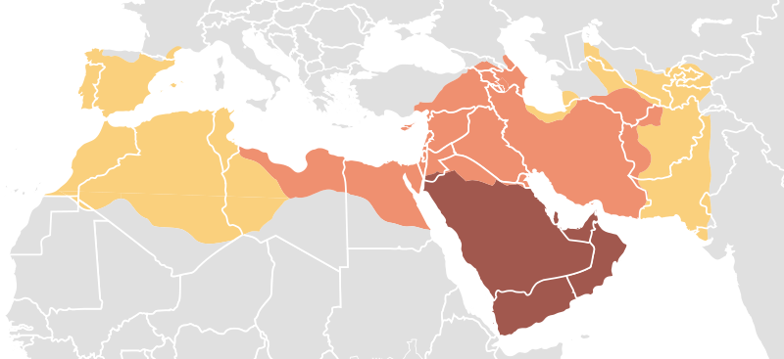[13]

This demonstrates the size of the Umayyad Caliphate during the Islamic Invasion of Gaul.

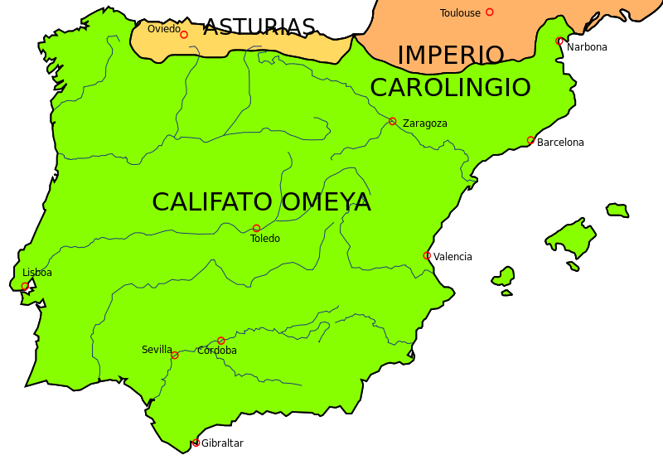[14]

This map shows (in green) the controlled land of the Umayyad Caliphate following the Conquest of Hispania.

List of Websites Used:

http://en.wikipedia.org/wiki/File:Mohammad_adil-Rashidun-empire-at-its-peak-close.PNG

http://www.jewishvirtuallibrary.org/jsource/History/Umayyad.html

http://www.britannica.com/EBchecked/topic/613719/Umayyad-dynasty

http://islamiccoins.ancients.info/umayyads/umayyadhistory.htm

http://www.mideastweb.org/Middle-East-Encyclopedia/umayyad.htm

http://www.pbs.org/wnet/wideangle/episodes/pilgrimage-to-karbala/who-are-the-shia/battle-of-karbala/1729/

http://www.britannica.com/EBchecked/topic/295765/Islamic-world/26890/The-second-fitnah

<http://www.newworldencyclopedia.org/entry/Umayyad_conquest_of_Hispania>

http://en.wikipedia.org/wiki/Umayyad_Caliphate

http://empires.findthedata.org/l/30/Umayyad-Caliphate

<http://www.britannica.com/EBchecked/topic/571875/Sufyanids>

<http://en.wikipedia.org/wiki/List_of_Umayyad_governors_of_al-Andalus>

1. Richard Hooker, "History of the Umayyad Caliphate," The Jewish Virtual Library, last modified January 1, 2013, accessed July 13, 2013, http://www.jewishvirtuallibrary.org/jsource/History/Umayyad.html.
2. "Rashidun Caliphate Empire," map, Wikipedia, January 1, 2013, accessed July 13, 2013, 1http://en.wikipedia.org/wiki/File:Mohammad_adil-Rashidun-empire-at-its-peak-close.PNG.
3. Encyclopedia Britannica, "Umayyad Dynasty," in *Encyclopedia Britannica*, accessed July 13, 2013, http://www.britannica.com/EBchecked/topic/613719/Umayyad-dynasty.
4. Islamic Coins, "The Umayyad History," Islamic Coins, last modified January 1, 2013, accessed July 13, 2013, http://www.mideastweb.org/Middle-East-Encyclopedia/umayyad.htm.
5. MidEast Encyclopedia, "Umayyad," Middle East Encyclopedia, last modified January 1, 2008, accessed July 13, 2013, http://www.mideastweb.org/Middle-East-Encyclopedia/umayyad.htm.
6. Islamic Coins, "The Umayyad History," Islamic Coins.
7. Encyclopedia Britannica, "Umayyad Dynasty," in *Encyclopedia Britannica*,[Page #], accessed July 13, 2013, http://www.britannica.com/EBchecked/topic/295765/Islamic-world/26890/The-second-fitnah.
8. New World Enyclopedia, "Umayyad Conquest of Hispania," New World Encyclopedia, last modified January 1, 2013, accessed July 13, 2013, http://www.newworldencyclopedia.org/entry/Umayyad_conquest_of_Hispania.
9. Wikipedia, last modified January 1, 2013, accessed September 6, 2013, <http://en.wikipedia.org/wiki/Tariq_ibn_Ziyad>
10. Wikipedia, last modified January 1, 2013, accessed September 6, 2013, <http://en.wikipedia.org/wiki/Tarif_ibn_Malik>
11. Wikipedia, last modified January 1, 2013, accessed September 6, 2013, <http://en.wikipedia.org/wiki/List_of_Umayyad_governors_of_al-Andalus> (All information drawn from this page/associated pages except for Tariq ibn Ziyad and Tarif ibn Malik.
12. Wikipedia, last modified January 1, 2013, accessed September 6, 2013, <http://en.wikipedia.org/wiki/Uthman_ibn_Naissa>
13. "Expansion of the Caliphate," map, Wikipedia, January 1, 2013, accessed July 13, 2013, http://en.wikipedia.org/wiki/File:Map_of_expansion_of_Caliphate.svg.
14. “Iberian Peninsula 720," map, Wikipedia, January 1, 2013, accessed July 13, 2013, https://en.wikipedia.org/wiki/File:Pen%C3%ADnsula_ib%C3%A9rica_750.svg.