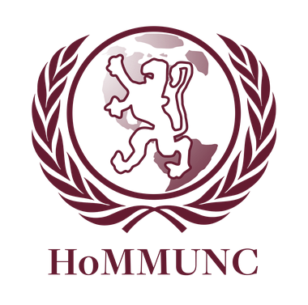

Social, Humanitarian and Cultural

Affairs Committee

Chair: Jay Rappaport

Moderator: Sahil Gupta

Dear Delegates,

Welcome to HoMMUNC XXVIII! My name is Jay Rappaport, and I’ll be chairing SOCHUM (the Social, Humanitarian and Cultural Affairs Committee). Details regarding the committee and the background guides are enclosed, but I wanted to take the time to tell you a little bit about what we’ll be doing and to welcome you all to HoMMUNC.

As I’m sure you know, to participate fully in committee a combination of public speaking, collaboration, and compromise will be required. Those may sound like large feats now, but we only ask that you do your best to accomplish them. This ought to go without saying, but we expect delegates to retain general decorum amongst themselves throughout the entirety of this conference.

Sahil Gupta ‘15 will moderate our committee. He’s worked diligently over the summer and is incredibly excited to meet you all as well.

A little bit about myself: I am a senior at Horace Mann this school year, and I have participated in Model UN every year I’ve been at the school. My first Model UN conference was HoMMUNC XXV, my freshman year. Model UN has been an incredible learning experience for me in policy, leadership, and collaboration.

See you in October!

Best wishes,

Jay Rappaport

SOCHUM Chair

[jay_rappaport@horacemann.org](mailto:jay_rappaport@horacemann.org)

**About SOCHUM**

The United Nations General Assembly consists of thirty committees, six of which are the main committees. The third committee of the General Assembly is known as the Social, Humanitarian and Cultural Affairs Committee (SOCHUM). Since its establishment in 1948, SOCHUM has played a vital role in issues regarding humanitarian affairs and social development. The committee uses Special Rapporteurs, experts, and the papers of other UN working groups to gather information on draft resolutions considered by the General Assembly. Due to its consideration of, according to Article Four of the UN Charter, “any questions relating to the maintenance of international peace and security”, SOCHUM’s resolutions are extensive and comprehensive.

SOCHUM deals with various issues, some of which often overlap. This special authority allows the committee to examine issues from the rights of indigenous populations, children, refugees and other minority groups to the issues of poverty, education, food and water shortages, as well as representation in government. Although SOCHUM is unable to impose sanctions, authorize armed intervention or pass binding resolutions, its resolutions are significant, and it is able to recommend methods of ameliorating the presented issues to the Security Council. As one of the six main committees of the General Assembly, SOCHUM has certainly influenced the actions of the UN.

**Topic A: Unfair Treatment of Juvenile Delinquents**

**Juvenile Delinquency**

Juvenile delinquency is participation in illegal behavior by those younger than the statutory age of majority.[1] Globally, average ages of first offence have dropped significantly as adolescent offences become increasingly commonplace and societally expected.[2]

**The Issue**

Most legal systems prescribe specific procedures for dealing with juveniles, such as juvenile detention centers and courts. However, there are still constant instances of overly severe and misguided punishment of minors without regard to the special treatment they require. Many argue that children do not possess the mental maturity to fully comprehend the consequences of their actions. As a result, due to their inability to foresee punishment, children are more likely to commit crimes.[3]

Furthermore, since children are arguably more impressionable than adults, receiving appropriate consequences is imperative in dealing with crime in the long run. By effectively reducing juvenile delinquency or by increasing the effectiveness of their treatment, the likelihood of these delinquents becoming repeat offenders will decrease along with the overall crime rate.

The issue of humane treatment of juvenile delinquents is of particular interest to SOCHUM because of the varying definitions of adulthood and acceptable punishments across the globe. Indeed the social and cultural aspects of the issue will be the committee’s greatest obstacles in devising universal solutions.

**International Involvement**

The treatment of juvenile delinquents including life sentences and use of capital punishment remain delicate issues for a variety of reasons. First, definitions of adulthood vary between countries. Additionally, different cultures consider with varying importance the notion of relatively diminished mental capacity of minors in prescribing punishment.[4]

In 1989 the General Assembly adopted the Convention on the Rights of the Child (UNCRC), which was incorporated into international law in 1990. The UNCRC provides the most comprehensive international document concerning children’s rights. The treaty discusses their political, social, and civil rights including protection against abuse, exploitation, and their treatment under law. Although the convention was adopted by the General Assembly and is the most ratified of any human rights treaty in history, Somalia and the United States have yet to ratify it, and Iran has passed laws superseding it.[5]

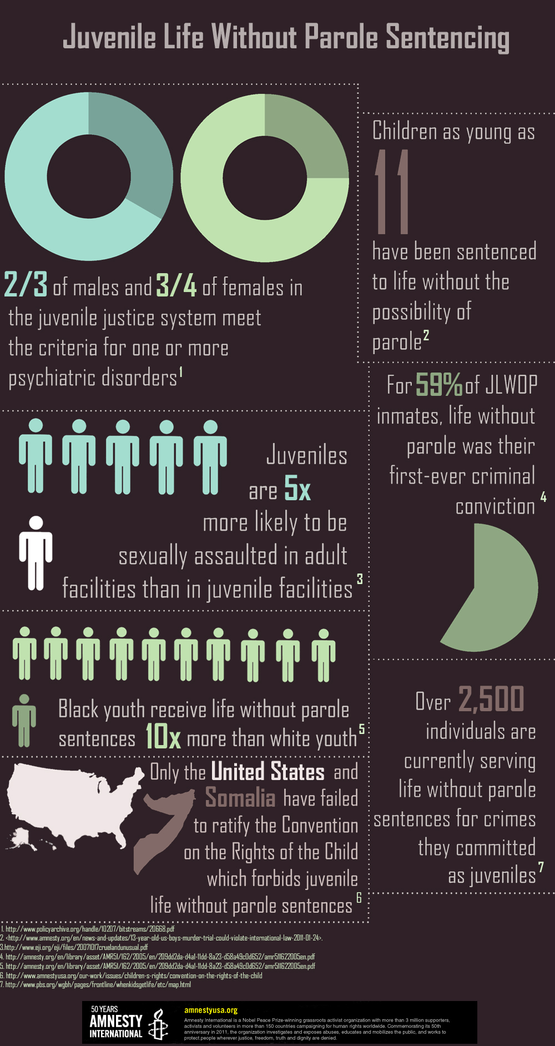

**Capital Punishment**

An overwhelming body of treaty, general, and customary international law outlaws the use of capital punishment on minors. In fact, Article 37 (a) of the United Nations (UN) Convention on the Rights of the Child (CRC) specifically prohibits the execution of juvenile offenders. Regional treaties also establish this prohibition. In the inter-American system, Article 4(5) of the American Convention on Human Rights prohibits the execution of juveniles; 25 of the 35 Member States of the Organization of American States are party to the Convention. Indeed, within Europe, Protocol No. 6 to the Convention for the Protection of Human Rights and Fundamental Freedoms Concerning the Abolition of the Death Penalty, as amended by Protocol No. 11 prohibits the imposition of the death penalty in peacetime. Protocol No.13 also abolishes the death penalty in all circumstances including crimes committed at times of war and imminent danger. Moreover, the UN has issued various resolutions confirming the prohibition against the execution of juveniles.[6]

As of 2008, seventy countries have allowed the death penalty as a form of punishment. Of these, only eight permit the death penalty to be sentenced to minors: China, Iran, the Democratic Republic of the Congo, Nigeria, Pakistan, Saudi Arabia, Yemen, and the United States of America. In the last three years this number dwindled to four: Iran, Pakistan, China, and the United States. The United States has consistently held the position of most executions of juveniles. In fact, except for the United States and Iran, these other nations in which executions of minors have occurred have all drafted and passed bills outlawing capital punishment for minors, after which all executions were anomalies and judicial transgressions. Since 1998, the United States has been the only country to reportedly execute juvenile offenders on a regular basis.  The US has, over the last decade, reportedly executed more juvenile offenders than every other nation of the world combined.[7]

**Case Study: Iran**

According to Nobel Peace Prize laureate Shirin Ebadi, the treatment of juvenile delinquents is vastly different in Iran. She says “Based on Iranian criminal laws, the age of liability for girls is nine and for boys 15. That means that if a child commits a crime, he or she would be treated as if a 40-year-old person committed that crime.”[8]

This idea of full liability at such a young age has resulted in numerous life sentences and even instances of capital punishment for the actions of fifteen-year-old boys that most would consider self-defense, but in the eyes of Iranian law are aggravated homicide. This directly violates the provisions of the UNCRC, which Iran has ratified, that define a child as anyone under the age of eighteen. Thus, a particular point of consideration is the conflict between the stipulations of the UNCRC and Islamic sharia law.[9]

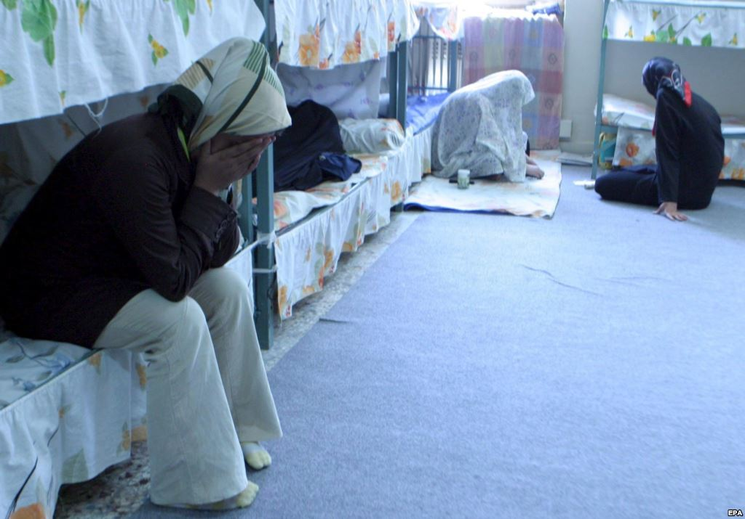

**Bloc Positions**

**The United States and South America**

The United States and many South American countries still use the death penalty as a form of punishment for the most severe offenses. They also often have specialized juvenile programs and seem to be the **middle ground between Europe and Africa/Middle East.**

**Europe**

The European Union has become an abolitionist group of countries and thus does not support the death penalty as a form of punishment. Many European nations also have specialized juvenile programs included as part of their criminal justice system to reform juvenile offenders and help them find and learn usable job skills. Likely, European nations would advocate the inclusion of specialized juvenile programs into other nation’s justice systems.

**Africa and the Middle East**

Many of these member states have the harshest punishments for juvenile offenders and many maintain the death penalty as a form of punishment. These nations likely want to continue treating juvenile delinquents as if they are adults, keeping the age to be considered an adult very low. Furthermore, if these nations were to reform their policies by adding juvenile programs to their national policies, many would struggle to come up with the funding on their own due to unstable and underdeveloped economies.

**Asia**

As Asia is the most populated and diverse continent, the punishment of juveniles varies dramatically across countries. Most nations do not execute children, and many have significant provisions to ensure that children are not mistreated by police and are not endangered within the prison system. While most countries have also passed laws dictating that child offenders should be separated from adults in prison, many do not have adequate facilities to ensure that this is always the case. Additionally, many of these nations define childhood differently, and older children are likely to be prosecuted as adults in some cases. On the other hand, many Asian nations have made progress over recent years in handling juvenile delinquency with more care and focusing on rehabilitation. Sri Lanka and India are examples of countries that have accepted substantial international and NGO assistance in order to implement innovative solutions in addressing juvenile delinquency (Juvenile Justice in South Asia).

**Questions to Consider:**

* How does your country define delinquent behavior?
* How does your country define juvenile offenders?
* Is your country one of the seventy member states that still permits the death penalty? Are you one of the eight member states who have executed a juvenile since 1990? How does this affect your position on reforming policy? What is your reasoning for these actions?
* How does your country feel about international policies surrounding the treatment of juvenile prisoners? Would you prefer a more national approach?
* If rehabilitation programs are the answer, what specific aspects should be included? Where is the funding going to come from?

**Topic B: Freedom of Religion**

**Introduction**

Religion is defined, by the UNHRC in 1993, as “theistic, non-theistic and atheistic beliefs, as well as the right not to profess any religion or belief.”[10]

While religions have been a source of faith, solace, and potential for billions across the globe, history shows us that they have also been a source for conflict and tension. It has been an ongoing struggle to codify the ideals of religious freedom into international law. This effort to confirm common values has been maintained throughout the twentieth century, yet the struggle subsists.[11]

**Definition**

The freedom of religion can be defined as the freedom of an individual or community, in public or private, to manifest religion or belief in teaching, practice, worship and observance. It has been generally recognized to include the freedom to change religion or not to follow a religion. The freedom to leave a religion or discontinue membership of a religious group (apostasy) is a vital component in defining this term. In a country with a state religion, freedom of religion is considered to mean that the government permits religious practices of other sects besides the state religion and does not persecute beliefs in other faiths.[12]

**International Law**

Article 18 of the Universal Declaration of Human Rights states that “Everyone shall have the right to freedom of thought, conscience, and religion. This right shall include freedom to have a religion or whatever belief of his *her+ choice.” Additionally, the International Covenant on Civil Political Rights (ICCPR), in order to elaborate, added the following:

*“1. Everyone shall have the right to freedom of thought, conscience and religion. This right shall include freedom to have or to adopt a religion or belief of his [her] choice, and freedom either individually or in community with others and in public or private, to manifest his [her] religion or belief in worship, observance, practice and teaching.*

*2. No one shall be subject to coercion which would impair his *her+ freedom to have or to adopt a religion or belief of his [her] choice. 3. Freedom to manifest one’s religion or belief may be subject only to such limitations as are prescribed by law and are necessary to protect public safety, order, health, morals or the fundamental rights and freedoms of others.*

*4. The States Parties to the present Covenant undertake to have respect for the liberty of parents and, when applicable, legal guardians, to ensure the religious and moral education of their children in conformity with their own convictions.”[13]*

Some of these articles in the ICCPR have become legally binding treaties. However, due to the complexity of the topic and political issues involved, Article 18 ICCPR has not been codified in the same way.

In 1981, the General Assembly adopted without a vote the Declaration on the Elimination of All Forms of Intolerance and of Discrimination Based on Religion or Belief. While the Declaration lacks enforcement procedures, it remains the most important contemporary codification of freedom of religion and belief.[14]

**Statistics**

Although there has been widespread affirmation of religious freedom, in reality this right is breached in more countries than it is protected.

The Pew Research Center’s Forum of Religion and Public Life is the foremost institute publishing studies on freedom of religion, using information from the United Nations, the US-American State Department and Human Rights Watch. In a study entitled “Global Restrictions on Religion” of December 17, 2009, the Forum stated that almost all countries protect religious freedom in their constitution or laws, while only about a quarter of countries were found to fully respect these legal rights in practice.[15]

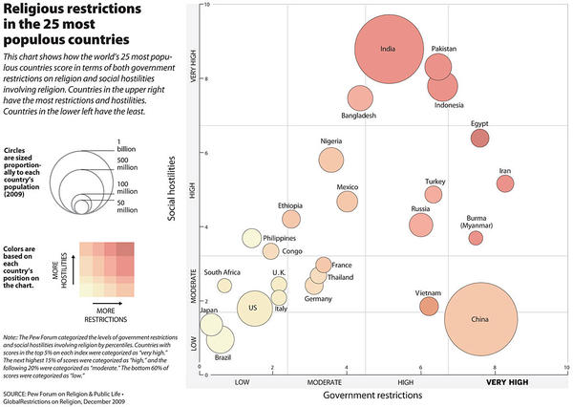

**Case Study: The Burqa Ban**

In certain European countries, the wearing of the burqa, the Christian cross, and/or the Jewish kippah has been banned. The recent “Burqa Ban” in France has aroused some international reaction.

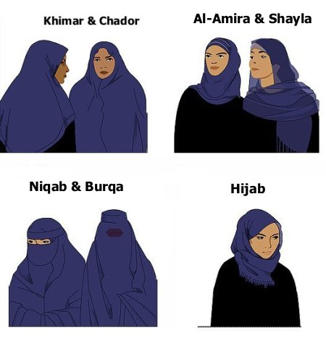

France has prohibited students and staff from wearing clearly visible religious symbols. As of April 11, 2011, France’s “bid to forbid concealing one’s face in public” effectively banned the wearing of burqas. While France has received the most media attention, other countries, such as Italy, have also passed similar “anti-terrorism laws” that ban concealing one’s face.[16]

**Bloc Positions**

*North and South America*

The Americas continue to have the lowest levels of both governmental and social restrictions on religion.

*Europe*

Though in most of Europe there are few restrictions set by the government, the rate of social hostilities involving religion is growing rapidly.

*Middle East and North Africa*

In this region the highest levels of governmental and social restrictions on religion occur. Governments highly favor Muslim citizens and in countries with Sharia law there is no freedom of conscience.

*Sub-Saharan Africa*

Social hostilities involving religion have been declining rapidly.

*Asia*

Most Asian countries have high governmental restrictions of religion and social hostilities are becoming more frequent.

**Sources**

Basta, Joanna. "Treatment of Juvenile Offenders- Study Outcomes since 1980." Behavioral Sciences and the Law 6.3 (1988): n. pag. Web. 25 Apr 2011. <http://onlinelibrary.wiley.com/doi/10.1002/bsl.2370060306/abstract>. Bravin, Jess. "Life in Prison for Minors- Cruel and Unusual?." Wall Street Journal Online. Wall Street Journal, 05 Oct 2009. Web. 07 Apr 2011. <http://online.wsj.com/article/SB125469908713662969.html>. "The Death Penalty Worldwide." infoplease.com. infoplease.com, 2007. Web. 22 May 2011. <http://www.infoplease.com/ipa/A0777460.html>. "Execution of Juveniles in the U.S and other countries." Death Penalty Information Center. Death Penalty Information Center, 23 Feb 2011. Web. 18 May 2011. <http://www.deathpenaltyinfo.org/execution-juveniles-us-and-othercountries#execsworld>. "Fatemeh Salbehi and Ehsan face imminent execution!." Stop Child Executions. Stop Child Executions, 08 Feb 2011. Web. 27 Feb 2011. <http://www.stopchildexecutions.com/index.php?option=com_content&view=article&id =213:fatemeh-salbehi-and-ehsan-face-imminentexecution&catid=36:scenews&Itemid=86>. Flash, Kimberly. "Treatment Strategies for Juvenile Delinquency: Alternative Strategies." Child and Adolescent Social Work Journal 20.6 (2003): n. pag. Web. 22 May 2011. <http://www.springerlink.com/content/p6263225kh782650/fulltext.pdf>. "Graham v. Florida." Legal Information Institute. Cornell University Law School, 2010. Web. 07Apr 2011. <http://www.law.cornell.edu/supct/html/08-7412.ZS.html>. Greenwood, Peter. "Prevention and Intervention Programs for Juvenile Offenders." Future of Children. Future of Children, 2008. Web. 28 Apr 2011. <http://futureofchildren.org/futureofchildren/publications/docs/18_02_09.pdf>. "Iran/ death penalty- A state terror policy." International Federation for Human Rights. International Federation for Human Rights, Apr 2009. Web. 13 Jun 2011.

"Juveniles still to face the noose in Iran." Amnesty International. Amnesty International, 20

Oct 2008. Web. 13 Jun 2011. <http://www.amnesty.org/en/news-andupdates/news/juveniles- still-face-noose-iran-20081020>.

O'Toole, Pam. "Iran rapped over child executions." BBC News- Middle East. BBC News, 27 June 2007. Web. 17 Mar 2011. <http://news.bbc.co.uk/2/hi/6244126.stm>. "Roper v. Simmons." Legal Information Institute. Cornell University Law School, 2005. Web. 07 Apr 2011. <http://www.law.cornell.edu/supct/html/03-633.ZS.html>.

"Sentencing Children to Die in Prison." Equal Justice Initiative. Equal Justice Initiative, n.d. Web. 05 Apr 2011. <http://eji.org/eji/files/07.27.09%20New%20CDIP%20OnePager.pdf>. UN Committee on the Rights of the Child (CRC), UN Committee on the Rights of the Child (2005): CRC/C/15/Add.254. Concluding Observations: The Islamic Republic of Iran, 6

July 2011. <http://www.unhcr.org/refworld/docid/43f305350.html>.2

1. Siegel, Larry J.; Welsh, Brandon (2011). *Juvenile Delinquency: The Core* (4th ed.). Belmont, CA: Wadsworth/cengage Learning. [ISBN](http://en.wikipedia.org/wiki/International_Standard_Book_Number) [0534519326](http://en.wikipedia.org/wiki/Special:BookSources/0534519326).
2. Steinberg, L. (2008). *Adolescence* (8th ed.). New York, NY: McGraw-Hill. [ISBN](http://en.wikipedia.org/wiki/International_Standard_Book_Number) [9780073405483](http://en.wikipedia.org/wiki/Special:BookSources/9780073405483).
3. MacArthur Foundation Research Network on Adolescent Development and Juvenile Justice. (2006, September). *Network overview: A century of change in juvenile justice*. Philadelphia, PA: Author.
4. Eadie, T.; Morley, R. (2003). "Crime, Justice and Punishment". In Baldock, J.; et al. *Social Policy* (3rd ed.). Oxford: Oxford University Press. [ISBN](http://en.wikipedia.org/wiki/International_Standard_Book_Number) [0199258945](http://en.wikipedia.org/wiki/Special:BookSources/0199258945).
5. http://www.unicef.org/crc/
6. http://www.crin.org/docs/resources/treaties/uncrc.asp
7. http://www.internationaljusticeproject.org/juvConst.cfm#14
8. http://www.rferl.org/content/article/1079355.html
9. <http://www.amnestyusa.org/research/reports/iran-the-last-executioner-of-children?page=show>
10. http://www.stoa.org.uk/topics/religion/Complexity%20of%20the%20Definition%20of%20Religion%20-%20Harvard%20Human%20Rights%20Journal.pdf
11. http://www.pewforum.org/2012/09/20/rising-tide-of-restrictions-on-religion-findings/
12. http://www.un.org/en/documents/udhr/index.shtml
13. http://www1.umn.edu/humanrts/edumat/studyguides/religion.html
14. http://www1.umn.edu/humanrts/edumat/studyguides/religion.html
15. http://www.pewforum.org/2013/06/20/arab-spring-restrictions-on-religion-findings/
16. http://www.theguardian.com/world/2011/sep/19/battle-for-the-burqa