

Special Political and Decolonization Committee

Chair: Ben Greene

Moderator: Ikaasa Suri

Dear Delegates,

My name is Ben Greene and I am honored to be chairing this HoMMUNC’s SPECPOL Committee! I am a senior at the Horace Mann School and a member of the Senior Executive Board of Horace Mann’s Model UN Team. Like so many of us, I have a keen interest for international relations and I am deeply excited to see the stimulating level of debate that will take place at this year’s HoMMUNC. Besides participating on the Model UN Team, I am a member of the varsity football and baseball teams so if you are a big sports fan, come tell me about it! Joining me on the Dais staff for this committee is our lovely moderator Ikaasa Suri who will wow you with her deep knowledge and care for the issues that we are discussing. Ikaasa and I hope that we get to know each one of you over the short period of time we get to spend together at HoMMUNC. Model UN has been a large part of my life ever since 9th grade so I am looking forward to sharing my Model UN experiences with each of you. If you have any funny jokes that don’t involving greecing dj’booty please let me know! Ikaasa and I are looking forward to a fun day of heated debate and pertinent discussions. It is important that you thoroughly research the intricacies of each topic that we will be discussing! We hope that in the process of debating, you will also be able to meet new people and create new relationships that will simply make your Model UN success even more evident!

Over the course of the day, your beliefs and your research will be challenged, and you will be forced to process new and pressing information in a timely manner. Model UN truly has the power to make us better thinkers, better listeners, and better problem solvers. I hope that you are all as excited about HoMMUNC as we are. In the following background guide, you will find a place to start your research – but we do expect that you research elsewhere so that the committee can engage in productive and respectful diplomatic discourse. Do not hesitate to contact either myself or Ikaasa! Let us know of your comments, concerns, dreams, or aspirations!

Good luck and see you in October!

Ben Greene

[benjamin_greene@horacemann.org](mailto:benjamin_greene@horacemann.org)

**HISTORY OF SPECPOL:**

Although the modern Special Political and Decolonization (SPECPOL) Committee was officially established in August 1993, its history extends much farther back to the Special Political Committee, a predecessor ad-hoc committee initially founded to deal with issues of international politics and security. In 1978, SPECPOL replaced the Trusteeship Committee as the fourth body of six United Nations committees. Ten years later, amidst efforts for freedom and self-government, the United Nations declared the 1990s to be the “International Decade for the Eradication of Colonialism.” In furtherance of this goal, the United Nations moved to modify this body, turning it into the advisory committee presently recognized as SPECPOL, with a mandate to oversee decolonization.

SPECPOL was initially given jurisdiction over custody and non-self-governing territories; however, after the dismantling of the trusteeship system resulting from independence being granted to all the trust territories, and the now-limited number of non-self-governing territories, that jurisdiction is insufficient to keep the committee occupied. Currently, as a primarily consultative committee, SPECPOL recommends courses of action to the Security Council, specialized agencies of the United Nations, governments of member states, international organizations, and non-governmental organizations (NGOs). It does not have the power to take military action, although counseling from this committee is highly valued.

Over the course of this conference we’ll be focusing on two topics questioning both the individual nation’s and the global community’s rights to end international conflicts at the price of ethics and foreign resource investment at the cost of exploitation and abuse. The SPECPOL Committee provides a forum for member nations to discuss political issues without mediation by the Security Council, stressing the issues of self-determination, colonialism, and decolonization. Typically solutions from this committee include the use of UN peacekeeping troops, but this conference we hope to strive beyond those borders and come up with more creative, innovative solutions to the issues at hand. As delegates of the SPECPOL Committee, it will be your jobs to apply your knowledge in the realms of political instability among or within member states and provide them a place in which they may discuss these various grievances. Due to SPECPOL’s historical emphasis on political crises, this committee will focus on the governmental aspects of the given matters and their potential impact on states and their rights.

Topic 1: Private Military Contractors

*Introduction*

As we delve deeper into the 21st century, the use of private military contractors (PMCs) rather than a nation’s armed forces in war, humanitarian crises, and security and peacekeeping operations has reshaped the nature of conflict internationally. These private contractors play a variety of roles in support of and in conjunction with a nation’s regular uniformed military personnel. The United Nations itself, along with non-governmental and international organizations, non-state actors, and private companies, has purchased the services of PMCs.

A private military contractor provides armed security services on a non-governmental level with expertise typically similar to those of military or police forces. Due to the United Nation’s ban on the hiring of mercenaries, PMCs make a specific differentiation between their commercial actions and the connotations surrounding the word “mercenary.” The issue, however, comes in when contractors use offensive forces in a war zone and are then at risk of being considered unlawful combatants. Since PMCs are motivated by finance and not by national loyalty, many claim they are extremely difficult to regulate. Opponents highlight concerns of accountability, regulation, cost, and the possibility of rogue forces. They are often criticized as an unnecessary expense in an increasingly swollen defense industry. Proponents of private contractors, on the other hand, argue that they are more efficient, effective, and innovative than traditional forces and can serve as a counterweight to the military in states with weak political infrastructure.

In the past, due to non-public and legislative obligations, minimal levels of scrutiny under the governmental microscope, and the absence of a hierarchical chain of command found in most armed forces, PMCs have faced widespread accusations of human rights abuses. It will be your jobs as delegates this conference to confront the legality and morality of the use of this new facet of the military and consider modes of accountability for their actions.

*History of Private Military Contractors*

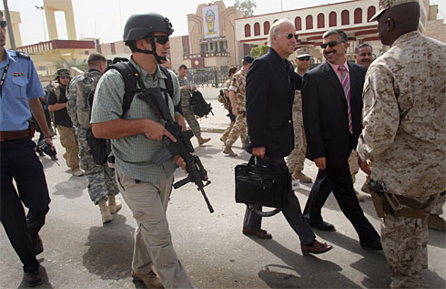 While international law bans the participation of mercenaries in war, whether PMCs actually fall under this definition of mercenaries outlined by the Geneva Conventions is up for debate. On December 4, 1989 the United Nations General Assembly passed a resolution banning the “…recruitment, use, financing, and training of mercenaries.”[1] Many nations including the United States and the United Kingdom are not signatories and have been working their way around the UN Mercenary Convention by way of PMCs.

Starting in the 1990s with a rising post-Cold War sentiment, the boom of the private security industry began the discharging of over six million military personnel. In regions such as South Africa and Russia with their 32nd Reconnaissance Battalion and former “Alpha” unit respectively, entire elite armies have been reorganized into private military companies. Now units such as the British Special Air Service, the Canadian Joint Task Force, and the US Special Operations Forces are making use of such industry.

*Past Uses of Private Military Contractors*

United States:

One of the greatest standing examples of private contractor adoption was the use of such in Iraq by the United States of America. In 2008, the United States Department of Defense had hired 155, 826 private contractors, outnumbering the 152,275 military troops sent to the ground.[2] This wasn’t the first time the United States, or any nation in fact, had made use of private security contractors, but it was most definitely the largest case. Over the course of the war, issues of accountability, especially in the case of contractors carrying weapons, rose. Debate on whether or not national Iraqi law took precedence over the United States’ legislation on PMCs came up as well.

In April 2005, Jamie Smith, CEO of SCG International Risk announced the expansion of service from PMCs’ previous traditional roles of protection and intelligence to military aviation support. This particular group pledged to provide air support, medical evacuation, rotary and fixed-wing transportation, heavy-lift cargo, armed escort, and executive air travel internationally.[3]

Africa:

In 1994 and 1995, a South African based PMC known as Executive Outcomes (EO) was involved in two distinct military actions in Africa. In 1994, EO fought on behalf of the Angolan government against what is today the second largest political party in Angola, UNITA, after a UN brokered peace settlement broke down. The second EO event was tasked with containing a guerrilla movement in Sierra Leone called the Revolutionary United Front. Both missions involved personnel from the firm training several thousand combat personnel for the Angolan government, retaking control of the diamond fields, and forming a negotiated peace in Sierra Leone.

Non-Governmental Organizations:

Non-governmental Organizations (NGOs) often use PMCs in dangerous regions such as Afghanistan, Somalia, and Sudan. NGOs find it easier to use these private groups rather than a military because of administrative costs and potential to outsource the liability. Opponents of such use argue that outsourcing security leaves these NGOs reliant on contractors and unable to develop their own security thinking. This in turn leads to organizations remaining closed about their use of private security, preventing informative knowledge sharing and discussion on the subject needed to improve NGOs’ and the international community’s overall decisions regarding this topic.

*Current Situation*

Somalia:

“As Somalia rebuilds its security institutions, the government should ensure that private security forces are properly regulated and do not become a substitute for competent and accountable police. All Somalis have the right to security, not just those who can afford to pay for it.”[4] These are the words of Faiza Patel, the Chairperson of the Working Group. Certain groups such as the Puntland Maritime Police Force (PMPF), created with the original intention of fighting piracy in the region, operate outside the constitutional framework for security institutions in Somalia and have engaged in operations unrelated to piracy, including one to prevent a candidate for the Puntland presidency from campaigning in Bossaso. On the other hand, this group reports directly to the president, avoiding a somewhat unnecessary system of bureaucracy. It will be your jobs as delegates to decide whether or not groups such as the PMPF should exist and if so, their legal and political boundaries.

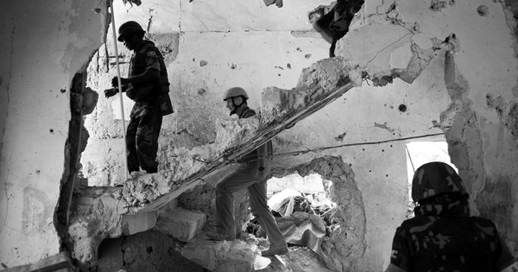

For Western nations, their fight is against the Shabab, a Somali group that could potentially carry out violent strikes against their enemies. The United States, for example, insists on avoiding “an American footprint or boot on the [Somali] ground.”[5] Instead the United States has been outsourcing to African soldiers and private companies, covertly training Somali intelligence operatives who are helping to build a large base in the region. The Shabab has also shown its ability to strike beyond Somalia, killing dozens of Ugandans in the summer of 2010, but thanks to Bancroft, a private security company, the militants have been forced to retreat. While some PMCs have received criticism for offensive attacks and human rights violations, Bancroft has been credited by both the African Union and the United Nations with improving the fighting skills of the African troops in Somalia, who themselves forced Shabab militants to withdraw from Mogadishu, the capital of the nation.

Afghanistan:

More recently, the number of private contractors in Afghanistan is on the rise, with more than 100,000 PMCs on the ground. Although the US presence in Afghanistan is ostensibly winding down towards an eventual handover to Afghan security forces, many believe the increase in contractors to troops ratio is yet another indication that a private army will remain in the country for years, despite the expected decline of military troops. This war, along with the US example of Iraq, indicates a strong reliance of the military on private contractors. What this does, in turn, is allow for a nation’s government to evade its legal obligations, including the responsibility to protect the human rights of civilians in war and peace, by allowing private individuals, rather than official state actors, to perform services on behalf of the military. This mission put out by the United States has also turned out to be quite costly, costing the Department of Defense (DOD) a total of $160 billion. This war has proven to be massive and destructive, wasting the lives and money of both nations and individuals. While the United States plans to remove combat troops from Afghanistan by 2014, the use of private security and military contractors implies a long-lasting Western influence through what some may call a “de facto army.”

Mexico:

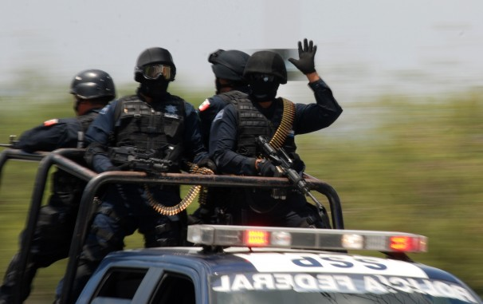

With the Iraqi war over, security contractors are looking for new prospects in Mexico, where growing criminal violence has created a high demand for battle-ready professionals. With a wide scope of PMCs located in the United States and Canada, contractors and private security firms of varying sizes and specialties are being drawn into a conflict closer to home. The only issue comes in when private companies realize they must abide by Mexico’s restrictive gun laws, implying foreign contractors must enter the bloody drug war unarmed. Motivated by commercial interest rather than national loyalty or patriotic reasoning, the direction of PMCs in Mexico is yet to be determined.

*Possible Solutions*

The issue at hand is by no means a simple question with a basic answer; rather, it is a growing problem with several centers relevant in all areas of the international community. It will be your jobs as delegates to decide whether national or international law should dictate the use of PMCs and other private firms. Many strong Western nations use PMCs as a tactic for avoiding legal obligations and military costs, while weaker nations use it as an alternative to an army. Even with the obvious advantages, PMCs pose a major threat when considering human rights and wartime boundaries. In solving this problem, you will have to consider the pros and cons of using PMCs to dictate international conflict. Delegates may choose to come up with specific definitions and limits of private firms to be integrated into international legislation, or may decide to leave it up to a sovereign nation’s choosing.

*Questions to Consider*

* Should PMCs be considered mercenaries?
* What is the exact definition of a PMC?
* Should PMCs be specified under international law or left up to individual nations?
* When a PMC enters a foreign country, does that nation’s law take precedence over the invading nation’s law?
* What are the future prospects for PMCs? Should they be used in the future or cut off before the military facet spreads?
* How can we increase communication in regards to PMC use?

Topic 2: The Question of Foreign Resource Interests

*Introduction*

A swift expansion of the global population and the scarcity of necessary materials have led to increased pressure to find and control the world’s remaining natural resources. The regulation of oil, gas, and mining industries, amongst others, is debated, as developing countries often do not have the infrastructure or technology necessary to properly refine or extract these resources. Other countries and multinational corporations seeking to exploit these assets for personal gain threaten to infringe upon national sovereignty for many of these developing countries. With natural resources higher in demand, the issue of who controls them and can benefit from them needs to be discussed.

*History of the Issue*

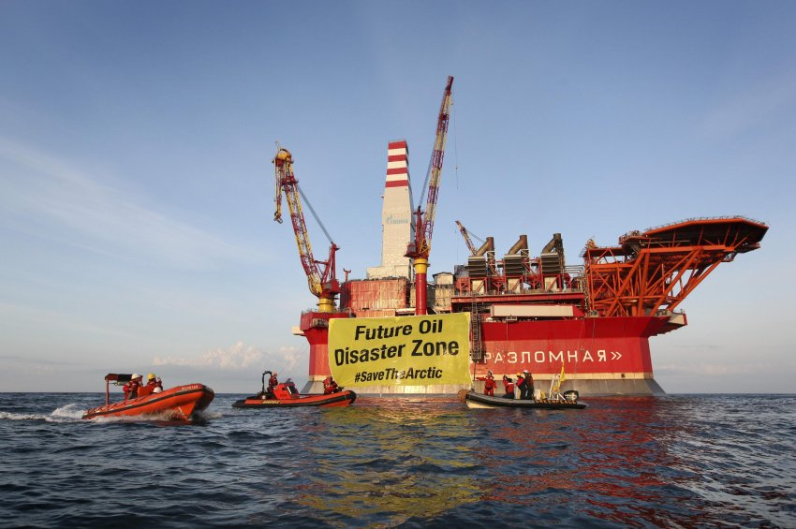

The exploitation of natural resources started to emerge in the 19th century as the technology for resource extraction starting cultivating itself into the political and social boundaries of the international community. Today, oil, coal, and gas, all originating from the extraction of fossil fuels, provide for about 80% of the world’s energy consumption. Subsoil minerals in the form of precious metals and intensive agriculture too are used in the production of industrial commodities, although they still hinder many aspects of the natural environment.

As science now allows us to view the trends of our planet, “going green” and conservation are two important themes currently relevant to the global society. With the increased sophistication of technology that now enables natural resources to be extracted at an exponentially higher and effective rate, deforestation, accelerated agriculture, and destructive mining are growing in popularity. Along with this, the 21st century phenomena of cultural consumerism forces production industries to produce materials at a higher rate, especially in the field of jewelry. Some of the specific issues arising from the exploitation of natural resources are outlined below.

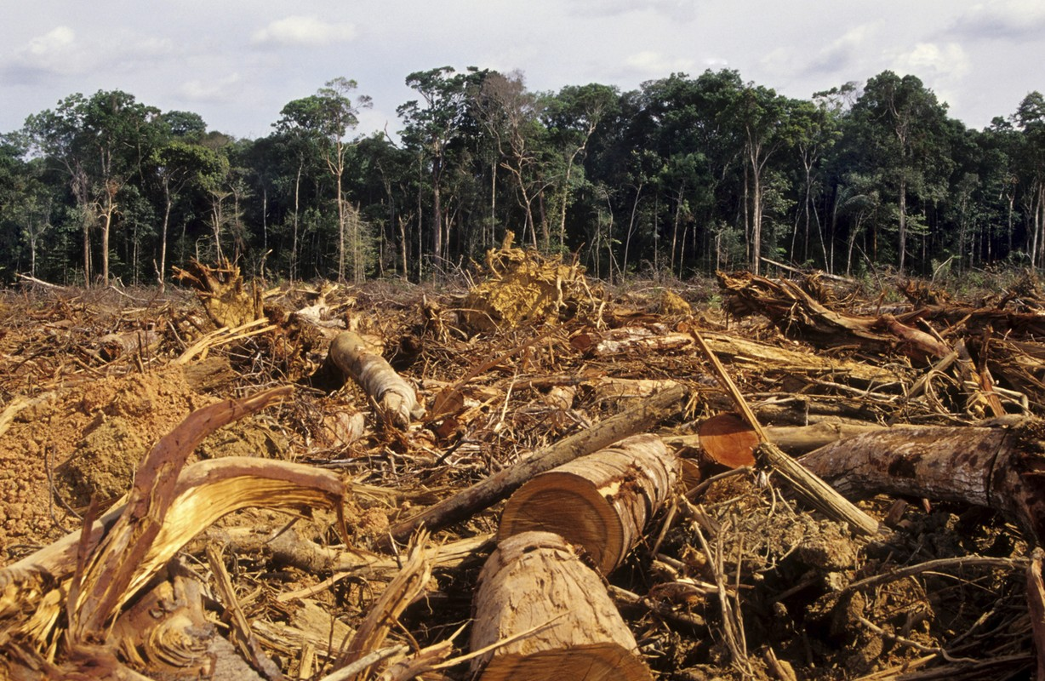

Deforestation: the removal of a forest typically for a commercial use where the land is thereafter used for that purpose

Deracination: the forced migration of a group of people mainly due to the depletion of resources in their specific region

Desertification: a process in which a land region becomes increasingly arid, typically losing its natural bodies of water, vegetation, and wildlife

Extinction: a process in which a species no longer exists due to environmental, or more usually, commercial, human-caused reasons

Oil depletion: the decline in oil production in an area typically caused by the removal of such in a short period of time

Ozone depletion: the steady decline of the ozone in the Earth’s stratosphere due to the exploitation of materials and release of pollutants into the atmosphere

Water pollution: the contamination of water bodies caused when pollutants are discharged into large bodies without adequate treatment

*Current Situation*

Latin and South America:

Picture this: Amazonian forests cleared in Ecuador, a mountain leveled in Peru, the Cerrado savannah converted to soy fields in Brazil, and oil fields under development in Venezuela; the South American continent is one of the biggest victims of natural resource exploitation. One of the greatest exploiters of these resources is China with its growing demand for regional commodities. More than the World Bank, Inter-American Bank and the US Import-Export Bank combined, China has provided billions of dollars in foreign direct investment to big-government run companies including Chinalco and CNOOC for raw materials.[6] On one hand, the economic benefits have been enormous. Trade between Latin America and China has surged to $241 billion, undoubtedly helping avoid the worst of the financial and economic crises that plagued much of the global community. It has played a major role in bolstering revenue for poverty alleviation programs and mitigated tensions between Latin nations and China. Venezuela, Ecuador, and Argentina have all been able to receive hefty loans from China, allowing them to keep up with international capital markets. On the other side though, this new relationship with China chains Latin American countries to bigger, stronger nations in that they now owe debt. This debt translates to guaranteed long-term commodity sales, leading to a commitment to push ahead with resource exploitation. Brazilian president, Dilma Rousseff, along with leaders of several other nations want to change the nature of their relationships with China by putting more emphasis on science and technological development. It will be the jobs of 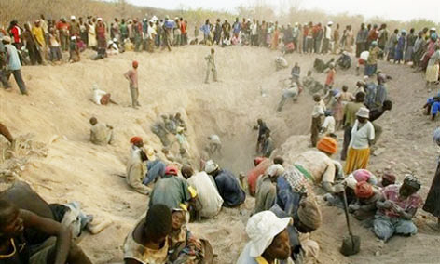SPECPOL’s member states to decide how to follow through on this and come up with reasonable, plausible solutions to this multifaceted issue.

Example of desertification in Africa

Africa:

In Africa, nations are struggling with resource exploitation on a larger scale. With already impoverished nations, private companies find themselves attracted to lower-income, less developed nations for resources. The only issue is, much of the wealth from natural resources fails to flow to local people, the ones who work hardest to retrieve those materials. A couple months ago in May, former UN secretary-general, Kofi Annan, urged prime minister of the United Kingdom, David Cameron, to use his influence to end some of the amoral practices of companies exploiting Africa’s vast reserves of natural resources. While a number of resource-rich African states such as Angola and Equatorial Guinea have achieved impressive economic growth rates in recent years, widening inequality amongst the rich and the poor supersedes this. On top of this, development indicators in thriving African countries, such as infant mortality, have failed to keep pace. While the average GDP per head in Equatorial Guinea now exceeds Poland, the life expectancy is 25 years less than that of the European nation.[7] In some cases, such as that of the Democratic Republic of Congo, Africa’s natural resource rights are sold to private companies who then sell ownership at hugely inflated prices, allotting the majority of profit to offshore private companies. The loss on these deals for African nations can skyrocket up to more than $1.3 billion.

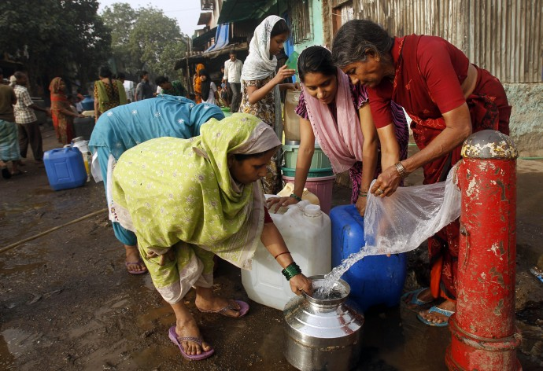

Water pollution: Women in India collecting water from a broken pipe in a slum

Asia:

In Indonesia, the exploitation of natural resources is running out of control. Much like in Latin America, while mining, logging, and fisheries have brought economic benefits to the country, illegal operators, corruption, and greed are damaging the environment and societies in ways that increase the risk of conflict.

In nations like India, the government itself is exploiting its rivers, lakes, and drinking water for power and industry, stealing India’s most precious resource from its people. City sewage treatment plants are ill equipped to cope with India’s large and growing population, ignoring the one resource all people desperately need. On top of this, with the number of multinational companies it has attracted in the past couple years (i.e. British Petroleum, Vodafone, Ford Motors, General Mills), economic expansion is a given. Unfortunately, along with the large number of jobs produced, cities are experiencing great population spurts and alarming health risks. To name a few, India is facing sewage problems on the city streets and pesticide contamination in large bodies of water.

*Possible Solutions*

While it is up to delegates how they propose to solve the issues at hand, the United Nations would encourage the use of legal trade, transparency, and taxes to balance out the positive and negative effects of natural resource digging. It will be your jobs to come up with a resource strategy that addresses improved law enforcement against key organizers of illegal and exploitative extractions and corrupt officials, ways to increase communication trans-borders, a regulation system, and political commitment. In order to solve this issue you must think about not only those causing the damage, but also those who are affected by the resource exploitation and those that need justice. Not only should you consider your individual roles as delegations in solving this issue, but also evaluate how this issue fits into the spectrum of SPECPOL. Make sure to keep the original goals of independence and decolonization in mind when assessing how private companies invade resource-rich nations.

*Questions to Consider*

* What defines which nations have the right to certain resources?
* Should resources be evenly distributed internationally, or should it be up to each nation to control individual commodities?
* How can the international community help poorer nations build up their technology so they can efficiently extract needed materials?
* How can we allow for the exploration of natural resources without furthering exploitation?

*Conclusion*

The information stated above is just the beginning of the issues, a way to outline the problems we hope to discuss over the course of the conference. Make sure to do more research beyond this in order to get a greater understanding of the issues as well as a greater scope on possible solutions. This HoMMUNC we hope to have a great session in which we will engage in serious debate with new and innovative ideas to solving these complex, yet pressing affairs.

1. <http://www.un.org/documents/ga/res/44/a44r034.htm>
2. <http://www.csmonitor.com/Commentary/Opinion/2013/0319/A-lesson-from-Iraq-war-How-to-outsource-war-to-private-contractors>
3. <http://www.youtube.com/watch?v=n9WENSo1yWA>
4. <http://www.ohchr.org/en/NewsEvents/Pages/DisplayNews.aspx?NewsID=12898&LangID=E>
5. <http://www.nytimes.com/2011/08/11/world/africa/11somalia.html?pagewanted=all&_r=0>
6. <http://www.guardian.co.uk/world/2013/mar/26/china-latin-america-resources-concern>
7. <http://www.guardian.co.uk/business/2013/may/10/kofi-annan-exploit-africa-natural-resources>