

Sengoku Jidai: Japan in Crisis

Chair: Jake Swinghamer

Moderator: Laszlo Herwitz

Dear Delegates,

My name is Jake Swinghamer and I could not be more excited to be on the dais of HoMMUNC’s Sengoku Jidai: Japan in Crisis! I am currently a senior at Horace Mann School, having participated in Horace Mann’s Model UN Team since freshmen year. As you probably could have guessed, I am interested in international relations and policy. Additionally, I am the President of Horace Mann’s Mock Trial Team, which I believe allows me to see problems from a legal perspective as well. Model UN has taught me what being a leader is really all about, and I hope that over the short time we get to spend together at HoMMUNC I will be able to share my love of MUN with all of you.

Laszlo and I are looking forward to a day of heated debate about the topics of this committee. I hope that while struggling to address these pertinent global issues you will also hone your leadership skills and meet new friends.

The issues that are presented to this committee were some of the most pressing issues of the world. Sometimes it will be necessary that you compromise and other times it will be necessary that you stand firm on your countries’ beliefs. Over the course of the day, your beliefs and your research will be challenged, and you will be forced to think on your feet #munproblemz. Model UN truly has the power to make us better thinkers, better listeners, and better problem solvers.

I hope that you are all as excited about HoMMUNC as we are. In the following background guide, you will find a place to start your research – but we do expect that you research elsewhere so that the committee can engage in productive and respectful diplomatic discourse.

Best Regards,

Jake Swinghamer

**Committee Procedure:**

This committee will be run, for the most part, like a traditional crisis committee. Speaking will take the form of moderated caucuses with specific topics, meaning moderated caucuses must be proposed only to address specific crises or issues. Unmoderated caucuses or suspension of traditional rules of debate may be allowed at the dais’s discretion. Throughout the course of the committee the dais will announce various breaking crises, which the delegates will have to respond to. These crises may come in the form of written news updates or visits from opposition figures. Delegates will be required to produce brief orders, known as directives, to respond to these crises. Directives must be approved by a simple majority (50%+1) in order to pass.

In addition to directives, there are two other types of documents that delegates may submit; Personal action orders, and communiqués. Personal Action orders utilize the portfolio powers of an individual delegate. These orders can call for actions such as troop movements, or espionage. Since these concern the powers of only one delegate, they do not need to be voted on by the rest of the committee. Communiqués are press releases which can be sent to opposition figures or released by one delegate to the rest of the committee. Joint communiqués must be voted on first however personal communiqués, used to indicate the intentions of a single delegate, need no prior approval. You will need to submit and negotiate treaties, which are normally not used in crisis committees. The purpose of treaties is to end conflict between various Daimyo, over issues such as territorial claims. These treaties must be approved and signed by all parties involved, remember that a treaty can be between multiple party. After the treaty is signed it will be given to the Moderator or the Chair, who will then inform the Committee of the terms and results of the treaty. There may also be a need for the committee as a whole to negotiate a peace treaty with a third party who is not present in the room. If this is the case treaties will need to be submitted to the chair and will be voted on. If the treaty is approved by a simple majority it will be “sent” to the third party and the Committee will receive a response from the third party as promptly as possible, the time may vary depending on the number of crises and the urgency of the situation.

As you are Japanese warlords, you will all have command over some number of troops; the exact numbers will be given to you at the start of the committee. You can use these troops however you please, keeping in mind that your actions may have negative consequences for you and the committee as a whole, meaning that troops should not be used carelessly as this can lead to significant setbacks and pitfalls for you and your clan. Also keep in mind that your troops can die and will not be immediately replaced so it is necessary to conserve your forces to ensure the safety of your lands and possessions.

On a final note, we know that assassinations are often one of the more entertaining and ambiguous aspects of Crisis Committees. For the purpose of this Committee, assassination requests must be submitted as private joint action orders. Such orders need the support of at least 3 Daimyo to be considered, which is not a guarantee of its approval. The approval of such requests will be at the Dais’s discretion, however the more Daimyo who sign the order the more likely it is to be approved. The Dais will generate a result of the order regardless of if the assassination is carried out. If the order does not have enough support or if the Chair does not approve it the result may have negative repercussions against its authors, be mindful of this when considering such a move.

**HISTORY OF THE SENGOKU PERIOD:**

As early as the beginning of the 15th century unrest was brewing all across Japan. The failure of the Ashikaga Shogunate to win the support of feudal Japanese lords (Daimyo) coupled with armed uprisings led by tax and debt weary farmers was creating a situation which threatened to rend Japan into dozens of warring factions.

Prior to the outbreak of the Sengoku Era, Japan was under the rule of the Ashikaga Shogunate. This particular Shogunate had instituted a warrior government based on traditional social economic rights as laid out in the Joei Code of 1232. Despite the power this code gave to Japan’s feudal lords, it failed to win the Ashikaga Shogunate the loyalty of many Daimyo, especially those whose domains were far from Kyoto.

Around the same time, growing trade with China had helped Japan’s economy develop and flourish. As the economy grew the use of money became widespread as the result of the growing numbers of markets and commercial cities. This newfound chance at both economic and social power led to desire for greater local autonomy and authority, especially among the more powerful Daimyo of the time. This struggle for dominance coupled with armed peasant uprisings created a hotbed of unrest which needed only a small spark to ignite it.

The unrest of the Sengoku period began with outbreak of the Onin War in 1467. The Onin War was fought between two powerful clans, the Hosokawa, and the Yamana. The fighting was mainly centered on Kyoto and lasted for 11 years. Once the city of Kyoto was destroyed, the fighting spread throughout the rest of Japan.

The Onin War had weakened considerably weakened central authority, leaving different Daimyo to fill the power vacuum. This new chance at increased authority caused a total breakdown of order in Japan, with Daimyo waging constant war to defend or enlarge their respective domains. The most powerful Daimyo of all during that time was Oda Nobunaga. Nobunaga reached the height of his power in 1573 when he successfully destroyed the Asakura and Azai clans, leading Azai Nagamasa to commit suicide. With Nagashima's destruction in 1574, the only threat to Nobunaga was the Takeda Clan, now led by Takeda Katsuyori. Nobunaga met his death in 1582 when he was betrayed by his own general and, as a result, committed Seppuku (ritualistic suicide). After his death, the struggle for control of Japan resumed, this time with two major players, Toyotomi Hideyoshi and Tokugawa Ieyasu, both former allies of Nobunaga. This period of bitter fighting lasted for almost 20 more years, finally ending with the Tokugawa Clan’s victory over Hideyoshi at Sekigahara in 1600. Tokugawa Ieyasu went on to reunite Japan and become the first Shogun of the Tokugawa Shogunate of Japan.

**ASSESMENT OF YOUR CURRENT SITUATION:**

The year is 1564 and Oda Nobunaga (Your Chair) and his faithful vassal Toyotomi Hideyoshi (Your Moderator) have convened a council of Daimyo in an attempt to bring an end to the almost century long conflict plaguing Japan. During the course of this meeting your objective will be to try to accumulate as much power as possible while also trying to maintain the stability of your region and country.

Some potential conflicts which may arise during the course of the committee include (but are not limited to):

-Peasant Uprisings

-Earthquakes

-Samurai rebellions

You will need to negotiate treaties with third parties as well as help negotiate treaties between individual Daimyo (For more information on treaties see Committee Procedure at the beginning of this guide). You may also find it prudent to form alliances with other members of the Committee in order to consolidate power and influence. By the end of the Committee you should seek to have resolved all or, at least, most of the conflicts plaguing the country.

**List of and information on the Clans of the Committee:**

**This portion gives a full history and outline of each clan as well as the name of the clan chief at the time of the committee, however please remember that this committee will only cover events and topics from before 1565.**

**-Azai Clan (sometimes spelled Asai):** The Azai Clan was a fairly powerful clan in the mid Sengoku period. However it chose to oppose Oda Nobunaga, leading to its utter destruction in 1570s.

Clan Chief: Azai Nagamasa

Territory: northern Omi Province

Enemies: Saito Clan

-**Late Hojo Clan (also known as the Odawara Hojo clan):** One of the most powerful clans of the Sengoku period. (it is called the Odawara Hojo Clan to distinguish it from the unrelated Hojo Clan)

Clan Chief: Hojo Ujiyasu

Territory: Kanto Region

Enemies: Takeda Clan.

-**Maeda Clan:** Allies and Vassals of Oda Nobunaga. Aided him in his fight to unify Japan. As a result of this alliance, the Maeda clan was given a large amount of land in 1583.

Clan chief: Maeda Toshiie

Territory: Arako Castle and surrounding lands,

Enemies: none of note

-**Miyoshi Clan:** Branch of the Takeda clan. It was a powerful family and a major political force during the Sengoku period.

Clan Chief: Miyoshi Nagayoshi

Territory: Settsu and Awa regions

Enemies: None of note

-**M**ō**ri Clan:** the Mōri clan was an up and coming clan, steadily increasing its power under the leader ship of Mōri Motonari. The Mōri would later fight against Oda Nobunaga and his general

Clan Chief: Mōri Motonari

Territory: Aki Province

Enemies: Otomo Clan

-**Otomo Clan:** The Otomo was a powerful force throughout the Sengoku period. It was one of the first clans to make contact with the Europeans. Its leader during the Sengoku period was also one of the first and only Daimyo to convert to Christianity.

Clan Chief: Otomo Sorin

Territory: Funai region on Kyushu, Japan’s southernmost island (see maps for exact geographical orientation).

Enemies: Mori Clan.

-**Sanada Clan:** The Sanada clan was a loyal ally of Takeda Shingen. It was considered one of the younger and less-developed clans having been established around 1510.

Clan Chief: Sanada Masayuki

Territory: Parts of Shinano province (in cooperation with the Takeda clan)

Enemies: None of note

-**Takeda Clan:** The Takeda Clan was one of the most powerful clans of the Sengoku period. It controlled a sizable amount of land and its warriors were considered very formidable. This skill at arms can be attributed to its leader during the Sengoku period, Takeda Shingen. Shingen was considered a tactical and military genius. The Takeda clan fought some of the fiercest battles of the Sengoku period against its rival the Uesugi clan.

Clan Chief: Takeda Shingen

Territory: Kai Province, Shinano Province

Enemies: Uesugi clan, Imagawa clan

**-Uesugi Clan:** The Uesugi Clan was another extremely powerful clan during the years of the Sengoku period. Its leader during this time, Uesugi Kenshin, possessed such military prowess that many of his warriors believed him to be the avatar of the Buddhist war god, calling him Kenshin god of war. The Uesugi Clan was a fierce rival of the equally powerful Takeda clan

Clan Chief: Uesugi Kenshin

Territory: Echigo Province

Enemies: Takeda Clan

**-Ukita Clan:** The Ukita Clan was inactive for many years prior to 1536 when Ukita Naoie came to power and steadily rebuilt its influence.

Clan Chief: Ukita Naoie

Territory: Bizen Province, Mimasaka Province

Enemies: None of note

**-Date Clan:** While they did not possess power or fame equal to that of more prominent Daimyo, the Date clan was an influential part of the Sengoku period. It helped the other Northern clans consolidate to form a defense against invasion of northern of Japan by clans such as the Takeda or Uesugi. It also helped negotiate alliances between smaller warlords.

Clan Chief: Date Terumune

Territory: Mutsu Province

Enemies: None of Note

**-Imagawa Clan:** The Imagawa clan was a very powerful clan during the early Sengoku period. It had lost some of its influence after the death of one of its leaders in 1560 however it still was considered influential. By 1570 the clan had all but unraveled as a result of its rivalry with the Takeda clan

Clan Chief: Imagawa Ujizane

Territory: Totomi Province, Mikawa Province, Suruga Province

Enemies: Takeda clan.

**-Chosokabe Clan:** The Chosokabe clan was prominent throughout the Sengoku period. Known for its vengeful nature the clan took revenge on the groups involved in its leaders death in 1508, using any means necessary to ensure that justice was served.

Clan Chief: Chosokabe Kunichika

Territory: Tosa Province

Enemies: none present at this gathering.

**-Shimazu Clan:** The Shimazu clan was the wealthiest clan of the Sengoku period. It was one of the older clans, having been founded near the end of the 12th century.

Clan Chief: Shimazu Yoshihiro

Territory: Satsuma Province, Osumi Province, Hyuga Province

Enemies: None of note

**-Tachibana Clan:** The Tachibana was one of the smaller clans of the Sengoku period. It was one of the few clans to ever have a female leader, who came to power in 1596 after her father died without any sons.

Clan Chief: Tachibana Dosetsu.

Territory: Chikugo Province

Enemies: Shimazu clan.

**RESEARCH TIPS:**

The Sengoku Period is, like most other time periods in Japanese history, a complex and dense thing to understand. This is because the history of the period hinges around wars between individual Daimyo over obscure and often miniscule provinces. As a result, one can spend a great deal of time reading about multiple different Daimyo and battles without ever finding what one needs. Keeping this in mind, we would recommend that you try to limit your research to an overview of the Sengoku period and information specific to your Daimyo, this is merely a suggestion and you are welcome to research other Daimyo or specific battles of the period if the topic interests you. When researching note only events which occurred pre 1565 as the crises in the committee will only concern events happening before said year. We do recommend that you come to committee with some sort of research binder. We advise you to, at minimum, print out and bring with to committee an overview of the period, a bio of your character, and the background guide, as well any maps you may deem useful, but you are encouraged to go further as we will be taking note of who seems to be prepared and as well as who seems to have a good grasp of the subject matter at hand. We also suggest that you carefully study the maps provided at the end of this guide in order to gain a working knowledge of which territories you own and which territories belong to your foes and rivals, as one of your objectives is to gain more land. **Position Papers are not required for this conference!!**

Some questions you should seek to answer during the course of your research include:

-How can territorial disputes be resolved without violence?

-What should be the role of the Daimyo in the future governance of Japan?

-What should be done to address the plight of the peasants and farmers?

-When violence is necessary, which is better; unilateral of joint action?

We wish you all the best of luck and look forward to seeing you all shine at next year’s HOMMUNC 2013! Please email Laszlo Herwitz or Jake Swinghamer (our emails are at the beginning of this guide) if you have any further questions.

Good Luck!!

-

**MAPS** (ignore key in bottom right hand corner of first map, only use one at top)

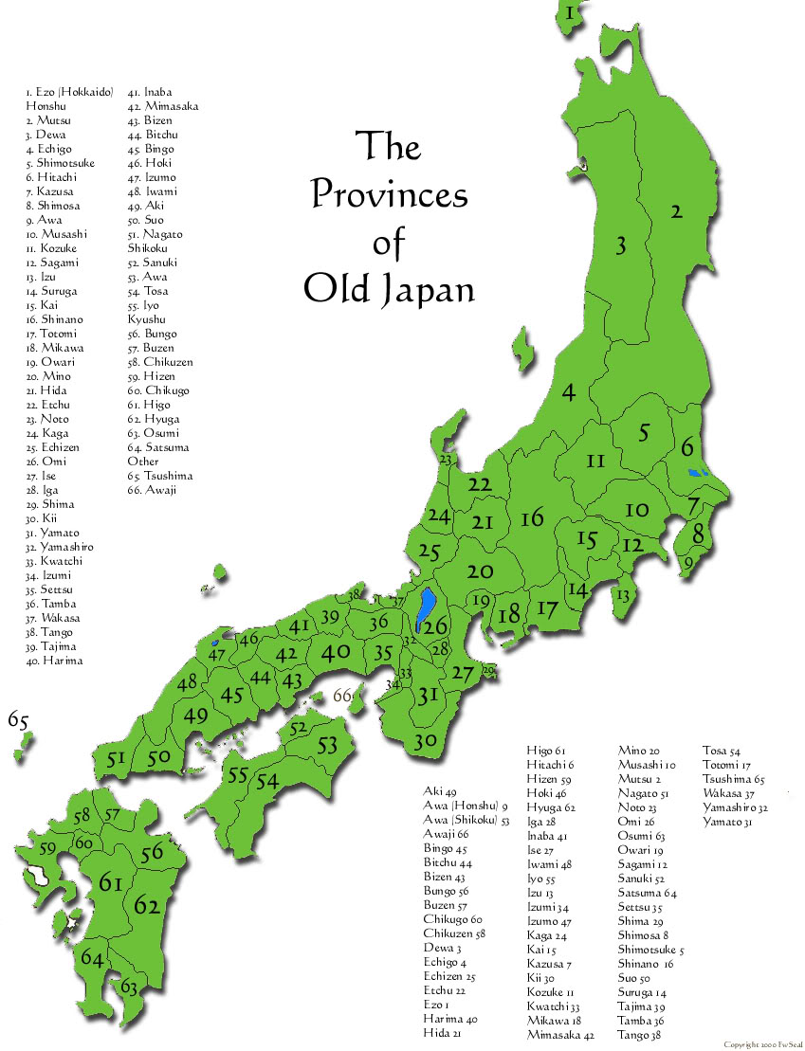

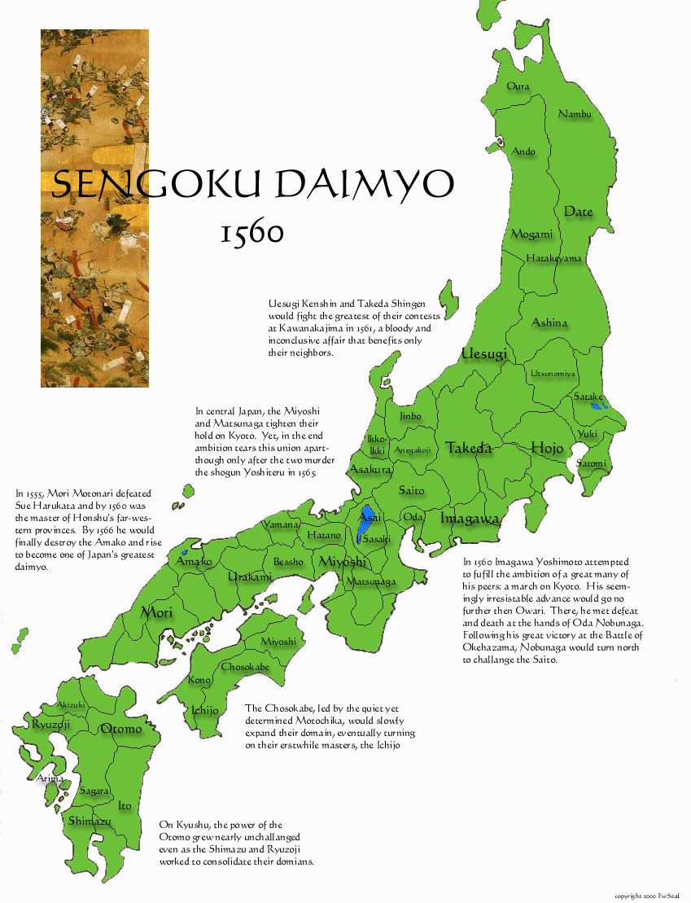

**Sources:**

Information from <http://en.wikipedia.org/wiki/Sengoku_period>

Sources of that information:

Sansom, George B. 2005. *A History of Japan: 1334-1615*. Tokyo: Charles E. Tuttle Publishing.

***a*** ***b*** ***c*** ["Sengoku period"](http://rekishi.jkn21.com/). *Encyclopedia of Japan*. Tokyo: Shogakukan. 2012. [OCLC](http://en.wikipedia.org/wiki/OCLC) [56431036](http://www.worldcat.org/oclc/56431036). Retrieved 2012-08-15.

^ ***a*** ***b*** ["誕"](http://rekishi.jkn21.com/). *Kokushi Daijiten* (in Japanese). Tokyo: Shogakukan. 2012. [OCLC](http://en.wikipedia.org/wiki/OCLC) [683276033](http://www.worldcat.org/oclc/683276033). Retrieved 2012-08-15.

**^** ["Ōnin War"](http://rekishi.jkn21.com/). *Encyclopedia of Japan*. Tokyo: Shogakukan. 2012. [OCLC](http://en.wikipedia.org/wiki/OCLC) [56431036](http://www.worldcat.org/oclc/56431036). Retrieved 2012-08-15.

<http://www.military-history.org/articles/samurai-wars/timeline-of-the-sengoku-period-japans-age-of-war.htm>

<http://www.jref.com/japan/history/sengoku_period.shtml>

**ALL DAIMYO BIOGRAPHY INFORMATION CAME FROM**

<http://www.samurai-archives.com/>

**MAPS:**

MAP #1: <http://www.samurai-archives.com/map.html>

MAP #2: <http://www.samurai-archives.com/1560.html>