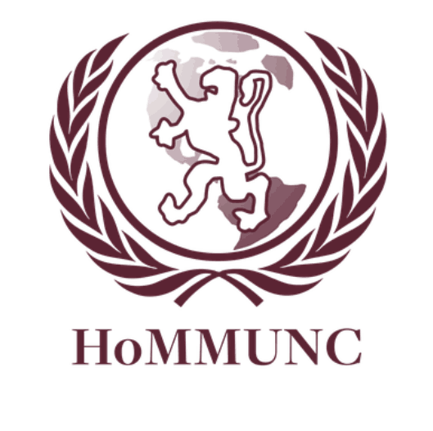

Security Council

Chair: David Shapiro

Moderator: Derek Chung

Dear Delegates,

My name is David Shapiro and I’m thrilled to be chair of the UNSC at this year’s HoMMUNC. I am a senior and one of Horace Mann MUN’s three Secretaries-General I’ve been on MUN since I was a freshman, and love debate and international relations. Other than MUN, I spend most of my time swimming with HM’s varsity team. Derek and I are looking forward to a day of heated and exciting debate on today’s most pertinent issues.

From Syria to Snowden, the day-to-day role the UNSC plays is ever more important. You should be updated on recent global events before coming to committee, as crisis updates will be relevant and frequent. With an open agenda, you will determine what we spend our time discussing. However, with such an array of pressing global concerns, I’m confident any topic we pursue will yield intense dialogue.

I’m looking forward to seeing where our committee leads, and how you will be able to cope with and find solutions to the real-world crises we currently face. IN the following background guide, you will find some suggested prevalent topics to start your research. However, delegates are free to propose a topic not contained within this guide, and are expected to conduct outside research. I know that we’ll have a very productive and exciting day, and can’t wait to meet you all.

Warm Regards,

David Shapiro

Chair, UNSC

Secretary-General, Horace Mann Model UN

david.shapiro@hommunc.org

Derek Chung

Moderator, UNSC

Operations Assistant, Horace Mann Model UN

derek.chung@hommunc.org

**Security Council Background Information**

The Security Council was created on the 26th of June 1945 when the United Nations Charter was signed. Under the charter, the Security Council has “the primary responsibility for the maintenance of international peace and security.” The council is also responsible for the agreement to accept and carry out the decisions of the Security Council and the regulation of armaments. The council has a total of 15 members, including 5 permanent members with veto power. The 5 permanent members are: China, France, Russia, the United Kingdom and the United States. Currently the 10 other members are: Argentina, Australia, Azerbaijan, Guatemala, Luxembourg, Morocco, Pakistan, Rwanda, South Korea and Togo. The Security Council has an open agenda, and determines the existence of a threat to the peace of the international community.

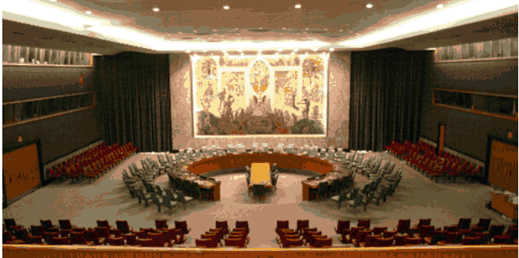

**Edward Snowden, NSA leaks, Asylum**

Edward Snowden is a former NSA technical contractor who is responsible for leaking classified information about American and British government surveillance programs. Snowden leaked information concerning cellphone interception and internet surveillance programs. On June 6th The Guardian and The Washington Post reported that the NSA had collected data from 120 million Verizon subscribers. Snowden also revealed the existence of secret government programs known as Prism and Tempora. Prism is a national security electronic surveillance program that has been run by the NSA since 2007. Prism allegedly monitors Internet users through Facebook, Google, Youtube, Skype, and other forms of social media. Tempora is a security electronic surveillance established in 2011 and operated by the British GCHQ. Snowden claims that the reason he leaked the information (and by doing so giving up his entire life) was to reveal the extent and danger of government surveillance. In an interview he is quoted saying: “I can’t allow the US Government to destroy privacy and internet freedom” He is also quoted saying that “I have no intention of hiding who I am because I know I have done nothing wrong.”

On June 14th, Edward Snowden was charged with espionage and theft of government property. On May 20th 2013, Edward Snowden left Hawaii (where he worked) for Hong Kong. This caused tension between the U.S. government and the Chinese government. The Obama Administration warned Chinese officials that allowing Edward Snowden to leave Hong Kong would have negative consequences. Despite these warnings, Chinese Officials showed support for Snowden’s actions and he was allowed to travel to Russia unimpeded. On June 23rd he arrived in Moscow where is believed to be currently. This also prompted conflict between American and Russian officials. The Obama Administration demanded that Snowden be extradited; however, Vladimir Putin rebuffed their demands. Recently Russia has granted Edward Snowden temporary asylum, and allowed him to leave Moscow’s Sheremetyevo Airport on August 1st. The White House has expressed outrage towards this decision, and there are talks of the U.S. boycotting the G20 summit in Russia.

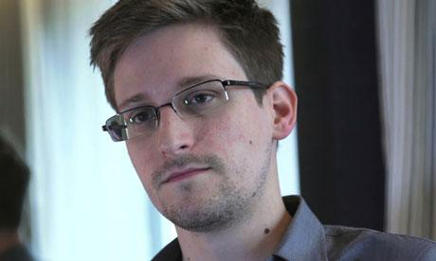

**Edward Snowden being interviewed in Hong Kong, June of 2013**

Snowden’s Asylum Controversy brings attention to International Asylum Law. Under Article 14 of the Universal Declaration of Human Rights all people are guaranteed the right “to seek and to enjoy in other countries asylum from persecution.” After his departure from the U.S. Snowden requested Asylum from 21 countries and the United States warned all countries not to grant Snowden’s request. Almost all countries immediately refused, and those who didn’t soon followed. Many smaller countries were be intimidated by the threats of the U.S. and coerced into making a decision. Now that Russia has granted Asylum to Snowden, there are many repercussions in the international community. There is massive U.S. support to delay bi-lateral talks with Russia, and many people have called for “serious repercussions”. It is also significant that Putin has granted a one year visa to Snowden. Granting Snowden permanent asylum would be detrimental to U.S. and Russian diplomatic relations. This one year asylum allows for Putin to appear politically strong by refusing the U.S. as well as not causing too much damage to bi-lateral diplomatic interests. On a small tangent, Edward Snowden was nominated for the Noble Peace Prize by a Swedish sociology professor named Stefan Svallfors. This exemplifies the mass support for his actions in the international community.

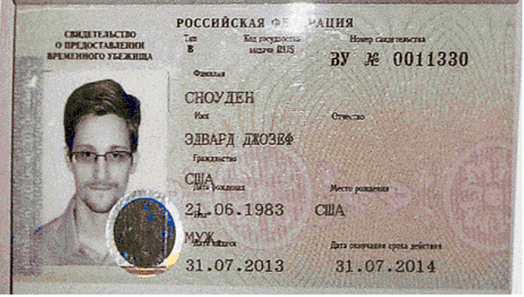

**Edward Snowden’s 1 year asylum papers**

**Protests in Egypt, Morsi Deposed by Military**

On November 2012 Egyptian President Mohammed Morsi issued a temporary constitutional declaration, granting his administration unlimited power. Thousands of protestors surrounded the presidential palace demanding that Morsi immediately step down. At the same time, supporters of the Morsi administration gathered in Cairo to show their support. The protests were originally peaceful, but turned violent once five protestors were killed. The Republican Guard surrounded the palace with military forces once violence between the protestors and supporters broke out. On December 8th 2012 Morsi annulled his temporary declaration, however it was a cursory gesture as very little changed. On July 3rd the Egyptian Armed Forces announced the end of Morsi’s presidency and that another election would be held shortly.

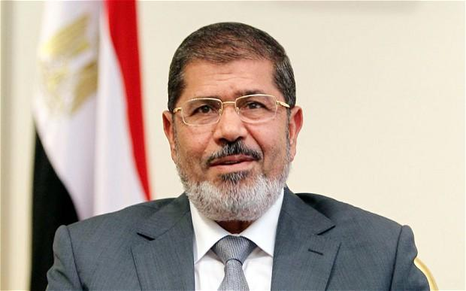

**Mohammed Morsi**

Mohammed Morsi is considered to be the first democratically elected president of Egypt. Following his controversial constitutional declaration and mass protest, Egyptian Armed Forces issued a 48 hour ultimatum (ending on July 3) for the countries political parties to meet the protestors’ demands. After the ultimatum was set, 4 ministers resigned their positions, leaving the Muslim Brotherhood in full control of the government. Morsi rejected the ultimatum on July 2nd and was removedfrom power by General Abdul Fatah al-Sisi on the 3rd. Adly Mansour (former Chief Justice) was declared the interim president of Egypt pending another democratic election. Morsi was placed under house arrest, and other Muslim Brotherhood government officials were arrested. Police forces took pro-morsi television shows off the air as well as shut down Muslim Brotherhood affiliated channels and arrested pro-morsi journalists.

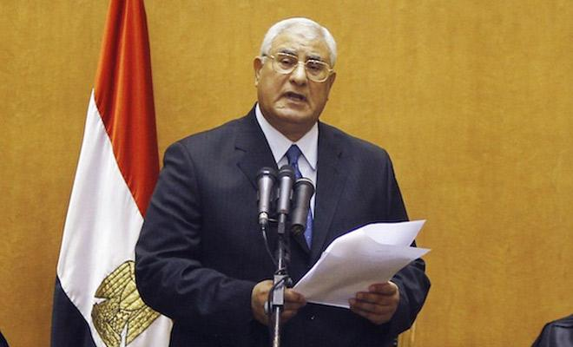 **Former Chief Justice and Interim President Adly Mansour**

Following Morsi’s removal from power, protestors took to the streets demanding Morsi be reinstated as president. The Muslim Brotherhood’s spokesman called for “strictly peaceful” protests. Protestors contended the legitimacy of the military coup, and violent demonstrations began to take place. By July 4th, hundreds of people had been injured through the protests. On July 5th, Muslim Brotherhood supporters rallied across Egypt for what is known as the “Friday of Rejection.” Clashes between the police and protestors turned violent, as police forces fired into crowds. At least 36 protestors were killed, and thousands were left injured. On July 8th, police forces allegedly killed 54 Morsi demonstrators by firing upon them during their dawn prayers. Police Forces claim that terrorists attempted to attack them, leading to the death of a police officer. Similarly on July 27th, 82 protestors were killed when police forces fired into a pro-Morsi demonstration. With increasingly severe animosity between Morsi supporters and military forces, Egypt faces difficulty reaching national reconciliation.

**North Korean Nuclear Program, North Korean Sanctions, International Security**

On October 9th 2006, North Korean Officials announced that they had conducted their first ever nuclear weapon test. Soon after the United Nations Security Council passed UN Resolution 1718 to impose sanctions on North Korea in an attempt to deter its nuclear program. Through negotiations, North Korea agreed to shut down the Yongbyun reactor and IAEA confirmed that the reactor was indeed non-operational. In April 2009, North Korea launched a rocket they claimed was intended to put a satellite into orbit. The UN condemned this rocket launch, infuriating North Korea who promptly began to reactivate its nuclear program. On May 25th North Korea tested its second nuclear weapon. In 2012, North Korea held two more ballistic missiles tests it claimed were to put satellites into orbit. In February 2013, North Korea held its third nuclear weapons test. The combination of these events has caused an increased tension between North and South Korea, as well as many other allied and local countries in the international community. North Korea’s threats of its preparedness to launch a nuclear weapon has put many countries at unease.

This January, North Korea announced its intentions to target the United States with its nuclear program. Barrack Obama warned North Korea that there would be sever consequences if it continued to further its nuclear program. During the Foal Eagle Training exercise in March,(a joint American and South Korean Military exercise). North Korea threatened to abandon the Korean Armistice Agreement claiming that the exercise put them at risk. A few days later North Korea withdrew from all non-aggression pacts in response to United Nations Security Council Resolution 2094.

On March 20th there was a large scale cyber attack against South Korea. Major television stations and banks were shut down with frozen terminals. South Korean Officials have confirmed that this attack originated from North Korea, as it was very similar to other attacks that occurred on 2009 and 2011. The incident has been linked to a Chinese IP address which North Korean hackers have been known to use to hide themselves. The Malware associated with this attack is known as “Dark Seoul” and was first used a year ago. The cyber attack paralyzed many banking systems, halting all operations and deleting files.

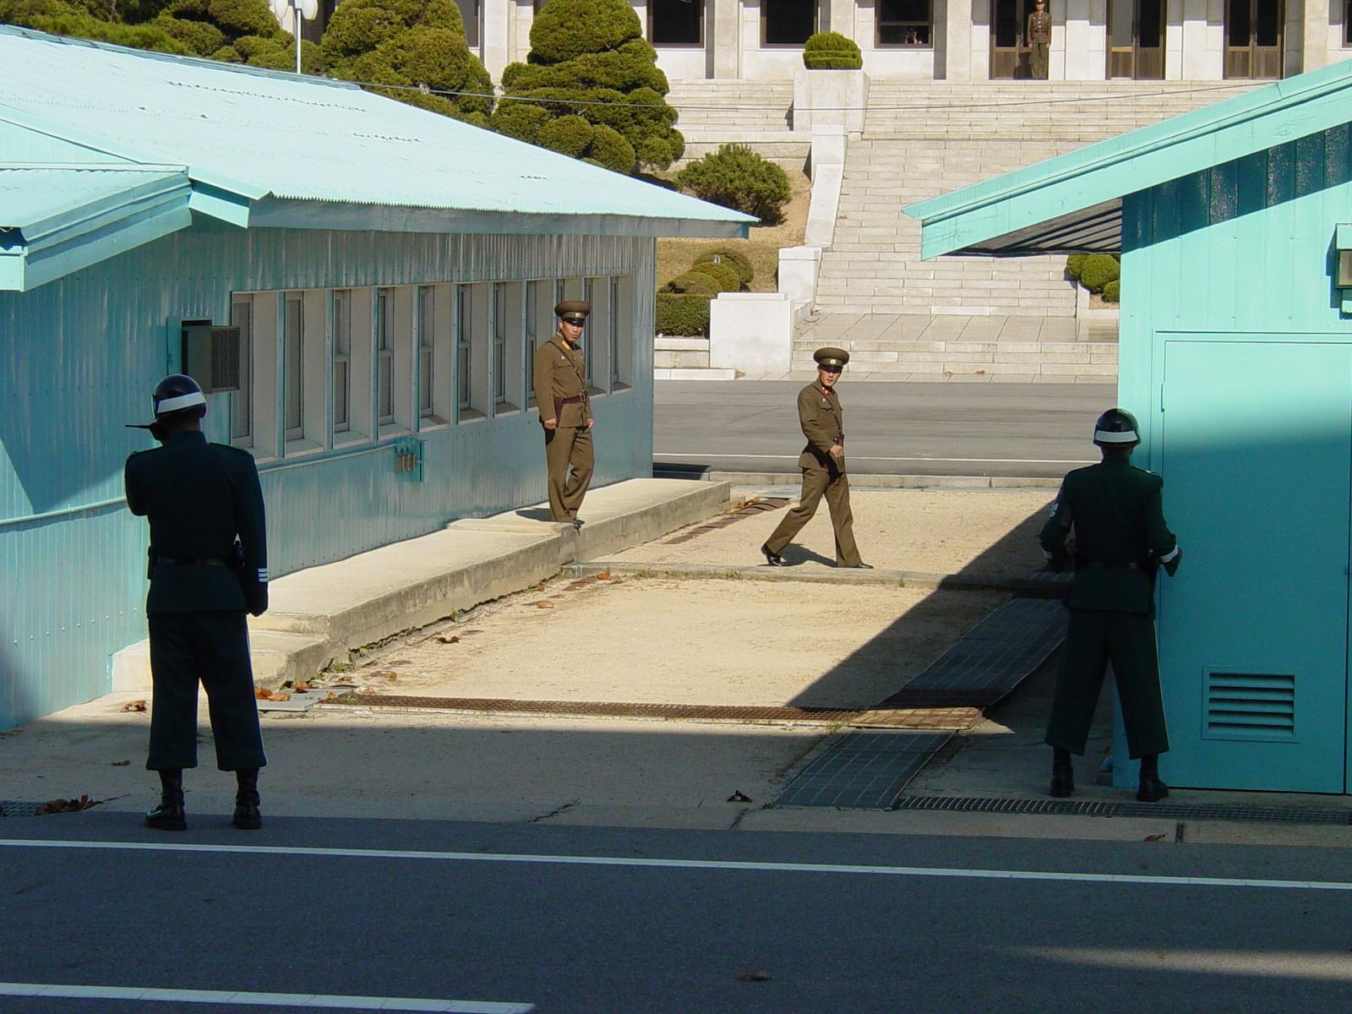

**North and South Korean Guards standing at opposite ends of the DMZ**

The continued aggression of North Korea has prompted action from all countries involved in the area. United States forces have flown stealth bombers over the Korean Peninsula to “clearly demonstrate United States ability to conduct long range, precision strikes quickly and at will.” Japan has also deployed 3 Japanese Maritime Self Defense Force destroyers into the local area. In response North Korea severed the North/South hotline, ending all communication between the two countries. On March 30th North Korea declared a state of war against South Korea, promising “stern retaliation” towards “any provocation act.” The United States Department of Defense states that “the United States is fully capable of defending itself and our allies against a North Korean attack. We are firmly committed to the defense of South Korea and Japan."

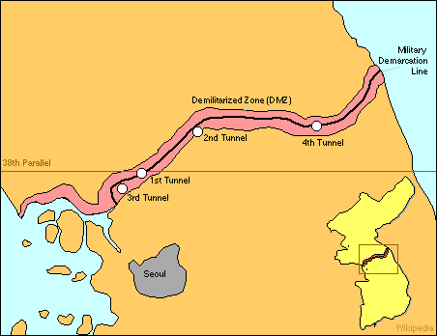

**A map showing the DMZ, Seoul is only 35 miles away from the border.**