**High Performance Computing Lab**

**Practical No. 8**

**Name:** Sahil Santosh Otari

**PRN:** 2020BTECS00025

**Batch:** B2

**Title of practical:** Implementation of Vector-Vector addition & N-Body Simulator using CUDA C

**Problem Statement 1:**

Implement Vector-Vector addition using CUDA C. State and justify the speedup using different size of threads and blocks.

Code:

%% cu

#include <stdio.h>

__global__ void addVector(int *v1, int *v2, int *result, int N)

{

    int i = threadIdx.x;

    if (i < N)

    {

        result[i] = v1[i] + v2[i];

    }

}

int main()

{

    int N = 100;

    int v1[N], v2[N], result[N];

    for (int i = 0; i < N; i++)

    {

        v1[i] = 1;

        v2[i] = 2;

    }

    //  initializing poiters for device vectors

    int *d_v1, *d_v2, *d_result;

    // allocating memory for the device vectors

    cudaMalloc(&d_v1, N * sizeof(int));

    cudaMalloc(&d_v2, N * sizeof(int));

    cudaMalloc(&d_result, N * sizeof(int));

    // copying from host to device

    cudaMemcpy(d_v1, v1, N * sizeof(int), cudaMemcpyHostToDevice);

    cudaMemcpy(d_v2, v2, N * sizeof(int), cudaMemcpyHostToDevice);

    addVector<<<1, N>>>(d_v1, d_v2, d_result, N);

    cudaDeviceSynchronize();

    // copying from device to host

    cudaMemcpy(result, d_result, N * sizeof(int), cudaMemcpyDeviceToHost);

    for (int i = 0; i < N; i++)

    {

        printf("%d ", result[i]);

    }

    return 0;

}

**Result:**

Problem size = 32, number of threads = n/2

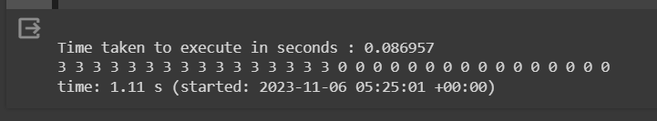

Problem size = 32, number of threads = n

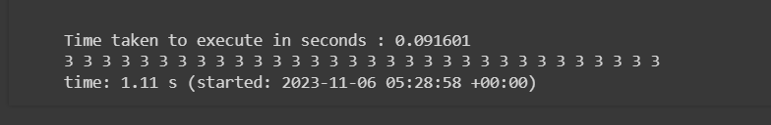

Problem size = 64, number of threads = n/2

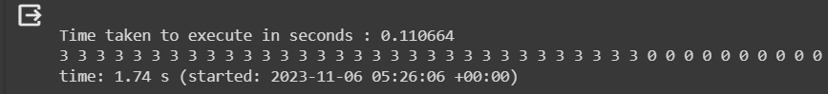

Problem size = 64, number of threads = n

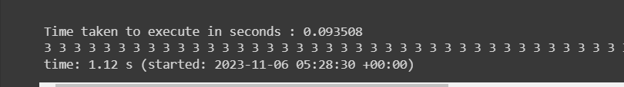

Problem size = 128, number of threads = n/2

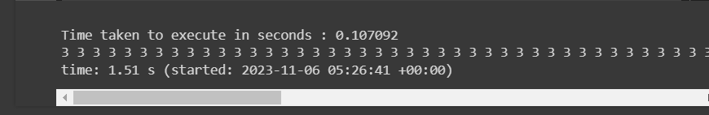

Problem size = 128, number of threads = n

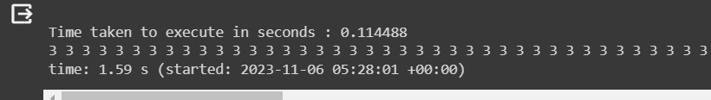

Problem size = 256, number of threads = n/2

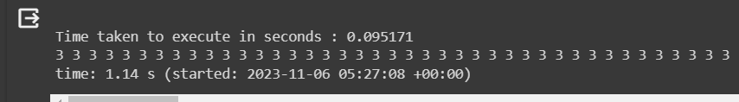

Problem size = 256, number of threads = n

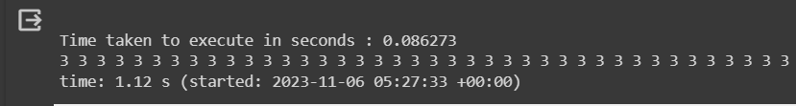

**Speedup analysis:**

|  |  |  |
| --- | --- | --- |
| **Number of threads** | **Data Size** | **Execution time** |
| N/2 | 32 | 0.086957 |
| N | 32 | 0.091601 |
| N/2 | 64 | 0.110664 |
| N | 64 | 0.093508 |
| N/2 | 128 | 0.107092 |
| N | 128 | 0.114488 |
| N/2 | 256 | 0.095071 |
| N | 256 | 0.086273 |

For performing addition of two vectors, two different ways are implemented.

i) One block is used consisting of n threads. In this case, each thread will perform the addition of one element each.

ii) One block is used consisting of n/2 threads. So, in this case, each thread needs to execute the addition of two elements.

On performing the comparison, we can see that the execution time for N threads is better than N/2 threads as here we are using dedicated thread for each element of the vector.

**Problem Statement 2:**

Implement N-Body Simulator using CUDA C. State and justify the speedup using different size of threads and blocks.

**Code:**

%% cu

#include <stdio.h>

#include <math.h>

#include <stdlib.h>

const float G = 6.67430e-11; // Gravitational constant

const float SOFTENING = 1e-9; // Softening factor to avoid singularities

__global__ void computeForces(float* positions, float* forces, int numParticles, float* mass) {

    int idx = blockIdx.x * blockDim.x + threadIdx.x;

    if (idx < numParticles) {

        float myPositionX = positions[2*idx];

        float myPositionY = positions[2*idx+1];

        forces[2*idx] = 0.0f;

        forces[2*idx+1] = 0.0f;

        for (int j = 0; j < numParticles; j++) {

            if (j != idx) {

                float deltaX = positions[2*j] - myPositionX;

                float deltaY = positions[2*j+1] - myPositionY;

                float dist = sqrt(deltaX*deltaX + deltaY*deltaY);

                float force = G * mass[idx] * mass[j] / (dist * dist + SOFTENING*SOFTENING);

                forces[2*idx] += force * deltaX / dist;

                forces[2*idx+1] += force * deltaY / dist;

            }

        }

    }

}

int main() {

    const int numParticles = 100;

    const int numIterations = 1000;

    float* h_positions;

    float* h_forces;

    float* d_positions;

    float* d_forces;

    float* d_mass;

    size_t size = 2 * numParticles * sizeof(float);

    h_positions = (float*)malloc(size);

    h_forces = (float*)malloc(size);

    // Initialize positions and masses (for simplicity, all masses are set to 1)

    for (int i = 0; i < 2 * numParticles; i++) {

        h_positions[i] = rand() / (float)RAND_MAX;

    }

    float* h_mass = (float*)malloc(numParticles * sizeof(float));

    for (int i = 0; i < numParticles; i++) {

        h_mass[i] = 1.0f;

    }

    cudaMalloc(&d_positions, size);

    cudaMalloc(&d_forces, size);

    cudaMalloc(&d_mass, numParticles * sizeof(float));

    cudaMemcpy(d_positions, h_positions, size, cudaMemcpyHostToDevice);

    cudaMemcpy(d_mass, h_mass, numParticles * sizeof(float), cudaMemcpyHostToDevice);

    int threadsPerBlock = 256;

    int blocksPerGrid = (numParticles + threadsPerBlock - 1) / threadsPerBlock;

    for (int iter = 0; iter < numIterations; iter++) {

        computeForces<<<blocksPerGrid, threadsPerBlock>>>(d_positions, d_forces, numParticles, d_mass);

        // Update positions based on forces and velocities

        // You should implement this based on your specific scenario.

        // Reset forces for the next iteration

        cudaMemset(d_forces, 0, size);

    }

    cudaMemcpy(h_positions, d_positions, size, cudaMemcpyDeviceToHost);

    // Print out the positions after the simulation

    for (int i = 0; i < numParticles; i++) {

        printf("Particle %d: x = %f, y = %f\n", i, h_positions[2*i], h_positions[2*i+1]);

    }

    // Clean up

    free(h_positions);

    free(h_forces);

    free(h_mass);

    cudaFree(d_positions);

    cudaFree(d_forces);

    cudaFree(d_mass);

    return 0;

}

Result:

