Sahil Palnitkar
UIN: 726001905

1)
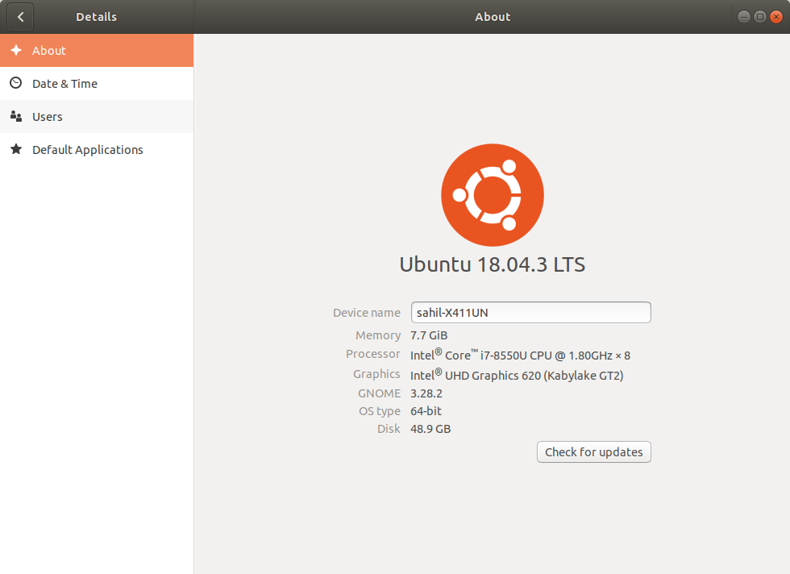

2) The command for compiling a cpp file with a specific output name is -
g++ buggy.cpp -o buggy

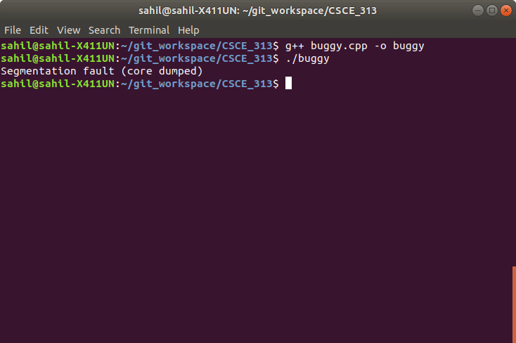
4)
5) The command for compiling a cpp file in debug mode is -
g++ -g buggy.cpp -o buggy

6)
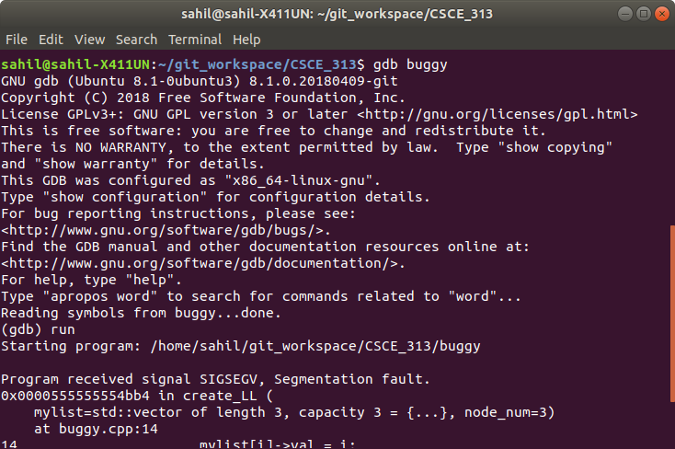
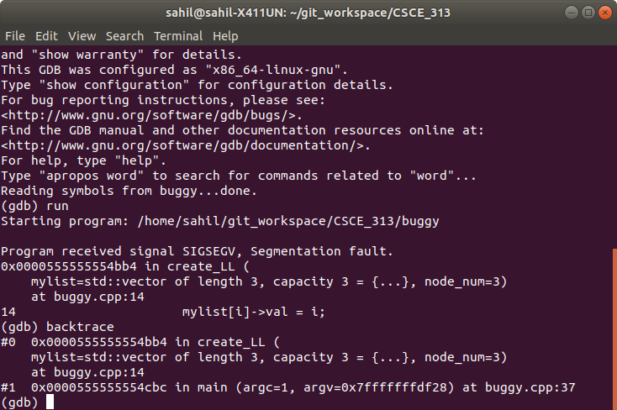
7)
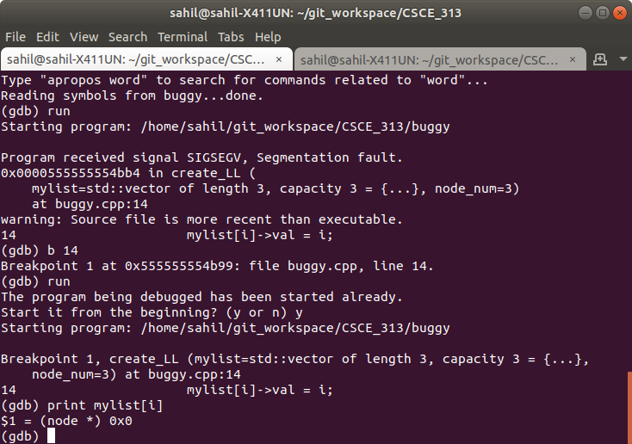

8) The value stored in mylist[i]->val is 0.

9) On line 25 of the file, the linked list is being created. It is linking the first node in the vector to the second, the second to the third and so on. The last node in the vector attempts to link to a node that is out of the range of the vector, causing a segmentation fault. Editing the code makes the last node in the vector point to NULL, eliminating the segmentation fault.

