Draft for the authors (not for submission as is). Prepared with an AI assistant from the repository at commit 42de28b. Rewrite every paragraph in your own words before submission (AME requires a signed anti-ghostwriting declaration), then move the text into the AME LaTeX template. Yellow items in square brackets are open. Every number was taken from the files in results/ and paper/tables/.
Keywords: swarm robotics, formation control, graph neural networks, imitation learning, DAgger, human–swarm interaction, partial observability
Sahil PANCHAVISHE¹, Yashwardhan ABHALE¹, Ishan ZADBUKE¹, Vivek KHANDELWAL¹, Anshul JAIN^{1,*}
¹ COEP Technological University, Pune, Maharashtra, India
* Corresponding author: anshul_ajmera2007@yahoo.co.in
ORCID: [ADD for all five authors]

How far must a gesture command travel? Message-passing depth for decentralised formation control of a partially informed robot swarm
Abstract
A human gesture can select a target formation for a robot swarm, but often only a few robots see it. We study how far that command must travel through the communication graph for a learned decentralised controller to succeed. Eight simulated e-puck robots form one of four formations. The gesture, a one-hot token, reaches only 25 %, 50 % or 100 % of the robots. Graph neural network (GNN) policies with K = 0 to 3 message-passing layers are trained by imitation learning with DAgger and tested on 600 paired episodes per model. At 25 % observability, two layers beat one by 25.2 percentage points (97.5 % vs 72.3 % success; 95 % CI 18.2–32.7; Holm-corrected p < 0.0001). About 16 points of this gap also appear with full observability, so network capacity explains part of it. A third layer adds no significant success but raises collision-free success from 47.5 % to 85.7 %. The GNN beats a memoryless token relay only at 25 % observability, and a relay with a one-bit memory matches the best learned policy with no contact. Exploratory tests suggest that memoryless policies use the robots' own positions as a memory of the command.

1. Introduction
Robot swarms are meant to work without a central controller: each robot acts on what it senses and on what its neighbours tell it [1]. Formation control, in which robots take up a geometric arrangement, is one of the basic tasks of such systems [2]. When a human directs the swarm, for example by a hand gesture, a new problem appears [3, 4]. Only some robots may see the operator, so the command has to spread through local communication before the whole swarm can act on it. Our earlier work used camera-based gesture recognition with decentralised behaviours on low-cost robots [5]. It did not ask how far the command must travel, or what a learned controller adds over simply relaying it.
Passing information over a communication graph is a classic topic in networked control [6]. Graph neural networks (GNNs) offer a learned version: each layer lets a robot combine information from its neighbours, so K layers reach K hops. GNN controllers trained by imitating a centralised expert have been used for swarm flocking [7], multi-robot path planning [8] and formation control [9]. In these studies the task is known to every robot. [CHECK against refs 7–9 and the two 2026 papers] They do not isolate the case in which the task itself is known only to a few robots and must be propagated.
This paper studies that case in a controlled simulation. Eight differential-drive robots must assemble one of four formations. A gesture, modelled as a one-hot token, is seen by 100 %, 50 % or 25 % of the robots. We train GNN policies with K = 0, 1, 2 and 3 message-passing layers by behaviour cloning followed by DAgger [10], and compare them on the same test episodes with an expert that knows the formation and with hand-designed relays that pass the token K hops. The contributions are:
- A paired, pre-specified comparison of message-passing depth under partial observability, with three training seeds, per-seed exact McNemar tests and Holm correction.
- A measurement of how much of the depth effect remains with full observability, which separates gesture propagation from network capacity only in part and states the confound openly.
- A comparison against two families of no-learning relays, which shows when a learned controller helps and when a one-bit memory is enough.
- Evidence from token ablation and token removal that the policy routes the gesture through the graph, and that a memoryless policy appears to use its own position as a memory of the command.
- An open repository in which every reported number is recomputed from raw episode files by a script.
Section 2 reviews related work. Section 3 describes the task, the robot model, the policies, their training and the statistics. Section 4 reports the results, Section 5 discusses them, and Section 6 lists the limitations and the deviations from the original plan.

2. Related work
Formation control and information spreading. Formation control is usually designed by hand, from consensus and potential-field methods [2]. Our expert is a potential-field controller of the kind introduced for obstacle avoidance by Khatib [11]. Consensus theory describes how a quantity known to some agents spreads over a communication graph [6]. Our relay baselines are the simplest form of this: the token is flooded K hops per control step.
Human–swarm interaction. Kolling et al. survey how humans command swarms and note that the operator often reaches only part of the swarm [3]. Alonso-Mora et al. used gestures to steer a multi-robot display [4]. Our own earlier system recognised gestures with MediaPipe and drove decentralised behaviours [5]. Here the gesture is abstracted to a one-hot token so that the study isolates propagation and control; recognition errors are outside its scope.
Learned decentralised control. Message-passing neural networks [12] let each node combine its neighbours' states over K rounds. Tolstaya et al. trained GNN controllers for robot swarms by imitating a centralised expert [7]. Li et al. used GNNs with imitation learning for decentralised multi-robot path planning [8], and Jiang et al. applied a GNN-based learning method to decentralised formation control [9]. DAgger [10] reduces the compounding error of behaviour cloning by relabelling states that the learner visits. [ADD 2–4 sentences on the 2026 RAS and 2026 ICRA papers and on work with partial task observability]
Gap. We found no study that varies the share of robots that know the task, measures the required message-passing depth, and compares the learned policy against relays on the same episodes. [CHECK after the literature reading]

3. Methods

3.1. Task and information model
Eight differential-drive robots must assemble one of four formations: circle, line, cluster or split (Fig. 1). A gesture selects the formation. Only the observers, round(ρ·8) robots for observability ρ ∈ {100 %, 50 %, 25 %}, receive it; that is 8, 4 or 2 robots. The others can learn it only from neighbours. Two robots are connected when their centre distance is at most R_{comm} = 0.50 m; the undirected graph is recomputed at every control step. Every robot knows its own world-frame position and its fixed role (robot i takes slot i), so the setting is not free of global information. What a non-observer lacks is only which formation was chosen.
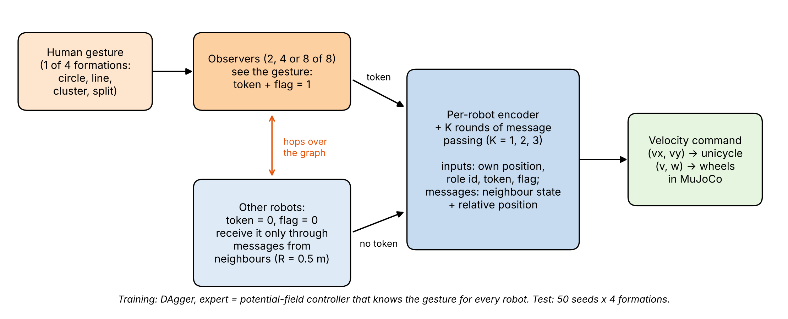
Fig. 1. Task and method overview. Observers (2, 4 or 8 of the 8 robots) receive the gesture as a 4-way one-hot token with a flag; the other robots receive it only through messages from neighbours within R_{comm} = 0.5 m. Each robot encodes its own state, runs K rounds of message passing and outputs a velocity command, which a heading controller converts to wheel speeds in MuJoCo.

3.2. Robot and simulation model
All experiments run in MuJoCo 3.17.0 [13], headless, in a 2.2 m × 2.2 m arena with walls. No official e-puck model exists for MuJoCo, so we built one from the published dimensions [14]. Table 1 lists every constant. A policy outputs a planar velocity u, which a heading controller converts to a forward speed v and a turn rate ω:
ω = k_{ω} e_{θ}, v = min(‖u‖, v_{max}) · max(cos e_{θ}, 0) (1)
where e_{θ} is the angle between the heading and u. The pair is scaled so that both wheel speeds stay within their limit. We compared the simulated robot with ideal unicycle kinematics in three tests (Table 2, Fig. 2). Path lengths and yaw angles differ by −3.5 % on a straight path, −3.2 % when spinning in place, and −2.3 % (path) and −8.0 % (yaw) on an arc, mainly because of motor start-up lag.
Table 1. Simulation, task and training constants.
Quantity | Value
Robots, arena | N = 8 e-puck models; 2.2 m × 2.2 m with walls
Wheel radius, axle length, robot radius | 0.0205 m, 0.052 m, 0.037 m
Wheel speed limit (max. forward speed) | 6.28 rad/s (v_{max} = 0.1287 m/s)
Wheel actuator | velocity gain 0.05, torque cap 0.004 N·m; chassis mass 0.15 kg
Physics / control step | 0.004 s / 0.032 s
Heading gain k_{ω} | 4.0 s⁻¹
Communication range R_{comm} | 0.50 m
Start box, min. separation | [−0.5, 0.5]² m, 0.15 m, random headings
Horizon | 1100 control steps (35.2 s)
Success / contact threshold | mean final slot error < 0.025 m / centre distance < 0.074 m
Expert gains | k_{att} = 2.8 s⁻¹, k_{rep} = 5×10⁻³, r_{inf} = 0.12 m, k_{tan} = 0.5
GNN hidden size; parameters (K = 0, 1, 2, 3) | 64; 23 170, 44 034, 64 898, 85 762
Demonstrations | 1200 episodes (300 per formation), states every 4th step
Behaviour cloning | smooth-L1 (β = 0.1), Adam, one-cycle lr 2×10⁻³, batch 256, 30 epochs
DAgger | 3 rounds × 240 roll-outs, 10 epochs at lr 5×10⁻⁴
Training seeds; test set | 0, 1, 2; seeds 10000–10049 × 4 formations × 3 observability levels

Table 2. Validation of the MuJoCo e-puck model against ideal unicycle kinematics.
Test | Ideal path (m) | Measured path (m) | Path error (%) | Ideal yaw (rad) | Measured yaw (rad) | Yaw error (%) | End-position error (m)
Straight, v = 0.10 m/s, 3 s | 0.301 | 0.290 | −3.5 | 0.000 | 0.000 | – | 0.010
Spin, ω = 2 rad/s, 2 s | 0.000 | 0.005 | – | 3.968 | 3.841 | −3.2 | 0.001
Arc, v = 0.08 m/s, ω = 0.5 rad/s, 4 s | 0.320 | 0.313 | −2.3 | 2.000 | 1.840 | −8.0 | 0.028

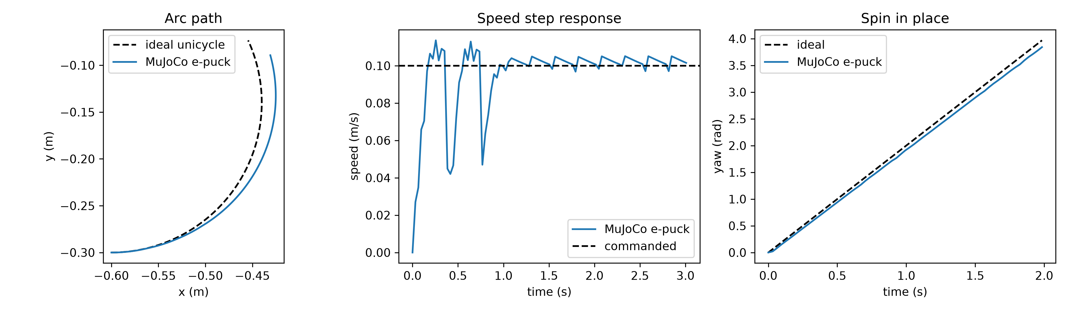
Fig. 2. Model validation. (a) Arc path of the MuJoCo e-puck against the ideal unicycle; (b) speed response to a 0.10 m/s step command; (c) yaw angle when spinning in place at 2 rad/s.

3.3. Formations, episodes and metrics
The circle has radius 0.45 m; the line has 0.20 m spacing on the x axis; the cluster is a 2 × 4 grid with 0.15 m spacing; the split is two 2 × 2 blocks with 0.15 m spacing centred at x = ±0.6 m (Fig. 3). Starts are uniform in [−0.5, 0.5]² m with at least 0.15 m between robots and random headings. We use this 1.0 m start box because with a 1.8 m box only 1.25 % of random starts form a connected graph at R_{comm} = 0.5 m, against 76.45 % for the 1.0 m box (Fig. 4). The horizon is 1100 control steps (35.2 s). The same episode seed gives the same starts and the same observers to every policy, so all comparisons are paired.
Success is a mean final slot error below 0.025 m. Contact is any centre distance below 0.074 m (two robot radii) during the episode. Collision-free success is success with no contact. We also report the minimum centre distance in each episode.
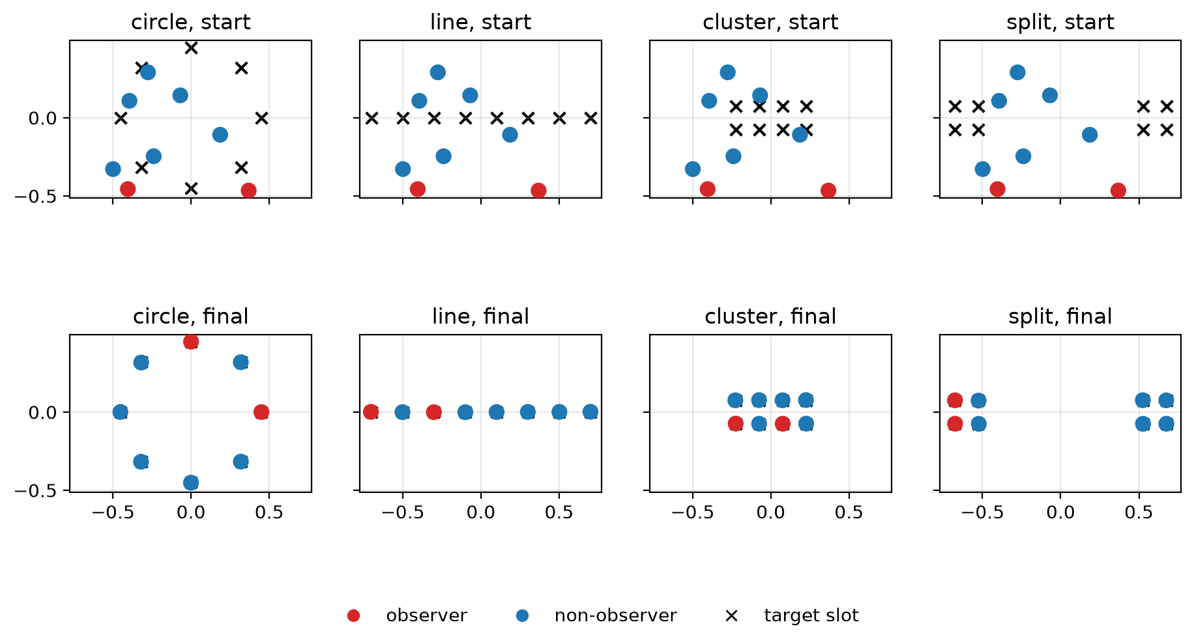
Fig. 3. Start (top) and final (bottom) configurations of the K = 2 GNN at 25 % observability for the four formations. Red: observers; blue: non-observers; crosses: target slots.
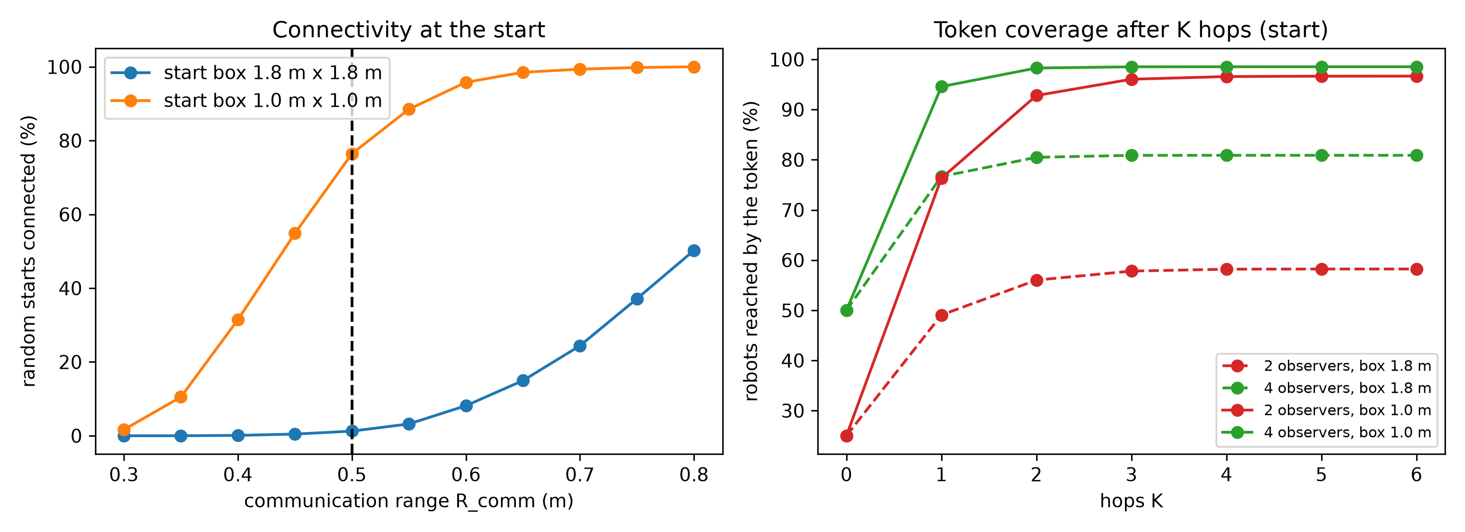
Fig. 4. (a) Share of random starts whose communication graph is connected, against R_{comm}, for the 1.0 m and 1.8 m start boxes; dashed line: R_{comm} = 0.5 m. (b) Share of robots reached by the token after K hops from 2 or 4 observers, for both start boxes.

3.4. Expert and relay baselines
The expert knows the formation and drives robot i at position p_{i} towards its slot s_{i}:
u_{i} = k_{att}(s_{i} − p_{i}) + Σ_{j} f_{rep}(d_{ij}) d̂_{ij} + k_{tan} Σ_{j} f_{rep}(d_{ij}) d̂_{ij}⊥ (2)
f_{rep}(d) = k_{rep} (1/d − 1/r_{inf}) / d² for d < r_{inf}, and 0 otherwise (3)
where d_{ij} = ‖p_{i} − p_{j}‖, d̂_{ij} is the unit vector from j to i and d̂⊥ is d̂ rotated by 90°. The repulsion follows the potential-field idea of [11]; the tangential term breaks symmetric deadlocks. The expert succeeds in all test episodes with no contact, with a mean convergence time of 8.7 s and a maximum of 14.8 s.
The relay baselines run the same expert. The token is flooded K hops per control step (K ∈ {0, 1, 2, 3, 7}; K = 7 is the largest possible hop count for eight robots), and robots that hold it go to their slot. In the memoryless relay a robot forgets the token as soon as no observer is within K hops, and uninformed robots hold still while avoiding others. The +mem relay keeps the token once received, which is one bit of memory per robot.

3.5. GNN policy
The input of robot i is its position divided by 1.1, a one-hot role vector (8 entries), the gesture token (4 entries) multiplied by a flag "knows the gesture", and the flag itself. A two-layer encoder (hidden size 64, ReLU) gives a hidden state h_{i}. Each of K message-passing layers [12] computes a message from h_{j} and the relative position (p_{j} − p_{i})/R_{comm} along each graph edge, sums the messages, divides them by 4, and updates h_{i} residually. A head maps h_{i}, the position and the role to a velocity in [−1, 1]², scaled by v_{max} and passed to the heading controller of Eq. (1). With K = 0 there is no message passing. In the latched ablation (K = 2), a robot also receives a bit that stays set once the token has reached it by K-hop flooding, which gives the policy an explicit memory of the gesture.

3.6. Training
The data are 1200 expert demonstrations (300 per formation). They are driven by the oracle or by memoryless K-hop relays (K = 1, 2, 3), so they include states in which some robots do not yet know the gesture. The labels are always the velocities of the oracle expert with every robot informed. States are stored every fourth control step and split 90/10 by episode. Behaviour cloning uses the settings of Table 1 (Fig. 5). DAgger [10] then runs three rounds: each rolls out the current policy on 240 training episodes, relabels every visited state with the oracle, adds it to the data and fine-tunes the network (Fig. 6). Every model is trained with seeds 0, 1 and 2. Seeds are split by purpose: 0–1199 for demonstrations, 1300–4299 for DAgger, 5000 and above for development checks, and 10000–10049 for testing.
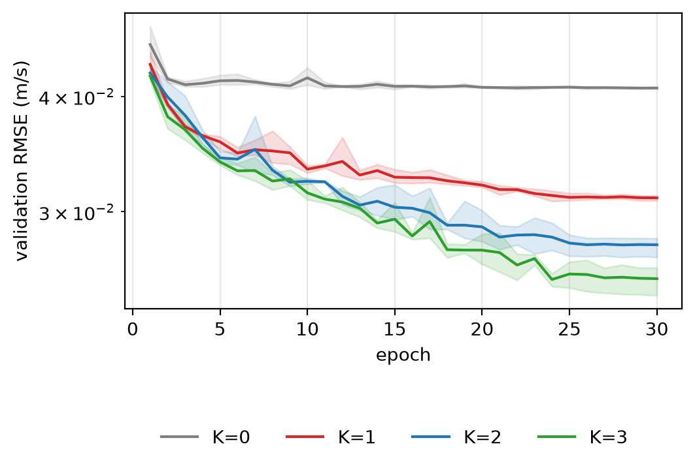
Fig. 5. Behaviour cloning: validation RMSE of the predicted velocity against epoch, for K = 0 to 3 (mean over three training seeds; band: range over seeds; logarithmic axis).
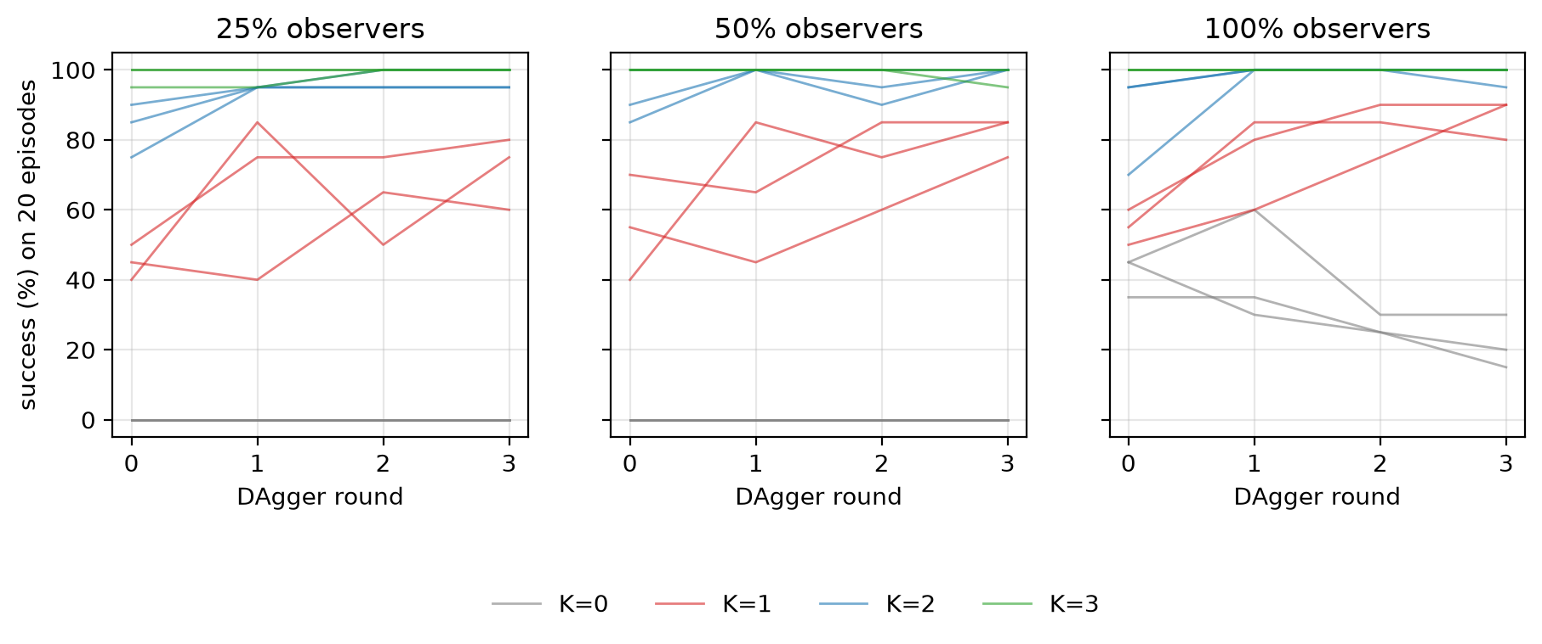
Fig. 6. DAgger: success on 20 development episodes after each round, at 25 %, 50 % and 100 % observers. One thin line per training seed.

3.7. Evaluation and statistics
Each trained model is tested on 50 seeds × 4 formations × 3 observability levels, that is 600 episodes per model and 200 per observability level. Success is compared with the exact McNemar test [15] and the final error with the two-sided Wilcoxon signed-rank test [16], separately for each training seed: GNN seed s is compared with the other GNN's seed s, and a relay with every seed. A comparison is called significant only if it is significant in every seed, so its p-value is the largest per-seed value. These p-values are Holm-corrected [17] over a family of 16 comparisons fixed in advance. The primary hypothesis, also fixed before any experiment, is that K = 2 has a higher success rate than K = 1 at 25 % observability. Intervals are two-level bootstrap intervals [18] that resample both the test scenarios (formation, seed) and the training seeds (5000 resamples).
With the exact McNemar test, the smallest attainable p-value depends on the number of discordant pairs. With five discordant pairs per seed it is 0.0625, so such a comparison cannot reach significance under our rule; we mark these cases. The token ablation (Section 4.5), the comparison of plain imitation with DAgger (Section 4.6), contact (Section 4.7) and two analyses designed after the main results (Sections 4.8 and 4.9) are exploratory and descriptive.

4. Results
Two message-passing layers are needed at low observability, a third adds safety rather than success, and a relay with one bit of memory matches the best learned policy. Table 3 gives every success rate and Table 4 the 16 pre-specified comparisons.
Table 3. Success, collision-free success, contact and minimum centre distance. GNN rows: 3 training seeds × 200 episodes per observability level; relays and expert: 200 episodes. Brackets: 95 % two-level bootstrap intervals. Relays were evaluated at 50 % and 25 % observability, the expert at 100 %.
Policy | Success 100 % obs. (%) | Success 50 % obs. (%) | Success 25 % obs. (%) | Collision-free success 25 % (%) | Contact 25 % (%) | Median min. distance 25 % (mm)
Expert (oracle) | 100.0 | – | – | 100.0* | 0.0* | 89.0*
Relay K = 1 | – | 85.5 [80.5, 90.0] | 39.0 [32.5, 46.0] | 39.0 | 0.0 | 90.4
Relay K = 2 | – | 97.0 [94.5, 99.0] | 85.5 [81.0, 90.0] | 85.5 | 0.0 | 89.3
Relay K = 3 | – | 98.5 [96.5, 100.0] | 89.0 [84.5, 93.0] | 89.0 | 0.0 | 89.2
Relay K = 7 | – | 98.5 [96.5, 100.0] | 89.5 [85.0, 93.5] | 89.5 | 0.0 | 89.2
Relay K = 1–7, +mem | – | 99.5 [98.5, 100.0] | 100.0 | 100.0 | 0.0 | 89.1–89.2
GNN K = 0 | 17.0 [10.2, 24.7] | 0.2 [0.0, 1.0] | 0.0 | 0.0 | 92.0 | 73.7
GNN K = 1 | 83.5 [77.0, 89.0] | 79.0 [72.5, 84.8] | 72.3 [65.0, 79.0] | 11.2 | 87.3 | 73.6
GNN K = 2 | 99.5 [98.3, 100.0] | 98.2 [95.7, 99.8] | 97.5 [95.7, 99.0] | 47.5 | 51.7 | 74.0
GNN K = 3 | 99.8 [99.0, 100.0] | 99.8 [99.0, 100.0] | 99.0 [97.5, 100.0] | 85.7 | 13.3 | 82.8
GNN K = 2, latched | 100.0 | 100.0 | 100.0 | 96.0 | 4.0 | 86.9
* Expert at 100 % observability. Relay K = 0 never succeeds (0.0 % at 50 % and 25 %). Source: paper/tables/table1_success_d13.csv.

4.1. Reference points
The expert succeeds in all 200 test episodes (100 % observability) with no contact. Without communication (K = 0) no relay succeeds. At 25 % observability the memoryless relay reaches 39.0 %, 85.5 %, 89.0 % and 89.5 % for K = 1, 2, 3 and 7, and every relay with memory reaches 100 %. The coverage of the communication graph explains the shape of these curves (Fig. 7). From two observers, a token reaches on average 76.3 % of the robots in one hop, 92.8 % in two and 96.0 % in three, and all eight robots in 12.8 %, 65.0 % and 80.8 % of starts. With four observers the figures are 94.6 %, 98.3 % and 98.5 % of robots, and 64.6 %, 88.6 % and 90.4 % of starts.
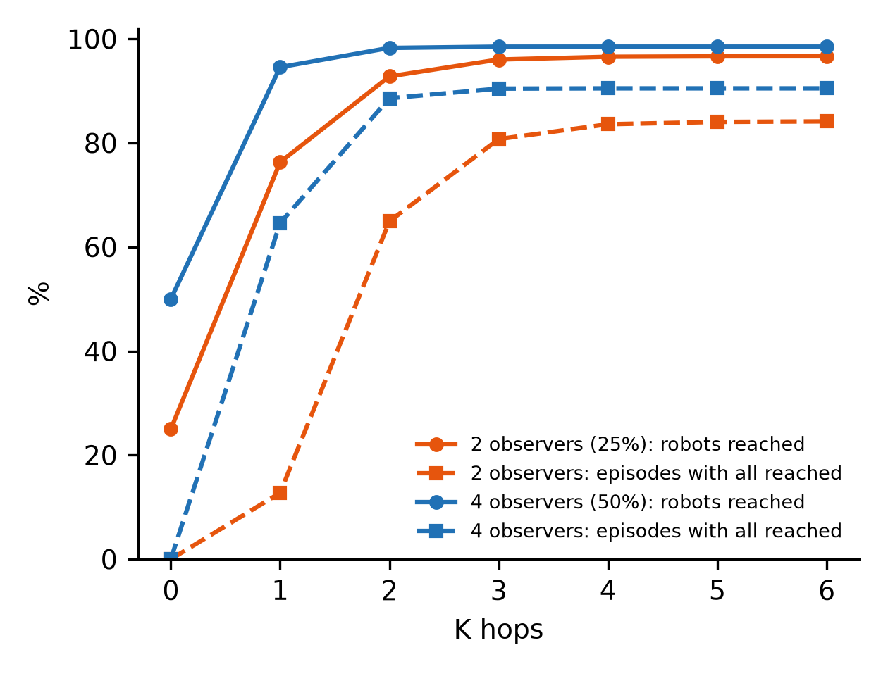
Fig. 7. Token coverage at the start of an episode (1.0 m start box) after K hops: share of robots reached (solid) and share of episodes in which all eight robots are reached (dashed), for 2 and 4 observers.

4.2. Primary result: K = 2 against K = 1
At 25 % observability K = 2 succeeds in 97.5 % of episodes and K = 1 in 72.3 % (Fig. 8, Fig. 9). The paired difference is 25.2 percentage points (95 % CI 18.2–32.7; Holm p < 0.0001) and the mean final error falls by 22.0 mm. Every training seed agrees: the per-seed differences are 22.0, 31.0 and 22.5 points. K = 2 reaches 97.5 % in each seed, while K = 1 reaches 75.5 %, 66.5 % and 75.0 %, so one-layer training runs differ by about 9 points. At 50 % observability the gap is 19.2 points (CI 13.0–26.3). Without communication (K = 0) the GNN never succeeds at 25 % observability. Fig. 10 shows one K = 2 episode on the split formation, in which the two observers start far apart and the robots converge in about 12 s.
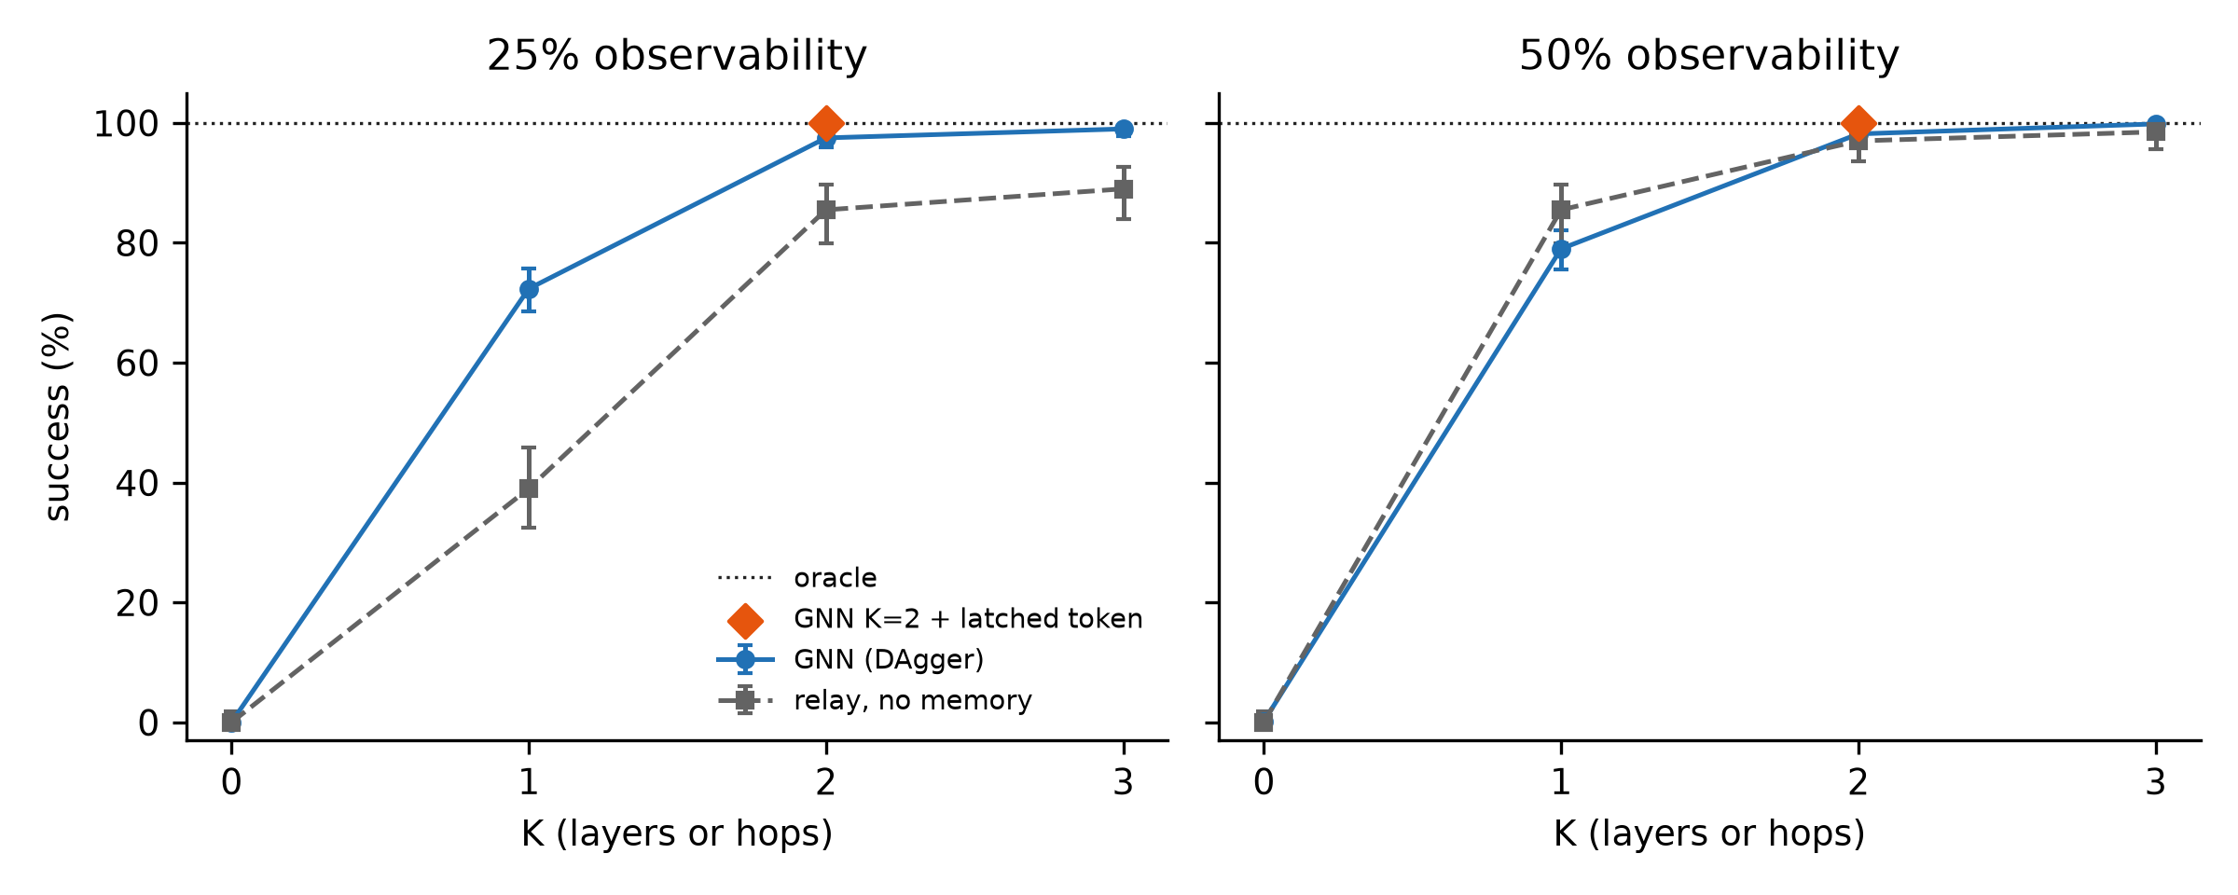
Fig. 8. Success against the number of message-passing layers (GNN, after DAgger) or relay hops (memoryless relay), at 25 % and 50 % observability. Diamond: latched K = 2 GNN; dotted line: expert. Error bars: 95 % Wilson intervals pooled over training seeds [CHECK: regenerate with the two-level bootstrap intervals of Table 3 for consistency].
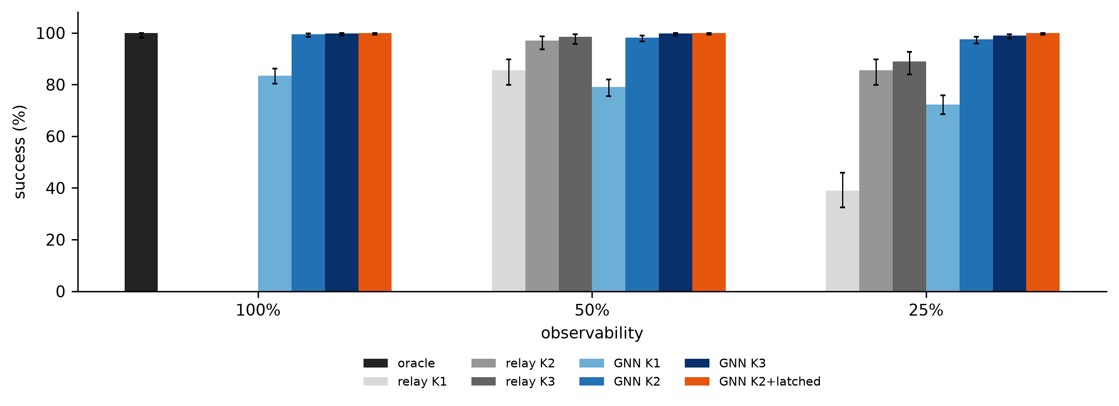
Fig. 9. Success of every policy at 100 %, 50 % and 25 % observability (error bars as in Fig. 8).
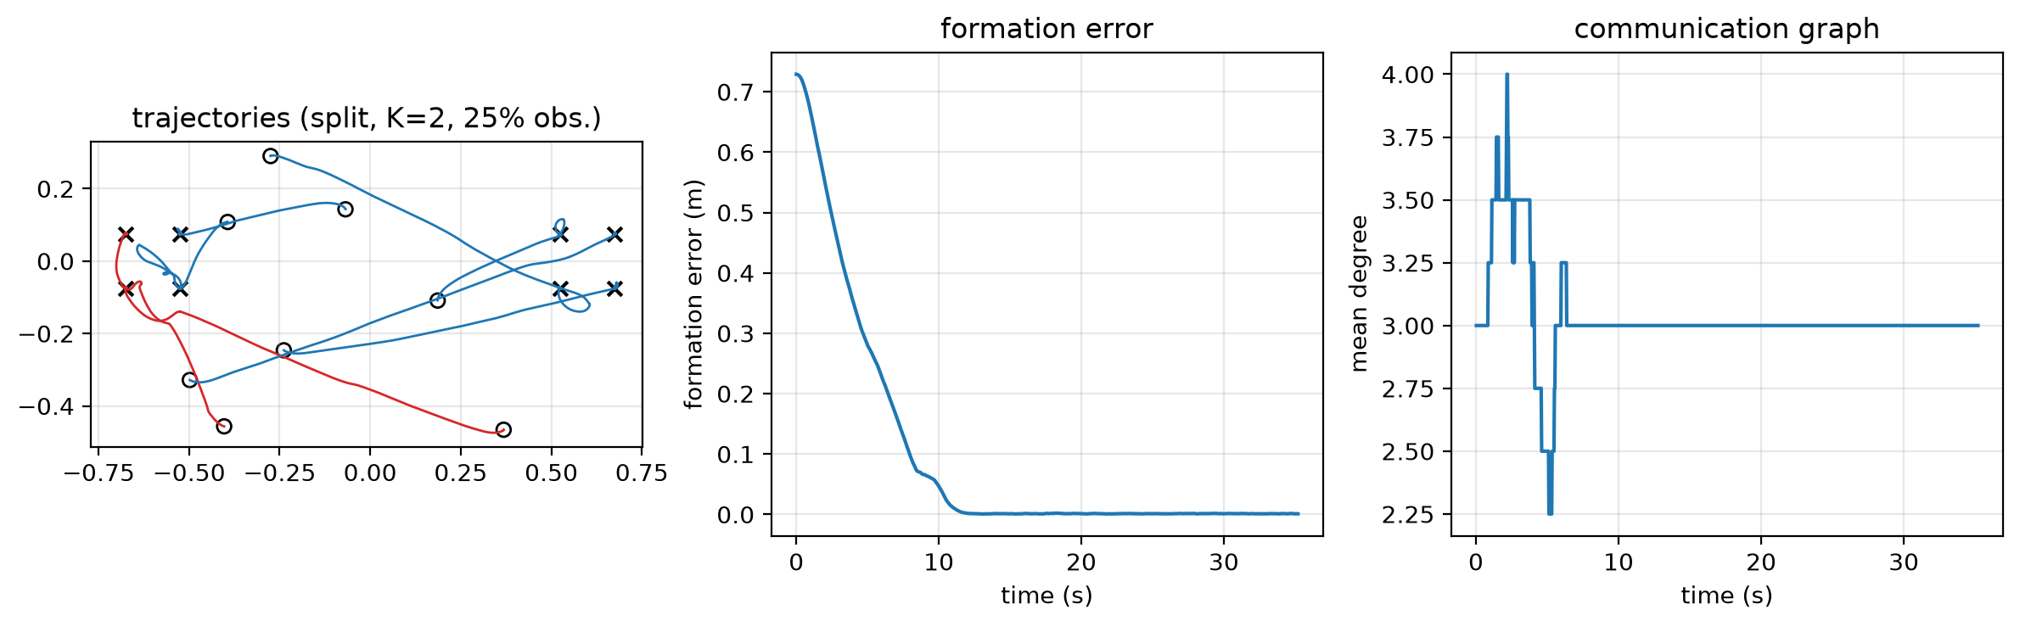
Fig. 10. Example episode: split formation, K = 2 GNN, 25 % observability. (a) Trajectories (red: observers; circles: starts; crosses: slots); (b) formation error against time; (c) mean degree of the communication graph.

4.3. Part of the effect is network capacity
With 100 % observability the gesture does not need to travel, yet K = 1 reaches only 83.5 % against 99.5 % for K = 2 (difference 16.0 points, CI 10.3–22.7, Holm p < 0.0001). A one-layer network is therefore a weaker controller even with full information, plausibly because it sees only its direct neighbours when avoiding them. About 16 of the 25.2 points at 25 % observability thus also appear without a propagation problem. The two differences come from different test conditions, so this is an estimate rather than a decomposition. K = 3 is not better than K = 2 in success (1.5 points at 25 %, CI −0.2 to 3.5, Holm p = 1.0).

4.4. Learned policy against relays
The GNN beats the memoryless relay only at low observability (Fig. 8, Table 4). At 25 % observability the difference is 33.3 points for K = 1 (CI 23.5–42.5), 12.0 for K = 2 (CI 7.0–17.3, Holm p = 0.0004) and 10.0 for K = 3 (CI 5.8–14.8, Holm p = 0.0014). At 50 % no difference is significant for any K (K = 1: −6.5, CI −14.5 to 1.5). The advantage is uneven across formations. For K = 2 at 25 % observability it is +40.0 points on split, +10.0 on circle, +2.7 on line and −4.7 on cluster. The split formation's two blocks are 1.2 m apart, beyond R_{comm}, and the memoryless K = 2 relay solves only 60.0 % of split episodes, whereas the K = 2 GNN solves all of them.
Against relays with memory, the latched GNN shows no difference in success (0.0 points at 25 %, +0.5 at 50 %), but it touches another robot in 4.0 % of its episodes while the relay never does.
Table 4. The 16 pre-specified paired comparisons (200 scenarios each). Exact McNemar test (success) and Wilcoxon signed-rank test (final error), run per training seed; the largest p over seeds is Holm-corrected over the family. Δ = A − B; intervals: two-level bootstrap.
Comparison (A vs B) | Obs. | Δ success, points [95 % CI] | Per-seed Δ success | Holm p (success) | Δ final error (mm) | Holm p (final error)
K = 2 vs K = 1 (primary) | 25 % | 25.2 [18.2, 32.7] | 22.0, 31.0, 22.5 | < 0.0001 | −22.0 | < 0.0001
K = 3 vs K = 2 | 25 % | 1.5 [−0.2, 3.5] | 1.0, 2.0, 1.5 | 1.0 | −1.5 | 1.0
K = 2 vs K = 0 | 25 % | 97.5 [95.7, 99.0] | 97.5, 97.5, 97.5 | < 0.0001 | −333.3 | < 0.0001
K = 2 vs K = 1 | 50 % | 19.2 [13.0, 26.3] | 15.0, 26.0, 16.5 | < 0.0001 | −15.4 | 0.0080
K = 3 vs K = 2 | 50 % | 1.7 [0.0, 4.2] | 3.5, 0.5, 1.0 | 1.0 | −0.8 | 1.0
K = 3 vs K = 1 | 100 % | 16.3 [10.7, 23.0] | 13.5, 21.5, 14.0 | < 0.0001 | −13.6 | 0.0034
K = 2 vs K = 1 | 100 % | 16.0 [10.3, 22.7] | 13.5, 21.0, 13.5 | < 0.0001 | −13.7 | 0.0386
Latched K = 2 vs K = 2 | 25 % | 2.5 [1.0, 4.3] | 2.5, 2.5, 2.5 | 0.5† | −2.4 | 1.0
GNN vs relay, K = 1 | 25 % | 33.3 [23.5, 42.5] | 36.5, 27.5, 36.0 | < 0.0001 | −61.8 | < 0.0001
GNN vs relay, K = 1 | 50 % | −6.5 [−14.5, 1.5] | −4.0, −12.0, −3.5 | 1.0 | 1.5 | 1.0
GNN vs relay, K = 2 | 25 % | 12.0 [7.0, 17.3] | 12.0, 12.0, 12.0 | 0.0004 | −17.7 | 0.0017
GNN vs relay, K = 2 | 50 % | 1.2 [−2.0, 4.3] | −0.5, 2.5, 1.5 | 1.0 | −1.4 | 1.0
GNN vs relay, K = 3 | 25 % | 10.0 [5.8, 14.8] | 9.5, 10.5, 10.0 | 0.0014 | −13.5 | 1.0
GNN vs relay, K = 3 | 50 % | 1.3 [−0.2, 3.3] | 1.5, 1.5, 1.0 | 1.0 | −0.8 | 1.0
Latched GNN vs relay +mem, K = 2 | 25 % | 0.0 [0.0, 0.0] | 0.0, 0.0, 0.0 | 1.0 | 0.0 | 1.0
Latched GNN vs relay +mem, K = 2 | 50 % | 0.5 [0.0, 1.5] | 0.5, 0.5, 0.5 | 1.0† | −0.4 | 1.0
† Too few discordant pairs per seed for the exact test to reach p < 0.05 (Section 3.7). "Relay" = memoryless relay. Source: results/d11_paired.csv.

4.5. The token travels through the graph
The ablation re-runs the seed-0 networks on 20 test seeds × 4 formations (80 episodes per cell) in three modes: the true token for the observers, an all-zero token, or the token of a different formation (Table 5, Fig. 11). With an all-zero token, success at 25 % observability falls to 1.2 % (K = 1), 2.5 % (K = 2), 8.8 % (K = 3) and 0 % (latched). When observers are shown a wrong token, success against the shown formation equals normal success and success against the true one is 0 %. In that mode 89.8 %, 99.6 %, 99.0 % and 100 % of the non-observers end within 0.05 m of their slot in the shown formation, against 21–25 % by chance in blank mode. Non-observers can only have received that token from neighbours.
Table 5. Token ablation, seed-0 networks, 80 episodes per cell. Success in %; "non-obs. at shown slot" = share of non-observing robots ending within 0.05 m of their slot in the formation shown to the observers.
Network | 25 %: true token | 25 %: blank | 25 %: wrong (vs shown) | 25 %: non-obs. at shown slot, wrong | 25 %: non-obs. at shown slot, blank | 100 %: true token | 100 %: wrong (vs shown)
GNN K = 1 | 70.0 | 1.2 | 70.0 | 89.8 | 22.1 | 86.2 | 86.2
GNN K = 2 | 98.8 | 2.5 | 98.8 | 99.6 | 21.2 | 100.0 | 100.0
GNN K = 3 | 97.5 | 8.8 | 97.5 | 99.0 | 24.8 | 100.0 | 100.0
GNN K = 2, latched | 100.0 | 0.0 | 100.0 | 100.0 | 0.0 | 100.0 | 100.0

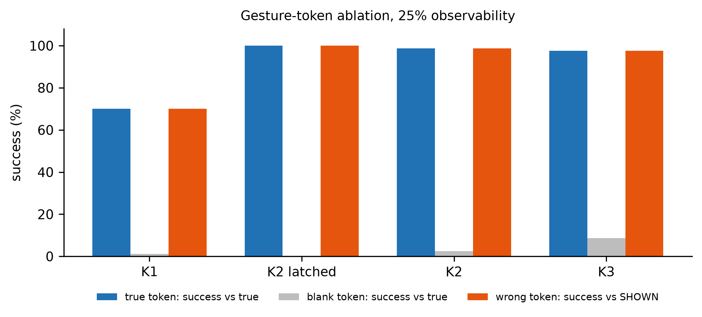
Fig. 11. Token ablation at 25 % observability: success with the true token (scored against the true formation), with a blank token, and with a wrong token (scored against the shown formation).

4.6. DAgger is necessary
Behaviour cloning alone is clearly worse (Table 6, Fig. 12). At 25 % observability DAgger raises success from 39.3 % to 72.3 % for K = 1, from 75.0 % to 97.5 % for K = 2 and from 94.2 % to 99.0 % for K = 3, and cuts contact for K = 2 from 86.8 % to 51.7 % and for K = 3 from 72.7 % to 13.3 %. One case goes the other way: K = 0 at 100 % observability falls from 36.3 % to 17.0 %. A K = 0 network cannot see its neighbours, while the expert's labels depend on them through the repulsion term, so part of what it is asked to imitate is unpredictable from its inputs.
Table 6. Plain behaviour cloning (BC) against BC followed by DAgger; 3 training seeds × 200 episodes per cell; values in %.
Network | Success 25 %: BC | Success 25 %: DAgger | Success 100 %: BC | Success 100 %: DAgger | Contact 25 %: BC | Contact 25 %: DAgger
GNN K = 0 | 0.0 | 0.0 | 36.3 | 17.0 | 87.5 | 92.0
GNN K = 1 | 39.3 | 72.3 | 56.3 | 83.5 | 93.2 | 87.3
GNN K = 2 | 75.0 | 97.5 | 80.3 | 99.5 | 86.8 | 51.7
GNN K = 3 | 94.2 | 99.0 | 96.5 | 99.8 | 72.7 | 13.3
GNN K = 2, latched | 100.0 | 100.0 | 100.0 | 100.0 | 12.0 | 4.0

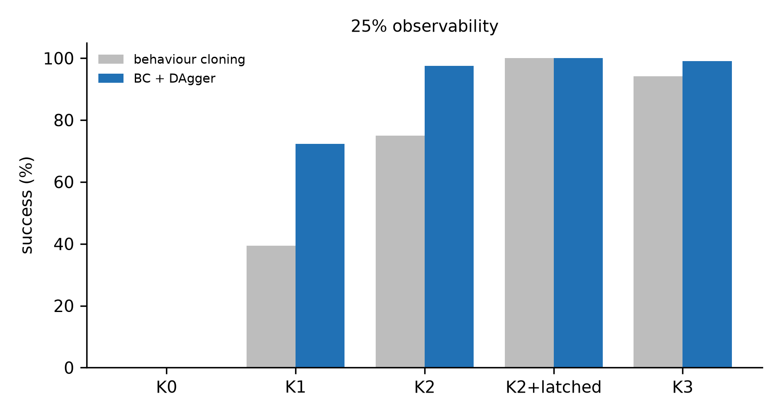
Fig. 12. Success at 25 % observability with plain behaviour cloning and with DAgger.

4.7. Contact
Contact is the main weakness of the learned policies (Fig. 13, Fig. 14). At 25 % observability it occurs in 87.3 % of K = 1 episodes, 51.7 % of K = 2, 13.3 % of K = 3 and 4.0 % of latched K = 2 episodes, with similar rates at 50 % and 100 %; the expert and every relay have none. For K = 2 it varies from 37.3 % (split) to 66.0 % (cluster). The median minimum centre distance is 73.6 mm for K = 1 and 74.0 mm for K = 2, against 82.8 mm for K = 3 and 89.3 mm for the K = 2 relay. The simulator's contact model keeps bodies from overlapping by more than a few millimetres (the smallest distance in any GNN episode is 72.5 mm), so the absence of deep overlap does not show that contacts are light. Collision-free success separates the policies: 11.2 % for K = 1, 47.5 % for K = 2, 85.7 % for K = 3 and 96.0 % for latched K = 2 (Table 3). This comparison was not in the pre-specified family and is descriptive.
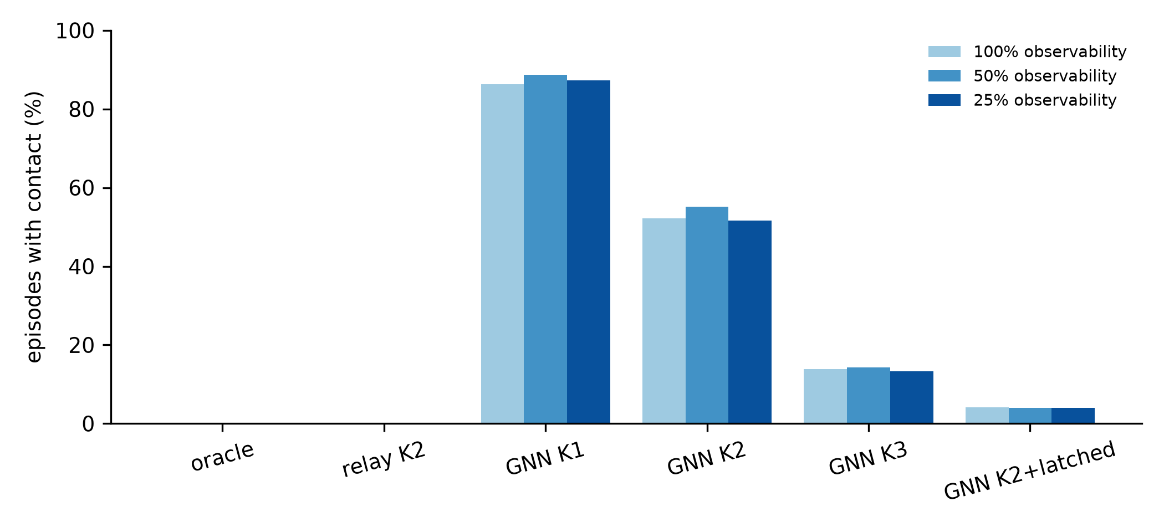
Fig. 13. Share of episodes with contact (centre distance below 74 mm) by policy and observability.
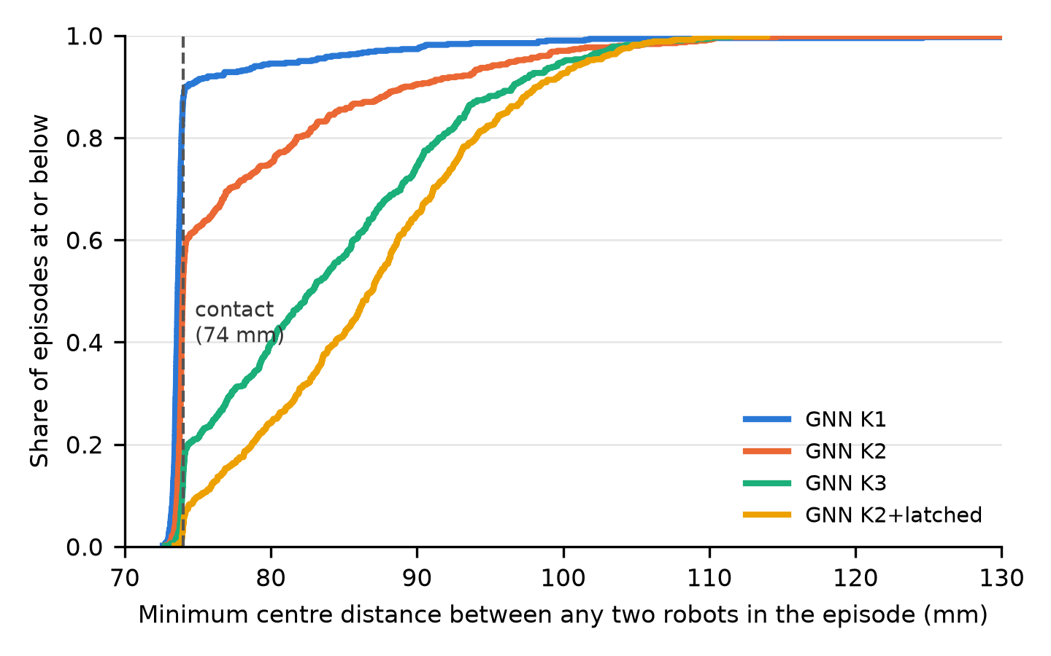
Fig. 14. Cumulative distribution of the minimum centre distance between any two robots in an episode, 25 % observability, GNN policies (600 episodes each). Dashed line: contact at 74 mm.

4.8. Exploratory: a stronger relay
The relay above lets robots without the token hold still, whereas the GNN's uninformed robots keep moving. In a second relay, robots without the token head for the mean of the four candidate slots of their role. It reaches 50.0 %, 81.5 %, 90.0 % and 90.0 % at 25 % observability for K = 1, 2, 3 and 7, and 92.0 %, 99.0 %, 99.0 % and 99.0 % at 50 %. The GNN still beats it at 25 % observability (Fig. 15): by 22.3 points for K = 1 (CI 14.2–30.2, Holm p = 0.0001), 16.0 for K = 2 (CI 10.5–21.7, Holm p < 0.0001) and 9.0 for K = 3 (CI 5.0–13.5, Holm p = 0.0002, though not significant for final error, p = 0.21). These comparisons form their own Holm family of 12. At 50 % the GNN is 13.0 points worse for K = 1 (CI −18.7 to −7.3) and indistinguishable for K = 2 (−0.8 points) and K = 3 (+0.8 points). Of the 33.3-point advantage of K = 1 over the hold-still relay, 11.0 points are thus explained by what uninformed robots do.
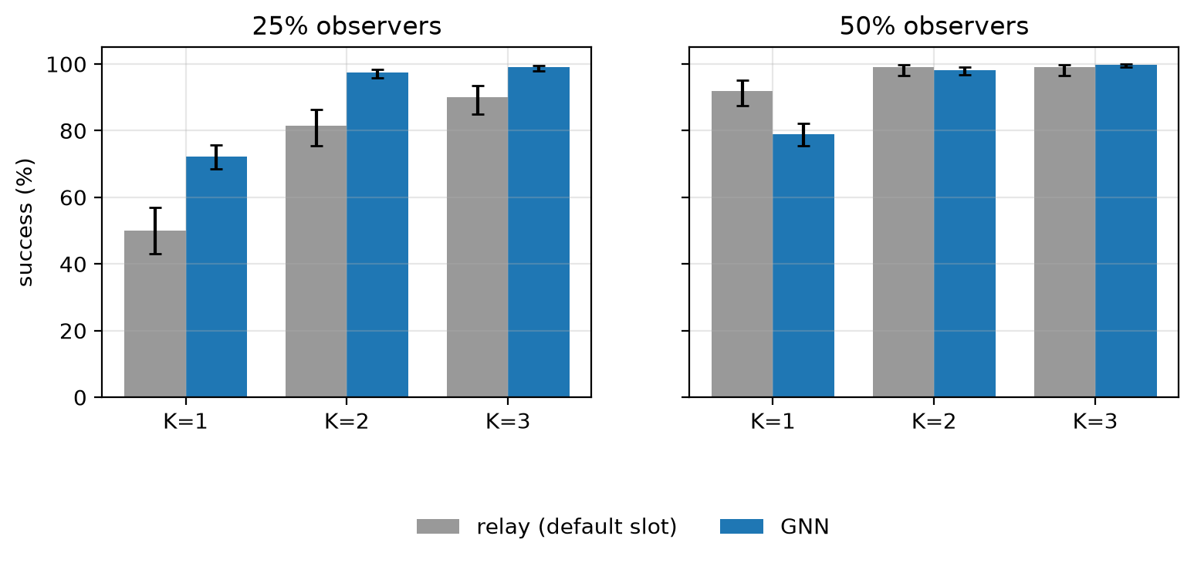
Fig. 15. GNN (after DAgger) against the default-slot relay at 25 % and 50 % observability. Error bars: 95 % Wilson intervals.

4.9. Exploratory: removing the token during the episode
To test whether a memoryless policy remembers the gesture through its position, the token and the flag are set to zero for every robot from step t_{cut} on, at 25 % observability (Table 7, Fig. 16a). A policy that is never told succeeds in about one episode in four, the rate of guessing one of four formations. Told and then cut off, K = 2 still completes 71.7–72.9 % of episodes. The three K = 2 seeds agree (75.0 %, 70.0 % and 73.8 % after a cut at step 700). The memory depends on the formation: after a cut at step 700, K = 2 succeeds in 100 % of circle and split episodes, 91.7 % of line and 0.0 % of cluster episodes, whose robots were 3.9 mm from complete at the cut and ended 431.1 mm away. When observers keep the flag while the token is zero (Fig. 16b), an input never seen in training, success collapses to 2.1–5.8 % for K = 2; we do not interpret that variant.
Table 7. Success (%) when the token and flag are removed for every robot from step t_{cut} on, 25 % observability.
Network (episodes per cell) | Never removed | Removed at step 0 | Removed at step 300 | Removed at step 700
GNN K = 1, seed 0 (80) | 70.0 | 17.5 | 55.0 | 61.3
GNN K = 2, seeds 0–2 (240) | 97.1 | 24.2 | 71.7 | 72.9
GNN K = 3, seed 0 (80) | 97.5 | 23.8 | 73.8 | 73.8

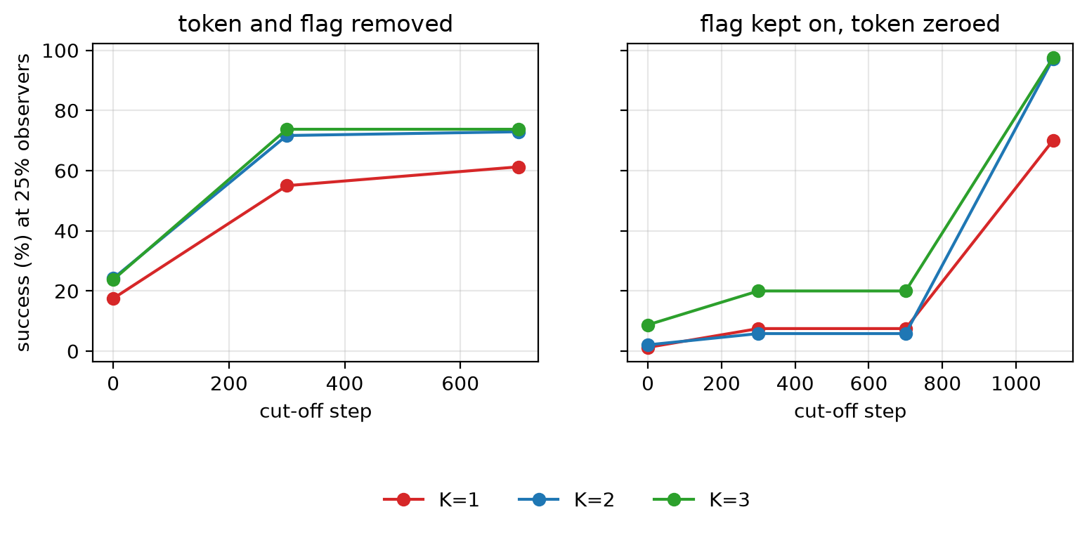
Fig. 16. Success after the token is removed at step t_{cut}, 25 % observability. (a) Token and flag removed for every robot; (b) flag kept on for observers with the token zeroed (an input not seen in training). Step 1100: never removed.

5. Discussion
What the results support. The learned policy depends on the gesture token, follows it when it is wrong, and passes it to robots that cannot see the operator (Section 4.5). Two message-passing layers beat one at low observability in every training seed and under a conservative per-seed test. DAgger is essential, because plain imitation fails on the states the learner itself reaches.
What they do not support. First, the depth effect is not purely about propagating the command: about 16 of the 25.2 points also appear with full observability. A parameter-matched one-layer network would separate the two, and we did not train one. Second, a third layer adds no success. Third, the task does not need a learned policy: a relay with one bit of memory per robot reaches 100 % success with no contact.
Where the learned policy helps. Against memoryless relays the GNN gains 10–33 points at 25 % observability, and most on the split formation, whose two blocks cannot exchange the token. The token-removal test suggests why. Near its slot, a robot's own position indicates which formation is being built, and a memoryless policy appears to use this as a stored command: cut off after step 300 or 700, K = 2 still finishes 71.7–72.9 % of episodes, against 24.2 % when never told. The effect fails for the cluster, the most compact formation; why is untested. Both analyses were designed after the main results, so we treat this as a hypothesis.
Depth and safety. The clearest benefit of the third layer is distance, not success. Collision-free success rises from 47.5 % (K = 2) to 85.7 % (K = 3), and to 96.0 % with an explicit latch (Fig. 14). This fits the idea that contact reflects uncertainty about the formation and about neighbours more than one or two hops away, but we did not test that idea. A deployable policy would still need a safety layer, for example a control-barrier-function filter [19], which we did not evaluate.
Implications for design. For gesture-commanded swarms, an explicit, persistent command register is the most effective single addition, whether in a hand-designed relay or a learned policy. Learned controllers are worth their cost when the command must be inferred under sparse communication, and they should be judged on collision-free success, not on success alone.

6. Limitations and deviations from the plan
- Simulation only. One MuJoCo model of eight e-pucks, within 8 % of ideal kinematics (Table 2); no hardware experiments.
- Fixed setting. Eight robots, four formations, fixed role assignment, a 1.0 m start box, exact positions and lossless, instantaneous messages. Other team sizes, unseen formations, wider starts, packet loss, delay and noise were not tested.
- Not free of global information. Robots know their world-frame position and their role; only the formation is hidden.
- The gesture is a token. Recognition errors and their spread are not modelled.
- Capacity confound. No parameter-matched controls were trained, so the depth effect cannot be separated cleanly from network size (Section 4.3).
- Training seeds. The protocol planned five seeds per model; three were used. The ablation uses seed 0, and the token-removal test seed 0 for K = 1 and K = 3.
- Reuse of test seeds. The test seeds 10000–10049 were reused in the exploratory analyses of Sections 4.8 and 4.9, so they are not an untouched hold-out set. A planned confirmatory evaluation on fresh seeds was registered in the repository but not run.
- Change of analysis. A first analysis tested seed-averaged success with a Wilcoxon test. It was replaced by the per-seed McNemar analysis after it had been run, because success is binary and averaging hides seed variation. Two earlier conclusions (K = 3 better than K = 2; latched better than memoryless) did not survive the change.
- Contact. The K = 2 policy touches another robot in about half of its episodes, and no safety filter was evaluated.
- Baselines. The relays are hand-designed. K = 0 lacks neighbour positions as well as the gesture, so it is not a clean no-communication baseline.
- Exploratory analyses. Sections 4.5–4.9 and the collision-free comparison are descriptive or use separate correction families, and should be read as hypotheses.

7. Conclusions
When only a quarter of a swarm sees a gesture command, a learned GNN controller needs two message-passing layers to form the commanded shape reliably: 97.5 % success against 72.3 % with one layer, consistently across training seeds. Part of that gain is network capacity rather than command propagation. A third layer does not raise success but nearly doubles collision-free success. The learned policy outperforms memoryless relays only when observability is low, and a relay with one bit of memory per robot matches it with no contact. Future work should train parameter-matched controls, add a safety filter, test on fresh seeds and on hardware, and replace the token with real gesture recognition.

Data availability
Code, trained models, raw episode results and the scripts that produce every table, figure and number are available at [ADD public repository link, or "from the corresponding author on request"], release v1.0-ame-submission.

Use of AI tools
[CHECK wording with all authors] An AI assistant (Claude, Anthropic) was used to review the analysis code and statistics, to write analysis scripts, and to prepare a first draft of the text from the authors' results. The authors designed the study, ran all experiments, verified every number against the raw results with scripts, rewrote the text, and take full responsibility for the content.

Acknowledgements
[ADD funding or institutional support, or state that there was none]

References
- M. Brambilla, E. Ferrante, M. Birattari, and M. Dorigo. Swarm robotics: a review from the swarm engineering perspective. Swarm Intelligence, 7(1):1–41, 2013. [ADD DOI]
- K.-K. Oh, M.-C. Park, and H.-S. Ahn. A survey of multi-agent formation control. Automatica, 53:424–440, 2015. doi: 10.1016/j.automatica.2014.10.022.
- A. Kolling, P. Walker, N. Chakraborty, K. Sycara, and M. Lewis. Human interaction with robot swarms: a survey. IEEE Transactions on Human-Machine Systems, 46(1):9–26, 2016. doi: 10.1109/THMS.2015.2480801.
- J. Alonso-Mora, S. Haegeli Lohaus, P. Leemann, R. Siegwart, and P. Beardsley. Gesture based human–multi-robot swarm interaction and its application to an interactive display. In Proc. IEEE International Conference on Robotics and Automation (ICRA), pages 5948–5953, Seattle, USA, 26–30 May 2015. [ADD DOI]
- I. Zadbuke, S. Panchavishe, V. Khandelwal, Y. Abhale, and A. Jain. Low-cost gesture guided swarm control using MediaPipe and decentralized behavior. In Proc. International Conference on Recent Advances in Intelligent and Sustainable Technologies (RAIST 2026), pages 222–231, Surat, India, 19–21 Feb. 2026. Atlantis Press. doi: 10.2991/978-94-6239-707-1_19.
- R. Olfati-Saber, J.A. Fax, and R.M. Murray. Consensus and cooperation in networked multi-agent systems. Proceedings of the IEEE, 95(1):215–233, 2007. doi: 10.1109/JPROC.2006.887293.
- E. Tolstaya, F. Gama, J. Paulos, G. Pappas, V. Kumar, and A. Ribeiro. Learning decentralized controllers for robot swarms with graph neural networks. In Proc. Conference on Robot Learning (CoRL 2019), PMLR 100:671–682, 2020.
- Q. Li, F. Gama, A. Ribeiro, and A. Prorok. Graph neural networks for decentralized multi-robot path planning. In Proc. IEEE/RSJ International Conference on Intelligent Robots and Systems (IROS), 2020. arXiv:1912.06095. [ADD pages and DOI]
- C. Jiang, X. Huang, and Y. Guo. End-to-end decentralized formation control using a graph neural network-based learning method. Frontiers in Robotics and AI, 10:1285412, 2023. doi: 10.3389/frobt.2023.1285412.
- S. Ross, G. Gordon, and D. Bagnell. A reduction of imitation learning and structured prediction to no-regret online learning. In Proc. 14th International Conference on Artificial Intelligence and Statistics (AISTATS), PMLR 15:627–635, 2011.
- O. Khatib. Real-time obstacle avoidance for manipulators and mobile robots. The International Journal of Robotics Research, 5(1):90–98, 1986. doi: 10.1177/027836498600500106.
- J. Gilmer, S.S. Schoenholz, P.F. Riley, O. Vinyals, and G.E. Dahl. Neural message passing for quantum chemistry. In Proc. 34th International Conference on Machine Learning (ICML), PMLR 70:1263–1272, 2017.
- E. Todorov, T. Erez, and Y. Tassa. MuJoCo: a physics engine for model-based control. In Proc. IEEE/RSJ International Conference on Intelligent Robots and Systems (IROS), pages 5026–5033, Vilamoura, Portugal, 2012. doi: 10.1109/IROS.2012.6386109.
- F. Mondada, M. Bonani, X. Raemy, J. Pugh, C. Cianci, A. Klaptocz, S. Magnenat, J.-C. Zufferey, D. Floreano, and A. Martinoli. The e-puck, a robot designed for education in engineering. In Proc. 9th Conference on Autonomous Robot Systems and Competitions, Castelo Branco, Portugal, 2009. [CHECK author list and pages against the EPFL PDF]
- Q. McNemar. Note on the sampling error of the difference between correlated proportions or percentages. Psychometrika, 12(2):153–157, 1947. [CHECK before citing]
- F. Wilcoxon. Individual comparisons by ranking methods. Biometrics Bulletin, 1(6):80–83, 1945. [CHECK on JSTOR]
- S. Holm. A simple sequentially rejective multiple test procedure. Scandinavian Journal of Statistics, 6(2):65–70, 1979.
- B. Efron and R.J. Tibshirani. An Introduction to the Bootstrap. Chapman & Hall, New York, 1993. [CHECK before citing]
- [ADD a control-barrier-function safety-filter reference, e.g. by A.D. Ames and co-authors]

