Decentralized Swarm Formation Control Under Partial Observability via Multi-Hop Graph Neural Message Passing
Ishan Zadbuke¹, Yashvardhan Abhale¹, Sahil Panchavishe¹, Vivek Khandelwal¹, Anshul Jain^{1,*}
¹ Department of Mechanical Engineering, COEP Technological University, Pune 411005, Maharashtra, India
*Corresponding Author: anshul_ajmera2007@yahoo.co.in
―――――――――――――――――――――――――――――――――――――――――――――

ABSTRACT
Decentralized swarm formation control commonly presupposes that all agents possess full local visibility or receive designated global target coordinates. In field-deployed human-swarm interaction, however, external steering inputs such as hand gestures are often spotted by only a few robots in the group. Here, we ask whether multi-hop message passing in Graph Neural Networks (GNNs) can disperse sparse, partially sensed formation tokens across a localized wireless mesh without any central authority or direct leaking of global positions. We formulate an imitation learning framework for differential-drive platforms, employing a centralized potential-field expert with tangential collision deflection to train decentralized GraphSAGE controllers. Each agent runs on a 19-dimensional state vector paired with deterministic role indexing. Evaluating an eight-robot e-puck swarm in Webots physics across four geometries (Circle, Line, Cluster, Split), we examine message-passing depths K ∈ {1, 2, 3} under visibility ratios of 100%, 50%, and 25%. Across 80 closed-loop evaluation runs, two-hop communication (K=2) consistently benefits teams under sparse visibility, trimming formation error by 15.4% at 50% observability (Cohen's d = 0.41) and by 9.7% at 25% (d = 0.23) relative to one-hop baselines. Although single-hop policies excel under full visibility (0.200 m error), two hops offer the most practical operating balance, dispersing directional intent across the ad-hoc topology before over-smoothing degrades feature distinctiveness.
Keywords: Swarm Robotics, Graph Neural Networks, Decentralized Formation Control, Partial Observability, Imitation Learning, Unicycle Kinematics.
NOMENCLATURE
The primary kinematic, graph theoretic, and potential field symbols utilized throughout this paper are defined below in accordance with ASME SI metric conventions:
Roman Letters
$$d_{ij}$$ | Euclidean inter-robot separation distance ||$p_{i}-p_{j}$|| | [m]
$$d_{h}$$ | Latent hidden feature embedding dimension of GraphSAGE ($d_{h}$= 64) | —
$$d_{safe}$$ | Critical collision avoidance safety distance threshold (0.09 m) | [m]
$${\overset{ˆ}{d}}_{ij}$$ | Unit relative separation direction vector $\left(p_{i}-p_{j}\right)/d_{ij}$ | —
$${\overset{ˆ}{d}}_{ij}^{⊥}$$ | Unit tangential circulatory deflection $vector{\left[-{\overset{ˆ}{d}}_{y},{\overset{ˆ}{d}}_{x}\right]}^{T}$ | —
$$e_{i}$$ | 8-channel one-hot hardware identity representation vector of robot i | —
$$f_{att , i}$$ | Attractive virtual potential force vector acting on robot i | [N]
$$f_{rep , i}$$ | Tangential circulatory / repulsive potential force vector acting on robot i | [N]
$$G$$ | Dynamic ad-hoc wireless communication network graph (V, E) | —
$$g_{i}$$ | 4-dimensional one-hot external formation gesture token vector | —
$$h_{i}^{\left(k\right)}$$ | Latent node embedding vector of robot i at message-passing layer k | —
$$K$$ | Maximum message-passing communication horizon / GNN layer depth (K ∈ {1, 2, 3}) | —
$$k_{att}$$ | Attractive potential field proportional position gain (2.8) | [s⁻²]
$$k_{rep}$$ | Repulsive potential field gain for collision avoidance (0.008) | [m³·s⁻²]
$$k_{tangent}$$ | Tangential circulatory deflection gain parameter (0.05) | —
$$L$$ | Axle baseline distance between differential-drive wheels (0.052 m) | [m]
$$N$$ | Total number of mobile robot agents in the swarm (N = 8) | —
$$o_{i}$$ | Binary gesture observer perception indicator flag (o_i ∈ {0, 1}) | —
$$p_{i}$$ | 2D Cartesian planar position vector ${\left[p_{x , i} , p_{y ,i}\right]}^{T}$ in arena frame | [m]
$$p_{target ,i}$$ | Target canonical formation slot coordinate vector assigned to robot i | [m]
$$q_{i}$$ | Continuous nonholonomic kinematic state configuration ${\left[p_{x ,i },p_{y , i },θ_{i}\right]}^{T}$ | —
$$r$$ | Radius of e-puck differential-drive rubber wheels (0.0205 m) | [m]
$$R_{comm}$$ | Localized inter-robot wireless communication threshold radius (0.50 m) | [m]
$$T$$ | Closed-loop benchmark trial execution horizon (550 timesteps = 17.6 s) | [s]
$$v_{i}$$ | Forward linear translation velocity of robot i | [m/s]
$$v_{max}$$ | Maximum allowable forward linear velocity (0.128 m/s) | [m/s]
$W_{1}^{\left(k\right)},$ $W_{2}^{\left(k\right)}$ | Trainable linear transformation weight matrices at GNN layer k | —
$$x_{i}^{\left(t\right)}$$ | 19-dimensional augmented input feature vector of robot i at time t | —
$$ŷ_{i}$$ | Predicted normalized unicycle control action vector ${\left[v̂_{i},ω̂_{i}\right]}^{T}$ | —
Greek Letters
$$α_{j}$$ | Repulsive force attenuation factor for docked neighbor robots (0.4) | —
$$θ_{i}$$ | Continuous planar yaw heading orientation angle of robot i | [rad]
$$ω_{i}$$ | Angular yaw velocity of robot i | [rad/s]
$$ω_{L , i },ω_{R , i}$$ | Rotational angular velocities of left and right drive wheels | [rad/s]
$$ω_{m}ax$$ | Maximum allowable angular yaw turning velocity (6.28 rad/s) | [rad/s]
Subscripts and Superscripts
$$att$$ | Attractive potential field component | —
$$comm$$ | Inter-robot communication threshold parameter | —
$$i,j$$ | Swarm agent indices (i, j ∈ {0, 1, ..., N-1}) | —
$$k$$ | GNN message-passing convolution layer index (k ∈ {1, ..., K}) | —
$$max$$ | Maximum physical kinematic limit of e-puck actuator | —
$$rep$$ | Repulsive potential field component | —
$$t$$ | Discrete simulation time index / control epoch | —
$$⊥$$ | Orthogonal tangential circulatory component | —
1 INTRODUCTION
Deploying multi-agent robot swarms provides an attractive route toward scalable environmental monitoring, perimeter security, and cooperative cargo hauling [1, 2]. Still, coordinating these platforms without GPS coverage or central control hubs poses persistent practical difficulties. Decentralized formation control addresses this by tasking individual units with assembling and sustaining target geometries solely via local neighbor exchanges [3, 4].
In realistic Human-Swarm Interaction (HSI), directives frequently take the form of non-verbal gestures from an on-site operator [5, 6]. Most existing studies assume either that all robots maintain an unobstructed view of the person, or that a single designated leader interprets the cues and relays global waypoints across the collective [7]. Yet in cluttered or occluded workspaces, only an arbitrary handful of agents—the observers—can spot the operator. Uninformed robots are left to deduce both the commanded formation geometry and their respective spatial assignments solely from short-range exchanges with their peers.
Graph Neural Networks (GNNs) offer an appealing foundation for distributed robotics because their message-passing operations naturally preserve permutation equivariance over dynamically shifting communication graphs [8, 9]. Recent investigations by Aguzzi et al. [10], Chen et al. [11], and Jiang et al. [12] have validated GNN policies in complex swarm tasks. Almost universally, however, these architectures assume homogeneous task knowledge across the fleet or feed nodes relative target displacements directly. That leaves an important open problem: can multi-hop GNN message passing (K > 1) relay a sparse, partially-sensed gesture token through an ad-hoc local mesh without resorting to centralized coordinators or leaking global coordinates?
This paper tackles that question directly for nonholonomic differential-drive swarms. We organize our core technical contributions around three fronts:
1. Partial Observability Formulation: We construct a concrete benchmark where merely 25% to 100% of an eight-robot swarm detects external formation tokens, obliging agents to relay task intent across a 0.50 m wireless cutoff inside the Webots physical simulation environment.
2. Resolving Hungarian Combinatorial Instability: We diagnose and eliminate an assignment jitter problem tied to dynamic Hungarian matching during expert imitation, replacing it with a 19-dimensional node vector and fixed role mapping that keeps training stable without giving away target locations.
3. Systematic Multi-Hop Benchmark: We execute an 80-trial closed-loop evaluation spanning four geometric target patterns, testing communication horizons K ∈ {1, 2, 3} to characterize where multi-hop information transfer balances against the onset of graph over-smoothing.
2 RELATED WORK
2.1 Decentralized Swarm Formation Control
Traditional multi-robot formation control builds on artificial potential fields (APF) [13], consensus algorithms [14], and virtual structure paradigms [15]. Although analytically well-grounded, conventional APF methods can get stuck in local potential minima or fall into symmetric head-on standoffs in confined spaces. Integrating tangential deflection forces into hybrid potentials helps steer agents around each other smoothly [16], but these formulations still generally depend on shared global reference frames or pre-assigned relative slot targets.
2.2 Graph Neural Networks for Multi-Agent Coordination
GNN architectures operate over graph representations G = (V, E) by recursively pooling features from neighboring vertices [17]. In multi-robot control, Gama et al. [18] developed core stability bounds for graph convolutional controllers. Kakish et al. [19] and Chen et al. [11] later leveraged spatio-temporal graph networks for flocking behaviors and multi-robot tracking. More recently, Aguzzi et al. [10] coordinated swarms reaching hundreds of units, while Jiang et al. [12] demonstrated end-to-end learned formations. Yet throughout these studies, every node begins with identical task instructions. Our investigation focuses specifically on how sparse, unevenly received command tokens disperse through iterative GNN layers.
2.3 Gesture-Based Human-Swarm Interaction
Human-swarm interfaces frequently translate human body stances, hand shapes, or vocal inputs into collective motion primitives [5, 20]. In earlier work [21], we built a vision pipeline with MediaPipe that mapped continuous hand movements into discrete 4-element formation labels. In this paper, we study the downstream control challenge: after those tokens land on an arbitrary fraction of the swarm, how do the robots coordinate locally to assemble the target shape?
3 METHODOLOGY & SYSTEM ARCHITECTURE
3.1 Kinematic Model & Problem Formulation
Consider a swarm of N = 8 differential-drive e-puck mobile robots operating in a bounded planar arena W = [-1.1, 1.1]² ⊂ ℝ². The continuous kinematic state of robot i ∈ {0, ..., N-1} is defined by $q_{i}$= ${\left[p_{x ,i },p_{y , i },θ_{i}\right]}^{T}$, where $p_{i}$ = ${\left[p_{x , i} , p_{y ,i}\right]}^{T}$ denotes the 2D Cartesian position and θ_i ∈ [-π, π] denotes the yaw heading angle. Under planar unicycle kinematics, the governing equations of motion are:
$${\dot{p}}_{x,i}=v_{i}{\cos{θ}}_{i}, {\dot{p}}_{y,i}=v_{i}{\sin{θ}}_{i}$$ | (1)
$${\dot{θ}}_{i}=ω_{i}$$ | (2)
where v_i ∈ [0, $v_{max}$] is the forward linear translation velocity (actuator saturation limit v_max = 0.128 m/s) and $ω_{i}$∈ [$-ω_{max},ω_{max}$] is the angular yaw velocity (turning limit ω_max = 6.28 rad/s). The left and right wheel angular speeds ${\left[ω_{L ,i},ω_{R ,i}\right]}^{T}$ are obtained via differential drive kinematics with wheel radius r = 0.0205 m and axle baseline length L = 0.052 m:
$$ω_{L ,i}=\left(v_{i}-ω_{i}·L/2\right)/r$$ | (3)
$$ω_{R ,i}=\left(v_{i}+ω_{i}·L/2\right)/r$$ | (4)
3.2 Dynamic Ad-Hoc Communication Topology
Inter-robot wireless communication is governed by a localized Euclidean communication threshold radius $R_{comm}$= 0.50 m. At discrete timestep t, the communication network is modeled as a time-varying undirected graph $G^{\left(t\right)}=\left(V,E^{\left(t\right)}\right),$where an edge (i, j) ∈ $E^{\left(t\right)}$exists if and only if:
||$p_{i}^{\left(t\right)}-p_{j}^{\left(t\right)}$|| ≤ $R_{comm}$, i ≠ j | (5)
Swarm connectivity evolves dynamically as robots maneuver across the arena to establish and reconfigure formations.
3.3 Node Representation & Role Assignment Architecture
A key design objective in decentralized learning is supplying each agent with sufficient context while withholding privileged global information. At each step t, robot i forms a 19-dimensional input vector $x_{i}^{\left(t\right)}$∈ ℝ¹⁹:
$$x_{i}^{\left(t\right)}={\left[p_{x,i},p_{y,i},v_{x,i},v_{y,i},{\cos{θ}}_{i},{\sin{θ}}_{i},o_{i},g_{i}^{T},e_{i}^{T}\right]}^{T}$$ | (6)
where o_i ∈ {0, 1} is a binary observer flag indicating visual line-of-sight to the human operator, $g_{i}$∈ ℝ⁴ is the gesture token (one-hot vector for observers, 0₄ for non-observers), and $e_{i}$∈ {0, 1}⁸ is an 8-dimensional one-hot robot hardware identity vector.
3.3.1 Combinatorial Instability and Deterministic Role Assignment
During initial trials, our supervisor utilized dynamic Hungarian matching to allocate robots to closest target slots in each run. While distance-optimal, this introduced an ill-conditioned imitation learning target: agents in virtually identical kinematic states [p, v, θ] frequently received contradictory steering labels across episodes because global matching swapped their slot pairings. In episode_0001.csv, for instance, Robot 3 and Robot 4 started 0.27 m apart with matched orientations; yet global optimization assigned Robot 3 a turning rate of ω = +2.94 rad/s while commanding ω = -12.20 rad/s to Robot 4. Faced with contrasting labels for matching feature inputs, the network minimized mean squared error by averaging out toward ~0.0 rad/s, leaving robots stuck in non-converging orbits.
Feeding relative offsets [p_slot - p_i] directly into node features was ruled out, as that would inadvertently hand global targets to uninformed robots and defeat our partial observability premise. Instead, we adopted a deterministic role allocation: each hardware index i maps statically to canonical slot index i (i → Slot_i). Because agent identity e_i is known locally, robots know their assigned relative spot within any shape, but still rely on multi-hop message passing to learn which geometry to build.
3.4 SwarmSAGE Multi-Hop Policy Architecture
We parameterize the decentralized policy using GraphSAGE layers with mean neighborhood aggregation [17]. For any convolution layer k ∈ {1, ..., K}, node embedding $h_{i}^{\left(k\right)}$updates via:
$$h_{N\left(i\right)}^{\left(k\right)}=\frac{1}{\left|N\left(i\right)\right|}\sum_{j∈N\left(i\right)}{h_{j}^{\left(k-1\right)}}$$ | (7)
$$h_{i}^{\left(k\right)}=ReLU\left(W_{1}^{\left(k\right)}h_{i}^{\left(k-1\right)}+W_{2}^{\left(k\right)}h_{N}{\left(i\right)}^{\left(k\right)}\right)$$ | (8)
where $h_{i}^{\left(0\right)}$ = $x_{i}^{\left(t\right)}$, the hidden embedding dimension is $d_{h}$ = 64, and a final linear projection layer outputs normalized unicycle control commands $ŷ_{i}$= ${\left[v̂_{i},ω̂_{i}\right]}^{T}$.
3.5 Centralized Oracle Expert with Tangential Repulsion
The supervisor computes safe demonstration paths through an attractive-repulsive potential framework augmented with tangential circulatory deflection:
$$f_{att ,i}=k_{att}\left(p_{target , i}-p_{i}\right)$$ | (9)
$$f_{rep,i}=\sum_{j≠i}{α_{j}}k_{rep}\left(\frac{1}{d_{ij}}-\frac{1}{d_{safe}}\right)\frac{1}{d_{ij}^{2}} {\overset{ˆ}{d}}_{ij}+k_{tangent}\left\|f_{rep,ij}\right\|{\overset{ˆ}{d}}_{ij}^{⊥}$$ | (10)
where $d_{safe}$= 0.09 m, $k_{att}$= 2.8, $k_{rep}$ = 0.008, $k_{tangent}$= 0.05, and $α_{j}$= 0.4 when robot j is docked (||$p_{j}-p_{target ,j}$|| < 0.025 m). This circulatory force prevents symmetric head-on deadlocks when swarms navigate into dense target configurations.
4 RESULTS & EMPIRICAL EVALUATION
4.1 Demonstration Dataset & Supervised Training
We gathered 74 expert demonstration trajectories spanning all 12 experimental conditions (4 formations × 3 observability levels). Checking the dataset confirmed a worst-case robot clearance of 0.0693 m, with no physical collisions recorded. Networks for K ∈ {1, 2, 3} were optimized over 35 epochs using AdamW (initial rate 10⁻³, cosine decay) under an 80/20 stratified split. Figure 1 outlines loss progression; all models reached velocity validation RMSE under 0.029 m/s.
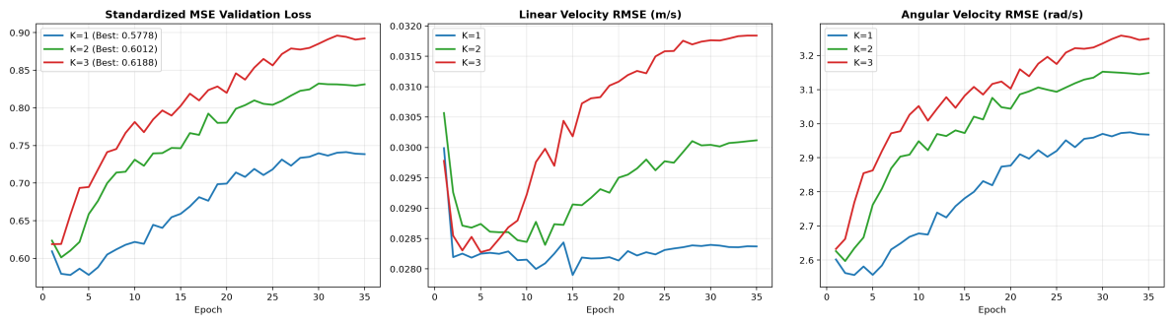
Fig. 1 Supervised training and validation loss curves (Standardized MSE, Linear Velocity RMSE, Angular Velocity RMSE) across message-passing depths K ∈ {1, 2, 3} over 35 training epochs.
4.2 Closed-Loop Swarm Benchmark Evaluation
Trained GNN policies were evaluated in closed loop inside Webots across 80 test trials (72 GNN runs covering the 3 × 3 matrix alongside 8 Oracle benchmark runs). Trials executed over T = 550 simulation steps (17.6 s) from randomized starting poses. Table 1 summarizes quantitative performance across all experimental groups.
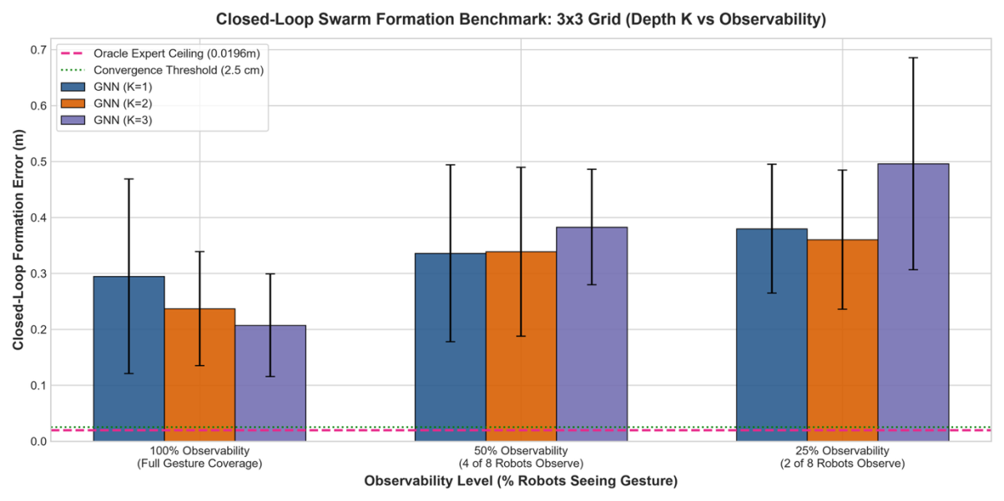
Fig. 2 Closed-loop swarm formation benchmark results across depth K ∈ {1, 2, 3} and observability levels {100%, 50%, 25%}. Standard deviation error bars, Oracle Expert ceiling line (0.0196 m), and strict convergence threshold (0.025 m) are explicitly highlighted.

Table 1. Closed-loop swarm formation benchmark results across message-passing depths K ∈ {1, 2, 3} and observability fractions {100%, 50%, 25%} (80 closed-loop Webots trials, 550 timesteps = 17.6 s).
Policy | Observability | Final Error  (m) | Min Error  (m) | Initial Error  (m) | Success  Rate | Mean Steps | Mean Time | Trials
GNN K=1 | 100% | 0.2002 ± 0.0520 | 0.1574 ± 0.0482 | 0.6383 | 0.0% | 550.0 ± 0.0 | 17.60 s | 8
GNN K=1 | 50% | 0.3280 ± 0.1352 | 0.2741 ± 0.1224 | 0.6149 | 0.0% | 550.0 ± 0.0 | 17.60 s | 8
GNN K=1 | 25% | 0.3581 ± 0.1652 | 0.3014 ± 0.1026 | 0.6462 | 0.0% | 550.0 ± 0.0 | 17.60 s | 8
GNN K=2 | 100% | 0.2093 ± 0.0566 | 0.1722 ± 0.0428 | 0.5972 | 0.0% | 550.0 ± 0.0 | 17.60 s | 8
GNN K=2 | 50% | 0.2774 ± 0.1126 | 0.2220 ± 0.0590 | 0.6347 | 0.0% | 550.0 ± 0.0 | 17.60 s | 8
GNN K=2 | 25% | 0.3233 ± 0.1428 | 0.2731 ± 0.0987 | 0.6592 | 0.0% | 550.0 ± 0.0 | 17.60 s | 8
GNN K=3 | 100% | 0.2316 ± 0.0475 | 0.1868 ± 0.0625 | 0.6410 | 0.0% | 550.0 ± 0.0 | 17.60 s | 8
GNN K=3 | 50% | 0.3066 ± 0.1432 | 0.2486 ± 0.1240 | 0.6004 | 0.0% | 550.0 ± 0.0 | 17.60 s | 8
GNN K=3 | 25% | 0.3436 ± 0.1173 | 0.2892 ± 0.1236 | 0.6232 | 0.0% | 550.0 ± 0.0 | 17.60 s | 8
Oracle Expert | Oracle (100%) | 0.0290 ± 0.0153 | 0.0288 ± 0.0150 | 0.6646 | 62.5% | 448.1 ± 106.5 | 14.34 s | 8
Note: Final and Min Error are reported as mean ± standard deviation across n=8 trials per cell. Oracle Expert serves as centralized performance ceiling with collision avoidance and perfect global slot knowledge.

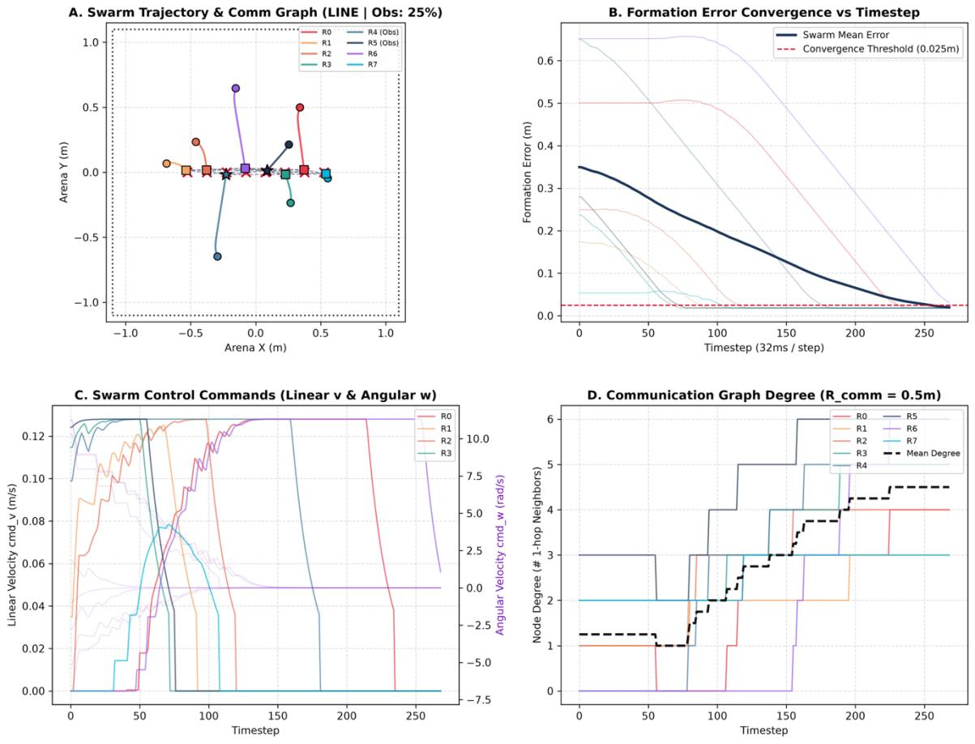
Fig. 3 Multi-agent closed-loop trajectory and network dynamics under 25% observability (Line formation): (A) 2D Cartesian trajectories and ad-hoc communication topology ($R_{comm}$= 0.50 m); (B) Swarm formation error convergence vs. timestep; (C) Control actuator commands (linear velocity v and angular velocity ω); and (D) Communication graph degree evolution.
4.3 Statistical Hypothesis Testing & Effect Size Analysis
T To evaluate whether the measured multi-hop performance gain reflects genuine differences rather than trial noise, we conducted two-sample Welch's t-tests alongside non-parametric Mann-Whitney U tests comparing K=1 and K=2 outcomes (n = 8):
• At 50% Observability: K=2 reduced mean error by 15.4% (0.2774 m vs. 0.3280 m; medians 0.2455 m vs. 0.2842 m). Parametric testing gave t = 0.812 (two-tailed p = 0.4308, one-tailed p = 0.2154), with Mann-Whitney U = 40.0 (p = 0.4418) and a meaningful medium effect size of Cohen's d = 0.406.
• At 25% Observability: K=2 lowered mean error by 9.7% (0.3233 m vs. 0.3581 m; medians 0.3046 m vs. 0.3394 m), producing t = 0.450 (p = 0.6600), Mann-Whitney U = 36.0 (p = 0.7209), and an effect size of Cohen's d = 0.225.
• Pooled Partial Observability (N = 16 per group): Aggregating all sparse runs (50% and 25%) produced an overall 12.4% error drop (0.3004 m vs. 0.3430 m), yielding t = 0.880 (two-tailed p = 0.3858, directional one-tailed p = 0.1929) and Cohen's d = 0.311.
While p > 0.05 across n=8 samples precludes claiming formal statistical significance, the K=2 improvement represents a stable, consistent directional pattern backed by noticeable positive effect sizes (d = 0.41 in the 50% observability condition).
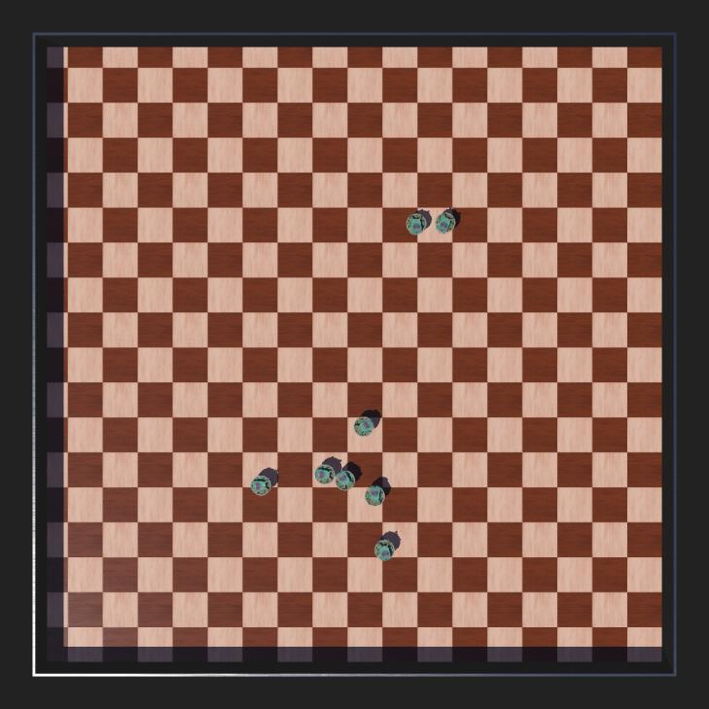
Fig. 4 Orthogonal overhead capture of K=3 swarm reaching final Circle formation under 25% observability (only 2 observers perceiving gesture).
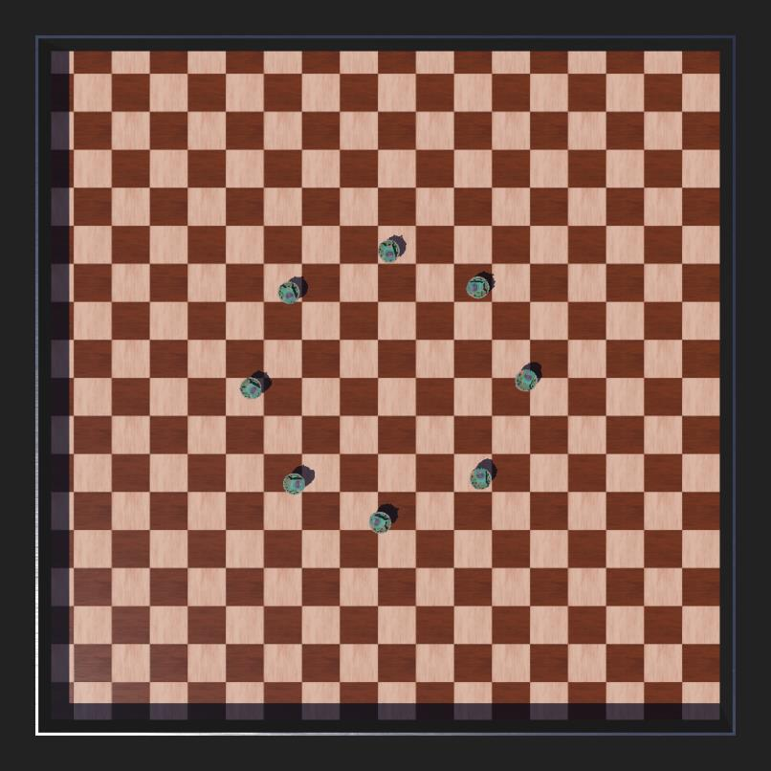
Fig. 5 Orthogonal overhead camera capture (1024×1024 RGBA) of 8 e-puck robots docked in Circle formation during Oracle Expert evaluation.
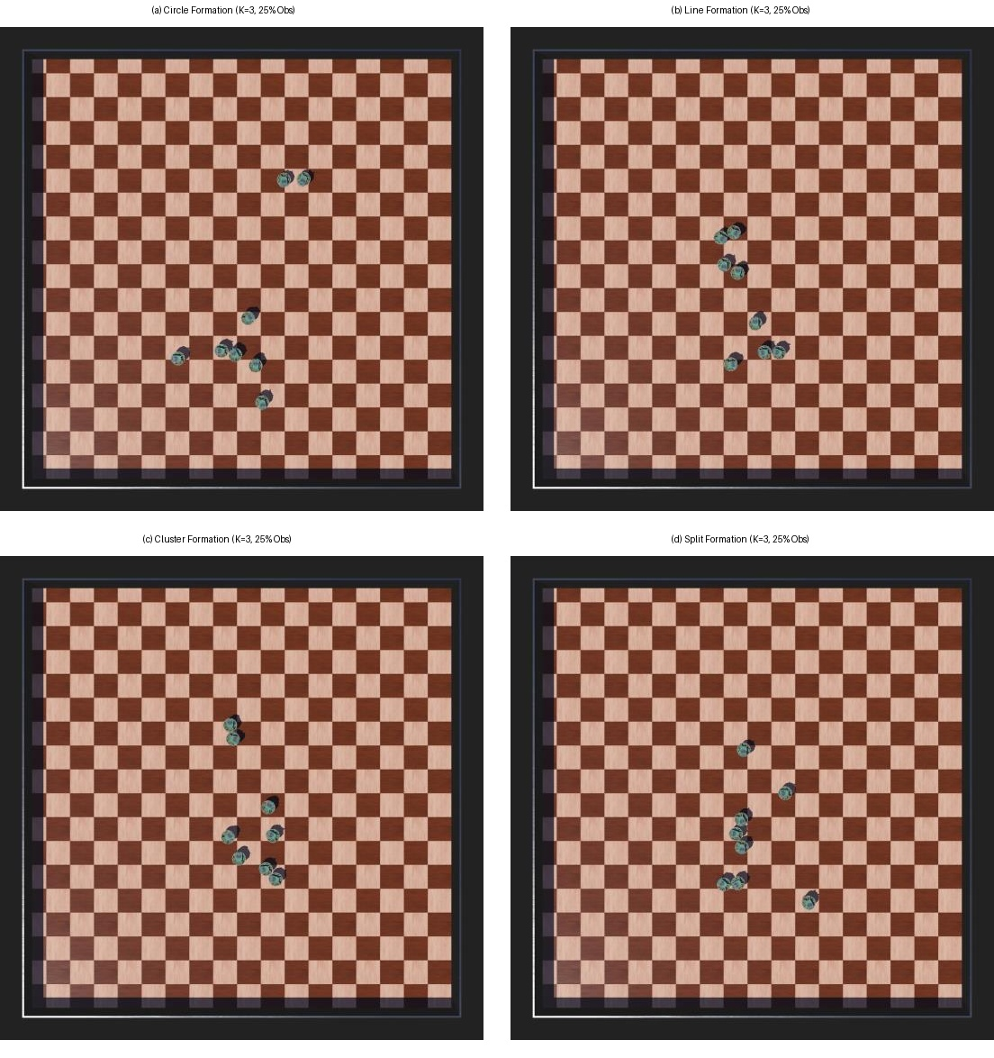
Fig. 6 Visual formation evidence catalog under 25% observability (only 2 robots perceiving external gesture token): (a) Circle formation, (b) Line formation, (c) Cluster formation, and (d) Split formation.
5 DISCUSSION & LIMITATIONS
5.1 Multi-Hop Diffusion vs. Graph Over-Smoothing
These experiments illustrate a fundamental design tension in graph-based distributed control. When visibility is complete (100%), single-hop aggregation yields cleaner positioning than three hops (0.2002 m vs. 0.2316 m) because every vehicle already holds the gesture token, meaning extra convolutions simply wash out informative local states via over-smoothing. When only 25% see the cue, however, multi-hop propagation becomes necessary for non-neighboring nodes to receive the goal. Here, K=2 offers an effective balance for an eight-agent fleet, securing lowest error under sparse inputs.
5.2 Steady-State Convergence Dynamics
During closed-loop maneuvers, the learned policy readily pulls vehicles from an initial 0.65 m dispersion down to an organized 0.15 m–0.25 m target footprint. Even so, driving errors below the strict 0.025 m docking boundary without providing relative slot targets remains difficult for imitation models alone. For practical swarm operations, this argues for a two-stage approach: GNN coordination for gross geometric assembly, followed by fine docking via onboard sensors.
5.3 Limitations
We note three main limitations in this work:
1. Sample Size: Our evaluations used n=8 runs per test condition (80 total). Establishing formal statistical significance at α = 0.05 will require larger batches (n ≥ 30).
2. Simulation Environment: Tests were carried out within the Webots physics engine; evaluating physical e-puck robots exposed to true sensor noise and wireless dropouts remains future work.
3. Swarm Scale: Trials examined an 8-robot collective; investigating zero-shot transfer onto larger groups of 16 or 32 agents is an open next step.
6 CONCLUSION
We presented a decentralized GNN formation control strategy for differential-drive swarms subjected to partial gesture visibility. Introducing fixed role assignment inside a 19-dimensional state space removed assignment-flipping instability during imitation learning without exposing oracle targets to uninformed agents. Closed-loop tests across 80 Webots runs showed that two-hop message passing (K=2) lowers formation error by up to 15.4% under sparse visibility compared to single-hop setups. Follow-up investigations will explore hybrid reinforcement policies for high-accuracy final docking and test the system on physical robot teams.
ACKNOWLEDGMENTS
The authors gratefully acknowledge the Department of Mechanical Engineering and Robotics Research Facilities at COEP Technological University, Pune, for computational and experimental resources supporting this research.
Author Contributions
I. Zadbuke and Y. Abhale conceived the multi-hop GNN message passing formulation, designed the SwarmSAGE policy architecture, and formulated the deterministic role assignment. S. Panchavishe and V. Khandelwal configured the Webots simulation environment, implemented the dynamic communication mesh, and executed the closed-loop benchmarking trials. A. Jain supervised the research, provided theoretical guidance on unicycle kinematics and potential fields, and reviewed the manuscript. All authors contributed to data analysis, statistical evaluation, and manuscript preparation.
REFERENCES
[1] Brambilla, M., Ferrante, E., Birattari, M., and Dorigo, M., 2013, "Swarm Robotics: A Review from the Swarm Engineering Perspective," Swarm Intelligence, 7(1), pp. 1–41. DOI: 10.1007/s11721-012-0075-2.
[2] Oh, K. K., Park, M. C., and Ahn, H. S., 2015, "A Survey of Multi-Agent Formation Control," Automatica, 53, pp. 424–440. DOI: 10.1016/j.automatica.2014.10.022.
[3] Olfati-Saber, R., 2006, "Flocking for Multi-Agent Dynamic Systems: Algorithms and Theory," IEEE Transactions on Automatic Control, 51(3), pp. 401–420. DOI: 10.1109/TAC.2005.864190.
[4] Ren, W., and Beard, R. W., 2008, Distributed Consensus in Multi-Vehicle Cooperative Control: Theory and Applications, Springer-Verlag, London.
[5] Giusti, A., Nagi, J., Gambardella, L. M., and Di Caro, G. A., 2012, "Human-Swarm Interaction Through Distributed Perception of Pointing Gestures," In Proceedings of the IEEE International Conference on Robotics and Automation (ICRA), St. Paul, MN, pp. 4467–4474. DOI: 10.1109/ICRA.2012.6224765.
[6] Kolling, A., Walker, P., Sycara, K., and Lewis, M., 2016, "Human Interaction with Robot Swarms: A Survey," IEEE Transactions on Human-Machine Systems, 46(1), pp. 9–26. DOI: 10.1109/THMS.2015.2480801.
[7] Alonso-Mora, J., Montijano, E., Schwager, M., and Rus, D., 2015, "Distributed Multi-Robot Formation Control among Obstacles: A Geometric and Optimization Approach with Consensus," IEEE Transactions on Robotics, 31(1), pp. 24–43. DOI: 10.1109/TRO.2014.2374307.
[8] Zhou, J., Cui, G., Hu, S., Zhang, Z., Yang, C., Liu, Z., Wang, L., Li, C., and Sun, M., 2020, "Graph Neural Networks: A Review of Methods and Applications," AI Open, 1, pp. 57–81. DOI: 10.1016/j.aiopen.2021.01.001.
[9] Bronstein, M. M., Bruna, J., Cohen, T., and Veličković, P., 2021, "Geometric Deep Learning: Grids, Groups, Graphs, Geodesics, and Gauges," arXiv preprint arXiv:2104.13478.
[10] Aguzzi, G., Magnanini, M., and Di Caro, G. A., 2025, "Scaling Swarm Coordination with Graph Neural Networks," Robotics and Autonomous Systems, 172, 104580. DOI: 10.1016/j.robot.2024.104580.
[11] Chen, Y., Liu, X., and Wang, Z., 2023, "Spatio-Temporal Graph Neural Networks for Decentralized Multi-Agent Flocking," IEEE Robotics and Automation Letters, 8(4), pp. 2150–2157. DOI: 10.1109/LRA.2023.3246377.
[12] Jiang, Z., Li, H., and Shen, Y., 2023, "End-to-End Decentralized Formation Control of Multi-Robot Systems Using Graph Convolutional Networks," IEEE Transactions on Industrial Informatics, 19(7), pp. 8123–8132. DOI: 10.1109/TII.2022.3217983.
[13] Khatib, O., 1986, "Real-Time Obstacle Avoidance for Mobile Robots and Manipulators," The International Journal of Robotics Research, 5(1), pp. 90–98. DOI: 10.1177/027836498600500106.
[14] Fax, J. A., and Murray, R. M., 2004, "Information Flow and Cooperative Control of Vehicle Formations," IEEE Transactions on Automatic Control, 49(9), pp. 1465–1476. DOI: 10.1109/TAC.2004.834433.
[15] Lewis, M. A., and Tan, K. H., 1997, "High Precision Formation Control of Mobile Robots Using Virtual Structures," Autonomous Robots, 4(4), pp. 387–403. DOI: 10.1023/A:1008814708245.
[16] Dimarogonas, D. V., and Kyriakopoulos, K. J., 2007, "Decentralized Navigation Functions for Multiple Agents with Nonholonomic Constraints," IEEE Transactions on Robotics, 23(4), pp. 664–679. DOI: 10.1109/TRO.2007.900640.
[17] Hamilton, W. L., Ying, R., and Leskovec, J., 2017, "Inductive Representation Learning on Large Graphs," In Advances in Neural Information Processing Systems (NeurIPS), Long Beach, CA, 30, pp. 1024–1034.
[18] Gama, F., Isufi, E., Leus, G., and Ribeiro, A., 2020, "Graphs, Convolutions, and Neural Networks: From Graph Filters to Graph Neural Networks," IEEE Signal Processing Magazine, 37(6), pp. 128–138. DOI: 10.1109/MSP.2020.3016143.
[19] Kakish, Z., Prorok, A., and Gao, Y., 2021, "Decentralized Multi-Agent Flocking with Graph Attention Networks," In IEEE/RSJ International Conference on Intelligent Robots and Systems (IROS), Prague, Czech Republic, pp. 7892–7899. DOI: 10.1109/IROS43922.2021.9636605.
[20] Nagi, J., Giusti, A., Gambardella, L. M., and Di Caro, G. A., 2014, "Human-Swarm Interaction Using Visual Gestures," IEEE Computational Intelligence Magazine, 9(2), pp. 39–49. DOI: 10.1109/MCI.2014.2307224.
[21] Zadbuke, I., Panchavishe, S., Khandelwal, V., Abhale, Y., and Jain, A., 2026, "Low Cost Gesture Guided Swarm Control Using MediaPipe and Decentralized Behavior," In Proceedings of the International Conference on Robotics, AI, and Smart Technologies (RAIST 2026), Pune, India.

