1. Create an API that lists the title, description based on the category passed as an input parameter.

:-

Parameters are options you can pass with the endpoint (such as specifying the response format or the amount returned) to influence the response. There are several types of parameters: header parameters, path parameters, and query string parameters. Request bodies are closely similar to parameters but are not technically a parameter.

[STEP 1:  
Resource description](https://idratherbewriting.com/learnapidoc/docapis_resource_descriptions.html)

→

[STEP 2:  
Endpoints and methods](https://idratherbewriting.com/learnapidoc/docapis_resource_endpoints.html)

→

[STEP 3:  
Parameters](https://idratherbewriting.com/learnapidoc/docapis_doc_parameters.html)

→

[STEP 4:  
Request example](https://idratherbewriting.com/learnapidoc/docapis_doc_sample_requests.html)

→

[STEP 5:  
Response example and schema](https://idratherbewriting.com/learnapidoc/docapis_doc_sample_responses_and_schema.html)

The different types of parameters are often documented in separate groups on the same page. Not all endpoints contain each type of parameter.

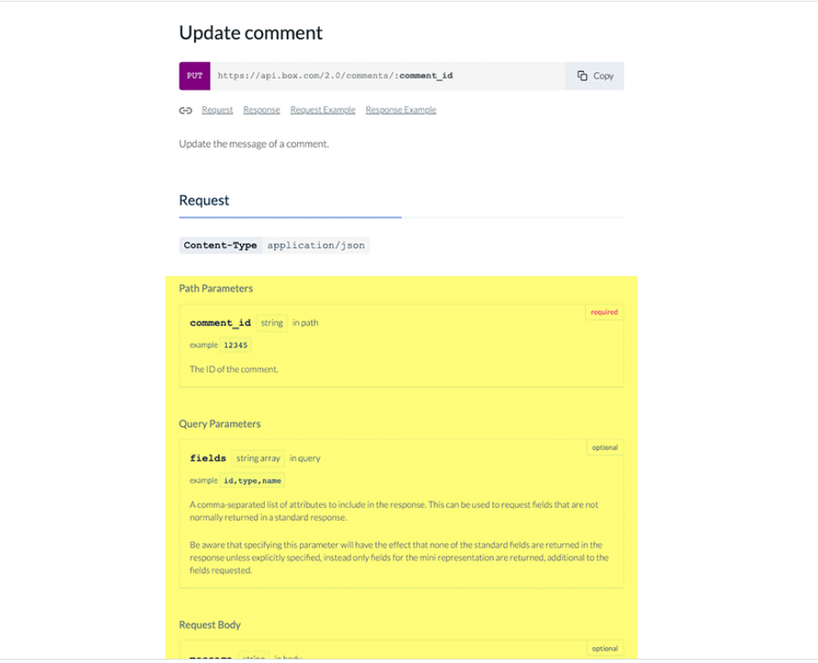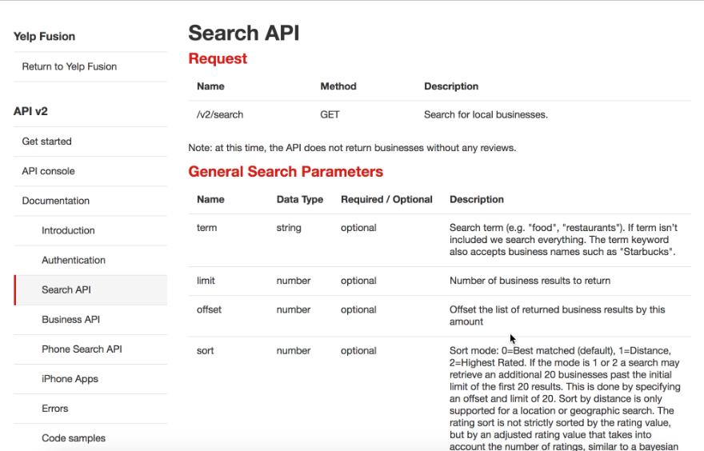

Several types of parameters

REST APIs have several types of parameters:

* : Parameters included in the request header, usually related to authorization.
* : Parameters within the path of the endpoint, before the query string (?). These are usually set off within curly braces.
* : Parameters in the query string of the endpoint, after the ?.

1. Create an API that would save a new entry with all the relevant properties which retrieves values from the endpoint GET /entries.

Ans:-

Retrieve using an alternate key

If an entity has an alternate key defined, you can also use the alternate key to retrieve the entity instead of the unique identifier for the entity. For example, if the Contact entity has an alternate key definition that includes both the firstname and emailaddress1 properties, you can retrieve the contact using a query with data provided for those keys as shown here

GET [Organization URI]/api/data/v9.0/accounts(00000000-0000-0000-0000-000000000001)

Retrieve a single property value

When you only need to retrieve the value of a single property for an entity, you can append the name of the property to the URI for an entity to return only the value for that property. This is a performance best practice because less data needs to be returned in the response.

This example returns only the value of the name property for an account entity.

Request

GET [Organization URI]/api/data/v9.0/accounts(00000000-0000-0000-0000-000000000001)?$select=name,revenue HTTP/1.1

Accept: application/json

Content-Type: application/json; charset=utf-8

OData-MaxVersion: 4.0

OData-Version: 4.0

HTTP/1.1 200 OK

Content-Type: application/json; odata.metadata=minimal

OData-Version: 4.0

Retrieve navigation property values

In the same way that you can retrieve individual property values, you can also access the values of navigation properties (lookup fields) by appending the name of the navigation property to the URI referencing an individual entity.

The following example returns the fullname of the primary contact of an account using the primarycontactid single-valued navigation property.

Request

{

"@odata.context": "[Organization URI]/api/data/v9.0/$metadata#accounts(name,revenue)/$entity",

"@odata.etag": "W/\"502186\"",

"name": "A. Datum Corporation (sample)",

"revenue": 10000,

"accountid": "00000000-0000-0000-0000-000000000001",

"_transactioncurrencyid_value":"b2a6b689-9a39-e611-80d2-00155db44581"

}

1. Question: what are the key things you would consider when creating/consuming an API to ensure that it is secure and reliable?

Businesses use APIs to connect services and to transfer data. Broken, exposed, or hacked APIs are behind major data breaches. They expose sensitive medical, financial, and personal data for public consumption. That said, not all data is the same nor should be protected in the same way. How you approach API security will depend on what kind of data is being transferred.

If your API connects to a third party application, understand how that app is funneling information back to the internet. To use the example above, maybe you don’t care if someone finds out what’s in your fridge, but if they use that same API to track your location you might be more concerned.

What is web API security? REST API security vs. SOAP API security.

Web API security is concerned with the transfer of data through APIs that are connected to the internet. OAuth (Open Authorization) is the open standard for access delegation. It enables users to give third-party access to web resources without having to share passwords. OAuth is the technology standard that lets you share that Corgi belly flop compilation video onto your social networks with a single “share” button.

Most API implementations are either REST (Representational State Transfer) or SOAP (Simple Object Access Protocol).

REST APIs use HTTP and support Transport Layer Security (TLS) encryption. TLS is a standard that keeps an internet connection private and checks that the data sent between two systems (a server and a server, or a server and a client) is encrypted and unmodified. This means that a hacker trying to expose your credit card information from a shopping website can neither read your data nor modify it. You know if a website is protected with TLS if the URL begins with “HTTPS” (Hyper Text Transfer Protocol Secure).

REST APIs also use JavaScript Object Notation (JSON), which is a file format that makes it easier to transfer data over web browsers. By using HTTP and JSON, REST APIs don’t need to store or repackage data, making them much faster than SOAP APIs.

SOAP APIs use built-in protocols known as Web Services Security (WS Security). These protocols define a rules set that is guided by confidentiality and authentication. SOAP APIs support standards set by the two major international standards bodies, the Organization for the Advancement of Structured Information Standards (OASIS) and the World Wide Web Consortium (W3C). They use a combination of XML encryption, XML signatures, and SAML tokens to verify authentication and authorization. In general, SOAP APIs are praised for having more comprehensive security measures, but they also need more management. For these reasons, SOAP APIs are recommended for organizations handling sensitive data.

What are some of the most common API security best practices?

You probably don’t keep your savings under your mattress. Most people their money in a trusted environment (the bank) and use separate methods to authorize and authenticate payments. API security is similar. You need a trusted environment with policies for authentication and authorization.

Here are some of the most common ways you can strengthen your API security:

Use tokens. Establish trusted identities and then control access to services and resources by using tokens assigned to those identities.

Use encryption and signatures. Encrypt your data using a method like TLS(see above). Require signatures to ensure that the right users are decrypting and modifying your data, and no one else.

Identify vulnerabilities. Keep up with your operating system, network, drivers, and API components. Know how everything works together and identify weak spots that could be used to break into your APIs. Use sniffers to detect security issues and track data leaks.

Use quotas and throttling. Place quotas on how often your API can be called and track its use over history. More calls on an API may indicate that it is being abused. It could also be a programming mistake such as calling the API in an endless loop. Make rules for throttling to protect your APIs from spikes and Denial-of-Service attacks.

Use an API gateway. API gateways act as the major point of enforcement for API traffic. A good gateway will allow you to authenticate traffic as well as control and analyze how your APIs are used.

API management and security

Finally, API security often comes down to good API management. Many API management platforms support three types of security schemes. These are:

An API key that is a single token string (i.e. a small hardware device that provides unique authentication information).

Basic Authentication (APP ID / APP Key) that is a two token string solution (i.e. username and password).

OpenID Connect (OIDC) that is a simple identity layer on top of the popular OAuth framework (i.e. it verifies the user by obtaining basic profile information and using an authentication server).

When you select an API manager know which and how many of these security schemes it can handle, and have a plan for how you can incorporate the API security practices outlined above.

Video: Red Hat's approach to security and compliance

Why choose Red Hat for API management and security

Data breaches are scary, but you can take steps toward better security. APIs are worth the effort, you just need to know what to look for. Red Hat publishes an annual Red Hat product risk report, which outlines global security vulnerabilities affecting enterprise software, and Red Hat's solutions for our products. A lot of it comes down to continuous security measures, asking the right questions, knowing which areas need attention, and using an API manager that you can trust. We are here to help.

At Red Hat, we recommend our award-winning Red Hat 3scale API Management. It includes:

An API manager which manages the API, applications, and developer roles

A traffic manager (an API gateway) that enforces the policies from the API manager

An identity provider (IDP) hub that supports a wide range of authentication protocols

At the API gateway, Red Hat 3scale API Management decodes timestamped tokens that expire; checks that the client identification is valid; and confirms the signature using a public key.

Theoretical Challenge

Suppose you have a CSV file with the data below.

A1: 5, A2: 7, A3: 9, B1: 3, B2: 8, B3: =4+5, C1: =5+A1, C2: =A2+B2, C3: =C2+B3

This can be represented in an excel sheet below:

A B C

1 5 3 =5+A1

2 7 8 =A2+B2

3 9 =4+5 =C2+B3

I want a program that will take the CSV input above and produce CSV output with the results. If it is a value, then return a value. If it is a formula then calculate the formula and return the value of that formula.

1. How will you tackle the challenge above?

Ans: -

When it comes to Excel, there isn’t much middle ground.

You have people who absolutely love it and will sing the praises of spreadsheets all day. And, then you have the people who absolutely detest it. They’d rather lock themselves in a phone booth full of mosquitos than have to go cross-eyed looking at all of those columns and rows.

Admittedly, I used to fall into that latter group. I’d open a new Excel workbook with the best of intentions. But, after 20 odd minutes of trying to get one stupid decimal point to appear properly in its cell, I’d throw my hands up once again and claim Excel just wasn’t for me.

Then, my life experienced a major plot twist: I married a total Excel whiz—someone who literally spends his entire workday creating complicated macros and some of the most impressive spreadsheets I’ve ever seen. And, he’s made it his personal mission to convert me to his tribe of Excel-lovers (honestly, I’m surprised it wasn’t in his wedding vows).

Since then? Well, he’s made some progress. I’ve been able to put my hatred aside and recognize that learning Excel can actually be an incredibly powerful tool for combing through information and finding exactly what you need—provided you know how to use it correctly.

It’s that last part that trips people up. But, fortunately, Excel isn’t nearly as complicated as you’re likely making it out to be.

In fact, there are plenty of helpful tricks and tools you can utilize—whether you’re a total newbie or an established expert. Here are six things you should absolutely know how to do in Excel (and, trust me, you’ll be glad you do!).

1. Sort data

Typically, spreadsheets are useful for storing and sorting a whole bunch of information—think a contact list for 800 people that you want to invite to your company’s luncheon, for example.

Now, let’s say that you want to sort those people accordingly. Perhaps you want them listed in alphabetical order by last name. Or, maybe you want to group them together by city.

Excel makes it easy to comb through your entire data set and sort everything into a clean and easy to read spreadsheet.

3. Basic math functions

Stop reaching for that calculator—Excel can handle all sorts of math functions for you! All you need to do is enter a few simple formulas.

Think that sounds like it’s way beyond your Excel knowledge? Think again. Trust me, if I can figure this out, so you can you.

Here are the basic formulas you’ll want to know:

Addition: Type “=SUM” in a blank cell where you want the total to appear, click the cells you want to add together, and then hit “Enter.”

Subtraction: Type “=” in a blank cell where you want the difference to appear, click the cell you want to subtract from, type “-”, click the cell you want to subtract, and then hit enter.

Multiplication: Type “=” in a blank cell where you want the total to appear, click the cell for a number you want to multiply, type “*”, click the cell for the other number you want to multiply, and then hit enter.

Division: Type “=” in a blank cell where you want the remainder to appear, click the cell for the number you want to divide, type “/”, click the cell for the number you want to divide by, and then hit enter.

Listen, I know these are a little confusing to put down in words. But, give them a try for yourself and I’m positive you’ll quickly see that they aren’t complicated at all. Here’s a look at what the SUM function looks like in practice:

INSIDER TIP: If you want to drag the same mathematical formula across a row, you can! After entering the formula into one cell, click that cell where the total appeared, click the little green box that appears in the lower right-hand corner, and drag it across the rest of the row where you need that formula to be applied.

Voila—it’ll happen automatically! You’ll be able to crunch numbers in different columns, without needing to enter the formula again and again.

4. Freeze panes

There’s nothing worse than scrolling through a huge spreadsheet that requires you to continuously go back up to the top to see what your column headers are.

Fortunately, you can make your column headers and your row numbers stay right where they are—meaning you can always see them, no matter how far down the spreadsheet you go. You can do this by using Excel’s handy “freeze panes” feature.

Here’s how you do it:

Click on the row underneath your column headers.

Click on the “View” tab.

Click the “Freeze Panes” button.

Scroll down and across your spreadsheet, and you’ll see that the information you need is always right there within view!

5. Insert current date

Sick of glancing at your calendar or the bottom of your computer monitor in order to get today’s date and enter it in your spreadsheet?

Excel can do it for you—with just one easy keyboard shortcut. Here it is:

Ctrl + ;

Put your cursor in the cell where you want the date to appear, use that shortcut, and Excel will automatically fill in today’s date for you. Easy peasy!

IMPORTANT NOTE: Dates entered using that function are static, meaning they won’t change as your spreadsheet ages!

6. Make the same change across worksheets

When you’re working with multiple tabs, it’s a hassle to comb through them all and make the same change over and over again. Fortunately, you don’t have to!

You can select the appropriate sheets in your workbook where that change should appear. Make the change once, and it’ll be applied across all of the sheets you selected.

Here’s how you do it:

Hold the “Command” key on your keyboard (or “Control” if you’re using a PC).

Select the appropriate tabs of your workbook.

Make the necessary change to one cell.

Check to make sure it applied across all of your worksheets.

Want to see this in practice? For simplicity’s sake, let’s assume I got married to Aaron Rodgers (hey, a girl can dream!). As a result, I changed my last name from “Boogaard” to “Rodgers.” Since my name appears in numerous different tabs of this spreadsheet, I’d use this handy trick to only have to enter my new last name one time.

Here’s how you do it:

Highlight the entire data set you want to sort (not just one column!) by either dragging your cursor across all of the cells or clicking the triangle in the upper left of your spreadsheet to select the entire thing.

Hit the “Data” tab.

Click the “Sort” button.

Select how you want to sort your data (in the example below, I sorted by city!).

Hit “OK.”

Then, your data will be sorted accordingly—in this case, alphabetical order by city.

IMPORTANT NOTE: It’s important that you select the entire data set you want to sort, and not just one column. That way, your rows will stay intact—meaning, in this case, the correct address will stay with the appropriate person.

Had I just selected the first column, Excel would’ve sorted only that one column alphabetically, making the addresses a mismatched mess.

2. Remove duplicates

It’s inevitable: When you’re working with a large dataset, there are bound to be a few duplicates that sneak their way in.

Rather than getting bleary-eyed and frustrated by scrolling through that entire spreadsheet and looking for them yourself, Excel can do all of that legwork for you and remove duplicates with the click of a button.

Here’s how you do it:

Highlight the entire data set.

Hit the “Data” tab.

Click the “Remove Duplicates” button.

Select what columns you want Excel to find duplicates in.

Hit “OK.”

IMPORTANT NOTE: Be careful that you choose enough qualifiers to weed out the true duplicates. For example, if I had just selected to remove duplicates in only Column A above (meaning Excel would’ve looked for duplicates of “Oprah”), I would’ve deleted one Oprah that indeed had the same address, but one that had a different last name and address altogether (a different Oprah entirely!)

The bottom line is, utilize enough information so that you’re removing rows that are true identical copies of each other—and don’t just share one similar value!

2. What type of errors you would you check for?

Ans:-  
The error can be:

1. #DIV/0
2. #N/A
3. #NAME?
4. #NULL!
5. #NUM!
6. #REF!
7. #VALUE!
8. #####
9. Circular Reference

***You are free to use this image on your website, templates, etc.,*Please provide us with an attribution link**

We have various functions to deal with these errors, which are –

1. IFERROR Function
2. [**ISERROR Function**](https://www.wallstreetmojo.com/iserror-excel-function/)
3. AGGREGATE Function

### Types of Errors in Excel with Examples

You can download this Errors Excel Template here – [**Errors Excel Template**](https://www.wallstreetmojo.com/errors-in-excel/#popmake-95356)

#### 1 – #DIV/0 Error

**#DIV/0!** Error is received when we work with a spreadsheet formula, which divides two values in a formula and the divisor (the number being divided by) is zero. It stands for divide by zero error.

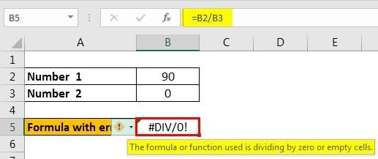

Here, in the above image, we see that number 90 is divided by 0. That is why we get the #DIV/0! Error.

##### How to Resolve this Error?

The first and foremost solution is to divide only with cells with a value not equal to zero. But there are situations when we also have empty cells in a spreadsheet. In that case, we can use the IF function as below.

##### Example – IF Function to Avoid #DIV/0 Error

Follow the steps below to use the IF function to avoid the #DIV/0! Error.

1. **Suppose we are getting a #DIV/0! Error as follows:**

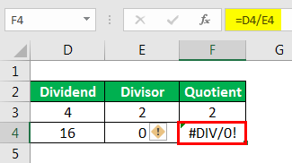

1. **To avoid this error, we can use the IF function as follows:**

#### 2 – #N/A Error

This error means **“no value available”** or **“not available.”** It indicates that the formula cannot find the value that we suppose it may return.

For example, [**using Excel’s VLOOKUP**](https://www.wallstreetmojo.com/vlookup-excel-function/), [**HLOOKUP**](https://www.wallstreetmojo.com/hlookup-excel/), [**MATCH**](https://www.wallstreetmojo.com/match-excel-function/), and [**LOOKUP functions**](https://www.wallstreetmojo.com/lookup-excel-function/), we may get this error if we do not find referenced value in the source data as an argument.

* When the source data and the lookup value are not of the same data type:

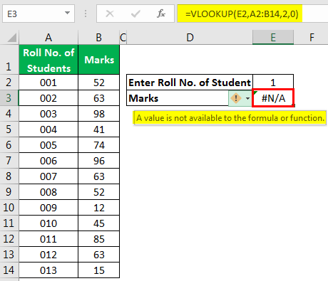

In the above example, we have entered “Roll No. of Students” as a number, but the roll numbers of students are stored as text in the source data. That is why the #N/A error appears.

To resolve this error, we can either enter the roll number as text-only or [**use the TEXT formula in excel**](https://www.wallstreetmojo.com/text-function-excel/) in the **VLOOKUP** Function.

##### Solution 1: To enter the Roll number as text

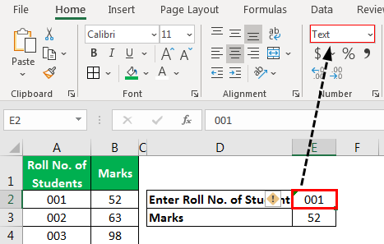

##### Solution 2: Use the TEXT Function

We can use the **TEXT** function in the VLOOKUP function for the **lookup_value** argument to convert entered numbers to **TEXT**.

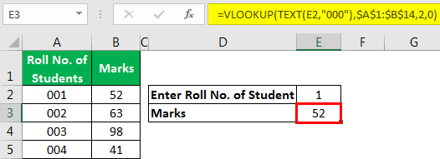

We could also use the [**IFERROR function in excel**](https://www.wallstreetmojo.com/iferror-excel-function/) to display the message if **VLOOKUP** cannot find the referenced value in the source data.

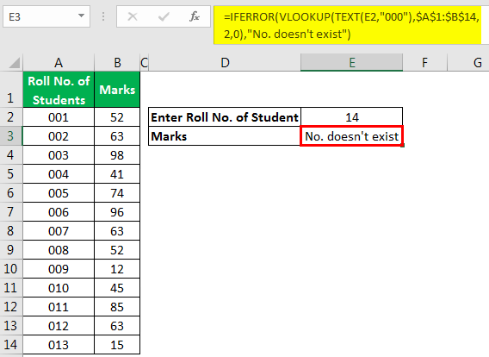

#### 3 – #NAME? Error

This error is displayed when we usually misspell the function name.

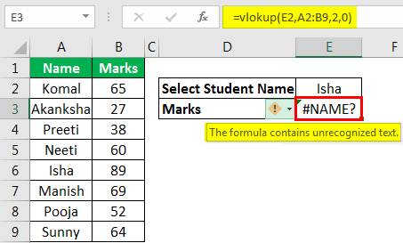

We can see in the above image that **VLOOKUP** is not spelled correctly; that is why **#NAME?** Error is being displayed.

To resolve the error, we need to correct the spelling.

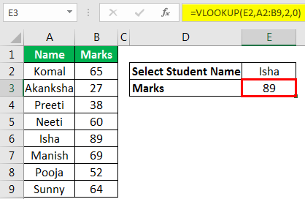

#### 4 – #NULL! Error

This error is usually displayed when [**cell references**](https://www.wallstreetmojo.com/cell-reference-in-excel/) are not specified correctly.

We get this error when we do not use the space character appropriately. The space character is called the “intersect operator,” which specifies the range that intersects each other at any cell.

In the below image, we have used the space character, but the ranges A2:A12 and B2:B12 are not intersecting; that is why this error is displayed.

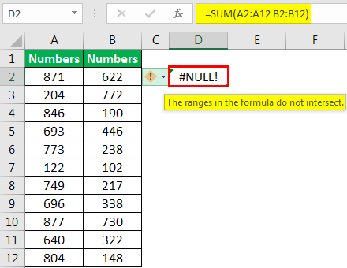

In the below image, we can see that the sum of range B2:B12 is being displayed in cell D2 as while specifying a range for SUM function, we have picked up two references (with space character), which overlap each other for range B2:B12. That is why the sum of the B2:B12 range is displayed.

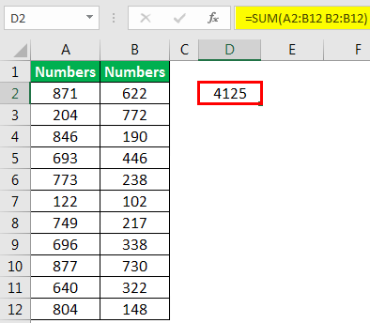

#NULL! an error can also be displayed when we use intersect operator (space character) instead of:

* **Mathematical Operator (Plus Sign)** to sum.
* **Range Operator (Colon Sign)** to specify the start and end cell for a range.
* **Union Operator (Comma Sign)** to separate individual cell references.

#### 5 – #NUM! Error

This error is usually displayed when a number for any function argument is found invalid.

##### Example 1

To find out the [**square root in excel**](https://www.wallstreetmojo.com/square-root-in-excel/) of a negative number is not possible as the square of a number always has to be positive.

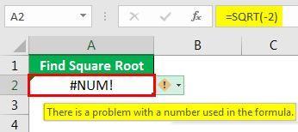

To solve the error, we need to make the number positive.

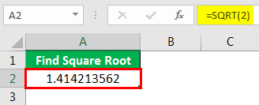

##### Example 2

MS Excel has a range of numbers that we can use. The number smaller than the shortest number or number greater than the longest number due to the function can return an error.

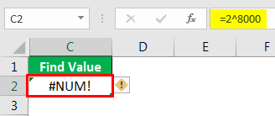

Here, we can see that we have written the formula as **2^8000,** which yields results greater than the longest number; that is why **#NUM!** Error is being displayed.

#### 6 – #REF! Error

This error stands for reference error. This error usually comes when

1. We accidentally deleted the cell which we referenced in the formula.
2. We cut and paste the referenced cell in different locations.

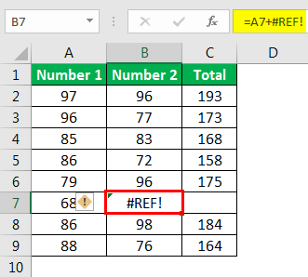

As we deleted cell B7, then cell C7 shifted left to take the place of B7, and we got a reference error in the formula as we deleted one of the referenced cells of the formula.

#### 7 – #VALUE! Error

This error comes when we use the wrong data type for a function or formula. For example, we can add only numbers. But if we use any other data type like text, this error will be displayed.

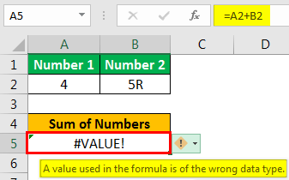

#### 8 – ###### Error

This error is displayed when the [**column width in excel**](https://www.wallstreetmojo.com/excel-column-width/) is not enough to show the stored value in the cell.

##### Example

In the below image, dates and times are written in the cells. But, as column width is not enough, ##### is being displayed.

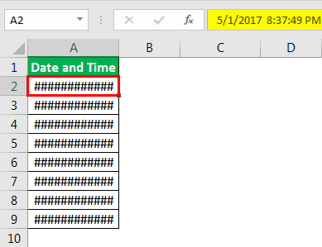

To resolve the error, we need to increase the column width as per requirement using the “Column Width” command available in the “Format” menu in the “Cell Size” group under the “Home” tab, or we can double click on the right border of the column.



#### 9 – Circular Reference Error

This type of error comes when we reference the same cell in which we are writing the function or formula.

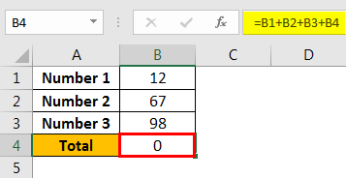

The above image shows that we have a sum of 0 as we have referenced B4 in the B4 cell itself for calculation.

Whenever we create this type of [**circular reference in excel**](https://www.wallstreetmojo.com/circular-reference-in-excel/), Excel alerts us about the same too.

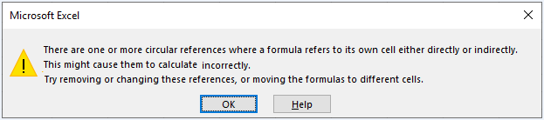

To resolve the error, we need to remove the reference for the B4 cell.

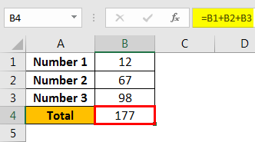

### Function to Deal with Excel Errors

#### 1 – ISERROR Function

This function is used to check whether there would be an error after applying the function or not.

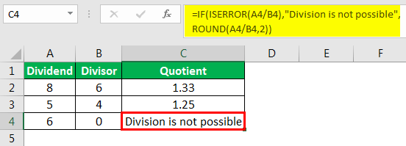

#### 2 – AGGREGATE Function

This function ignores error values. Therefore, when we know that there can be an error in the source data, we need to use this function instead of the SUM, COUNT function, etc.

##### Example

We can see that the [**AGGREGATE function**](https://www.wallstreetmojo.com/aggregate-excel-function/) avoids error values.

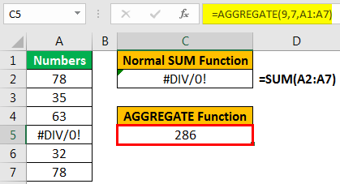

### Things to Remember

* To resolve any error in the formula, we can take online help also. First, we need to click on the **“Insert Function”**button under the “Formulas” tab and choose **“Help on this function.”**

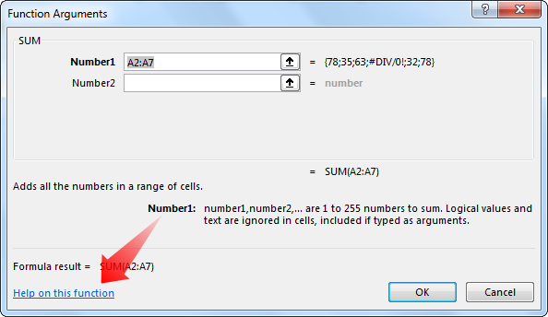

* To avoid the #NAME? Error, we can choose the desired function from the drop-down list opened when we start typing any function in the cell, followed by the “=” sign. Next, we need to press the **“Tab”** button on the keyboard to select a function.
* 3. How might a user break your code?
* Ans: -

## Modes in VBA

VBA operates in 3 modes:

1. **Run mode**: The execution of code.
2. **Break mode**: A halt in the execution especially for debugging purposes.
3. **Design mode**: The state of the VBA Editor in which code is typed.

## The meaning of “Runtime” or “Run mode” and related shortcut keys

**Runtime** is simply the duration during which code runs or executes after being compiled. Runtime duration and speed can be controlled in VBA programming using the F5 and F8 keys.

**F5**can be used to initiate or execute a full run of [a sub procedure](https://software-solutions-online.com/vba-call-sub/).

**F8**is used to execute the lines of code step-by-step.

## What is break mode?

Break mode is **a state of code execution where it has been halted for some reason**. In general, code execution can be halted for several reasons — allow me to explain. Here’s why you’d want to go into break mode:

1. **Re-execute** the previous steps in order to observe the execution. This can be done by dragging the yellow cursor along the margin to the line you want to re-execute. Re-execution of certain code might require you to stop execution altogether and then start execution all over again.
2. **Make minor changes** in previous steps and re-execute any piece of code that were run before. If major changes that affect the logic of the code are made, VBA may require us to end the execution and start it all over. There might even be an alert which automatically ends the execution if we click on its “Okay” button. Any more advanced changes will be allowed only if the execution is ended.
3. Flow of execution can be **observed and confirmed** to make sure it is meeting our expectations.

## How to enter break mode

We can explicitly enter break mode using any one of the 3 methods explained below.

1. Using breakpoints
2. Ctrl + Break shortcut or F9
3. Stop statements

Some **errors** can automatically get us into break mode. We can continue with execution after fixing them.

### **Breakpoints**

A breakpoint is an element that is used to halt the execution of your code at any specific position or line, entering you into break mode in order to debug the code. In VBA, the line is colored in yellow for identification purposes. A breakpoint could be compared a speed bump on the road.

Here is a picture of a program execution halted using a breakpoint. A breakpoint can be inserted using the Debug menu or the shortcut key F9 after placing the cursor on the desired line.

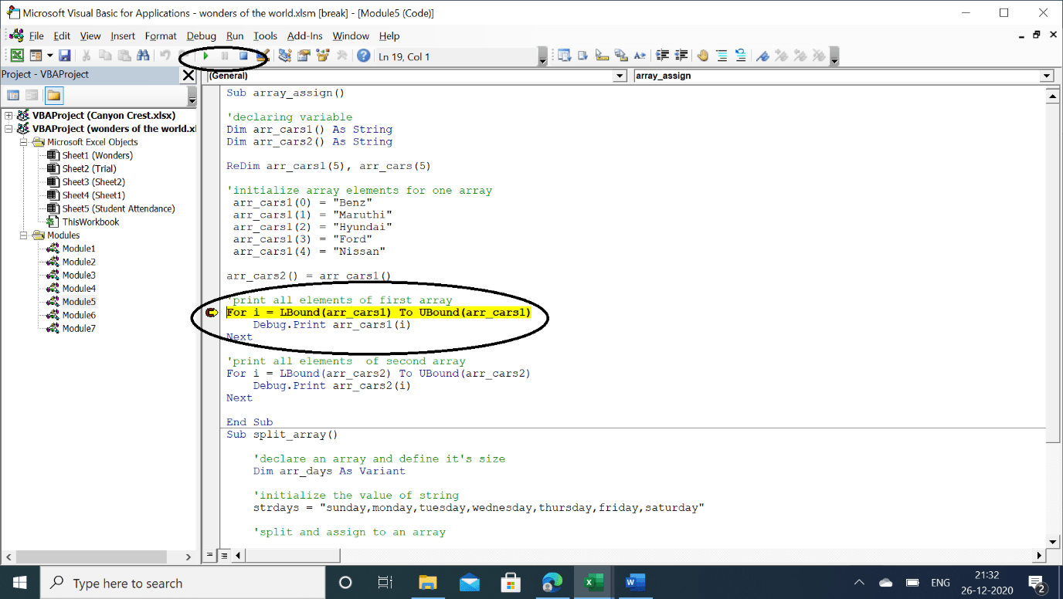

### **Using the Ctrl+Break option**

To explicitly enter break mode for debugging purpose, we can use Ctrl + Break anytime before or during execution. There is also a menu for this as shown in the picture below.

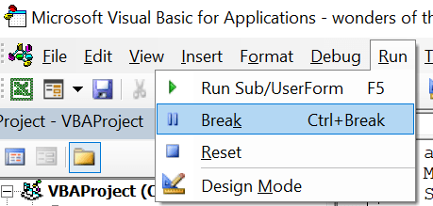

### **Using the Stop statement**

Just like [the Wait statement](https://software-solutions-online.com/vba-wait-method/), we have a “Stop” statement in VBA that can halt execution and take the user into break mode. Check out the example below.

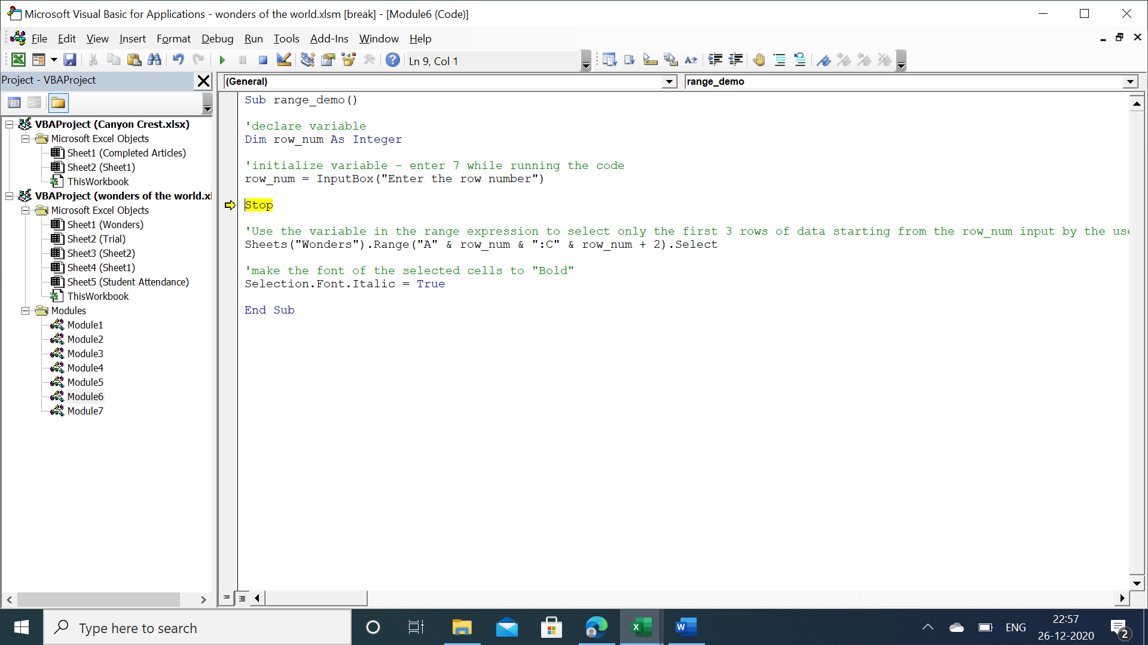

## 

## Errors that lead to break mode during execution

There are some run time and syntax errors that may lead to break mode while your code is getting executed. Some number of errors can be fixed on the spot, and we can click on “Continue” button for the execution to continue.

Below are some examples of situations with errors in break mode.

[Running code from Macro dialog box while the VBA editor is already in break mode](https://software-solutions-online.com/cant-execute-code-in-break-mode/).

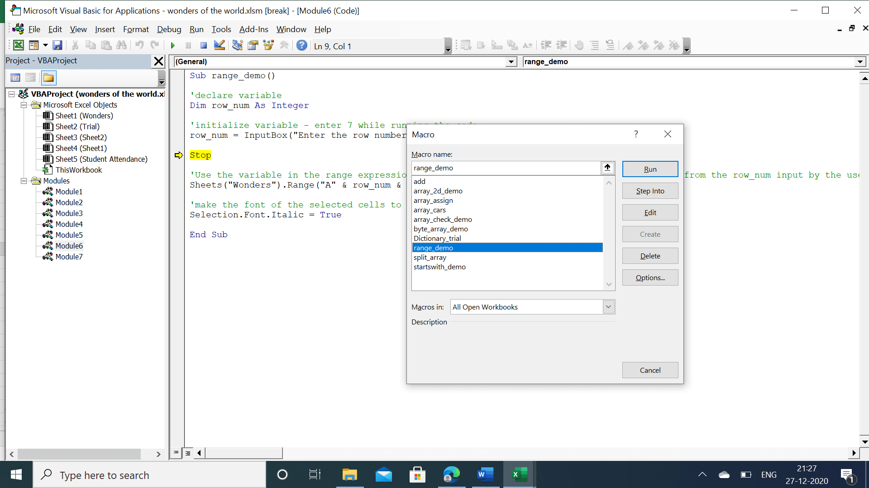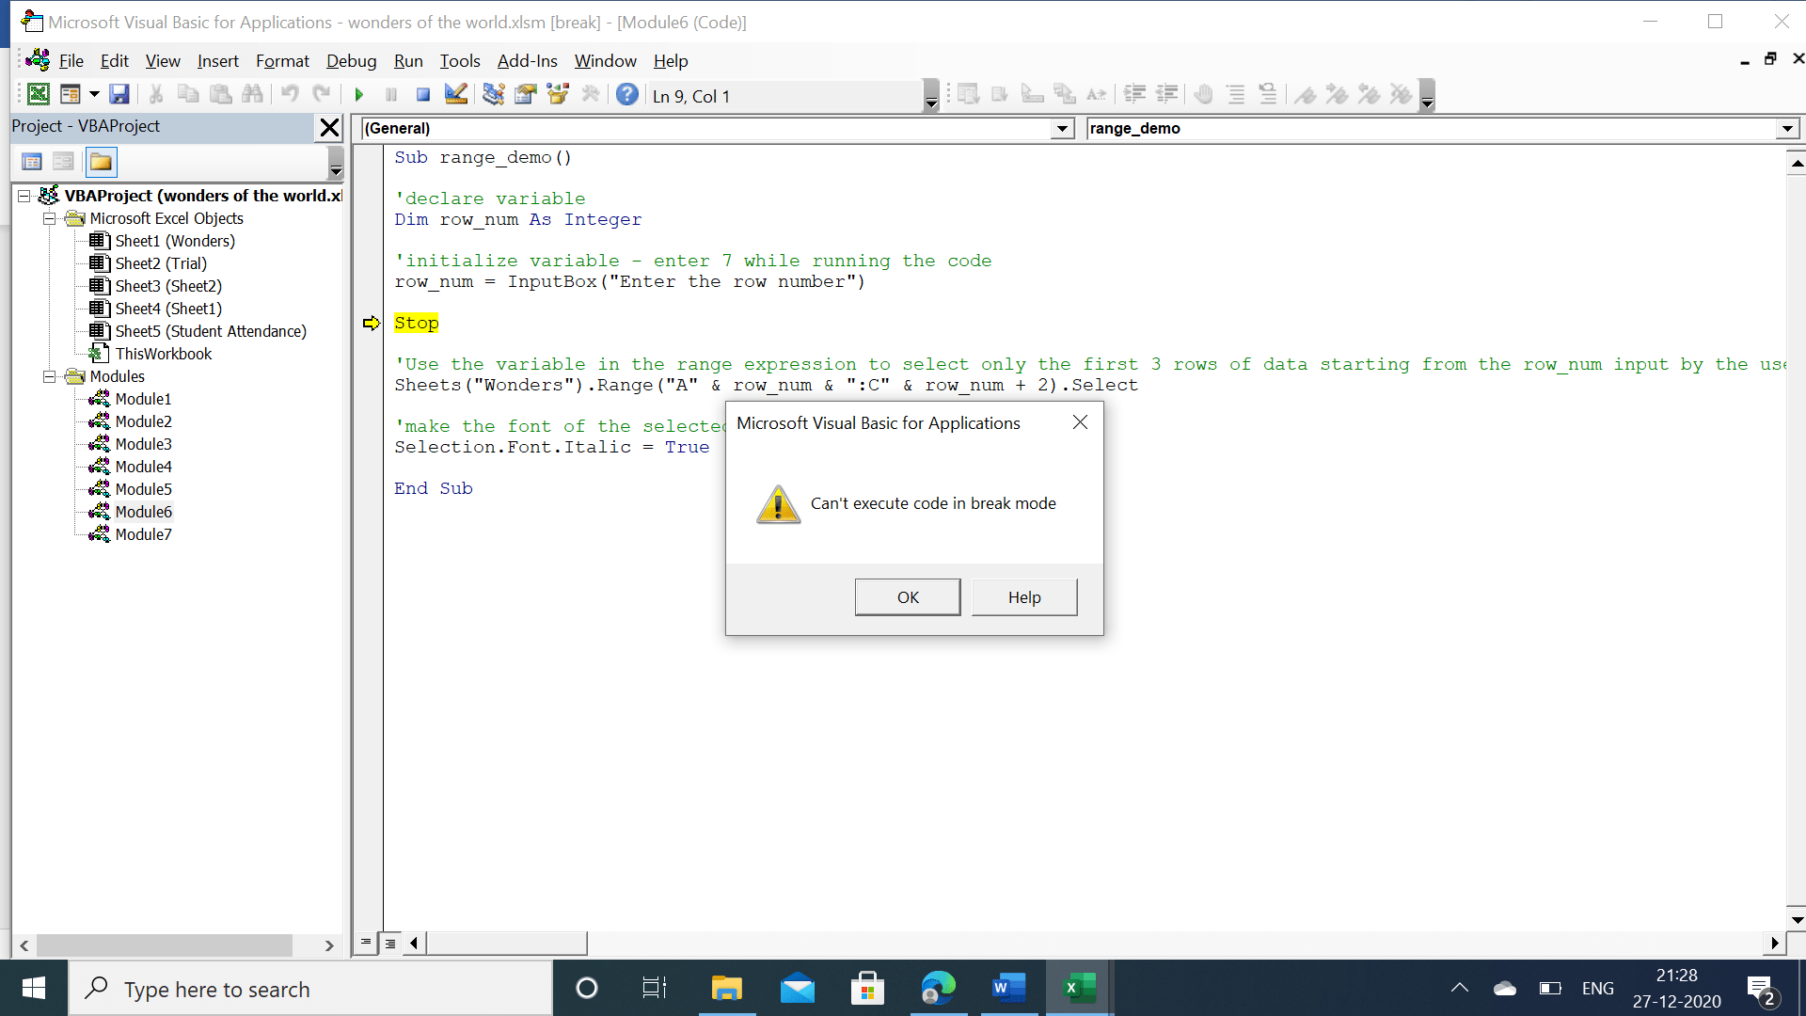

In the case below, we have entered into a break mode using breakpoint.

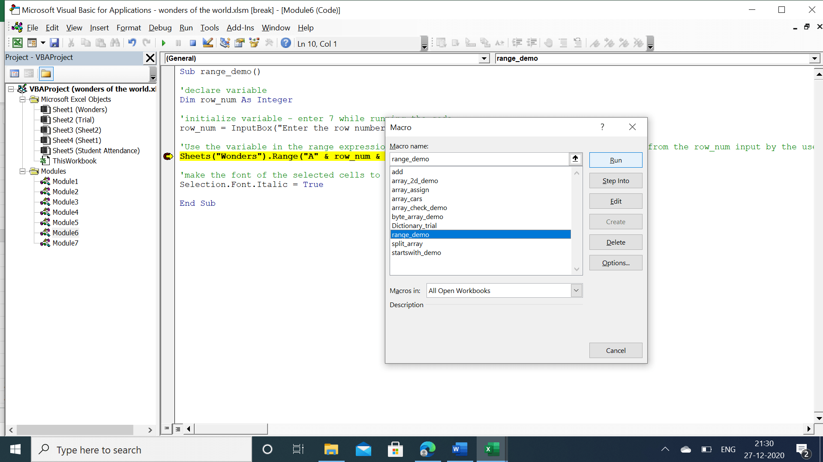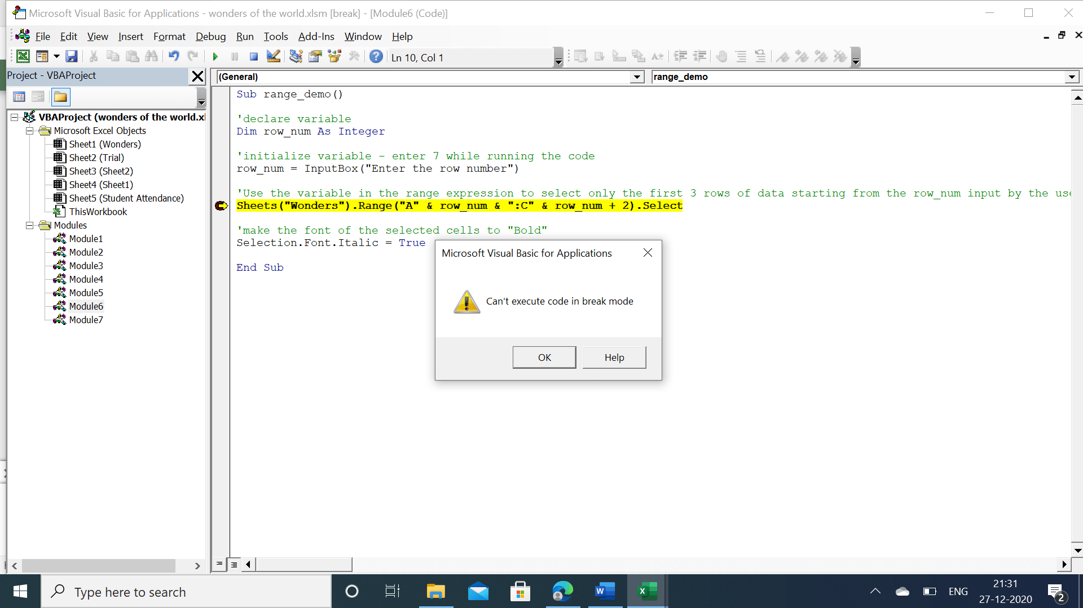

## Conclusion

Break mode in VBA is used for debugging and fixing errors. If we need to continue with execution, we should either click on the play button or press F5 or F8. Or we should just end the program’s execution and start a fresh run of the code.

Executing a sub procedure from the Macro dialog box while the code is in Break mode will only lead to the aforementioned error. So you need to be cautious to avoid it.