A Software Engineering Project

On

Blood Bank & Donation Management System

as the partial fulfillment of

Semester -V study

for the degree of

Bachelor of Science (Computer Science)

(Affiliated to Veer Narmad South Gujarat University)

during the academic year 2022-2023.

Developed By: Guided By:

Devani Yagnik Dr. Priti Patel

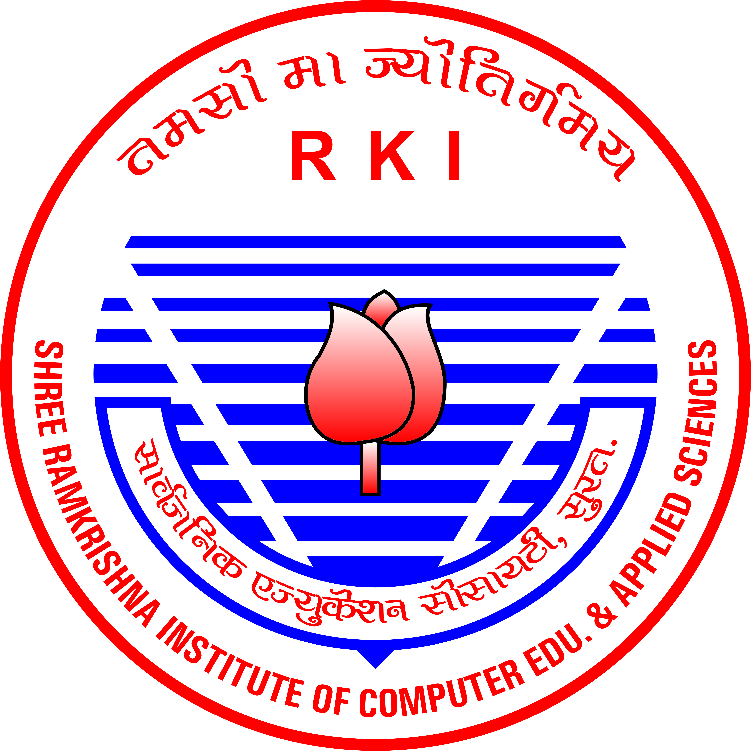

Sarvajanik Education Society

Shree Ramkrishna Institute of Computer Education and Applied Sciences

Behind P.T Science College, M.T.B. College Campus, Athwalines, Surat-395 001.

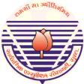

Sarvajanik Education Society

Shree Ramkrishna Institute of Computer Education and Applied Sciences

Behind P.T. Science College, M.T.B College Campus, Athwalines, Surat-395 001.

CERTIFICATE

DEPARTMENT OF COMPUTER SCIENCE

This is to certify that Exam no(spid)

1) Devani Yagnik 20192 (E20110192000310026)

has / have successfully completed his / her / their software engineering project work entitled

Blood Bank & Donation Mangement System

as the partial fulfillment of

Semester -V study
for the degree of

Bachelor of Science (Computer Science)

(Affiliated to Veer Narmad South Gujarat University)
during the academic year 2022-2023.

___________________ ____________________

Internal Project Guide HOD

Dept. of Computer Science

Date : ____________ Place : Surat

University Examination:

Examination No. : ____________

Signature of External Examiners : _______________________________

_______________________________

_______________________________

