# Vidyavardhini’s College of Engineering & Technology Department of Computer Engineering

56 - Sahil Pawar

|  |
| --- |
| Experiment No. 1 |
| Analyze the Boston Housing dataset and apply appropriate  Regression Technique |
| Date of Performance: 27/07/23 |
| Date of Submission: 17/08/23 |

**Aim:** Analyze the Boston Housing dataset and apply appropriate Regression Technique.

**Objective:** Ablility to perform various feature engineering tasks, apply linear regression on the given dataset and minimise the error.

## Theory:

Linear Regression is a machine learning algorithm based on supervised learning. It performs a regression task. Regression models a target prediction value based on independent variables. It is mostly used for finding out the relationship between variables and forecasting. Different regression models differ based on – the kind of relationship between dependent and independent variables they are considering, and the number of independent variables getting used.

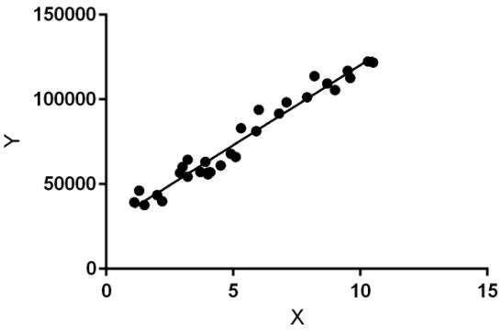

Linear regression performs the task to predict a dependent variable value (y) based on a given independent variable (x). So, this regression technique finds out a linear relationship between x (input) and y(output). Hence, the name is Linear Regression.

In the figure above, X (input) is the work experience and Y (output) is the salary of a person. The regression line is the best fit line for our model.

**Dataset:**

The Boston Housing Dataset

The Boston Housing Dataset is a derived from information collected by the U.S. Census Service concerning housing in the area of Boston MA. The following describes the dataset columns:

CRIM - per capita crime rate by town

ZN - proportion of residential land zoned for lots over 25,000 sq.ft. INDUS - proportion of non-retail business acres per town.

CHAS - Charles River dummy variable (1 if tract bounds river; 0 otherwise) NOX - nitric oxides concentration (parts per 10 million)

RM - average number of rooms per dwelling

AGE - proportion of owner-occupied units built prior to 1940 DIS - weighted distances to five Boston employment centres RAD - index of accessibility to radial highways

TAX - full-value property-tax rate per $10,000 PTRATIO - pupil-teacher ratio by town

B - 1000(Bk - 0.63)^2 where Bk is the proportion of blacks by town LSTAT - % lower status of the population

MEDV - Median value of owner-occupied homes in $1000's

## Code:

import numpy as np import pandas as pd import os print(os.listdir("../input"))

from pandas import read_csv

column_names = ['CRIM', 'ZN', 'INDUS', 'CHAS', 'NOX', 'RM', 'AGE', 'DIS',

'RAD', 'TAX', 'PTRATIO', 'B', 'LSTAT', 'MEDV']

data=read_csv('../input/housing.csv',header=None,delimiter=r"\s+",names=colu mn_names)

print(data.head(5))

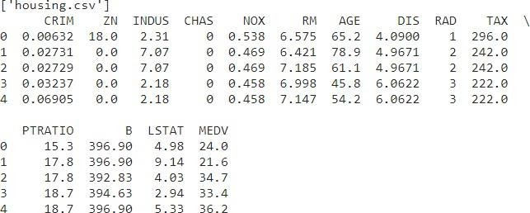

import seaborn as sns

import matplotlib.pyplot as plt from scipy import stats

fig, axs = plt.subplots(ncols=7, nrows=2, figsize=(20, 10)) index = 0

axs = axs.flatten()

for k,v in data.items():

sns.boxplot(y=k, data=data, ax=axs[index]) index += 1

plt.tight_layout(pad=0.4, w_pad=0.5, h_pad=5.0)

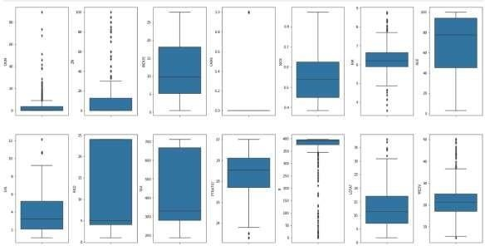

for k, v in data.items(): q1 = v.quantile(0.25) q3 = v.quantile(0.75) irq = q3 - q1

v_col = v[(v <= q1 - 1.5 * irq) | (v >= q3 + 1.5 * irq)] perc = np.shape(v_col)[0] * 100.0 / np.shape(data)[0] print("Column %s outliers = %.2f%%" % (k, perc))

data = data[~(data['MEDV'] >= 50.0)] print(np.shape(data))

fig, axs = plt.subplots(ncols=7, nrows=2, figsize=(20, 10)) index = 0

axs = axs.flatten()

for k,v in data.items(): sns.distplot(v, ax=axs[index]) index += 1

plt.tight_layout(pad=0.4, w_pad=0.5, h_pad=5.0)

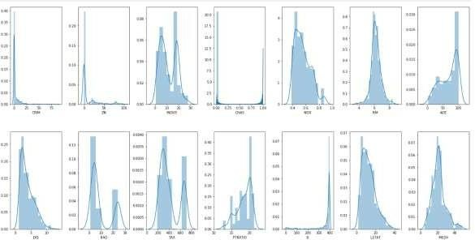

plt.figure(figsize=(20, 10)) sns.heatmap(data.corr().abs(), annot=True)

# Vidyavardhini’s College of Engineering & Technology Department of Computer Engineering

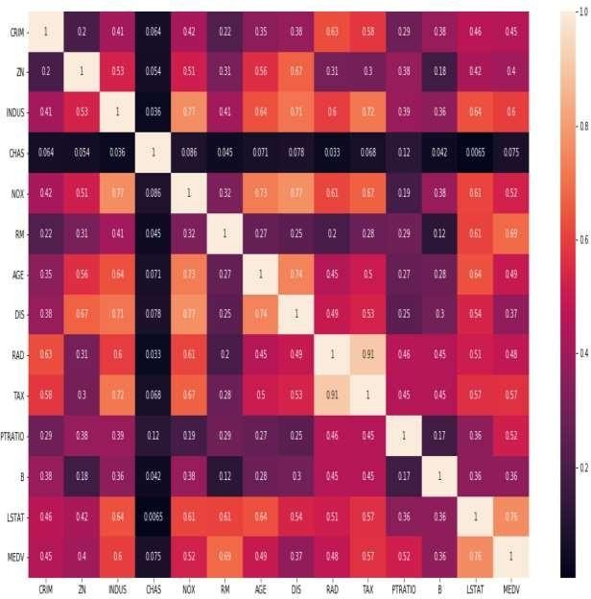

from sklearn import preprocessing min_max_scaler = preprocessing.MinMaxScaler()

column_sels = ['LSTAT', 'INDUS', 'NOX', 'PTRATIO', 'RM', 'TAX', 'DIS', 'AGE']

x = data.loc[:,column_sels] y = data['MEDV']

x=pd.DataFrame(data=min_max_scaler.fit_transform(x), columns=column_sels)

fig, axs = plt.subplots(ncols=4, nrows=2, figsize=(20, 10)) index = 0

axs = axs.flatten()

for i, k in enumerate(column_sels): sns.regplot(y=y, x=x[k], ax=axs[i])

plt.tight_layout(pad=0.4, w_pad=0.5, h_pad=5.0) y = np.log1p(y)

for col in x.columns:

if np.abs(x[col].skew()) > 0.3: x[col] = np.log1p(x[col])

from sklearn import datasets, linear_model

from sklearn.model_selection import cross_val_score from sklearn.model_selection import KFold

import numpy as np

l_regression = linear_model.LinearRegression() kf = KFold(n_splits=10)

min_max_scaler = preprocessing.MinMaxScaler()

x_scaled = min_max_scaler.fit_transform(x) scores=cross_val_score(l_regression,x_scaled,y,cv=kf,scoring='neg_mean_squa red_error')

print("MSE: %0.2f (+/- %0.2f)" % (scores.mean(), scores.std())) MSE: -0.04 (+/- 0.04)

## Conclusion:

### Features have been chosen to develop the model:

1. CRIM - Per capita crime rate by town
2. CHAS - Charles River dummy variable (1 if tract bounds river; else 0)
3. NOX - Nitric oxides concentration (parts per 10 million)
4. RM - Average number of rooms per dwelling
5. DIS - weighted distances to five Boston employment centres
6. RAD - Index of accessibility to radial highways
7. TAX - Full-value property-tax rate per $10,000
8. PTRATIO - Pupil-teacher ratio by town
9. LSTAT - Lower status of the population

### Mean Squared Error calculated:

* Calculated Mean Squared Error: 0.04 (+/- 0.04)
* The Mean Squared Error measures how close a regression line is to a set of data points.
* Lesser the Mean Squared Error refers to Smaller is the error and Better the estimator.