Assignment-1

• Install Power BI Desktop and share the final screenshot of the report view page which appears when power desktop starts.

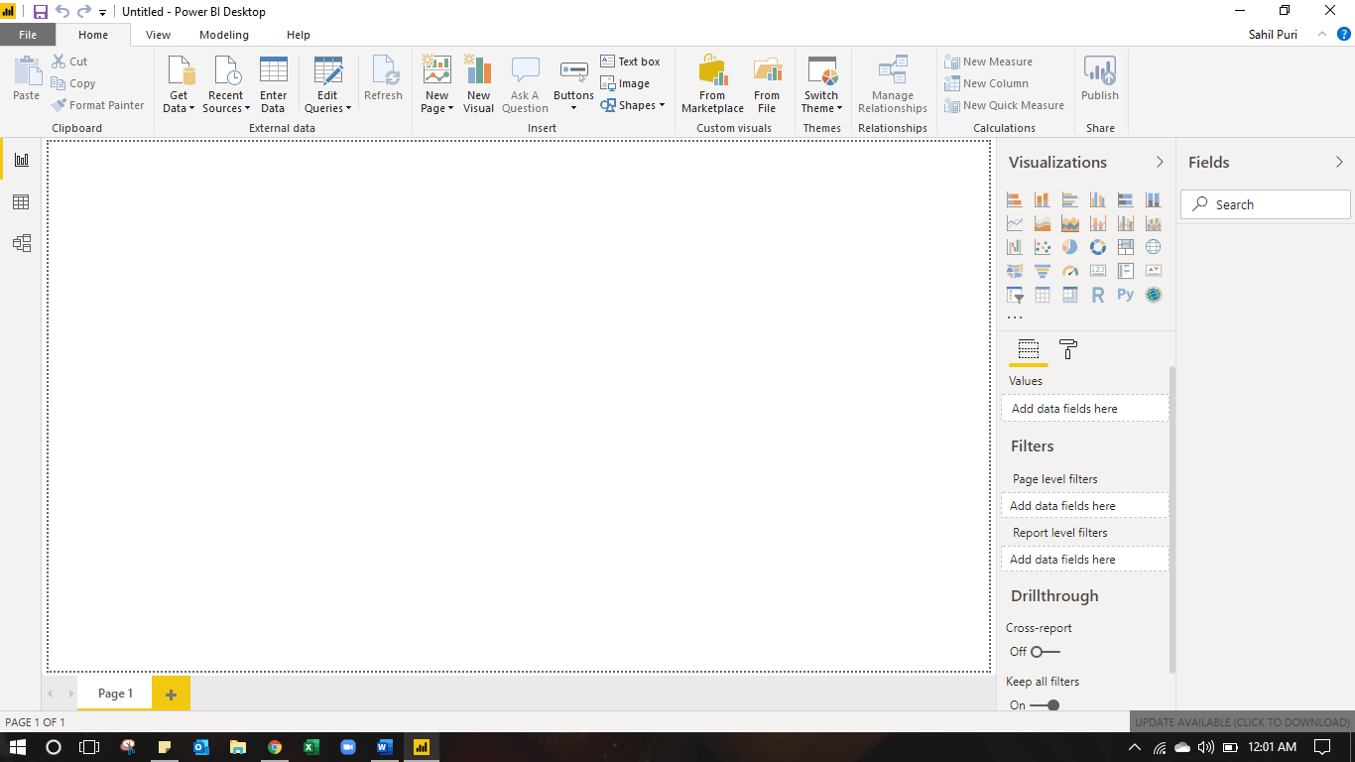

• Prepare a document and with the following screenshot
− Report View
− Data View
− Model View
− Power Query Editor
− Advance Editor

- Report View

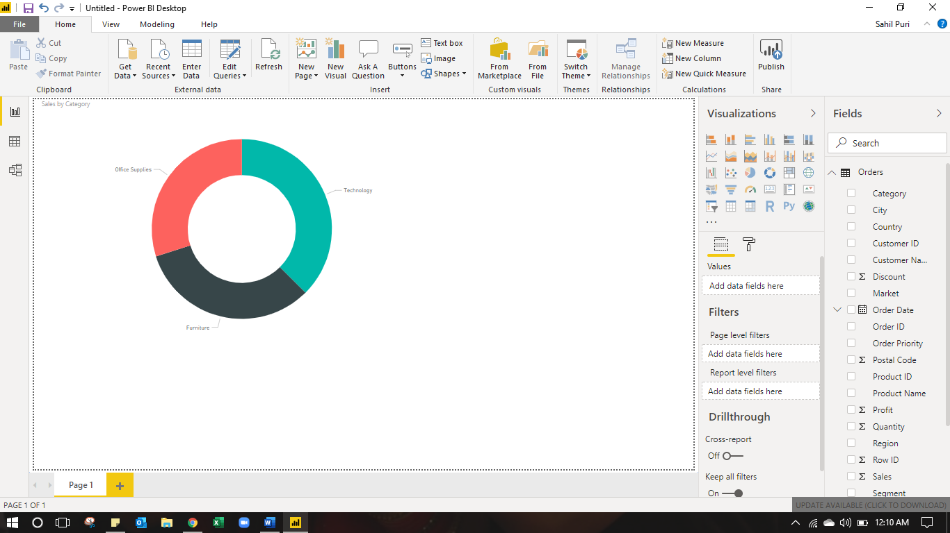

- Data View

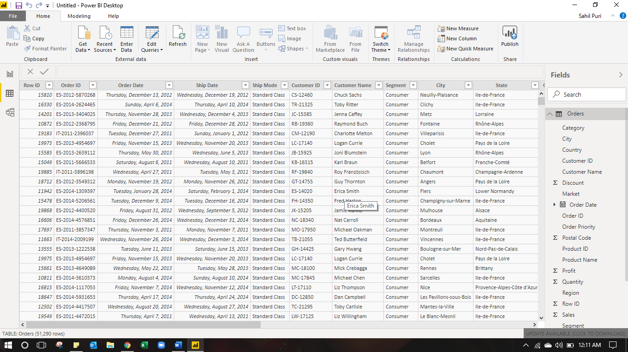

- Model View

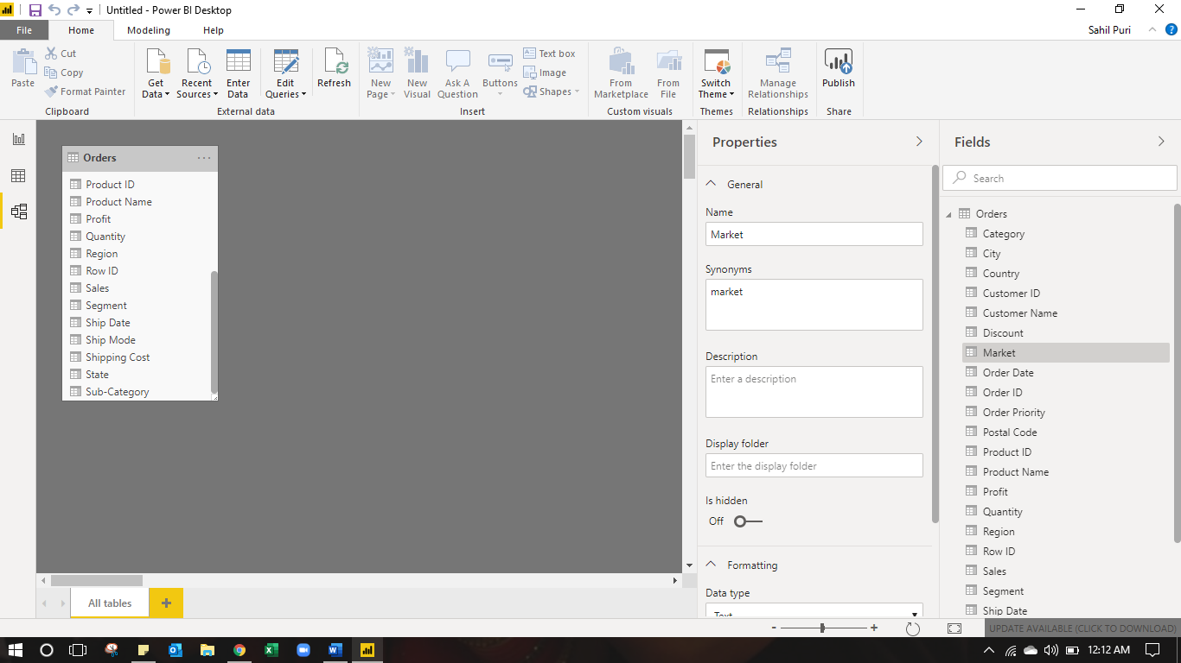

- Power Query Editor

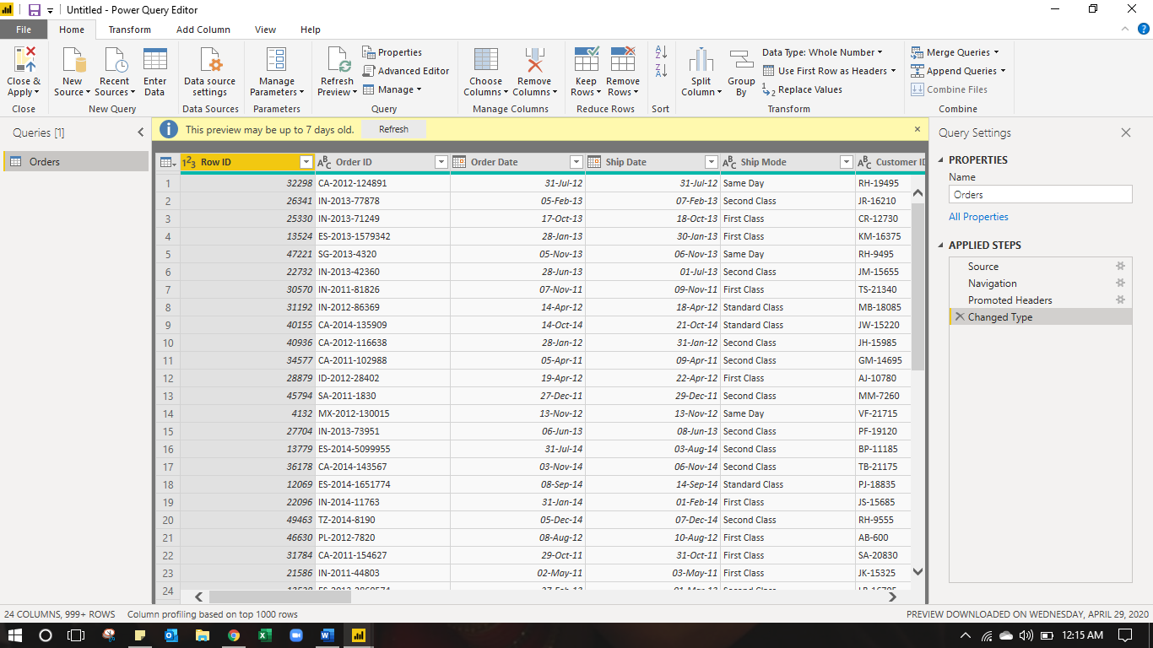

- Advanced Editor

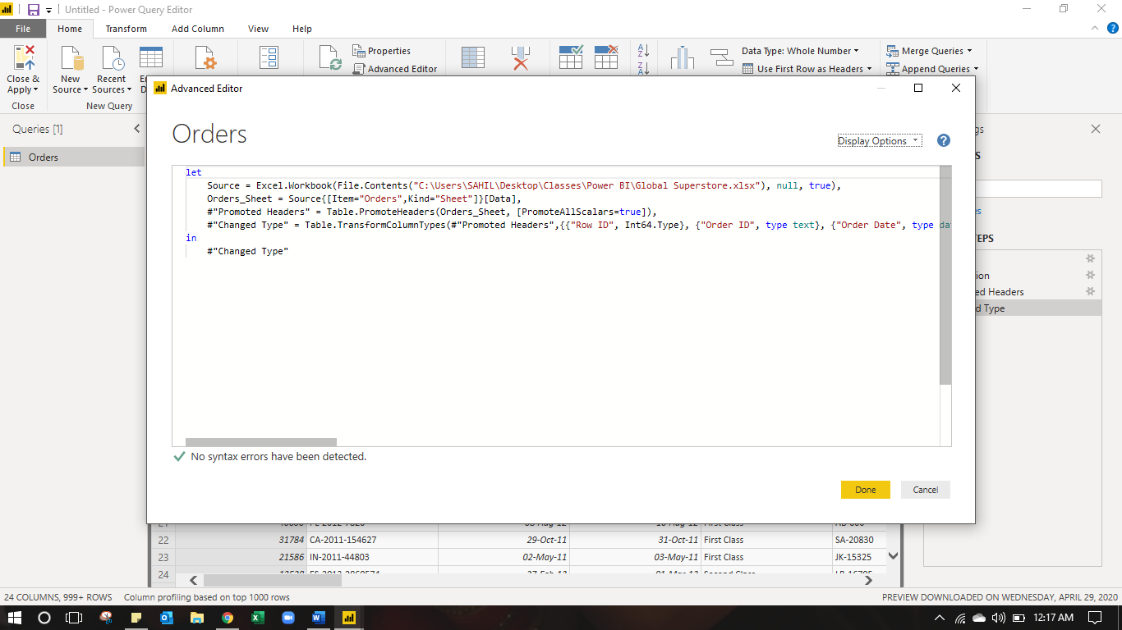

Prepare a document with details of the following along with their price
− Power BI Desktop - Free
− Power BI Pro - ₹660.00 (Monthly price per user)
− Power BI Premium - ₹330,190 (Monthly price per dedicated cloud compute and storage resource with annual subscription)

