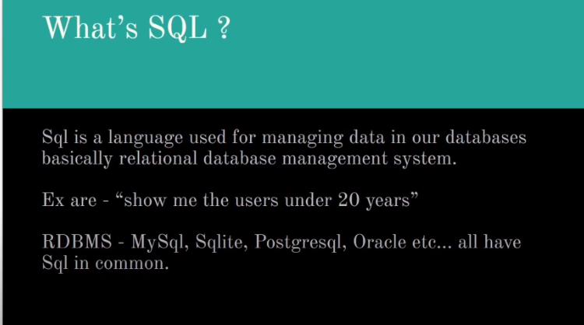

Skeleton Of a DBMS

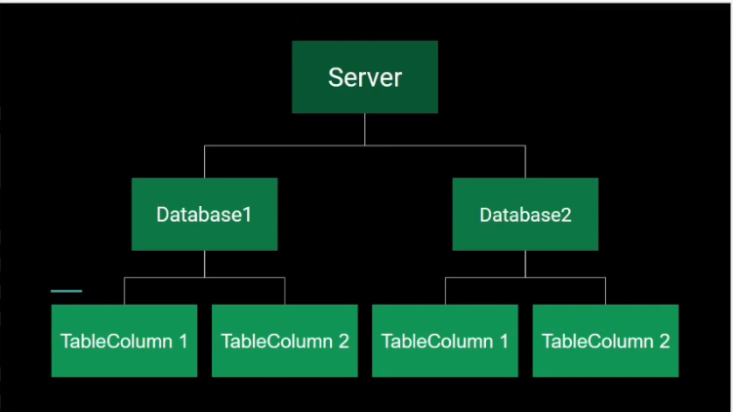

**SELECT-** The select statement retrieves **data from the database by easily selecting the rows and columns from a table**.

**FROM-** The from clause specifies **which table** the select statement will use.

select * from country

where continent='Asia'

order by name

LIMIT 5;



This query will print first 5 result.

**LIMIT** clauseshould be always after **ORDER BY** clause.

select name,region,lifeexpectancy from country

where continent='Asia'

order by name

LIMIT 5

OFFSET 5;

This query will ignore the first 5 records, as the **OFFSET =** 5 and will print the next 5 records as the **LIMIT**=5



**select COUNT(*) as TOTAL_NUM_ROWS from Country;**

**COUNT** is used to count the number of **rows or records** in a table.

#**Insert Query**

INSERT INTO customer (id,name,address,city,state,zip)

VALUES (4,'Sahil Singh','411 PWC','Pune','MH','411015');

INSERT INTO customer (id,name,city)

VALUES (5,'Eka','Pune');

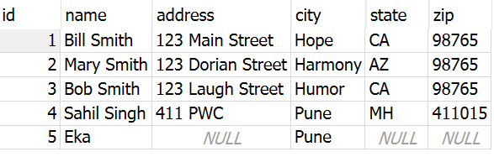

What if we don’t provide the column name ? See below

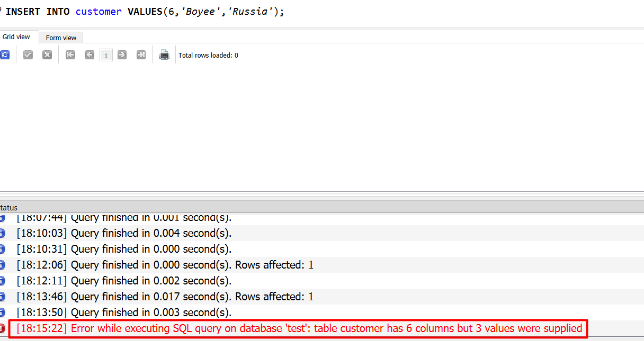

**#Update**

UPDATE customer

SET address='479 singh street'

WHERE id=5;

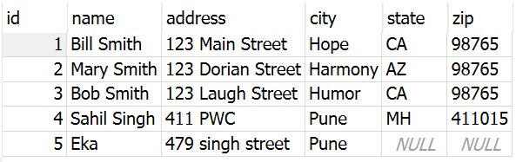

**UPDATE customer SET name='Sahilsi';**

*If you don’t specify the WHERE clause, then all the columns will be updated with the said SET statement.*

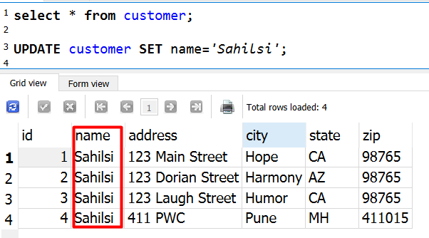

**#Delete**

To delete the RECORDS from a table.

DELETE FROM customer

WHERE name='Eka';

The RECORD of Eka is deleted from the table.

