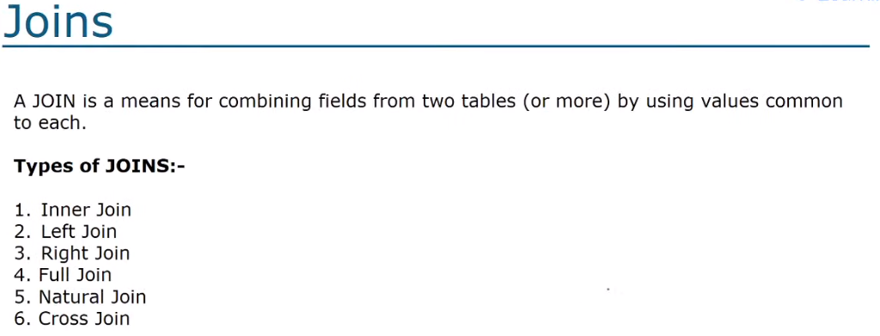



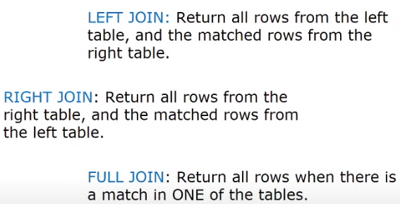

🡪**INNER JOIN**

SELECT l.id, l.description

FROM left l

JOIN right r ON l.id=r.id;

Inner Join is the simple join, that gives us the Intersection of the two tables.

🡪**OUTER JOIN**

It can be of two types:

1. **LEFT OUTER JOIN**

SELECT l.id,l.description as Left, r.description as Right

FROM left l

LEFT OUTER JOIN right r ON l.id=r.id;

This will give all the data in the left table + the intersection of Left and Right.

1. **RIGHT OUTER JOIN**

SELECT l.description as Left, r.description as Right

FROM right r

LEFT OUTER JOIN left l ON r.id=l.id;

This will give the data in the right table + the intersection of Right and Left.

Notice that I have used LEFT OUTER JOIN here too as some DB doesn’t support RIGHT JOINs, but it will result in RIGHT OUTER JOIN as we have changed the table names.

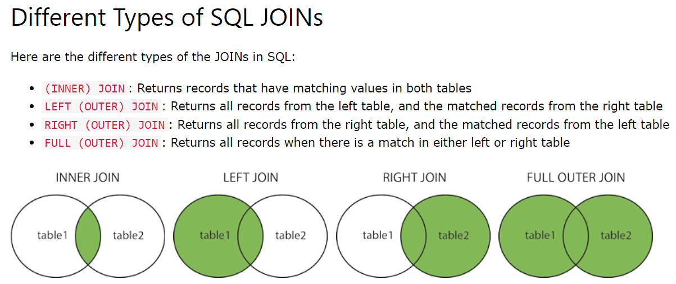

**WHAT IS A JOIN JUNCTION??**