**#6Aggregates**

**GROUP BY and HAVING clause**

GROUP BY clause is used for aggregation of data on certain column name.

For Example:

SELECT * FROM Country;



#This will print all the contents (Row * Column) of table Country

#What can we do to fetch or get count of countries in each continent?

This is where GROUP BY clause comes in picture….lets go GROUP BY!!

SELECT a.Continent, COUNT(a.Name) as Countries

FROM Country a

**GROUP BY (a.Continent);**

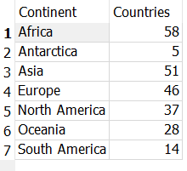

**HAVING** clause is used after aggregation, that is after GROUP BY, this is to provide conditions for columns produced after aggregation.

Example:

#After GROUP BY clause the output is: SELECT a.Continent, COUNT(a.Name) as Countries FROM Country a GROUP BY (a.Continent);

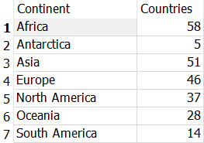

**#Using HAVING we can print only the Continents with Countries count more than 20.**

SELECT a.Continent, COUNT(a.Name) as Countries

FROM Country a

GROUP BY (a.Continent)

**HAVING Countries>20;**

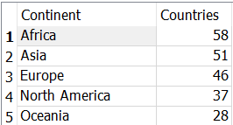

**#Using WHERE clause with GROUP BY and HAVING**

#The below query will print the number of countries in each continent which have Surface Area > 7000

#**Check the difference in count b/w this result and above result(without WHERE)**

SELECT a.Continent, COUNT(a.Name) as Countries

FROM Country a

WHERE a.SurfaceArea > 7000

GROUP BY (a.Continent);

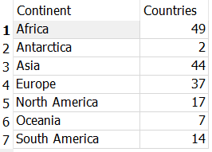

**Without WHERE clause output**



**AGGREGATE FUNCTIONS**

1. **Average Function**

SELECT AVG(SurfaceArea) as AVERAGE FROM Country;



SELECT Continent,ROUND(AVG(SurfaceArea),1) as AvgSurfaceArea

FROM Country

GROUP BY Continent

ORDER BY AvgSurfaceArea;

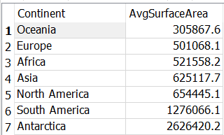

1. **MIN and MAX function**

SELECT Continent, MIN(SurfaceArea), MAX(SurfaceArea)

FROM Country

GROUP BY Continent;

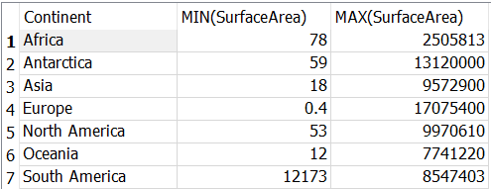

1. **SUM function**

SELECT Continent, SUM(SurfaceArea) as Sum FROM Country

GROUP BY Continent

ORDER BY Sum;

